Report on task 4

**Name: Temirlan Igenov**

**Group: BD-2004**

**E-mail: 201107@astanait.edu.kz**

Step 0:

We will be using the sequential ray tracing program from Task 1. Download and install Mini-Rt library (https://github.com/georgy-schukin/mini-rt), if necessary.

Step 1: Prepare a directory for the Task 4



Step 2: Implement parallel program with MPI

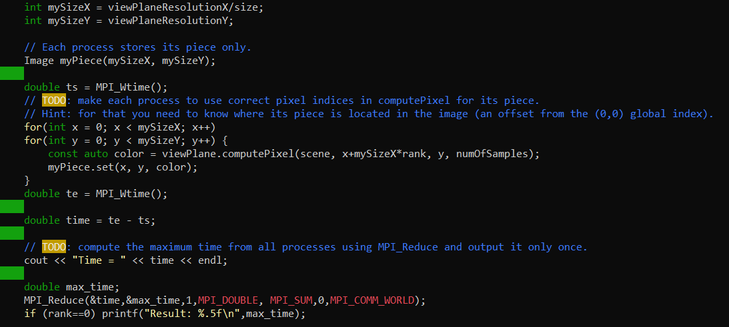

Step 3: Study performance of your parallel program

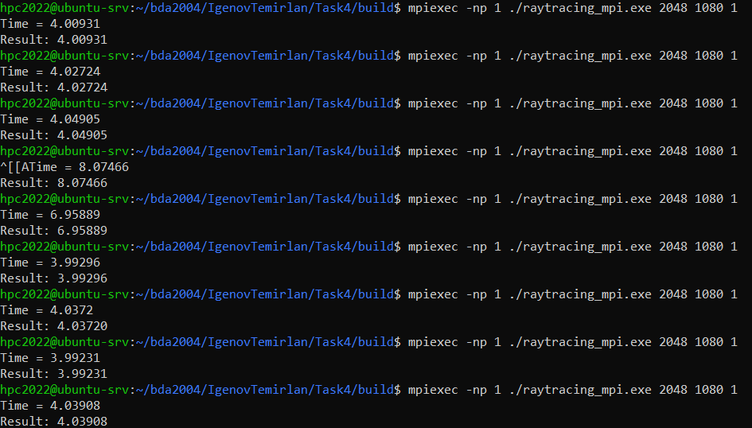

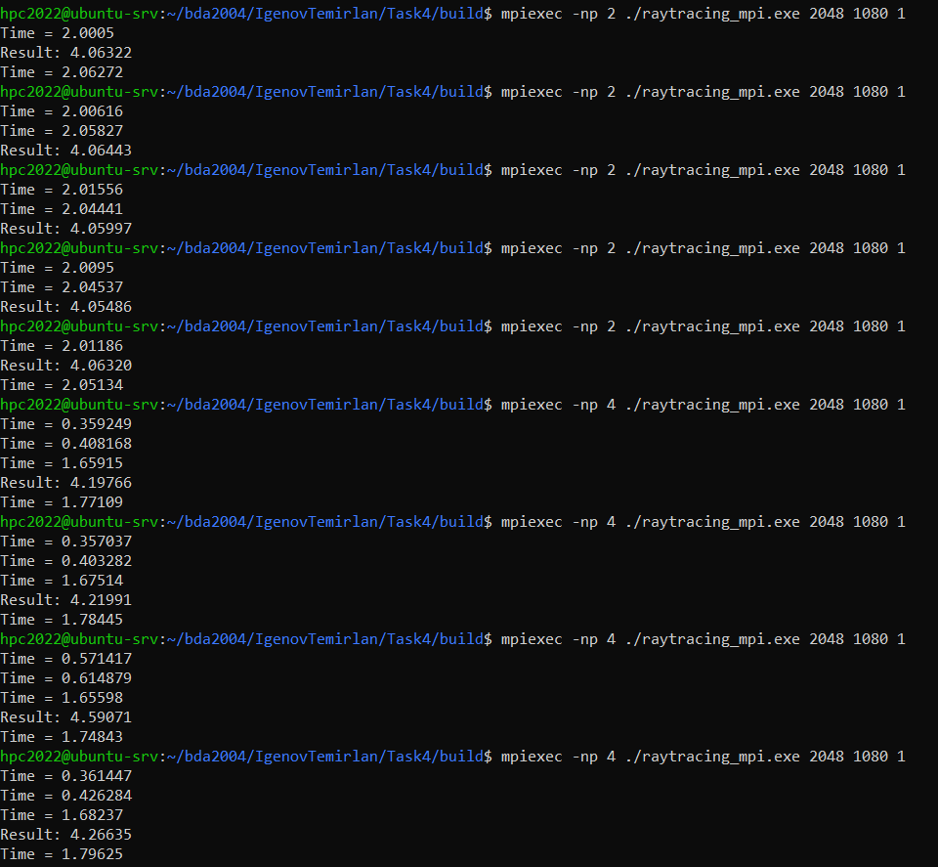

|  |  |  |  |  |  |  |  |  |
| --- | --- | --- | --- | --- | --- | --- | --- | --- |
| Threads | Run 1 (s) | Run 2 (s) | Run 3 (s) | Run 4 (s) | Run 5 (s) | **Min. time(s)** | Speedup | Efficiency |
| 1 | 4.00931 | 4.02724 | 4.04905 | 3.99296 | 4.03720 | 3.99296 | 100% | 100% |
| 2 | 4.06322 | 4.06443 | 4.05997 | 4.05486 | 4.06320 | 4.05486 | 0,98% | 49% |
| 4 | 4.19766 | 4.21991 | 4.59071 | 4.26635 | 4.19263 | 4.19263 | 0,95% | 23.75% |
| 8 | 5.05257 | 4.23762 | 4.25440 | 4.24728 | 5.05285 | 4.23762 | 0,94% | 11.75% |
| 16 | 5.52023 | 5.06820 | 4.76965 | 4.81158 | 4.78321 | 4.76965 | 0,84% | 5.25% |

Step 4: Commit and push your changes to the Gitlab server

[**https://github.com/alquimista-it/hpc2022/tree/main/Task4/build**](https://github.com/alquimista-it/hpc2022/tree/main/Task4/build)

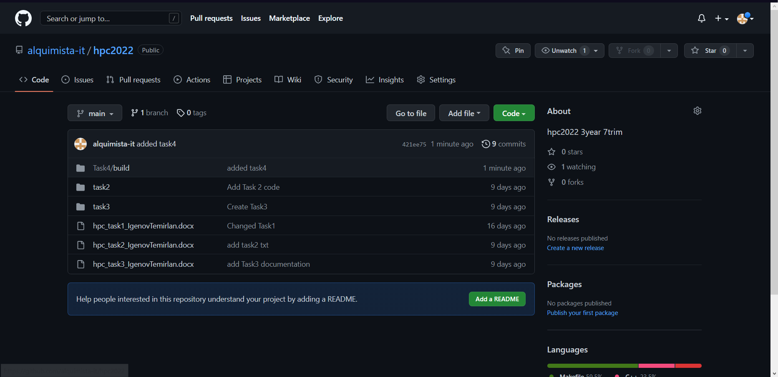

Step 5: Conclusion in a free form

I realized that with the planned parallelization using mpi, the speed decreases with increasing threads. Since the actions that the threads perform are the same and do not have any complex logical structure, the time remains almost the same. Only with an increase in threads does the time increase, since it takes time to glue these threads together, since everyone is waiting for the end of the previous thread.