Here in the Unit test we performed, we verified the behavior of the components in isolation independent of the user interface. The goal is to confirm that each method works as expected, data is stored and retrieved correctly, and constraints such as reservation limits are properly enforced.
- MemberUseCaseTest on Member Class:

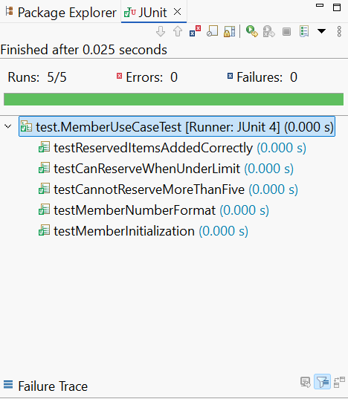
testMemberInitialization that checks the member has created correctly, by matching the expected values.
testMemberNumberFormat that membership number is created in the expected format.
testCanReserveWhenUnderLimitit works by adding some reservations to check that adding under the limit works.
testCannotReserveMoreThanFive to enforce the max limit reservations.
testReservedItemsAddedCorrectly, verifies items added to member reserved list are stored correctly.

- ItemTestUseCase on Item Class:
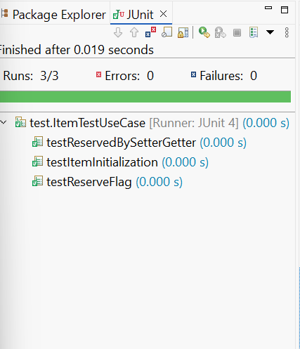
testItemInitialization, verifies item constructor correctly assigns the attributes.
testReserveFlag, that checks the isReserved can be updated. To ensure system mark item reserved when member reserves them.
testReservedBySetterGetter, verifies that reservedBy correctly track which member reserve it, to ensure reserved item correctly identifies the member who reserved it.
- LibraryDataUseCaseTest on LibraryData Class:
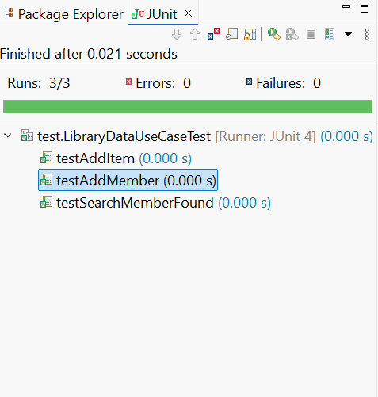
testAddMember, to ensure registering new member is working properly.
testSearchMemberFound, to ensure searching for existing member working properly.
testAddItem, ensure items are added to the library data correctly.

