Task 5: Test at least two quality requirements (NFRs)
1. Modifiability:
This system supports modifiability, meaning that internal changes can be applied without affecting the rest of the system. For this test, we modified the reservation limit inside the Reserve Item use case.
Originally, the system allowed a maximum of 3 reserved items per member. To demonstrate modifiability, we changed the limit to 5 items. After updating the condition in the code, the system continued to operate correctly with no errors.
1. Before Modification
To demonstrate modifiability, we first captured the system’s original behavior before any code changes.
The system originally allowed up to 3 reservations per member.

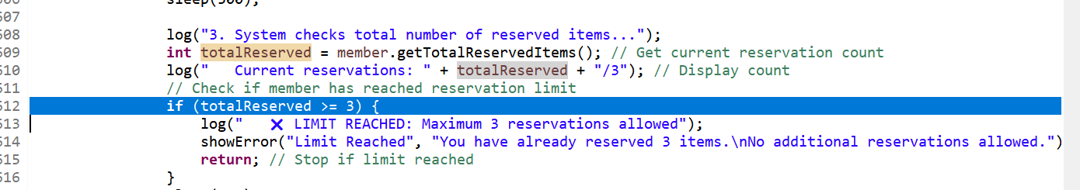

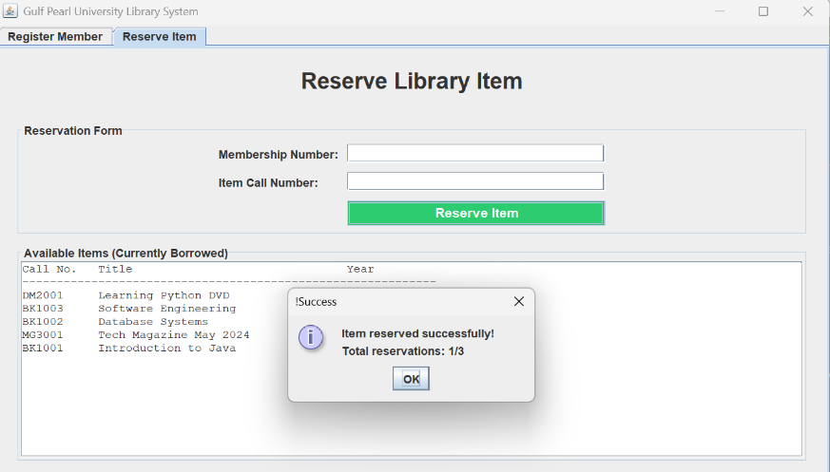

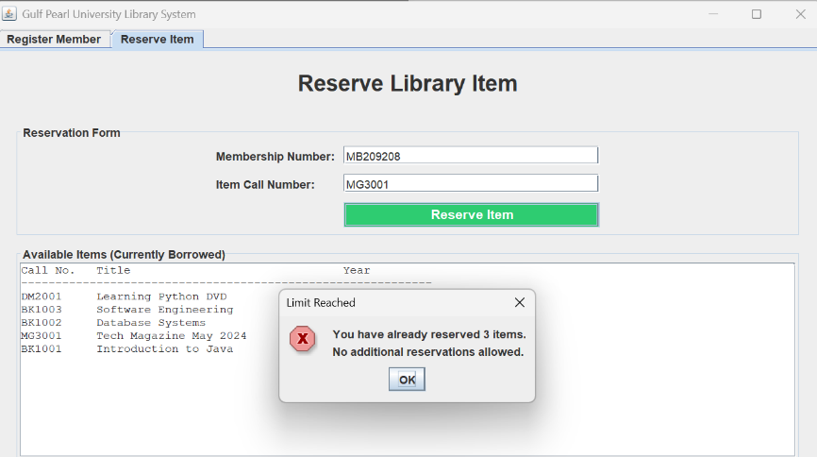

2. Code Modification
To test the modifiability requirement, we modified the reservation limit from 3 items → 5 items, while expecting the system to continue working normally without breaking any other functionality.

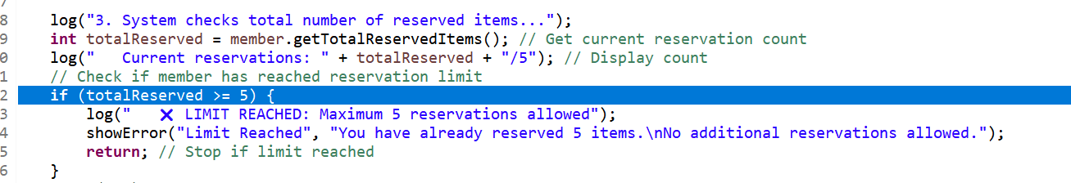

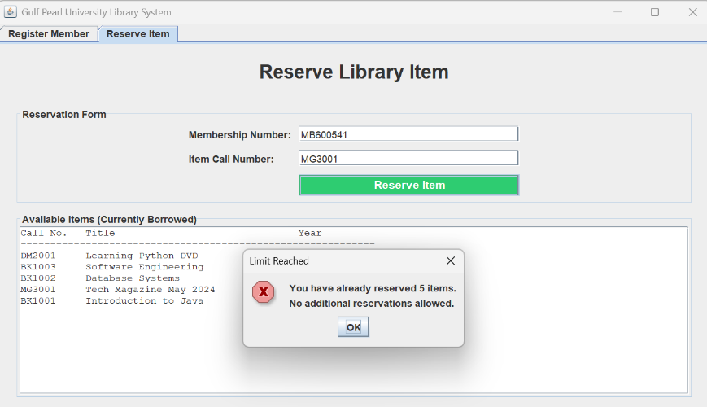

2. Performance:
To evaluate the Performance quality requirement, Apache JMeter was used to test how the system handles repeated calls to the reserveItem() operation.
We configured the test with:
Thread Group: 10 threads (simulated users)-
Ramp-Up Period: 10 seconds-
Loop Count: 10 loops-
This means that each of the 10 users executed the operation 10 times, resulting in a total of approximately 100 samples (the exact number may vary slightly due to JMeter’s internal processing).

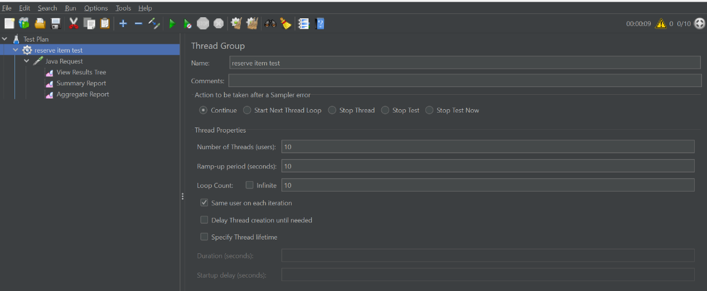
Test Results
Based on the View Results Tree, Summary Report, and Aggregate Report:
-All requests were successful (0% error rate).
The average response time was 2 ms, with a minimum of 2 ms and a maximum of 5 ms.-
The throughput was approximately 47.5 requests per minute.-
The system did not show any slowdown or failures.-
