- First pattern is: Factory pattern
The Factory Pattern is used to centralize and simplify the creation of different item types in the system. Instead of creating objects like Book2, Magazine2, and digital media manually, the factory handles this process based on the type requested. In the code, an interface named Item defines the common behaviors, and each item class implements it with its own loan period. The Item Factory class contains a method that checks the given type and returns the correct object accordingly. Inside Item Store, an instance of the factory is created and used to request items without exposing the creation logic. This makes the system cleaner, reduces duplication, and makes it easier to add new item types in the future with minimal changes.

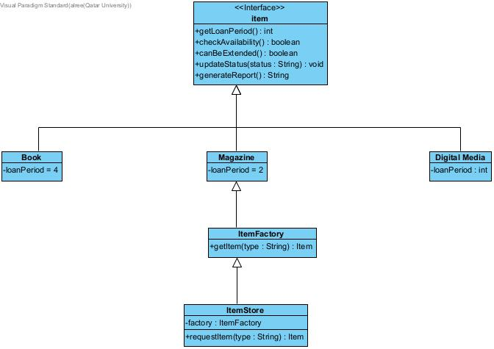
- Factory Package:

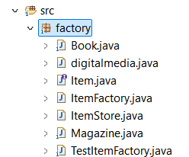

- Item interface
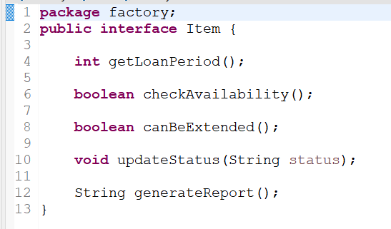

- Book
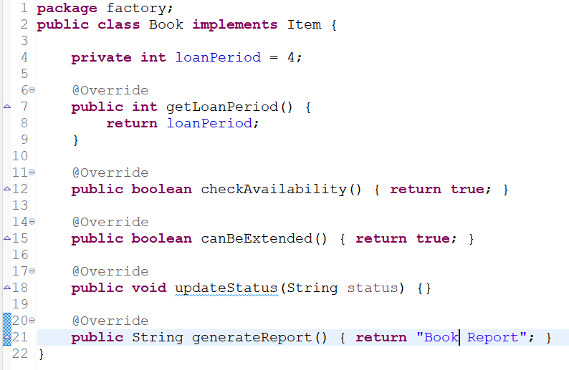

- digital media
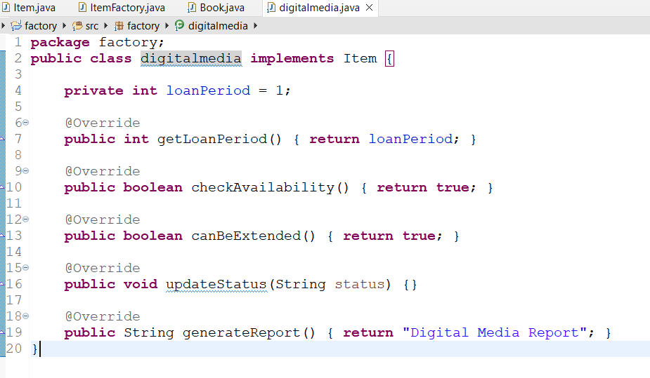

- Magazine
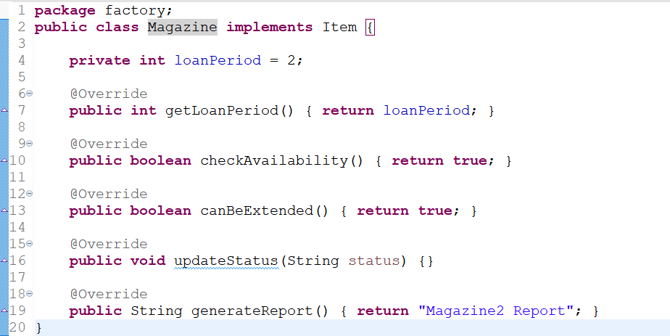
- Item Factory
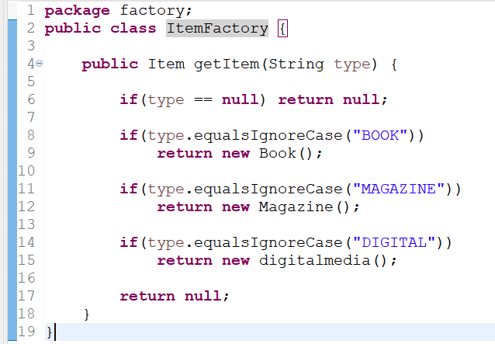
- Item Store
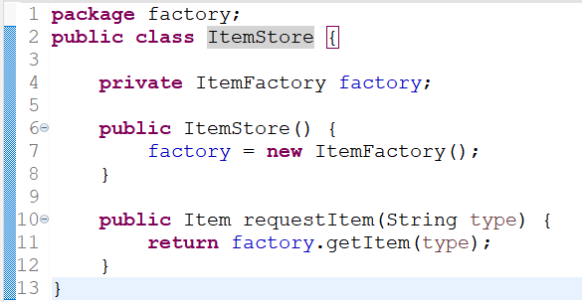

- Test Item Factory

