**Project**

**Android Controlled Robot Car**

**Faculty : Rakibul Hasan**

**Section:10**

**Submission Date :17/12/2018**

**Submitted by**

|  |  |
| --- | --- |
| Name | ID |
| Masud Rana | 1511400042 |
| Shoba Banik | 1521172642 |
| Md.Forhad Sarker | 1430046042 |



Department of Electrical and Computer Engineering

North South University

Fall 2018

**Project Aim:**

Our aim was to build a android controlled robot car. In our project we used several hardware components. Short description of the hardwires are given below:

**1.Arduino Nano**

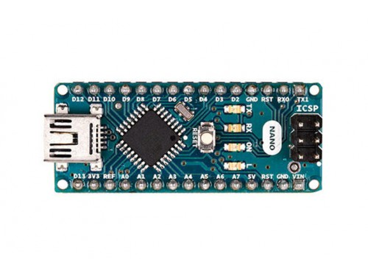

The Arduino Nano is a small, complete, and breadboard-friendly board based on the ATmega328P (Arduino Nano 3.x)

Specs:

|  |  |
| --- | --- |
| Microcontroller | ATmega328 |
| Architecture | AVR |
| Operating Voltage | 5 V |
| Flash Memory | 32 KB of which 2 KB used by bootloader |
| SRAM | 2 KB |
| Clock Speed | 16 MHz |
| Analog IN Pins | 8 |
| EEPROM | 1 KB |
| DC Current per I/O Pins | 40 mA (I/O Pins) |
| Input Voltage | 7-12 V |
| Digital I/O Pins | 22 (6 of which are PWM) |
| PWM Output | 6 |
| Power Consumption | 19 mA |
| PCB Size | 18 x 45 mm |
| Weight | 7 g |

**Arduino Nano Pinout:**

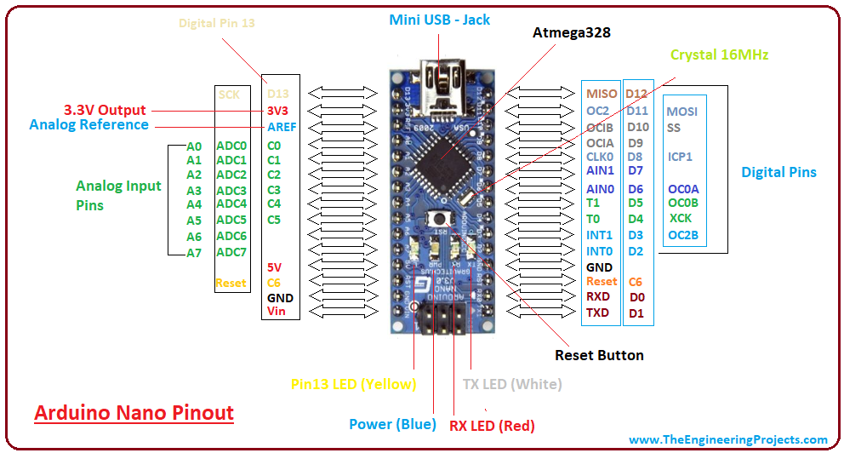

**2.Arduino Nano Programming Cable**

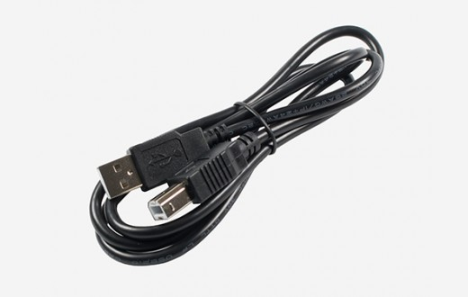

It is a Mini-B USB cable, which connects arduino nano with computer

**3. 4WD Robot Chasis Kit**

The kit contains

**Layered acrylic chasis(2),**

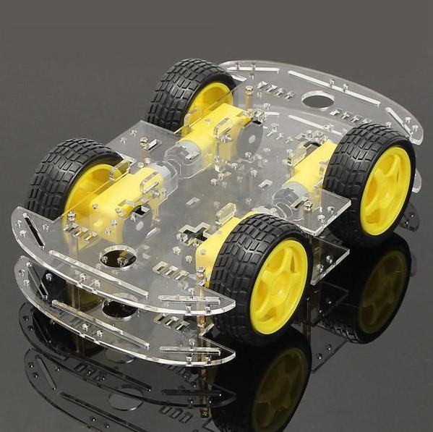

**Gear motors(4),**

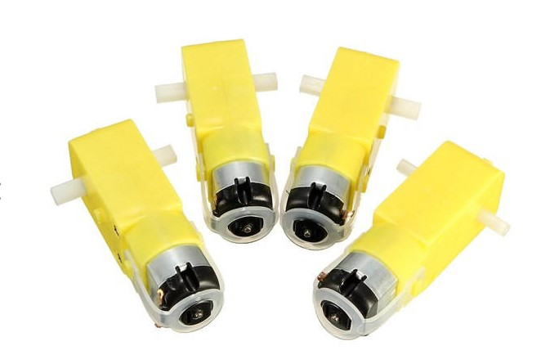

**Compatible wheels(4),**



**Screw and supportive parts**

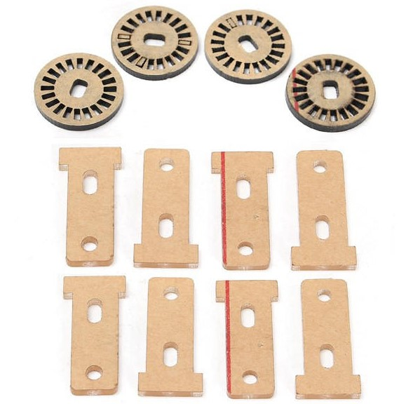

**4.L298 H Bridge Module**

H-Bridge's are typically used in controlling motors speed and direction. An H-Bridge can drive a current in either polarity and be controlled by Pulse Width Modulation (PWM). Pulse Width Modulation is a means in controlling the duration of an electronic pulse.

**Specifications:**

* Double H bridge Drive Chip: *L298N*
* Logical voltage: *5V Drive voltage: 5V-35V*
* Logical current: *0-36mA Drive current: 2A (MAX single bridge)*
* Max power: *25W*
* Dimensions: *43 x 43 x 26mm*
* Weight: *26g*

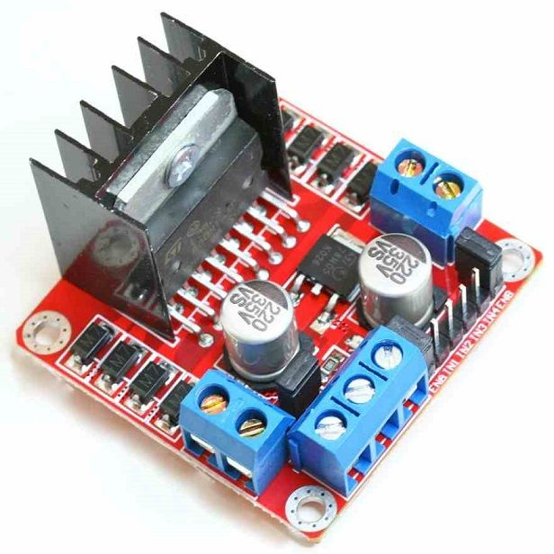

**Pins:**

* Out 1: Motor A lead out
* Out 2: Motor A lead out
* Out 3: Motor B lead out
* Out 4: Mo (*Can actually be from 5v-35v, just marked as 12v*)
* GND: Ground
* 5v: 5v input (*unnecessary if your power source is 7v-35v, if the power source is 7v-35v then it can act as a 5v out*)
* EnA: Enables PWM signal for Motor A (Please see the "Arduino Sketch Considerations" section)
* In1: Enable Motor A
* In2: Enable Motor A
* In3: Enable Motor B
* In4: Enable Motor B
* EnB: Enables PWM signal for Motor B (Please see the "Arduino Sketch Considerations" section)

**5. Bluetooth Module hc-06**

The HC-06 is a class 2 slave Bluetooth module designed for transparent wireless serial communication. Once it is paired to a master Bluetooth device such as PC, smart phones and tablet, its operation becomes transparent to the user. All data received through the serial input is immediately transmitted over the air. When the module receives wireless data, it is sent out through the serial interface exactly at it is received. No user code specific to the Bluetooth module is needed at all in the user microcontroller program.

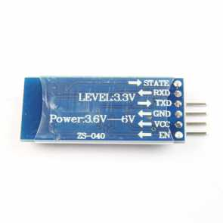

**Pin Description**

* **VCC**: positive pole of the power source.
* **GND**: Ground.
* **TXD**: serial interface, transmitting terminal.
* **RXD**: serial interface, receiving terminal.

**6. 2x18650 Li-ion battery with Holder**

These batteries are the power source of the robot

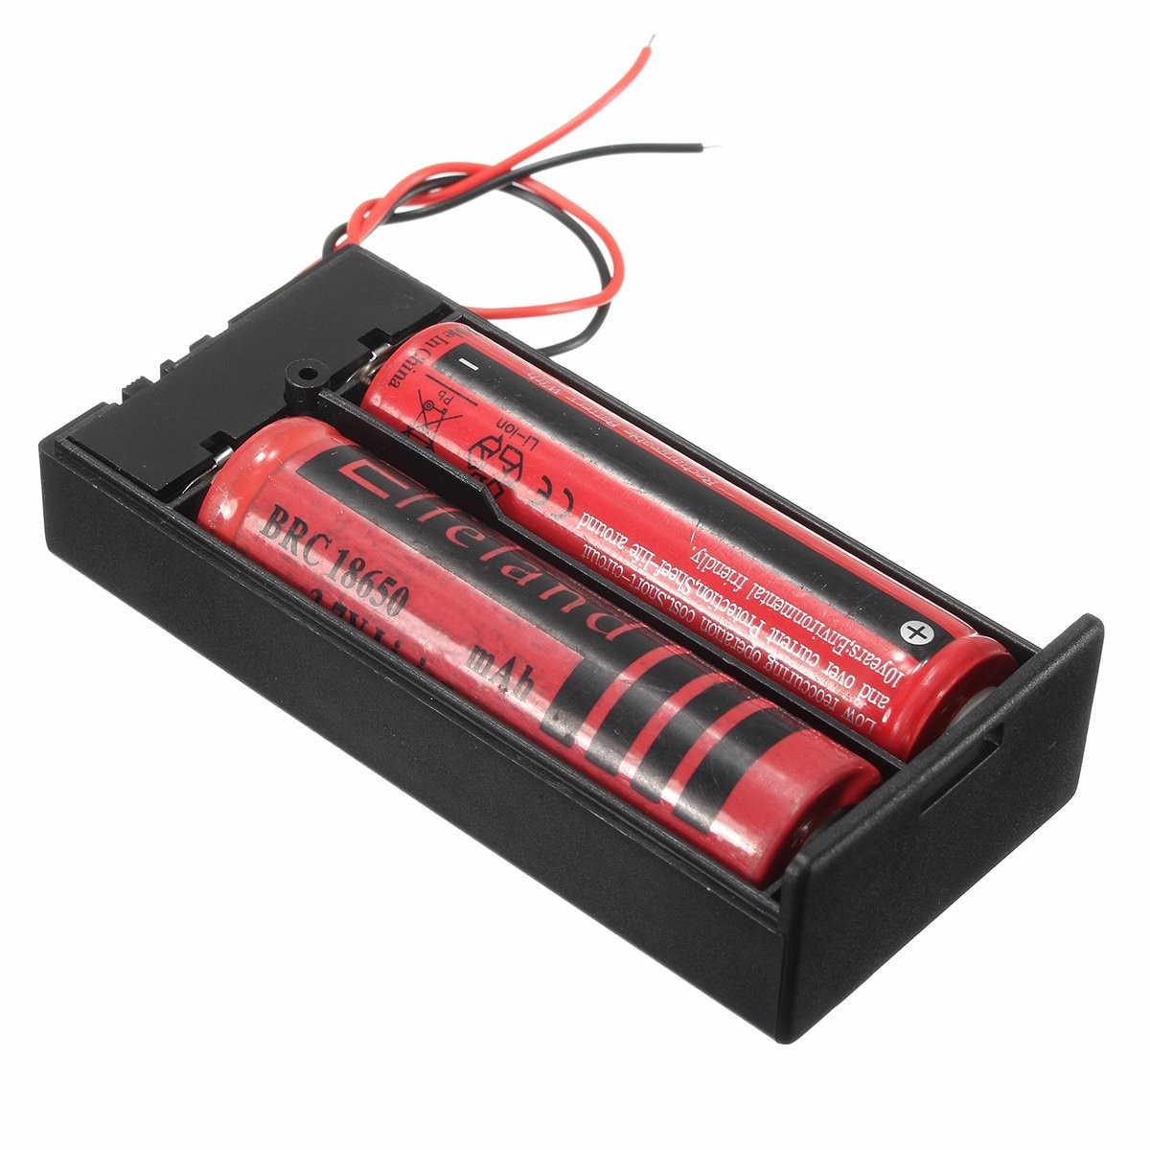

**7. Mini Bread board**

Interconnection(parallel and series ) between pin of Arduino NANO.

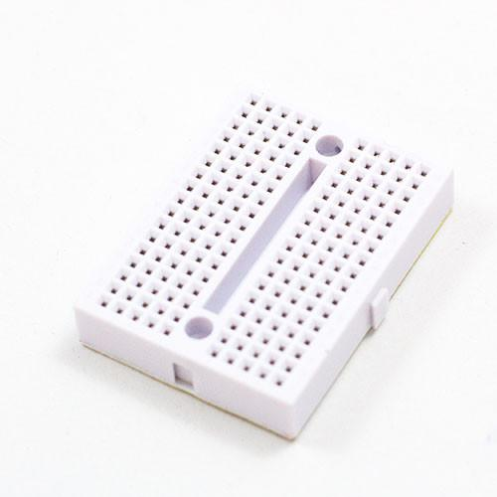

**8. Male Female Jumper Wire**

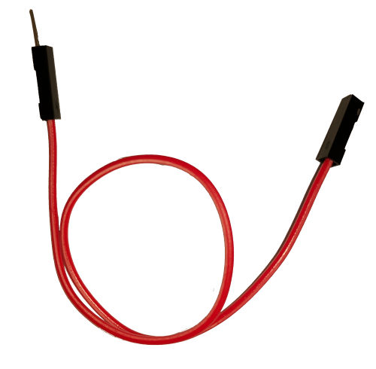

These wire has been used to connect between Arduino Nano,H Bridge and Bluetooth Module.

**9. Male Male Jumper wire**

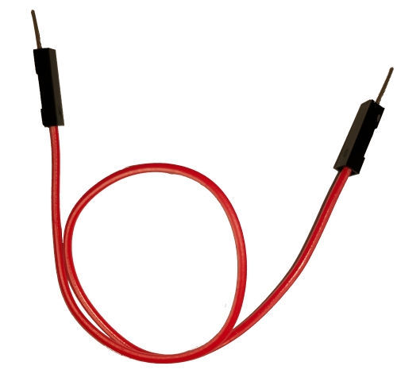

These wire has been used to connect between Arduino Nano,H Bridge and Bluetooth Module.

**10. 0.5 sq mm Wire**

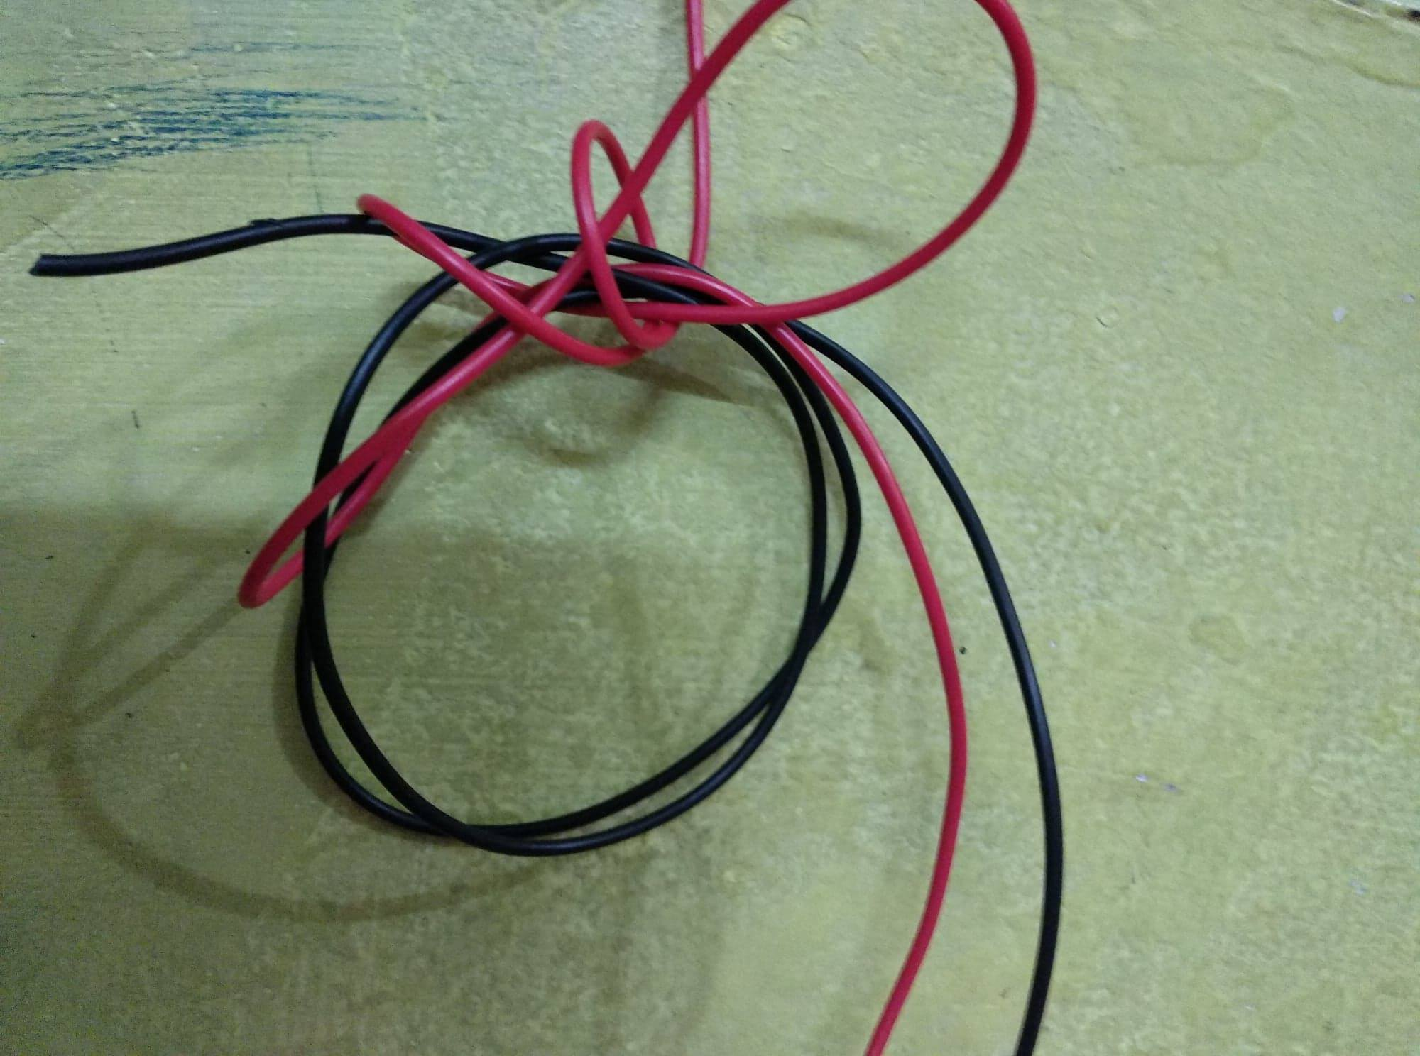

These wire hase been used to connect motors and batteries.

**10. Duct Tape**

We used Duct tape to hold the wires and other parts properly.



**Wiring Diagram:**

**Motor to H-bridge:**

Out1 -> Left side Motor Red Wire(+)

Out2 -> Left side Motor Black Wire(-)

Out3 -> Right side Motor Red Wire(+)

Out4 -> Right side Motor Black Wire(-)

**LM298 -> Arduino:**

IN1->D5

IN2->D6

IN3->D9

IN4->D10

**Bluetooth Module -> Arduino:**

Rx->Tx

Tx->Rx

Gnd->GND

VCC->3.3volt

**Power:**

12V -> Connect battery Red Wire

GND -> Connect Battery Black wire and Arduino GND pin

5V -> Connect to Arduino 5V pin

**Technology Platform:**

* **Development tools:**
* **Language:**  C++
* **Platform:** Arduino Nano
* **IDE:** Arduino
* **API:**
* **Software Requirement**: A Smartphone withandroid supportted **,**laptop arduino supported
* **Minimum Android OS:** API 22: Android 5.1 (Lollipop)
* **RAM: 1 GB.**
* **HDD: 500 MB free recommended.**