Hospital Management System 1.0 | 🏥
Software Architecture Document (version 1.0)

Software Architecture Document
Hospital Management System 1.0
Course: Software Architecture
Phase 1 — Architecture Design & Initial Implementation
Submission Date: 4 May 2026

SAD Revision History
Date | Version | Description | Author
2026-04-12 | 0.1 | Significant Use-Cases: key requirements | HMS Architecture Team
2026-04-15 | 0.2 | Candidate architecture: high level architecture | HMS Architecture Team
2026-04-20 | 0.3 | Initial Deployment Model | HMS Architecture Team
2026-04-24 | 0.4 | Key abstractions: key data elements | HMS Architecture Team
2026-04-28 | 0.5 | Analysis Model | HMS Architecture Team
2026-05-01 | 0.6 | Design Model + React Frontend Integration | HMS Architecture Team
2026-05-04 | 1.0 | Phase 1 — Use Case, Logical, and Process Views | HMS Architecture Team

Team and Contributions
This SAD document and the corresponding implementation were produced by the HMS Architecture Team. The contribution of each team member to Phase 1 is summarized below.
Name | Student ID | Role | Phase 1 Contribution
Marwan Mohammed Taher Alkhatib | 220911700 | Backend / Domain Engineer | Logical View design (13 ORM entities, class diagram, design packages, RBAC permission matrix), Process View (sequence diagrams, activity diagram, concurrency analysis), Django REST API backend (api_views.py, serializers, URL routing), permissions.py.
Anas Ravioglu | 2309015858 | Frontend / Integration Engineer | Use Case View (use cases, actors, use case diagram), complete React SPA frontend (LoginPage, Dashboard, BookAppointment, ViewAppointments, Sidebar), CSS design system (medicare.css), REST API client integration with token authentication.
Saleem Yahya Ahmad Almadfaie | 210911095 | Documentation Engineer | SAD document compilation and template alignment, Section 1 (Introduction, Scope, Quality), revision history maintenance, references, Appendix A (run instructions), supporting work on the deployment view .

1. Introduction
This document provides a comprehensive architectural overview of the Hospital Management System (HMS), a web-based application for managing patient registration, doctor scheduling, appointment booking, and medical records. The system uses a React Single-Page Application (SPA) frontend communicating with a Django REST API backend, following the 4+1 view model of architecture.
Architectural Activity | SAD Section
Step 1 — Identify and prioritize significant Use-Cases | Section 2
Step 2 — Define the candidate architecture | Sections 3, 6.1
Step 3 — Define the initial Deployment Model | Section 5
Step 4 — Identify key abstractions | Section 3.2
Step 5 — Create an Analysis Model | Section 3
Step 6 — Create the Design Model | Section 3
Step 7 — Document concurrency mechanisms | Section 4
Step 8 — Create the Implementation Model | Section 6

1.1 Purpose

The SAD lays out the architecture of the system from different angles. It’s here to make those big-picture technical decisions clear and grounded in the 4+1 view model of architecture [KRU41].

1.2 Scope

Phase 1 focuses on the Use Case, Logical, and Process Views. Right now, it’s about getting patient registration, login, appointment booking, doctor scheduling, and medical record creation up and running. The setup uses a two-tier structure — there’s a React SPA as the frontend (served by Vite at localhost:5173) and a Django REST API as the backend (running at localhost:8000). Phase 2 will add Development and Deployment Views when the system grows.

1.3 Architectural Representation

You’ll find all the details here using the 4+1 view model. So we’re talking Logical View, Process View, Implementation View, Deployment View, and Use Case View.

1.4 Technical Platform

The HMS uses two main tech stacks talking to each other over a REST API:

- Frontend: React 18 (JavaScript), Vite, and a custom CSS design system. It loads in the browser at http://localhost:5173.

- Backend: Django on Python 3.10+, Django REST Framework, SQLite (for Phase 1). Backend lives at http://localhost:8000.

- Authentication: Token-based using rest_framework.authtoken. React keeps the token in memory, sending it in every API call’s Authorization header.

- CORS: django-cors-headers lets React at localhost:5173 hit the Django API without trouble.

1.5 Transaction

The HMS manages transactions using Django ORM’s built-in tools. Any API action that changes something — booking, prescribing, stock adjustment — runs within request-bound transactions in Django, keeping changes atomic per HTTP request. Database constraints (like unique_together on Appointment) add extra protection.

1.6 Quality (Security, Reliability and Performance)

The system deals with Protected Health Information (PHI) and locks down access pretty tightly:

- Authentication: Tokens via Django REST Framework. React only keeps tokens in memory, not localStorage.

- Authorization: Six roles (Patient, Doctor, Nurse, Pharmacist, Management, Admin) managed in a central RBAC matrix (accounts/permissions.py).

- Confidentiality: Sensitive information (User.phone, Patient.address) is encrypted at rest using Fernet (AES-128-CBC).

- CORS Protection: django-cors-headers restricts API access to authorized origins.

- Session Security: It’s all token-based, no server-side sessions on the API layer.

2. Use-Case View

This section pulls together the actors and the use cases for the Hospital Management System. Appointment booking stands out — it runs the full request pipeline with token authentication, role checks, ORM persistence, and REST API serialization. Plus, it touches all the key entities (User, Patient, Doctor, Appointment).

2.1 Actors

- Patient: Registered user. In React, can log in, view dashboard, browse doctors, book appointments, and see appointment history.

- Doctor: Medical staff. Can view daily schedule, write medical records, and prescribe meds.

- Nurse: Clinical support, has department-limited, read-only access to prescriptions and medical records.

- Pharmacist: Runs the pharmacy, manages Drug catalog and DrugStock for the entire hospital.

- Management: Keeps tabs on operations with a read-only KPI dashboard (no PHI access).

- Admin: Handles users and departments through Django admin UI.

2.2 Book Appointment

Here’s how booking works: The patient logs into React, heads to Book Appointment. React grabs the doctor list using GET /api/doctors/. The patient picks a doctor, chooses a date and time, adds a reason, and hits Confirm Booking. React sends a POST to /api/appointments/book/<doctor_id>/ with the chosen time and reason. Django checks the token, confirms the PATIENT role, creates an Appointment with status PENDING, and sends back the appointment as JSON. React then redirects the patient to My Appointments, and the new booking shows up right away.

2.3 Use-Case Realizations

Phase 1 covers sixteen use cases spread across six actor types:

- Patient: UC-1 Register, UC-2 Log in, UC-3 Browse doctors, UC-4 Book appointment, UC-5 View my appointments.

- Doctor: UC-2 Log in, UC-6 View daily schedule, UC-7 Add medical record, UC-8 Prescribe medication.

- Nurse: UC-2 Log in, UC-9 View department prescriptions (read-only).

- Pharmacist: UC-2 Log in, UC-10 Manage drug catalog, UC-11 Adjust drug stock.

- Management: UC-2 Log in, UC-14 Update equipment status, UC-15 View management dashboard.

- Admin: UC-16 Manage users, profiles, and departments

.2.4 Use Case Diagram
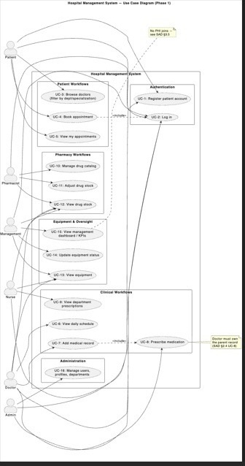
Figure 1 — Use Case Diagram showing the six actors and their associated use cases.

2.5 Frontend UI — React Implementation
The patient-facing use cases (UC-2 through UC-5) are realized by the React SPA. The UI is implemented in App.jsx and App.css using functional components with useState/useEffect hooks. The table below maps each component to the use cases it covers.
Component | Page | Use Cases Covered
LoginPage | Initial screen | UC-2: Login, POST /api/login/, token stored in state
Dashboard | page=dashboard | UC-3, UC-5: Stats, upcoming appointments, doctor list
BookAppointment | page=book | UC-4: Doctor dropdown, date, time slot, POST /api/appointments/book/
ViewAppointments | page=appointments | UC-5: Appointment cards, filter by All / Upcoming / Completed
Sidebar | Navigation | Page navigation, patient info, logout

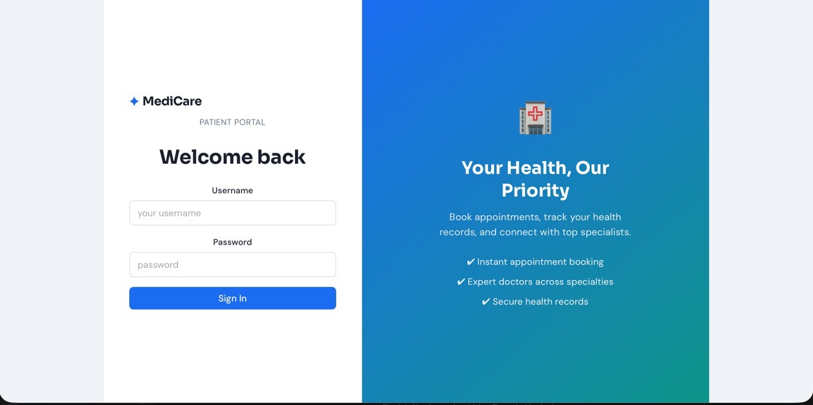
Figure 2 — Login page (split-card layout, standalone chrome).
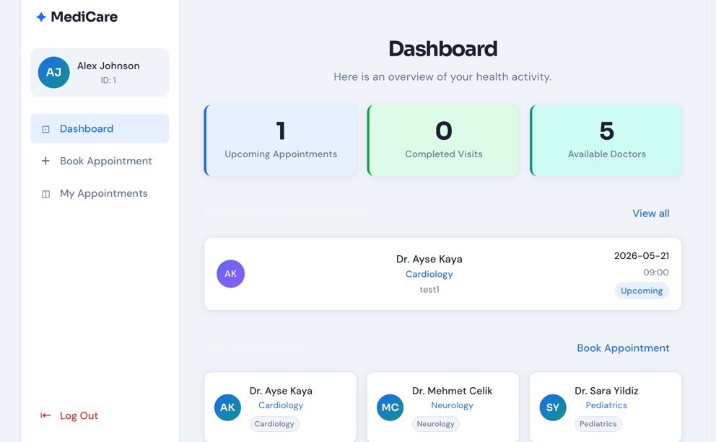
Figure 3 — Patient Dashboard showing stats, upcoming appointments, and our specialists.
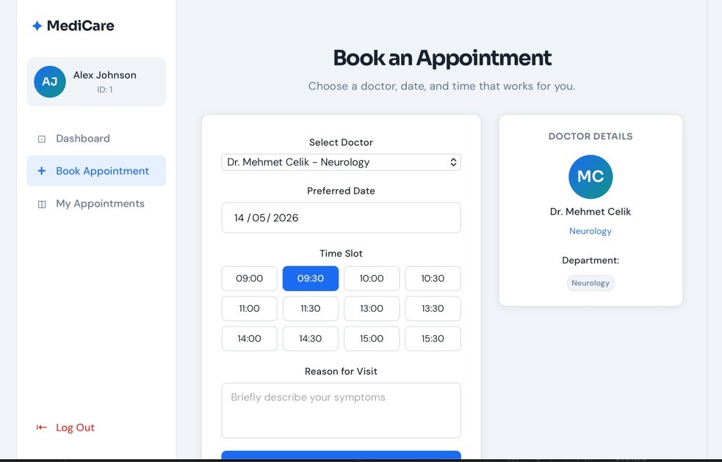
Figure 4 — Book Appointment form with date picker and time-slot grid.
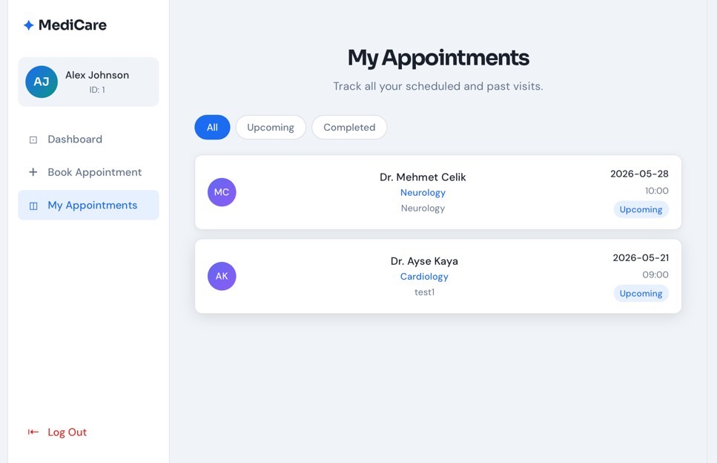
Figure 5 — My Appointments list with All / Upcoming / Completed filter chips.

2.5.1 Code Snippet — LoginPage component
The following excerpt from src/App.jsx shows the LoginPage component, which realizes UC-2 (Log in). The component manages local state with React hooks, calls the apiFetch helper to POST credentials to /api/login/, and lifts the returned user/token up to the App-level state.
JavaScript / React (src/App.jsx)
// LoginPage.jsx — realizes UC-2 (Log in)
// Source: src/App.jsx (excerpt)

const API = "http://localhost:8000";

async function apiFetch(path, options = {}, token = null) {
const headers = { "Content-Type": "application/json" };
if (token) headers["Authorization"] = `Token ${token}`;
const res = await fetch(`${API}${path}`, { ...options, headers });
const data = await res.json();
if (!res.ok) throw new Error(data.error || "Request failed");
return data;
}

function LoginPage({ onLogin }) {
const [form, setForm] = useState({ username: "", password: "" });
const [error, setError] = useState("");
const [loading, setLoading] = useState(false);

async function handleSubmit(e) {
e.preventDefault();
setError("");
if (!form.username || !form.password) {
setError("Please fill in all fields.");
return;
}
setLoading(true);
try {
const data = await apiFetch("/api/login/", {
method: "POST",
body: JSON.stringify(form)
});
onLogin(data.user, data.token); // store token in App state
} catch (err) {
setError("Invalid username or password.");
} finally {
setLoading(false);
}
}

return (
<div className="login-bg">
<div className="login-card">
<h2 className="login-heading">Welcome back</h2>
{error && <div className="alert alert-error">{error}</div>}
<form onSubmit={handleSubmit}>
<input type="text" placeholder="username"
value={form.username}
onChange={(e) => setForm({ ...form, username: e.target.value })} />
<input type="password" placeholder="password"
value={form.password}
onChange={(e) => setForm({ ...form, password: e.target.value })} />
<button type="submit" disabled={loading}>
{loading ? "Signing in..." : "Sign In"}
</button>
</form>
</div>
</div>
);
}

3. Logical View

3.1 Overview
The HMS uses the Model-View-Controller (MVC) architectural pattern realized by Django and React. With the addition of the React frontend, the architecture is extended to a Client-Server pattern where React is the View layer and Django provides the Controller and Model layers via a REST API.
MVC Layer | Technology | Responsibility
View (Presentation) | React 18, JavaScript, CSS | UI components, state management, user interaction
API Bridge | Django REST Framework | JSON serialization, token auth, CORS, /api/* endpoints
Controller | Django api_views.py + views.py | Request handling, RBAC, form validation, business logic
Model (Domain) | Django ORM, SQLite | 13 domain entities, integrity constraints, field-level encryption
Cross-Cutting | permissions.py, forms.py | Centralized RBAC matrix, form validators

3.2 Class Diagram
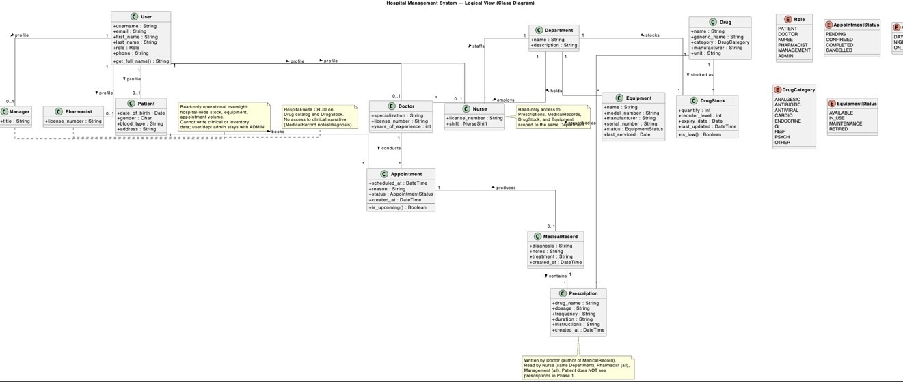
Figure 6 — Class Diagram of the 13 domain entities and their relationships.

3.3 Entity Descriptions
- User — Custom Django user with role attribute (PATIENT, DOCTOR, NURSE, PHARMACIST, MANAGEMENT, ADMIN). Phone encrypted at rest.
- Patient — Profile 1:1 with User of role PATIENT. Stores DOB, gender, blood type, address (encrypted).
- Doctor — Profile 1:1 with User of role DOCTOR. Belongs to one Department.
- Nurse — Profile 1:1 with User of role NURSE. Department-scoped read-only access.
- Pharmacist — Profile 1:1 with User of role PHARMACIST. Hospital-wide Drug/DrugStock authority.
- Manager — Profile 1:1 with User of role MANAGEMENT. Read-only operational oversight.
- Department — Clinical department. Unit of access scope for clinical roles.
- Appointment — Patient–Doctor meeting. Status: PENDING → CONFIRMED → COMPLETED.
- MedicalRecord — Diagnosis and notes for a completed Appointment (1:1).
- Prescription — Medication entry tied to MedicalRecord (1:N).
- Drug — Hospital-wide medication catalog (WHO Essential Medicines source).
- DrugStock — Per-department inventory row, unique per (drug, department).
- Equipment — Physical equipment per Department with status tracking.

3.4 REST API Layer
The REST API layer bridges the React frontend and Django backend. It is implemented in accounts/api_views.py and accounts/serializers.py.
Endpoint | Method | Description | Auth
/api/login/ | POST | Authenticate user, return token + user info | No
/api/logout/ | POST | Delete auth token | Yes
/api/doctors/ | GET | List all doctors with department info | Yes
/api/appointments/ | GET | List patient's own appointments only | Yes (Patient)
/api/appointments/book/<id>/ | POST | Book appointment with specific doctor | Yes (Patient)

3.4.1 Code Snippet — Doctor list endpoint
The following excerpt from accounts/api_views.py shows the api_doctor_list controller that realizes UC-3 (Browse doctors). It illustrates how the Controller layer queries the Model layer via the Django ORM, applies optional filters, and returns serialized JSON to the React frontend.
Python / Django REST Framework (accounts/api_views.py)
# accounts/api_views.py — REST API: list doctors
# Realizes UC-3 (Browse doctors). Called by React on the Book Appointment page.

from rest_framework.decorators import api_view, permission_classes
from rest_framework.permissions import IsAuthenticated
from rest_framework.response import Response

from .models import Doctor
from .serializers import DoctorSerializer

@api_view(['GET'])
@permission_classes([IsAuthenticated])
def api_doctor_list(request):
"""GET /api/doctors/ — list doctors, with optional filtering."""
qs = Doctor.objects.select_related('user', 'department').all()

department = request.GET.get('department', '').strip()
specialization = request.GET.get('specialization', '').strip()

if department:
qs = qs.filter(department__name__iexact=department)
if specialization:
qs = qs.filter(specialization__icontains=specialization)

serializer = DoctorSerializer(qs, many=True)
return Response(serializer.data)

3.5 Permission Matrix
Resource / Action | Patient | Doctor | Nurse | Pharmacist | Mgmt | Admin
Log in | Yes | Yes | Yes | Yes | Yes | Yes
Browse doctors (API) | Yes | No | No | No | No | Yes
Book appointment (API) | Yes | No | No | No | No | Yes
View own appointments | own | own | dept | No | No | Yes
View MedicalRecord | No | own pts | dept R | No | No | Yes
Write MedicalRecord | No | own pts | No | No | No | Yes
View Prescription | No | own pts | dept R | all R | No | Yes
View Drug catalog | No | all R | all R | all R/W | all R | Yes
View DrugStock | No | dept R | dept R | all R/W | all R | Yes
Management dashboard | No | No | No | No | Yes | Yes

3.6 Architecturally Significant Design Packages

3.6.1 Identity and Profiles
Responsible for authentication and role-based identity. Contains the custom User entity and the six role-specific profile entities. The role attribute drives all RBAC decisions in accounts/permissions.py.

3.6.2 Appointments and Records
Responsible for scheduling and clinical records. A Patient creates an Appointment (PENDING). The Doctor confirms (CONFIRMED), conducts the visit, and writes a MedicalRecord (COMPLETED). The unique_together = ('doctor', 'scheduled_at') constraint prevents double-booking at the database level.

3.6.3 Pharmacy
Contains the Drug catalog (hospital-wide) and DrugStock (per-department inventory). Pharmacists have hospital-wide write authority; Doctors and Nurses have department-scoped read access.

3.6.4 Equipment
Physical equipment assigned to Departments with status tracking. Doctors and Nurses see their department's equipment (read-only); Management has hospital-wide read and update authority.

4. Process View
The Process View describes how requests flow through the system. With the React frontend, the pipeline is extended from a browser-to-Django flow to a React-to-API-to-Django flow.
Step | Component | Action
1 | React (Browser) | User interaction triggers fetch() call with Authorization: Token header
2 | Django URL Dispatcher | Routes /api/* paths to api_views.py functions
3 | Auth / Permissions | Token validated by TokenAuthentication; role checked by permissions.py
4 | Controller (api_views.py) | Business logic, ORM calls, form/data validation
5 | Django ORM (models.py) | Queries or mutates SQLite; integrity constraints catch race conditions
6 | Serializer (serializers.py) | Converts model instances to JSON
7 | React State | Updates component state with JSON response, re-renders UI

4.1 Sequence Diagram — Book Appointment
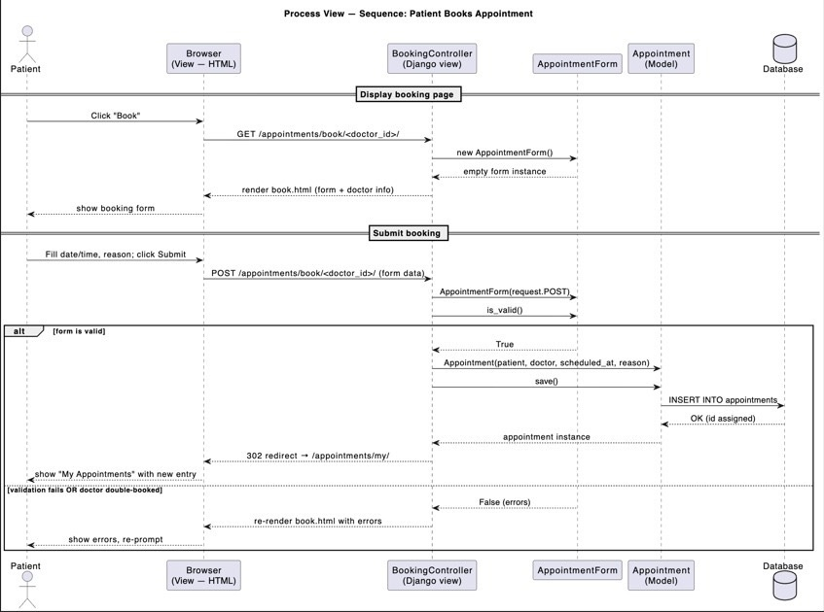
Figure 7 — Sequence Diagram for the Book Appointment flow (React → Django REST API → Database).
Walkthrough: the patient is logged in with a valid token. React fetches GET /api/doctors/ to populate the dropdown. Patient submits — React POSTs to /api/appointments/book/<doctor_id>/ with scheduled_at and reason. Django validates the token, checks the PATIENT role, creates the Appointment row (unique_together prevents double-booking), and returns serialized JSON. React redirects the user to My Appointments.

4.2 Activity Diagram — Appointment Lifecycle
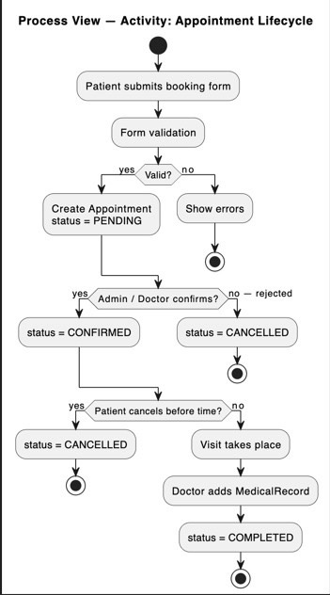
Figure 8 — Activity Diagram showing the PENDING → CONFIRMED → COMPLETED lifecycle with CANCELLED branches.
Lifecycle: PENDING (booked via React) → CONFIRMED (doctor confirms) → COMPLETED (after the doctor writes a MedicalRecord). CANCELLED is reachable from PENDING or CONFIRMED.

4.3 Sequence Diagram — Prescription Workflow
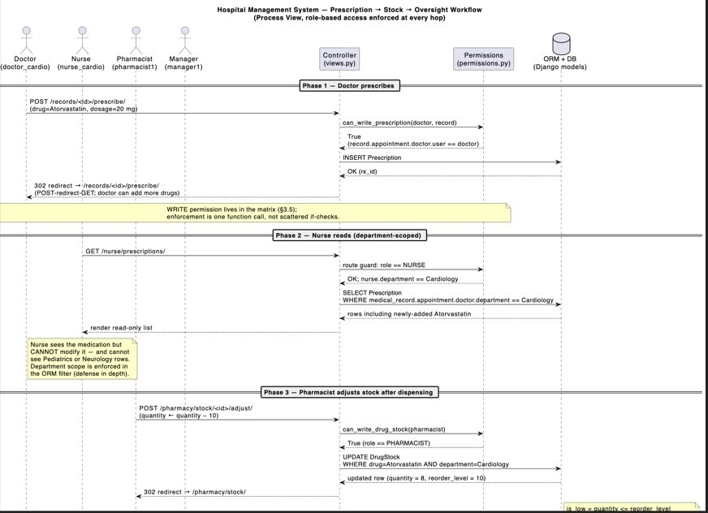
Figure 9 — Three-role prescription workflow: Doctor prescribes → Nurse views (department-scoped) → Pharmacist adjusts stock.
This diagram demonstrates how the centralized RBAC matrix is enforced across three roles. Each transition is gated by a single function call to permissions.py rather than by scattered if-checks throughout the controllers.

4.4 Concurrency
Phase 1 uses Django's single-process dev server and React's Vite dev server. Concurrency safety is provided by (a) the unique_together constraint on (doctor, scheduled_at) preventing double-booking at the database level, and (b) Django's default request-bound transaction wrapping each controller's ORM mutations. Phase 2 will use Gunicorn with multiple worker processes and PostgreSQL with explicit transaction isolation levels for read-heavy report queries.

4.5 Code Snippet — Book Appointment controller
The following excerpt from accounts/api_views.py shows api_book_appointment, which realizes UC-4 (Book Appointment). Each numbered comment maps to one step of the request pipeline described above: token authentication is enforced by the @permission_classes decorator, the role gate is the explicit role check, doctor lookup is the ORM .get(), input validation precedes the ORM .create(), and serialization converts the model instance to JSON for React.
Python / Django REST Framework (accounts/api_views.py)
# accounts/api_views.py — REST API: book appointment
# Realizes UC-4 (Book Appointment). The full Process View pipeline:
# token auth → role gate → doctor lookup → ORM create → JSON response.

@api_view(['POST'])
@permission_classes([IsAuthenticated])
def api_book_appointment(request, doctor_id):
"""POST /api/appointments/book/<doctor_id>/ — book an appointment."""

# 1. Role gate (centralized RBAC)
if request.user.role != 'PATIENT':
return Response({'error': 'Patients only.'},
status=status.HTTP_403_FORBIDDEN)

# 2. Doctor lookup
try:
doctor = Doctor.objects.get(pk=doctor_id)
except Doctor.DoesNotExist:
return Response({'error': 'Doctor not found.'},
status=status.HTTP_404_NOT_FOUND)

# 3. Input validation
scheduled_at = request.data.get('scheduled_at')
reason = request.data.get('reason', '')
if not scheduled_at:
return Response({'error': 'scheduled_at is required.'},
status=status.HTTP_400_BAD_REQUEST)

# 4. ORM create — unique_together('doctor','scheduled_at') prevents
# double-booking at the database level (concurrency safety).
try:
appt = Appointment.objects.create(
patient=request.user.patient_profile,
doctor=doctor,
scheduled_at=scheduled_at,
reason=reason,
status='PENDING',
)
except Exception as e:
return Response({'error': str(e)},
status=status.HTTP_400_BAD_REQUEST)

# 5. Serialize → JSON response
serializer = AppointmentSerializer(appt)
return Response(serializer.data, status=status.HTTP_201_CREATED)

5. Deployment View

Phase 1 Deployment (Current)
- React SPA — Vite dev server at http://localhost:5173. Serves the single-page application to the browser.
- Django REST API — dev server at http://127.0.0.1:8000. Serves /api/* endpoints as JSON.
- SQLite database — db.sqlite3 co-located with the Django project.
- CORS — configured to allow requests from localhost:5173.
- External services — none in Phase 1; the system is self-contained.
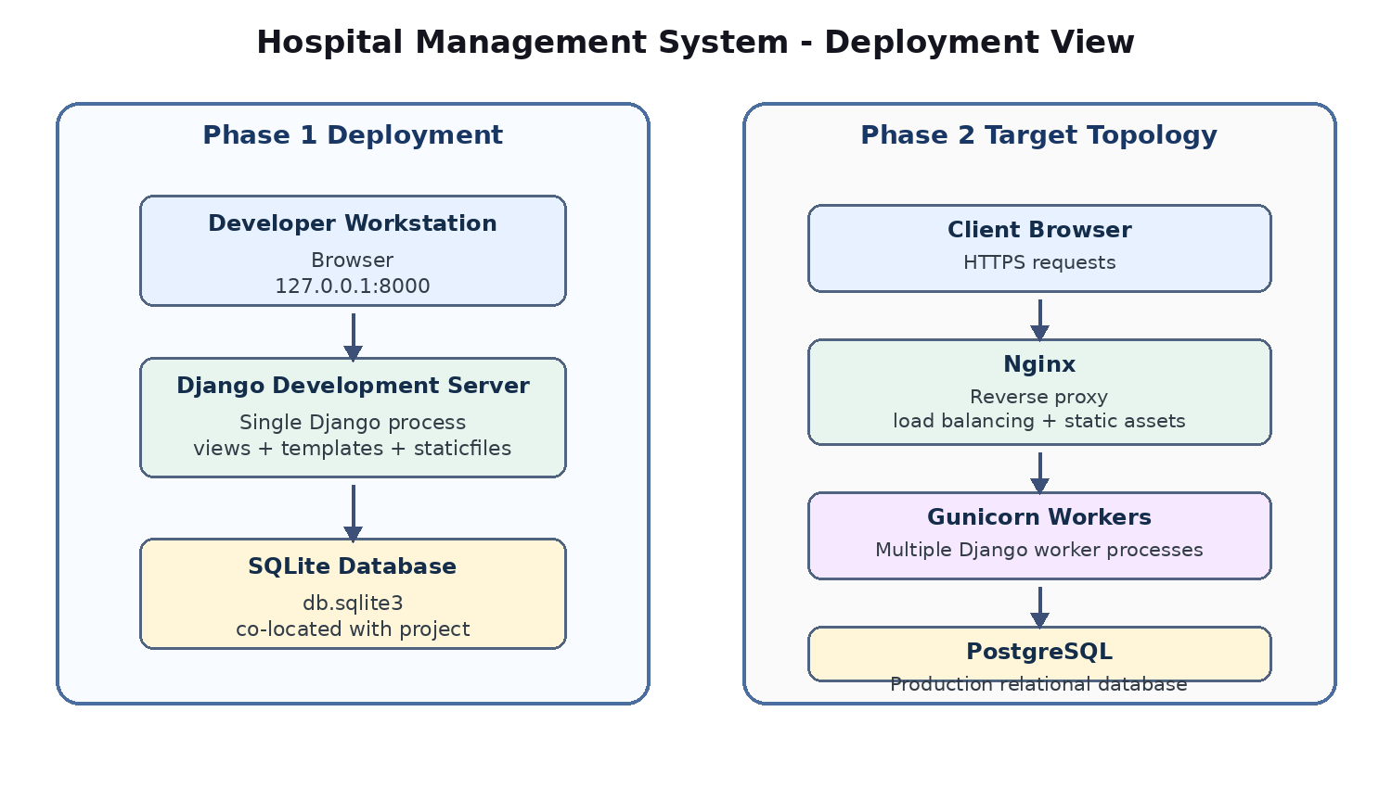
Figure 10 — Phase 1 deployment topology: React (Vite:5173) ↔ Django REST API (8000) ↔ SQLite.

Phase 2 Deployment (Planned)
- React production build (npm run build) served by Nginx or Vercel CDN.
- Django served by Gunicorn with multiple worker processes behind Nginx.
- PostgreSQL replacing SQLite, with disk-level encryption.
- TLS/HTTPS termination at Nginx.
- Separate staging and production environments.

6. Implementation View

6.1 Overview
The implementation is organized into two main codebases: the React frontend and the Django backend.
Repository | URL | Owner
React Frontend | https://github.com/alrawii2/hospital-frontend | Anas Ravioglu
Django Backend | https://github.com/alrawii2/hospital-management-system | Anas Ravioglu

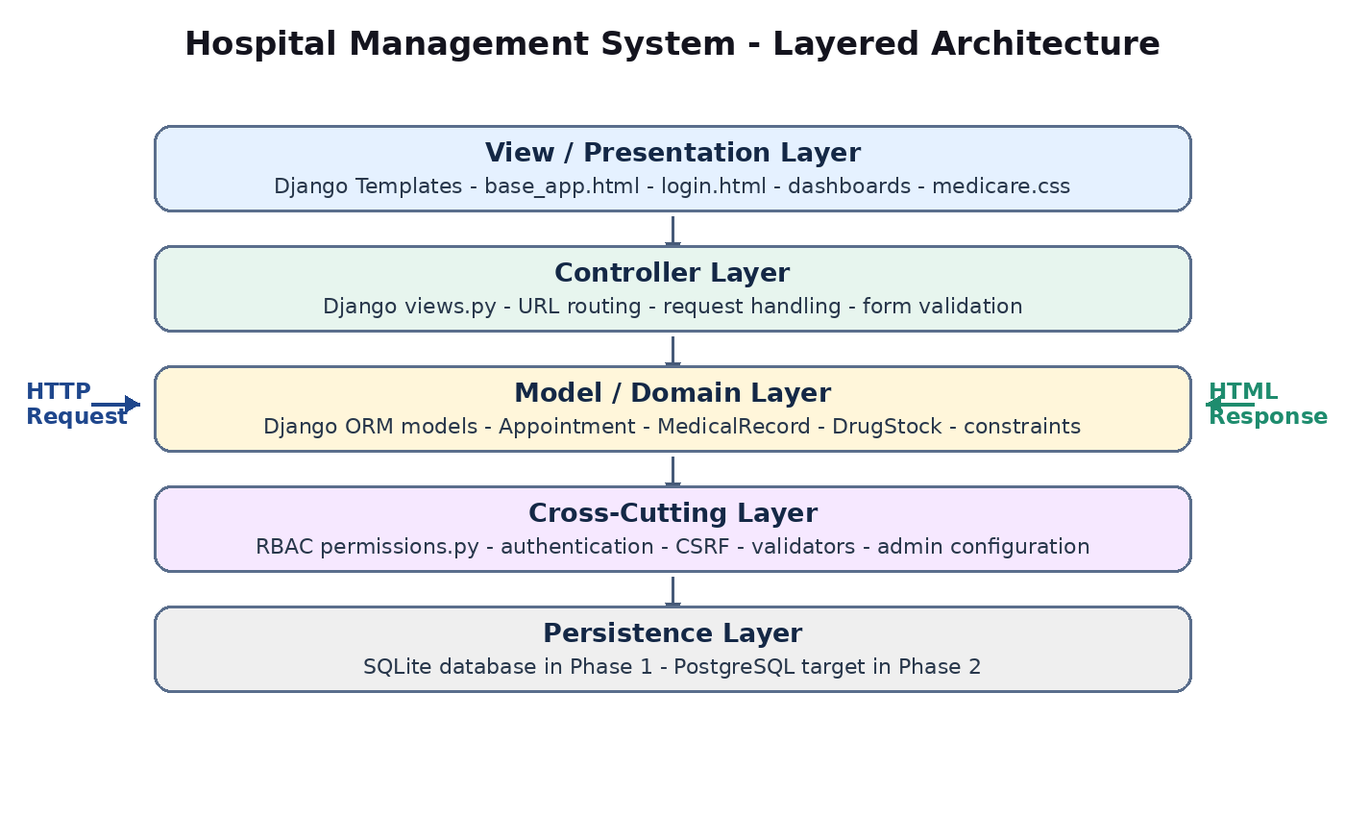
Figure 11 — Layered architecture: View, Controller, Model, and Cross-Cutting layers.

6.2 Layers

6.2.1 View (Presentation) Layer — React Frontend
The View layer is the React SPA. All UI logic lives in src/App.jsx (five components: LoginPage, Dashboard, BookAppointment, ViewAppointments, Sidebar) and src/App.css (custom design system, no external UI libraries).

6.2.2 API Bridge Layer
The apiFetch() function in App.jsx handles all communication with the Django backend. It attaches the Authorization: Token header to every authenticated request and parses JSON responses. Django's api_views.py and serializers.py implement the server side of this layer.

6.2.3 Controller Layer — Django Backend
The Controller layer is realized by accounts/api_views.py (REST API controllers) and accounts/views.py (template-based controllers). URL routing in hospital_project/urls.py maps /api/* paths to api_views and HTML paths to views.

6.2.4 Model (Domain) Layer
The Model layer is accounts/models.py — 13 Django ORM model classes with integrity constraints (unique_together on Appointment), status enumerations, and field-level encryption (User.phone, Patient.address).

6.2.5 Cross-Cutting Layer
accounts/permissions.py — centralized RBAC matrix with boolean helpers (can_book_appointment, can_write_prescription, etc.). accounts/forms.py — form validators. accounts/serializers.py — JSON serialization for the React frontend.

6.3 Implementation Status
Component | Status | File / Location
Domain models (13 entities) | Complete | accounts/models.py
Permission matrix (RBAC, 6 roles) | Complete | accounts/permissions.py
Django admin | Complete | accounts/admin.py
Forms (validation) | Complete | accounts/forms.py
Django controllers (views) | Complete | accounts/views.py
URL routing | Complete | hospital_project/urls.py
REST API views | Complete | accounts/api_views.py
REST API serializers | Complete | accounts/serializers.py
Token authentication | Complete | rest_framework.authtoken
CORS configuration | Complete | django-cors-headers, settings.py
React Login page | Complete | src/App.jsx — LoginPage
React Dashboard | Complete | src/App.jsx — Dashboard
React Book Appointment | Complete | src/App.jsx — BookAppointment
React My Appointments | Complete | src/App.jsx — ViewAppointments
React Sidebar navigation | Complete | src/App.jsx — Sidebar
React CSS styling | Complete | src/App.css
Frontend-Backend integration | Complete | Token auth + fetch() API calls
Field-level encryption | Complete | django-encrypted-model-fields
Automatic setup script | Complete | setup.sh

7. References
- [KRU41] Kruchten, P. "The 4+1 View Model of Architecture." IEEE Software, vol. 12, no. 6, pp. 42–50, November 1995.
- [DJANGO] Django Software Foundation. Django Documentation. https://docs.djangoproject.com/
- [DRF] Django REST Framework. https://www.django-rest-framework.org/
- [REACT] Meta Open Source. React Documentation. https://react.dev/
- [WHO-EML] World Health Organization. Model List of Essential Medicines, 23rd Edition. Geneva: WHO, 2023.
- [OWASP] Open Web Application Security Project. OWASP Top Ten 2021. https://owasp.org/Top10/
- [RUP] Kruchten, P. The Rational Unified Process: An Introduction, 3rd Edition. Addison-Wesley, 2003.

Appendix A — How to Run the System

Quick Start (Automatic)

Clone the repository and run the setup script

git clone https://github.com/alrawii2/hospital-management-system.git

cd hospital-management-system

And then :

Mac / Linux:

bash setup.sh

or

Windows:

.\setup.bat

The browser opens automatically at http://localhost:5173.Demo Login Credentials
Username | Password | Role
patient1 | test123 | PATIENT

