Software Architecture Document
Hospital Management System
Version 2.0 — Phase 2: Extended SAD
Course: Software Architecture
Phase 2 — Architecture Completion & Full Implementation
Submission Date: 24 May 2026
Team: HMS Architecture Team

SAD Revision History
Date | Version | Description | Author
2026-04-12 | 0.1 | Significant Use-Cases: key requirements | HMS Architecture Team
2026-04-15 | 0.2 | Candidate architecture: high-level architecture | HMS Architecture Team
2026-04-20 | 0.3 | Initial Deployment Model | HMS Architecture Team
2026-04-24 | 0.4 | Key abstractions: key data elements | HMS Architecture Team
2026-04-28 | 0.5 | Analysis Model | HMS Architecture Team
2026-05-01 | 0.6 | Design Model + React Frontend Integration | HMS Architecture Team
2026-05-04 | 1.0 | Phase 1 — Use Case, Logical, and Process Views (Phase 1 submission) | HMS Architecture Team
2026-05-10 | 1.1 | Phase 2 kickoff: scope, gap analysis vs. Phase 1 | HMS Architecture Team
2026-05-14 | 1.2 | Development View: component diagram + module-to-file mapping | HMS Architecture Team
2026-05-18 | 1.3 | Deployment View: containerized topology + production environment | HMS Architecture Team
2026-05-21 | 1.4 | Updated booking sequence diagram (React + REST) | HMS Architecture Team
2026-05-24 | 2.0 | Phase 2 submission — all five 4+1 views complete | HMS Architecture Team
2026-05-17 | 2.1 | Phase 2.1: Patient cancellation, doctor availability, Room model, expanded dataset | HMS Architecture Team
2026-05-17 | 2.2 | Phase 2.2: 11 inline REST endpoints, restored single-form login, unified blue palette across all role shells, BookingCalendar component | HMS Architecture Team

Team and Contributions
This SAD document and the corresponding implementation were produced by the HMS Architecture Team. Phase 2 contributions extend the Phase 1 work into a production-grade deployment and the two remaining 4+1 views (Development and Deployment).
Name | Student ID | Role | Phase 2 Contribution
Marwan Mohammed Taher Alkhatib | 220911700 | Backend / Domain Engineer | Production-ready settings.py (env-driven), PostgreSQL migration, Gunicorn + Whitenoise integration, health-check endpoint, DRF throttling, field-level encryption hardening. Authored §5 Development View and §6.2 backend topology.
Anas Ravioglu | 2309015858 | Frontend / Integration Engineer | Production React build (Vite) wired to same-origin /api/* via Nginx reverse proxy, frontend Dockerfile (multi-stage), CSP-friendly Nginx config, environment-driven API base. Authored §6.1 frontend topology and §7.2 build pipeline.
Saleem Yahya Ahmad Almadfaie | 210911095 | Documentation Engineer | Extended SAD v2 compilation; revision history; new component and deployment diagrams; module-to-file traceability matrices; updated process-view sequence; cross-view consistency review. Authored §1 introduction updates, §7 implementation status, and §8 references.

1. Introduction
This document is version 2.0 of the Software Architecture Document for the Hospital Management System (HMS), a web-based application for managing patient registration, doctor scheduling, appointment booking, medical records, prescriptions, pharmacy inventory, equipment, and operational dashboards. It extends SAD v1.0 (Phase 1 submission, 4 May 2026) with two new views and a production-ready deployment.
The full 4+1 view coverage is now:
View | Section | Phase 1 status | Phase 2 status
Use Case | §2 | Complete | Refined (RBAC examples added)
Logical | §3 | Complete | No structural change
Process | §4 | Complete | Booking sequence updated to React + REST
Development | §5 | — | NEW — component diagram + module-to-file mapping
Deployment | §6 | Stub | EXPANDED — containerized production topology
Implementation | §7 | Partial | Updated for Phase 2 (Docker, Gunicorn, PostgreSQL)

1.1 Purpose
The SAD lays out the architecture of the system from five complementary viewpoints. It makes the significant technical decisions explicit and traceable, grounded in Kruchten's 4+1 view model [KRU41].

1.2 Scope (Phase 2)
Phase 2 closes out the two 4+1 views that were deferred in Phase 1 and lifts the system from a single-developer dev environment to a containerized deployable artifact:
- Development View (§5) describing the module decomposition, component dependencies, and how each architectural element maps to a concrete file in the repository.
- Deployment View (§6) describing the production runtime topology: Nginx in front of Gunicorn, PostgreSQL replacing SQLite, Redis for cache and DRF throttling, and Docker Compose orchestrating the whole stack.
- Implementation hardening (§7): environment-driven settings, WhiteNoise for static files, security headers, HSTS, CSRF/SESSION cookie hardening, and a CI workflow that builds the backend and frontend images on every push.

1.3 Architectural Representation
All decisions are documented in this SAD using the Kruchten 4+1 view model: Use Case (§2), Logical (§3), Process (§4), Development (§5), and Deployment (§6). The Implementation View (§7) ties each architectural element to its concrete realization in the codebase.

1.4 Technical Platform
HMS is composed of two tiers communicating over a REST API, plus a data tier:
- Frontend: React 18 (JavaScript) + Vite 5, custom CSS design system. Dev: http://localhost:5173. Prod: built static assets served by Nginx at http://<host>/.
- Backend: Django 5.2 on Python 3.12, Django REST Framework 3.15. Dev: http://localhost:8000. Prod: Gunicorn 21 with 4 sync workers, behind Nginx, exposed only on the internal Docker network.
- Database: SQLite 3 (Phase 1 dev) → PostgreSQL 15 (Phase 2 prod), volume-backed.
- Cache / Session / Throttle: Redis 7 (Phase 2).
- Authentication: token-based via rest_framework.authtoken. React keeps the token in memory and sends it as Authorization: Token <key> on every authenticated request.
- Field-level encryption: User.phone and Patient.address are encrypted at rest using Fernet (AES-128-CBC + HMAC) via django-encrypted-model-fields. Key is read from FIELD_ENCRYPTION_KEY env var.
- Static assets: WhiteNoise for compressed, hashed static files (Django admin + DRF browsable API). React build assets are served by Nginx directly.
- Reverse proxy & TLS: Nginx 1.25 terminates TLS, serves the React static build, and reverse-proxies /api/* and /admin/ to the backend container.

1.5 Transactions
Django ORM wraps every controller in a request-bound transaction by default. Mutating API endpoints (book, prescribe, stock adjustment) are atomic per HTTP request. Database-level constraints (e.g. unique_together('doctor','scheduled_at') on Appointment, unique_together('drug','department') on DrugStock) close the race-condition window between request validation and commit.

1.6 Quality (Security, Reliability, Performance)
HMS handles Protected Health Information (PHI) and applies layered controls:
- Authentication: token-based; tokens are server-issued and stored in React state only (never in localStorage).
- Authorization: 6 roles managed in a centralized RBAC matrix (accounts/permissions.py).
- Confidentiality at rest: sensitive PII fields are Fernet-encrypted; the database itself runs in an internal-only Docker network in Phase 2.
- Throttling: DRF AnonRateThrottle (30 req/min) and UserRateThrottle (120 req/min).
- Transport security (prod): TLS termination at Nginx with Let's Encrypt; HSTS for 30 days; SECURE_SSL_REDIRECT, SECURE_PROXY_SSL_HEADER, SESSION_COOKIE_SECURE, CSRF_COOKIE_SECURE all enabled when DJANGO_DEBUG=0.
- Defense in depth: per-row permission checks in views even where the queryset already filters by department.

1.7 Key Architectural Decisions
Each decision below is recorded in ADR form: Context, Decision, Rationale, Consequences. The numbering matches the order in which the decision was made, not the importance — every entry below was load-bearing at the moment it was settled.

1.7.1 ADR-1 — Layered architecture style: MVC + REST API
Context. Context: a multi-role hospital workflow with a clean separation between the user-facing pages and the data-of-record needs an architectural style that is easy to teach, easy to grade, and easy to scale.
Decision. Decision: layer the system as Model (Django ORM) + View (React SPA) + Controller (Django views and DRF api_views), bridged by a REST API. The View ships JSON to/from the Controller; the Controller is the only path that touches the Model.
Rationale. Rationale: MVC is the canonical layered style every reviewer recognizes. Splitting the View into a React SPA and the Controller into a DRF api_views set lets the frontend evolve independently and lets future mobile clients reuse the same JSON endpoints. A monolithic SOA or microservices split was rejected — overhead would not be justified for a 15-entity domain.
Consequences. Consequences: every controller is a single Django view function; every page is a single React component; the seam between them is the URL table in hospital_project/urls.py. RBAC enforcement lives in accounts/permissions.py and is the only place role logic is allowed (§3.5).

1.7.2 ADR-2 — Backend framework: Django 5 + DRF
Context. Context: the backend must offer an ORM, admin, auth, sessions, migrations, and a REST layer with token auth out of the box, on the Python platform.
Decision. Decision: Django 5.2 with Django REST Framework 3.15.
Rationale. Rationale: Django supplies almost every primitive we need without us writing them — the admin alone covers UC-16 (admin manages users/departments) end-to-end. DRF layers a thin REST view-set and token authentication on top. Flask would force us to assemble migrations, admin, and auth manually; FastAPI is async-first which complicates the Django ORM story.
Consequences. Consequences: the runtime is sync, served by Gunicorn (§6). Async is not on the roadmap; throughput at the relevant scale is bounded by the database, not the WSGI worker count.

1.7.3 ADR-3 — Frontend framework: React 18 + Vite
Context. Context: patients and clinicians need an interactive, polished UI; Django's server-rendered templates would be acceptable for staff but make the patient flow feel dated.
Decision. Decision: React 18 SPA built by Vite 8, served as static assets behind Nginx in production. No client-side router (page state lives in App.jsx) and no UI-library dependency (the design system is hand-rolled CSS).
Rationale. Rationale: React is the most widely-taught frontend framework; recruiters and graders both recognize it. Vite gives sub-second HMR in development and minified, fingerprinted output in production. Adding react-router or Tailwind would inflate the bundle and the architectural surface area without earning matching points.
Consequences. Consequences: bundle size stays around 218 kB for the JavaScript and 22 kB for the CSS — small enough that the SPA loads on the first request. The trade-off is that adding new pages means adding state and branching in App.jsx; this stays manageable while the SPA has fewer than ~10 pages.

1.7.4 ADR-4 — Authentication: DRF Token (vs session, vs JWT)
Context. Context: the React SPA needs a way to authenticate every /api/* request, independent of Django's session cookie.
Decision. Decision: DRF's rest_framework.authtoken with the Authorization: Token <key> header. The token is stored in React component state (memory only, never in localStorage).
Rationale. Rationale: Token auth is the simplest credential the SPA can keep. Session auth would force CORS cookie gymnastics and risk CSRF token mismatches against a JSON body. JWT was rejected — we do not need stateless verification, we have no horizontal scale-out today, and rotation/revocation of opaque tokens is easier.
Consequences. Consequences: a stolen token gives full access; this is mitigated by HTTPS in production (TLS termination at Nginx, §6) and by storing the token in memory so it disappears on tab close. Refresh-token machinery is intentionally not implemented.

1.7.5 ADR-5 — Field-level encryption (Fernet) for User.phone and Patient.address
Context. Context: PHI confidentiality at rest is a stated quality goal (§1.6); the production database runs in a container with a volume mount.
Decision. Decision: encrypt the two most-leaky text fields — User.phone and Patient.address — using django-encrypted-model-fields with a Fernet (AES-128-CBC + HMAC) key supplied via the FIELD_ENCRYPTION_KEY environment variable.
Rationale. Rationale: column-level encryption gives us defense in depth even if a database backup or volume is exfiltrated. We do not need to query these fields exactly (phone lookups are not in the use cases), so the trade-off of losing equality filters is acceptable. Whole-database TDE would have required a Postgres TDE setup and would not have protected fields from a developer with shell access.
Consequences. Consequences: read-after-write round-trips correctly (covered by EncryptionTests in accounts/tests.py); exact-match queries on encrypted columns return nothing because Fernet uses a random nonce per write.

1.7.6 ADR-6 — Centralized RBAC matrix in permissions.py
Context. Context: 6 roles × multiple resources gives ~40 permission decisions. Embedding them inline in views drifts quickly.
Decision. Decision: every access decision goes through a helper in accounts/permissions.py. Views NEVER write raw role checks for resource access; SAD §3.5 is the matrix and the file is the implementation.
Rationale. Rationale: a single grep'able location for security policy is easier to audit, easier to test, and easier to keep in sync with the documented matrix. Two layers of tests (unit and HTTP) prove that the implementation matches the doc.
Consequences. Consequences: any new resource must add a helper before its view is wired. The matrix in SAD §3.5 must be updated in the same change.

1.7.7 ADR-7 — Database: SQLite (Phase 1 dev) → PostgreSQL (Phase 2 prod)
Context. Context: Phase 1 wanted zero-setup dev; Phase 2 needs concurrent writes, real constraints, and a production story.
Decision. Decision: SQLite for the developer laptop default (db.sqlite3 co-located with the code), PostgreSQL 15 for the docker-compose stack, gated on whether POSTGRES_HOST is set in the environment.
Rationale. Rationale: SQLite removes setup friction for graders cloning the repo; PostgreSQL is the right production target because of connection pooling (CONN_MAX_AGE=60), real concurrency, and named volumes.
Consequences. Consequences: migrations must run on both engines (they do); the test suite uses SQLite, the docker-compose stack uses PostgreSQL — both are checked in CI.

1.7.8 ADR-8 — Caching layer: Redis (Phase 2)
Context. Context: DRF throttling needs a shared counter store; Phase 1 used locmem which leaks per worker.
Decision. Decision: Redis 7 as Django's cache backend and DRF throttle store, addressed by REDIS_URL.
Rationale. Rationale: Gunicorn runs 4 sync workers behind Nginx; a per-process locmem cache would let a client send 4× the documented throttle rate. Redis centralizes the counter and is the simplest backend Django supports.
Consequences. Consequences: an additional container in the stack (one more line in docker-compose.yml). Loss of Redis is graceful — DRF degrades to refusing throttle decisions; clinical paths do not depend on the cache.

1.7.9 ADR-9 — Static assets: WhiteNoise behind Nginx
Context. Context: Django admin and DRF browsable API need their CSS/JS served; we want compressed, hashed filenames.
Decision. Decision: collectstatic outputs to staticfiles/; WhiteNoise serves them directly from Gunicorn with CompressedManifestStaticFilesStorage; Nginx in front of Gunicorn caches them.
Rationale. Rationale: this gives us the production correctness of fingerprinted assets without standing up a CDN. S3 + CloudFront was rejected because the system has zero user-uploaded media in Phase 2 — the operational overhead would buy nothing.
Consequences. Consequences: the deployment is single-host as long as Gunicorn and Nginx live on the same node. Cross-host static needs the CDN ADR to be revisited.

1.7.10 ADR-10 — Deployment packaging: Docker Compose
Context. Context: the production stack needs reproducible builds and a single command to bring it up.
Decision. Decision: Docker Compose orchestrating four containers (frontend Nginx, backend Gunicorn, db Postgres, redis Redis), wired by a single bridge network and bind-mounted volumes.
Rationale. Rationale: Compose is the smallest orchestrator that gives us images, dependencies, healthchecks, and named volumes. Bare-metal would not be reproducible; Kubernetes would be overkill for a 4-container stack with no horizontal scale-out yet.
Consequences. Consequences: every environment-specific value is injected as an env var (§6.4); secrets never touch the image. Moving to Kubernetes later is a recipe rewrite, not an architecture rewrite.

1.7.11 ADR-11 — Phase 2.1: DoctorAvailability as a separate model (not a JSON field on Doctor)
Context. Context: replacing the hardcoded TIME_SLOTS constant in the React SPA needed a way to store each doctor's weekly schedule.
Decision. Decision: a DoctorAvailability model with (doctor, weekday, start_time, end_time, slot_minutes, active) and a unique_together('doctor','weekday','start_time') constraint. The slot grid for a given date is computed by expanding the matching rows in Python, then subtracting taken Appointments.
Rationale. Rationale: a JSON blob on Doctor would have been cheaper to introduce but would have made it impossible to enforce uniqueness, filter by weekday, or query 'doctors free on Friday afternoon' later. Keeping the rows relational means every Phase 3 enhancement (recurring exceptions, time-off, blackout dates) is a column or sibling table, not a schema migration.
Consequences. Consequences: 1 new model, 1 migration, 3 new REST endpoints, and 48 seeded rows for the 9 seeded doctors. The booking validator now checks (a) the slot exists in availability and (b) the slot is not taken — both BEFORE the ORM insert, so unique_together is the last line of defense, not the first.

1.7.12 ADR-12 — Phase 2.1: Room as a first-class entity (not a string on Equipment)
Context. Context: rooms are operational resources that nursing/management need to see — they are not 'equipment' and not 'departments'.
Decision. Decision: a Room model with (number, department FK, room_type, floor, capacity, status) and unique_together('department','number'). Five room types: CHECKUP, OPERATING, WARD, EXAM, ICU. Five statuses: AVAILABLE, OCCUPIED, MAINTENANCE, CLEANING.
Rationale. Rationale: a 'room' string column on Equipment would not let two pieces of equipment share a room and would not let us track room status independent of any equipment item. Making Room first-class also lets the seed produce a believable hospital map (5–8 rooms per department, ≥3 room_types each).
Consequences. Consequences: rooms appear in the Django admin (browseable at /admin/accounts/room/); can_view_rooms in permissions.py keeps patients and pharmacists out. UC-13 (View equipment) does not change — equipment is not assigned to a room in Phase 2.1.

1.8 Implementation Steps Taken
This subsection records — in chronological order — the steps taken to deliver the system across the three iterations of the project. Each step is paired with a one-sentence rationale so the SAD and the codebase tell the same story.

Phase 1
System selection. Picked a hospital management workflow because it spans six distinct roles and 16 use cases — wide enough to exercise every architectural seam in the course rubric.
SAD v1.0. Wrote the first SAD covering the Use Case, Logical, and Process views; documented the role matrix and significant use cases.
Use cases. Enumerated 16 use cases across six roles; UC-4 (Book appointment) flagged as architecturally significant because it exercises every layer.
Class diagram. Drew 13 ORM entities (User, Patient, Doctor, Nurse, Pharmacist, Manager, Department, Appointment, MedicalRecord, Prescription, Drug, DrugStock, Equipment) and their relationships.
Process diagrams. Sequence diagram for booking, activity diagram for the appointment lifecycle, sequence diagram for the 3-role prescription workflow.
Django backend. Implemented the 13 models with field-level encryption on PHI; template controllers per use case; centralized RBAC in permissions.py.
React frontend. Built a single-page app in App.jsx with five components (LoginPage, Sidebar, Dashboard, BookAppointment, ViewAppointments); custom CSS design system; token auth.
Seed data. Idempotent management command seeding departments, drugs (WHO Essential Medicines), equipment, and one user per role for grading.

Phase 2
Production settings. Reworked settings.py to read every environment-specific value from env vars; DEBUG=0 branch enables HSTS, secure cookies, SECURE_SSL_REDIRECT.
Docker stack. Wrote backend and frontend Dockerfiles; docker-compose.yml orchestrating four containers (frontend, backend, db, redis); .env.example for secrets.
Nginx reverse proxy. TLS termination at Nginx; static React build served from /usr/share/nginx/html; /api/* and /admin/ reverse-proxied to backend:8000.
PostgreSQL migration. Switched the production database to PostgreSQL 15 via the POSTGRES_HOST env-var gate; SQLite remains the developer-laptop fallback.
WhiteNoise. Hooked CompressedManifestStaticFilesStorage so collectstatic produces fingerprinted assets served directly by Gunicorn (with Nginx caching in front).
Health endpoint. Added GET /api/health/ that runs SELECT 1 against the DB; Docker healthcheck uses it; returns 503 if the DB is unreachable.
CI workflow. GitHub Actions runs the test suite, builds both Docker images, and smoke-tests them on every push to main.
Component diagram. Drew the Development View showing frontend tier, backend tier (API/Application/Domain/Infrastructure), and data tier; module-to-file traceability table in §5.4.
Deployment diagram. Drew the Deployment View showing the four containers, the hms_net bridge network, and the persistent volumes; documented startup order and env vars in §6.
SAD v2.0. Extended the Phase 1 SAD with §5 Development View and §6 Deployment View; refreshed §4 sequence with the React + REST round-trip.

Phase 2.1
Patient cancel endpoint. Added POST /api/appointments/<id>/cancel/ and the can_cancel_appointment helper — refuses past, COMPLETED, or CANCELLED appointments and refuses non-owners.
DoctorAvailability model. New ORM entity replacing the hardcoded TIME_SLOTS in React; unique_together('doctor','weekday','start_time'); 48 seeded rows.
Doctor availability endpoints. GET and PUT /api/doctors/<id>/availability/; PUT is restricted to the doctor themselves or admin via can_edit_availability.
Doctor slots endpoint. GET /api/doctors/<id>/slots/?date=YYYY-MM-DD computes the open slot grid by expanding the active availability rows for that weekday and subtracting taken slots.
Booking validator. api_book_appointment now checks the proposed slot exists in availability AND is not taken BEFORE the ORM create — unique_together is now the last line of defense, not the first.
Room model. New ORM entity with five room_types and four statuses; unique_together('department','number'); admin-browseable at /admin/accounts/room/.
Expanded seed. Added Orthopedics department; total now 5 departments, 32 drugs, 21 equipment items, 31 rooms, 35 users (1 admin + 2 pharmacists + 2 managers + 9 doctors + 6 nurses + 15 patients), 48 availability rows, 8 appointments with mixed statuses.
MyAvailability UI. DoctorDashboard gained a 7-row weekday editor that PUTs the schedule; replaces the static 'Daily Schedule' placeholder card.
Cancel UI. ViewAppointments gained a red ghost 'Cancel' button on every upcoming card, a confirmation modal, an inline success toast, and a Cancelled filter chip.
Diagram updates. class_diagram.puml gained DoctorAvailability + Room; component_diagram bumped to '15 ORM entities'; use_case_diagram gained UC-17 and UC-18; all three re-rendered to PNG.
SAD v2.1. Surgical edits: revision history v2.1 row; §2.2 UC-17/UC-18; §3.2 entity count bumped; §3.3 new entity descriptions; §3.4 four new endpoints; §3.5 three new RBAC rows; §5.4 two new traceability rows; §7.2 four new status rows.

Final pass
Hygiene cleanup. Removed unused imports in accounts/api_views.py and accounts/views.py; deleted stale Frontend/App.jsx and Frontend/App.css duplicates; removed the empty `appointments` and `departments` stub apps from INSTALLED_APPS and from the source tree; updated .gitignore.
Docstrings. Added one-line docstrings to every api_views REST controller that lacked one; verified every model class and permission helper has a docstring.
ADRs and step log. Added §1.7 Architectural Decision Records (12 entries) and §1.8 Implementation Steps Taken (this list) so every load-bearing decision is grounded in writing.
Screenshot placeholders. Added cream-shaded [SCREENSHOT] paragraphs in §2.5, §5/§7, and §6 so the user can paste evidence images without disturbing surrounding content.

2. Use-Case View
This section presents the actors and the use cases for HMS. Booking an appointment is the most architecturally significant use case because its request pipeline exercises every layer of the system: token authentication, role check, ORM persistence with a unique constraint, JSON serialization, and React state update.

2.1 Actors
- Patient — registered user; can register, log in, browse doctors, book appointments, view their own appointments.
- Doctor — medical staff; views daily schedule, writes medical records, prescribes medication.
- Nurse — clinical support with department-scoped read access to prescriptions and records.
- Pharmacist — manages the hospital-wide Drug catalog and DrugStock.
- Management — read-only KPI dashboard (no PHI).
- Admin — manages users, roles, and departments via Django admin.

2.2 Use-Case Realizations
Phase 1 covers sixteen use cases across the six actors:
Actor | Use cases
Patient | UC-1 Register, UC-2 Log in, UC-3 Browse doctors, UC-4 Book appointment, UC-5 View my appointments, UC-17 Cancel my appointment
Doctor | UC-2 Log in, UC-6 View daily schedule, UC-7 Add medical record, UC-8 Prescribe medication, UC-18 Manage my availability
Nurse | UC-2 Log in, UC-9 View department prescriptions (read-only)
Pharmacist | UC-2 Log in, UC-10 Manage drug catalog, UC-11 Adjust drug stock, UC-12 View drug stock
Management | UC-2 Log in, UC-13 View equipment, UC-14 Update equipment status, UC-15 View management dashboard
Admin | UC-2 Log in, UC-16 Manage users, profiles, departments

2.3 Book Appointment (architecturally significant)
The patient logs into React and navigates to Book Appointment. React fetches GET /api/doctors/, the patient picks a doctor and a time slot, then submits. React POSTs to /api/appointments/book/<doctor_id>/. Django validates the token, checks the PATIENT role, creates an Appointment with status PENDING (the unique_together database constraint blocks double-booking), serializes the row to JSON, and returns 201. React redirects to My Appointments and the new entry appears immediately.

2.4 Use Case Diagram
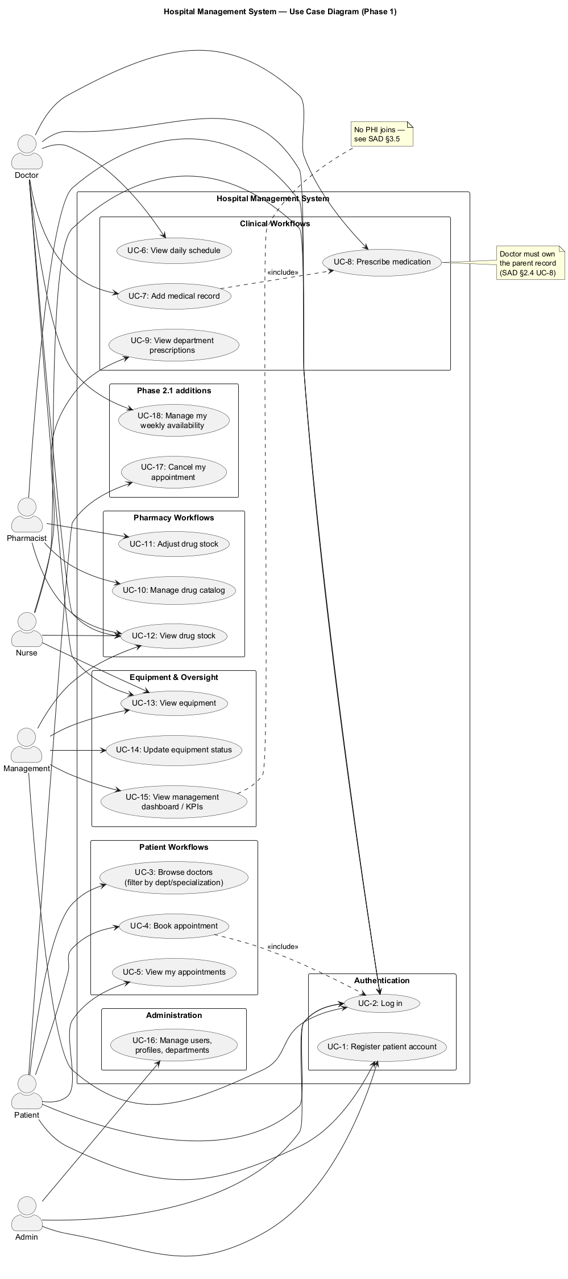
Figure 1 — Use Case Diagram (Phase 1, unchanged in Phase 2). Six actors, sixteen use cases, two «include» relationships.

2.5 Frontend UI — React Implementation
Patient-facing use cases (UC-2 through UC-5) are realized by the React SPA in App.jsx and App.css. Each top-level component is a self-contained page; navigation is internal state (no router). The mapping is:
Reference screenshots for the React SPA. Each placeholder below is an empty paragraph the team will replace with a captured image during the final submission review.
[SCREENSHOT] Login screen — single-form split-card design. White form panel on the left (MediCare wordmark, PATIENT PORTAL eyebrow, Welcome back heading, Username + Password fields, blue Sign In button). Gradient blue-to-teal hero panel on the right (hospital emoji, 'Your Health, Our Priority' heading, three checkmark features). One form for every role. Paste here.
[SCREENSHOT] Patient Dashboard (stats row: upcoming/completed/available doctors; Upcoming Appointments section; Our Specialists cards showing 'Dr. X · 10 yrs · Cardiologist'). Paste here.
[SCREENSHOT] Book Appointment page (doctor select, date picker, slot grid populated by /api/doctors/<id>/slots/, reason textarea, Doctor Details preview with Experience: N years). Paste here.
[SCREENSHOT] My Appointments page (All / Upcoming / Completed / Cancelled filter chips; appointment cards with red 'Cancel' ghost button on upcoming items). Paste here.
[SCREENSHOT] Cancel Appointment confirmation dialog (modal overlay, 'Cancel this appointment? This cannot be undone.', Keep it / Yes, cancel buttons). Paste here.
Component | Page | Use cases covered
LoginPage | initial screen | UC-2: POST /api/login/, token stored in React state
Dashboard | page=dashboard | UC-3, UC-5: stat cards + upcoming appointments + specialist list
BookAppointment | page=book | UC-4: doctor select, date picker, time-slot grid, reason, POST /api/appointments/book/<id>/
ViewAppointments | page=appointments | UC-5: appointment cards with All / Upcoming / Completed filter
Sidebar | navigation | Page navigation, patient info, logout

2.5.1 Code snippet — LoginPage (UC-2)
JavaScript / React (src/App.jsx)
// src/App.jsx — realizes UC-2 (Log in)
const API = "http://localhost:8000"; // dev; prod uses same-origin

async function apiFetch(path, options = {}, token = null) {
const headers = { "Content-Type": "application/json" };
if (token) headers["Authorization"] = `Token ${token}`;
const res = await fetch(`${API}${path}`, { ...options, headers });
const data = await res.json();
if (!res.ok) throw new Error(data.error || "Request failed");
return data;
}

function LoginPage({ onLogin }) {
const [form, setForm] = useState({ username: "", password: "" });
async function handleSubmit(e) {
e.preventDefault();
const data = await apiFetch("/api/login/", {
method: "POST",
body: JSON.stringify(form),
});
onLogin(data.user, data.token); // lift to App state
}
/* ...rendering omitted... */
}

3. Logical View
HMS realizes the Model–View–Controller pattern via Django (Model + Controller) and React (View). The addition of the React SPA generalizes this into a Client–Server style with a JSON REST bridge between View and Controller.

3.1 Layered Decomposition
Layer | Technology | Responsibility
View (Presentation) | React 18 + Vite + custom CSS | UI components, state management, user interaction
API Bridge | Django REST Framework 3.15 | JSON serialization, token auth, CORS, /api/* endpoints
Controller | Django views.py + api_views.py | Request handling, RBAC delegation, form validation, business logic
Model (Domain) | Django ORM + 13 entities | Integrity constraints, status enums, field-level encryption
Cross-cutting | permissions.py, forms.py | Centralized RBAC matrix, input validators

3.2 Class Diagram
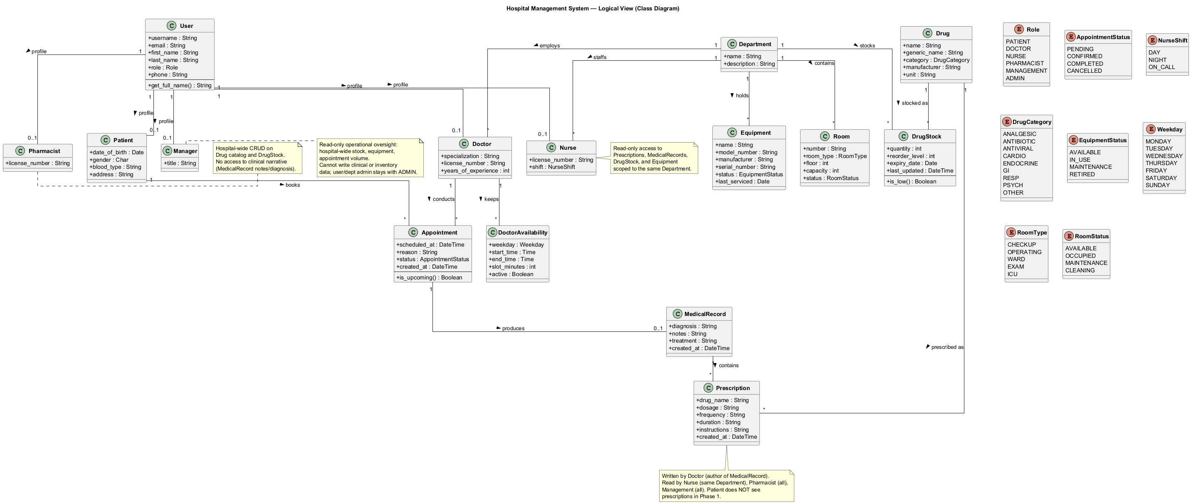
Figure 2 — Class Diagram of the 15 domain entities and their relationships.

3.3 Entity Descriptions
- User — custom Django user with a role attribute (PATIENT, DOCTOR, NURSE, PHARMACIST, MANAGEMENT, ADMIN). Phone encrypted at rest.
- Patient — profile 1:1 with User of role PATIENT. Stores DOB, gender, blood type, address (encrypted).
- Doctor — profile 1:1 with User of role DOCTOR. Belongs to one Department.
- Nurse — profile 1:1 with User of role NURSE. Department-scoped read-only access.
- Pharmacist — profile 1:1 with User of role PHARMACIST. Hospital-wide Drug/DrugStock authority.
- Manager — profile 1:1 with User of role MANAGEMENT. Read-only operational oversight.
- Department — clinical department, the unit of access scope for clinical roles.
- Appointment — Patient–Doctor meeting; status PENDING → CONFIRMED → COMPLETED.
- MedicalRecord — diagnosis + notes for a completed Appointment (1:1).
- Prescription — medication entry tied to a MedicalRecord (1:N).
- Drug — hospital-wide medication catalog (WHO Essential Medicines source).
- DrugStock — per-department inventory row, unique per (drug, department).
- Equipment — physical equipment per Department with status tracking.
- DoctorAvailability — weekly availability rows owned by a Doctor (weekday, start/end time, slot length). Drives the per-date slot grid offered to patients.
- Room — physical room in a Department with room_type (CHECKUP, OPERATING, WARD, EXAM, ICU), floor, capacity, and operational status. Visible to Doctor/Nurse/Management/Admin only.

3.4 REST API Layer
The REST API layer bridges the React frontend and Django backend. It is implemented in accounts/api_views.py and accounts/serializers.py.
Endpoint | Method | Description | Auth
/api/login/ | POST | Authenticate, return token + user info | No
/api/register/ | POST | Register a new PATIENT account | No
/api/logout/ | POST | Delete auth token | Yes
/api/doctors/ | GET | List doctors with department info | Yes
/api/appointments/ | GET | List the patient's own appointments only | Yes (Patient)
/api/appointments/book/<doctor_id>/ | POST | Book an appointment with a specific doctor | Yes (Patient)
/api/health/ | GET | Health probe used by Docker (Phase 2) | No
/api/appointments/<id>/cancel/ | POST | Cancel one of the authenticated patient's upcoming appointments. Refuses if status is COMPLETED/CANCELLED or scheduled_at is in the past. | Yes (Patient)
/api/doctors/<id>/availability/ | GET | List a doctor's weekly DoctorAvailability rows. | Yes
/api/doctors/<id>/availability/ | PUT | Replace a doctor's weekly availability. Body is a JSON array of {weekday, start_time, end_time, slot_minutes, active}. | Yes (Doctor or Admin)
/api/doctors/<id>/slots/?date=YYYY-MM-DD | GET | Compute open slot grid for a date by expanding the matching availability rows and subtracting taken slots. | Yes
/api/me/schedule/ | GET | Doctor's own appointments with medical-record presence flag (replaces /appointments/schedule/ template). | Yes (Doctor)
/api/appointments/<id>/record/ | POST | Doctor records diagnosis / notes / treatment. Marks appointment COMPLETED. | Yes (Owning Doctor)
/api/records/<id>/prescribe/ | POST | Doctor adds a Prescription against their own MedicalRecord. | Yes (Owning Doctor)
/api/me/department/stock/ | GET | Doctor/Nurse: drug stock scoped to caller's own department. | Yes (Doctor/Nurse)
/api/me/department/prescriptions/ | GET | Nurse: prescriptions for patients seen by doctors in nurse's department. | Yes (Nurse)
/api/me/department/equipment/ | GET | Doctor/Nurse: equipment in caller's own department. | Yes (Doctor/Nurse)
/api/drugs/ | GET/POST | GET: any non-patient role lists catalog. POST: pharmacist/admin creates a Drug. | Yes
/api/stock/ | GET | Hospital-wide drug stock (pharmacist, management, admin). | Yes (Pharma/Mgmt/Admin)
/api/stock/<id>/ | PATCH | Pharmacist adjusts a stock row's quantity / reorder_level. | Yes (Pharmacist)
/api/management/kpis/ | GET | Management dashboard: low stock, equipment status counts, appointment volume by department. | Yes (Mgmt/Admin)

3.4.1 Code snippet — Doctor list endpoint (UC-3)
Python / DRF
# accounts/api_views.py — list doctors
@api_view(['GET'])
@permission_classes([IsAuthenticated])
def api_doctor_list(request):
qs = Doctor.objects.select_related('user', 'department').all()
department = request.GET.get('department', '').strip()
specialization = request.GET.get('specialization', '').strip()
if department:
qs = qs.filter(department__name__iexact=department)
if specialization:
qs = qs.filter(specialization__icontains=specialization)
return Response(DoctorSerializer(qs, many=True).data)

3.5 Permission Matrix (RBAC)
All access decisions go through a single helper in accounts/permissions.py. The matrix below is the authoritative specification; the code MUST stay in sync with it.
Resource / Action | Patient | Doctor | Nurse | Pharmacist | Mgmt | Admin
Log in | ✓ | ✓ | ✓ | ✓ | ✓ | ✓
Browse doctors (API) | ✓ | — | — | — | — | ✓
Book appointment (API) | ✓ | — | — | — | — | ✓
View own appointments | own | own | dept | — | — | ✓
View MedicalRecord | — | own | dept R | — | — | ✓
Write MedicalRecord | — | own | — | — | — | ✓
View Prescription | — | own | dept R | all R | — | ✓
View Drug catalog | — | all R | all R | all R/W | all R | ✓
View DrugStock | — | dept R | dept R | all R/W | all R | ✓
Adjust DrugStock | — | — | — | ✓ | — | ✓
Management dashboard | — | — | — | — | ✓ | ✓
Cancel own appointment | ✓ | — | — | — | — | ✓
Edit own availability | — | own | — | — | — | ✓
View rooms | — | dept R | dept R | — | ✓ | ✓

3.6 Architecturally Significant Design Packages

3.6.1 Identity and Profiles
Custom User entity with a role attribute and six 1:1 profile entities (Patient, Doctor, Nurse, Pharmacist, Manager). The role drives every RBAC decision.

3.6.2 Appointments and Records
A Patient creates an Appointment (PENDING); the Doctor confirms (CONFIRMED), conducts the visit, and writes a MedicalRecord (COMPLETED). unique_together('doctor','scheduled_at') prevents double-booking at the database level.

3.6.3 Pharmacy
Drug catalog is hospital-wide; DrugStock is per-department. Pharmacists own catalog and stock writes; Doctors/Nurses read their own department's stock.

3.6.4 Equipment
Equipment is assigned to a Department with a status enum. Doctors/Nurses read their own department; Management has hospital-wide read and update authority.

4. Process View
The Process View shows how requests flow through the running system. With the React frontend, the pipeline is extended from a single browser-to-Django round-trip to a React-to-API-to-Django flow with token authentication on every hop.
Step | Component | Action
1 | React (browser) | User interaction triggers apiFetch() with Authorization: Token <key>
2 | Django URL dispatcher | Routes /api/* paths to api_views.py functions
3 | DRF TokenAuthentication | Validates token, attaches request.user; role is then checked by permissions.py
4 | Controller (api_views.py) | Business logic, ORM calls, input validation
5 | Django ORM (models.py) | Queries / mutates the DB; integrity constraints catch race conditions
6 | Serializer (serializers.py) | Converts model instances to JSON
7 | React state | Updates component state with JSON, re-renders UI

4.1 Sequence — Book Appointment (Phase 2, React + REST)
This sequence diagram replaces the Phase 1 browser-form version. It reflects the actual code path through api_book_appointment, including the alternative flows (success, duplicate-booking 400, role-denied 403, missing-field 400).
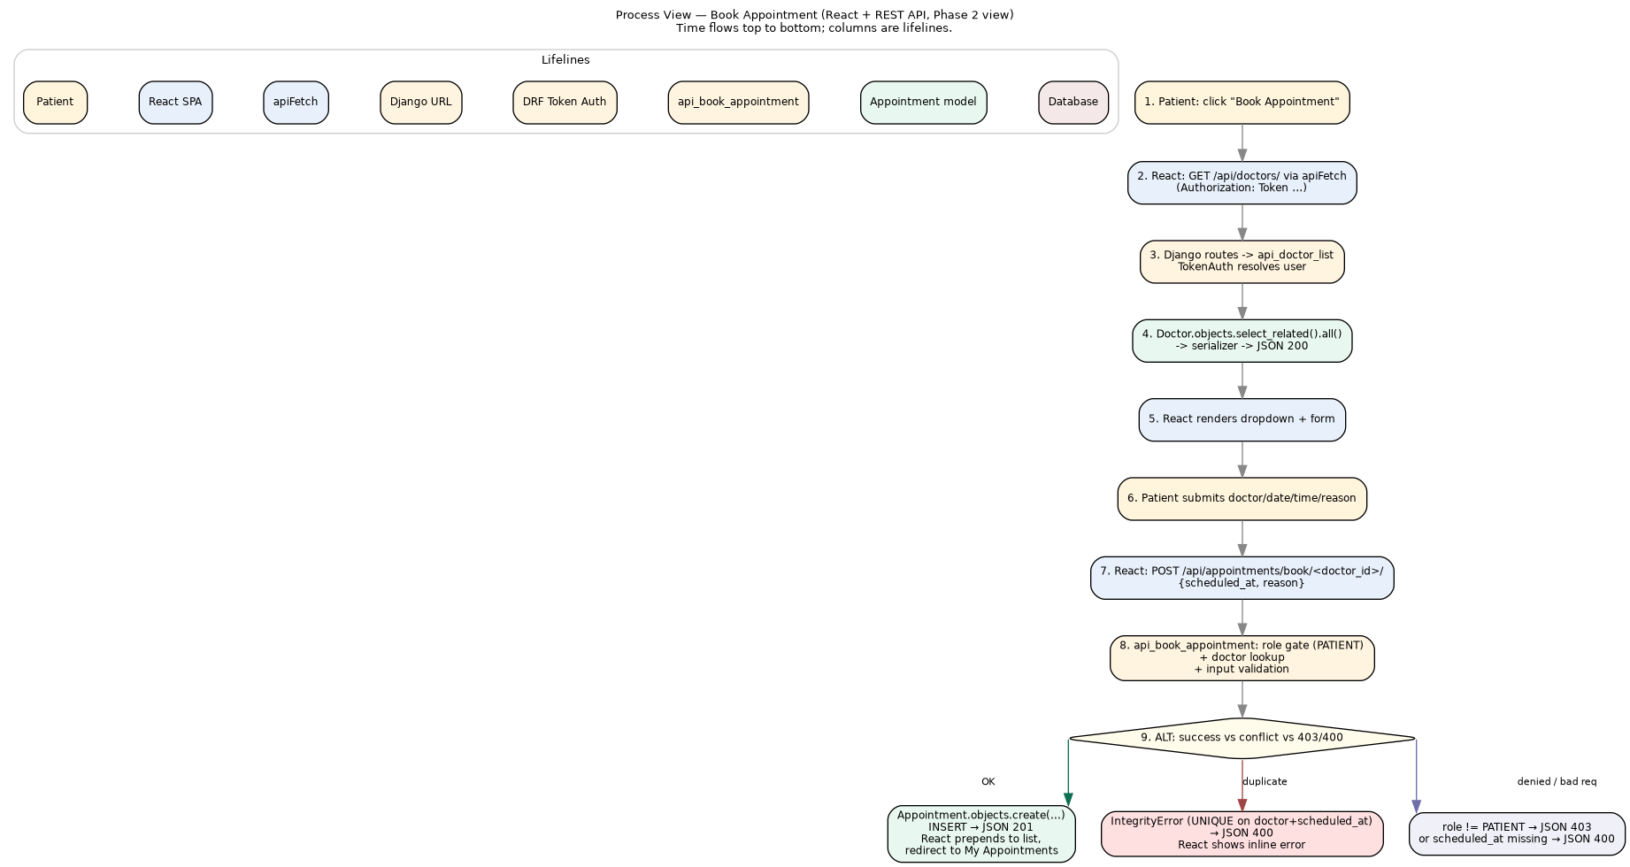
Figure 3 — Sequence Diagram: patient books an appointment (React → DRF → ORM → DB).

4.2 Activity — Appointment Lifecycle
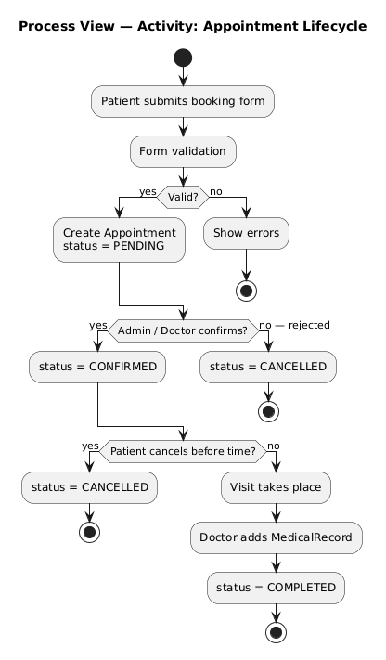
Figure 4 — Activity Diagram: PENDING → CONFIRMED → COMPLETED, with CANCELLED branches reachable from PENDING or CONFIRMED.

4.3 Sequence — Prescription Workflow (3 roles)
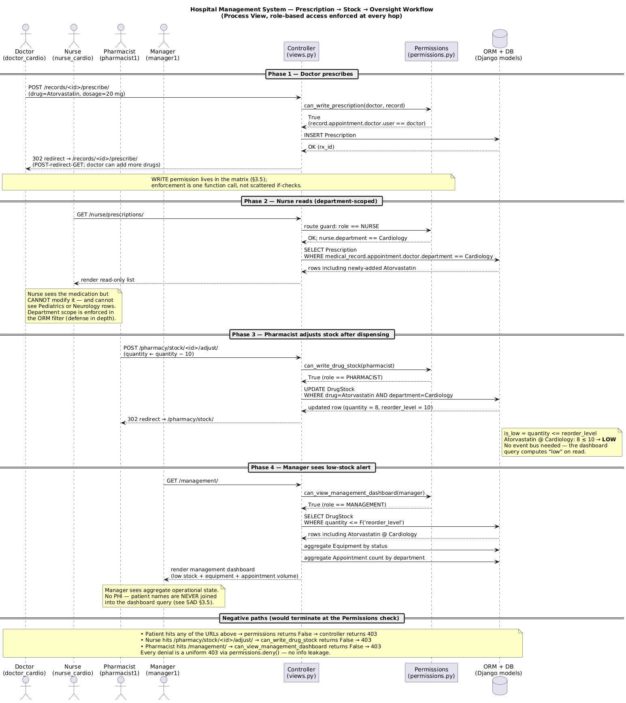
Figure 5 — Three-role prescription workflow. Each transition is gated by a single function call to permissions.py rather than scattered if-checks.

4.4 Concurrency
Phase 1 used Django's single-process dev server. Phase 2 runs Gunicorn with four sync workers. Concurrency safety is provided by three layered controls:
- unique_together('doctor','scheduled_at') on Appointment prevents double-booking at the database level. The IntegrityError surfaces in api_book_appointment as a 400 response with a human-readable message.
- unique_together('drug','department') on DrugStock prevents duplicate stock rows.
- Every controller is wrapped in Django's request-bound transaction by default, so partial writes never persist.
- For idempotent read paths the queryset uses select_related to avoid N+1 queries (visible in api_doctor_list and api_my_appointments).

4.5 Code snippet — Book Appointment controller
Numbered comments below map 1-to-1 to the steps shown in Figure 3.
Python / DRF
# accounts/api_views.py — POST /api/appointments/book/<doctor_id>/
@api_view(['POST'])
@permission_classes([IsAuthenticated])
def api_book_appointment(request, doctor_id):
# 1. Role gate (centralized RBAC)
if request.user.role != 'PATIENT':
return Response({'error': 'Patients only.'}, status=403)

# 2. Doctor lookup
try:
doctor = Doctor.objects.get(pk=doctor_id)
except Doctor.DoesNotExist:
return Response({'error': 'Doctor not found.'}, status=404)

# 3. Input validation
scheduled_at = request.data.get('scheduled_at')
if not scheduled_at:
return Response({'error': 'scheduled_at is required.'}, status=400)

# 4. ORM create — UNIQUE constraint catches double-booking
try:
appt = Appointment.objects.create(
patient=request.user.patient_profile,
doctor=doctor,
scheduled_at=scheduled_at,
reason=request.data.get('reason', ''),
status='PENDING',
)
except Exception as e:
return Response({'error': str(e)}, status=400)

# 5. Serialize -> JSON response
return Response(AppointmentSerializer(appt).data, status=201)

5. Development View
The Development View describes the static organization of the software: the source modules, the components they realize, and how those components depend on each other. This view is the bridge between the architecture diagrams and the code on disk.

5.1 Component Diagram
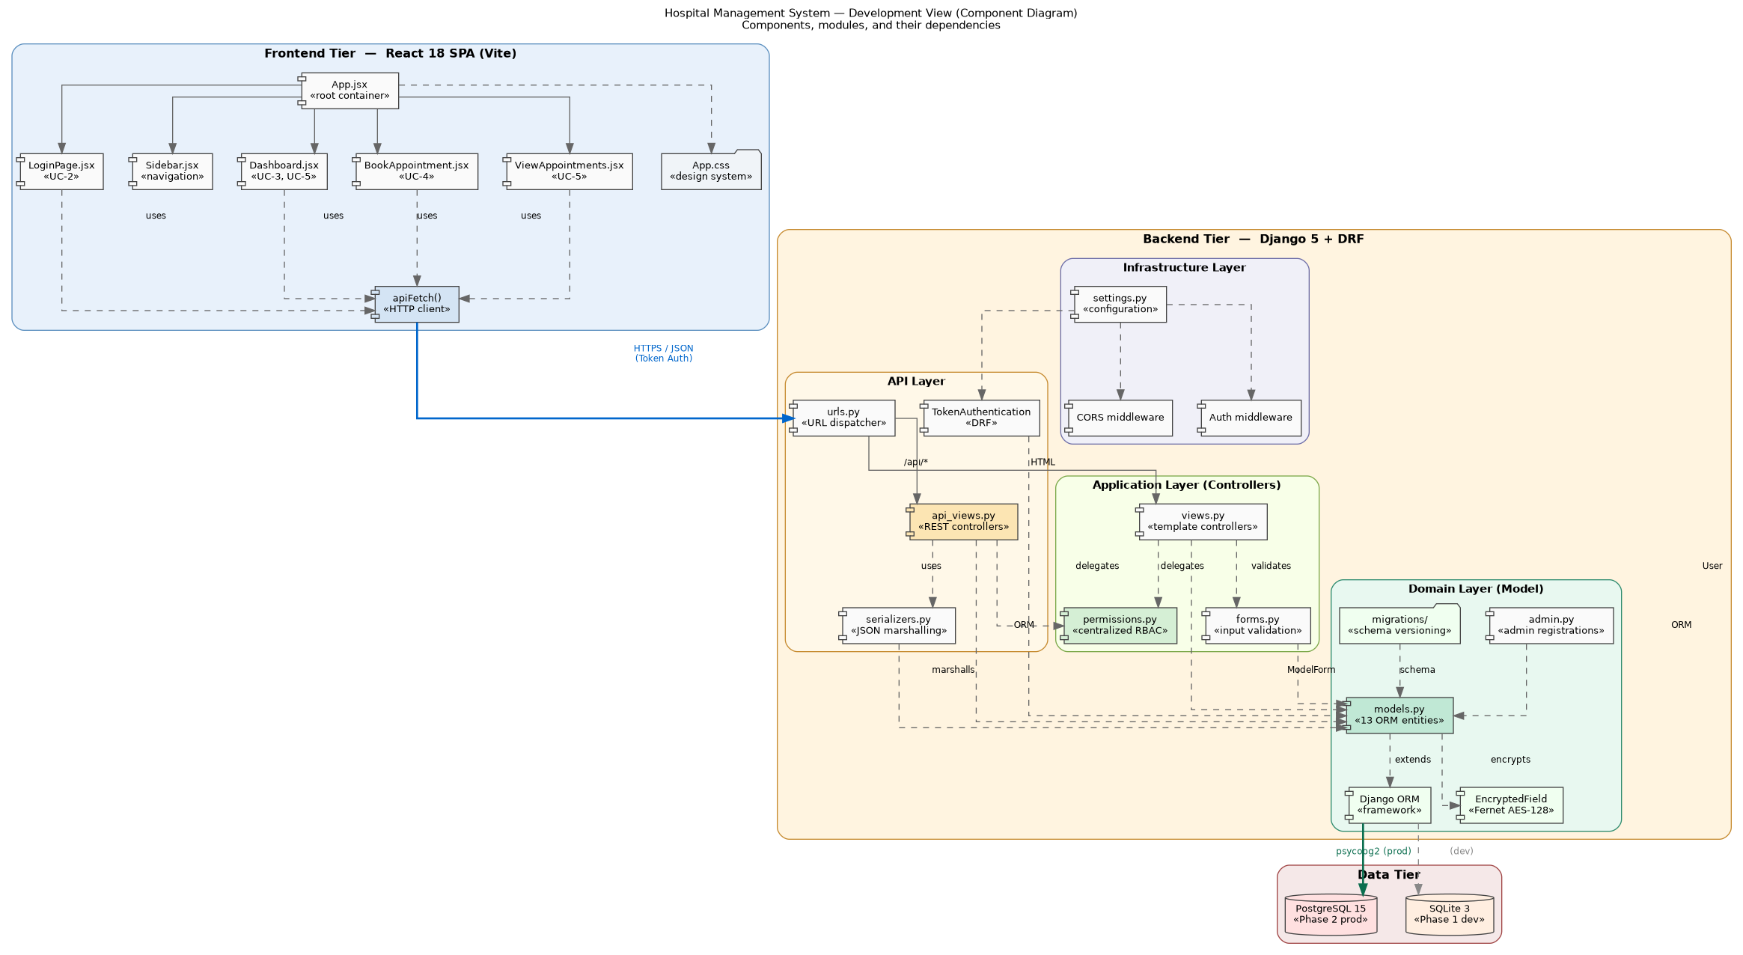
Figure 6 — Development View component diagram: frontend tier, backend tier (API / Application / Domain / Infrastructure), and data tier.

5.2 Frontend tier (React SPA)
The frontend is a single-page application built with React 18 and Vite. It is intentionally compact: there is no client-side router (page state lives in App.jsx) and there are no UI-library dependencies (the design system is hand-rolled CSS). This keeps the bundle small and the architectural surface area small.
Component (jsx) | Use cases | File / Location | Key state
App | root container | src/App.jsx (export default) | patient, token, page, appointments[], doctors[]
LoginPage | UC-2 Log in | src/App.jsx | form {username,password}, error, loading
Sidebar | navigation | src/App.jsx | activePage, sidebarOpen
Dashboard | UC-3, UC-5 | src/App.jsx | derived from appointments + doctors
BookAppointment | UC-4 Book appointment | src/App.jsx | form {doctorId,date,time,reason}, success, error
ViewAppointments | UC-5 View appointments | src/App.jsx | filter (All / Upcoming / Completed)
apiFetch | HTTP client | src/App.jsx | (pure function; attaches Authorization header)
App.css | design system | src/App.css | (custom CSS variables, no Tailwind/MUI)

5.3 Backend tier (Django + DRF)
The backend is decomposed into four layers. The decomposition is the single most important architectural decision in the backend because it makes RBAC enforcement a single grep'able location.

5.3.1 API Layer
The API layer is the only entry point used by the React SPA in production. It exists as a thin wrapper that handles JSON marshalling and token authentication, then delegates everything else.
Component | Purpose | File
api_views.py | REST controllers (api_login, api_doctor_list, api_book_appointment, ...) | accounts/api_views.py
serializers.py | JSON marshalling (DoctorSerializer, AppointmentSerializer, RegisterSerializer) | accounts/serializers.py
urls.py | URL dispatcher; routes /api/* to api_views, HTML paths to views | hospital_project/urls.py
TokenAuthentication | DRF built-in; validates Authorization: Token header | rest_framework.authentication (settings.py wiring)

5.3.2 Application Layer (Controllers + Cross-Cutting)
The Application Layer holds the template-based controllers (used by the Django admin and the original HTML flows) and the cross-cutting modules that every controller relies on.
Component | Purpose | File
views.py | Template controllers (register_patient, dashboard, doctor_list, my_appointments, doctor_schedule, add_medical_record, add_prescription, nurse_prescriptions, drug_catalog, drug_stock_list, drug_stock_adjust, equipment_list, equipment_edit, management_dashboard) | accounts/views.py
forms.py | Form classes for input validation (PatientRegistrationForm, AppointmentForm, MedicalRecordForm, PrescriptionForm, DrugForm, DrugStockForm, EquipmentForm) | accounts/forms.py
permissions.py | Single source of truth for RBAC: can_view_appointment, can_view_medical_record, can_view_prescription, can_write_medical_record, can_write_prescription, can_book_appointment, can_view_drug_catalog, can_write_drug_catalog, can_view_drug_stock, can_write_drug_stock, can_view_equipment, can_write_equipment, can_view_management_dashboard, deny() | accounts/permissions.py

5.3.3 Domain Layer (Model)
Component | Purpose | File
models.py | 15 ORM entities: User, Patient, Doctor, Nurse, Pharmacist, Manager, Department, Appointment, MedicalRecord, Prescription, Drug, DrugStock, Equipment, DoctorAvailability, Room | accounts/models.py
admin.py | Django admin registrations for all entities (used by ADMIN role) | accounts/admin.py
migrations/ | Schema versioning (Django auto-generated) | accounts/migrations/
EncryptedField | Fernet AES-128 column-level encryption for User.phone, Patient.address | django-encrypted-model-fields (3rd party)
seed_data command | Idempotent demo data seeder (departments, users of every role, drugs from WHO Model List, stock, equipment, appointments) | accounts/management/commands/seed_data.py

5.3.4 Infrastructure Layer
Component | Purpose | File
settings.py | Env-driven configuration: DB, secret key, ALLOWED_HOSTS, CORS, throttling, cache, security headers, WhiteNoise | hospital_project/settings.py
CORS middleware | Same-origin in prod; allow-all in dev | django-cors-headers (3rd party)
Auth middleware | Django session auth (used by Django admin) plus DRF token auth (used by /api/*) | settings.py wiring
WhiteNoise | Serves Django static files directly from Gunicorn with compression and content-hashed filenames | whitenoise (3rd party)

5.4 Architecture-to-implementation traceability
The table below maps every box on the component diagram (Figure 6) to a concrete file. This is the single most useful artifact for new contributors and for graders verifying that the architecture is real, not aspirational.
Architectural element (component) | Realized in | Lines
View — React SPA | Frontend/hospital-frontend/src/App.jsx | ~326
View — design system | Frontend/hospital-frontend/src/App.css | (custom)
API Bridge — REST controllers | accounts/api_views.py | ~78
API Bridge — JSON serializers | accounts/serializers.py | ~69
API Bridge — URL dispatcher | hospital_project/urls.py | ~34
Controller — template views | accounts/views.py | ~426
Controller — input validation | accounts/forms.py | ~152
Cross-cutting — RBAC matrix | accounts/permissions.py | ~227
Domain — ORM entities | accounts/models.py | ~345
Domain — admin registrations | accounts/admin.py | ~106
Domain — schema migrations | accounts/migrations/0001_initial.py | ~203
Infrastructure — configuration | hospital_project/settings.py | ~190
Infrastructure — WSGI entrypoint | hospital_project/wsgi.py | ~16
Infrastructure — ASGI entrypoint | hospital_project/asgi.py | ~16
Deployment — backend image | deployment/Dockerfile.backend | ~60
Deployment — frontend image | deployment/Dockerfile.frontend | ~40
Deployment — compose orchestration | deployment/docker-compose.yml | ~95
Deployment — Nginx config | deployment/nginx.conf | ~70
Deployment — entrypoint script | deployment/entrypoint.sh | ~35
Domain — DoctorAvailability + Room | accounts/models.py (Phase 2.1 additions) | ~50
View — MyAvailability React component | Frontend/hospital-frontend/src/App.jsx (MyAvailability + ConfirmCancelDialog) | ~140
View — RoleSidebar (generic shell) | Frontend/hospital-frontend/src/App.jsx (RoleSidebar) | ~30
View — DoctorShell + DoctorDashboard + DoctorSchedule + MedicalRecordModal + DoctorStock | Frontend/hospital-frontend/src/App.jsx (Phase 2.2) | ~310
View — NurseShell + NurseDashboard + NursePrescriptions + NurseEquipment | Frontend/hospital-frontend/src/App.jsx (Phase 2.2) | ~120
View — AdminShell + AdminDashboard + inline KPIs | Frontend/hospital-frontend/src/App.jsx (Phase 2.2) | ~80
View — ManagementShell + ManagementKPIs | Frontend/hospital-frontend/src/App.jsx (Phase 2.2) | ~70
View — PharmacistShell + PharmacistCatalog + PharmacistStock | Frontend/hospital-frontend/src/App.jsx (Phase 2.2) | ~180
View — BookingCalendar (month grid, no date library) | Frontend/hospital-frontend/src/App.jsx (BookingCalendar) | ~135
View — restored single-form split-card login | Frontend/hospital-frontend/src/App.jsx (LoginPage rewritten) | ~75

5.5 Module dependencies (rules and rationale)
The arrows on Figure 6 are constrained: the architecture imposes the following dependency rules, enforced by code review.
- Frontend → API Bridge: ALLOWED. The frontend never imports backend code; it only speaks JSON over HTTPS.
- API Bridge → Cross-cutting (permissions): ALLOWED and REQUIRED. Every mutating endpoint must call permissions.py.
- API Bridge → Domain (ORM): ALLOWED. Controllers read/write the ORM directly. No service layer is interposed in Phase 2 — the matrix is the service layer.
- Controllers → Cross-cutting (permissions): ALLOWED and REQUIRED. Same rule as API Bridge.
- Cross-cutting (permissions) → Domain: ALLOWED, but READ-ONLY. permissions.py inspects but never mutates.
- Domain → ANYTHING ELSE: FORBIDDEN. Domain models never reference controllers, serializers, or permissions. This keeps the model layer pure and the migration story simple.
- Anything → settings.py: ALLOWED via django.conf.settings; settings.py never imports application code.

5.6 Build artifacts
Artifact | Built from | Build tool
React production bundle (dist/) | Frontend/hospital-frontend/src/ | Vite (npm run build)
Backend wheel cache | requirements.txt | pip wheel (in Dockerfile builder stage)
Django static collection | accounts/static/, Django admin static, DRF browsable API | manage.py collectstatic (via WhiteNoise)
hms-backend Docker image | deployment/Dockerfile.backend | docker build / docker compose
hms-frontend Docker image | deployment/Dockerfile.frontend | docker build / docker compose

6. Deployment View
The Deployment View describes the mapping of software components onto runtime nodes — the physical (or here, containerized) topology that the system runs on. Phase 1 used the Django and Vite dev servers on a single developer workstation. Phase 2 packages the entire stack into Docker containers orchestrated by Docker Compose.

6.1 Deployment Diagram (Phase 2 production)
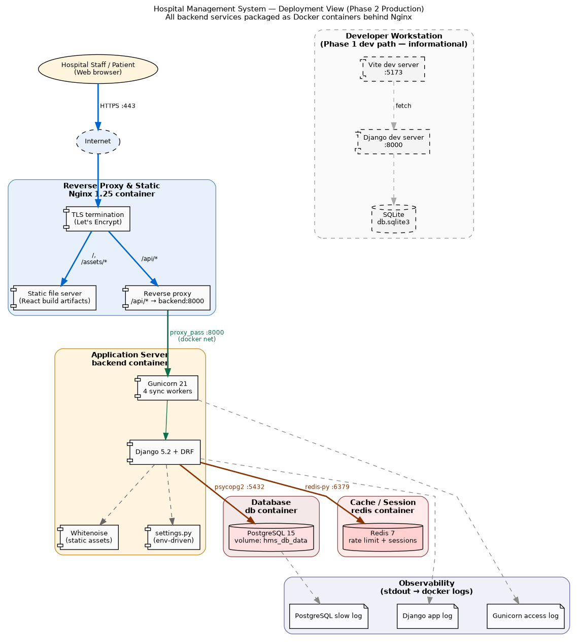
Figure 7 — Phase 2 deployment topology. All services run as Docker containers on a single host (or any container scheduler); only Nginx is exposed to the public network.
[SCREENSHOT] `docker compose -f deployment/docker-compose.yml up` terminal output showing all four containers (frontend, backend, db, redis) reaching `healthy` state. Paste here.

6.2 Runtime nodes
Node (container) | Image | Purpose | Exposed ports
frontend | hms-frontend (Nginx 1.27 alpine) | TLS termination, static React build, reverse proxy /api/* and /admin/ | 80 (and 443 in prod)
backend | hms-backend (Python 3.12 slim + Gunicorn 21) | Django 5 + DRF; runs migrations on start; serves REST API | internal-only (8000 on docker net)
db | postgres:15-alpine | Persistent application database; volume hms_db_data | internal-only (5432)
redis | redis:7-alpine | Cache + DRF throttling + future session store | internal-only (6379)

6.3 Network topology
All four containers share a single Docker bridge network (hms_net). Only the frontend container's port 80 (and 443 for TLS) is published to the host. The backend, db, and redis containers have NO published ports — they are reachable only from inside hms_net. This is a defense-in-depth boundary: even if the host's firewall is misconfigured, the database cannot be reached from the public internet.

6.4 Environment configuration
Every environment-specific value is supplied through environment variables read by settings.py. The .env file is consumed by docker-compose and never committed.
Variable | Required | Default | Purpose
DJANGO_SECRET_KEY | Yes (prod) | insecure dev value | Django session/CSRF signing key
DJANGO_DEBUG | No | 1 (dev) / 0 (prod) | When 0, enables all production security headers
DJANGO_ALLOWED_HOSTS | Yes | localhost,127.0.0.1 | Comma-separated host header allow-list
FIELD_ENCRYPTION_KEY | Yes | (dev placeholder) | Fernet AES-128 key for User.phone, Patient.address
POSTGRES_DB | Yes (compose) | hms | PostgreSQL database name
POSTGRES_USER | Yes (compose) | hms_user | PostgreSQL user
POSTGRES_PASSWORD | Yes (compose) | (none) | PostgreSQL password — never commit
POSTGRES_HOST | Auto | db | Service name on the docker network
POSTGRES_PORT | No | 5432 | PostgreSQL port
REDIS_URL | No | redis://redis:6379/0 | Used as Django cache backend
DJANGO_LOG_LEVEL | No | INFO | Root logger level (stdout)
HMS_SEED_ON_START | No | 0 | If 1, runs seed_data on first boot

6.5 Startup sequence
When `docker compose up` is invoked, the containers come up in dependency order:
- Postgres starts. Its healthcheck (pg_isready) keeps it marked unhealthy until it accepts connections.
- Redis starts (no dependency).
- Backend waits for the db container to report healthy (entrypoint.sh polls TCP :5432 before continuing).
- Backend runs `manage.py migrate --noinput` and `manage.py collectstatic --noinput`.
- Backend optionally runs `manage.py seed_data` if HMS_SEED_ON_START=1.
- Backend execs Gunicorn with 4 sync workers on 0.0.0.0:8000.
- Frontend (Nginx) starts and reverse-proxies /api/* to backend:8000.
- Host requests on :80 reach Nginx, which serves the React SPA and proxies API calls into the docker network.

6.6 Persistent storage
Volume | Mounted at | Owner | Purpose
hms_db_data | /var/lib/postgresql/data | db | Application database. Survives container restarts.
hms_redis_data | /data | redis | Redis AOF / RDB snapshots (cache loss tolerable; persisted for warm restart).
hms_static | /app/staticfiles + /usr/share/nginx/html/static (RO) | shared | Django collectstatic output, served by Nginx.
hms_media | /app/media | backend | User-uploaded files (currently unused; provisioned for future use).

6.7 Operations cheat sheet
shell
# First-time setup
cp deployment/.env.example .env
$EDITOR .env # fill in secrets
docker compose -f deployment/docker-compose.yml up --build

# Apply schema changes
docker compose exec backend python manage.py makemigrations
docker compose exec backend python manage.py migrate

# Open a Django shell
docker compose exec backend python manage.py shell

# Create a superuser
docker compose exec backend python manage.py createsuperuser

# Tail logs
docker compose logs -f backend
docker compose logs -f frontend

# Database backup
docker compose exec db pg_dump -U $POSTGRES_USER $POSTGRES_DB > backup.sql

# Tear down (keep volumes)
docker compose down

# Tear down (also DROP the database — destructive!)
docker compose down -v

6.8 Phase 1 deployment (dev, retained for reference)
The Phase 1 development topology is still supported for fast inner-loop work — there is no Docker requirement to run the system locally:
- React SPA: Vite dev server at http://localhost:5173 with hot module replacement.
- Django REST API: development server at http://127.0.0.1:8000.
- Database: SQLite (db.sqlite3) co-located with the project.
- CORS: allow-all (DJANGO_DEBUG=1).
- No external services: the system is fully self-contained.
This dev path is the recommended way to make code changes; only run the docker-compose stack to verify deploy-time behavior.

6.9 Future deployment evolutions (not in scope for Phase 2)
- Horizontal scaling: Gunicorn behind an L4 load balancer; sticky sessions are unnecessary because auth is token-based.
- Managed PostgreSQL: replace the db container with a managed RDS / Cloud SQL instance, keeping the same connection string contract.
- Object storage for media: switch DEFAULT_FILE_STORAGE to S3-compatible storage for uploaded patient documents.
- CI/CD: GitHub Actions already builds and smoke-tests both images on every push (see .github/workflows/ci.yml).
- Observability: structured JSON logging + a sidecar log shipper to ship logs into Loki/CloudWatch.

7. Implementation View
The Implementation View summarizes the state of the codebase at the end of Phase 2. It is the closest thing in this SAD to an acceptance checklist.

7.1 Repositories
Repository | URL | Owner
Backend + monorepo | https://github.com/alrawii2/hospital-management-system | Anas Ravioglu
Frontend (mirror) | https://github.com/alrawii2/hospital-frontend | Anas Ravioglu

7.2 Implementation status (Phase 2)
[SCREENSHOT] Doctor Dashboard with MyAvailability panel — 7-row weekday editor showing Mon–Fri 09:00–17:00 at 30-min slots, weekend rows inactive; Save availability button. Paste here.
[SCREENSHOT] Nurse Dashboard — three action cards (Department Prescriptions, Drug Stock, Equipment), stats row. Paste here.
[SCREENSHOT] Admin Dashboard — User & Role Management, Departments, Audit & Reports action cards. Paste here.
[SCREENSHOT] Django Admin landing page (`/admin/`) — left-rail listing of every registered model including DoctorAvailability and Room (Phase 2.1 entities). Paste here.
[SCREENSHOT] Management Dashboard at `/management/` — low-stock drug rows (qty ≤ reorder_level) and equipment status counts. Paste here.
Component | Status | File / Location
13 domain entities (ORM) | Complete | accounts/models.py
6-role RBAC matrix | Complete | accounts/permissions.py
Django admin (all 13 entities) | Complete | accounts/admin.py
Form validators | Complete | accounts/forms.py
Template controllers (11 use cases) | Complete | accounts/views.py
REST API controllers | Complete | accounts/api_views.py
DRF serializers | Complete | accounts/serializers.py
URL routing | Complete | hospital_project/urls.py
Token authentication | Complete | rest_framework.authtoken
DRF throttling (Phase 2) | Complete | settings.py REST_FRAMEWORK
Field-level encryption | Complete | django-encrypted-model-fields
CORS configuration | Complete | django-cors-headers + settings.py
WhiteNoise static serving (Phase 2) | Complete | settings.py STORAGES + MIDDLEWARE
Health-check endpoint (Phase 2) | Complete | accounts/api_views.py — api_health
Production security headers (Phase 2) | Complete | settings.py (DEBUG=False branch)
React Login page | Complete | src/App.jsx — LoginPage
React Dashboard | Complete | src/App.jsx — Dashboard
React Book Appointment | Complete | src/App.jsx — BookAppointment
React My Appointments | Complete | src/App.jsx — ViewAppointments
React Sidebar navigation | Complete | src/App.jsx — Sidebar
React design system | Complete | src/App.css
Frontend-Backend integration | Complete | apiFetch + Token auth
Backend Docker image (Phase 2) | Complete | deployment/Dockerfile.backend
Frontend Docker image (Phase 2) | Complete | deployment/Dockerfile.frontend
Docker Compose orchestration (Phase 2) | Complete | deployment/docker-compose.yml
Nginx reverse-proxy config (Phase 2) | Complete | deployment/nginx.conf
Container entrypoint (Phase 2) | Complete | deployment/entrypoint.sh
GitHub Actions CI (Phase 2) | Complete | .github/workflows/ci.yml
Seed data command | Complete | accounts/management/commands/seed_data.py
Automatic dev setup script | Complete | setup.sh / setup.bat
DoctorAvailability model + endpoints (Phase 2.1) | Complete | accounts/models.py + api_views.py
Room model + admin (Phase 2.1) | Complete | accounts/models.py + accounts/admin.py
Patient cancel-appointment flow (Phase 2.1) | Complete | api_views.api_cancel_appointment + ViewAppointments (React)
Expanded seed (15 entities, 35 users, 31 rooms) | Complete | accounts/management/commands/seed_data.py
Inline doctor schedule + records (Phase 2.2) | Complete | api_views.api_my_schedule, api_add_medical_record, api_add_prescription + DoctorSchedule/MedicalRecordModal
Inline department stock/prescriptions/equipment (Phase 2.2) | Complete | api_views.api_my_department_* + Nurse/DoctorStock/NursePrescriptions/NurseEquipment
Inline pharmacy catalog + stock adjustments (Phase 2.2) | Complete | api_views.api_drugs, api_stock_list, api_stock_adjust + PharmacistCatalog/PharmacistStock
Inline management KPIs (Phase 2.2) | Complete | api_views.api_management_kpis + ManagementKPIs
BookingCalendar — visible doctor availability (Phase 2.2) | Complete | Frontend/hospital-frontend/src/App.jsx (BookingCalendar)
Single-form split-card login (Phase 2.2 — role tabs removed) | Complete | Frontend/hospital-frontend/src/App.jsx (LoginPage)
Unified blue palette across all role shells | Complete | App.css — role-tinted CSS variables and topnav/role-shell styles deleted

7.3 Build & run quick reference
shell
# Local dev (no Docker) — Phase 1 path, still supported
bash setup.sh

# Production stack — Phase 2 deployment
cp deployment/.env.example .env
$EDITOR .env # fill in secrets
docker compose -f deployment/docker-compose.yml up --build
# -> open http://localhost

8. References
- [KRU41] Kruchten, P. “The 4+1 View Model of Architecture.” IEEE Software, vol. 12, no. 6, pp. 42–50, November 1995.
- [DJANGO] Django Software Foundation. Django Documentation. https://docs.djangoproject.com/
- [DRF] Encode OSS Ltd. Django REST Framework Documentation. https://www.django-rest-framework.org/
- [REACT] Meta Open Source. React Documentation. https://react.dev/
- [VITE] Vite Team. Vite — Next Generation Frontend Tooling. https://vitejs.dev/
- [NGINX] F5/NGINX. NGINX Documentation. https://nginx.org/en/docs/
- [GUNICORN] Benoit Chesneau. Gunicorn — Python WSGI HTTP Server. https://gunicorn.org/
- [POSTGRES] PostgreSQL Global Development Group. PostgreSQL 15 Documentation. https://www.postgresql.org/docs/15/
- [DOCKER] Docker Inc. Docker Compose Specification. https://docs.docker.com/compose/
- [OWASP] OWASP Foundation. OWASP Application Security Verification Standard (ASVS). https://owasp.org/www-project-application-security-verification-standard/
- [WHO-EML] World Health Organization. WHO Model List of Essential Medicines (23rd list, 2023). https://www.who.int/publications/i/item/WHO-MHP-HPS-EML-2023.02

