Alrich Rigonios
CSD-310 Module 4 Assignment
Movies ERD
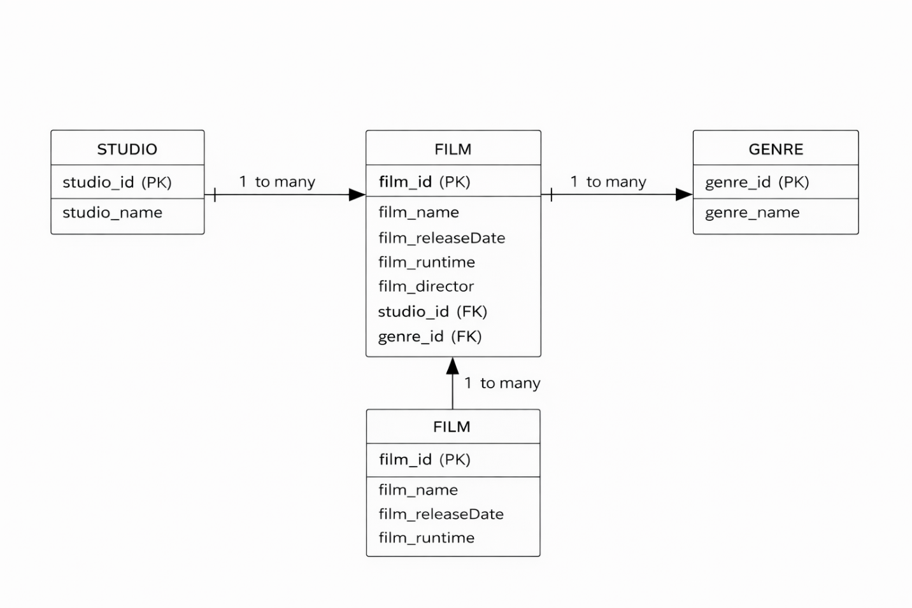
This ERD represents a movie database with three entities: STUDIO, FILM, and GENRE. The Studio entity has a one-to-many relationship with the FILM entity, meaning one studio can produce many films. The Genre entity also has a one-to-many relationship with the FILM entity, meaning one genre can describe many films. The Film table includes foreign keys (studio_id and genre_id) to connect it to the Studio and Genre tables.

