Alrich Rigonios
CSD-310 Module 7 Assignment
Movies Update & Deletes
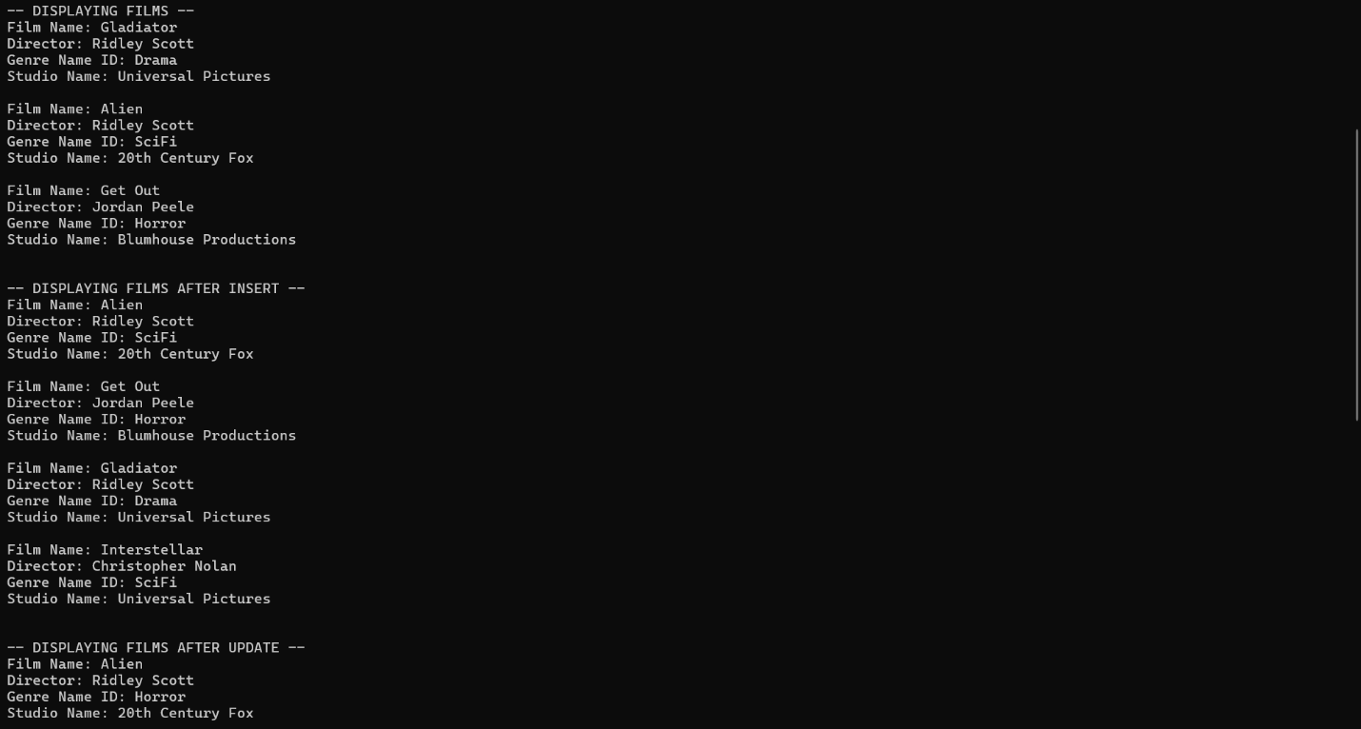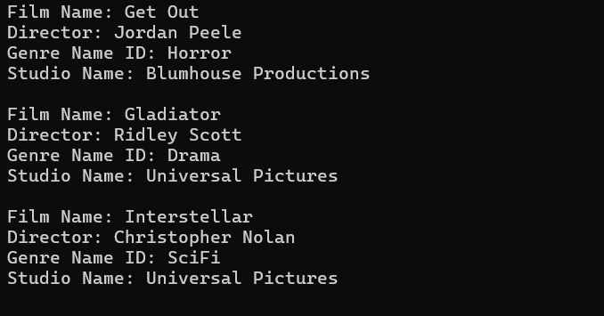
https://github.com/alrichg1018-cloud/csd-310

