Alrich Rigonios
Module 2 – Data Models
March 25, 2026

JSON
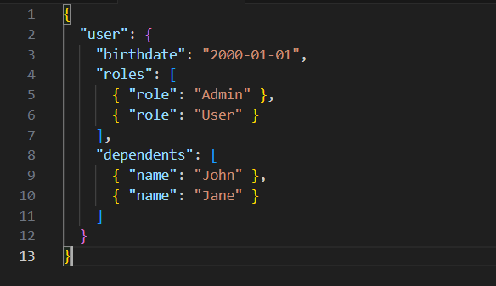
ERD
