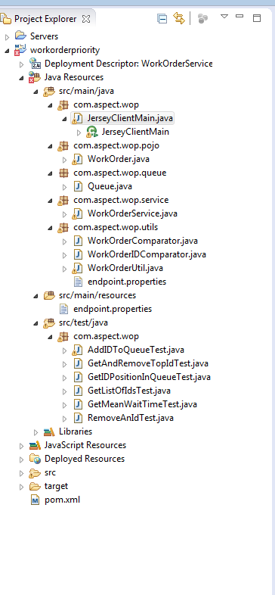

The application shown above as developed using Eclipse (Mars), it is a Maven web application.

Application Setup:

Download the application from the repository. To view the source in eclipse it has to be imported in Eclipse as maven web application. There are plenty of material online as to how to achieve this.

If you are just interested in seeing the result, I have provide Junit test classes that you can run use the mvn test commands.

{"id":7196742982591906839,"date":"08/10/2015 09:17:08","timeMilisec":1439212626533,"woclass":"PRIORITY","woclassInt":3,"rank":0}

{"id":9213963725776419016,"date":"08/10/2015 09:17:11","timeMilisec":1439212630859,"woclass":"NORMAL","woclassInt":4,"rank":0}

{"id":7664265679078664898,"date":"08/10/2015 09:17:11","timeMilisec":1439212631117,"woclass":"PRIORITY","woclassInt":3,"rank":0}

{"id":8960669580130875379,"date":"08/10/2015 09:17:11","timeMilisec":1439212631375,"woclass":"NORMAL","woclassInt":4,"rank":0}

{"id":3051913404247956832,"date":"08/10/2015 09:17:11","timeMilisec":1439212631631,"woclass":"NORMAL","woclassInt":4,"rank":0}

{"id":4921649040131180117,"date":"08/10/2015 09:17:12","timeMilisec":1439212631859,"woclass":"NORMAL","woclassInt":4,"rank":0}

{"id":2147464181960382752,"date":"08/10/2015 09:17:12","timeMilisec":1439212632084,"woclass":"NORMAL","woclassInt":4,"rank":0}

{"id":6037415815710738796,"date":"08/10/2015 09:17:12","timeMilisec":1439212632265,"woclass":"NORMAL","woclassInt":4,"rank":0}

{"id":8960634059929950093,"date":"08/10/2015 09:17:12","timeMilisec":1439212632539,"woclass":"PRIORITY","woclassInt":3,"rank":0}

{"id":3339438269920980203,"date":"08/10/2015 09:17:12","timeMilisec":1439212632739,"woclass":"NORMAL","woclassInt":4,"rank":0}

-----------Start SORTED List--------------

ID: 7196742982591906839

Date: 08/10/2015 09:17:08

Time: 1439212626533

Rank: 58085

Class rank id: 3

Class: PRIORITY

________________________________________

ID: 7664265679078664898

Date: 08/10/2015 09:17:11

Time: 1439212631117

Rank: 15373

Class rank id: 3

Class: PRIORITY

________________________________________

ID: 8960634059929950093

Date: 08/10/2015 09:17:12

Time: 1439212632539

Rank: 3823

Class rank id: 3

Class: PRIORITY

________________________________________

ID: 9213963725776419016

Date: 08/10/2015 09:17:11

Time: 1439212630859

Rank: 2278

Class rank id: 4

Class: NORMAL

________________________________________

ID: 8960669580130875379

Date: 08/10/2015 09:17:11

Time: 1439212631375

Rank: 1762

Class rank id: 4

Class: NORMAL

________________________________________

ID: 3051913404247956832

Date: 08/10/2015 09:17:11

Time: 1439212631631

Rank: 1506

Class rank id: 4

Class: NORMAL

________________________________________

ID: 4921649040131180117

Date: 08/10/2015 09:17:12

Time: 1439212631859

Rank: 1278

Class rank id: 4

Class: NORMAL

________________________________________

ID: 2147464181960382752

Date: 08/10/2015 09:17:12

Time: 1439212632084

Rank: 1053

Class rank id: 4

Class: NORMAL

________________________________________

ID: 6037415815710738796

Date: 08/10/2015 09:17:12

Time: 1439212632265

Rank: 872

Class rank id: 4

Class: NORMAL

________________________________________

ID: 3339438269920980203

Date: 08/10/2015 09:17:12

Time: 1439212632739

Rank: 398

Class rank id: 4

Class: NORMAL

________________________________________

-----------End SORTED List--------------