Test Case for: lab1_voter_registration_application.py
TC # | Input | Expected Output | Actual Output | Pass?
1 | What, yes | Repeat same question | Repeated same question | Yes
2 | Yes, Andrew, Yes, Roney, yes, 17, no | Prompt exit | Prompted user to exit | Yes
3 | Yes, Andrew, Yes, Roney, yes, 17, yes, 18, no | Ask age again, then ask us citizenship status, prompt exit | It did ask age again and prompted user to exit on failed citizenship answer | Yes
4 | Yes, Andrew, Yes, Roney, yes, 17, yes, 18, yes, Maryland, MD | Ask state question again | Asked state question again | Yes
5 | Yes, Andrew, Yes, Roney, yes, 17, yes, 18, yes, Maryland, MD, yes 123, 21784 | Ask zipcode question again | Asked zipcode question again | Yes
6 | Yes, Andrew, Yes, Roney, yes, 17, yes, 18, yes, Maryland, MD, 123, 21784, yes | Display the results of the application | Displayed the results of the application | Yes

Pylint Result: 10/10

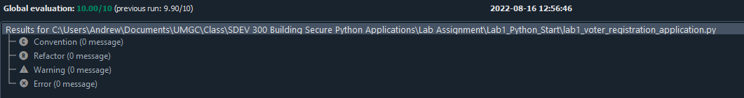
It was annoying that it would not let me just use exit(). Instead I had to import sys and do sys.exit(). Also forcing to change all my non-snake_naming was also annoying.

TC1:
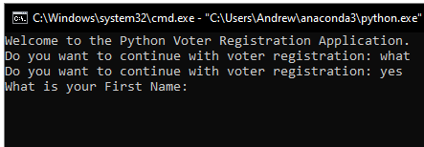

TC2:
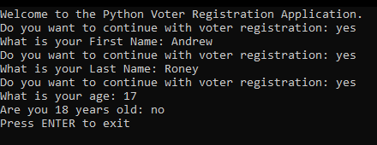

TC3:
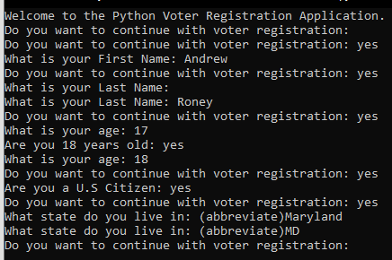

TC4:
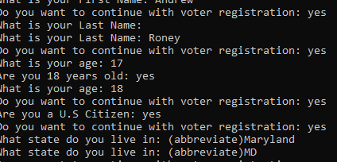

TC5:
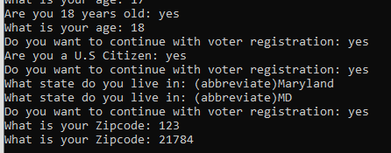

TC6:
