Case # | Input | Expected Output | Actual Output
1 | a | Password generated | Password is generated
2 | B, 4,12 | 33.33% | 33.33%
3 | B,5,0 | Error Try again | Error try again displayed
4 | c | Total days remaining | Remaining days displayed
5 | D,12,10,30 | 6.01 | 6.012
6 | D,10,12, 180 | Error Try again | Error try again displayed
7 | D,0,0,90 | Error Try again | Error try again displayed
8 | E, 10, 3 | 282.74 | 282.74
9 | E, 0, 2 | Error Try again | Error try again displayed
10 | F | Enter to exit | Enter to exit displayed

TC1:
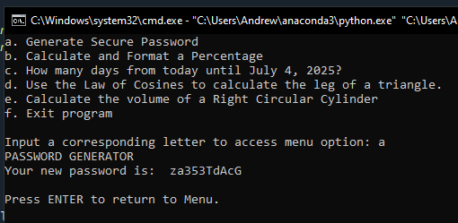
TC2:
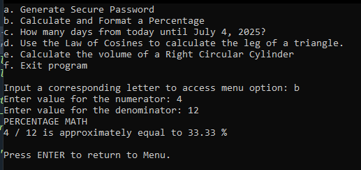
TC3:
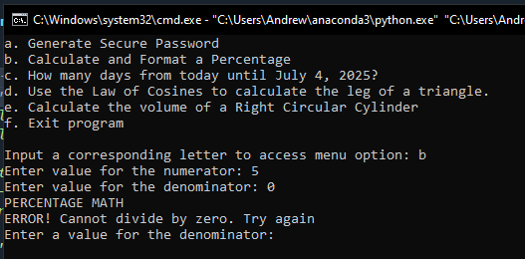
TC4:
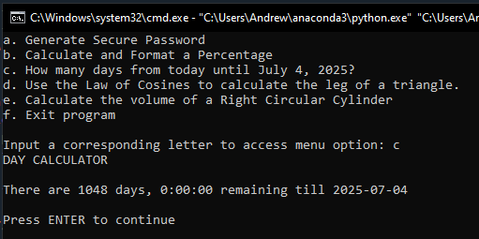
TC5:
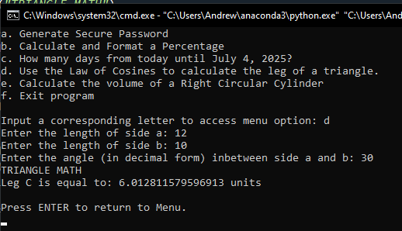
TC6:
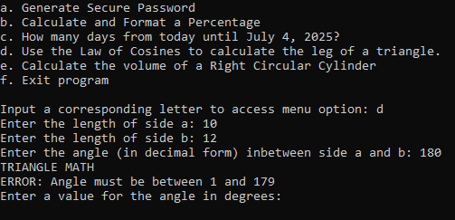
TC7:
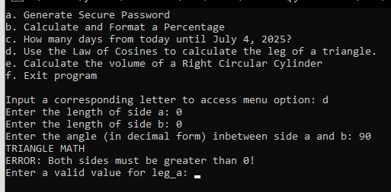
TC8:
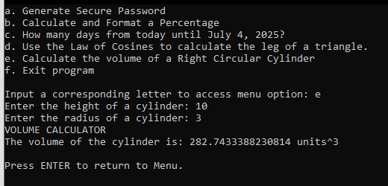
TC9:
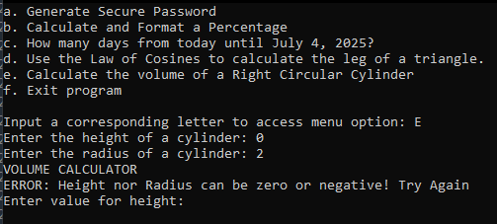
TC10:
