Case # | Input | Expected Output | Actual Output
1 | 1 | Display all states | All states were displayed
2 | 2, md | Error retry | Error displayed to retry
3 | 2,maryland | Display info on Maryland | Maryland info displayed
4 | 3 | Display population graph | Population graph displayed
5 | 4, maryland,-5 | Error retry | Error displayed to retry
6 | 4, maryland, 10000 | Update population for MD | Population updated for MD
7 | 4, maryland, abc | Error retry | Error displayed to retry
8 | 5 | Display exit message | Exit message displayed
9
10

Pylint Result:
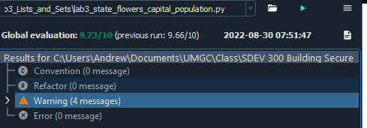
TC1:
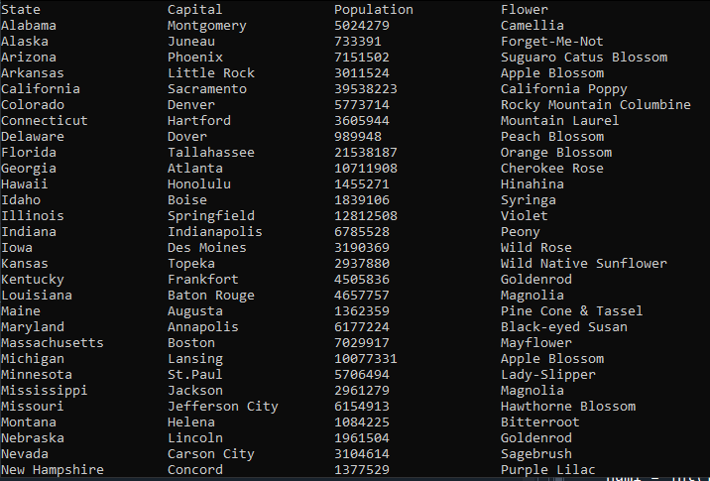

TC2:
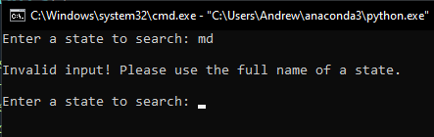

TC3:
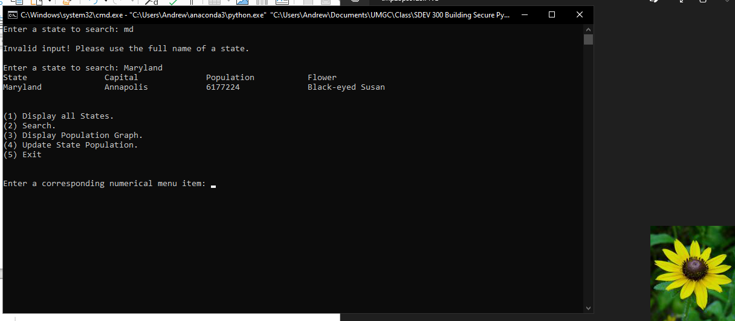

TC4:
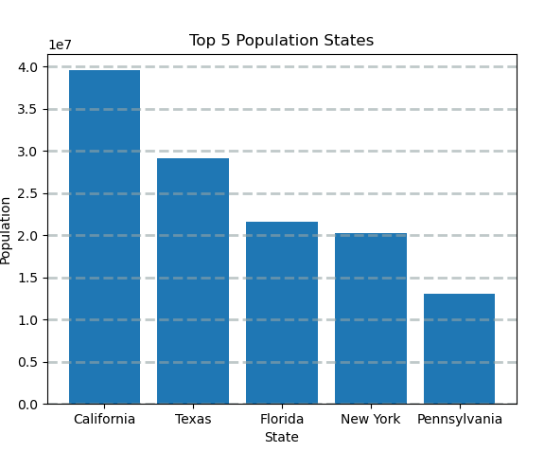

TC5:
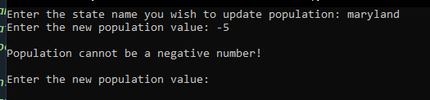

TC6:

TC7:
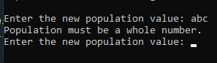

TC8:
