Healthcare – Technical notes
The code is composed of three parts.
- healthcare contains the implementation of the specifications.
- test contains unit tests of healthcare.
- console contains an example application using healthcare. Main.py starts this part of the code.
- initializer contains an additional package to start console with example data.

Employee domain
The similarities between Receptionist and HealthcareProfessional suggested creating a superclass Employee. This choice is also supported by the chosen representation on the database.
Receptionist’s method “make appointment” is split into “propose appointment” and “register appointment” to let Patient choose the appropriate moment.
The original design did not suggest a solution to register patients. The implementation adds “lookup patient”, “find available doctors” and “register patient” to verify the existence of a registration, propose a list of Doctor to a new Patient, and complete a registration.
“Approve repeat” in Doctor was added to match “request repeat” in Patient.

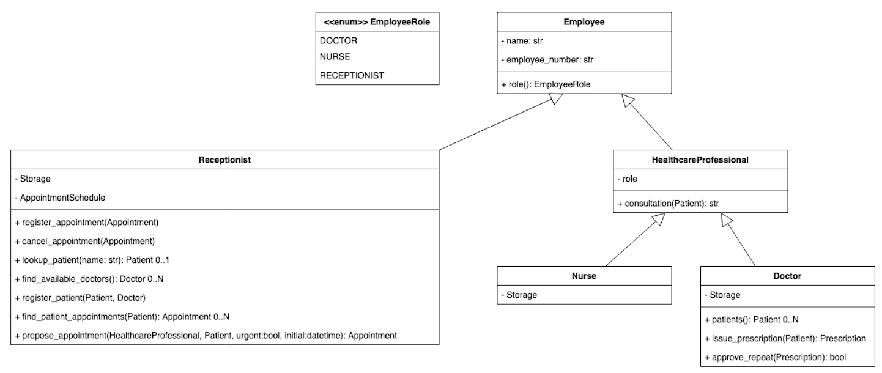
Patient domain
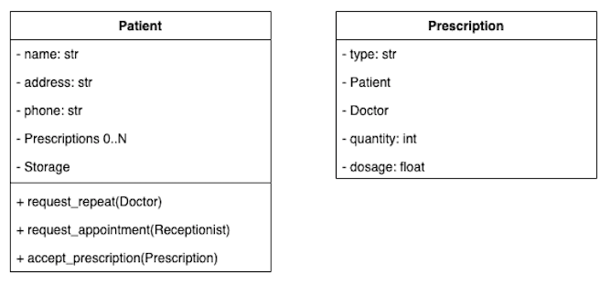
Patient has one addition to the original design: “accept prescription” to let the Patient become aware of a new Prescription. With “request appointment” Patient interacts with Receptionist who will register him (the first time) and propose a different Appointment until the Patient accepts.

Appointment domain
This domain is faithful to the original design. The method “find dates with appointments” was added only for the convenience of console. AppointmentSchedule implements a simple logic to differentiate appointments: they can be scheduled from Monday to Friday, if urgent between 8 AM and 3 PM, otherwise between 9 AM and 2 PM.

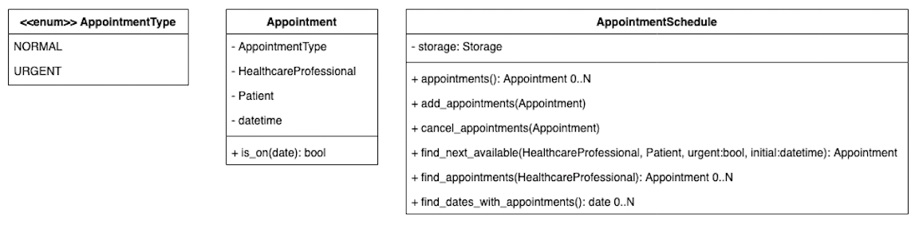
Storage
The database schema is as follows:
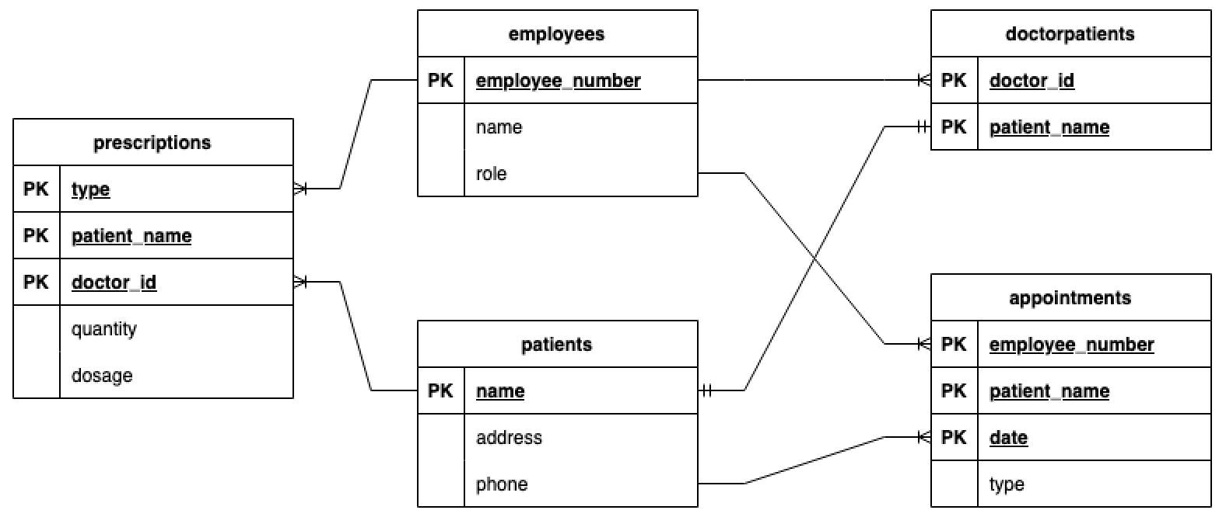
Employees corresponds to the classes Doctor, Nurse, and Receptionist.
Patients corresponds to Patient. The relationship between Patient and Doctor is modeled by doctorpatients. It is possible to collapse doctorpatients into patients, however the chosen design allows for reasonable extensions such as patients registered with multiple specialists.
Appointments and prescriptions are two many-to-many relationship tables between employees and patients.
This model does not make it clear that only doctors participates in the prescription table, nor that only doctors and nurses participates in appointments. Splitting employees into healthcareproviders and receptionists would have solved only one of these issues. Splitting employees into one table per role would have required also the creation of doctorsappointments and nursesappointments. The choice was to give precedence to simplicity and solve the issue programmatically.
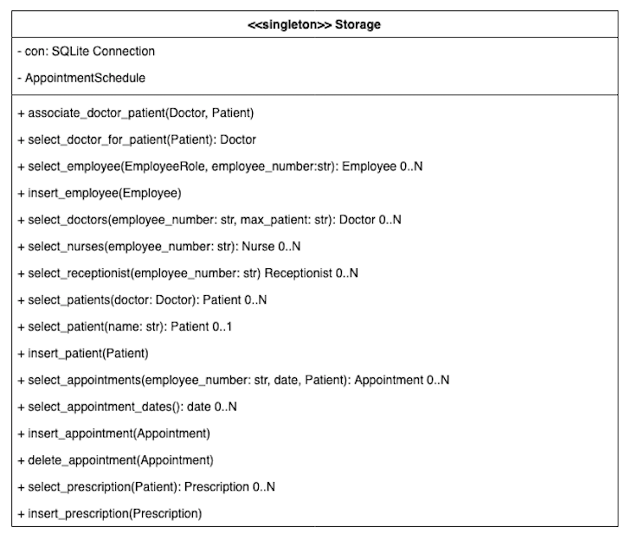
Storage models the queries to an embedded SQLite database.

Singletons
Storage and AppointmentSchedule are implemented as singletons.
@classmethod
def instance(cls):
if cls._instance is None:
cls._instance = Storage()
return cls._instance
Both classes mimic 3rd-party services such as a MySQL database and a shared calendar, therefore being singletons seems appropriate. The implementation as singletons also simplified the design because it made it unnecessary to pass references of Storage and AppointmentSchedule to users such as Receptionist.

Additional code
The additional code in console serves to manually test the application. It gives a view of the data let the tester interact with Receptionist, Doctor, or Nurse. The design of console is a simple state machine supported by utility methods for I/O (ConsoleUtility). A loop continuously checks the state to dispatch the execution to the appropriate handler mapped in the handlers’ dict.
def loop(self):
self._state = State.CONNECTED
context = {}
while self._state != State.QUIT:
self._state = self._handlers[self._state].handle(context)

The initialization package supports console inserting records in the database making it easier to perform manual testing.

How to run the code
Install the dependencies with:
pip3 install -e .
Run the tests with
python3 setup.py test
Start console (sample application) with
python3 main.py
Console accepts two optional parameters:
- -h, --help show the help message
- -k, --keep keeps existing db, with no initialization

