MyMONIT
Collecting measurements to monitor CERN’s experiments - README

Table of Contents
Application composition 2
Overview 2
Class diagram 3

Word count:

Application composition

Overview
The application is composed of seven containers running in Docker.
- App is the core component containing the business logic in Python. It exposes REST APIs (not directly reachable) and consumes AMQP messages.
- Mysql is the core database containing the users with access to App, and the data relative to the experiments.
- Rabbit is the AMQP message broker responsible for the collection of the measures and the delivery to App.
- Nginx is the HTTP/S proxy that exposes App's REST APIs to the external world.
- Logstash is responsible for log collection, formatting, and correct storage in Elasticsearch.
- Elasticseach is the database responsible for the collection of all the logs from all other containers.
- Kibana is the frontend application that visualizes the content of Elasticsearch.
Additionally, the application has "adapters": small applications designed to translate external input into a correctly formatted message that can be enqueued in Rabbit.

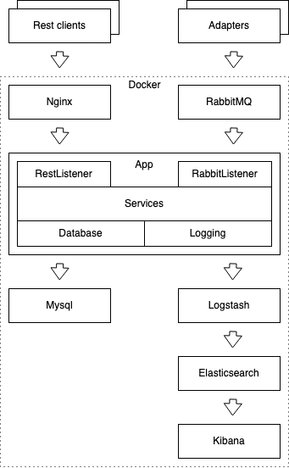

Class diagram

