MyMONIT
Collecting measurements to monitor CERN’s experiments

Table of Contents
High-level description 2
Requirements 3
Functional requirements 4
Non-Functional Requirements 4
Assumptions 5
Architecture 6
Information flow 8
Security 10
Overview 10
Authentication 10
Authorization 10
Security Risks 10
Spoofing 10
Tampering 11
Repudiation 12
Information disclosure 12
Denial of service 13
Elevation of privilege 14
System Requirements 15
Storage space 15
CPU and memory 15
GDPR Consideration 16
References 17

Word count: 1013

High-level description
CERN uses a variety of independently developed systems to monitor its infrastructure (Aimar et al., 2019). MyMONIT will be a solution to unify the monitoring of experiments into a single software integrating different streams of measurements to centralize this information.
MyMONIT will be scalable to ensure that it can cope with increasing demand. The solution will also include monitoring to detect anomalies in the system itself and the flow of the measurements.
MyMONIT will store confidential information and will be a key component in the monitoring infrastructure. Adequate security measures will be implemented to address the associated risks.

Requirements
The following diagram illustrates all the use cases.
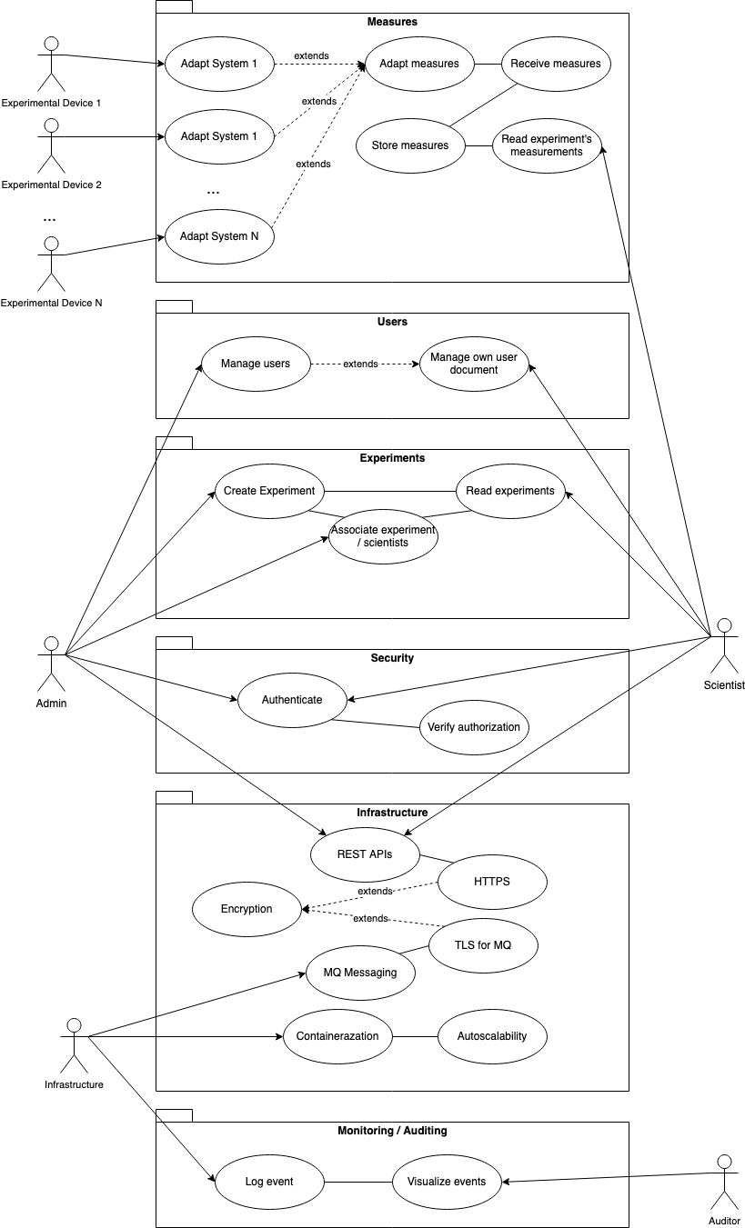

Functional requirements
- There will be three user types with the following role matrix:
role | resource | scope | access
Administrators | users | complete | RW
Administrators | experiments | complete | RW
Administrators | measurements | complete | R
Administrators | audits | No access | /
Scientists | users | user's record | RW
Scientists | experiments | only records associated with the user | RW
Scientists | measurements | only records associated with user's experiments | R
Scientists | audits | No access | /
Auditors | users | No access | /
Auditors | experiments | No access | /
Auditors | measurements | No access | /
Auditors | audits | complete | R

- For each source, an adapter will normalize the measure and transmit it to MyMONIT.
- The measures will be persisted, indexed per experiment, and made available through APIs to authorized scientists.
- A complete audit will be available from a separate interface.

Non-Functional Requirements
- Access points will be authenticated.
- Access to experiments will require per-user authorization.
- The system must serve concurrent users and concurrent experiments.
- 100% of data must be retained.
- The attack surface must be limited.

Assumptions
- The system’s capacity must accommodate at least 10 years of data.
- Autoscale functionalities will be sufficient to deal with variable demand (Kubernetes, N.D. a).
- It is expected an elevated flow of measurements and that queues will absorb peaks of traffic (Reagan, 2018).
- Users will visualize measures polling the APIs and pagination will be sufficient to reduce the performance load.
- The total number of users will be in the range of a few thousand.
- Experiments will produce less than 1 million measurements each.

Architecture
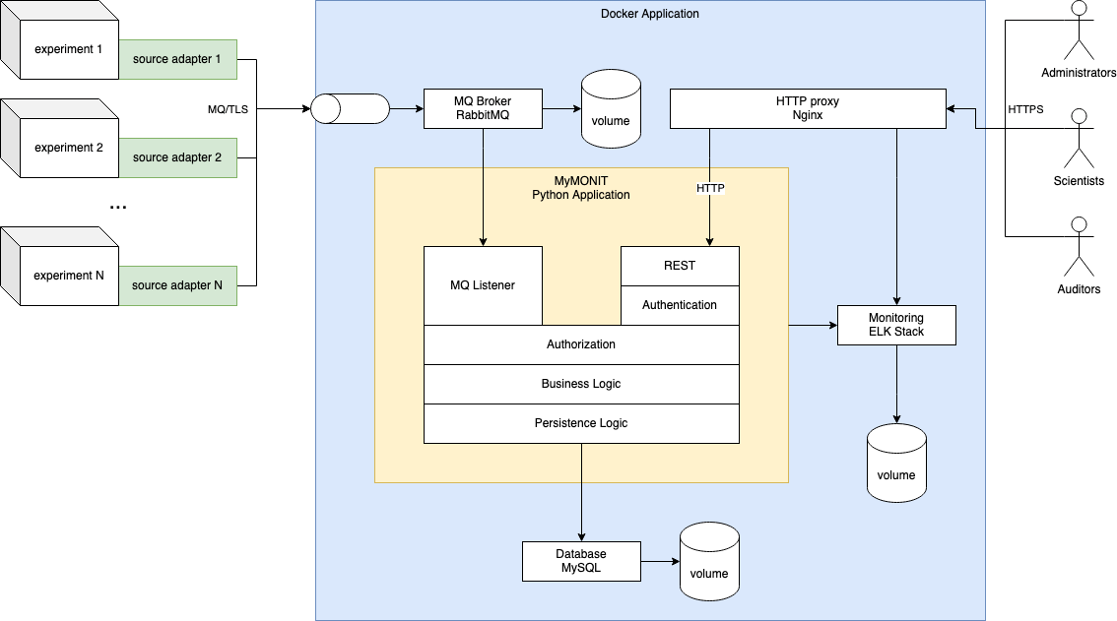

The adapters (in green) will send the measurements to the solution (in blue) where the main component (in yellow) will index them and expose them via REST APIs.
- Docker and Docker Compose: the solution will be containerized and will be portable to compatible solutions such as Kubernetes (Kubernetes, N.D. b).
- The adapters will be Python scripts customized to each specific case and will be installed at the experiment’s location.
- Nginx will be used as a reverse proxy with SSL offloading and will hide all HTTP resources from the outside network. Nginx is currently one of the market leaders in this field (W3Techs, 2022).
- RabbitMQ will be used as MQ Broker to accept data streams from the experiments encrypted in TLS. RabbitMQ is a popular solution and it was preferred to Kafka because it guarantees global message ordering in a cluster (Souza, 2020) even if Kafka offers better scalability for high volumes of traffic (Rabiee, 2018; Souza, 2020)
- MySQL will be responsible for the storage of the application's data. The design will allow to replace it with a more scalable NoSQL database if necessary (Khasawneh, 2020).
- ELK Stack (Elastic Search, Logstash, and Kibana) will be used for log collection and dashboarding. Filebeats will be used as an adapter where needed. ELK Stack is the only open source among the most popular solutions of this kind (Gillespie & Givre, 2021).
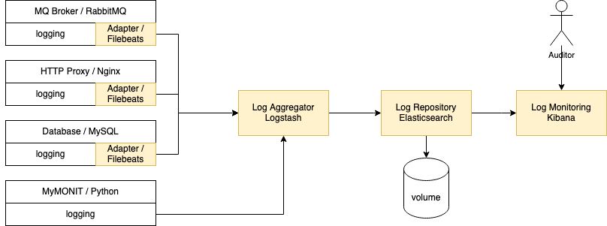
- MyMONIT will be a Python application using Flask and Pika. Flask allows for rapid web development (Ghimire, 2020). Pika is the recommended library to support RabbitMQ in Python (RabbitMQ, N.D.). The following diagram illustrates the internal design of MyMONIT. There will be no direct interactions between the components consuming messages from the broker (in blue) and the components exposing REST endpoints (in green). The Storage (in yellow) will mediate the communications between the two parts.
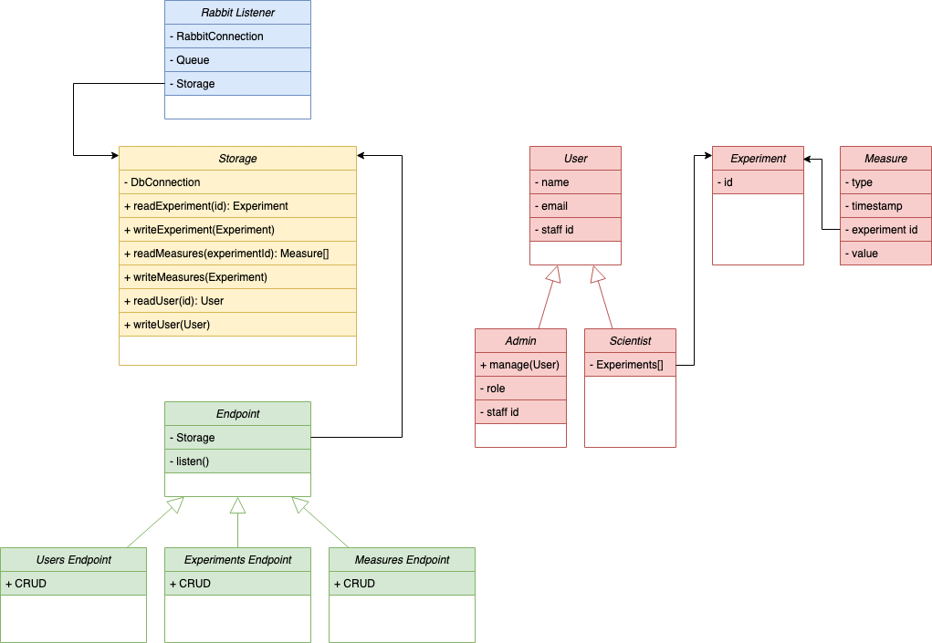

Information flow
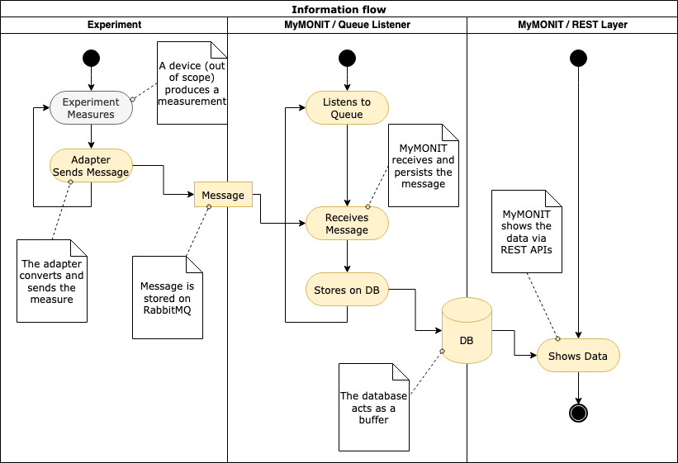
The diagram shows from a location perspective how information flows between components.
The following diagram, instead, represents the same flow from a time perspective:
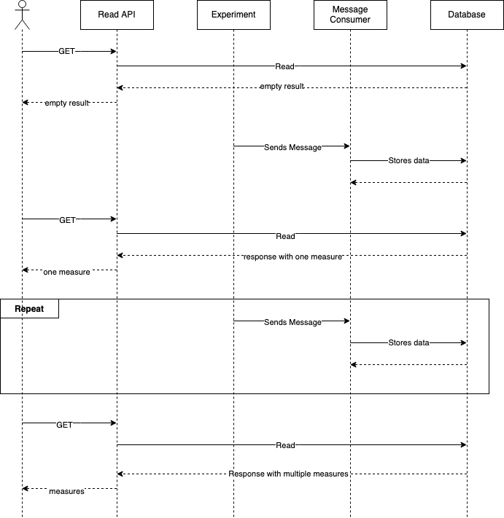

Security

Overview
The main security concerns are the risks of sabotage and information leak. Being a monitoring tool, an attacker may try to disrupt the operations to cover another attack. Information leaks could endanger the process of peer reviews allowing scientists to steal data from parallel research. Being an application exposed only to an internal network, cyberattacks from external sources will be limited.

Authentication
The authentication will be based on JSON web tokens that will remain valid for a limited time and will be required in all interactions. A shared secret (API key) will also be required to limit the chances of brute force attacks (OWASP, REST Security).

Authorization
Authorization to the users, experiments, and measurements endpoints will be role-based. Auditors will have full access limited to audits.

Code quality
- Secure coding practices (OWASP, Secure coding)
- Automated code scanners

Auditing
The main goal will be:
- identification of incidents and fraudulent activity
- detection of anomalies
The following events will be logged:
- failed authentications
- authorization failures
- throughput
The following data will never be logged:
- credentials and tokens
- personal data, except for staff identification
(OWASP, Logging)

Security Risks
Using the STRIDE model, the following threats were identified and classified with DREAD (OWASP, Threat Modeling).

Spoofing
User's credentials violation
Type | Level
Damage | High (10), experiments would be exposed, users' records compromised, data leak
Reproducibility | High (10)
Exploitability | High (10)
Affected users | Low-Medium (4). One user. All, if the user is administrator
Discoverability | Medium (6). User's credentials may be easy to guess
DREAD | High (8)
Mitigation | Password policy: minimum complexity with expiration

Measurements adapter’s credential violation
Type | Level
Damage | High (10). It could allow for DDoS on queues or tampering
Reproducibility | Low (2). Audit will reveal additional login attempts
Exploitability | High (10). If discovered, credentials could be easily used to authenticate scripts
Affected users | Low (2). One experiment
Discoverability | Medium (6). Adapters may be poorly designed with low security in their design
DREAD | Medium (6)
Mitigation | Complex passwords with password rotation

Cross site request forgery
Type | Level
Damage | High (10). Administrators may accidentally modify data
Reproducibility | Low (1). It would be very difficult to perform such an attack
Exploitability | Medium (5). The setup may be easy
Affected users | High (8). Potentially all users
Discoverability | Low (1). The attacker needs a deep understanding of the system
DREAD | Medium (5)
Mitigation | Correct APIs design, usage of token (OWASP, CSRF)

Tampering
Employee installs tampered measurement adapter
Type | Level
Damage | High (10), experiments would be invalidated
Reproducibility | Medium (6). The highest risk is broker's authentication
Exploitability | High (10). Employees in certain position have easy access
Affected users | High (10). All scientists
Discoverability | Medium (6). Employees in certain positions have easy access
DREAD | High (8.4)
Mitigation | Mandatory lifecycle management for production software, including measurement adapters, with mandatory peer approval to promote software to production

Employee manipulates audits
Type | Level
Damage | Medium (5), it could be part of a more vast attack and it could delay the detection of an issue
Reproducibility | Low (1). It requires another violation
Exploitability | Low (1). It is hard to manipulate audits stored in Elasticsearch
Affected users | Low (3). Auditors
Discoverability | Low (1). Elasticsearch is not directly exposed. Only a limited number of employees could easily explore possible attacks.
DREAD | Low (2.2)
Mitigation | Access to the filesystem must be restricted. Filesystem should be encrypted.

Administrator manipulates documents
Type | Level
Damage | Medium (4), data could be recovered through backups, activities could suffer delays
Reproducibility | High (10). Administrators could easily manipulate records
Exploitability | High (10). Administrators can manipulate records as part of their role
Affected users | High (10). All scientists
Discoverability | High (10). Administrators can manipulate records as part of their role
DREAD | High 8.8
Mitigation | Monitoring and auditing will detect fraudulent activity. Screening of employees in this role is recommended.

Repudiation
User denies committing an action
Type | Level
Damage | Low (1).
Reproducibility | Low (1). All actions are audited. Administrator do not have W access to audits
Exploitability | Low (1). Administrators do not have W access to audits
Affected users | Low (1).
Discoverability | Low (1). Without an attack to audits, repudiation would be ineffective
DREAD | Low (1)
Mitigation | No mitigation is necessary

Information disclosure
Database breach
Type | Level
Damage | High (10), data would be compromised.
Reproducibility | Low (1). Database is not directly exposed, authentication is in place
Exploitability | Low (1). Attacker should compromise at least another system first
Affected users | High (10). All
Discoverability | Low (1). Only few employees could easily explore attacks
DREAD | Medium (4.6)
Mitigation | Database won’t be exposed to the external network, access will be authenticated

Scientists stealing information
Type | Level
Damage | Medium (5). Peer reviews may be invalid
Reproducibility | Low (1). It requires another violation
Exploitability | Low (1). It requires another violation
Affected users | Medium (5). Scientists involved in the experiments, external stakeholders
Discoverability | Low (1)
DREAD | Low (2.4)
Mitigation | No mitigation will be implemented. Employer’s disciplinary procedures should be a sufficient deterrent.

Auditors steal information through audits
Type | Level
Damage | Medium (4). Peer reviews may be invalid. Security may be compromised
Reproducibility | High (10). Auditors have access to audits as part of their role
Exploitability | High (10). Auditors have access to audits as part of their role
Affected users | High (10). Administrator, Scientists, and Stakeholders
Discoverability | High (10). Auditors have access to audits as part of their role
DREAD | High (8.8)
Mitigation | Auditors actions will be audited as well. Employer’s disciplinary procedures should be a sufficient deterrent.

Denial of service
DDoS on APIs
Type | Level
Damage | High (10), system may become inoperative
Reproducibility | Low (3). The system should be exposed only in the internal network
Exploitability | Low (3). It would be easy to block the attack in the internal network
Affected users | High (10). All
Discoverability | Low (1). It would be difficult to plan an effective attack.
DREAD | Medium (5.4)
Mitigation | Out of scope in this project. System administrator must be able to isolate the segment of the network causing the attack.

DDoS on Audit and Monitoring
Type | Level
Damage | Medium (6). It may cover a more vast attack
Reproducibility | Low (1). The system should be exposed only in the internal network
Exploitability | Low (1). It would be easy to block the attack in the internal network
Affected users | Low (3). Auditors
Discoverability | Low (1). It would be difficult to plan an effective attack.
DREAD | Low (2.4)
Mitigation | Out of scope in this project. System administrator must be able to isolate the segment of the network causing the attack.

Ransomware attack
Type | Level
Damage | High (10), all data may be lost
Reproducibility | Medium (6). Measures are in place, but every day organizations fall under this attack
Exploitability | High (10). The attack may come in the form of phishing.
Affected users | High (10). All
Discoverability | Medium (6). It is hard to evaluate the level of the current defenses
DREAD | High (8.4)
Mitigation | MyMONIT’s network will be in a separate segment and virtualized in the container infrastructure. Containers’ images will be maintained up-to-date. Offline backups will ensure the recoverability of data. (OWASP, Ransomware)

Elevation of privilege
Scientists becoming administrators
Type | Level
Damage | High (8), the attacker could disrupt the system
Reproducibility | Low (1). It would require database access since no system function manipulates roles
Exploitability | Low (1). Attacker should compromise at least another system first
Affected users | High (10). All
Discoverability | Low (1)
DREAD | Medium (4.2)
Mitigation | Code reviews and vulnerability scanner will be used to improve the quality of the code and limit this risk

Auditor getting Administrator privileges or Administrator accessing to audits
Type | Level
Damage | Medium (5). It can result in information leakage or be part of a larger attack
Reproducibility | Low (1). The two sets of users are separated
Exploitability | Low (1). Being part of one of the two groups does not give any advantage to elevate privileges. Audits do not contain usernames or passwords
Affected users | High (8). Administrators and Auditors
Discoverability | Low (1)
DREAD | Low (3.2)
Mitigation | No action will be taken

System Requirements

Storage space
User and experiment data will require less than 1Kb per record, therefore a few megabytes will be sufficient to store them.
Each measurement is expected to require at least 22 bytes. With 1 million measures per experiment, each experiment will require about 21Mb of space.
field | type | size
Measure type | integer | 2 bytes
Timestamp | Timestamp with nano precision | 8 bytes
Experiment id | integer | 4 bytes
Measure | Double precision floating point | 8 bytes

CPU and memory
CPU and memory requirements will be determined with load testing after the initial deployment. Minimum resources will be set to values able to sustain the expected average daily traffic. Maximum resources will be set to values able to sustain 200% of the maximum expected traffic. Autoscale will be configured to follow the demand and contain costs.

GDPR Consideration
The application design requires only a minimal amount of personal information. All users will be able to retrieve, update and delete their own information, in compliance with GDPR. Complete deletion will preserve Staff Identification for traceability (GDPR, 2016).
An administrator will be able to assist users with their GDPR request.
Document | Field | Description
User’s record | Staff identification | Unique id number from the HR system
User’s record | Name | Given name(s)
User’s record | Surname | Family name
User’s record | Email Address | Professional email address
Experiment | None
Measurement | None
Audit | User’s staff identification | Only the user’s staff identification will be stored in the audit

References
- Aimar, A., Corman, A. A., Andrade, P., Fernandez, J. D., Bear, B. G., Karavakis, E., ... & Magnoni, L. (2019). MONIT: monitoring the CERN data centres and the WLCG infrastructure. In EPJ Web of Conferences (Vol. 214, p. 08031). EDP Sciences. Available from https://www.epj-conferences.org/articles/epjconf/pdf/2019/19/epjconf_chep2018_08031.pdf [Accessed 2/April/2022]
- GDPR - Consolidated text: Regulation (EU) 2016/679 of the European Parliament and of the Council of 27 April 2016 on the protection of natural persons with regard to the processing of personal data and on the free movement of such data, and repealing Directive 95/46/EC (General Data Protection Regulation) – Art 17 – right to be forgotten (2016). Available from:
https://eur-lex.europa.eu/legal-content/EN/TXT/PDF/?uri=CELEX:02016R0679-20160504&from=EN
- Gillespie M. & Givre C. (2021) Understanding Log Analytics at Scale. 2nd Ed. O’Reilly Media Inc.
- Ghimire, D. (2020). Comparative study on Python web frameworks: Flask and Django. Available from https://www.theseus.fi/bitstream/handle/10024/339796/Ghimire_Devndra.pdf?sequence=2 [Accessed 2/April/2022]
- Khasawneh, T. N., AL-Sahlee, M. H., & Safia, A. A. (2020, April). Sql, newsql, and nosql databases: A comparative survey. In 2020 11th International Conference on Information and Communication Systems (ICICS) (pp. 013-021). IEEE. Available from https://www.researchgate.net/profile/Mahmoud-Alsahlee/publication/340978543_SQL_NewSQL_and_NOSQL_Databases_A_Comparative_Survey/links/5ec46445a6fdcc90d685d608/SQL-NewSQL-and-NOSQL-Databases-A-Comparative-Survey.pdf [Accessed 2/April/2022]
- Kubernetes (N.D.) Horizontal Pod Autoscaling. Available from https://kubernetes.io/docs/tasks/run-application/horizontal-pod-autoscale/ [Accessed 2/April/2022]
- Kubernetes (N.D.) Translate a Docker Compose File to Kubernetes Resources. Available from https://kubernetes.io/docs/tasks/configure-pod-container/translate-compose-kubernetes/ [Accessed 2/April/2022]
- OWASP (N.D.) Cross Site Request Forgery (CSRF). Available from https://owasp.org/www-community/attacks/csrf [Accessed 2/April/2022]
- OWASP (N.D.) Logging Cheatsheet. Available from https://cheatsheetseries.owasp.org/cheatsheets/Logging_Cheat_Sheet.html [Accessed 2/April/2022]
- OWASP (N.D.) OWASP Anti-Ransomware Guide. Available from https://owasp.org/www-project-anti-ransomware-guide/migrated_content [Accessed 2/April/2022]
- OWASP (N.D) REST Security Cheatsheet. Available from https://cheatsheetseries.owasp.org/cheatsheets/REST_Security_Cheat_Sheet.html [Accessed 2/April/2022]
- OWASP (N.D.) Secure Coding Practices. Available from https://owasp.org/www-project-secure-coding-practices-quick-reference-guide/migrated_content [Accessed 2/April/2022]
- OWASP (N.D) Threat Modeling Process. Available from https://owasp.org/www-community/Threat_Modeling_Process#stride [Accessed 2/April/2022]
- Rabiee, A. (2018). Analyzing Parameter Sets For Apache Kafka and RabbitMQ On A Cloud Platform. Available from https://www.diva-portal.org/smash/get/diva2:1232563/FULLTEXT01.pdf [Accessed 2/April/2022]
- RabbitMQ (N.D.) Client Libraries and Developer Tools. Available from https://www.rabbitmq.com/devtools.html [Accessed 2/April/2022]
- Reagan, R. (2018). Message Queues. In: Web Applications on Azure. Apress, Berkeley, CA. https://doi.org/10.1007/978-1-4842-2976-7_9
- Souza, R. D. A. (2020). Performance analysis between Apache Kafka and RabbitMQ. Available from http://dspace.sti.ufcg.edu.br:8080/jspui/bitstream/riufcg/20339/1/RONAN%20DE%20ARAU%CC%81JO%20SOUZA%20-%20TCC%20CIE%CC%82NCIA%20DA%20COMPUTAC%CC%A7A%CC%83O%202020.pdf [Accessed 2/April/2022]
- W3Techs (2022) Usage statistics of Nginx. Available from https://w3techs.com/technologies/details/ws-nginx [Accessed 2/April/2022]

