MyMONIT
Collecting measurements to monitor CERN’s experiments – README

Team 2: Ahmed, Padukka, Rossotto, Thompson, Wimalendran

Table of Contents
Application composition 3
Overview 3
Components 3
Class diagram of APP 6
Overview 6
RestListener 6
RabbitListener 7
Logging 8
Storage 10
Dependency Injection 11
Orchestration 13
Technical specifications 15
Requirements 15
Containers overview 15
Summary of container images 15
Production configuration 16
Scalability of App 16
Scalability of MySQL, Nginx, and RabbitMQ 16
Scalability of Logstash, Elasticsearch, and Kibana 17
Ports 17
Setup 17
Authentication 18
User creation 18
Authentication process 20
Testing 21
Unit testing 21
Automatic scanners 21
Bandit 22
Coverage 22
Pylint 23
Manual testing 24
APIs sequence 25
Calling the APIs 26
API documentation 27
List of attachments 28
References 29

Application composition

Overview
As mentioned in the analysis (Rossotto et al, 2022), CERN uses a variety of independently developed systems to monitor the infrastructure used in the experiments (Aimar et al., 2019). MyMONIT unifies the monitoring and integrates the streams of different applications into a single repository.
MyMonit collects the input from the experiments (the measures) via message broker and expose REST APIs to consume them. MyMonit exposes a separate interface for auditing the solution itself. The whole solution is composed of different containers orchestrated by Docker Compose.

Components
The application is composed of seven containers running in Docker.
- App is the core component. It hosts the business logic and it is written in Python. It exposes REST APIs and consumes messages via AMQP. Its stack is composed of
  - Flask (Flask, N.D.): framework used to create REST APIs.
  - Pika (Pika, N.D.): framework to consume messages from the AMQP interface.
  - MySQL Connector (MySQL Connector, N.D.): database connector.
  - Python Logstash (Elastic, N.D.): connector to the Logstash server to store logs for auditing purpose.
  - Firebase (Firebase, N.D.): connector to Firebase for the authentication of Json Web Tokens.
  - Dependency Injector (Dependency Injector, N.D.): framework to implement dependency injection in Python.
  - Colorama (Hartley J. (2021): framework to output ANSI colored text in console.
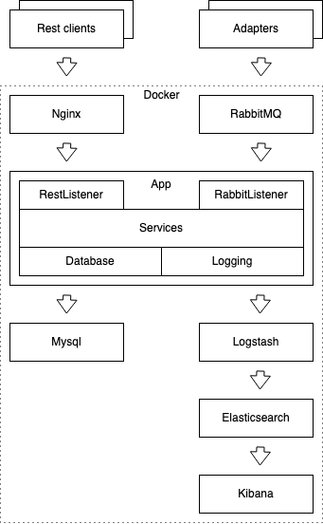
- MySQL (MySQL, N.D.) is the core database. It contains the users with access to App, and the data relative to the experiments.
- RabbitMQ (RabbitMQ. N.D.) is the AMQP message broker responsible for the collection of the measures and the delivery to App.
- Nginx (Nginx, N.D.) is the HTTP/S proxy that exposes App's REST APIs to the external world.
Figure 1
- Logstash (Logstash, N.D.) is responsible for log collection, formatting, and correct storage in Elasticsearch.
- Elasticseach (Elasticsearch, N.D.) is the database responsible for the collection of all the logs from all other containers.
- Kibana (Kibana, N.D.) is the frontend application that visualizes the content of Elasticsearch.
Additionally, the application supports "adapters": small applications designed to translate external input into a correctly formatted message that can be enqueued in RabbitMQ.
Figure 1 illustrates the overview of the components and their interaction.

Class diagram of APP

Overview
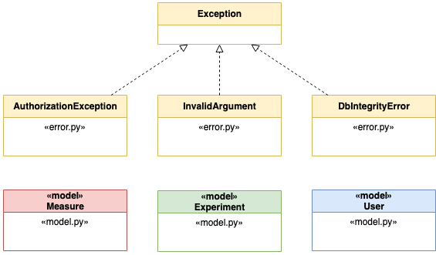
The model is composed of Measure, Experiment, User, and Exceptions (Figure 2).
Figure 2
A specialised service is responsible for the three main elements of the model (Figure 3).
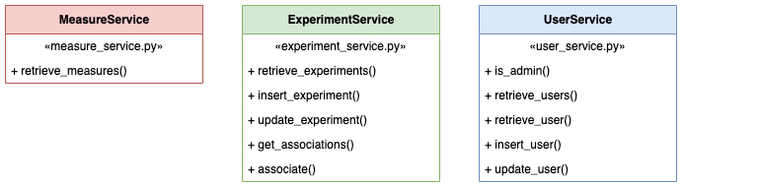
Figure 3

RestListener
RestListener is responsible for the REST interface of the application. RestListener uses RestConfiguration to model the configuration, and delegates the handling of the resources to specialised resource components (MeasureResource, ExperimentResource, ExperimentAssociationResource, UserResource, and ExceptionResource) (Figure 4).
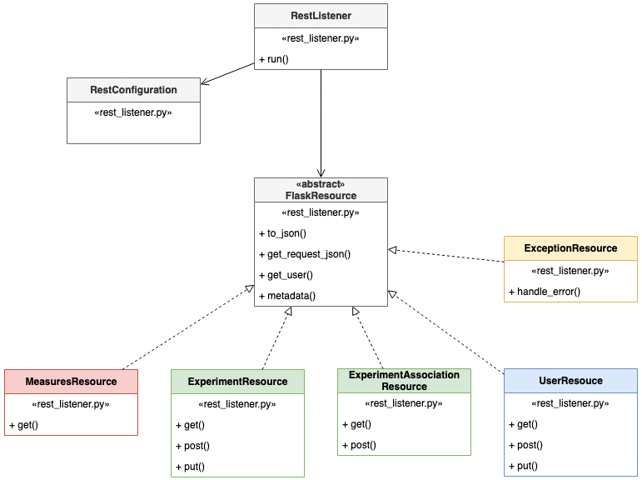
Figure 4

RabbitListener
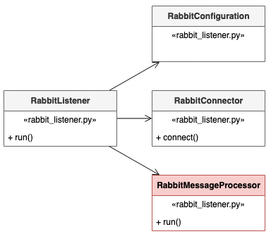
RabbitListener is the service responsible for the connection to RabbitMQ and it uses a RabbitConfiguration to model the configuration. RabbitConnector is a component of the listener used to extract the IO functions and simplify unit testing. The extraction makes it possible to mock the component and avoid a real I/O in the test. RabbitMessageProcessor contains the logic to store the measures in the database (Figure 5).
Figure 5

Logging
Logging is a cross-cutting service used in different components.

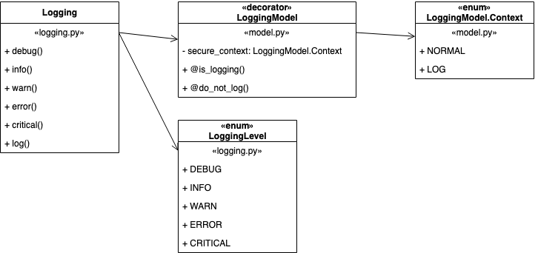
Figure 6
Logging supports faceted data (Schmitz, 2016) via two decorators @is_logging and @do_not_log to respectively mark functions that perform logging, and parts of the model that should not appear in the logs with their real value to prevent data leaks.
@is_logging wraps the decorated call setting the context’s value (Figure 7).
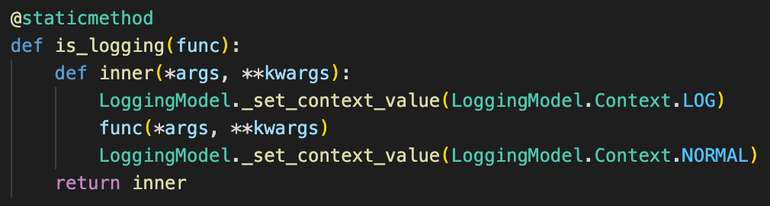
Figure 7
@do_no_log checks the context’s value and redirects the call to the original method or returns “***” depending on the context’s value. This simple mechanism can hide secrets in the logs without implementing a case-by-case logic in the logging component (Figure 8).
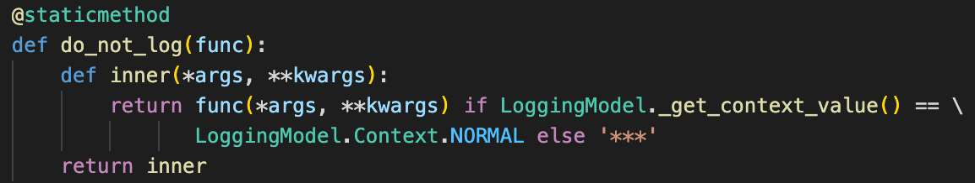
Figure 8
The component supports multithreading with a dictionary of contexts indexed by thread id (Figure 9).
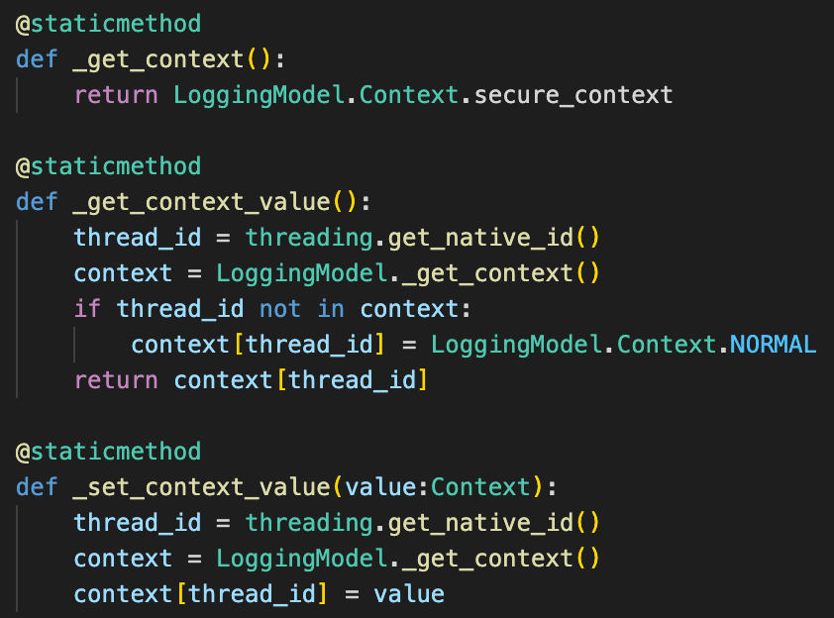
Figure 9

Storage
Storage is responsible for the IO with the database (Figure 10).
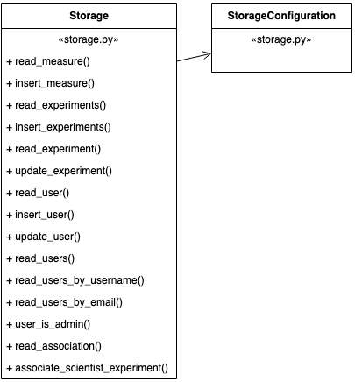
Figure 10

Dependency Injection
Container is responsible for the configuration and dependency injection. Thanks to Container, components do not instantiate one another simplifying unit testing (Figure 11).
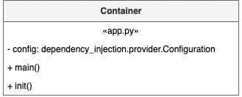
Figure 11
The configuration of Container is in app.py. The parameters have a default value that can be overridden by the environment’s parameters (Figure 12).
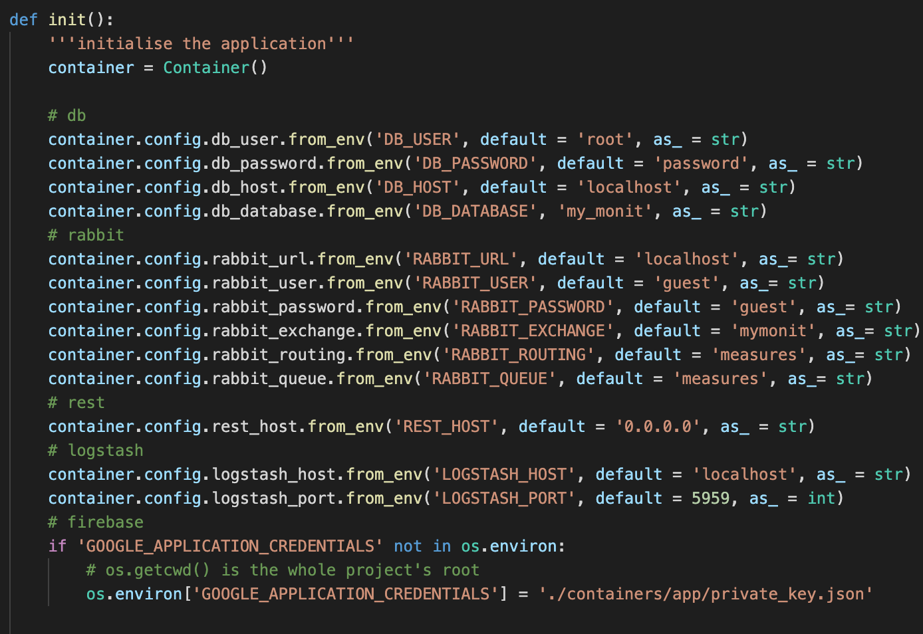
Figure 12
The dependency injection mechanism in Container uses the containers.config to create some object and inject the objects one into another.
For example, logging is a basic object without dependencies and it is injected into storage (Figure 13).
Dependency injection is essential to perform accurate unit testing because it makes object-mocking easy.
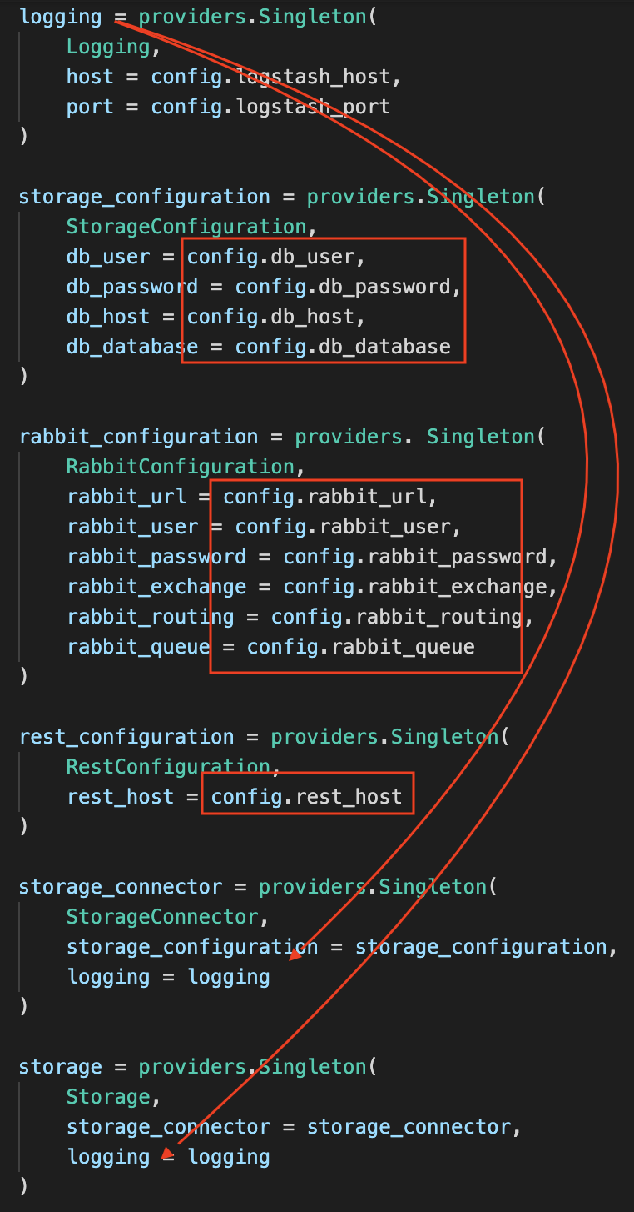
Figure 13

Orchestration
The orchestration uses Docker Compose (Docker Compose, N.D.) via the descriptor docker-compose.yml (Figure 14).
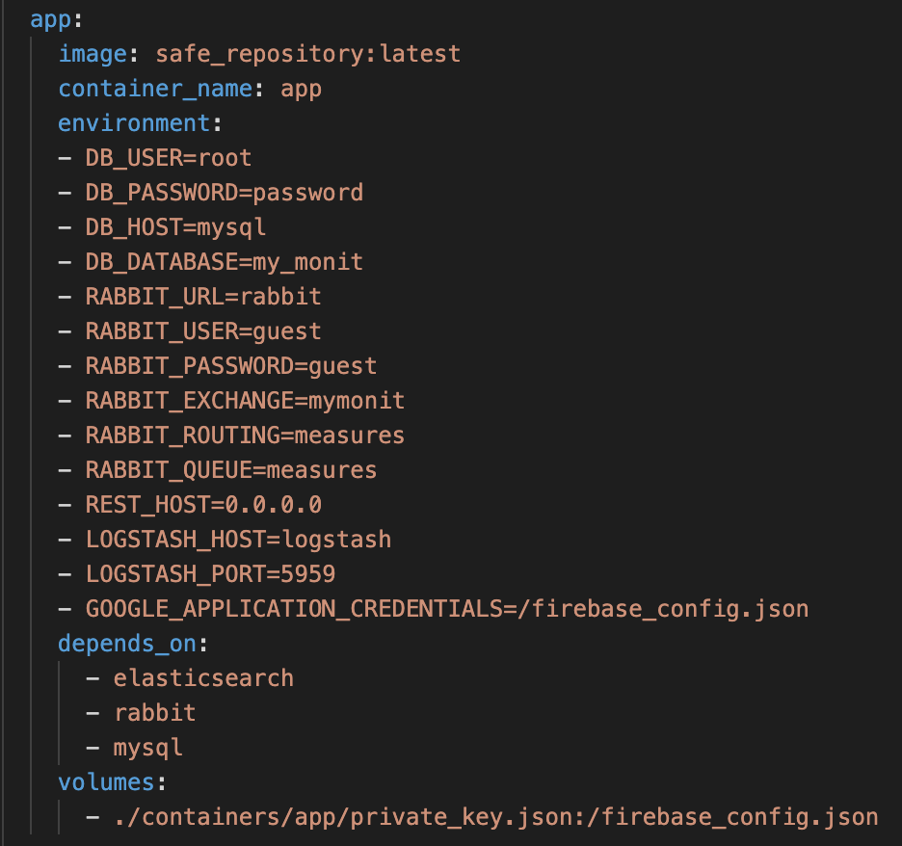
Figure 14
The environment list specifies the variables for the container, including the secrets. The included example does not use strong secrets and it is supposed to be only an example. It is recommended to change the secrets in a production environment. It is also recommended to use this configuration as a model to deploy into Kubernetes that offers a stronger solution for deployment, including the possibility to separate the secrets from the code (Kubernetes, N.D.).

Some ports, such as the RabbitMQ console on 15672 (Figure 15) are exposed to easily demonstrate the usage of the components. Only the ports mentioned in the section “production configuration” are required for a correct functioning.
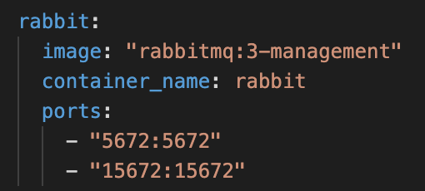
Figure 15

Technical specifications

Requirements
It is required to have the Docker daemon running. For the development, the chosen platform was Docker Desktop. It is recommended to assign at least 4gb of ram to Docker: with less memory, some containers may fail. It is always possible to restart failing containers should that happen.
All scripts require a unix-like system (eg. Mac).
Python 3.9 is required to build App alone. All dependencies are specified in setup.py and can be installed with “pip3 install -e .”

Containers overview
The configuration of all containers is visible in “docker-compose.yml”. The file is meant to be an example and it is not suitable for production environment because it contains unencrypted secrets and exposes internal ports.

Summary of container images
Container’s name | Base image | Customisation
App | Python:3.9 | Injection of the application
Nginx | Nginx:latest | Inject of configuration and SSL certificates
Rabbit | Rabbit:3-management | None
Mysql | Mysql:5.7 | None
Elasticsearch | Elasticsearch:6.5.4 | None
Kibana | Kibaba:6.5.4 | None
Logstash | Logstash:6.5.4 | None

Production configuration
It is recommended to deploy the application in Kubernetes. Kubernetes makes it easy to share secrets in a safe way without embedding them in the code, and offers advanced functions to ensure scalability.

Scalability of App
The core Python application is stateless and it is possible to start multiple instances in parallel to improve performances.
If the goal is to increase performances of the REST APIs, it is required a change in the Nginx configuration to implement load-balancing between the nodes.
If the goal is to increate performances of the consumption of AMQP messages through the RabbitMQ interface, it is sufficient to increase the number of nodes to multiply the consumers. All the calls to the REST APIs will be handled by one single node, but this does not represent an issue.

Scalability of MySQL, Nginx, and RabbitMQ
These components natively support clustering through configuration (MySQL – Clustering, N.D.; Nginx – Clustering, N.D; RabbitMQ – Clustering, N.D.).

Scalability of Logstash, Elasticsearch, and Kibana
The ELK stack supports clustering through configuration (Elastic – Clustering. N.D.). It is reasonable to expect that the components under pressure may be Logstash and Elasticsearch because they have the responsibility to store logs from all components.
Kibana’s users will be limited and it is not expected to suffer of scalability problems.

Ports
The only ports that need to be published in a production environments are:
- 443: Nginx
- 5672: RabbitMQ
- 5601: Kibana
All other ports in the docker compose descriptor are exposed only for testing and should remain closed to external connections in a production environment.

Setup
The script “run.sh” automatically builds and starts all the containers.
The script “run-infra.sh” starts only a subset of the containers (Mysql and RabbitMQ) and it is convenient for the development of the core application in Python.
The Python application can be built with “pip3 install -e .” launched in the App’s container base folder. The command downloads automatically the dependencies specified in “setup.py”.

Authentication
The authentication process is externalized. The application contains GDPR sensitive data (namely emails), but no passwords in any form.
The chosen platform for the external authentication is Firebase (Firebase, N.D.) hosted in the cloud by Google.
Users must register and verify their identity only with Firebase to generate a signed Json Web Token that contains their unique id and can be verified by App during a REST call.

User creation
A user must be created in the Firebase console (Firebase – Console, N.D.). The console can be accessed using the credentials in the attachment.
The console shows all the users and their User UID which is the information that links a Firebase’s User with App’s User (Figure 16).
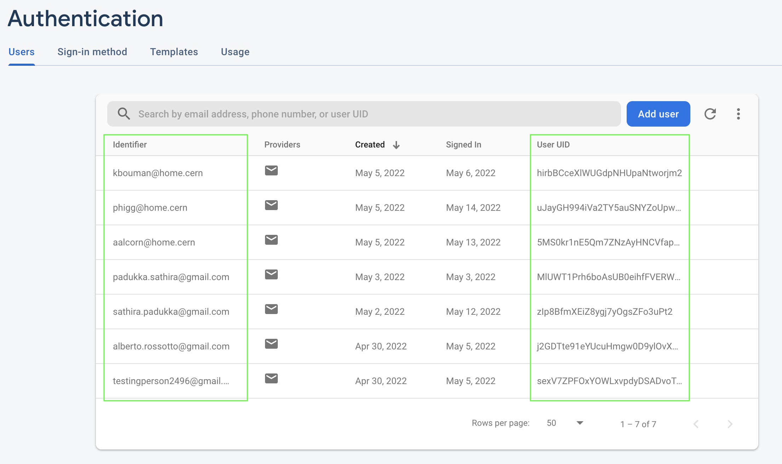
Figure 16
If a new user needs to be created, the user can navigate to the console page, enter the credentials, and register the user. This will create a new user in firebase.
The corresponding user must be then created in APP using the User API (Figure 17).
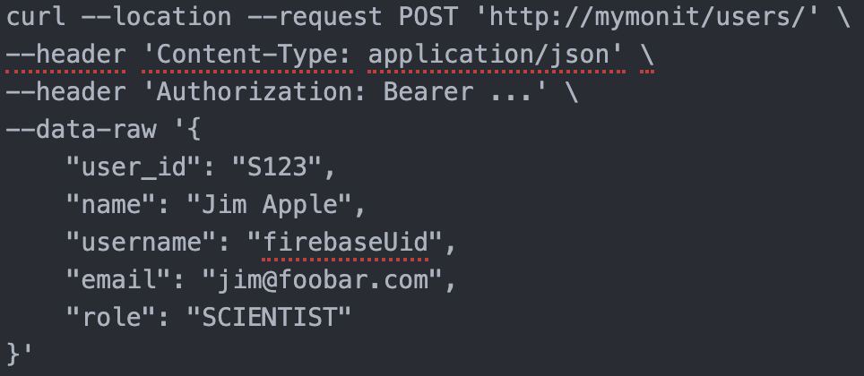
Figure 17
The field “username” must correspond to the User’s uid in Firebase.

Authentication process
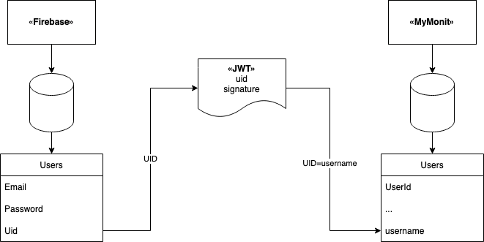
The authentication generates a signed Json Web Token with the user’s information on the Firebase side. The token is included as Bearer token to the App’s backend in each REST API call. App’s backend verifies the signature and maps the Firebase’s Uid with App’s username. App can then use the authenticated user for the authorization of each call (Figure 18).
Figure 18

Testing

Unit testing
Unit tests cover a vast portion of the application to help detect regressions during the development.
Unit test use of Mock and MagicMock (Python Mock, N.D.) to replace the dependencies in the class under test. The mocks can return values set programmatically and make it easy to test how the class under test called them (Figure 19).
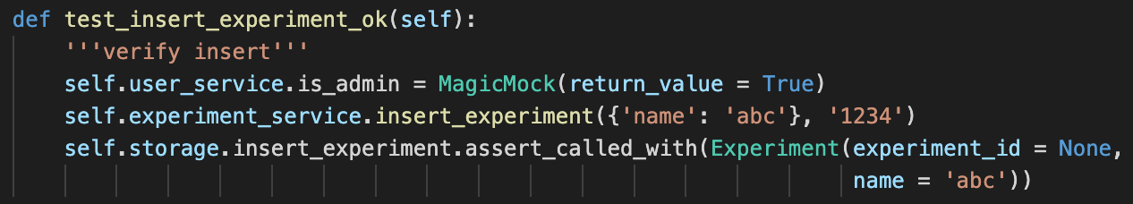
Figure 19
In this test, user_service and storage are mocks. MagicMock ensures that the call to is_admin returns True in order to pass an authorization check, and the test verifies that the class under test, experiment_service, calls insert_experiment on storage with specific parameters.

Automatic scanners
The project uses Pylint (Pylint, N.D.) and Bandit (Python Code Quality Authority, 2022) to spot unused variables, formatting issues, and potential vulnerabilities. Coverage.py (Coverage.py, N.D.) measures the code coverage. It is possible to launch the three utilities with the run-checks.sh script in containers/app with results in containers/app/reports.

Bandit
Bandit reports a possible vulnerability:
>> Issue: [B104:hardcoded_bind_all_interfaces] Possible binding to all interfaces.
Severity: Medium Confidence: Medium
This refers to the default configuration of the APP container that binds Flask on 0.0.0.0. This is not a vulnerability: the restriction on the connectivity is delegated to Docker.

Coverage
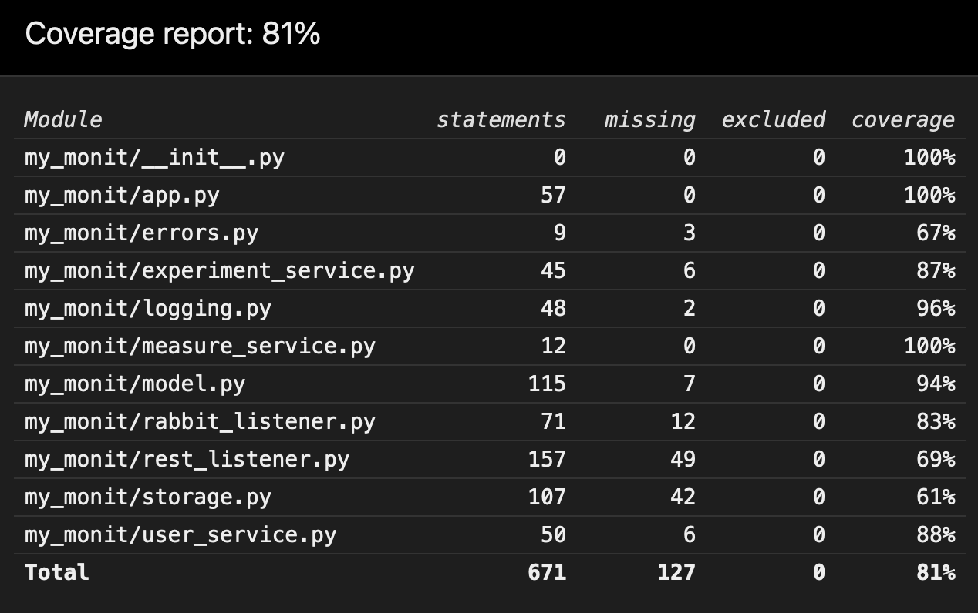
The test coverage is above 80%. The report shows precisely which lines are not covered and they are mostly lines that would not be useful to test (eg. getter) or it would require heavy usage of mocking rendering the test insignificant (eg. I/O) (Figure 20).
Figure 20

Pylint
The report mentions one possible defect:
************* Module my_monit.logging
my_monit/logging.py:78:15: W0703: Catching too general exception Exception (broad-except)
------------------------------------------------------------------
Your code has been rated at 9.98/10
It refers to a line in a method that performs logging. Although it is not a good practice, catching Exceptions aims to capture any unforeseen issue during logging and print it in stdout as a fallback.

Manual testing
Manual testing detected the differences with the initial specifications and ensured the overall quality of the application.
The following are useful url to inspect the application when deployed with the provided test configuration.
Service | URL
Base APIs URL | https://localhost
RabbitMQ Console | http://localhost:15672/
Kibana | http://localhost:5601/login
Mysql Console | localhost:3306

APIs sequence
The following diagram illustrates a valid sequence of calls.
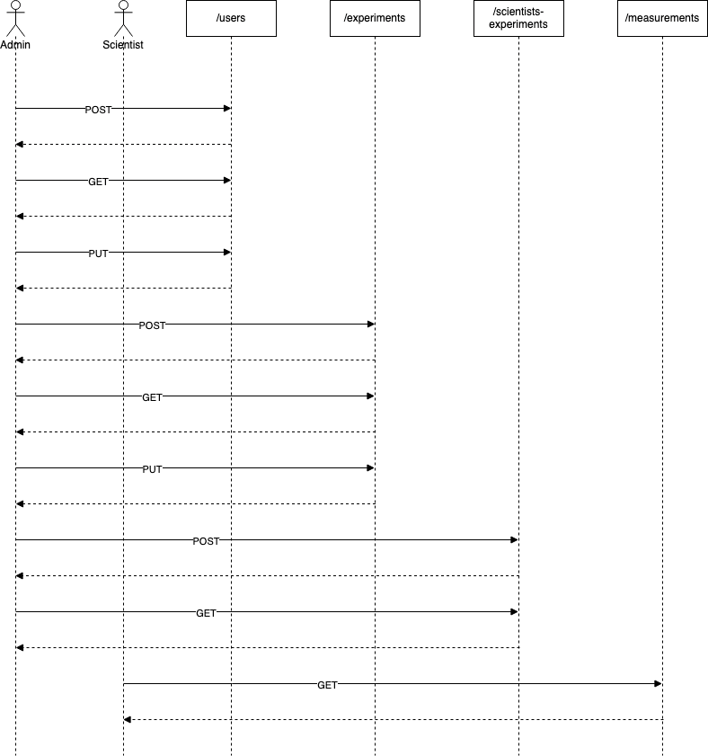
Figure 21
An administrator must create a User of type SCIENTIST. Subsequently, the Admin can retrieve and modify the User. Similarly, the Admin can create an Experiment.
With at least one User and one Experiment, it is possible to associate them to give access to the Experiment.
When associated, the User can retrieve the Measurements.

Calling the APIs
A collection of all the API calls is available for Postman (Postman, N.D.) between the attachments (Figure 22).
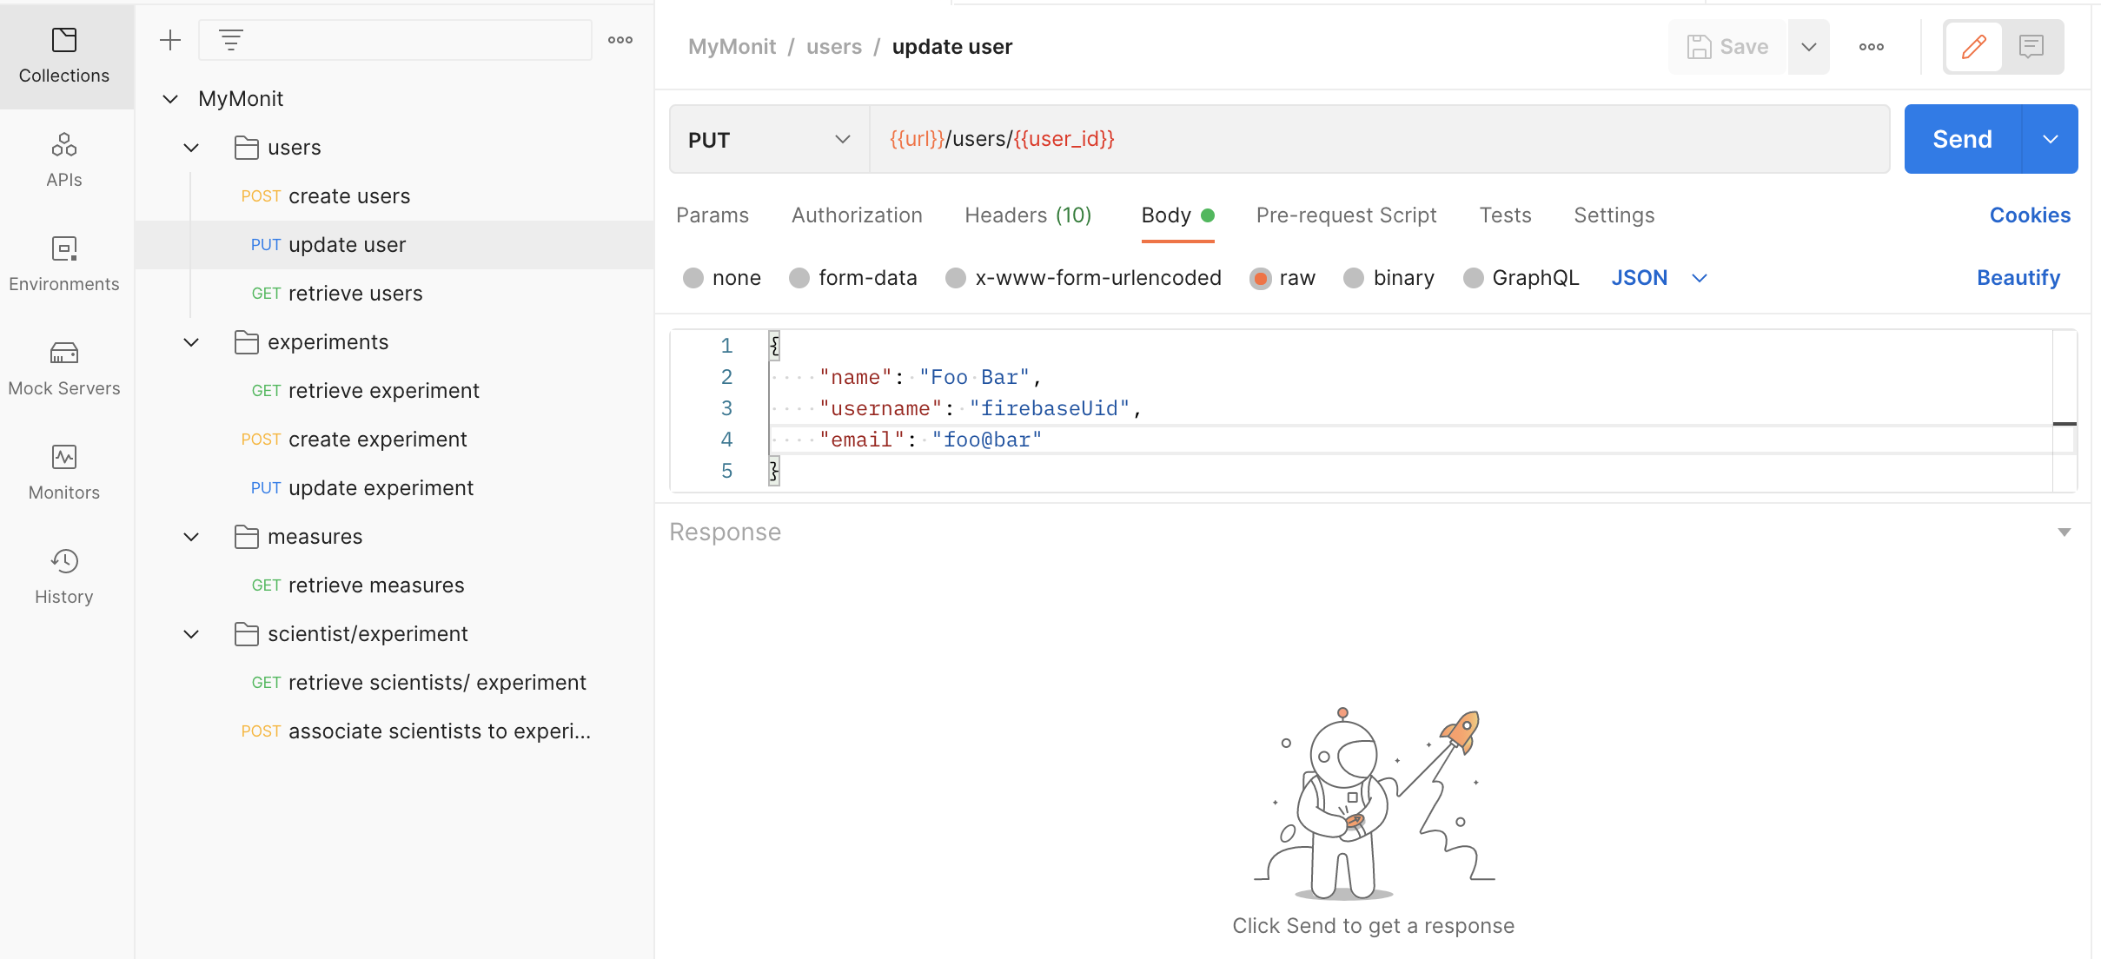
Figure 22
The collection uses variables that can be specified in the Environment tab (Figure 23).
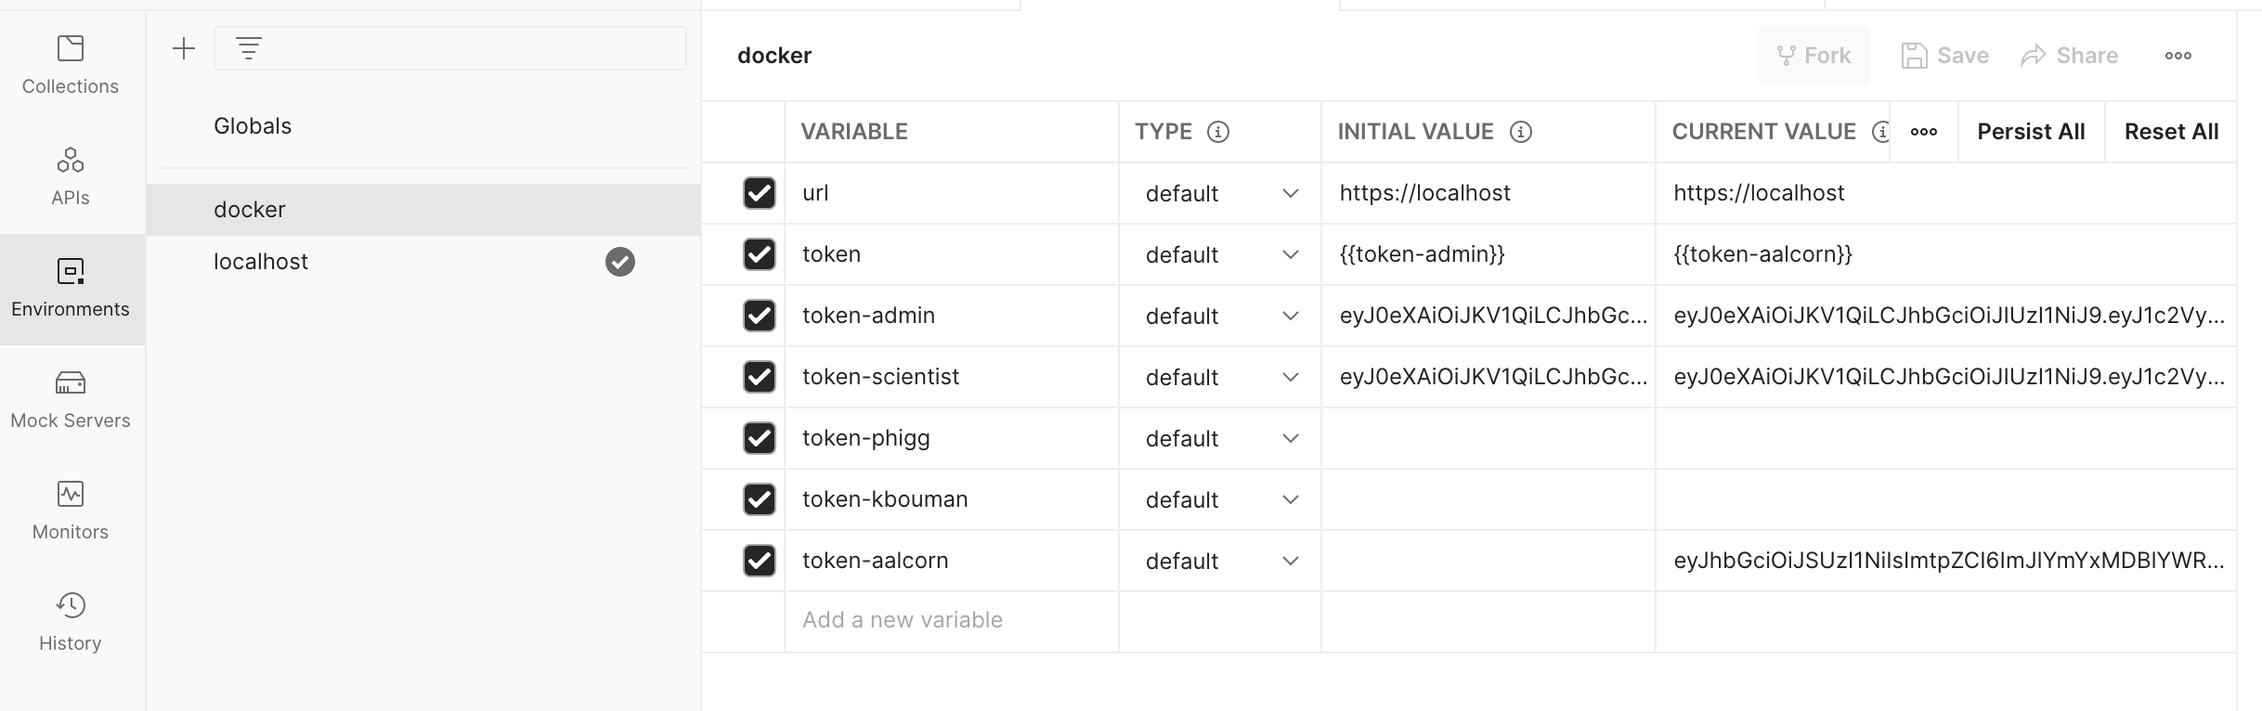
Figure 23

API documentation
The APIs are documented in the attached api.html using Swagger (Swagger, N.D.) (Figure 24).
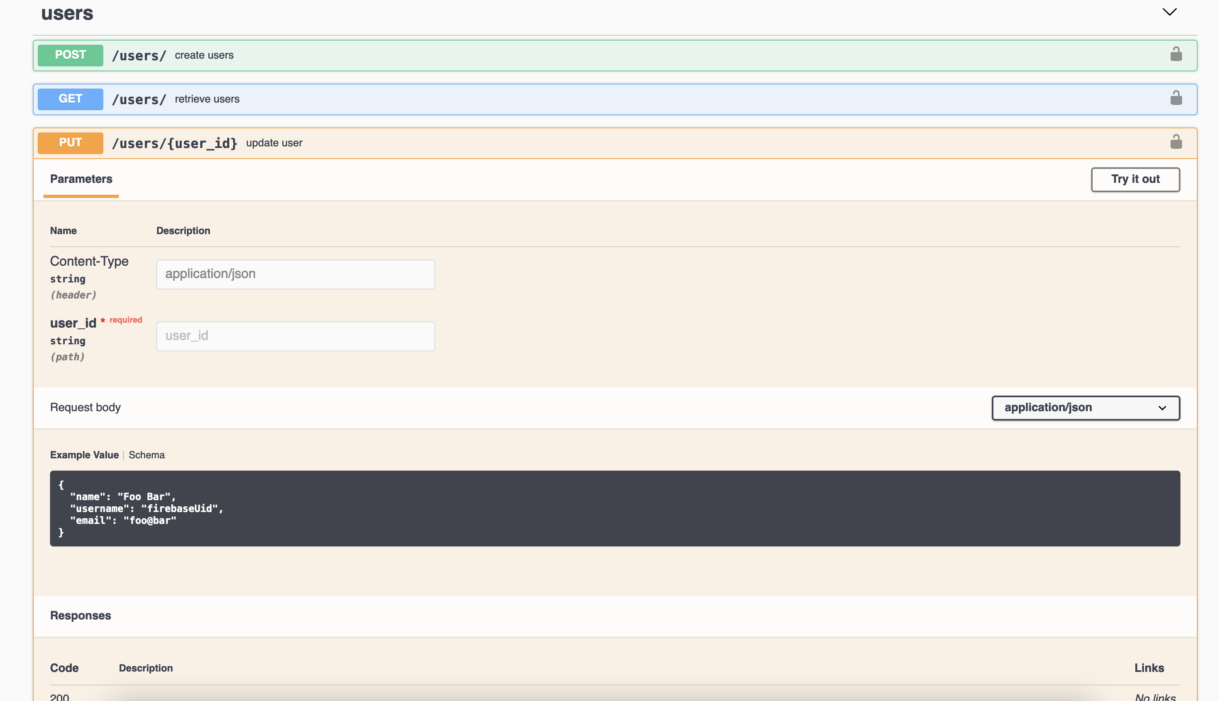
Figure 24

Differences from the specifications
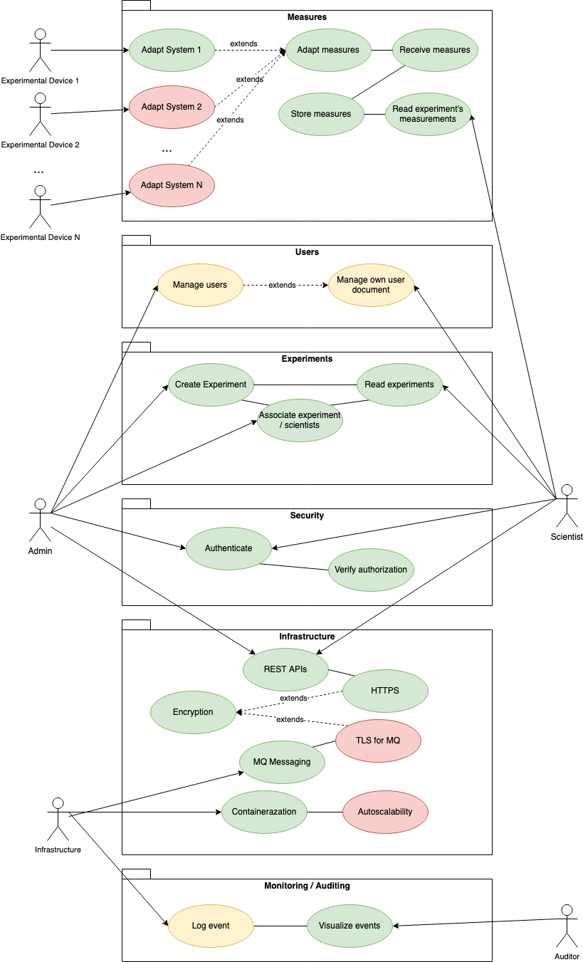
The following is an adaptation of the original use case diagram. It illustrates which use-cases were fully implemented (in green), partially implemented (in yellow), and omitted from the final deliverable.
Figure 25
- Adapters: only one adapter was developed as a proof of concept to demonstrate the functionality.
- User management: it is not currently possible to explicitly delete users. The deletion of the user was delayed because it cannot be a simple deletion. Part of the user’s record must be preserved for auditing, while all information non strictly required for auditing must be removed in compliance with GDPR. It is however possible to update the user achieving the same practical result, although the solution is not ideal. It is also observed that no information that allows the direct identification of a user is being logged, therefore auditing is not affected by the issue.
- RabbitMQ encryption: it was not implemented. It is therefore possible to intercept or manipulate measurements unless other technical solutions (eg. a VPN) are in place.
- Autoscalability: this requirement was ignored because Docker Compose does not support the functionality. It is however possible to run the application in Kubernetes and configure autoscale linked to CPU usage (Kubernetes – autoscale, N.D.).
- Log event: this requirement was implemented only partially.
  - App’s logs are transmitted to Logstash directly and are available in Kibana.
  - Nginx’s logs are transmitted to Logstash with Filebeat (Filebeat, N.A.) and are available in Kibana. Filebeat works as an adapter between Nginx’s logs and Logstash.
  - MySQL’s logs are available only locally through Docker. The implementation of the connection to the ELK stack suffered from a configuration issue that made it unstable. It was impossible to connect MySQL directly to Logstash. There was the attept to use Filebeat but the service could not start in the correct order inside the container requiring the manual intervention of an operator to establish a connection. Problems persisted also with manual intervention because the volume of logs caused stability issues in Elasticsearch.
  - RabbitMQ logs: they are available only locally through Docker. The implementation suffered from the same issues as for the MySQL’s logs.

List of attachments
- Firebase: credentials for the Firebase console. This attachment contains credentials and should be removed when the documentation is shared with third parties.
- Postman: postman collection with examples of the APIs usage.
- Reports: reports generated with ‘run-check.sh’
  - bandit.txt: report generate with bandit
  - cov: report generated with coverage
  - pylint.txt: report generated with pylint
- Swagger: description of the APIs

Repository
The project’s repository is available at https://github.com/ros101/ssdcs-assignment

References
- Aimar, A., Corman, A. A., Andrade, P., Fernandez, J. D., Bear, B. G., Karavakis, E., ... & Magnoni, L. (2019). MONIT: monitoring the CERN data centres and the WLCG infrastructure. In EPJ Web of Conferences (Vol. 214, p. 08031). EDP Sciences. Available from https://www.epj-conferences.org/articles/epjconf/pdf/2019/19/epjconf_chep2018_08031.pdf [Accessed 14/May/2022]
- Coverage.py (N.D.) Coverage.py. Available from https://coverage.readthedocs.io/en/6.3.3/ [Accessed 14/May/2022]
- Dependency Injector (N.D.) Dependency Injector — Dependency injection framework for Python. Available from https://python-dependency-injector.ets-labs.org/ [Accessed 14/May/2022]
- Docker Compose (N.D.) Overview of Docker Compose. Available from https://docs.docker.com/compose/ [Accessed 14/May/2022]
- Elastic (N.D.) Centralize, transform & stash your data. Available from https://www.elastic.co/logstash/ [Accessed 14/May/2022]
- Elasticsearch (N.D.) What is Elasticsearch? Available from https://www.elastic.co/what-is/elasticsearch [Accessed 14/May/2022]
- Elastic (N.D.) Set up a cluster for high availability. Available from https://www.elastic.co/guide/en/elasticsearch/reference/current/high-availability.html [Accessed 14/May/2022]
- Filebeat (N.D.) Lightweight shipper for logs. Available from https://www.elastic.co/beats/filebeat [Accessed 14/May/2022]
- Firebase (N.D.) Firebase. Available from https://firebase.google.com/ [Accessed on 14/May/2022]
- Firebase (N.D.) Add the Firebase Admin SDK to your server. Available from https://firebase.google.com/docs/admin/setup [Accessed 14/May/2022]
- Firebase (N.D.) Firebase Console. Available from https://console.firebase.google.com/project/coding-output/authentication/users [Accessed 14/May/2022]
- Flask (N.A.) Flask, web development one drop at a time. Available from https://flask.palletsprojects.com/en/2.1.x/ [Accessed 14/May/2022]
- Hartley J. (2021) Colorama. https://github.com/tartley/colorama [Accessed 14/May/2022]
- Kibana (N.D.) Your window into the Elastic Stack. Available from https://www.elastic.co/kibana/ [Accessed 14/May/2022]
- Kubernetes (N.D.) Secrets. Available from https://kubernetes.io/docs/concepts/configuration/secret/ [Accessed 14/May/2022]
- Kubernetes (N.D.) Horizontal Pod Autoscaling. Available from https://kubernetes.io/docs/tasks/run-application/horizontal-pod-autoscale/ [Accessed 14/May/2022]
- MySQL Connector (N.D.) MySQL Connector/Python Developer Guide. Available from https://dev.mysql.com/doc/connector-python/en/ [Accessed 14/May/2022]
- MySQL (N.D.) MySQL - The world's most popular open source database. Available from https://www.mysql.com/ [Accessed 14/May/2022]
- MySQL (N.D.) MySQL Cluster: Getting Started. Available from https://www.mysql.com/products/cluster/start.html [Accessed 14/May/2022]
- Nginx (N.D.) Nginx. Available from https://nginx.org/en/ [Accessed 14/May/2022]
- Nginx (N.D.) What Is Clustering? https://www.nginx.com/resources/glossary/clustering/ [Accessed 14/May/2022]
- Pika (N.D.) Introduction to Pika. Available from https://pika.readthedocs.io/en/stable/ [Accessed 14/May/2022]
- Pylint (N.D.) Pylint User Manual. Available from https://pylint.pycqa.org/en/latest/ [Accessed 14/May/2022]
- Python Code Quality Authority (2022) Bandit. Available from https://github.com/PyCQA/bandit [Accessed 14/May/2022]
- Python Mock (N.D.) unittest.mock — mock object library. Available from https://docs.python.org/3/library/unittest.mock.html [Accessed 14/May/2022]
- Postman (N.D.) Postman. Available from https://www.postman.com/ [Accessed 14/May/2022]
- RabbitMQ (N.D.) RabbitMQ. Available from https://www.rabbitmq.com/ [Accessed 14/May/2022]
- RabbitMQ (N.D.) Clustering Guide. Available from https://www.rabbitmq.com/clustering.html [Accessed 14/May/2022]
- Rossotto, A, Ahmed, B, Padukka, S, Thompson, V, Wimalendran, P (2022) MyMONIT - Collecting measurements to monitor CERN’s experiments.
- Schmitz, T., Rhodes, D., Austin, T.H., Knowles, K., Flanagan, C. (2016) Faceted Dynamic Information Flow via Control and Data Monads. In: Piessens F., Viganò L. (eds) Principles of Security and Trust. POST 2016. Lecture Notes in Computer Science, vol 9635. Springer, Berlin, Heidelberg.
- Swagger (N.D.) Swagger. Available from https://swagger.io/ [Accessed 14/May/2022]

