Zirui Cao
Cambridge OCR A Level Computer Science Non-Exam Assessment
BitFisher
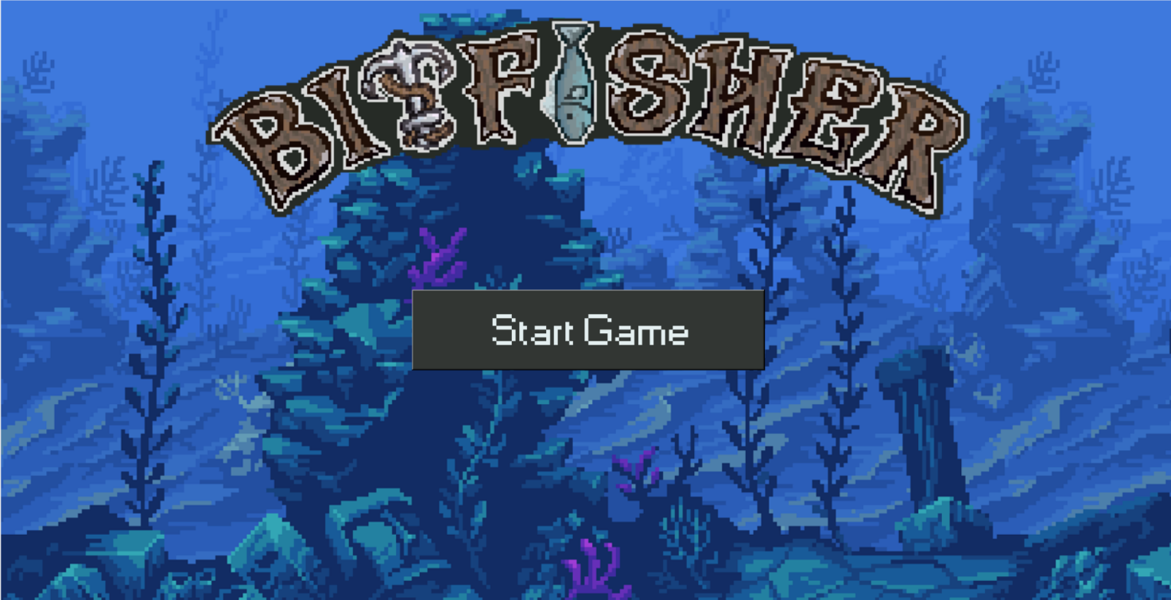
An adaptive Python fishing game using mathematical wave formulae to simulate fish motion

Table of Contents
Table of Contents 1
1. Analysis of the problem 5
1.1 Problem identification 5
1.1.1 Why is it suitable for a computational approach? 5
1.2 Stakeholders 7
1.2.1 Main stakeholders 7
1.2.2 Possible potential stakeholders: 7
1.3 Research 7
1.3.1 Market interview 7
1.3.2 Interview results 10
1.4 Existing solutions to review 15
1.4.1 Tiny fishing 15
1.4.2 Ultimate fishing simulator 18
1.5 Potential Limitations of my program 20
1.5.1 Hardware limitations 20
1.5.2 Software limitations 20
1.6 Core mechanism based on the market research 21
1.7 Success criteria 21
1.7.1 Wave motion criteria 21
1.7.2 Adaptability criteria 22
1.7.3 Feedback system criteria 22
1.7.4 Other Functionality criteria 23
1.7.5 Usability and Interface criteria 23
2. Design 25
2.1 Decomposition 25
2.1.1 Breaking it into components 25
2.1.2 Structure diagram 26
2.1.3 Rough plan of GUI 29
2.1.4 Overall program flowchart 31
2.2 The Solutions 33
2.2.1 Solutions using flowcharts 34
2.2.3 Solutions using external libraries 44
2.2.4 Solutions using Pseudocode 46
2.3 Data Table of Content 53
2.3.1 Table of Variables 53
2.3.2 Table of Functions 55
2.5 User interface design 56
2.5.1 Main window (main.py) 56
2.5.2 Fish 57
2.5.3 Fishing Bar 58
2.5.4 Green Bar 58
2.5.5 Progress Bar 59
2.5.6 Pause menu 59
2.5.7 Title Screen 60
2.6 Solution using Validation 61
2.7 Input output table 62
2.8 Stage plans 62
2.8.1 Stage 1: Layout and Display Setup 62
2.8.2 Stage 2: Green Bar Physics and Logic 62
2.8.3 Stage 3: Circular Progress Bar and Success Events 63
2.8.4 Stage 4: Fish Movement Patterns and Performance Scaling 63
2.8.5 Stage 5: File Handling and Modularization 63
2.8.6 Stage 6: Object-Oriented Fish Generation 63
2.8.7 Stage 7: Starting screen and Pause Menu 63
2.8.8 Stage 8: Fish Sprite and overall GUI tidy up 63
2.8.9 Stage 9: Reviewing and improving maintainability 63
2.9 Test plan 64
2.9.1 Testing method 64
2.9.2 Test Data 65
2.9.3 Test Design for Final Testing 65
3. Development 67
3.1 Stage 1 – Layout and Display Setup 67
3.1.1 Stage 1 Test Plan 68
3.1.2 Stage 1 Code Analysis 68
3.1.3 Stage 1 Validation 73
3.1.4 Stage 1 Final Testing 74
3.1.5 Stage 1 Final program run screen: 75
3.1.6 Stage 1 Final code: 76
3.2 Stage 2 – Green Bar Physics and Logic 78
3.2.1 Stage 2 Test Plan 78
3.2.2 Stage 2 Code Analysis 79
3.2.3 Stage 2 Validation 83
3.2.4 Stage 2 Final Testing 84
3.2.5 Stage 2 Final program run screen: 86
3.2.6 Stage 2 Final code: 87
3.3 Stage 3 – Circular Progress Bar and Success Events 90
3.3.1 Stage 3 Test Plan 90
3.3.2 Stage 3 Code analysis 91
3.3.3 Stage 3 Validation 94
3.3.4 Stage 3 Final Testing 95
3.3.5 Stage 3 Final program run screen: 98
3.3.6 Stage 3 Final code: 99
3.4 Stage 4 – Fish Movement Patterns and Performance Scalin 104
3.4.1 Stage 4 Test plan 104
3.4.2 Stage 4 Code analysis 105
3.4.3 Stage 4 Validation 108
3.4.4 Stage 4 Final testing 109
3.4.5 Stage 4 Failed tests analysis: 110
3.4.6 Stage 4 Final program run screen: 114
3.4.7 Stage 4 Final code: 114
3.5 Stage 5 – File Handling and Modularization 120
3.5.1 Stage 5 Test plan 120
3.5.2 Stage 5 Code analysis 121
3.5.3 Stage 5 Validation 123
3.5.4 Stage 5 Final testing 124
3.5.6 Stage 5 Final program run screen 126
3.5.7 Stage 5 Final code: 126
3.6 Stage 6 – Object-Oriented Fish Generation 132
3.6.1 Stage 6 Test plan 132
3.6.2 Stage 6 Code Analysis 134
3.6.3 Stage 6 Validation 142
3.6.4 Stage 6 Final Testing 143
3.6.5 Stage 6 Final program run screen 147
3.6.6 Stage 6 Final code 147
3.7 Stage 7 – Starting screen and Pause Menu 153
3.7.1 Sketch of the starting screen and pause menu for reference: 153
3.7.2 Stage 7 Test plan 154
3.7.3 Stage 7 Code Analysis 154
3.7.4 Stage 7 Validation 163
3.7.5 Stage 7 Final testing 164
3.7.6 Stage 7 Final program run screen 166
3.7.7 Stage 7 Final code 166
3.8 Stage 8 – Fish Sprite and overall GUI tidy up 175
3.8.1 Stage 8 Test plan 175
3.8.2 Fish Sprite design 176
3.8.3 Stage 8 Code Analysis 181
3.8.5 Stage 8 Final testing 189
3.8.6 Stage 8 Program run screen 191
3.8.7 Stage 8 Final code 192
3.9 Stage 9 – Reviewing and improving Maintainability 202
3.9.1 Plans for changes 202
3.9.2 Removing unnecessary code 202
3.9.3 Simplifying code to reduce steps 203
3.9.4 Organizing function blocks 204
3.9.5 Adding annotations 205
3.9.6 Conclusion: 207
3.10 Stakeholder’s Review 208
3.10.1 The questions 208
3.10.2 The responses 208
3.10.3 Conclusion drawn from the interview: 209
3.10.4 Extra modules to implement 210
3.11 Design - Extra modules based on stakeholder input 211
3.11.1 Performance chart 211
3.11.2 Clear saved data 212
3.11.3 Display names and rarity of fish 213
3.11.4 Separate count for each fish type 214
3.12 Stage 10 – Feedback Performance Graph & In game fish category 215
3.12.1 Stage 10 Test plan 215
3.12.2 Rough plan of fish type display 216
3.12.3 Stage 10 Code Analysis 216
3.12.4 Stage 10 Validation 226
3.12.5 Stage 10 Final testing 227
3.12.6 Stage 10 Final program run screen 228
3.13 Final Testing 229
3.13.1 Additional testing due to added Stage 10: 233
3.13.2 Failed test 234
4. Evaluation 235
4.1 Post-development testing 235
4.1.1 Stakeholder testing 235
4.1.2 Stakeholder interview results 235
4.1.2 Robustness testing 238
4.1.3 Hardware testing 240
4.2 Evaluation of success criteria reached/ not reached 241
4.2.1 Wave motion criteria 241
4.2.2 Adaptability criteria 241
4.2.3 Feedback system criteria 241
4.2.4 Other Functionality criteria 242
4.2.5 Usability and Interface criteria 242
4.3 Discussion of Success Criteria 243
4.3.1 Wave function criteria 243
4.3.2 Adaptability criteria 244
4.3.3 Feedback system criteria 245
4.4.4 Functionality criteria 246
4.4.5 Usability criteria 249
4.4 Potential limitations of the program 251
4.5 Maintenance and sustainability discussion 252
4.5.1 Maintenance for Player Experience 252
4.5.2 Maintenance for Other Programmers 252
4.6 Possible future development 253
4.7 Skills I have gained through this project 253
5. References: 254
5.1 Code and GUI Development 254
5.2 Imaging and Media 255
5.3 User Interface and Asset Design 255
5.4 Game Inspiration and Reference 255
5.5 Video Resources 255
6. Final Code 256
‘Main.py’ 256
‘Starting_Screen.py’ 267

Analysis of the problem

1.1 Problem identification

Currently, there are many fishing simulator games available on the market that involve the player hooking and catching fish primarily based on reaction time, such as Fishing Planet. However,fewer fishing simulation games focus exclusively on modelling fish movement using wave functions while also providing real-time adaptive feedback based on the player’s reaction time and accuracy. In most existing games, difficulty or gameplay behaviour only changes if the user manually adjusts settings; these adjustments are not made automatically in response to player performance. As a result, many players may disengage, as the game can become either too difficult to play or too easy to remain engaging. I proposed a solution which addresses this limitation by adapting gameplay based on the player’s skill level, ensuring that the level of challenge remains engaging throughout the game.

Additionally, games developed using the Tkinter framework are relatively uncommon. However, this framework enables the game to run directly on any device with Python installed, without requiring intermediary platforms such as HTML or web browsers. This increases accessibility and ease of deployment.

1.1.1 Why is it suitable for a computational approach?
In the proposed game, fish movement is determined by mathematical wave equations, which a computer can calculate efficiently. The game updates in short intervals to produce smooth motion, and actions such as catching fish are tracked using variables. Random elements, including the type of fish that appears, are controlled algorithmically through weighted pseudorandom selection. The game also maintains and updates state information, such as progress, score, and difficulty, in memory to support reliable real-time interaction. All these features benefit greatly from a computational approach.

1.1.1.a Decomposition
Decomposition refers to the process of breaking a large, complex problem down into smaller, self-contained subproblems that can be solved independently. The problem could be easily broken down into smaller, components such as fish movement, player input handling, collision checking between the fish and the bar, progress tracking, difficulty adjustment and data storage. Each component can be designed and tested independently, making the overall system easier to develop and debug.

1.1.1.b Divide and conquer
Divide and conquer is a follow on to decomposition, where once the problem has been broken down into individual parts and solved, they are then combined together to form the final solution. Each sub-problem in the fishing game is solved separately using appropriate algorithms. For example, calculating wave-based fish movement independently from user input, and handling difficulty scaling separately from rendering. These solutions are then combined to produce the full fishing simulation.

1.1.1.c Abstraction
Abstraction involves removing unnecessary detail and focusing only on the essential features needed to solve a problem. In this game, complex behaviours such as fish movement and difficulty adaptation are represented using simplified models like wave functions and numeric difficulty values. This allows the system to focus on core behaviours such as position, speed, and responsiveness without unnecessary detail, making the logic clearer and easier to modify.

1.1.1.d Heuristic approach
Heuristics are methods of closest approach that produce approximate solutions when exact solutions would be too slow or resource intensive. The game uses heuristics to estimate the player’s skill level based on performance, such as how quickly fish are caught or how often they escape. Although the result may not perfectly match the player’s true skill level, it still provides an adaptive challenge without requiring exhaustive calculations.

1.1.1.e Performance modelling
Performance modelling uses mathematical models and measured variables to predict how a system or user will perform under different conditions. In this system, player performance is measured using variables such as reaction time, catch success rate, and time taken to fill the progress bar. These metrics are processed to model player skill level and adjust difficulty, ensuring the game remains challenging but achievable without needing extensive real-world testing.

1.1.1.f Visualisation
Visualisation is the representation of data in a graphical or visual form to make patterns, states, and changes easier to understand. In the game, abstract data such as fish position, player input, and progress are represented visually through moving icons, bars, and meters. This visual feedback allows the player to understand the system’s state in real time and respond accordingly, making the computational processes intuitive to interact with.

1.2 Stakeholders

1.2.1 Main stakeholders
The game is aimed at children and young adults who want fun and a bit of a challenge, as this age group usually has fast reaction times and enjoys skill-based competition, but it will be easy to pick up so adults and older players can enjoy it too.

Casual players are the main audience, and they will use the game to relax, pass the time, or play with friends. I choose to focus on a younger demographic since they are more likely to enjoy gameplay that is simple but engaging and allows for short sessions that fit easily into their day. I plan on focusing on two different age groups (12–16) and (16–22), as these represent teenagers and late adolescents who are likely to be potential users of the game. Group one (younger players) can use it to improve their reaction times and hand-eye coordination, while group two (older players) can enjoy it as a low-pressure way to unwind. Similar existing games like Snake.io, Minesweeper and Tetris show that there is a large market for games with simple and skill-based control, therefore the game should also see popularity.

Another way the game could be used is in education, where it could be adapted to include real species of fish, showing their habitats, water temperatures, and appearances, so children could learn about ecosystems while playing. In this case, teachers and schools could become important stakeholders, as the game would teach kids about biology while also helping them practice reaction times and hand-eye coordination in a fun and playful way.

1.2.2 Possible potential stakeholders:
In the future, the game could expand its target audience to include the senior market, as it is simple to play and does not require complex knowledge. This is similar to popular casual games such as Candy Crush or Block Blast, which appeal to a wide age range due to their simplicity and accessibility. Alternatively, the game could introduce features such as fish customisation or cosmetics around the asset interface to allow for creativity and diversity. These additions could be implemented in future updates to encourage greater user engagement and participation.

1.3 Research

1.3.1 Market interview
To clearly define the requirements of the proposed game, I plan to conduct interviews with a range of stakeholders. This will include casual gamers from two different age groups (12–16) and 16–22), as these represent teenagers and late adolescents who are likely to be potential users of the game. In addition to gamers, I will also interview tutors who do not regularly play video games to gather their opinions on whether they would be willing to engage with a similar game and what factors might encourage or discourage them from introducing it to their class.

Each stakeholder group will be asked a core set of standardised questions to ensure consistency and meaningful comparison of responses. Additionally, tailored questions will also be included where appropriate to gather more detailed and relevant feedback. During the interview, follow-up questions may be asked where necessary to allow participants to elaborate on their responses and to clarify any points made.

1.3.1.a Plan of interview questions

1.3.1.b General questions
- What makes an activity engaging or enjoyable for you?
This question looks at what keeps participants interested and motivated. It helps identify what elements should be included in the game to make it engaging.
- When completing a task, which type of feedback do you find most useful (e.g., visual, audio, etc.)?
This asks how participants prefer to receive feedback. The answers will help design the game so that players understand what they are doing and can improve their performance.
- How do you respond when a task is too easy or too difficult?
This question looks at how participants respond to challenges. It helps determine how the game should adjust its difficulty to keep players engaged without causing frustration or boredom. Some players may enjoy a game that is slightly more challenging than they can easily handle, while others may stop playing if it becomes too difficult. Understanding this helps me find the right balance between these preferences.
- Would you prefer an activity that adjusts difficulty automatically based on your performance, or one where you set the difficulty yourself?
This question checks whether participants prefer automatic difficulty or manual control. Some players enjoy a game that adapts to their skill without their input, while others like to set the challenge themselves. Understanding this helps design the game to suit different player preferences.

1.3.1.c Specialised questions for gamers
- How often do you play video games each week, and for how long per session?
This helps understand the participant’s gaming habits. Frequent players may expect more complex or challenging gameplay than casual players.
- Have you played any fishing or simulation games before? If so, which ones and how did you find them?
This identifies previous experience with the genre and what features players enjoyed or disliked, which can help improve the new game.
- What do you value the most in a game? (gameplay, visuals, mechanics etc.)
This question explores which aspects of a game are most important to the participant. Understanding their priorities, such as whether they focus on gameplay, graphics, or game mechanics, helps guide the design to ensure the game meets the expectations and preferences of the target audience.
- Do you prefer games that include competitive elements, such as comparing your performance with friends?
This looks at whether players like social or competitive elements, which can guide features like leaderboards or the scoring options.

1.3.1.d Specialised questions for tutors
- Would you consider using a game like this as part of a classroom activity? Why or why not?
This question investigates whether the game could be realistically used in an educational setting. It helps identify potential benefits or limitations of including the game as part of a lesson.
- What factors would make you confident that your students would engage with the game?
This explores what features are necessary to capture students’ attention. Understanding these factors ensures the game is engaging and accessible to a classroom audience.
- Would you prefer a game that adapts automatically to each student’s skill level, or one where the teacher controls the difficulty settings?
This question asks for preferences for adaptive difficulty in an educational context. It helps determine whether the game should personalise challenges for each student or allow the teacher to manage difficulty to match classroom needs.

1.3.2 Interview results

  - Emily (age 21 – casual gamer)

- What makes an activity engaging or enjoyable for you?
“I enjoy activities that feel rewarding but not stressful, especially the ones with a main objective or goal to achieve. I love that feeling of accomplishment. Currently, I’m learning to play chess, and I have been enjoying it so far.”
- When completing a task, which type of feedback do you find the most useful?
“I feel like visual feedback helps me the most, like a progress meter or some graphic or animations that show I’ve done something right. I enjoy when there is immediate feedback to my actions. Audio feedback is nice too, but visuals are more important for me.”
- How do you respond when a task is too easy or too difficult?
“If it’s too easy, I’d get bored quite quickly. If it’s too hard, I’ll try for a bit but eventually stop if it doesn’t improve.”
- Would you prefer automatic or manual difficulty adjustment?
“I prefer automatic difficulty because I don’t want to keep changing settings. It feels better when the game adapts without me having to think about it; it gives a more immersive experience.”
- How often do you play video games each week?
“I play a few times a week, usually for about an hour at a time. It’s mostly casual games rather than competitive ones. My favourite game at this moment has been The Legend of Zelda. I love the freedom it gives me.”
- Have you played fishing or simulation games before?
“I’ve played quite a few simulation-style games, such as The Sims 4 and Animal Crossing, but not many fishing games. I liked the relaxing pace, but some of them felt repetitive and not very engaging.”
- What do you value most in a game?
“Gameplay is the most important thing for me. Graphics are nice, but if the game feels smooth and fun, that matters more.”
- Do you like competitive elements in games?
“I don’t really care about competing with others. I prefer focusing on my own progress. I feel like if player vs player was added, it ruins the fun of some games, since people start only to do what is ‘optimum’.”
Conclusion:
The interviewee enjoys games that are rewarding without being stressful, with clear goals and a strong sense of progression. They prefer immediate visual feedback, such as progress bars or animations, and quickly lose interest if a task is either too easy or too difficult. Casual, non-competitive games with smooth gameplay appeal to them most. They value personal progress and immersive experiences over graphics or player-versus-player competition.

  - Elena (age 17 – Frequent Gamer)

- What makes an activity engaging or enjoyable for you?
“I think an activity attracts me when it is easy to understand but also has an element of challenge to it. I liked the sense of accomplishment.”
- When completing a task, which type of feedback do you find the most useful?
“I like seeing the impact my progress has in relation to the total possible progress. As this shows where I am as well as gives me immediate feedback. I like it when the feedback comes with an audio cue, since sometimes it is easy to miss out visual cues.”
- How do you respond when a task is too easy or too difficult?
“When it is too easy, I become disengaged really quickly. But when it is too difficult, I get rage baited. Overall I would prefer a task with an element of challenge, as I would rather be challenged than not feel any sense of accomplishment.”
- Would you prefer automatic or manual difficulty adjustment?
“I prefer it to be automatically changed as it is way more convenient. But I would love to still have the manual adjustment as an option if I were to not enjoy the automatic decision.”
- How often do you play video games each week?
“I play video games two to three times a week, each session about two to three hours. I like relaxing games and sandbox games, for example, Minecraft. As well as relaxing mobile games such as Tom Gold Run.”
- Have you played fishing or simulation games before?
“I have played fishing games, such as Tiny Fishing, an online fishing simulator. I found it very fun at first, but afterwards it was difficult to save my progress as there is no way of tracking my account, so I stopped playing.”
- What do you value most in a game?
“For me, the most important aspect is the cleanliness of the gameplay. I am able to enjoy a wide range of games but if its not smooth to play, then I would not enjoy it as much.”
- Do you like competitive elements in games?
“No, because I never win. The game becomes irrelevant when I see others who are much better than me and I know I will never be able to beat them. ”

Conclusion:
This interviewee enjoys activities that are easy to understand but still challenging, valuing the sense of accomplishment. They prefer progress-based feedback that shows their position relative to the overall goal, supported by audio cues to avoid missing visual feedback. They disengage quickly if tasks are too easy and become frustrated if too difficult, preferring automatic difficulty with optional manual control. They enjoy relaxing and sandbox-style games, value smooth and clean gameplay, dislike competitive elements, and stopped playing fishing games previously due to poor progress tracking.

  - Alex (age 14 – Competitive Gamer)

- What makes an activity engaging or enjoyable for you?
“I like activities when I get a lot of positive feedback. It makes me feel good about myself. For example, I love it when I know I am good at an activity; it gives me an ego boost.”
- When completing a task, which type of feedback do you find the most useful?
“I like verbal feedbacks especially when it writes paragraphs to complement my personal achievements, but it also needs to be backed with some nice graphic designs that are good to look at.”
- How do you respond when a task is too easy or too difficult?
“When a task is too difficult, it makes me doubt my abilities and intelligence, which makes me want to rage quit. When it’s too easy, I feel like it is underestimating my abilities, and I deserve better. I feel like my skills are not being recognised enough.”
- Would you prefer automatic or manual difficulty adjustment?
“Definitely manual difficulty adjustment. Because when it adjusts the difficulty without my permission, I feel like my authority over the game is being undermined.”
- How often do you play video games each week?
“I play at least three hours of video games a day. I enjoy play first person shooting games such as Fortnite and Valorant, but I also enjoy JRPG for the good characters and their immersive experience provided with charismatic characters.”
- Have you played fishing or simulation games before?
“I don’t think I’ve played these games before. Even if I did, they would not leave a lasting impression on me as I find this genre of games too underwhelming and not engaging enough”
- What do you value most in a game?
“What intrigues me to play a game will definitely the characters are designed, as I enjoy the stunning graphics. But what makes me play a game for longer is the positive feedback I gain from it”
- Do you like competitive elements in games?
“Yes, but only when I'm winning.”

Conclusion:
This interviewee is motivated by strong positive feedback and enjoys feeling recognised for their skills. They value detailed verbal feedback supported by appealing graphics and become frustrated when tasks are either too difficult or too easy, as both feel dismissive of their abilities. They strongly prefer manual difficulty adjustment to maintain control and enjoy competitive games, but only when they are performing well.

  - Sophie (age 16 – Infrequent gamer)

- What makes an activity engaging or enjoyable for you?
“I like activities that are easy to understand and not confusing. If I can learn it quickly, I enjoy it more.”
- When completing a task, which type of feedback do you find the most useful?
“I like clear visual feedback, like colours changing or messages telling me what I did. It helps me know if I’m doing it right.”
- How do you respond when a task is too easy or too difficult?
“If it’s too hard, I usually stop because it feels frustrating. I like when things start easy and slowly get harder.”
- Would you prefer automatic or manual difficulty adjustment?
“I prefer automatic difficulty because I wouldn’t know what to change. It makes it less stressful.”
- How often do you play video games each week?
“I don’t play games very often, maybe once a week. When I do, it’s usually simple games.”
- Have you played fishing or simulation games before?
“No, I haven’t played fishing games before. But I think I would try it if it were simple and relaxing. The concept sounds quite appealing.”
- What do you value most in a game?
“I care most about it being easy and fun. I don’t really mind how it looks.”
- Do you like competitive elements in games?
“Not really, I prefer playing on my own. Competing makes me nervous.”

Conclusion:
This interviewee prefers simple, easy-to-learn activities with clear visual feedback such as colour changes or on-screen messages. They become frustrated by high difficulty and prefer gradual progression supported by automatic difficulty adjustment. They play games infrequently, enjoys simple and relaxing experiences which are prioritised over graphics and dislike competition.

  - Sarah (age 42 – Mathematics Tutor)

- What makes an activity engaging or enjoyable for you/your students?
“I enjoy activities that are clear, structured, and rewarding. I find that if students can see progress and feel successful, it keeps them motivated.”
- When completing a task, which type of feedback do you find the most useful?
“I find visual feedback very helpful, like progress indicators or highlights. Audio cues can be useful too, but clear visuals are essential.”
- How do you respond when a task is too easy or too difficult?
“If a task is too easy, I notice that attention and focus drop quickly. If it’s too difficult, I like to break it down or adjust the approach so it’s achievable.”
- Would you prefer automatic or manual difficulty adjustment?
“I think automatic adjustment is better in a classroom context. It allows each student to work at their own pace without needing constant intervention.”
- Would you consider using a game like this as part of a classroom activity?
“Yes, if it is simple to set up and clearly linked to learning goals. It could be a fun way to engage students.”
- What factors would make you confident that your students would engage with the game?
“Clear instructions, instant feedback, and a hint of competitiveness among students would be important. It should feel achievable and rewarding, quickly.”
- Would you prefer a game that adapts automatically to each student’s skill level, or one where the teacher controls the difficulty settings?
“Automatic adjustment is preferable because it allows students to progress individually. Teacher control could be used occasionally but would be too time-consuming for every session.”
Conclusion:

This interviewee values clear, structured, and rewarding activities, particularly in learning contexts, and believes visible progress helps maintain motivation. Visual feedback such as progress indicators is considered essential, while tasks that are too easy or too difficult reduce focus and engagement. Automatic difficulty adjustment is preferred to allow individuals to progress at their own pace, and the game would need to be easy to set up, clearly goal-oriented, and engaging to be used in a structured environment.

1.3.2.a Analysis of the results
Across all interviews, several common themes emerged: players value clear goals, visible progression, and meaningful feedback, with visual feedback being the most important and audio cues acting as a useful supplement. Engagement drops quickly when tasks are either too easy or too difficult, highlighting the need for well-balanced challenge through adaptive difficulty. Most participants preferred automatic difficulty adjustment to reduce stress and maintain immersion, though some valued having manual control as an option. Competitive elements were generally less important and, when included, should be optional and low-pressure.

To incorporate these findings, the fishing game simulation should focus on:

Reference | Features
S1 | Clear, simple and well-structured user interface with smoothly running graphics
S2 | Relaxed, low competition game play
S3 | Simple and intuitive controls (keyboard/or touchscreen) with clear instructions
S4 | High accessibility across multiple platforms
S5 | Clear progression system with rewarding feedback such as animations, progress meters and positive messages
S6 | Balanced level of challenges, including offering both adaptive difficulty and optional manual controls

1.4 Existing solutions to review

1.4.1 Tiny fishing
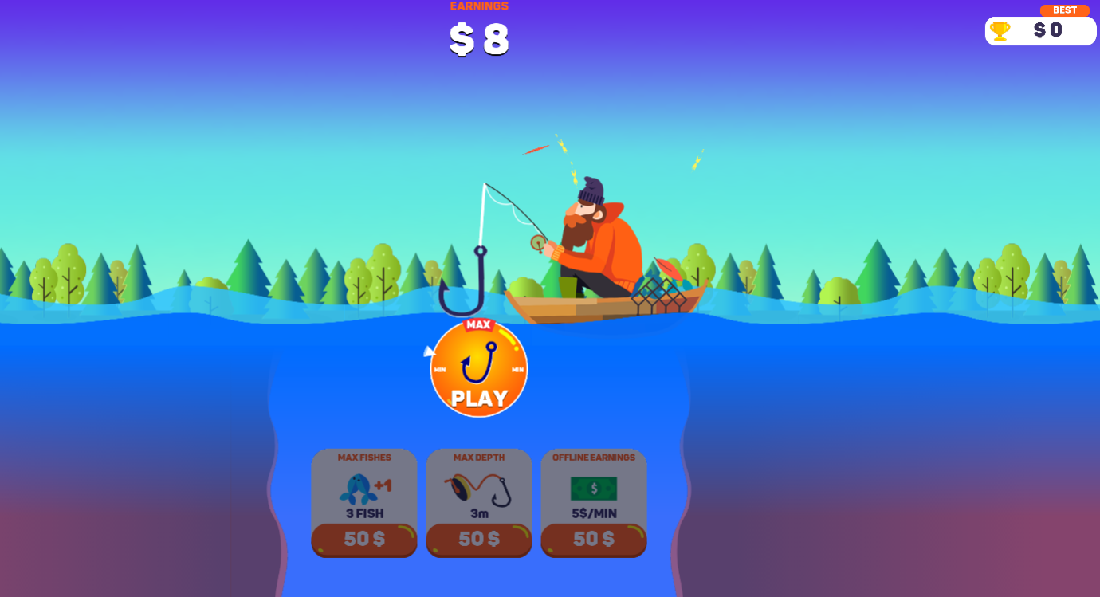
(main menu)

Tiny Fishing is a web game where players cast a fishing line into the water to catch fish and earn coins. The core mechanic requires the player to drop a hook into the water, control its movement using the mouse to find different types of fish, and then reel them in. The deeper the cast go, the rarer and more valuable the fish become. Coins earned from catches can be spent on upgrades like longer lines, stronger hooks, or better fishing gear, which allows the player to reach even deeper waters.

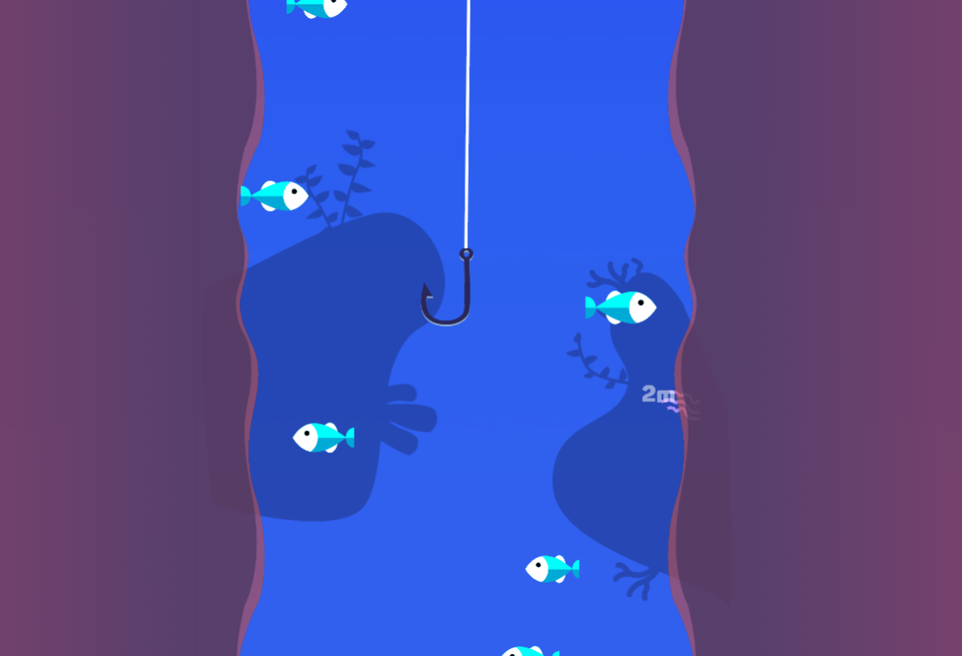
(game play)

Pros | Cons
- The game uses a simple fishing concept, making it easy for users to understand without extensive instructions. | - The game cannot be played without an internet connection, limiting accessibility in offline environments.
- Simple controls (mouse or touchscreen) result in a low learning curve and make the game suitable for new or casual players. | - A compatible web browser is required, which may restrict use on some devices or older systems.
- Accessible across multiple platforms (PC, tablet, and mobile) without the need for specialised or expensive hardware. | - Player data and progress may be lost, as the game does not require user accounts or persistent data storage.
- As a web-based game, it does not require downloading or installation, allowing instant access for players. | - Privacy concerns may arise, as web games often rely on cookies or browser storage to function properly.
- Easy distribution, as the game can be accessed by anyone with a link or through a simple web search. | - Progression may become repetitive over time, which might reduce long-term player engagement.
- Updates, bug fixes, and maintenance can be deployed quickly by modifying the web page, without requiring user action. | - Performance may vary depending on browser efficiency, device capability, or network speed.
- Low development and deployment costs compared to native or console games. | - Limited graphics and processing power compared to native applications or downloadable games.
- Suitable for short play sessions, making it ideal for casual gaming. Since it takes little time to start the game. | - Lack of clearly defined system requirements may lead to inconsistent user experiences.

1.4.1.a Elements to Be Incorporated
Based on the research into Tiny Fishing, the following elements will be incorporated into the project:

Reference | Feature
M1 | A simple and well-structured user interface  This will ensure users can navigate the game easily and without confusion, improving the overall user experience and accessibility.
M2 | A low-competition, relaxed style of gameplay that promotes enjoyment rather than pressure.  This approach makes the game more appealing to casual players who prefer entertainment and stress-free gameplay over intense competition.
M3 | Simple and intuitive controls using a keyboard and/or touchscreen, ensuring ease of use.  Straightforward controls reduce the learning curve and allow players of varying skill levels to engage with the game comfortably.
M4 | A clear progression system, such as unlocking equipment or new fish species.  This provides players with motivation to continue playing and creates a sense of achievement over time.

1.4.1.b Elements to Avoid
- Repetitive gameplay
Repetition can cause players to lose interest quickly, meaning that they are less likely to play for long terms.
- Gameplay that is overly simplistic and does not provide enough challenge for the player.
A lack of challenge may make the game feel uninteresting and reduce replay value.
- Failure to save player data or progress
Losing progress may frustrate users and create a negative impression on the game, discouraging them from returning to the game.
- Technical issues such as crashes
Frequent crashes disrupt gameplay. This can damage the game’s credibility and significantly reduce user satisfaction.
- Poor optimisation or slow performance.
Performance issues can negatively impact gameplay smoothness, particularly on lower-end devices.

1.4.2 Ultimate fishing simulator
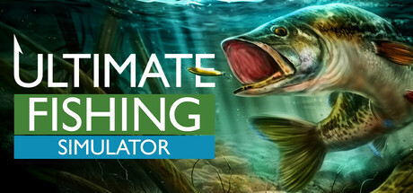
(title page)
Ultimate Fishing Simulator is a PC game where players simulate real-world fishing across a variety of locations and conditions. The core mechanic requires the player to select appropriate gear and bait, cast a line, and wait for fish to bite. Players must then use timing and control to reel in the fish, taking into account factors such as fish species and weather conditions. The game includes multiple fishing techniques. Caught fish can be measured, displayed, sold, or released, and progression is achieved through acquiring better equipment and exploring new fishing areas.

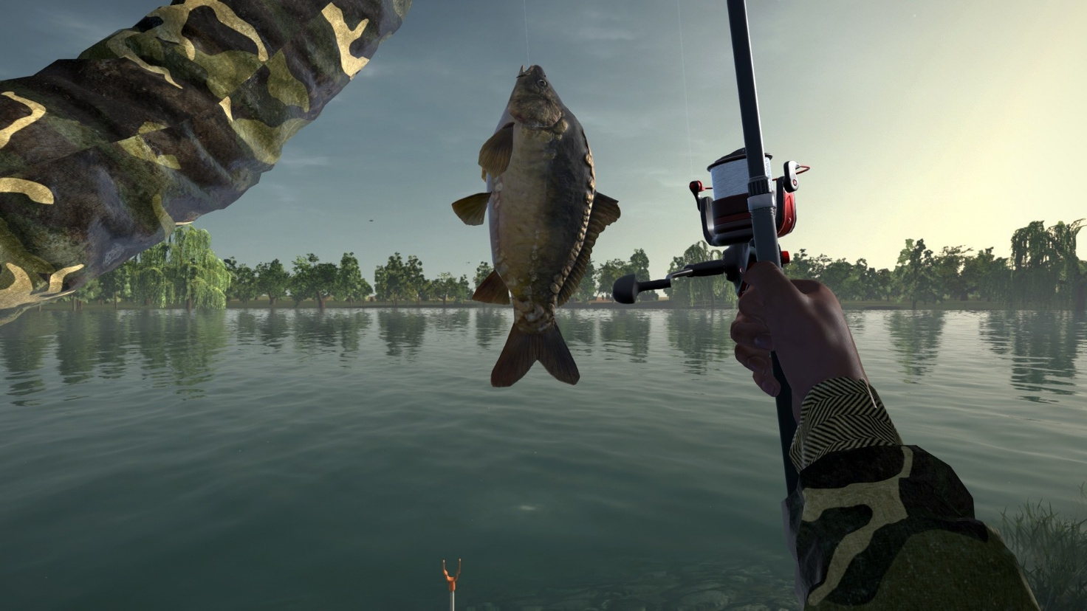
(gameplay)

Pros | Cons
The game offers a realistic fishing simulation, closely reflecting real-world fishing techniques and conditions. | The complexity of mechanics and controls may be overwhelming for new or casual players.
A wide range of fishing methods (float, spinning, bottom, and ice fishing) provides new experiences and depth to gameplay. | Requires a relatively powerful PC, limiting accessibility for users with lower-end hardware.
Multiple locations, fish species, and environmental factors (such as weather and water depth) to avoid repetitive gameplay. | The game must be downloaded and installed, which requires storage space and longer setup time.
Progression through unlocking equipment and locations gives players a strong sense of achievement. | Gameplay pace can be slow, which may not appeal to players seeking fast or action-oriented games.
Detailed equipment selection encourages strategic thinking and planning. | High realism may reduce accessibility for players unfamiliar with fishing concepts.
Offline play is possible once installed, allowing uninterrupted gameplay. | Updates and bug fixes require manual downloads, unlike web-based games.
High-quality graphics and sound design improve realism and immersion. | Longer play sessions are often required, making it less suitable for quick or casual gameplay.
Appeals strongly to fishing enthusiasts looking for an authentic experience. | Less suitable for younger players or those seeking a relaxed, arcade-style experience.

1.4.2.a Elements to Be Incorporated
Based on research into Ultimate Fishing Simulator, the following elements could be incorporated into the project:

Reference | Feature
M5 | A clear sense of progression through positive feedback.  Providing rewards, achievements, or visual feedback will motivate players to continue playing and create a sense of accomplishment.
M6 | Gameplay mechanics that reward skill, and strategic decision-making.  Incorporating these elements will make the game more engaging and satisfying, as success will depend on player ability rather than chance alone.
M7 | Increased variety in gameplay through different fishing techniques and conditions.  Introducing varied mechanics and environments will prevent repetition and maintain long-term player interest.
M8 | Realistic environmental factors, such as weather or fish behaviour patterns.  Including these features can enhance immersion while adding depth to the gameplay experience.

1.4.2.b Elements to Avoid
- Overly complex mechanics that may discourage inexperienced or casual players.
Excessive complexity could make the game intimidating and reduce its accessibility to a wider audience.
- Steep learning curves without sufficient guidance or tutorials.
Without clear instructions or a gradual introduction of features, players may become frustrated and stop playing.
- Long periods of inactivity may cause players to lose interest.
Extended waiting times without interaction can reduce engagement and make the gameplay feel slow.
- Excessive hardware requirements reduce accessibility for a wider audience.
High system demands would limit the number of potential players able to run the game smoothly.
- Overemphasis on realism at the expense of enjoyment.
While realism can improve immersion, prioritising it too heavily may make the game less fun and approachable.

1.5 Potential Limitations of my program

1.5.1 Hardware limitations
- My program must run on lower-end devices, which limits visual effects, realism, and smoothness, reducing immersion. This is a limitation because not all players have high-performance devices, so I need to ensure the game is playable on a wide range of hardware.
- Differences between devices may cause inconsistent performance or minor glitches, affecting accessibility and the overall experience. This exists because hardware, screen size, and browser performance vary, making it difficult to guarantee the same smooth experience for every player.

1.5.2 Software limitations
- Due to my limited development time and experience, my program may not include advanced features like complex fish behaviour, varied environments, or high-quality graphics. These are limitations because implementing them requires more coding skill and testing than I can achieve within the project scope.
- The core gameplay loop of cast, catch, and upgrade may become repetitive, as I have limited time to add variety and depth. This could lower long-term player engagement.
- Player progress in my program may be stored locally, risking data loss, and cross-device saving or secure online accounts are beyond my current scope. This limits convenience and continuity for players who want to play on multiple devices.
- Limited testing may result in difficulty balance issues, making the game feel too easy or too hard for some players. This is a limitation because I cannot fully predict all player reactions or skill levels within the time available, and I do not have the resources to run beta testing of the program in order to make balancing changes.

1.6 Core mechanism based on the market research
After assessing the stakeholder requirements and the current market, I concluded a few core points to help the program stand out from the others:
- The main focus of this project will be the use of random variables to create unique wave-based motion. The program will generate waves using random integers, producing a wide range of movements and shapes. This ensures each fish appears different and prevents repeated patterns. This randomness is crucial to the design and is intended to keep the experience varied and fresh.
- Another main focus will be user adaptivity. The program will adjust automatically based on the user's performance and change difficulty during use. This auto-adaptive behaviour will tailor the overall experience for each user and aims to keep the program suitable for different skill levels. The system will monitor performance and respond to maintain engagement.
- Feedback systems will also support these core ideas. The program will include strong visual feedback, such as a progress meter, appearance changes, and a counter. These features will show performance and reinforce improvement to the player.

1.7 Success criteria
Other than the points listed above, I also evaluated success criteria to determine whether the program meets the required specifications. These criteria are grouped into core mechanics, extra functionality, and usability aspects of the GUI. This structure ensures all parts of the program are covered and that a wide range of goals are assessed to aid the development of the program. The criteria were based on market research, including stakeholder feedback and analysis of existing solutions, to ensure they meet expected standards.

(S1 refers to element 1 of 1.3.2.a Analysis of the results and M1 refers to element 1 of the 1.4.1.a Elements to Be Incorporated)

1.7.1 Wave motion criteria
No | Criteria | How to evidence | Link to research
W1 | Fish movement uses a wave function | Code snippet showing sine or cosine function and gameplay clip | S1 / M6
W2 | Movement is smooth and continuous | Video showing consistent motion without stuttering | S1 / M1
W3 | Wave variables control movement (amplitude or frequency) | Code showing variables and gameplay showing change in movement | M6
W4 | Different fish show varied wave patterns | Video showing multiple movement styles | M6 / M7
W5 | Movement updates in real time during gameplay | Screen recording showing continuous motion | S1 / M4

1.7.2 Adaptability criteria
No | Criteria | How to evidence | Link to research
A1 | Game increases difficulty after well performed fish catch | Code snippet showing difficulty value increasing after catch and video showing faster fish or reduced catch window | S6 / M6
A2 | Game decreases difficulty after badly performed catches | Code showing failure tracking and reduced difficulty plus test recording | S6 / M2
A3 | Difficulty scaling is gradual and controlled | Table or graph of difficulty values over time and gameplay clip showing smooth change | S6 / M6
A4 | Player performance affects difficulty adjustment | Code showing use of success rate or reaction time and gameplay evidence | S5 / M4 / M6
A5 | Gameplay visibly reflects difficulty changes | Video or screenshots showing fish speed or behaviour changes after catches | S5 / M5
A6 | Difficulty stays within defined limits | Code showing min and max difficulty values and test results | S6 / M6
A7 | Fish behaviour changes as difficulty increases | Gameplay recording showing more complex movement patterns after progression | M6 / M7
A8 | Difficulty updates in real time after each catch | Screen recording showing continuous adjustment without restarting | S5 / M4

1.7.3 Feedback system criteria
No | Criteria | How to evidence | Link to research
Fe1 | Game provides visual feedback after successful or failed catch | Video showing UI changes such as colour shift, icon change, or animation after action | S5 / M5
Fe2 | Game includes a progress or score counter that updates in real time | Screen recording showing score or progress value changing during gameplay | S5 / M4
Fe3 | Game includes a visual indicator for the current difficulty level | Screen recording showing how fish movement corresponds to displayed difficulty | S5 / M4
Fe4 | Feedback appears immediately after player action | Video showing no delay between action and feedback response | S5 / M5

1.7.4 Other Functionality criteria
No | Criteria | How to evidence | Link to research
Fu1 | Additional option to set difficulty manually | Screenshot of settings menu and testing showing changes in gameplay | S6
Fu2 | Game assets are being updated to create smooth animation | Screen recording of the window running with all assets moving correctly and smoothly | S1
Fu3 | Calibration system detects player input accurately | Screenshot of calibration process and testing showing successful detection | S3/M3
Fu4 | Large stop button to safely exit gameplay | Screenshot of stop button and test results showing the program closing correctly | S2/M2
Fu5 | Relaxed gameplay with no time pressure or penalties | Video showing gameplay without timers or penalties for slow reactions | S2/M2
Fu6 | Game runs without crashes during extended use | Testing log showing continuous runtime over a set time period | S4
Fu7 | Game includes multiple fish types or behaviours to increase variety | Screenshot or video showing different fish movement patterns or types | M6
Fu8 | Game runs on different screen sizes or devices without layout issues | Testing on different sized devices and screenshot taken | S4
Fu9 | Player score changes persist after restart | Screenshot and testing showing saved data being retained after closing and reopening the program | S5/M4

1.7.5 Usability and Interface criteria
No | Criteria | How to evidence | Link to research
U1 | When game is started, a main game window pops up and displays the fishing environment and all assets clearly and properly | Screen recording of the main game window showing the fishing area and animated fishing bar | S1/M1
U2 | Simple and uncluttered user interface | Screenshot showing large, clearly labelled buttons with minimal on-screen elements | S1/M1
U3 | Consistent colour scheme and readable text | Screenshot demonstrating high-contrast text and consistent colours across menus and game screens | S1/M1
U4 | Visual indicators for player feedback (e.g., progress bar, fishing bar, fish count display) that conveys instruction without using too much text | Screenshot showing on-screen visual feedback during gameplay | S5/M4
U5 | Separate starting screen which kickstarts the game | Video recording of the starting screen leading to the main game window | S1
U6 | Clear labelled difficulty selection button | Screenshot of the buttons, likely on starting screen, and showcase of the effect they have on the game | S6
U7 | Clear instructions displayed on the main menu | Screenshot showing how-to-play text visible before starting the game | S3/M3
U8 | Buttons and controls are accessible and appropriately sized | Screenshot highlighting button layout and spacing for easy navigation | S3/M3

2. Design

2.1 Decomposition
In the Design stage, I first looked at the fishing game as a whole and identified the main parts and how they interact. I then broke each part down into smaller functions and planned the variables needed to make them work. Decomposition is a key part of computational thinking and involves splitting a problem into smaller sub-problems that are easier to design, code, and test.
This helped me understand the structure of my fishing game more clearly. It let me focus on one feature at a time, such as the fish movement, the progress bar, or the player control bar. It also made the program easier to manage because I could test each part separately. Some parts, like the fish movement logic and collision detection, could also be reused or adapted if I wanted to extend the game later. This is why modular design works well for my project, since the game has many moving parts that need to work together smoothly.

2.1.1 Breaking it into components
I started by identifying the elements to include in the project. The core assets selected were:
- fishing bar
- green bar (detection area)
- fish
- progress bar
- text box
- pause menu
- start menu
In this program, decomposing by assets is more suitable than the traditional by function because the program is GUI-heavy and uses animation through Tkinter. Each asset, such as fish, progress bar, and player bar, requires both a visual GUI element and code logic, so grouping them by asset improves cohesion. Function-based decomposition would separate related visual and behavioural code, making updates harder to manage due to continuous redraws and event loops.

2.1.1.a Why will Fish be implemented as a class?
The fish asset will be handled differently because I plan to use an object-oriented programming approach. The fish should be implemented as a class. A class keeps related data and methods together, which improves the structure of the code. The class uses encapsulation, so properties such as position, speed, and movement behaviour are stored within the same structure. This reduces errors and keeps the program organised and easy to follow.
Using a class also makes it easier to create multiple instances of fish objects. Each fish uses the same structure but operates independently. This improves code reuse and makes the program easier to extend in the future with more types of fish. The movement logic stays inside the class, so the rest of the program does not need to know how each fish moves. The program only calls the required methods, which helps prevent unnecessary changes to variables and reduces the risk of unintended behaviour.

2.1.2 Structure diagram
First, I decided to create a structure diagram to support the decomposition. The structure diagram gives a clear visual representation of the system using a top-down design approach. Each level shows further decomposition of the system. The top level represents the overall system, while lower levels break it into smaller modules until each component can be implemented using one or two functions. This improves modularity and reduces complexity during development.
I chose six layers to balance detail and clarity. Fewer layers would reduce clarity by grouping too many functions. More layers would make the diagram overly complex. Six layers act as a heuristic approach that provides enough detail while keeping the structure simple and easy to follow.
Each asset has two aspects. Each one includes a GUI design component and a functionality code-focused component. In the diagram, I included both components for every element. I also broke them down into as much detail as possible.
Key:
Colour | Layer | What this level represents
Red | System level architecture | Full program structure. Includes the main application container, game framework, and top-level modules.
Orange | Core engine and primary modules | The main functional blocks are separated into the code logic module and the GUI module. Controls how the program operates at a structural level.
Yellow | Rough separation of components | This separates major parts of the program such as the fish class, the Tkinter canvas, core functions, and the main game window. It provides a basic structure that distinguishes between gameplay logic, GUI assets and canvas initialization.
Green | Separation based on the asset | This groups the module by asset type. It includes all visible UI elements such as progress bars, text boxes, buttons, and the overall game window layout. It also includes fish class attributes and methods.
Blue | Processing and runtime logic | Active functions that update the game in real time such as movement calculation, detection checks, speed updates, and UI refresh logic.
Purple | Behaviour rules and outcome control | Higher level decision systems such as difficulty adjustment after catch, fish selection rules, wave generation logic, and process repetition control.
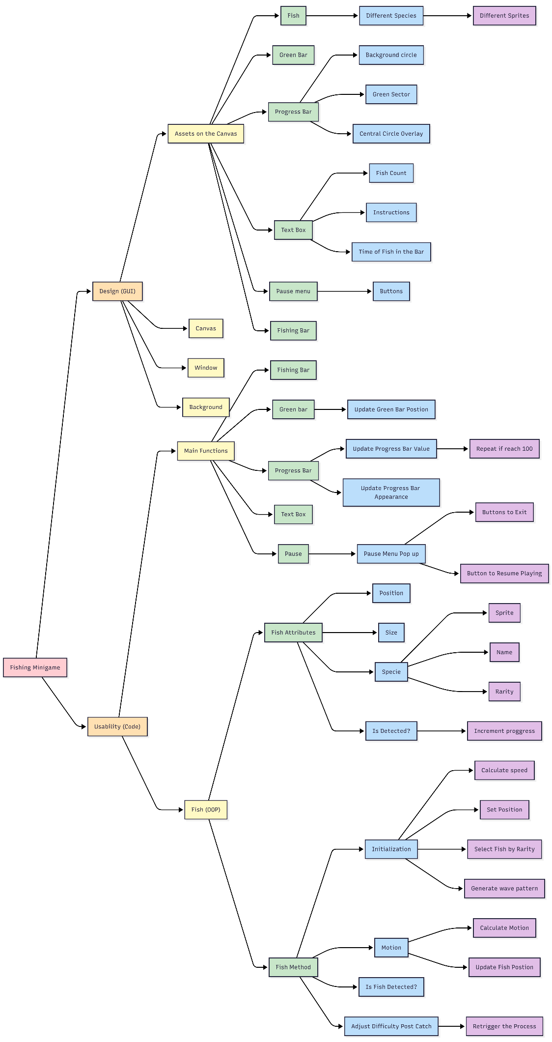
One of the core aspects of the program, as outlined in 1.6 Core mechanism based on the market research, is adaptability based on user performance. Since this logic seems complex and difficult to implement, I broke the mechanism down into smaller components to make the system easier to understand.

2.1.2.a Adaptability Module
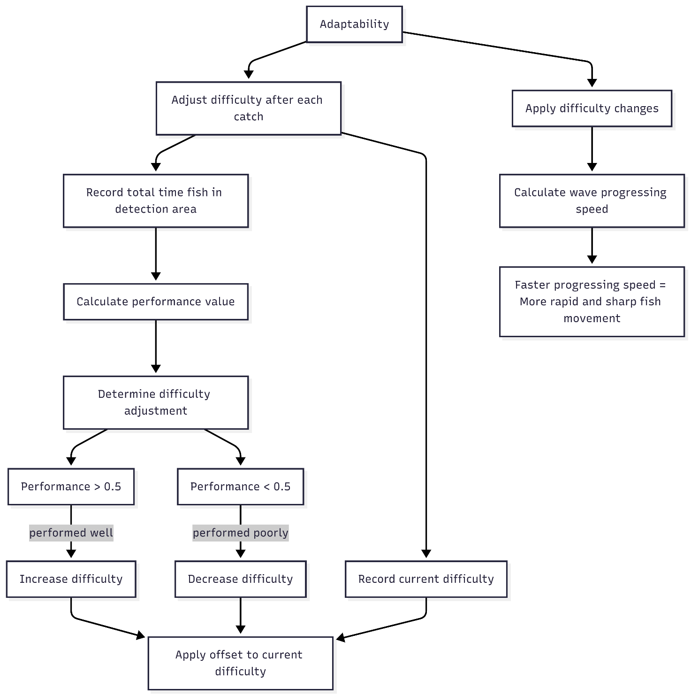

I separated adaptability into two main components. The first calculates a numerical value representing the player's performance. The second applies this value to the program by adjusting the speed of the wave function’s progression. A faster progression speed produces more rapid and less predictable fish movement, which increases difficulty.

2.1.2.b Data flow and structure
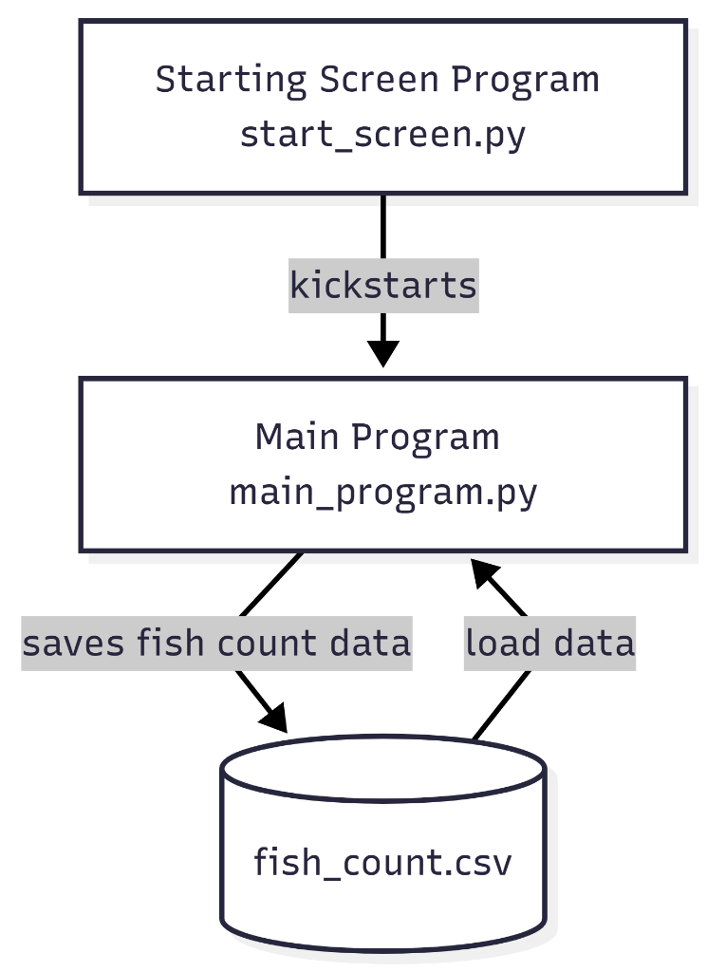
The program uses three main files to manage the flow of the system. start_screen.py handles the menu and starting interface. After the user begins the game, control passes to main_program.py, where the main gameplay and processing take place. Fish count data is then stored in fish_count.csv for persistent storage.
This modular structure gives each file a clear responsibility, which improves organization and maintainability. Changes to the menu system can be made without affecting the main gameplay code, while updates to the storage system remain separate from the interface logic.
A CSV file was chosen because it is lightweight, easy to read, and works well with Python through the built-in csv library. Python provides simple functions for reading and writing CSV data, which reduces code complexity and improves reliability. The format is also human-readable and compatible with spreadsheet software, making testing, debugging, and validating saved data easier.

2.1.3 Rough plan of GUI
With the core mechanics and the main components planned out, I then drew a rough sketch of the GUI layout, assuming all assets are contained within a single main window. More details on each of the assets will be discussed later in 2.5 User interface design.

(components: fishing bar, green bar, fish, progress bar, text box, pause menu)

2.1.3.a Main window
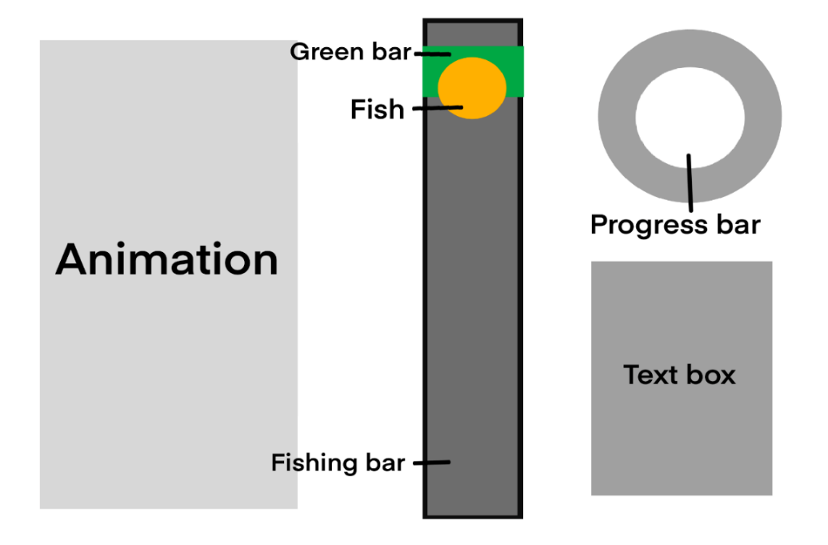
The animation feature is a further development plan for implementation if time remains in development. It is designed to provide additional visual feedback for aesthetic purposes. This section is intentionally left flexible to allow space for development changes if required.
The planned animation at this stage involves a fisherman casting a hook each time a fish is successfully caught. This feature is simple to implement, so I decided not to focus on it too much for now.

2.1.3.b Pause menu
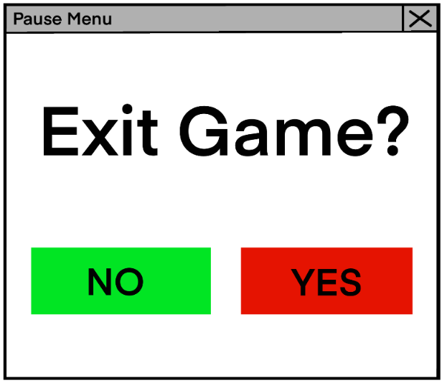
This sketch shows the pause menu pop-up window used to exit the game. When activated, it pauses all other program functions and stops gameplay until the user resumes or exits.

2.1.3.c Start menu
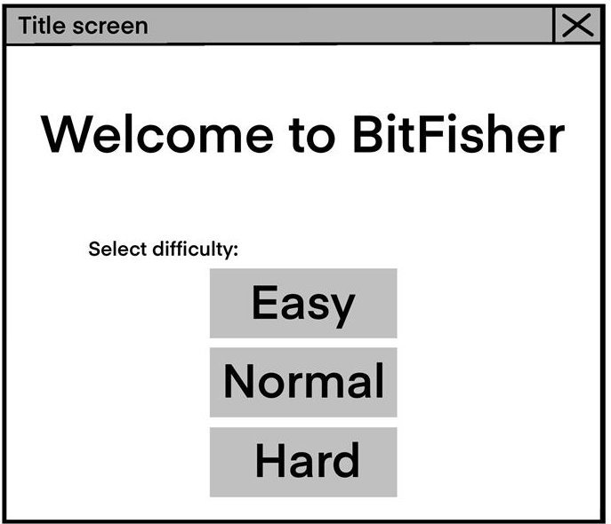

This design shows the start menu where players choose a starting difficulty level. A manual selection system provides players with more choices through three specific buttons. These buttons use clear text for easy reading while the centered title identifies the screen. The menu appears when the game boots. Selecting a difficulty level starts the main program.

2.1.4 Overall program flowchart
To plan the main algorithms, I used mermaid.live to produce flowcharts. This is a simple, easy-to-use tool that allowed me to visualise complex processes more clearly, particularly for functions with multiple steps or decision points.
I simplified the explanation by removing the start screen from the flowchart. I wish to focus on the main game systems, such as adaptability and wave modelling, which define the core gameplay and differentiate the project from similar games. Including every interaction would make the diagram too complex and harder to interpret.
The start screen exists as a separate module, so its removal from the flowchart does not affect the program logic. Keeping the diagrams separate ensures that I can stay focused on a single part of the system.

Below is a flowchart of the main program:
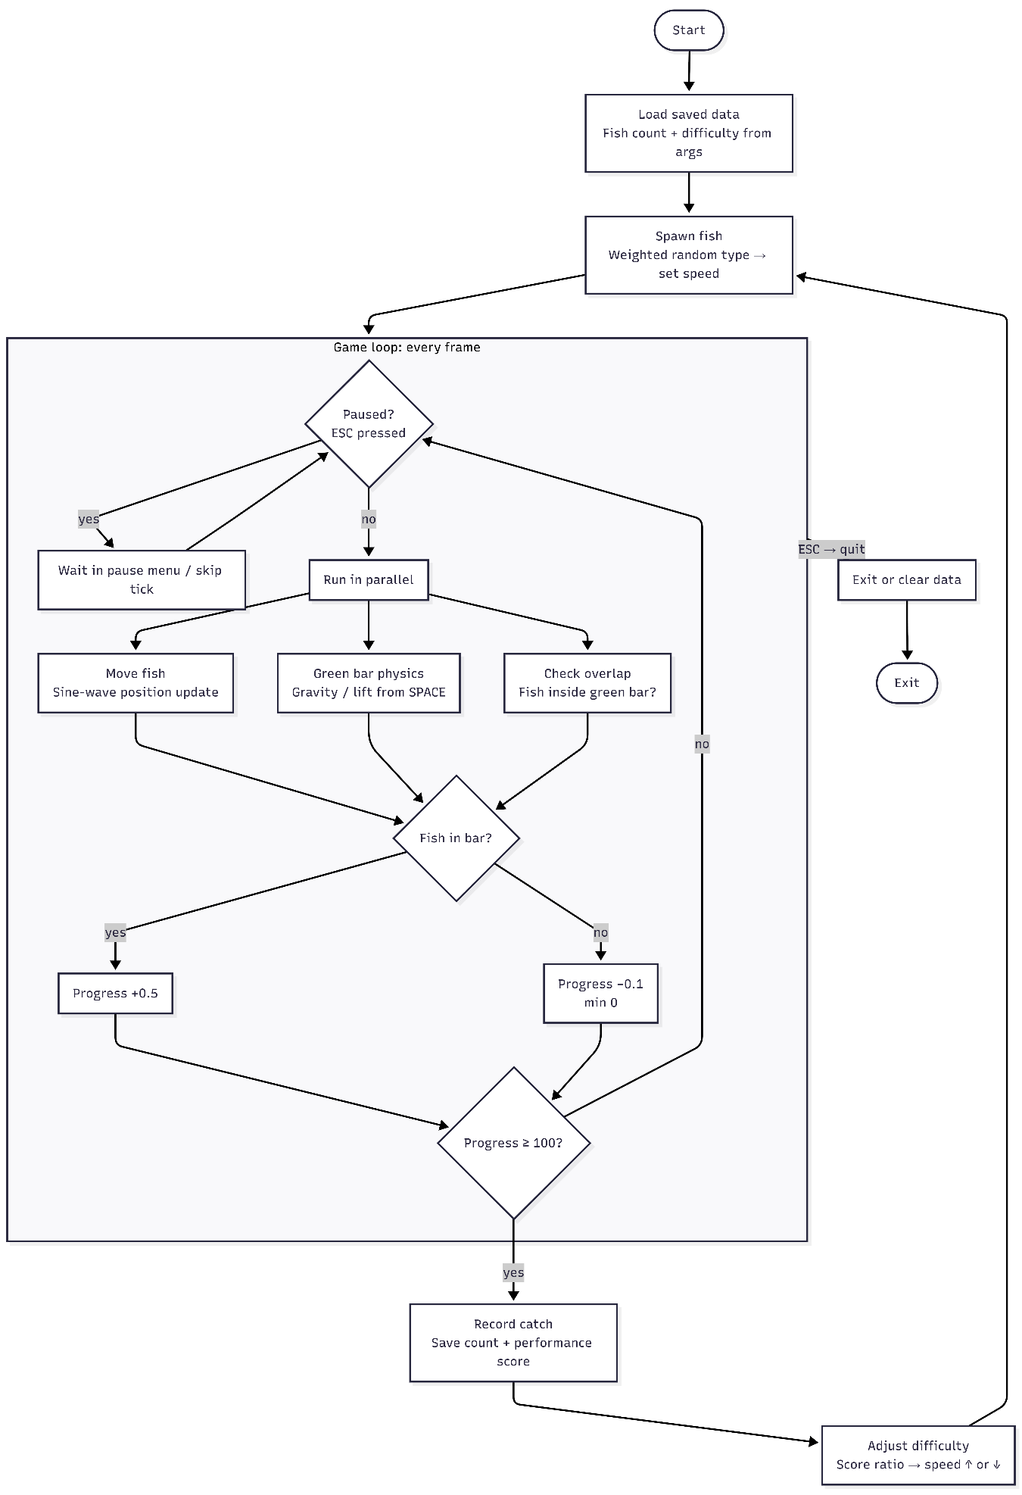
Saved files & starting screen

As shown in the flowchart, the program begins by loading all saved data from a local CSV file into memory. Once the data is loaded, the program initializes a new fish. During initialization, a movement wave pattern is generated and a fish is spawned within the fishing area. The fish type is selected using weighted rarity values, so common fish appear more frequently while rare fish appear less often.
The program then enters a recursive loop that runs roughly every 30 milliseconds. This serves as the game's refresh rate and influences overall performance across different systems. Each cycle of the loop performs the main gameplay checks and updates.
The first step is a pause check. This is treated as a priority condition because it overrides all other updates. If pause is set to true, the program halts gameplay updates and displays the pause menu. If pause is false, the program continues with the main gameplay modules. These modules run each frame concurrently to maintain smooth interaction.
- The first module updates fish movement. The program advances along the previously generated wave pattern and calculates a new vertical position. This produces a natural up and down motion for the fish.
- The next module handles green bar physics. The bar moves downward by default due to gravity. When the space key is pressed or held, the bar rises at a faster rate. This creates a controlled movement system where the player attempts to align the bar with the fish.
- The overlap check module then determines whether the fish is inside the green bar. The program compares their vertical positions and checks for overlap. If overlap is detected, the progress value increases.
After these modules execute, the program updates the visual progress indicator. The progress value is converted into a doughnut-shaped display so the player can track progress. The program also checks whether the progress has reached full. When the indicator is full, a fish is considered caught and the loop proceeds to handle the capture.
The current fish is removed, the fish counter is incremented, and a new fish is spawned using another weighted rarity selection. A new wave pattern is generated for movement, and the loop continues. This cycle repeats until the player opens the pause menu and chooses to exit. When exiting, the program saves all progress to the CSV file, overwrites the previous data, and closes the application.

2.2 The Solutions
After determining the overall flow of the program, the plan is structured around the different modules identified earlier. This creates a clear development process by decomposing the main problem into smaller, manageable sections.
After decomposing the program, abstraction is applied as flowcharts by defining what each module should do without focusing on low-level implementation details. This helps maintain clarity and prevents unnecessary complexity during development.

2.2.1 Solutions using flowcharts
I use additional flowcharts to plan the detailed logic inside each module. These include the internal functions as well as the fish class and its associated methods.
Each flowchart has been hyperlinked to its corresponding pseudocode

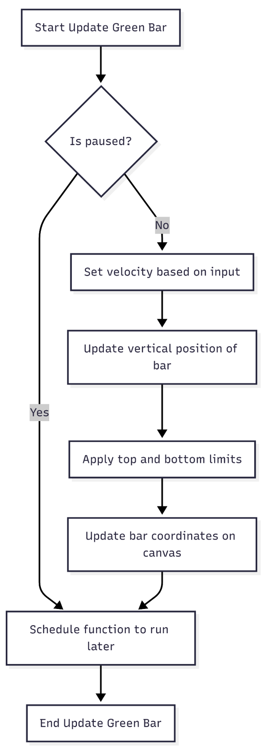
2.2.1.a Functions outside Fish class
Update Green bar Position
This function moves the green bar by updating its y coordinate based on user input. A flag is used to track whether the user is pressing the space key or not. When input is detected, the velocity is set to a positive value, which moves the bar upward. When there is no input, the velocity switches to a negative value, which pulls the bar downward to simulate gravity.

This means the user has to hold the key down to move the bar up, and letting go causes it to drop. The function calls itself repeatedly at a set frame rate, which ensures this check is performed continuously throughout the game and keeps the bar's position up to date on every frame.

Link to 1.7 Success criteria:

- Fu3 - accurate input detection

Update progress bar values

This function recurs at the same set frame rate and controls how the progress bar fills and resets during a fishing attempt.
At the start, it checks if the game is paused. If so, it skips everything and schedules itself to run again in the next frame anyway, so it stays ready to resume.
If the game is not paused, it checks whether the fish is inside the bar zone. If it is, progress increases by 0.5 each frame.
if fish is inside bar:
progress += 0.5
Once progress reaches 100, the game treats the fish as caught. It removes the fish from the screen, increments the fish count, and saves the count. It then calls the update difficulty function, which calculates how well the player performed based on how long the fish spent inside the bar. A new fish is then created and placed back on screen. The new fish gets an offset to the movement speed based on how difficult the game has become over time, and the displayed difficulty number updates to reflect this. Progress resets to 0 so the next fish starts fresh.
If the fish is outside the bar, progress decreases by 0.1 each frame and is prevented from going below zero:
if fish is outside bar:
progress -= 0.1
progress = max(progress, 0)
At the end of every frame, regardless of what happened, the progress bar is redrawn on screen, and the function schedules itself to run again in the next frame. This loop keeps running throughout the entire game.

Link to 1.7 Success criteria:
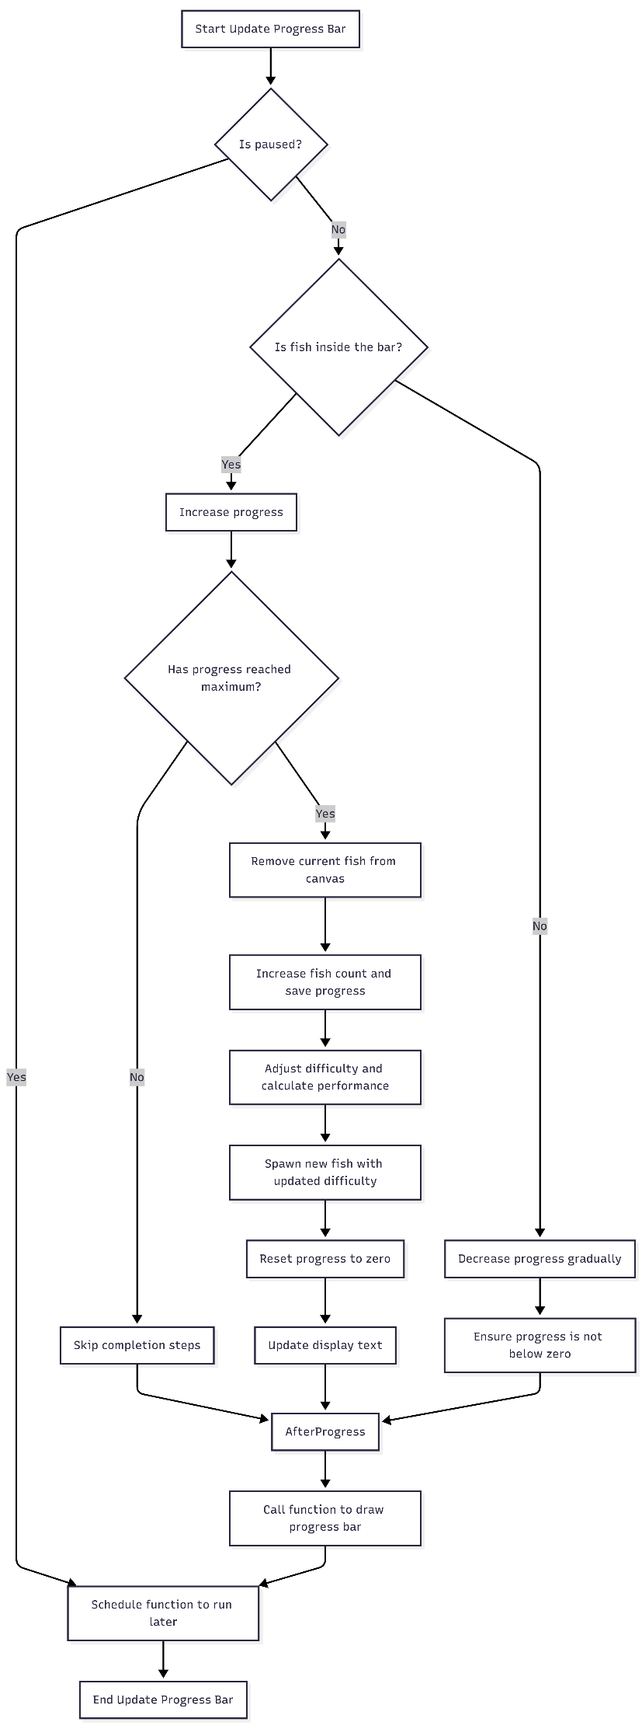
- Fe2 – progress/score counter update
- Fe3 – visual indicator for difficulty
- Fe4 – immediate feedback

Update progress bar appearance

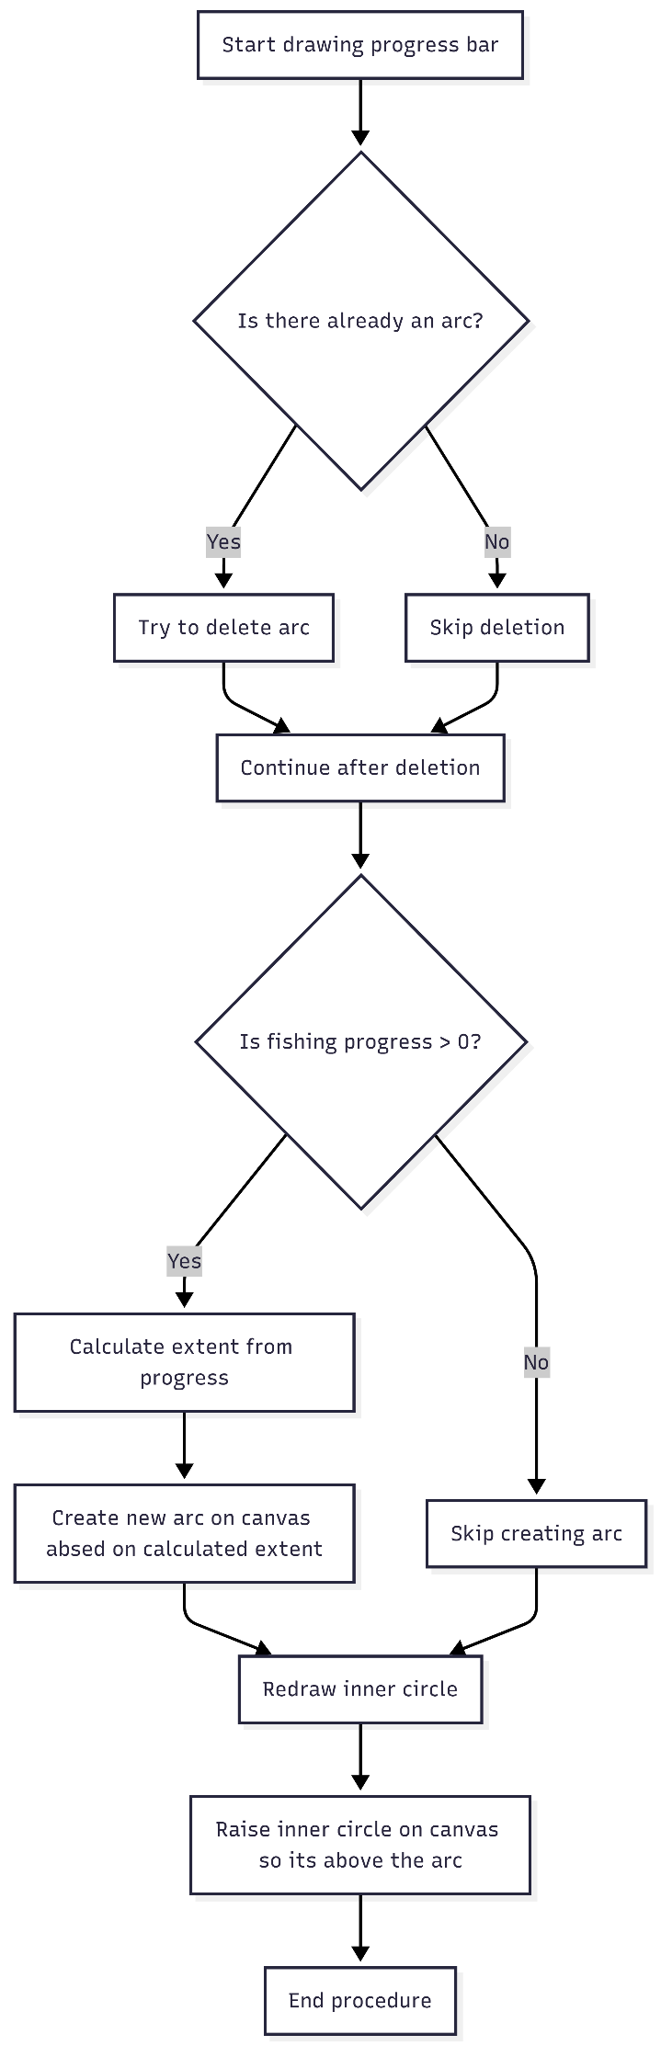
This function redraws the circular progress bar each time it is called.

It starts by deleting any arc already on the canvas to prevent old drawings from stacking on top of the new one. Then it checks if progress is above zero. If it is, it converts the current progress value into a clockwise angle starting from the top of the circle, where 100% progress equals a full 360 degrees. It uses this angle to draw a new arc on the canvas.

extent = (progress / 100) * 360
draw arc sweeping clockwise by extent degrees

If progress is zero, no arc is drawn and the circle appears empty.

Regardless of either outcome, the inner circle is repositioned and raised above the arc layer. This keeps the display looking like a ring instead of a filled wedge.

Link to 1.7 Success criteria:

- Fe1 – visual feedback after successful catch
- Fe2 – progress visual update
- Fe3 – visual indicator for difficulty
- Fu2 – assets updated smoothly

Pausing Interrupt Handling
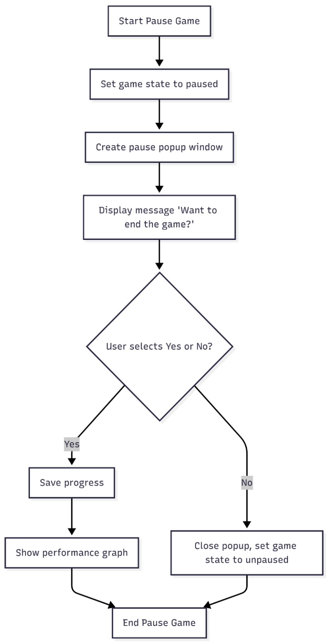
This function pauses the game and asks the player if they want to quit.
When triggered, it sets the game state to paused and opens a popup window displaying the message "Want to end the game?" with two buttons, Yes and No.
If the player selects Yes, the game saves the current progress and then runs the two actions visible at the bottom of the Yes branch, which are cut off in the diagram but follow from saving.
If the player selects No, the popup closes and the game state returns to unpaused, resuming where the player left off.

Link to 1.7 Success criteria:

- Fu4 – stop button to exit gameplay
- Fu6 – game runs without crashes
- Fu9 – score persist after restart

2.2.1.b Fish Class constructor
The Fish Class
The class diagram shows a simplified outline of the fish class. It lists the main variables used, with clear and consistent naming to improve readability and maintainability. This helps ensure the code stays organised and reduces confusion when making changes.

All key methods are also shown underneath the variables. This gives a clear structure of how the class works and how each part of the fish behaviour is handled within the program.
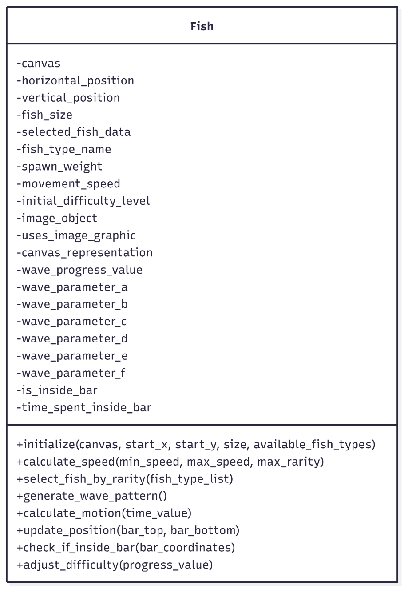

2.2.1.c Fish Class methods
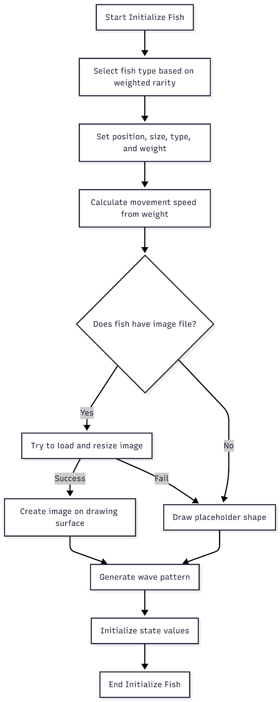
Initialize Fish
This method handles spawning a new fish and loading its associated data, such as type and speed. It also attempts to load the correct fish sprite image and manages calls to other related methods needed for setup. This process runs every time a fish is caught and a new one needs to be spawned.

Link to 1.7 Success criteria:

- Fu7 – multiple fish types/behaviours
- W4 – unique wave pattern per fish

Calculate speed:

The calculate speed method sets each fish speed using a predefined weight value. Higher difficulty fish have higher weights, which produce faster speeds. The method checks the weight is not zero, then applies a formula to calculate a speed offset.
This value is used when the fish is initialized and is called inside the initialize fish method.

Link to 1.7 Success criteria:

- A7 – behaviour changes as difficulty increases
- A6 – difficulty stays within defined limits

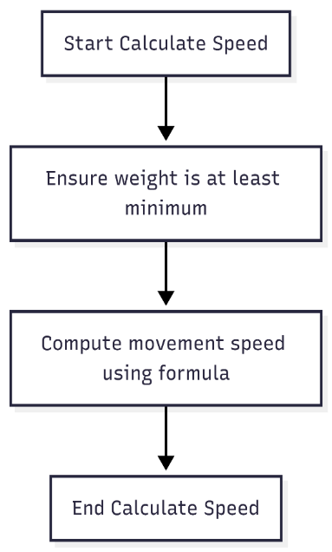

Select fish based on rarity

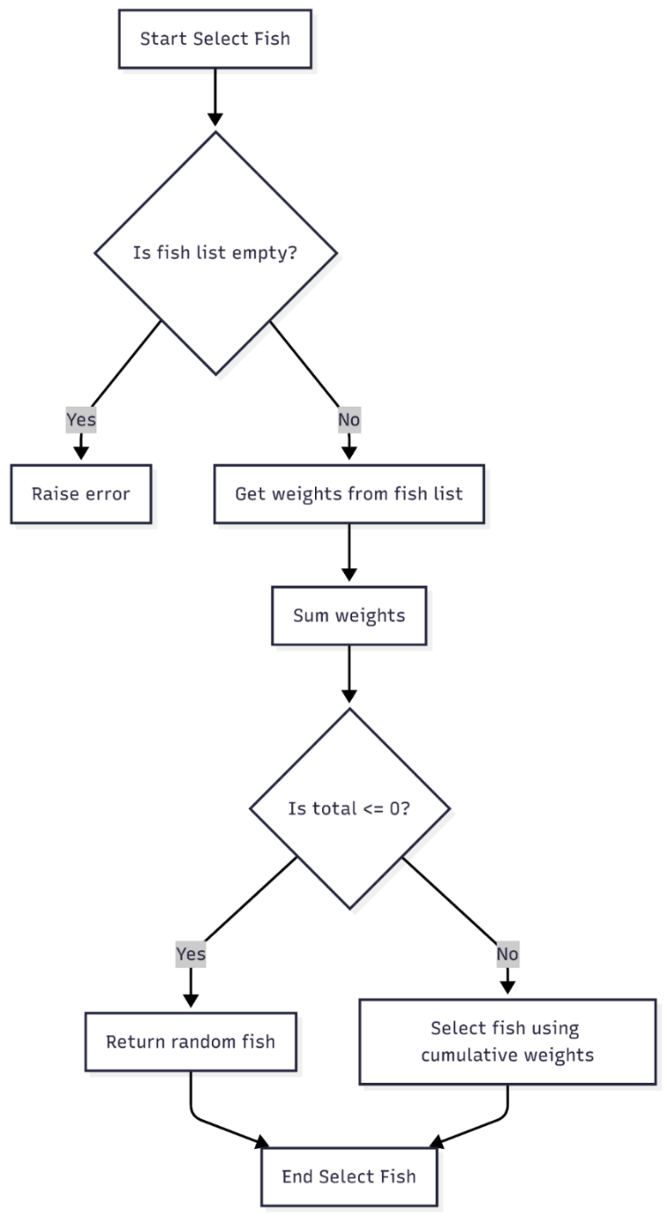
This method randomly selects a fish from a list of fish objects, then verifies that its weight is non-zero. This weight is also used in the fish speed calculation, ensuring that more difficult fish are also rarer. The method then selects a fish using the cumulative weight probability of each fish, which guarantees a random yet statistically consistent distribution of fish selections.
Link to 1.7 Success criteria:

- Fu1 – difficulty selection
- Fu7 – multiple fish type
- A5 – gameplay visibly reflects changes in difficulty

Generate wave pattern
Calculate motion using wave

This method is better demonstrated visually than described with a flowchart, so I have created a Desmos simulation to illustrate the concept. The simulation uses six randomly generated variables (a through f) alongside an x value that increments by a small amount on each frame update. This simulates a progressive wave, where the resulting y value represents the fish's vertical position on screen.
- W1 – wave function controls fish
- W2 – smooth and continuous movements
- W3 – random variables control movements
- Fu7 – multiple fish behaviour
Link to 1.7 Success criteria:

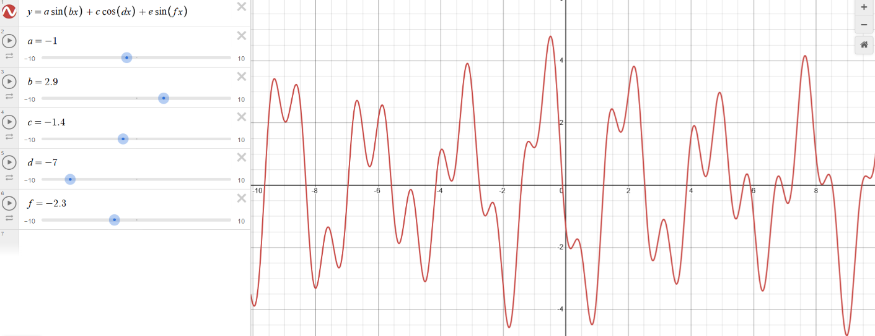
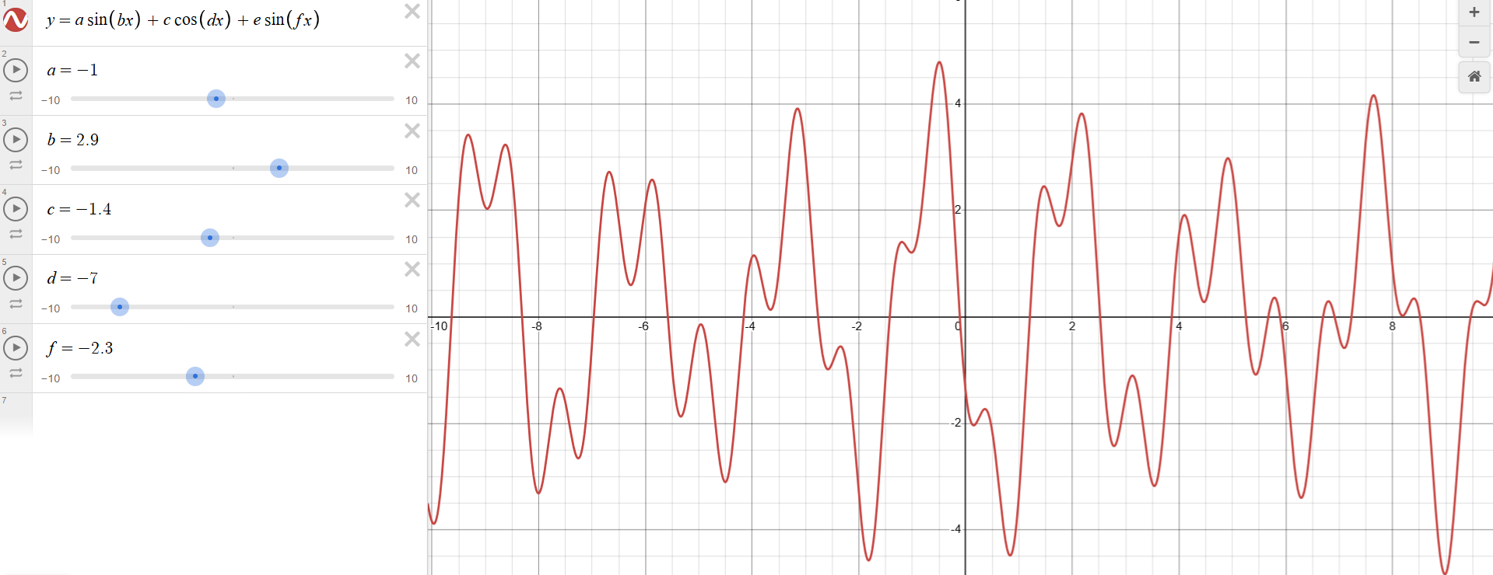

Update Position of Fish
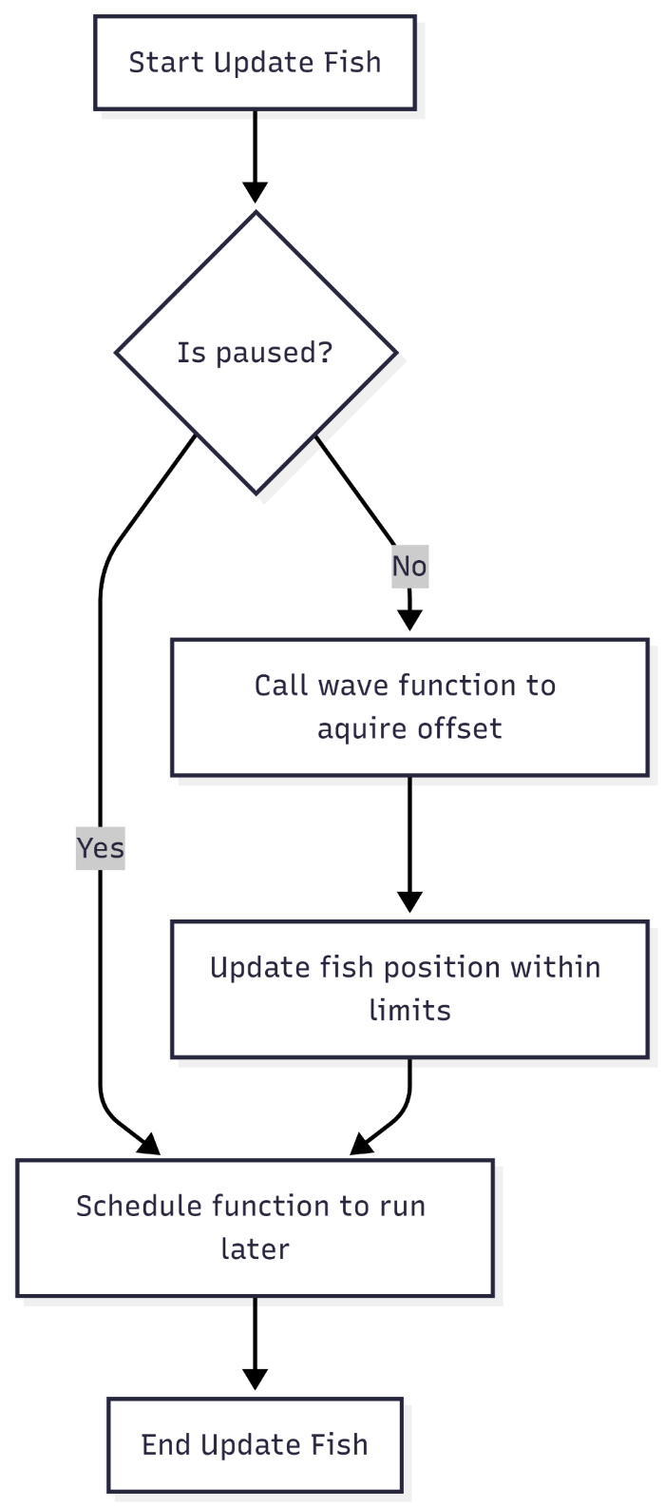
This method moves the fish using the y value generated by the wave pattern method described earlier. It first checks whether the pause flag is active; if not, it sets the fish's new coordinates accordingly.

The method calls itself recursively after a short delay, effectively acting as the animation's frame refresh loop. Within it, the detection area check method is also called on every frame update.

Link to 1.7 Success criteria:

- W5 – movement update in real time
- Fu2 – asset updated smoothly
- Fu5 – no penalty for failed catches

Check if Fish is Inside Detection Area

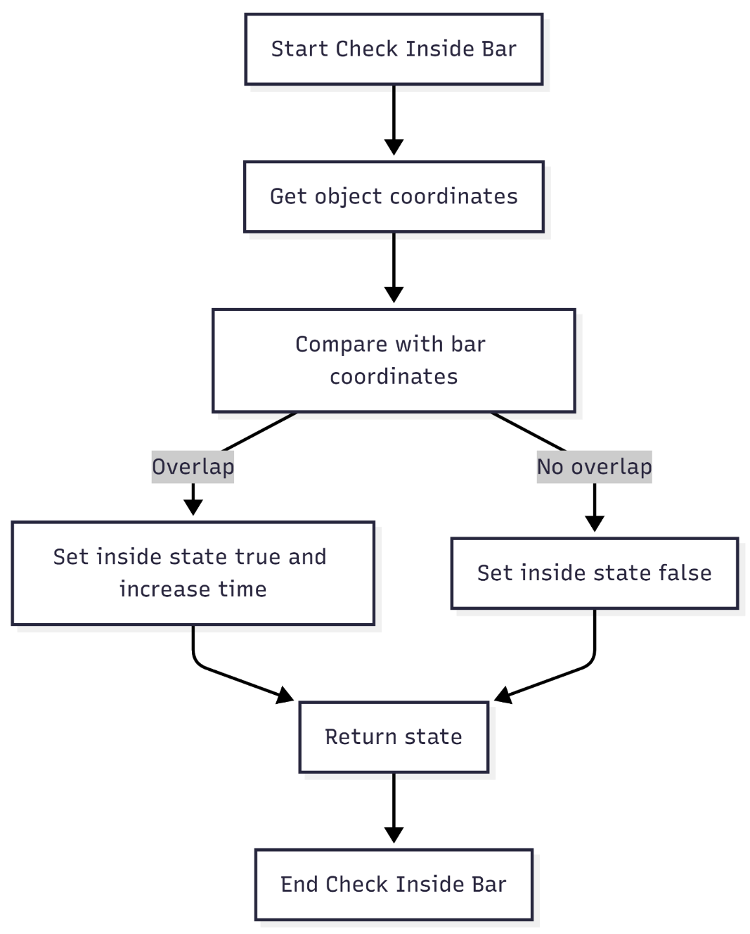

This method checks whether the fish is inside the green bar by comparing their y coordinates. It gets the top and bottom edges of both the bar and the fish, then checks if they overlap vertically.
The condition checks two things. First, the top of the bar has to be above the bottom of the fish. Second, the bottom of the bar has to be below the top of the fish. If both are true at the same time, the fish is inside the bar, so the inside state is set to true and the time counter increases. If either condition fails, the inside state is set to false.

Link to 1.7 Success criteria:
- A8 – difficulty updates in real time
- Fe4 – feedback appears immediately

Adjust the difficulty after each successful catch

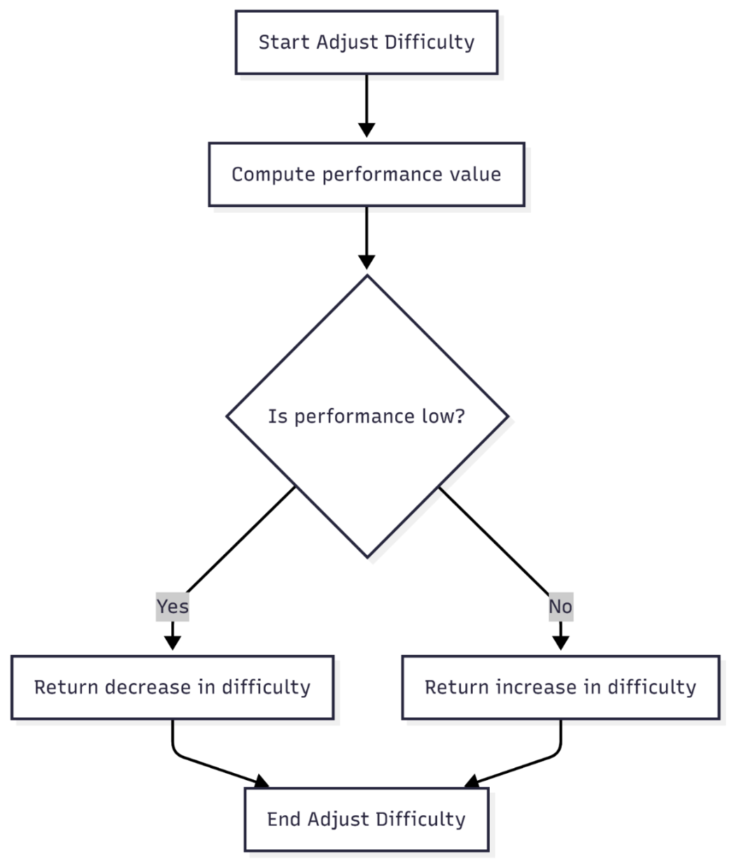
This method checks the user's performance and works out the offset value to add to the difficulty.
It takes the total time the fish spent inside the bar and uses it to calculate a performance score. The score is worked out by dividing the progress value by the time spent in the bar. Since progress always goes from 0 to 100, the method always checks against 100, which means the comparison is consistent regardless of how long the session lasts.

For example, if the user reaches 100% progress while the fish has been inside the bar for 200 frames, the performance score works out to 0.5. A higher score means the user kept the fish in the bar for less time relative to their progress, meaning they performed worse. A lower score means they kept the fish in the bar for longer, meaning they performed better.
Because this check only runs when a fish is caught, the progress value at that point will always be 100, which makes the formula reliable and easy to scale.

Link to 1.7 Success criteria:
- A1 – increase difficulty when performed well
- A2 – decrease difficulty when performed poorly
- A3 – difficulty scaling is gradual
- A4 – player performance affects difficulty
- A6 – difficulty stays within calibrated limits
- A8 – difficulty updates in real-time

2.2.3 Solutions using external libraries
The program will use the Tkinter library as the main external library for building the graphical user interface. Tkinter is suitable for this project because it is built into Python, lightweight, and works well for 2D applications with real-time updates. It supports canvas-based drawing, event handling, and continuous screen updates, which are required for the fishing game’s animation and interactive elements such as the moving fish and progress bar. Compared to other GUI libraries, Tkinter is simpler to implement and does not require external installations, making it more practical for rapid development and testing.
The program will also use supporting libraries such as PIL (Python Imaging Library) and os. PIL is used for loading, resizing, and converting image files, which is necessary for importing fish sprite PNGs and displaying them correctly on the canvas. This is important because the game requires image assets for a better user experience. The os library is used for file handling, such as locating image directories and managing file paths in a way that works across different systems. This improves reliability when accessing assets like sprites and saved data files.
Below I have listed the functions and their usage context that may be needed for this project. Since external libraries require specific syntax tied to their documentation, they are not included in the rough pseudocode. Instead, placeholders will be used in their place. This allows focus on the core logic of the program, such as game mechanics and behaviour, without being slowed down by library-specific syntax details.

2.2.3.a Table of tkinter functions used
Code | Function | Context | Why used?
tk.Tk() | Creates main window object | Game initialization | Required root container for all interface components and event handling in Tkinter applications
window.title(text) | Sets window title | UI configuration | Provides user-facing identification of the application in the operating system window manager
window.geometry(size string) | Defines window dimensions | Layout setup | Ensures consistent screen scaling instead of relying on default dynamic sizing
tk.Canvas(parent) | Creates drawing surface widget | Main rendering system | Chosen because it supports real-time drawing of shapes, images, and text in a single unified area, unlike Label or Frame which are static
canvas.pack() | Places widget in window layout | UI positioning | Simple geometry manager used instead of grid/place for full-screen canvas control without manual coordinate layout management
tk.Toplevel(parent) | Creates secondary window | Pause menu system | Used instead of opening a new program instance because it maintains shared event loop and memory state
tk.Label(parent) | Displays text | Pause menu display | Used instead of canvas text when fixed UI text is needed without manual redraw logic
tk.Button(parent) | Creates clickable UI control | Menu interaction | Preferred over custom click detection because Tkinter handles state changes and event binding internally
window.bind(event, function) | Links keyboard input | Input system | Used instead of polling input state because event-driven design reduces CPU usage and improves responsiveness
canvas.create_oval() | Draws oval shape | Game graphics fallback + UI meter | Used instead of images when lightweight procedural rendering is required and avoids file dependency overhead
canvas.create_rectangle() | Draws rectangle shape | Fishing zone and bar | More efficient than images for collision zones because geometry is directly computable
canvas.create_text() | Renders text | HUD system | Preferred over Label when text must move or update dynamically inside a canvas-based game world
canvas.create_image() | Displays image | Fish sprites | Used for sprite rendering because Canvas supports fast image placement with coordinate control
canvas.coords(item, new values) | Updates object position | Movement engine | Used instead of deleting and redrawing objects because it reduces rendering cost and prevents flicker
canvas.itemconfig(item, options) | Updates item properties | Dynamic UI updates | Allows real-time text and styling updates without recreating canvas objects
canvas.tag_raise(item) | Changes drawing order | Rendering priority control | Ensures important game objects remain visible above background layers
window.after(ms, function) | Schedules repeated execution | Game loop system | Used instead of while loops because it integrates with Tkinter event loop and prevents UI freezing

2.2.3.b Table of PIL and os functions used

Code | Function | Context | Why used?
Image.open(path) | Loads image file from storage | Asset loading | Required because Tkinter alone cannot decode external image formats such as PNG properly
Image.resize(size) | Changes image dimensions | Sprite preparation | Used instead of Tkinter scaling because it produces cleaner resampling and avoids pixel distortion
ImageTk.PhotoImage(image) | Converts PIL image to Tkinter-compatible format | Rendering bridge | Necessary because Tkinter canvas cannot directly display PIL image objects
os.path.join() | Builds file path strings | Cross-platform file access | Used instead of manual string concatenation to avoid path errors across operating systems
os.path.dirname(file) | Gets script directory location | Asset path resolution | Used to reliably locate image folder regardless of current working directory
os.path.exists(path) | Checks file presence | Save/load system | Prevents runtime errors compared to direct file opening without validation
os._exit(0) | Forcefully terminates program | Emergency shutdown from graph window | Used instead of Tkinter destroy alone because it ensures full Python process termination including background loops

2.2.4 Solutions using Pseudocode
After mapping out the algorithms with flowcharts, the next step was turning them into pseudocode using a Python-like style to make development easier later on. This helped split the game into clear logical steps before any real coding started, so attention stayed on how each part works rather than getting stuck on syntax.
As mentioned before, most functions rely on the tkinter library, which has strict syntax rules. Because of that, placeholders are used where tkinter elements will eventually go.
At this point, the focus stays on the main behaviour of each function instead of full implementation details.
Each pseudocode has been hyperlinked to its corresponding flowcharts

2.2.4.a Functions outside Fish class
Update green bar

def function update_greenbar()
repeat every frame
#section 1
if paused == False then
if space_pressed == True then
velocity = lift
else
velocity = gravity
endif
#section 2
green_y = green_y + velocity
if green_y < top_limit then
green_y = top_limit
endif
if green_y > bot_limit then
green_y = bot_limit
endif
#section 3
tkinter .coords() function to update the visual coordinates of the green_bar
endif
endrepeat
endfunction

- Section 1: Checks against the user's input; if the space bar is held, it sets the velocity to a negative lift value to move up, otherwise it applies a positive gravity value to fall.
- Section 2: Updates the vertical coordinate of the green bar using the velocity and ensures the bar stays within the physical boundaries of the fishing area.
- Section 3: This uses the tkinter .coords function, which updates the position of a canvas item. In this case, it moves the green bar by changing its coordinates.

Update progress bar values

function update_progress_bar()
repeat every frame
if paused == False then
# Section 1
if in_bar == True then
fishing_progress = fishing_progress + 0.5
else
fishing_progress = fishing_progress - 0.1
endif

# Section 2
if fishing_progress < 0 then
fishing_progress = 0
endif

# Section 3
if fishing_progress >= 100 then
fish_caught = fish_caught + 1
register the fish and trigger fish caught events
endif
endif
endrepeat
endfunction

- Section 1: Increments the progress if the fish is currently inside the green bar or penalizes the player by decreasing progress if it is not.
- Section 2: Validates that the progress value never drops below zero.
- Section 3: Checks for the win condition; if progress is full, it increments the total catch count, saves the data, and resets the game state for the next fish.

Update progress bar appearance

function draw_progress()
repeat every frame
# Section 1
if fishing_progress > 0 then
progress_arc_degree = (fishing_progress / 100) * 360
endif

# Section 2
# draw arc at progress_center_x, progress_center_y using progress_arc_degree
redraw inner circle to cover up part of the arc, creating a donut shape
endrepeat
endfunction

- Section 1: Converts the linear progress percentage into a degree value out of 360 to define the size of the circular arc.
- Section 2: Uses the calculated degrees and center coordinates to visually render the donut-shaped progress UI.

Pause game

function pause_game()
# Section 1
paused = True

# Section 2
if user_quits == True then
save to fish_count_file
close game
else
paused = False
endif
endfunction

- Section 1: Halts all movement and logic updates by setting the paused flag to True.
- Section 2: Provides a conditional branch where the user can either trigger the save-and-exit sequence or resume the game.

2.2.4.b Fish Class constructor
Initialize Fish

function init_fish()
# Section 1
fish_x = (fishing_x1 + fishing_x2) / 2
fish_y = fishing_y1 + 500

# Section 2
# call weighted_choice to set fish_type and fish_rarity
# call calculate_speed_from_rarity to set fish_speed

# Section 3
wave_x = 0.0
time_in_bar = 0
endfunction

- Section 1: Sets the starting horizontal and vertical spawn coordinates for the fish.
- Section 2: Determines the identity, rarity, and movement speed of the fish based on randomized selection logic.
- Section 3: Resets the fish's internal movement timers and performance trackers.

2.2.4.c Fish Class methods
Calculate Speed

function calculate_speed_from_rarity()
# Section 1
if fish_rarity < 1 then
fish_rarity = 1
endif

# Section 2
fish_speed = min_speed + (100 - fish_rarity) / 100 * (max_speed - min_speed)
endfunction

- Section 1: Ensures the rarity variable is within a valid range to prevent division or logic errors.
- Section 2: Uses an inverse relationship to set the speed; the lower the rarity (harder fish), the higher the resulting fish_speed.

Select Fish by Rarity

function weighted_choice()
# Section 1
total_rarity = 0
for each fish in fish_types
total_rarity = total_rarity + fish_rarity
next fish

random_target = random_float(0, total_rarity)

# Section 2
cumulative_weight = 0
for each fish in fish_types
cumulative_weight = cumulative_weight + fish_rarity
if random_target <= cumulative_weight then
return fish
endif
next fish
endfunction

- Section 1: Calculates the total pool of rarity weights and picks a random "target" value within that range.
- Section 2: Iterates through the available fish types to find which one corresponds to the random target, ensuring rarer fish appear less often.

Generate wave pattern

function generate_new_wave()
# Section 1
A = random_integer(150, 500)
B = random_float(8, 12)
C = random_integer(750, 1000)

# Section 2
★ D = random_float(12, 18)
E = random_integer(300, 650)
F = random_float(18, 22)
Endfunction

- Section 1: Assigns random amplitudes and frequencies to the first set of wave parameters to ensure unpredictable movement.
- Section 2: Assigns random parameters to the remaining variables to further complexify the sine/cosine movement pattern.

Calculate motion

function motion(t)
# Section 1
speed_offset = (A * sin(B * t)) + (C * sin(D * t)) + (E * cos(F * t)) ★

# Section 2
return speed_offset
endfunction
- Section 1: Combines multiple sine and cosine waves using the pre-generated coefficients to calculate a complex vertical offset.
- Section 2: Returns the final calculated value to be used in the position update.

★ Why these specific values?
The movement pattern uses three wave components to calculate the vertical position. Each component consists of a magnitude (how far) and a frequency (how fast).

Variable Purposes
- Amplitudes (A, C, E): Control the total distance moved. High values make the fish move further; low values keep it more central.

- Frequencies (B, D, F): Control the oscillation speed. High values make the movement "twitchy" and fast; low values make it smooth and slow.

Variable Pair | Functional Role | Effect on Gameplay
A and B | Large scale movement | Moves the fish across large sections of the bar.
C and D | Medium/Fast jitter | Creates sharper, sudden changes in direction.
E and F | Phase variance | Uses a Cosine wave to break repetitive "up-down" cycles.

Parameter Calibration
- Scaling: The values for A, C, and E are scaled by a factor of 0.15. This ensures the total vertical offset remains within the 700-pixel height of the fishing bar.
- Speed Selection: The values for B, D, and F are set between 8 and 22. This creates a movement frequency that is fast enough to challenge player reaction times without becoming a high-speed vibration.
- Randomization: By generating new values for these six variables upon every spawn, every fishing attempt has a unique movement profile.

Update position of fish

function update_position()
repeat every frame
# Section 1
Inherite fish_speed from calculate speed function
calculate new fish_speed with all the offsets
wave_x = wave_x + fish_speed
★ speed_offset = motion(wave_x) * 0.15

# Section 2
fish_y = bar_mid + speed_offset

if fish_y < top_limit then
fish_y = top_limit
endif
if fish_y > bot_limit then
fish_y = bot_limit
endif

endfunction

- Section 1: Advances the internal wave timer by the fish's speed and calculates the new raw vertical offset.
- Section 2: Applies the offset to the fish's y-coordinate and clamps the value to ensure the fish sprite stays inside the fishing bar.

★ Why 0.15 is used
- Without scaling, a movement of 2150 (the maximum amount possible) pixels would force the fish off the screen instantly, making the game unplayable
- Multiplying by 0.15 reduces the maximum movement to approximately 322 pixels (2150 x 0.15 = 322.5).
- Since the bar is 700 pixels high, the fish can move roughly 350 pixels up or down from the center. The 0.15 value ensures the fish is fast and erratic but physically stays within the bar's boundaries.

Check if fish is inside detection area

function check_in_bar()
repeat every frame
# Section 1
if green_y_top < fish_y_bottom AND green_y_bottom > fish_y_top then
in_bar = True
time_in_bar = time_in_bar + 1
else
in_bar = False
endif

# Section 2
return in_bar
endrepeat
endfunction

- Section 1: Performs a collision check between the green bar and the fish; if they overlap, it sets the status to True and increments the time_in_bar counter.
- Section 2: Returns the current boolean status of the overlap for use in progress calculations.

Adjust Difficulty

function update_difficulty()
# Section 1
performance_score = fishing_progress / time_in_bar

# Section 2
★ if performance_score <= 0.5 then
return -0.001
else if performance_score > 0.5 then
return 0.0015
endif
endfunction

- Section 1: Calculates a performance ratio by comparing the total progress made against the total time the fish was actually inside the bar.
- Section 2: Returns a difficulty adjustment value; if the player struggled (low score), the game slows down; if they succeeded easily, the speed increases.

★ Why these values
- The values 0.0015 and -0.001 are temporary placeholders used to represent the general scale of possible adjustments. They act as offsets applied to fish speed and will be refined later to improve user experience and balance.
- These adjustments are kept small, in thousandths, to ensure gradual changes in difficulty. This avoids sudden shifts in fish behaviour and supports smooth movement progression between rounds.
- The increase value is deliberately larger than the decrease value. This design choice makes difficulty rise more strongly than it falls, which encourages continuous improvement in player performance.

2.3 Data Table of Content

2.3.1 Table of Variables
This table lists the essential variables identified at this stage of planning. Additional variables might be introduced during development as the program becomes more refined. These will be explained in the development section.
The variables are grouped according to the main purposes of the functions they support.

Function it belongs to | Name | Type | Description
Green bar | green_x | int | Horizontal center of the green bar; fixed to the middle of the fishing column
Green bar | green_y | int | Vertical center of the green bar; changes every frame based on player input
Green bar | green_width | int | Width of the green bar in pixels
Green bar | green_height | int | Height of the green bar in pixels
Green bar | velocity | int | Vertical speed applied to the green bar each frame
Green bar | space_pressed | bool | True while the spacebar is held down
Green bar | gravity | int | Downward speed added when spacebar is not held
Green bar | lift | int | Upward speed applied when spacebar is held
Green bar | top_limit | int | Highest y-coordinate the green bar can reach inside the fishing column
Green bar | bot_limit | int | Lowest y-coordinate the green bar can reach inside the fishing column
General game state | fishing_progress | float | 0-100 value tracking how close the player is to catching the current fish
General game state | fish_in_bar | bool | True when the fish overlaps the green bar
General game state | fish_caught | int | Total fish caught this session; saved to file between sessions
General game state | paused | bool | Stops all update loops when true
General game state | time_fish_in_bar | int | Cumulative frames the fish has spent inside the green bar for the current catch
General game state | level | int | Displayed difficulty number derived from the fish's wave speed
General game state | initial_difficulty | float | Speed offset read from the command-line argument at startup
General game state | fish_count_file | str | Path to the file storing the persistent total fish caught across sessions
Progress arc | progress_arc_degree | float | Sweep angle drawn on the arc, proportional to fishing_progress
Progress arc | progress_center_x | int | Horizontal center of the progress arc on the canvas
Progress arc | progress_center_y | int | Vertical center of the progress arc on the canvas
Progress arc | radius_outer | int | Outer radius of the progress arc ring in pixels
Progress arc | radius_inner | int | Inner radius of the progress arc ring; creates the donut cutout

Table of variable in fish class
Function it belongs to | Name | Type | Description
Fish (Constructor) | fish_x | int | Horizontal position of the fish; fixed to the center of the fishing column
Fish (Constructor) | fish_y | float | Vertical position of the fish; updated each frame by the motion formula
Fish (Constructor) | fish_sprite | ImageTk | Loaded image object used to draw the fish on the canvas
Fish (Constructor) | fish_rarity | int | Numeric weight for this fish type; higher values spawn more often
Fish (Constructor) | fish_type | str | Name of the fish species selected at spawn
Fish (Constructor) | fish_size | int | Radius in pixels used for drawing and collision detection
Fish (Constructor) | fish_speed | float | Rate at which the wave parameter advances each frame
Fish (Constructor) | in_bar | bool | Set each frame; true when the fish overlaps the green bar
Fish (Constructor) | time_in_bar | int | Frame count the fish has spent inside the green bar during this catch attempt
Fish (Constructor) | wave_x | float | Accumulated wave parameter passed to the motion formula each frame
Fish Initial speed calculation | min_speed | float | Slowest possible wave speed, assigned to the rarest fish
Fish Initial speed calculation | max_speed | float | Fastest possible wave speed, assigned to the most common fish
Fish Initial speed calculation | fish_rarity | int | The fish's rarity value used to interpolate between min and max speed
Weighted fish selection | fish_type | dict | The fish dictionary selected from the list according to rarity weights
Weighted fish selection | fish_rarity | int | Weight extracted from each fish dictionary to build the probability pool
Generate new wave | A | int | Amplitude of the first sine component
Generate new wave | B | float | Frequency of the first sine component
Generate new wave | C | int | Amplitude of the second sine component
Generate new wave | D | float | Frequency of the second sine component
Generate new wave | E | int | Amplitude of the cosine component
Generate new wave | F | float | Frequency of the cosine component
Fish motion | t | float | Current wave_x value; the time-like input to the motion formula
Update difficulty | speed_offset | float | Small value returned to adjust the next fish's wave speed up or down

2.3.2 Table of Functions
The table follows the order of the flowcharts provided. For additional detail, click on function name for hyperlinks.
Functions and variables within the fish class are bolded and italicise, function names have been hyperlinked to corresponding flowcharts

Function name | Description | Other functions it requires | Variables it requires
Update Green bar Position | Moves the green bar up or down based on space bar input; applies gravity when released and keeps the bar within the fishing bar boundaries | N/A | green_x, green_y, green_width, green_height, velocity, space_pressed, gravity, lift, top_limit, bot_limit
Update progress bar values | Increases or decreases fishing progress depending on whether the fish is inside the bar; triggers catch logic when progress reaches 100 and resets for the next fish | Update progress bar appearance,  Initialize Fish,  Adjust the difficulty after each successful catch | fishing_progress, fish_in_bar, fish_caught, paused, time_fish_in_bar, level, fish_wave_x, stats_display
Update progress bar appearance | Draws circular progress bar based on progress value calculated, and then draws inner circle to keep the donut shape | N/A | progress_arc_degree, fishing_progress, progress_center_x, progress_center_y, radius_outer, radius_inner
Pausing Interrupt Handling | Pauses game, creates popup, allows user to quit or resume, saves data when quitting | Save fish count | paused
Initialize Fish | Spawns a new fish and load associated data. | Calculate speed,  Select fish by rarity,  Generate wave pattern | Fish_x, fish_y, fish_sprite, fish_rarity, fish_type, fish_size, fish_speed
Calculate speed: | Calculate the base speed with no adjustment of the fish based on rarity value | N/A | fish_rarity, fish_speed, min_speed, max_speed
Select fish based on rarity | Select one fish type using weighted random probability | N/A | Fish_type, fish_rarity
Generate wave pattern | Generate random parameters for fish movement wave | N/A | A, B, C, D, E, F, t
Calculate motion using wave | Using the generated random values, calculates vertical motion offset using sine and cosine waves | Sin, cos | A, B, C, D, E, F, t
Update Position of Fish | Updates fish vertical position using wave motion, clamps inside bar, updates drawing coordinates | Calculate motion | fish_speed, wave_x, fish_x, fish_y, fish_sprite
Check if Fish is Inside Detection Area | Checks if fish overlaps with green bar and updates time inside bar | N/A | fish_x, fish_y, in_bar, time_in_bar, green_x, green_y
Adjust the difficulty after each successful catch | Calculates performance and returns difficulty adjustment value | N/A | Time_in_bar, speed_offset, fishing_progress

2.5 User interface design
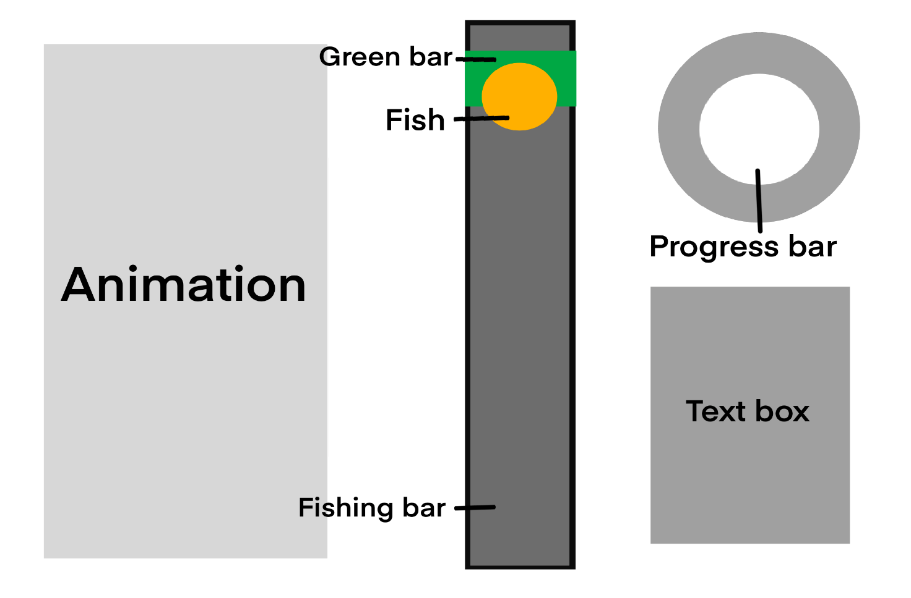
(rough layout of the main display window)

2.5.1 Main window (main.py)
The main game window is designed to keep the interface clear and easy to follow during gameplay. Important assets are placed in visible positions so the player can quickly understand the current game state without confusion. The GUI uses simple shapes, readable text, and consistent colours to help players recognise different mechanics during fast movement and animation. Since the game relies heavily on real time interaction, the layout avoids unnecessary interface elements that could distract the player. The interface is built directly in Tkinter, allowing all assets and animations to update smoothly during gameplay.

The main window displays all assets listed before:
- The fishing bar
- The animated fish
- The green detection bar
- The circular doughnut-shaped progress bar
- A text panel showing instructions and fish count, as well as the current difficulty level
- An animation of a fisherman on the side to signify when a fish is hooked

When I place assets onto the canvas, I will use padding to keep them away from the edges of the screen. I will also use Tkinter to get the screen size and window dimensions, then use those values to position assets relative to the screen. This helps keep spacing consistent across different screen sizes and improves layout stability when the program runs on different devices.
This structure forms the foundation of the solution for my program. The way I have broken them down allows for easy modularisation since I can base my development stages around each asset and implement one part at a time. I have used this approach to split a large problem into smaller, more manageable tasks, which makes the overall system easier to understand and build.

Link to 1.7 Success criteria:
- U1 – main game window displaying fishing environment
- U2 – simple user interface
- U7 – clear instructions
- Fe3 – visual indicator for difficulty level
- Fu8 – game runs on different screen sizes

2.5.2 Fish
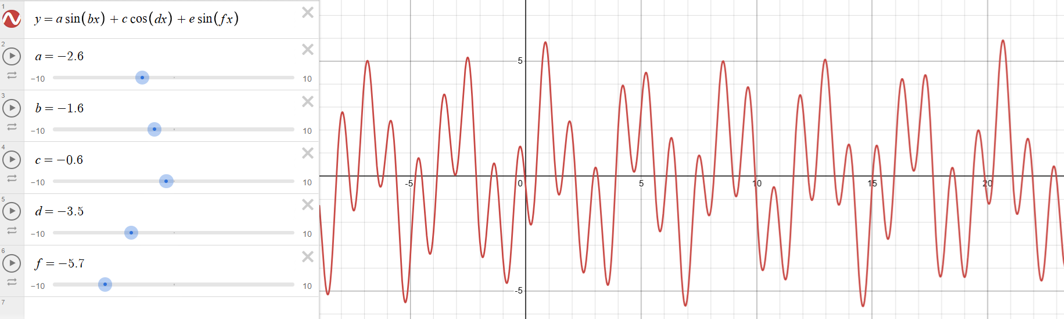
(a visual representation of the random wave progression using graphic calculator Desmos)
As mentioned in the function design section, the fish movement uses mathematical wave patterns, shown above using Desmos.
For the GUI, I plan to include multiple fish species, each represented with its own sprite PNG. The sprites use a simplified pixel art style with a cartoony look. This reduces rendering load and keeps the visual design consistent across different fish types. Pixel art is also easier to produce and integrate into the program compared to high detail graphics, which helps maintain development efficiency. Since the game targets a casual audience rather than a professional one, this style improves accessibility and visual appeal for general players.
During the early development, the fish will be represented using a simple orange Tkinter oval instead of an imported image. This reduces unnecessary complexity while the main mechanics are being developed and tested. Using a built in shape also avoids image importing issues and unwanted interactions between assets.
The fish sits on the top layer of the canvas so it never becomes obstructed by other interface elements.
Link to 1.7 Success criteria:
- Fu7 – multiple fish types and behaviours
- W1 – fish movement with wave function
- W4 – fish has varied wave pattern
- Fu2 – game asset moves smoothly
- W2 – movement is smooth
- W3 – wave variable control movement

2.5.3 Fishing Bar
The fishing bar acts as the main movement area for gameplay and defines the vertical range where the fish can move. The fish moves up and down within set limits to simulate wave motion.
The bar will be designed in the same pixel art style as the fish, with a background of light colour with a bold outline. I will avoid using colours that are similar to the fish sprite colour. This ensures there is always strong contrast between the fish and the fishing bar, regardless of the fish’s position within the bar, making it easier to track movement during gameplay.

The bar also serves as the coordinate reference for the fish, green bar, and collision detection, where all elements update continuously to link input with game state and provide responsive visual feedback.
Link to 1.7 Success criteria:
- U1 – Main game window displaying fishing environment
- U3 – consistent colour scheme

2.5.4 Green Bar
The green bar represents the player controlled detection area. It moves vertically within the same boundaries as the fishing bar and matches its width so it appears visually contained inside it. A dark, highly saturated green colour is used to make the bar easy to identify quickly during gameplay. The green bar is layered above the fishing bar but below the fish so all assets remain visible at all times.
The green bar’s behaviour is validated by boundary checks to ensure it never leaves the fishing bar. This prevents invalid states and maintains consistent gameplay.
Link to 1.7 Success criteria:
- Fu3 – calibration system detects player input
- U4 – visual indicator conveying instructions without text
- A5 – gameplay visibly reflects difficulty changes
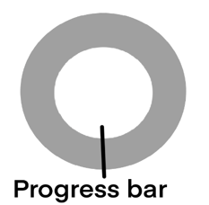
(Progress
bar at 0%)
(Progress
bar at 40%)

2.5.5 Progress Bar
The circular doughnut-shaped progress bar shows the player’s fishing progress in real time. Its position on the top right of the screen and shape make it easy to distinguish from the other vertical gameplay elements on screen. It provides continuous visual feedback on performance by filling when the fish is inside the green bar and decreasing when it leaves.
I plan to create the doughnut shape by first drawing a grey circle as the background layer. I will then add a green arc on top, where the arc angle increases based on the current progress value. Finally, I will place a smaller circle in the background colour over the centre to remove the middle section, forming the doughnut effect.

Link to 1.7 Success criteria:
- Fe1 – provides visual feedback after successful catch
- Fe2 – progress counter that updates in real time
- Fe4 – feedback appears immediately after action
- U4 – visual indicator without text instructions

2.5.6 Pause menu
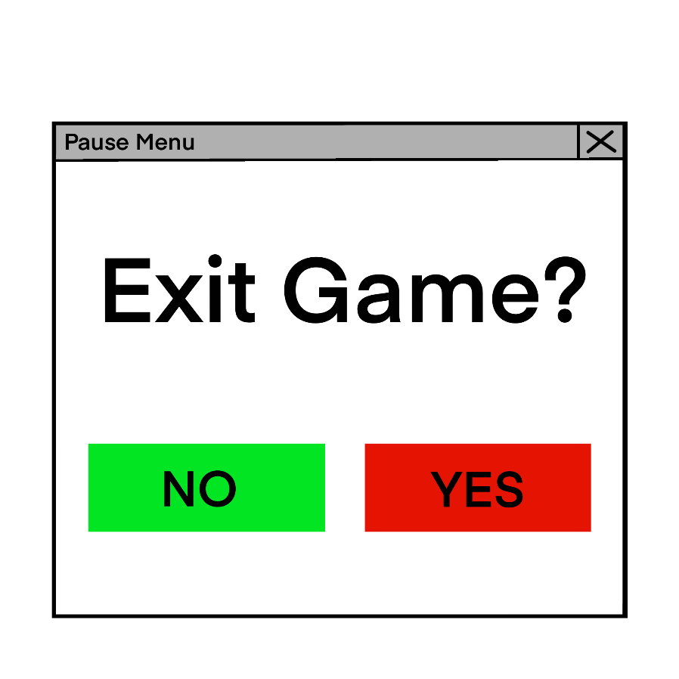
The pause menu appears as a pop up when the ESC key is pressed. It overlays the main gameplay screen and temporarily stops player interaction so the current state of the game is not affected while the menu is open. A large text prompt displays the message “Exit game?” to clearly communicate the action being confirmed.
The menu includes two options. A green “No” button is used to keep the player in the game and continue playing, while a red “Yes” button confirms exiting the game. The use of strong colour contrast helps separate the choices and guides the player’s attention quickly during decision making. The layout is designed to reduce accidental exits by making the exit option visually distinct and requiring a deliberate selection.

Link to 1.7 Success criteria:
- Fu4 – large stop button to exit gameplay
- Fu6 – crash prevention
- U8 – accessible and appropriately sized buttons

2.5.7 Title Screen

The title screen will contain three buttons, where each button represents a different starting difficulty for the game. This gives players direct control over the challenge level before gameplay begins and makes the menu simple to understand without needing extra instructions.
I chose to keep the same colour scheme across all three buttons because the title screen is designed for selection rather than warning or confirmation like the pause menu. Using strong contrasting colours would make the interface feel too harsh and distracting for the user. Instead, I will use text labels such as “Easy”, “Normal”, and “Hard” to communicate the difficulty clearly. This keeps the layout cleaner, more accessible, and supports the calm, low pressure atmosphere I want the game to have.

2.6 Solution using Validation
Validation is used throughout the program to maintain stable behaviour and prevent invalid data from affecting gameplay. The following list shows the main validation checks used within each function, presented in the same order as the flowchart. Other validation methods also exist across the program and are explained in more detail in the development section.

Function | Validation method | How it is achieved | Why it is needed
Green bar position update | Limit checking | The bar’s position is kept between a set minimum and maximum value | Stops the bar from moving outside the playable area
Progress value update | Minimum value check | The progress value is checked each update and reset if it goes below zero | Prevents negative values that would cause errors in the progress system
Progress bar appearance update | Condition check | The progress bar is only drawn when the progress value is above zero | Avoids drawing unnecessary elements on the screen
Game pause control | Pause flag check | All movement and logic stop when the pause flag is active | Ensures the game fully pauses without breaking ongoing processes
Fish initialization | Data validation with fallback | A fish with sprite is only created if valid data exists; otherwise a backup option such as plain shape is used | Prevents crashes caused by missing or invalid fish data
Movement speed calculation | Scaling within set limits | Rarity values are converted into a controlled speed range | Keeps fish speeds consistent and prevents extreme values
Fish selection system | Data validation using input verification | Rarity values are checked to ensure they are positive and normalised before probability selection is applied | Prevents invalid or zero-weight entries from breaking the selection system
Wave pattern generation | Random values within limits | Movement values are randomly generated but kept within a fixed range | Produces smooth and predictable movement instead of random spikes
Fish position update | Boundary clamping | Fish positions are updated but restricted to stay inside the play area | Stops fish from leaving the screen and becoming uncatchable
Detection area check | Overlap validation | Fish and green bar coordinates are compared to confirm valid spatial overlap | Ensure only true collisions trigger increment of progress
Difficulty adjustment after catch | Output validation using capped adjustment values | Difficulty offsets are checked to ensure they remain within an allowed adjustment range | Prevents sudden extreme difficulty spikes or drops that would destabilise gameplay

2.7 Input output table
Input | Asset Affected | Process | Output
Hold space bar | Green bar | Sets velocity to lift, overcoming gravity to move the bar upward. | The green bar rises within the fishing column.
Release Space bar | Green bar | Reverts velocity to gravity constant, pulling the bar downwards | The green bar falls toward the bottom of the column.
Press Escape Key | Game State / Menu | Pauses all movement loops and triggers a popup window. | Game freezes and the "Want to end the game?" menu appears.
Click “Yes” (Pause Menu) | Overall Application | Saves the final fish count and exit the game windows | The game window closes along with any additional pop-ups
Click "No" (Pause Menu) | Game State | Closes the popup window and resumes all the function loops | The menu disappears and gameplay continues.

2.8 Stage plans
I decomposed the project into nine stages after defining the required functions and variables. I chose nine stages to distribute the workload evenly across the required functions. This structure follows a logical incremental progression. Each stage incorporates the code from the previous phase while adding or modifying features. I used bullet points for this plan to avoid overplanning. This approach prevents me from restricting my options too much during development. I decided to keep specific details out for now.
Iteration is helpful because I can test each module as I build it. This helps me find and fix errors early in development. I can modify or add inputs for specific stages without affecting the rest of my code. This process also ensures I have functional backups at each stage if I need to revert my changes.

2.8.1 Stage 1: Layout and Display Setup
- Initialize the game window and coordinate system to work across different screen sizes.
- Draw the fish sprite and use simple rectangles to map out where the UI elements sit.
- Create a basic layout to ensure the visual components do not overlap or move out of bounds.

2.8.2 Stage 2: Green Bar Physics and Logic
- Program the green bar to rise when you press the space bar and fall due to gravity when you release it.
- Create a variable to track if the fish and the bar are touching.
- Set up a timer that increases while the fish is inside the bar and resets at the start of each round.

2.8.3 Stage 3: Circular Progress Bar and Success Events
- Draw a green circular sector that grows as the fish remains in the bar; redraw the center circle to keep the donut shape.
- Implement logic to shrink the sector if the fish leaves the bar to show progress loss.
- Trigger a win event once the progress bar is full and reset the game state for the next fish.

2.8.4 Stage 4: Fish Movement Patterns and Performance Scaling
- Use trigonometric equations to move the fish up and down in a predictable pattern.
- Calculate a performance decimal by comparing time spent in the bar against total time.
- Use this decimal to adjust the speed and randomness of the fish to match user skill levels.

2.8.5 Stage 5: File Handling and Modularization
- Organize the code into separate modules to keep the logic clear and easy to manage.
- Write subroutines to save and load user scores or settings from an external text or data file.
- Link the different parts of the program so data flows correctly between the game and the storage system.

2.8.6 Stage 6: Object-Oriented Fish Generation
- Use classes to define fish objects with specific traits like speed and difficulty.
- Implement a weighted randomizer to decide which fish spawns based on rarity.
- Apply the difficulty settings from earlier stages to the attributes of each new fish object.

2.8.7 Stage 7: Starting screen and Pause Menu
- Build a start screen, a pause menu, and a difficulty selection interface.
- Create a main loop that switches the screen display based on the current game state.
- Finalize the UI design to provide clear feedback and navigation for the user.

2.8.8 Stage 8: Fish Sprite and overall GUI tidy up
- Replace placeholder shapes with images to improve visual quality and make the fish and UI look more realistic
- Add a folder to store PNG sprite files and import them into the program for fish graphics
- Improve the GUI layout by organising interface elements and adding visuals such as title images

2.8.9 Stage 9: Reviewing and improving maintainability
- Add comments, annotations, and descriptions to make future development easier to understand and follow
- Remove unnecessary code and debugging code to keep the program clean and efficient
- Organise functions more clearly and separate them into modules to improve structure and maintainability

2.9 Test plan

2.9.1 Testing method
Throughout development, each feature of the fishing game will be tested as it is created to make sure it functions correctly before moving onto the next stage. This helps identify bugs early and ensures the final game remains stable and functional. Testing each stage individually also makes debugging easier because problems are isolated to smaller sections of the program.
The testing during development will include both the player inputs and the program outputs. This includes testing movement controls, fishing interactions, scoring systems, timers, menus, and user interface elements. I will compare the expected result with the actual result to confirm whether the feature behaves correctly. If any errors or crashes occur, I will record the console output and use debug information such as variable values to identify the cause of the issue.
I have downloaded Carnac, a keylogger tool which displays key presses on screen in real time. This improves testing because the exact keyboard inputs used during gameplay are visible in the recording. This makes troubleshooting easier and also helps demonstrate how the game responds to player controls.
Because this program relies heavily on the GUI, most testing will use screen recordings as evidence. I will test during and after each development stage to check the stage requirements. Each stage will have its own recording showing the relevant features, as well as both the player input and the resulting output from the game. After development is complete, I will conduct a final round of testing. This will include normal gameplay testing, boundary testing, and destructive testing to ensure the game behaves correctly under incorrect or unexpected conditions.
After the testing is complete, I will show the program to the stakeholders to confirm that the game meets the original requirements and to gather feedback on any improvements or additional features they would like added.

Destructive testing
Destructive testing will involve intentionally providing incorrect or unusual inputs to see how the program handles them. For example, I will rapidly press keys, attempt invalid menu interactions, resize the game window unexpectedly, or interrupt gameplay actions to check whether the game remains stable. I will also test situations such as missing assets or invalid game states to see if suitable error handling is in place.

Iterative development
I will use iterative development to develop this fishing game. This means the program will be divided into smaller problems and features, such as player movement, fishing mechanics, scoring systems, and menus, which will each be developed separately. After each stage is completed, the feature will be tested before moving onto the next stage.
This process allows the game to gradually develop through multiple working prototypes. Testing after every stage helps identify bugs early, improves stability throughout development, and ensures each feature works correctly before more systems are added. The process will continue until the final version of the game is complete.

2.9.2 Test Data
Testing data for this fishing game mainly consists of keyboard inputs and gameplay interactions. The game is response based, so there is no large dataset or complex user input required. Most tests will involve actions such as movement, fishing, menu navigation, and timing-based interactions to check whether the game responds correctly.
Because the program mainly reacts to key presses, the exact testing data used is not highly important. The focus of testing is whether the correct output is produced from the input given. I will also test unusual situations, such as rapid key presses or interrupted actions, to check stability and error handling.
Most testing will be carried out by me to keep the results more consistent. Using the same person for testing helps reduce differences in reaction speed and gameplay behaviour, making it easier to compare results across different stages of development.
Testing evidence will mainly use screen recordings, screenshots, console outputs, and visible key presses recorded using Carnac.

2.9.3 Test Design for Final Testing

No. | Test detail | Data to be used | Type of test | Expected result | Link to success criteria
T1 | Verify starting screen appears and launches main game window | Open program and press start | Normal | Starting screen appears and loads main fishing window correctly | U5
T2 | Verify difficulty selection buttons change gameplay | Start game using each difficulty option | Normal | Fish movement speed changes depending on selected difficulty | U6, Fu1
T3 | Verify instructions visible on screen | Observe UI before gameplay | Normal | Clear instructions displayed to player | U7, U4
T4 | Verify interface is simple and uncluttered | Observe UI layout | Normal | Only essential UI elements visible and readable | U2
T5 | Verify consistent colour scheme and readable text | Observe UI elements | Normal | Text readable and colours consistent across screen | U3, U1
T6 | Verify fish moves using wave based motion | Observe fish movement and print motion values | Normal | Fish follows smooth oscillating wave motion | W1, W3
T7 | Verify fish animation remains smooth during gameplay | Run game continuously | Normal | Movement remains smooth without stuttering | W2, Fu2
T8 | Verify multiple fish types appear | Catch several fish | Normal | Different fish sprites and behaviour visible | Fu7, W4
T9 | Verify progress increases when fish inside bar | Hold bar over fish and print progress | Normal | Progress increases steadily | Fe2
T10 | Verify progress decreases when fish outside bar | Move bar away from fish | Normal | Progress decreases gradually | Fe4
T11 | Verify progress upper boundary | Keep fish inside for long period | Boundary | Progress stops increasing at maximum | Fe1
T12 | Verify progress lower boundary | Keep fish outside continuously | Boundary | Progress never drops below minimum | Fe1
T13 | Verify green bar responds to input | Press input key repeatedly | Normal | Bar moves up when pressed | U8
T14 | Verify green bar falls when input released | Release input key | Normal | Bar moves downward | W5
T15 | Verify green bar upper boundary | Hold input continuously | Boundary | Bar stops at top limit | A6
T16 | Verify green bar lower boundary | Leave input unpressed | Boundary | Bar stops at bottom limit | A6
T17 | Verify automatic difficulty increases after success | Catch multiple fish | Normal | Fish becomes harder to catch | A1, A4
T18 | Verify automatic difficulty decreases after failure | Fail multiple attempts | Normal | Fish becomes easier to catch | A2, A8
T19 | Verify difficulty boundary values | Force extreme performance values using print | Boundary | Difficulty remains within playable range | A3, A6
T20 | Verify pause system stops movement | Activate pause and print values | Normal | Fish and progress stop updating | A5, A7
T21 | Verify pause exit closes game safely | Pause and choose exit | Normal | Program closes and saves data | Fu4
T22 | Verify relaxed gameplay with no penalties | Leave fish uncaught | Normal | Game continues without forced loss | Fu5
T23 | Verify calibration detects input accurately | Press and release input repeatedly | Normal | Movement reflects input immediately | Fu3
T24 | Verify saved data persists after restart | Catch fish then restart | Normal | Fish count retained | Fu9
T25 | Verify performance logging saved correctly | Catch multiple fish | Normal | Performance data recorded correctly | Fe3
T26 | Verify program runs long duration without crash | Leave running extended time | Stress | No crashes occur | Fu6
T27 | Verify UI scales to different screen sizes | Run on different resolutions | Compatibility | UI elements remain visible | Fu8

Development

3.1 Stage 1 – Layout and Display Setup
For this stage, I plan to set up the canvas with Tkinter and lay out a foundation for further code. The different assets of the game should be marked out, each with simple shapes as placeholders; in future stages, they can then be replaced with detailed UI elements. My main objectives are:
- Create a blank canvas in a new window that pops up when the code is run
  - The window should automatically be set to full screen
  - It should also be compatible with most hardware
- Mark out the rough location of assets using simple shapes
  - Place a grey vertical rectangle (fishing bar) on the right side of the screen. This should take up most of the vertical screen.
  - Place a smaller green horizontal rectangle (green bar) inside the fishing bar. The width should be the same as the fishing bar
  - Place a doughnut-shaped empty progress bar on the top right corner of the screen. The doughnut should be created out of a larger grey circle placed underneath a smaller white circle.
  - Place a text box on the bottom right corner, including texts such as money, fish caught, level, etc.
  - Place an orange circle (this will later be replaced with images of fish; it acts as a temporary place holder) inside the fishing bar
The left side of the window will be left blank on purpose as in future stages I plan to add an animation of a fisherman hooking a fish to add visual interest to the game.

GUI layout plan:

3.1.1 Stage 1 Test Plan

*Since this stage is highly GUI-oriented, the testing process will primarily involve manual evaluation. However, by commenting out specific sections of the code, I can still perform isolated tests on individual modules.

In addition, I can conduct usability and adaptability tests to assess how the program performs under different hardware. Currently, it’s challenging to access multiple physical machines for cross-platform testing, but in the future, I plan to use virtual machines to run the program on different operating systems.

Test No. | Test | Data to be used | Type of test (Normal/Boundary/Erroneous) | Expected Result
1 | Basic window set up | N/A | Normal | A blank window should appear and fill in the whole screen
2 | Fishing bar set up | N/A | Normal | A grey rectangle with black boarder should appear on the centre-right side of the screen.
3 | Green bar set up | N/A | Normal | A smaller green rectangle should appear in the middle of the fishing bar. The rectangle should be within the boundary of the fishing bar.
4 | Fish set up | N/A | Normal | An orange sphere should appear completely within the perimeters of the green bar.
5 | Progress donut set up | N/A | Normal | A grey donut should appear around the top right corner of the screen.
6 | Text box set up | N/A | Normal | A text box containing some text should show up on the bottom right of the screen
7 | All of asset 2-6 set up on same canvas | N/A | Normal | All the assets mentioned above should show up together in the canvas.

3.1.2 Stage 1 Code Analysis

Objective 1.a.i - window should be full screen

Objective 1.a.ii - should be compatible with hardware
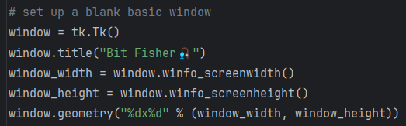

Line | Description
1 | I created a blank window with the title “Bit Fisher” using tkinter’s built-in method tk.TK().
2
3 | I then obtained the width and height of the screen of the current device through the Python function winfo_screen(width/height)
4
5 | The window.geometry() method takes a string in the format "widthxheight" to define the window’s dimensions in pixels. I use "%dx%d" as a format string where %d placeholders are replaced with the values of window_width and window_height from lines 3-4. This will set up a window the exact size of the screen, regardless of the device used.

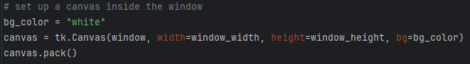

Line | Description
1 | The background colour of the canvas is set to white temporarily
2 | A canvas is drawn inside the window just created using tkinter’s .Canvas method. Canva is used rather than the window, as it provides a wider range of possible widgets and makes adding widgets easier. It utilises the width and height obtained earlier as dimensions.
3 | The canvas is packed into the window

Objective 1.b.i – fishing bar appearance
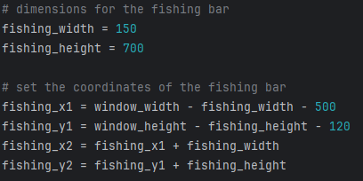

Line | Description
1 | Sets the initial dimensions of the fishing bar, this can then be used later to generate the coordinates of the rectangle
2
3 | Determines the x and y coordinates of the top-left corner of the rectangle by subtracting from the dimensions of the screen obtained earlier in 1.a. This ensures that no matter what device is running the program, the fishing bar should always be situated near the right side of the screen
4
5 | Calculates the x and y coordinates of the bottom-right corner of the rectangle. By using the previously computed values from lines 3 and 4, any future changes to the fishing bar’s width or height can be easily accommodated. Which ensures flexibility and maintainability.
6

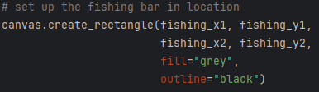

Line | Description
1 | Using the coordinates calculated, in the order top-right -> bottom left, sets up the rectangle in location
2
3 | Temporarily sets the fill of shape to grey and outline to black, this can then be changed in later stages
4

Objective 1.b.ii – green bar appearance
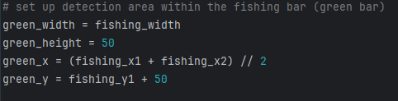

Line | Description
1 | Inherits the same width from 1.b.i of the fishing bar. This ensures the green bar will always stay inside the bar
2
3 | Sets the centre of the green bar by finding the midpoint of the x-coordinates of the fishing bar. This can later be used to draw the rectangle by adding or subtracting the width.
4 | The y-coordinate is calculated by adding the height of the green bar to the y-coordinate of the top of the fishing bar, positioning the green bar somewhere along the top section of the fishing bar.

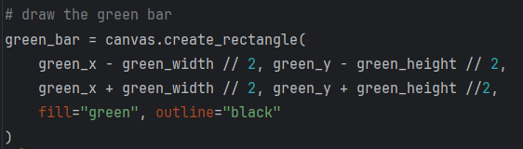

Line | Description
1 | Using the midpoint coordinate obtained earlier, subtract half the width of the green bar from it to find the x-coordinate of the leftmost point. To find the x-coordinate of the rightmost point, add half the width of the bar instead
2
3 | The same is then done for the y coordinates

Objective 1.b.iii – progress bar appearance

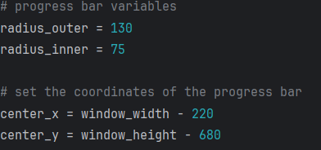
Line | Description
1 | Since the progress bar is doughnut-shaped, I plan first to draw a larger grey circle, then cover its centre with a smaller circle matching the background colour to create the hollow effect. Here I am initialising the two variables for radius.
2
3 | The centre of the circle is determined by subtracting the values obtained for the device’s height and width in Objective 1.a, ensuring that the doughnut remains positioned at the top-right corner of the screen. Since the shapes are concentric, they share the same centre; therefore, the same variable can be used to generate both.
4

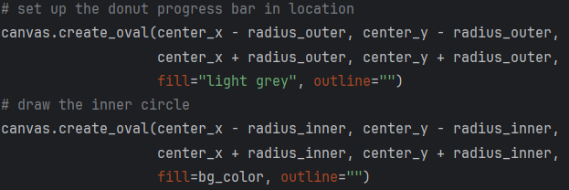

Line | Description
1 | Using the Tkinter function create_oval, I can draw the larger circle. The parameters are set as follows: the top-left coordinate of the circle is obtained by subtracting the radius from the centre’s x and y coordinates, while the bottom-right coordinate is obtained by adding the radius to the centre’s coordinates.
2
3
4 | This procedure is then repeated for the smaller circle, with the only difference being the radius value.
5
6

Objective 1.b.iv – text box appearance
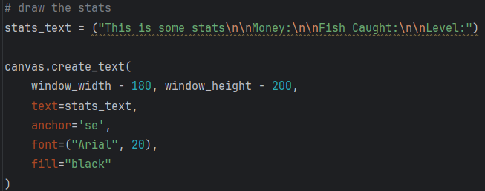

Line | Description
1 | Store the displayed text in a single variable for easier access later. Using the \n notation, I can start a new line for each different stat.
2 | Draw the text onto the canvas, positioning it near the bottom-right corner using the width and height variables obtained in Objective 1.a. Use the text stored in the variable from the previous step, set the anchor to SE (bottom-right), and format the text in Arial with black colour.

Objective 1.b.v – fish appearance

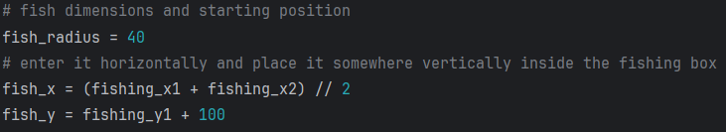
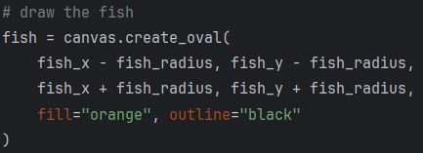

Line | Description
1 | For now, the fish will be represented by an orange circle with a radius of 40. This ensures that the fish fits easily within the fishing bar from 1.b.i and it is large enough to serve as a target for the green bar from 1.b.ii.
2 | The centre of the circle will again be the midpoint of the fishing bar, calculated by adding the two x-values and dividing by two.
3 | The fish will appear along the top half of the fishing bar, so its y-coordinate is obtained by adding an offset to the fishing bar’s y-coordinate.
4 | Similar to 1.b.iii with the progress bar, the fish is drawn using the top-left and bottom-right corner coordinates, which are obtained by subtracting and adding the radius from the centre coordinates.

3.1.3 Stage 1 Validation
Below are the validations implemented in this stage and their justification:
Validation check | What is being validated | How it is done in code | Why it is implemented | Why it is important
Screen size retrieval | Window fits the user’s display | window.winfo_screenwidth() and window.winfo_screenheight() are used to get device dimensions | Prevents fixed window sizes that break on different monitors | Keeps the UI visible and usable on different screen sizes
Full screen window setup | Window fills the screen correctly | window.geometry uses the retrieved width and height values | Avoids partial windows or scaling issues | Ensures consistent layout space for all UI elements
Relative positioning of assets | UI elements stay within visible bounds | Coordinates use screen width and height with offsets such as window_width - value | Prevents elements from going off screen | Maintains a stable layout across resolutions
Fishing bar boundary definition | Fishing area is correctly contained | fishing_x1, fishing_y1, fishing_x2, fishing_y2 define a fixed rectangle area | Ensures other elements reference a valid area | Provides a clear structure for placing interactive elements later
Center alignment of elements | Fish and green bar stay centered horizontally | Midpoint calculated using (x1 + x2) // 2 | Avoids misalignment inside the fishing bar | Keeps visual balance and predictable positioning
Containment of inner elements | Fish and green bar stay inside fishing bar | Their positions are derived from fishing bar coordinates | Prevents overlap or rendering outside the bar | Ensures correct gameplay area for future logic
Consistent dimension usage | Shapes maintain correct proportions | Fixed variables such as radius_outer, fishing_width, fish_radius are reused | Avoids inconsistent sizing across elements | Keeps the UI visually coherent and easier to manage
Layered drawing for progress bar | Donut shape renders correctly | Larger grey oval is drawn first, smaller inner oval overlays it | Prevents incorrect visual stacking | Ensures the progress bar appears as intended
Text placement validation | Stats text stays visible in bottom right | Coordinates use screen size with anchor set to 'se' | Prevents text from appearing off screen | Keeps important game information readable

3.1.4 Stage 1 Final Testing
Please also refer to the video stage 1 – testing in the attached file

Test No. | Test | Data to be used | Type | Expected Result | Pass  /Fail | Evidence
1 | Basic window set up | N/A | Normal | A blank window should appear and fill in the whole screen | Pass | 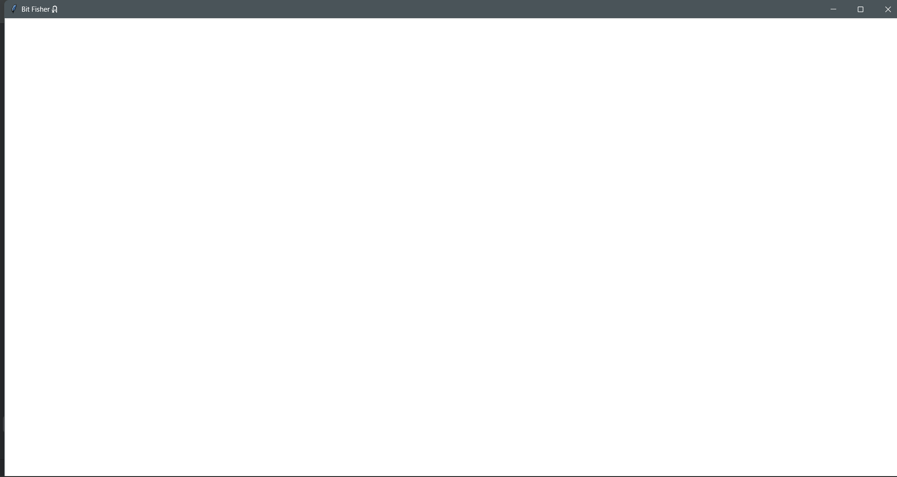
2 | Fishing bar set up | N/A | Normal | A grey rectangle with black boarder should appear on the centre-right side of the screen. | Pass | 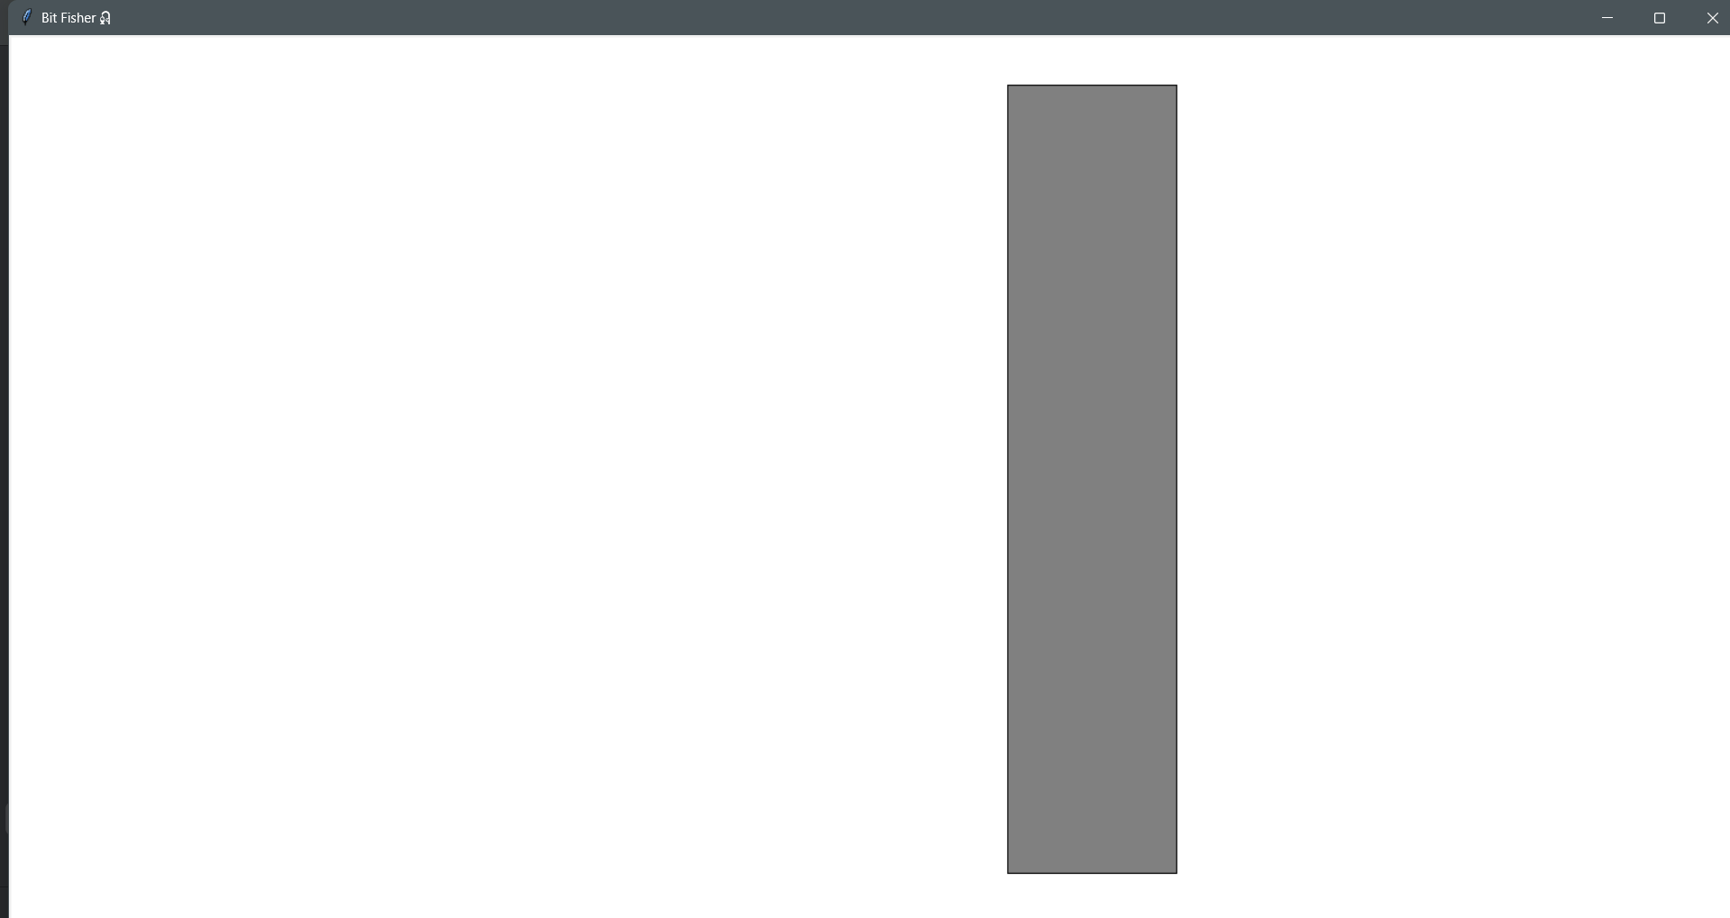
3 | Green bar set up | N/A | Normal | A smaller green rectangle should appear in the middle of the fishing bar. The rectangle should be within the boundary of the fishing bar. | Pass | 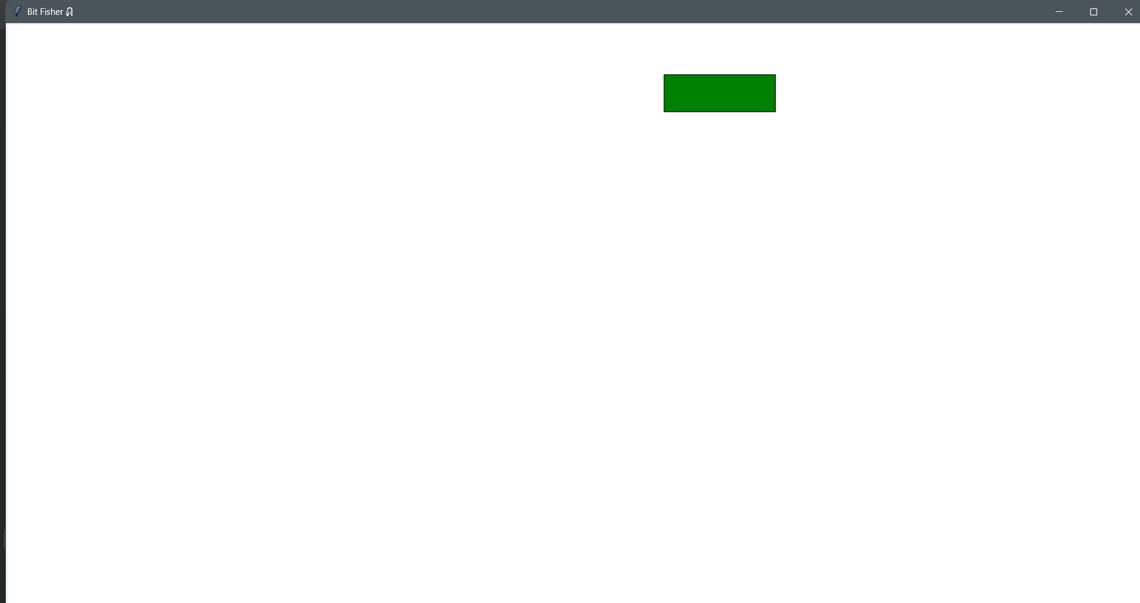
4 | Fish set up | N/A | Normal | An orange sphere should appear completely within the perimeters of the green bar. | Pass | 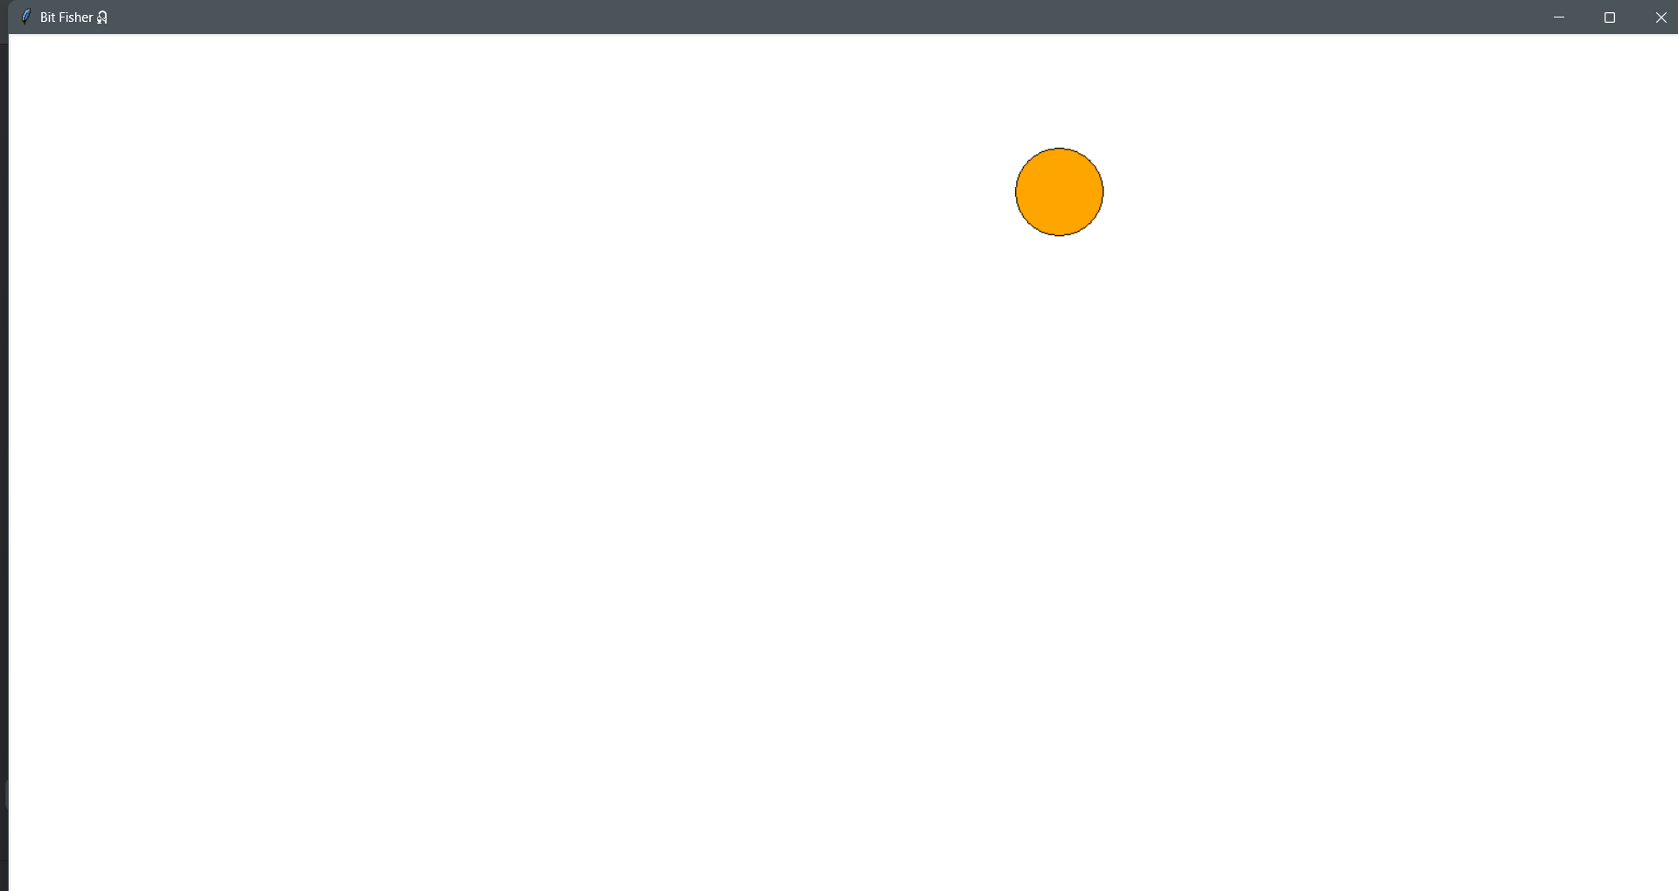
5 | Progress donut set up | N/A | Normal | A grey donut should appear around the top right corner of the screen. | Pass | 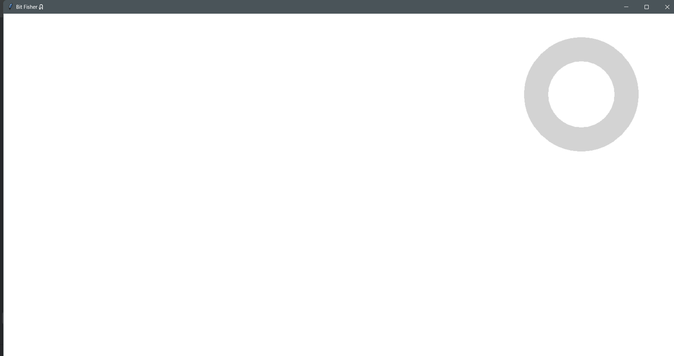
6 | Text box set up | N/A | Normal | A text box containing some text should show up on the bottom right of the screen | Pass | 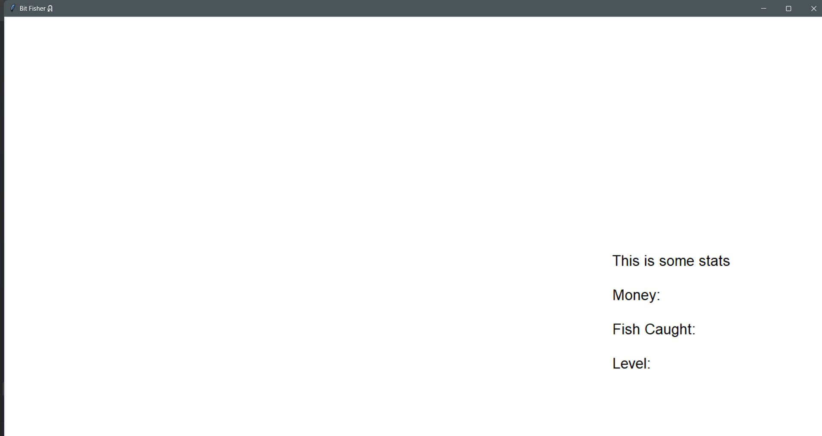
7 | All of asset 2-6 set up on same canvas | N/A | Normal | All the assets mentioned above should show up together in the canvas. | Pass | 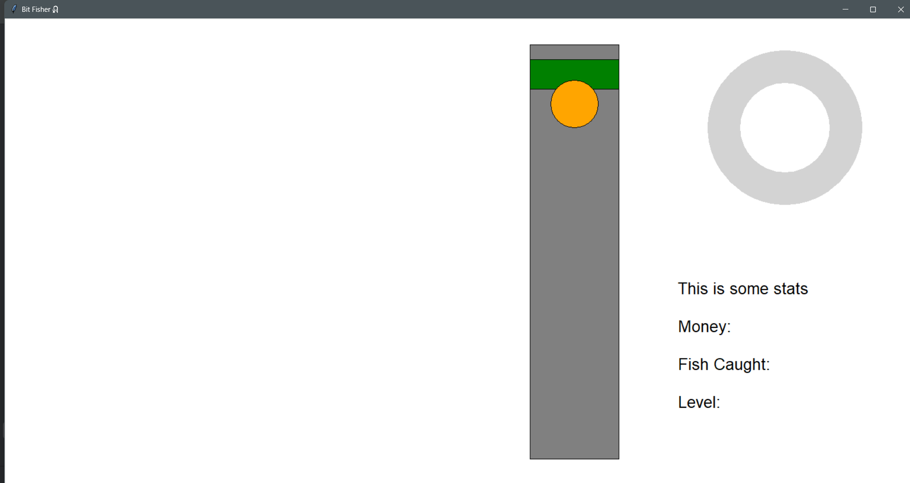

3.1.5 Stage 1 Final program run screen:

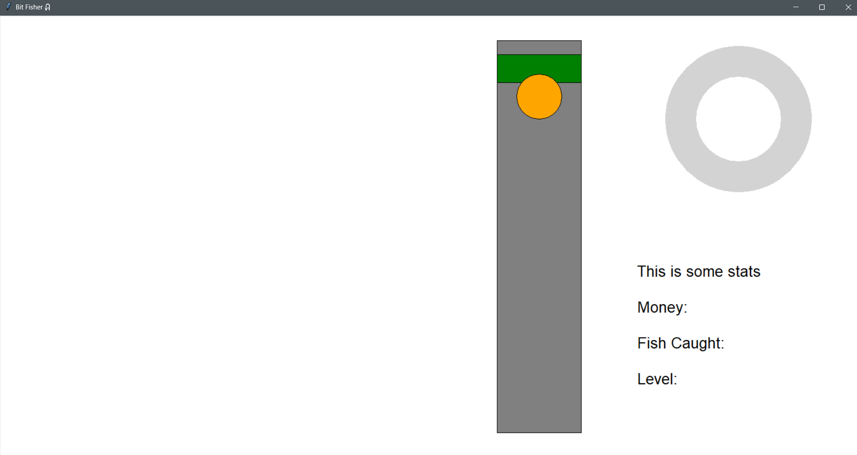

3.1.6 Stage 1 Final code:

import tkinter as tk
# set up a blank basic window
window = tk.Tk()
window.title("Bit Fisher🎣")
window_width = window.winfo_screenwidth()
window_height = window.winfo_screenheight()
window.geometry("%dx%d" % (window_width, window_height))
# progress bar variables
radius_outer = 130
radius_inner = 75
# set the coordinates of the progress bar
center_x = window_width - 220
center_y = window_height - 680
# dimensions for the fishing bar
fishing_width = 150
fishing_height = 700
# set the coordinates of the fishing bar
fishing_x1 = window_width - fishing_width - 500
fishing_y1 = window_height - fishing_height - 120
fishing_x2 = fishing_x1 + fishing_width
fishing_y2 = fishing_y1 + fishing_height
# set up detection area within the fishing bar (green bar)
green_width = fishing_width
green_height = 50
green_x = (fishing_x1 + fishing_x2) // 2
green_y = fishing_y1 + 50
# fish dimensions and starting position
fish_radius = 40
# enter it horizontally and place it somewhere vertically inside the fishing box
fish_x = (fishing_x1 + fishing_x2) // 2
fish_y = fishing_y1 + 100
# set up a canvas inside the window
bg_color = "white"
canvas = tk.Canvas(window, width=window_width, height=window_height, bg=bg_color)
canvas.pack()
# draw the stats
stats_text = ("This is some stats\n\nMoney:\n\nFish Caught:\n\nLevel:")
canvas.create_text(
window_width - 180, window_height - 200,
text=stats_text,
anchor='se',
font=("Arial", 20),
fill="black"
)
# set up the donut progress bar in location
canvas.create_oval(center_x - radius_outer, center_y - radius_outer,
center_x + radius_outer, center_y + radius_outer,
fill="light grey", outline="")
# draw the inner circle
canvas.create_oval(center_x - radius_inner, center_y - radius_inner,
center_x + radius_inner, center_y + radius_inner,
fill=bg_color, outline="")
# set up the fishing bar in location
canvas.create_rectangle(fishing_x1, fishing_y1, fishing_x2, fishing_y2, fill="grey", outline="black")
# draw the green bar
green_bar = canvas.create_rectangle(
green_x - green_width // 2, green_y - green_height // 2,
green_x + green_width // 2, green_y + green_height //2,
fill="green", outline="black"
)
# draw the fish
fish = canvas.create_oval(
fish_x - fish_radius, fish_y - fish_radius,
fish_x + fish_radius, fish_y + fish_radius,
fill="orange", outline="black"
)
window.mainloop()

3.2 Stage 2 – Green Bar Physics and Logic
For this stage, I plan to focus on the green bar. The bar should fall naturally due to gravity and rise in response to the space bar, with its movement constrained within the boundaries of the fishing bar. It should also track the state of the fish, whether it is inside the green bar or not, and store the duration it remains in the bar in a variable. By the end, I aim to achieve the following objectives:
- Implement functionality for the green bar
- When space is pressed, update a variable to indicate this action
- Implement bar physics so that it moves down when the space bar is released, and moves up when space is pressed
- The maximum and minimum of the green bar’s location should not exceed the boundaries of the fishing bar, e.g. when the bar reaches the top, it no longer reacts to the space bar being pressed, as it cannot go any further
- Track the time the fish is inside the green bar
- Detect when the fish is inside and add to a timer
- Reset the timer at the start of each attempt

3.2.1 Stage 2 Test Plan

Test No. | Test | Data to be used | Type of test | Expected Result
1 | Not touching any key | N/A | Boundary | The green bar naturally falls to the bottom of the fishing bar but stops at the bar’s boundary, staying at the bottom once it reaches it.
2 | Pressing keys other than the space bar | [N],[SHIFT],[1]  keys | Erroneous | The bar should not react to keys being pressed and should behave the same as in Test 1.
3 | Tap the space bar for a single time | [Space] | Normal | Pressing the space bar should cause the bar to rise, but it should continue to fall once the key is released.
4 | Keep holding the space bar | [Space] | Boundary | The bar should continue rising toward the top but must not exceed the upper boundary of the fishing bar.
5 | Holding and releasing the space bar to keep the fish within the green bar | [Space] | Normal | The timer should increase while the bar is touching the fish and stop once they are no longer in contact.
6 | Make the timer exceed 1000 | [Space] | Normal | By repeating the procedure in test 5, make the timer exceed 1000 to observe if the timer has an upper limit

3.2.2 Stage 2 Code Analysis

Objective 2.a.i – detecting space input:
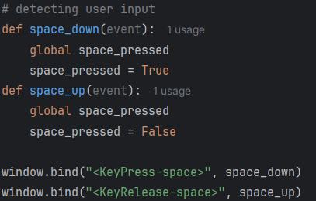

Line | Description
1 | Define a new routine space_down, taking event as a parameter, since Tkinter automatically passes an event object to any function that handles user interactions. Within the routine, set the global Boolean variable space_pressed to True, indicating that the space key has been pressed.
2
3
4 | Similar to lines 1-3, this defines another routine named space_up that sets the variable space_pressed to False when space key is release.
5
6
7 | Using the .bind() function from Tkinter, I can link the action of pressing the space key to the space_down function. This means that when the space key is pressed, the variable space_pressed is set to True.
8 | Similarly, by binding the action of releasing the space key to the space_up function, the variable space_pressed is set to False once the key is released. In other words, it will only remain True while the space key is being pressed.

Objective 2.a.ii – bar physics implementation:
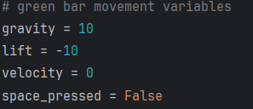

Line | Description
1 | Initialises the variables for the green bar’s movement. The gravity and lift values enable the speed of the bar to be adjusted easily, providing a simpler way to update the green bar’s y-coordinate later on.
2
3
4 | Initialises a Boolean variable for the routines in objective 2.a.i.

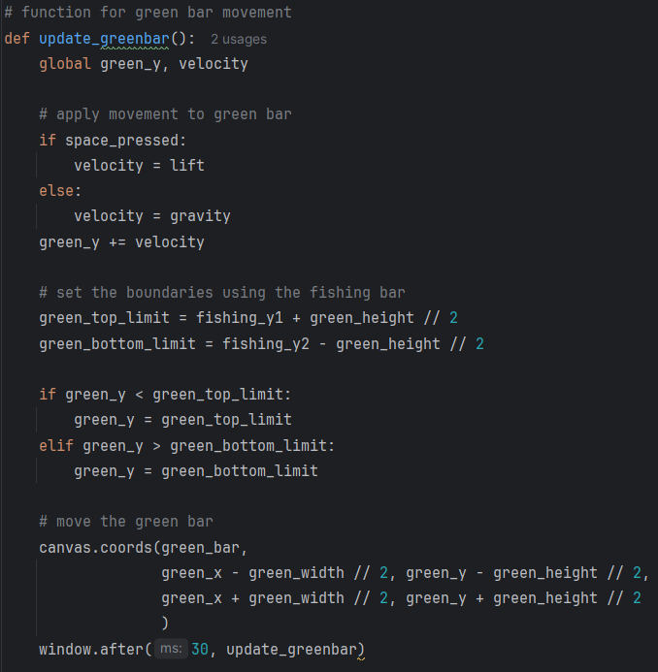

Line | Description
1 | Defines a routine that can be called repeatedly to create an infinite loop, allowing the location to be continuously updated after the program starts running.
2 | Globalising the two variables used to determine the fish’s new y coordinate
3 | Checks the Boolean variable from Objective 2.a.i to determine whether the space bar is being pressed. If it is True, the variable velocity is set to the lift value (a negative number); otherwise, it is set to the gravity value (a positive number). The use of a separate velocity variable helps manage the frequent and rapid changes in movement. By using velocity as an intermediary, the program avoids unintentionally altering the lift and gravity values, ensuring the integrity of the system.
4
5
6
7 | Add the velocity to the green bar’s y-coordinate, enabling it to control the location of the green bar.

(still within the same routine update_greenbar)

Line | Description
1 | By using the .coords() function in Tkinter, I can update the coordinates of the green bar, moving it to a new location. The updated green_y value determines the bar’s position based on whether the space bar is being pressed.
2
3
4 | This routine repeats every 30 milliseconds, allowing the green bar’s position to be continuously updated and refreshed while the program is running.

Objective 2.a.iii – set boundaries for green bar:
(within the routine update_greenbar)

Line | Description
1 | Sets the upper and lower limits of the green bar’s y-coordinate by adding or subtracting half of the green bar’s height to the fishing bar’s y-coordinate. This corresponds to the calculation in 2.1.ii, where the green bar’s position was determined using its center coordinate and adding or subtracting half its height. By reversing this calculation, I can determine the boundaries for the center y-axis.
2
3 | Continuously checks whether the green bar’s y-coordinate exceeds the set upper or lower limits. If it is detected outside the range, the y-coordinate is reset to the nearest limit. This effectively ‘drags’ the green bar back within bounds whenever it goes out of range, making it appear as if it has stopped moving.
4
5
6

Objective 2.b.i – timer for fish detection:
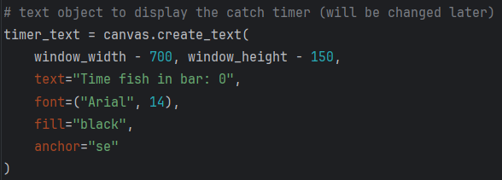

Line | Description
1 | Creates a text element on a Tkinter canvas showing 'Time fish in bar: 0', near the bottom-left of the window in 14-point Arial black font. This will be updated live to display how long the fish stays in the bar, making testing easier, and will be removed in later stages.
2
3
4
5
6
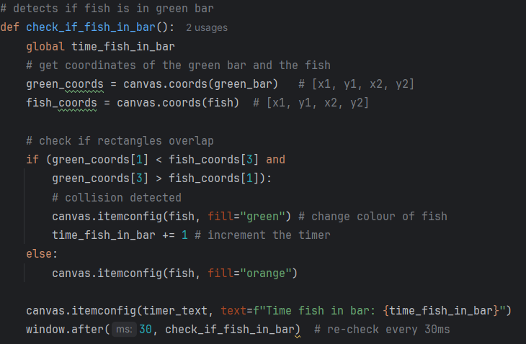

Line | Description
1 | Define a new function named check if fish in bar
2 | A new variable that acts as the timer for when the fish is touching the green bar
3 | By using the .coords() function, I can extract the coordinate arrays of both the fish and the green bar in the format [x1, y1, x2, y2], where [x1, y1] represents the top-left corner and [x2, y2] represents the bottom-right corner of the shape. These coordinates can later be used to compare the positions of the two shapes and determine whether an overlap is occurring.
4
5 | Since the fish and the green bar only move vertically, only their y-axis values need to be compared. The if statement checks the y-coordinates of both shapes to detect vertical overlap. Specifically, it ensures that the top edge of the green bar is above the bottom edge of the fish and that the bottom edge of the green bar is below the top edge of the fish. When both conditions are true, the fish’s vertical position lies within the green bar’s range, indicating that the fish is inside the bar.
6
7 | This line gives visual feedback by turning the fish green, making it easier to test the program and quickly verify whether the detection function is working correctly.
8 | Using the variable set earlier, it increments by 1 whenever the check is performed
9 | The else condition resets the fish to orange, restoring its state when the overlap condition is no longer met.
10
11 | Shows the timer on screen to make testing easier, letting me see it increase when the fish is inside the green bar. The text is set earlier, and here the itemconfig function updates the displayed text with the current variable.
12 | Refreshes the function every 30 ms, ensuring the check runs repeatedly while the program is running.

Objective 2.b.ii – reset timer at start of attempt
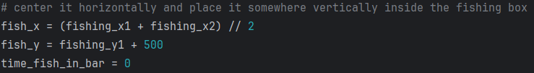

Line | Description
1 | Inherited code from objective 1.b.v.
2 | Inherited code from objective 1.b.v.
3 | Initialises the timer variable at the start of the program

3.2.3 Stage 2 Validation
Below are the validations implemented in this stage and their justification:
Validation check | What is being validated | How it is done in code | Why it is implemented | Why it is important
Space key input handling | The program correctly detects when the player presses or releases the space bar | window.bind connects KeyPress and KeyRelease events to functions that update the Boolean variable space_pressed | Prevents incorrect or delayed input states | Ensures the green bar responds accurately to player actions
Controlled movement physics | The green bar moves up or down based on input state | velocity is assigned either lift or gravity depending on whether space_pressed is True or False | Prevents undefined movement behaviour | Creates predictable and responsive bar movement
Boundary validation for the green bar | The green bar stays inside the fishing bar limits | green_top_limit and green_bottom_limit are calculated from the fishing bar coordinates, then checked with if statements | Prevents the bar moving off screen or outside the playable area | Keeps gameplay fair and visually correct
Continuous update loop validation | Movement and collision checks run repeatedly without freezing the program | window.after(30, ...) is used to repeatedly call update_greenbar and check_if_fish_in_bar | Prevents the interface from becoming unresponsive | Maintains smooth animation and real time interaction
Collision detection between fish and green bar | The program correctly detects when the fish overlaps with the green bar | canvas.coords retrieves object boundaries and compares their vertical coordinate ranges | Prevents false collision detection | Ensures the catch mechanic works correctly
Timer increment validation | Time only increases while the fish is inside the green bar | time_fish_in_bar increases only when overlap conditions are true | Prevents inaccurate progress tracking | Ensures player performance is measured correctly
Visual feedback validation | The player receives clear feedback about collision state | canvas.itemconfig changes the fish colour between orange and green depending on overlap | Prevents confusion about whether the fish is inside the bar | Makes gameplay easier to understand
Timer initialisation validation | The timer starts from a valid value each attempt | time_fish_in_bar is set to 0 before the checking loop begins | Prevents old values carrying into new attempts | Ensures fair and accurate tracking from the start

3.2.4 Stage 2 Final Testing
Please also refer to the video stage 2 – testing in the attached file

Test No. | Test | Data to be used | Type of test | Expected Result | Pass  /Fail | Evidence
1 | Not touching any key | N/A | Boundary | The green bar naturally falls to the bottom of the fishing bar but stops at the bar’s boundary, staying at the bottom once it reaches it. | Pass | 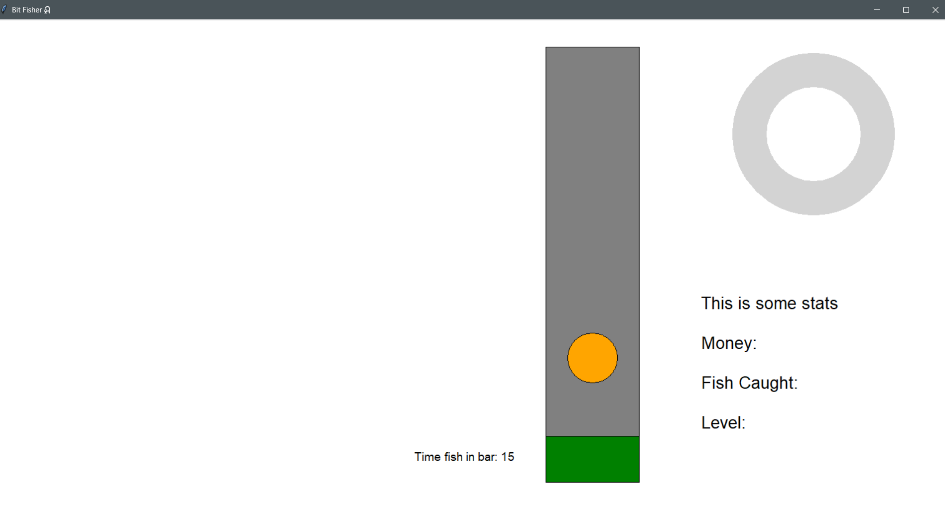
2 | Pressing keys other than the space bar | [N],  [SHIFT],  [1] keys | Erroneous | The bar should not react to keys being pressed and should behave the same as in Test 1. | Pass
3 | Tap the space bar for a single time | [Space] | Normal | Pressing the space bar should cause the bar to rise, but it should continue to fall once the key is released. | Pass | 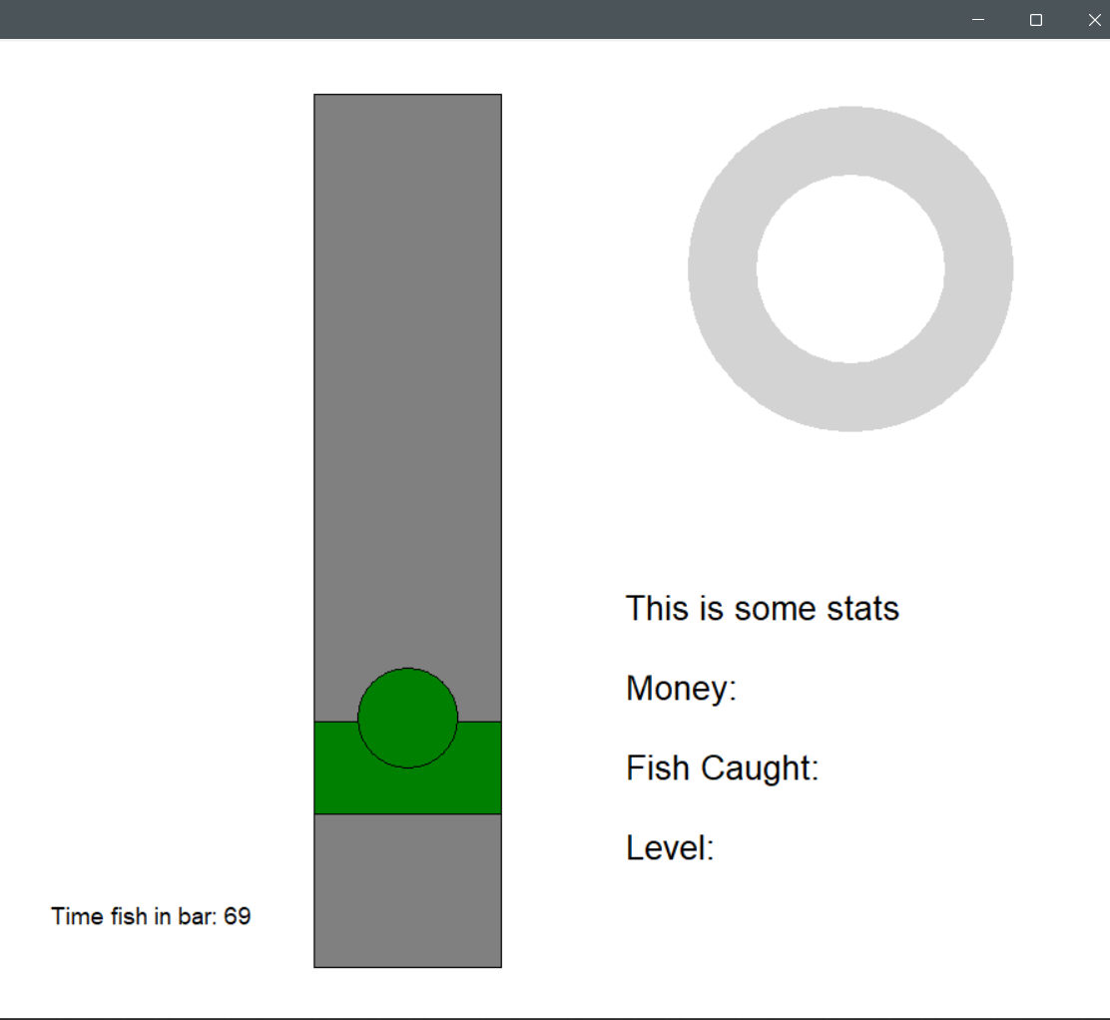
4 | Keep holding the space bar | [Space] | Boundary | The bar should continue rising toward the top but must not exceed the upper boundary of the fishing bar. | Pass | 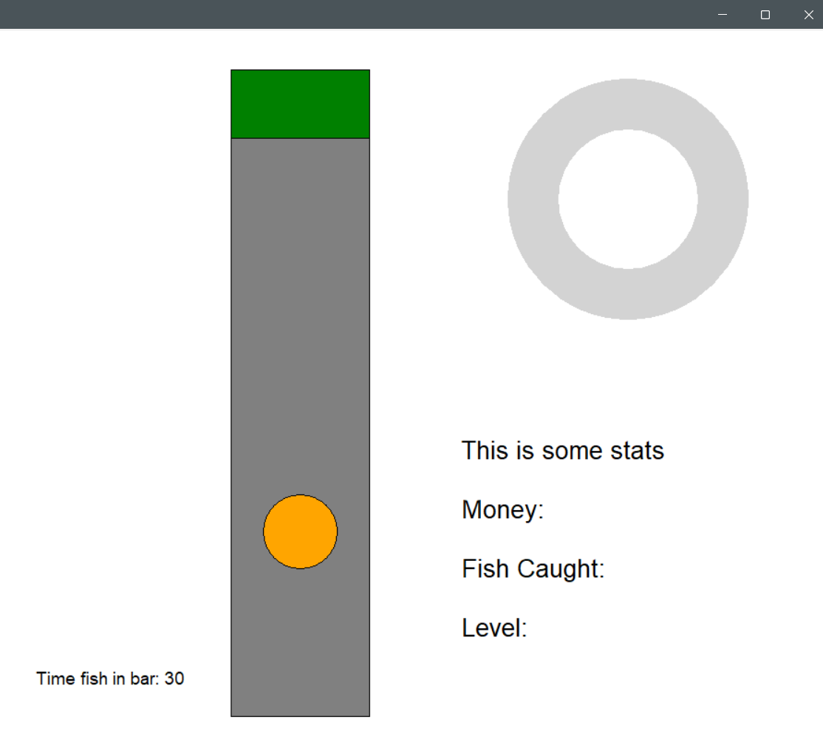
5 | Holding and releasing the space bar to keep the fish within the green bar | [Space] | Normal | The timer should increase while the bar is touching the fish and stop once they are no longer in contact. | Pass | 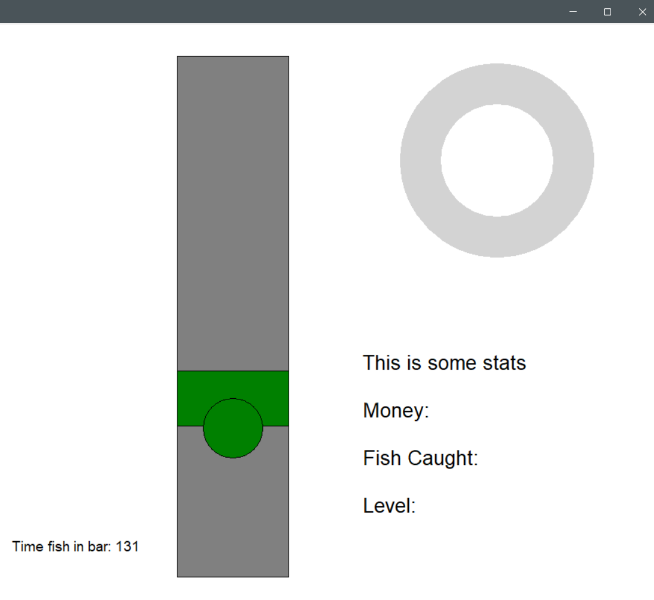
6 | Make the timer exceed 1000 | [Space] | Normal | By repeating the procedure in test 5, make the timer exceed 1000 to observe if the timer has an upper limit | Pass | 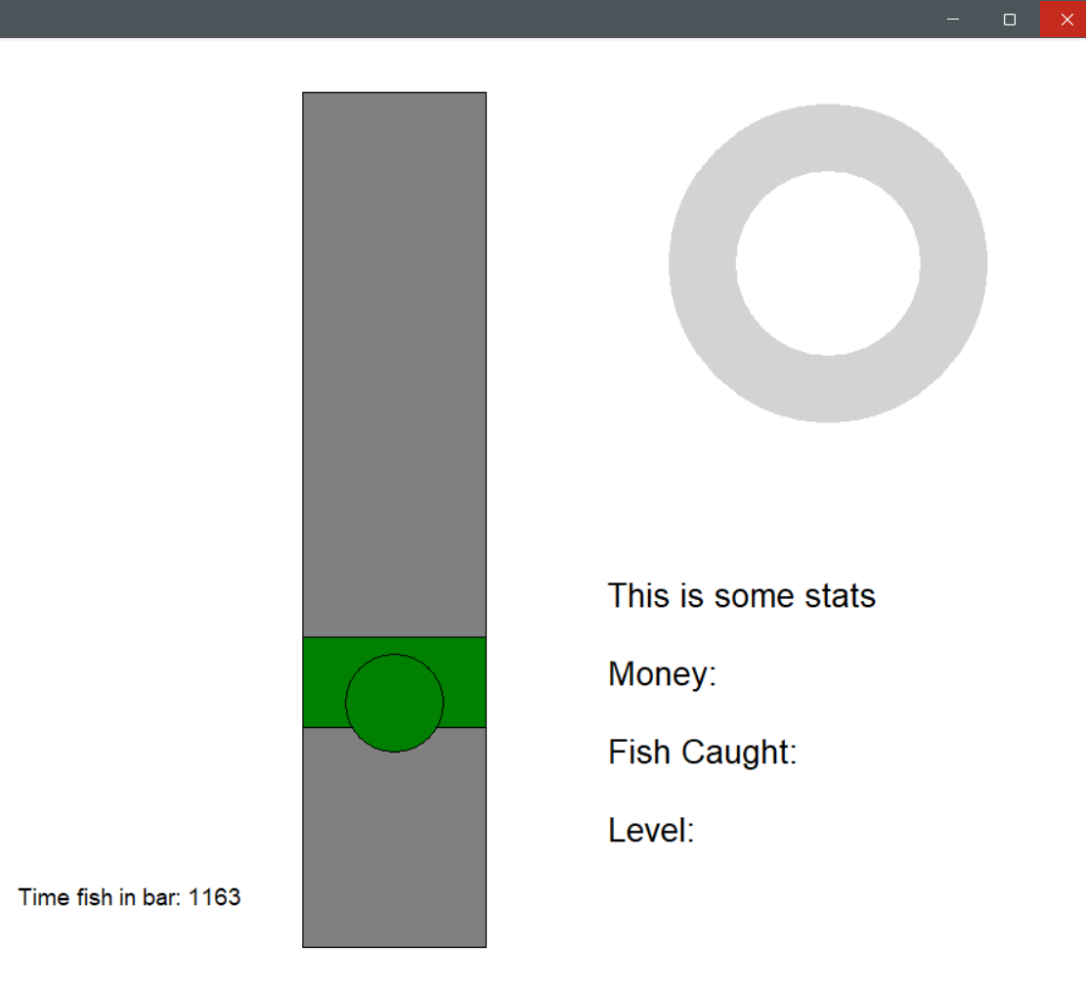

3.2.5 Stage 2 Final program run screen:
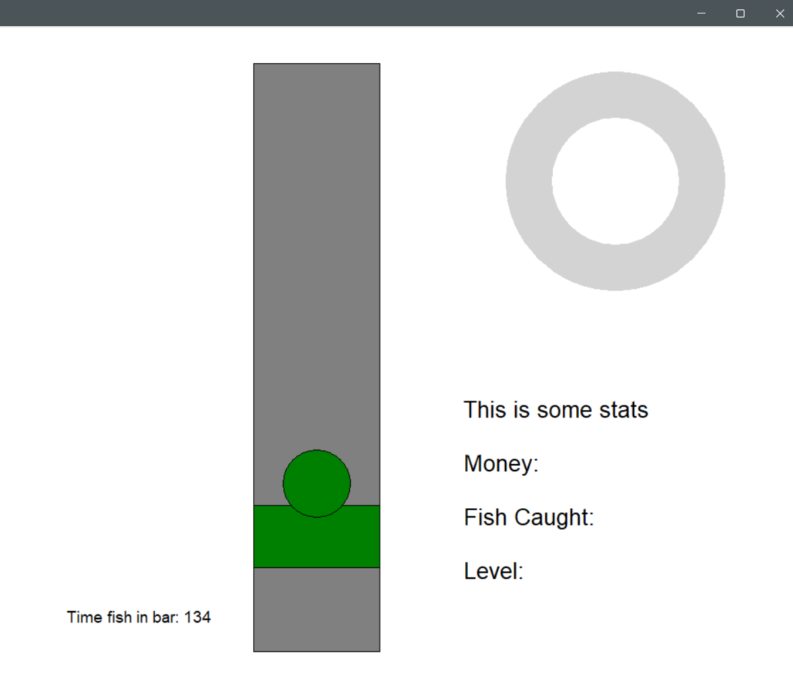

3.2.6 Stage 2 Final code:

import tkinter as tk
# set up a blank basic window
window = tk.Tk()
window.title("Bit Fisher🎣")
window_width = window.winfo_screenwidth()
window_height = window.winfo_screenheight()
window.geometry("%dx%d" % (window_width, window_height))
# progress bar variables
radius_outer = 130
radius_inner = 75
# set the coordinates of the progress bar
center_x = window_width - 220
center_y = window_height - 680
# dimensions for the fishing bar
fishing_width = 150
fishing_height = 700
# set the coordinates of the fishing bar
fishing_x1 = window_width - fishing_width - 500
fishing_y1 = window_height - fishing_height - 120
fishing_x2 = fishing_x1 + fishing_width
fishing_y2 = fishing_y1 + fishing_height
# set up detection area within the fishing bar (green bar)
green_width = fishing_width
green_height = 75
green_x = (fishing_x1 + fishing_x2) // 2
green_y = fishing_y1 + 50
# green bar movement variables
gravity = 10
lift = -10
velocity = 0
space_pressed = False
# fish dimensions and starting position
fish_radius = 40
# center it horizontally and place it somewhere vertically inside the fishing box
fish_x = (fishing_x1 + fishing_x2) // 2
fish_y = fishing_y1 + 500
time_fish_in_bar = 0
# set up a canvas inside the window
bg_color = "white"
canvas = tk.Canvas(window, width=window_width, height=window_height, bg=bg_color)
canvas.pack()
# draw the stats
stats_text = ("This is some stats\n\nMoney:\n\nFish Caught:\n\nLevel:")
canvas.create_text(
window_width - 180, window_height - 200,
text=stats_text,
anchor='se',
font=("Arial", 20),
fill="black"
)
# set up the donut progress bar in location
canvas.create_oval(center_x - radius_outer, center_y - radius_outer,
center_x + radius_outer, center_y + radius_outer,
fill="light grey", outline="")
# draw the inner circle
canvas.create_oval(center_x - radius_inner, center_y - radius_inner,
center_x + radius_inner, center_y + radius_inner,
fill=bg_color, outline="")
# set up the fishing bar in location
canvas.create_rectangle(fishing_x1, fishing_y1, fishing_x2, fishing_y2, fill="grey", outline="black")
# draw the green bar
green_bar = canvas.create_rectangle(
green_x - green_width // 2, green_y - green_height // 2,
green_x + green_width // 2, green_y + green_height //2,
fill="green", outline="black"
)

# function for green bar movement
def update_greenbar():
global green_y, velocity
# apply movement to green bar
if space_pressed:
velocity = lift
else:
velocity = gravity
green_y += velocity
# set the boundaries using the fishing bar
green_top_limit = fishing_y1 + green_height // 2
green_bottom_limit = fishing_y2 - green_height // 2
if green_y < green_top_limit:
green_y = green_top_limit
elif green_y > green_bottom_limit:
green_y = green_bottom_limit
# move the green bar
canvas.coords(green_bar,
green_x - green_width // 2, green_y - green_height // 2,
green_x + green_width // 2, green_y + green_height // 2
)
window.after(30, update_greenbar)

# detecting user input
def space_down(event):
global space_pressed
space_pressed = True
def space_up(event):
global space_pressed
space_pressed = False
window.bind("<KeyPress-space>", space_down)
window.bind("<KeyRelease-space>", space_up)
# draw the fish
fish = canvas.create_oval(
fish_x - fish_radius, fish_y - fish_radius,
fish_x + fish_radius, fish_y + fish_radius,
fill="orange", outline="black"
)
# text object to display the catch timer (will be changed later)
timer_text = canvas.create_text(
window_width - 700, window_height - 150,
text="Time fish in bar: 0",
font=("Arial", 14),
fill="black",
anchor="se"
)
# detects if fish is in green bar
def check_if_fish_in_bar():
global time_fish_in_bar
# get coordinates of the green bar and the fish
green_coords = canvas.coords(green_bar) # [x1, y1, x2, y2]
fish_coords = canvas.coords(fish) # [x1, y1, x2, y2]
# check if rectangles overlap
if (green_coords[1] < fish_coords[3] and
green_coords[3] > fish_coords[1]):
# collision detected
canvas.itemconfig(fish, fill="green") # change colour of fish
time_fish_in_bar += 1 # increment the timer
else:
canvas.itemconfig(fish, fill="orange")
canvas.itemconfig(timer_text, text=f"Time fish in bar: {time_fish_in_bar}")
window.after(30, check_if_fish_in_bar) # re-check every 30ms
check_if_fish_in_bar()
update_greenbar()
window.mainloop()

3.3 Stage 3 – Circular Progress Bar and Success Events
For this stage, I plan to focus on implementing the doughnut-shaped progress bar and ensuring it responds dynamically to the player’s actions. The primary goal is to visually represent fishing progress based on the duration the fish remains within the green bar. My main objectives are:

- Increase and decrease the progress bar visually when the fish is inside the green bar
- Increment a float variable that tracks progress whenever the fish is detected within the green bar
- Use this variable to draw a green sector over the existing grey progress bar, expanding clockwise to represent the current progress.
- After each update, redraw the white circle in the centre to maintain the doughnut shape
- Trigger fishing success and reset
- When the progress bar becomes full, trigger an event indicating the fish has been successfully caught and update the text on screen
- Reset the progress bar to 0 to prepare for the next catch

3.3.1 Stage 3 Test Plan

Test No. | Test | Data to be used | Type of test | Expected Result
1 | Not touching any key | N/A | Boundary | The progress bar stays at 0, and the appearance stays grey
2 | Pressing keys other than the space bar | [N], [SHIFT], [1] keys | Erroneous | It should not respond to any key presses and behave the same as in Test 1.
3 | Increasing the progress bar to 50% | [space] | Normal | The bar should fill up clockwise until it reaches the halfway point
4 | Increasing the progress bar to 50% then letting it decrease | [space] | Normal | It should behave the same as in Test 3 while the spacebar is held down; once the spacebar is released, the bar should decrease back to the same state as in Test 1.
5 | Rapidly switch between “fish in bar” and “fish outside bar” | [space] | Boundary | Checks the spontaneous response of the progress bar to the corresponding change in the state of the green bar
6 | Fill up the progress bar to 100% | [space] | Normal | When the bar becomes completely green, it should reset to 0 automatically
7 | Catch 5 fish | [space] | Normal | The fish counter on screen should show 5, and the bar should be in the same state as in test 1

3.3.2 Stage 3 Code analysis

Objective 3.a.i – increment progress variable:
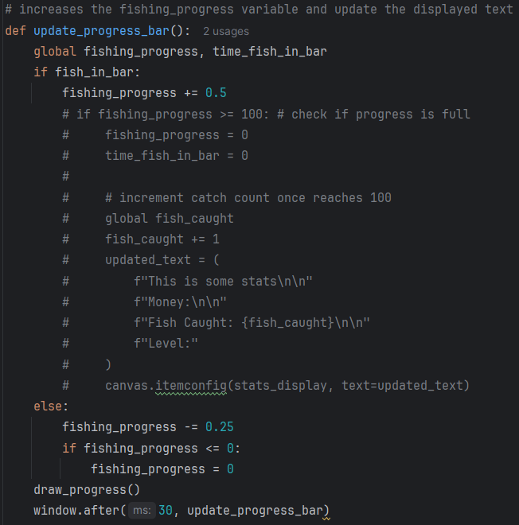

Line | Description
1 | Define a new function to calculate the player’s progress toward catching the fish, represented as a numeric variable to allow easy manipulation of the progress bar’s angle.
2
3 | The function first checks if fish_in_bar (from objective 2.b.i) is true. If so, it increases the progress variable by 0.5 to indicate advancement.
4
5 | If the fish leaves the green bar, the function decreases the progress variable by 0.25, which is half the increase amount, to make the game more balanced and enjoyable.
6
7 | After each decrease, the function ensures the progress variable does not drop below 0, resetting it if necessary.
8
9 | calls the function that draws the progress bar to update its visual appearance.
10 | Check and update are repeated every 30 milliseconds to ensure the game runs continuously and smoothly.

Objective 3.a.ii – drawing the green sector:
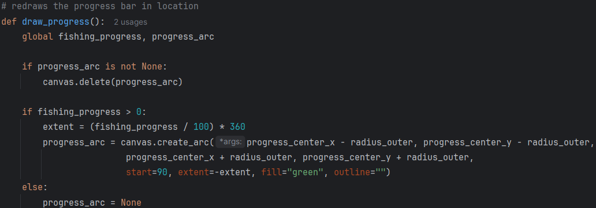

Line | Description
1 | Defines a new function that will draw the sector based on the progress value determined in 3.a.i calculation
2
3 | Checks whether a previous progress arc already exists on the canvas
4 | If an old progress arc exists, it deletes it to prepare for redrawing the updated version
5 | Checks if there is any progress to display (i.e., the value is greater than zero)
6 | Calculates the angle of the green sector based on the progress percentage, converting it into degrees for the arc
7 | Draws a green arc that inherits the same coordinates as the grey circle in objective 1.b.iii. The arc starts from the top and expands clockwise according to the calculated extent. The canvas item ID is stored in progress_arc, allowing the same shape to be efficiently updated or replaced during future redraws.
8 | In case there is no progress to display, sets progress_arc to None to indicate that no progress arc exists on the canvas
9

Objective 3.a.iii – drawing white inner circle:
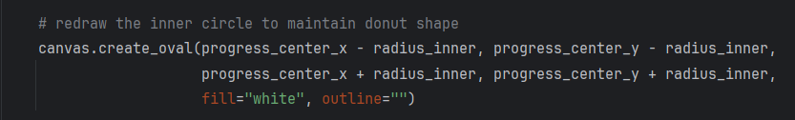

Line | Description
1 | Using a similar procedure to objective 1.b.iii. to draw the inner circle after each time the arc is updated. This keeps the doughnut shape of the progress bar by effectively covering the inner part of the green progress arc.
2
3

Objective 3.b.i – update text when fish is caught:

Objective 3.a.ii – reset progress to 0 when full:
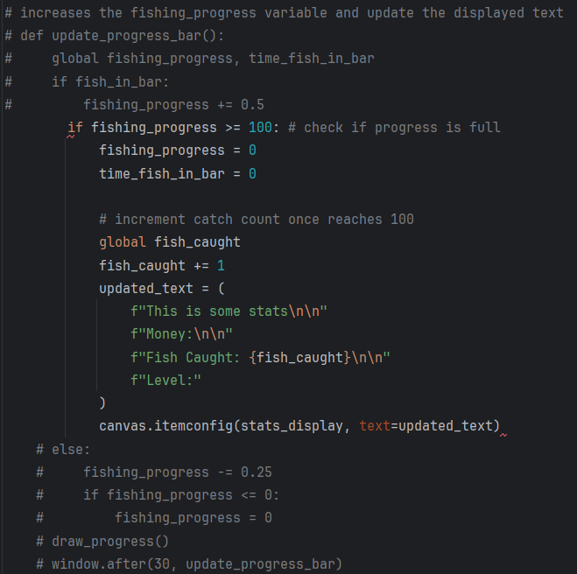

Line | Description
1 | Checks whether the fishing progress has reached or exceeded 100%, meaning the fish has been successfully caught
2 | Resets the progress bar back to 0 to prepare for the next catch
3 | Resets the timer that tracks how long the fish has stayed inside the green bar
4 | Declares that the variable fish_caught refers to the global version, allowing the function to modify it
5 | Increases the number of fish caught by one to record a successful catch
6 | Creates a new string that updates the stats display to include the new fish count
7 | Updates the existing text item on the canvas with the new stats so the change appears visually in the game window

3.3.3 Stage 3 Validation
Below are the validations implemented in this stage and their justification:
Validation check | What is being validated | How it is done in code | Why it is implemented | Why it is important
Progress value boundary validation | Fishing progress stays between 0 and 100 | if statements clamp fishing_progress so it never drops below 0 or rises above 100 | Prevents invalid percentages and drawing errors | Keeps the progress system stable and visually correct
Conditional progress increase and decrease | Progress only changes based on fish position | fish_in_bar determines whether fishing_progress increases or decreases | Prevents progress changing at incorrect times | Ensures player actions directly affect game progress
Catch completion validation | A fish is only counted as caught when the bar is full | fishing_progress >= 100 triggers the catch event and resets values | Prevents incomplete catches from counting | Ensures fair and consistent gameplay progression
Progress reset validation | Progress and timers return to valid starting values after a catch | fishing_progress and time_fish_in_bar are reset to 0 after success | Prevents previous attempts affecting future catches | Keeps each fishing attempt independent and accurate
Progress arc redraw validation | Only one active progress arc exists on the canvas | Existing progress_arc is deleted before a new one is created | Prevents overlapping graphics and memory buildup | Keeps the UI clean and improves rendering performance
Doughnut shape preservation | The centre of the progress bar remains hollow after updates | The inner white circle is redrawn after each arc update | Prevents the progress bar from becoming a filled circle | Maintains the intended visual design
Continuous UI update validation | Progress updates occur smoothly in real time | window.after(30, update_progress_bar) repeatedly refreshes the progress system | Prevents frozen or delayed visual feedback | Ensures responsive and smooth gameplay
Statistics display validation | The fish caught counter matches internal game data | canvas.itemconfig updates the displayed text whenever fish_caught changes | Prevents mismatch between stored values and visible UI | Keeps player feedback accurate and reliable

3.3.4 Stage 3 Final Testing
Please also refer to the video stage 3 – testing in the attached file

Test No. | Test | Data to be used | Type of test | Expected Result | Pass  /Fail | Evidence
1 | Not touching any key | N/A | Boundary | The progress bar stays at 0, and the appearance stays grey | Pass | 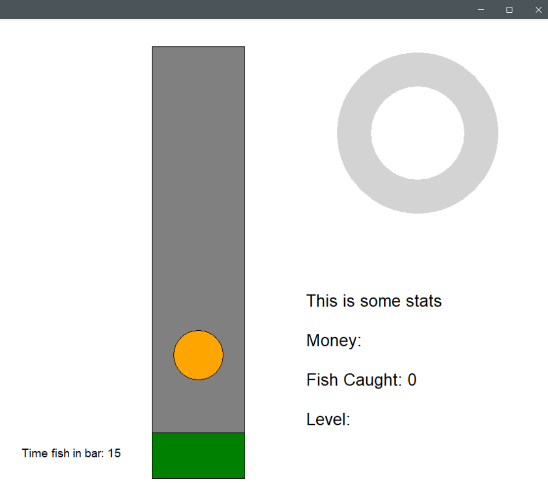
2 | Pressing keys other than the space bar | [N], [SHIFT], [1] keys | Erroneous | It should not respond to any key presses and behave the same as in Test 1. | Pass
3 | Increasing the progress bar to 50% | [space] | Normal | The bar should fill up clockwise until it reaches the halfway point | Pass | 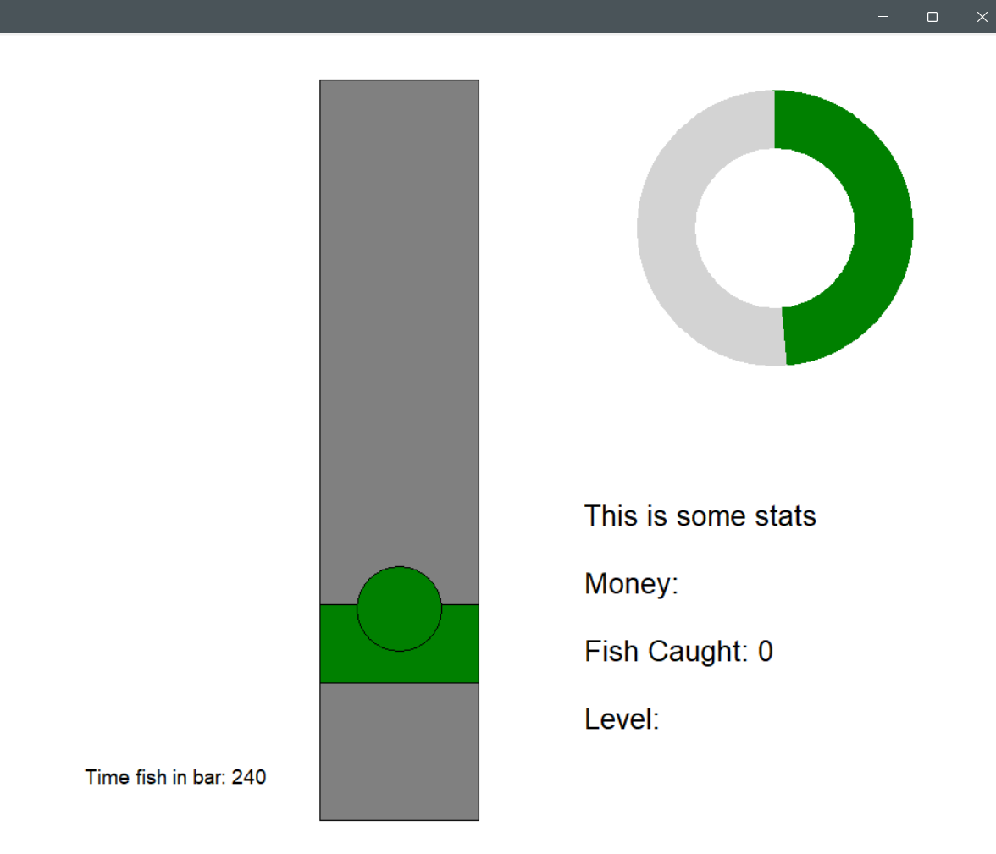
4 | Increasing the progress bar to 50% then letting it decrease | [space] | Normal | It should behave the same as in Test 3 while the spacebar is held down; once the spacebar is released, the bar should decrease back to the same state as in Test 1. | Pass | 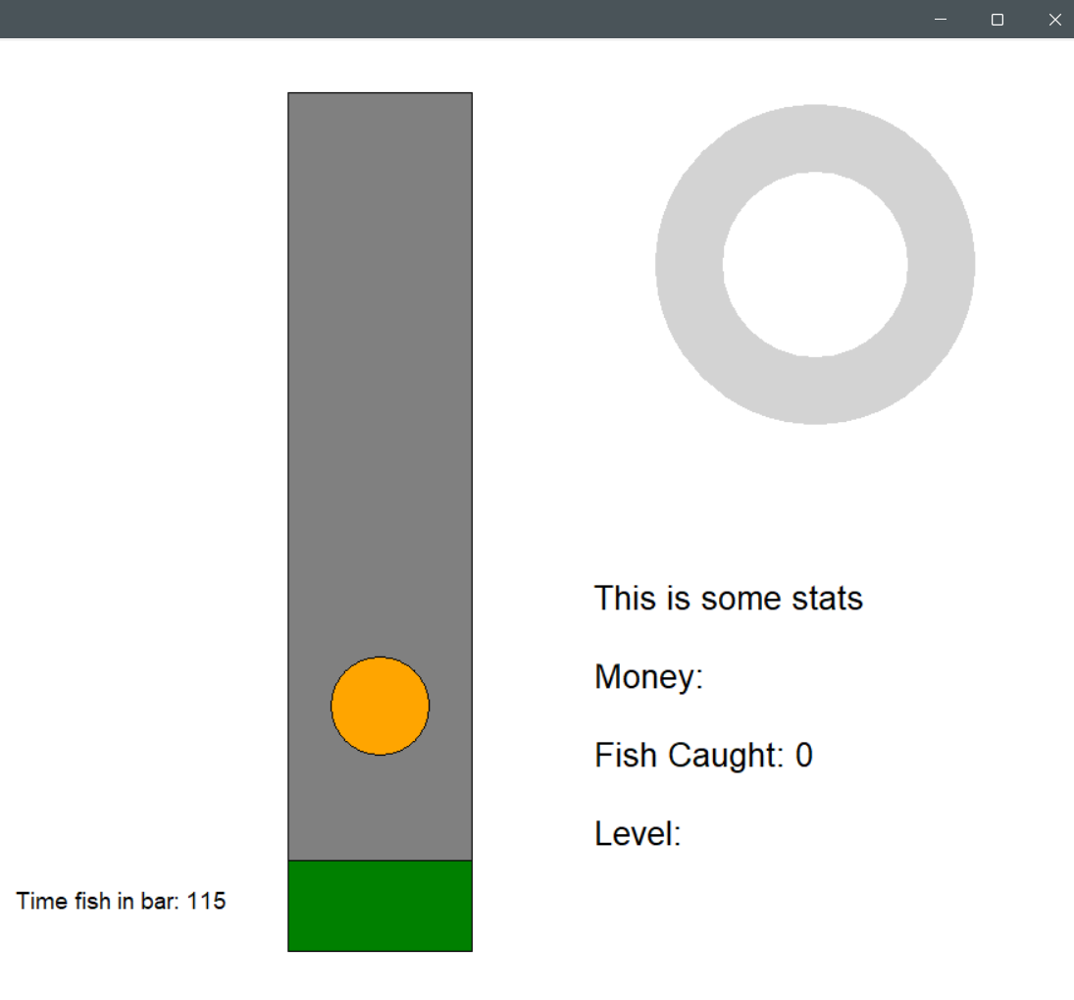
5 | Rapidly switch between “fish in bar” and “fish outside bar” | [space] | Boundary | Checks the spontaneous response of the progress bar to the corresponding change in the state of the green bar | Pass | 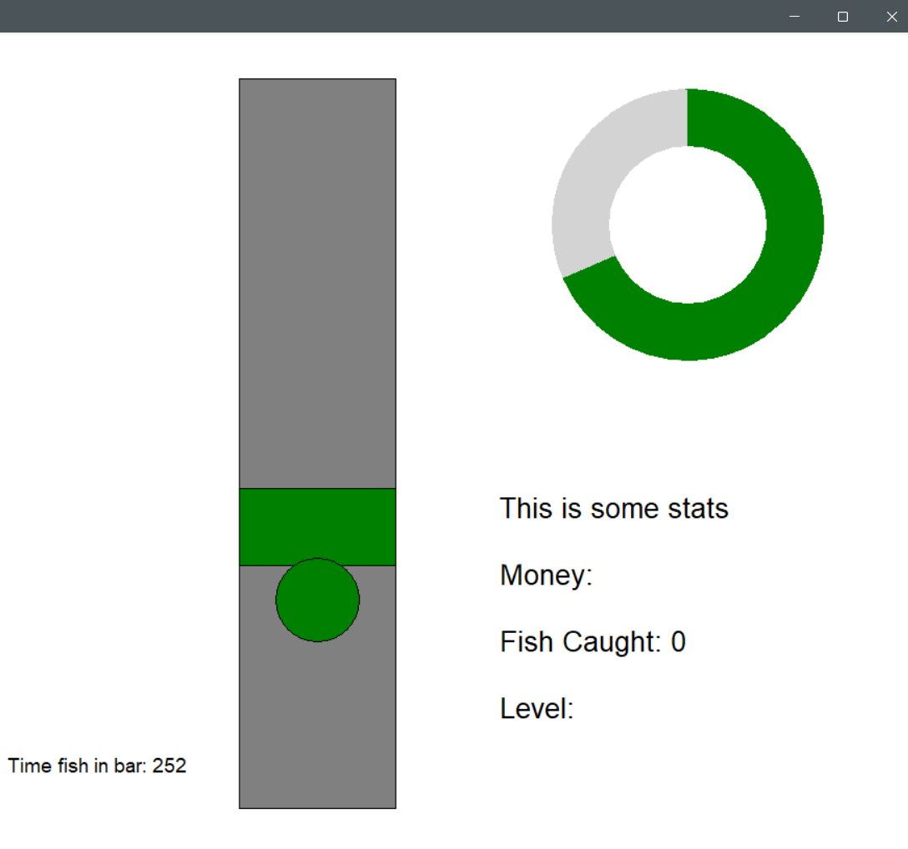
6 | Fill up the progress bar to 100% | [space] | Normal | When the bar becomes completely green, it should reset to 0 automatically | Pass | 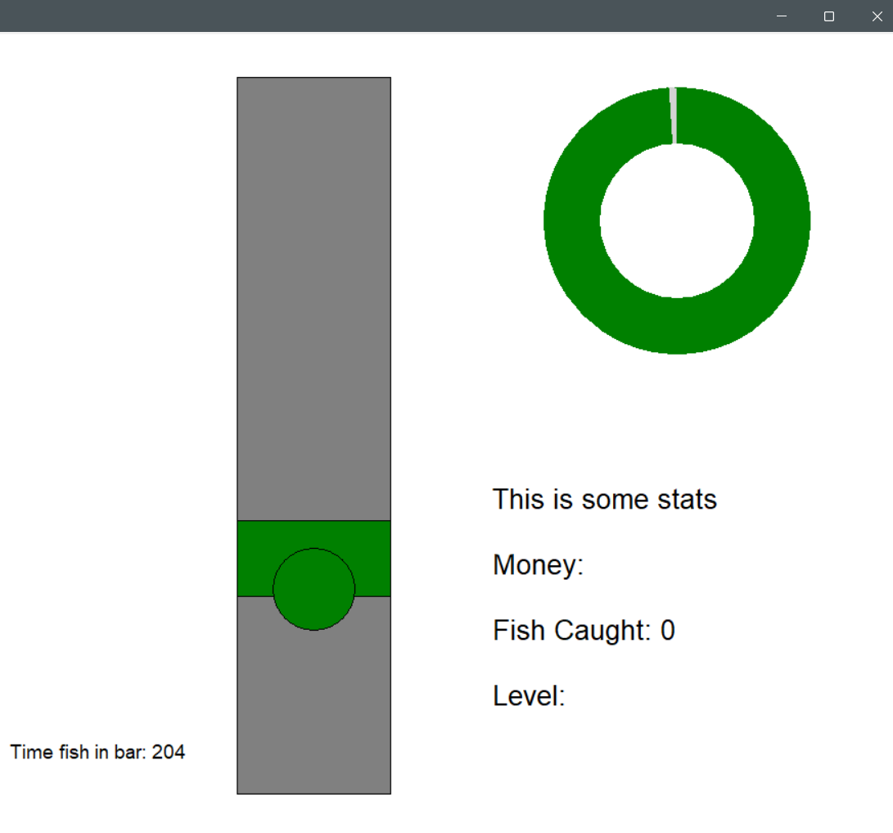
7 | Catch 5 fish | [space] | Normal | The fish counter on screen should show 5, and the bar should be in the same state as in test 1 | Pass | 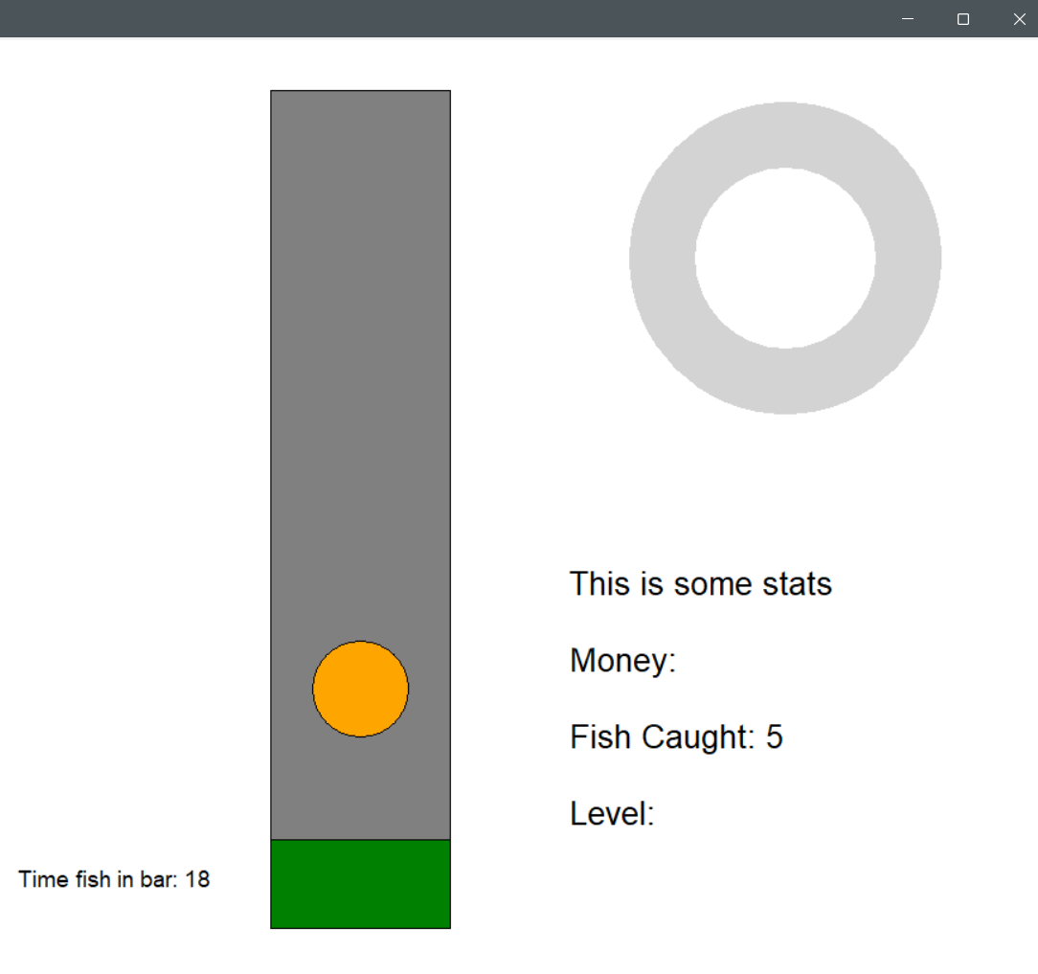

3.3.4.a Mistake sported while testing:
While testing the program, I noticed that running the game for a long period of time caused the screen to slow down significantly. After a few minutes, the game became extremely laggy and difficult to continue playing. I first suspected that the issue was caused by the assets constantly refreshing, since this might place too much strain on the system. After researching online, I found that a refresh rate of 30ms should not create a major burden on the CPU, so I began checking the code instead.
I then suspected that an asset was being created but never deleted from the canvas. After investigating the code, I discovered that the inner circle was being drawn repeatedly without removing the previous one. Each time draw_progress() ran, a new white circle was created, but because its ID was never stored, the old circle could not be deleted. This caused the canvas to slowly fill with hundreds of overlapping white ovals.
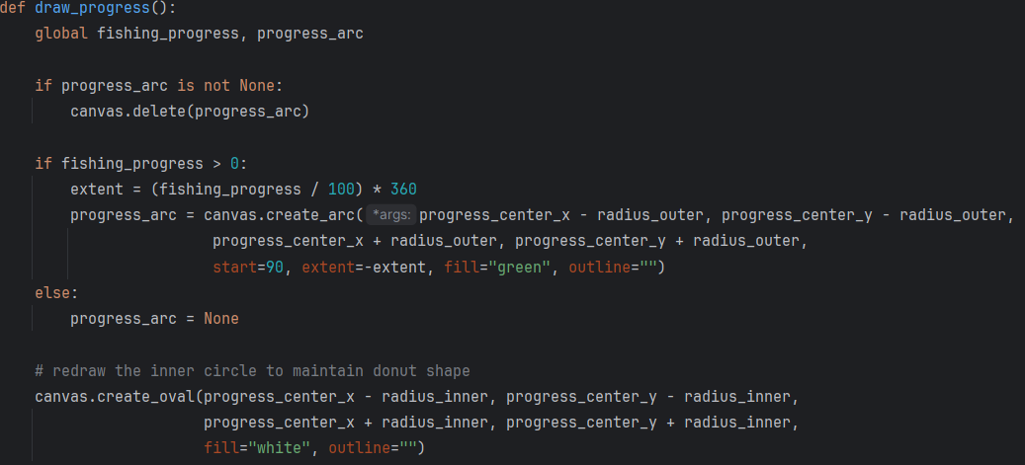
The old arc was deleted correctly, and a new arc was drawn each time, but the old inner circles remained underneath the new ones. Visually the game appeared normal because each new circle covered the previous one, but the canvas continued storing invisible objects, which caused the performance issues over time.
To fix this, I identified two possible solutions. The first solution is to delete the inner circle each time draw_progress() is called and then redraw it. The second solution is to move the inner circle outside of the function and use Tkinter’s tag_raise() function to bring the existing circle to the front layer. This reuses the same circle instead of creating a new one every refresh of the progress arc. Both solutions prevents unnecessary objects from building up on the canvas.
I choose to go with the second solution. The second solution is better for the program because it reduces unnecessary object creation on the canvas. Instead of generating a new inner circle every time draw_progress() runs, the same object is reused and only its display order is changed using tag_raise(). It also reduces memory usage over time, since fewer objects are created and tracked by the system. The rendering process becomes more efficient because the program only updates the position in the drawing layer rather than deleting and recreating shapes each frame. This approach is also more stable in the long term. Reusing a single object reduces the risk of accumulation bugs, in which invisible elements build up and slow the game down.
With the changes in mind, I modified the draw_progress function to be as follows:
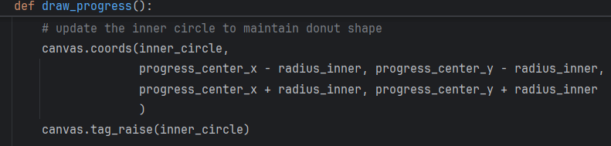

I then added this code to the end of the program file, near the function to draw the progress bar:
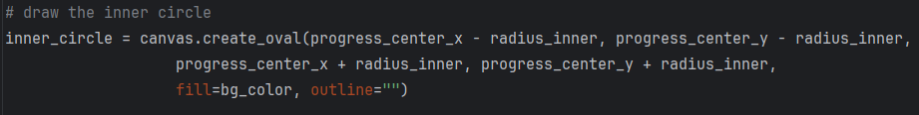

The inner circle is created once here and assigned a tag so it can be reused within draw_progress. I then tested the program by letting it run for 10 minutes and observed no significant slowdown. The performance issue was resolved.

3.3.5 Stage 3 Final program run screen:
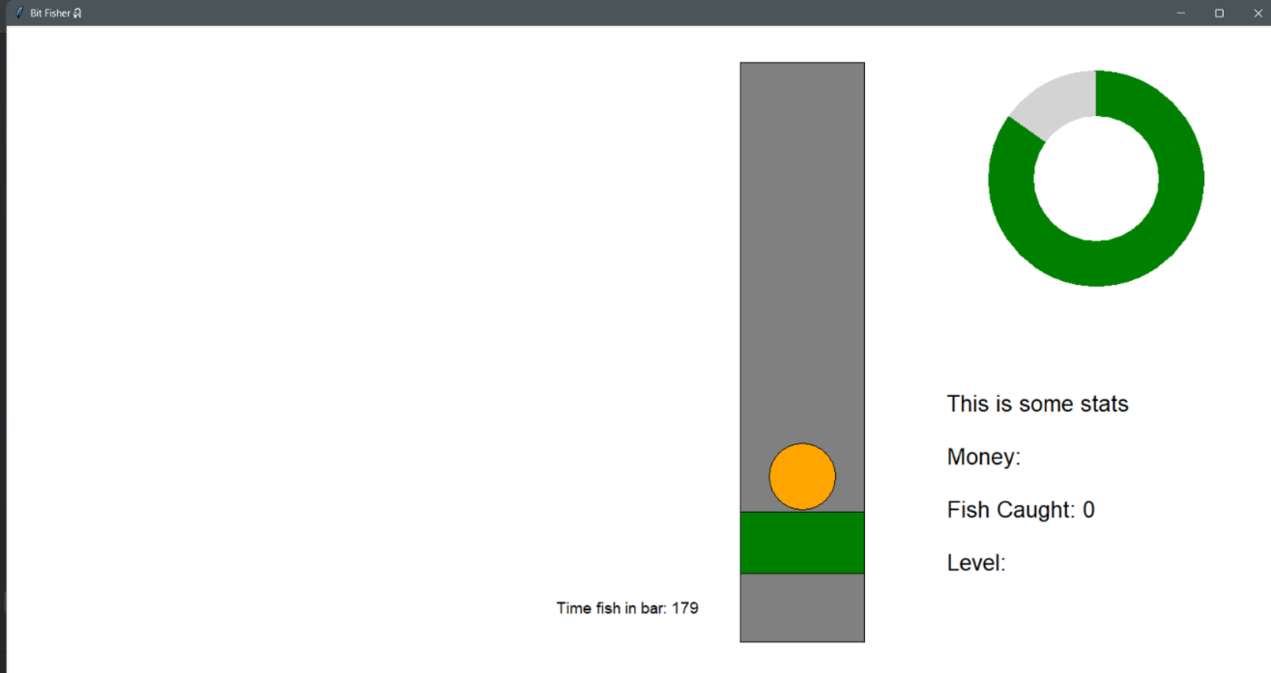

3.3.6 Stage 3 Final code:
import tkinter as tk
# set up a blank basic window
window = tk.Tk()
window.title("Bit Fisher🎣")
window_width = window.winfo_screenwidth()
window_height = window.winfo_screenheight()
window.geometry("%dx%d" % (window_width, window_height))
# ============================================================
# INITIAL VARIABLE SECTION
# This section creates and sets the variables used in widgets
# ============================================================
# progress bar variables
radius_outer = 130
radius_inner = 75
fishing_progress = 0
progress_arc = None
# set the coordinates of the progress bar
progress_center_x = window_width - 220
progress_center_y = window_height - 680
# dimensions for the fishing bar
fishing_width = 150
fishing_height = 700
# set the coordinates of the fishing bar
fishing_x1 = window_width - fishing_width - 500
fishing_y1 = window_height - fishing_height - 120
fishing_x2 = fishing_x1 + fishing_width
fishing_y2 = fishing_y1 + fishing_height
# set up detection area within the fishing bar (green bar)
green_width = fishing_width
green_height = 75
green_x = (fishing_x1 + fishing_x2) // 2
green_y = fishing_y1 + 50
# green bar movement variables
gravity = 10
lift = -10
velocity = 0
space_pressed = False
# fish dimensions and starting position
fish_radius = 40
# Center it horizontally and place it somewhere vertically inside the fishing box
fish_x = (fishing_x1 + fishing_x2) // 2
fish_y = fishing_y1 + 500
time_fish_in_bar = 0
fish_in_bar = False
fish_caught = 0
# set up a canvas inside the window
bg_color = "white"
canvas = tk.Canvas(window, width=window_width, height=window_height, bg=bg_color)
canvas.pack()
# ==========================================================
# STATS DISPLAY SECTION
# This section creates and manages the text displays,
# including Money, Fish Caught, and Level.
# ==========================================================
# draw the stats
stats_text = (
f"This is some stats\n\n"
f"Money:\n\n"
f"Fish Caught: {fish_caught}\n\n"
f"Level:"
)
stats_display = canvas.create_text(
window_width - 180, window_height - 200,
text=stats_text,
anchor='se',
font=("Arial", 20),
fill="black"
)
# text object to display the catch timer (will be deleted later)
timer_text = canvas.create_text(
window_width - 700, window_height - 150,
text="Time fish in bar: 0",
font=("Arial", 14),
fill="black",
anchor="se"
)
# ==========================================================
# DEFINING FUNCTION SECTION
# This section creates functions for later usage,
# including: key binding, progress bar display and update,
# green bar movement, fish state checking
# ==========================================================

# detecting user input
def space_down(event):
global space_pressed
space_pressed = True
def space_up(event):
global space_pressed
space_pressed = False

# binding key inputs to function
window.bind("<KeyPress-space>", space_down)
window.bind("<KeyRelease-space>", space_up)
# increases the fishing_progress variable and update the displayed text
def update_progress_bar():
global fishing_progress, time_fish_in_bar
if fish_in_bar:
fishing_progress += 0.5
if fishing_progress >= 100: # check if progress is full
fishing_progress = 0
time_fish_in_bar = 0
# increment catch count once reaches 100
global fish_caught
fish_caught += 1
updated_text = (
f"This is some stats\n\n"
f"Money:\n\n"
f"Fish Caught: {fish_caught}\n\n"
f"Level:"
)
canvas.itemconfig(stats_display, text=updated_text)
else:
fishing_progress -= 0.25
if fishing_progress <= 0:
fishing_progress = 0
draw_progress()
window.after(30, update_progress_bar)

# redraws the progress bar in location
def draw_progress():
global fishing_progress, progress_arc
if progress_arc is not None:
canvas.delete(progress_arc)
if fishing_progress > 0:
extent = (fishing_progress / 100) * 360
progress_arc = canvas.create_arc(progress_center_x - radius_outer, progress_center_y - radius_outer,
progress_center_x + radius_outer, progress_center_y + radius_outer,
start=90, extent=-extent, fill="green", outline="")
else:
progress_arc = None
# redraw the inner circle to maintain donut shape
canvas.create_oval(progress_center_x - radius_inner, progress_center_y - radius_inner,
progress_center_x + radius_inner, progress_center_y + radius_inner,
fill="white", outline="")
# function for green bar movement
def update_greenbar():
global green_y, velocity
# apply movement to green bar
if space_pressed:
velocity = lift
else:
velocity = gravity
green_y += velocity
# set the boundaries using the fishing bar
green_top_limit = fishing_y1 + green_height // 2
green_bottom_limit = fishing_y2 - green_height // 2
if green_y < green_top_limit:
green_y = green_top_limit
elif green_y > green_bottom_limit:
green_y = green_bottom_limit
# move the green bar
canvas.coords(green_bar,
green_x - green_width // 2, green_y - green_height // 2,
green_x + green_width // 2, green_y + green_height // 2
)
window.after(30, update_greenbar)
# detects if fish is in green bar
def check_if_fish_in_bar():
global time_fish_in_bar, fish_in_bar
# get coordinates of the green bar and the fish
green_coords = canvas.coords(green_bar) # [x1, y1, x2, y2]
fish_coords = canvas.coords(fish) # [x1, y1, x2, y2]
# check if rectangles overlap
if (green_coords[1] < fish_coords[3] and
green_coords[3] > fish_coords[1]):
# collision detected
fish_in_bar = True
canvas.itemconfig(fish, fill="green") # change colour of fish
time_fish_in_bar += 1 # increment the timer
else:
fish_in_bar = False
canvas.itemconfig(fish, fill="orange")
canvas.itemconfig(timer_text, text=f"Time fish in bar: {time_fish_in_bar}")
window.after(30, check_if_fish_in_bar) # re-check every 30ms
# =============================================
# DRAWING THE WIDGETS ONTO THE CANVAS
# =============================================
# set up the donut progress bar in location
canvas.create_oval(progress_center_x - radius_outer, progress_center_y - radius_outer,
progress_center_x + radius_outer, progress_center_y + radius_outer,
fill="light grey", outline="")
# draw the inner circle
canvas.create_oval(progress_center_x - radius_inner, progress_center_y - radius_inner,
progress_center_x + radius_inner, progress_center_y + radius_inner,
fill=bg_color, outline="")
# set up the fishing bar in location
canvas.create_rectangle(fishing_x1, fishing_y1, fishing_x2, fishing_y2, fill="grey", outline="black")
# draw the green bar
green_bar = canvas.create_rectangle(
green_x - green_width // 2, green_y - green_height // 2,
green_x + green_width // 2, green_y + green_height //2,
fill="green", outline="black"
)
# draw the fish
fish = canvas.create_oval(
fish_x - fish_radius, fish_y - fish_radius,
fish_x + fish_radius, fish_y + fish_radius,
fill="orange", outline="black"
)
draw_progress()
update_progress_bar()
check_if_fish_in_bar()
update_greenbar()
window.mainloop()

3.4 Stage 4 – Fish Movement Patterns and Performance Scalin
For this stage, I plan to implement fish movement mechanics and dynamically adjust their behaviour in response to player performance. Each fish’s y-axis position will follow continuous wave patterns generated using trigonometric functions, such as sine and cosine, with the movement speed adapting according to the player’s performance. My main objectives are:

- Make the fish move in a natural bopping pattern
- Use the random library to generate a series of random values, introducing variability in fish movement
- Use mathematical functions, such as sine and cosine, to generate each fish’s y-coordinate and ensure the wave progresses smoothly
- Validate the generated values through a series of checks to avoid errors or out-of-bound positions
- Move the fish to the corresponding y-axis position based on the generated value
- Adjust the difficulty of the fish movement dynamically
- Calculate the percentage of time the fish remains inside the green bar relative to the total time it is fished
- Use this percentage to determine the difficulty level, which adjusts the wave progression speed and consequently the fish’s movement speed, raising the difficulty of the game

3.4.1 Stage 4 Test plan

Test No. | Test | Data to be used | Type of test | Expected Result
1 | Verify random variability in the variables | values generated by the random library | Functional | The 10 values should range from 100 to 1000 randomly
2 | Check that the y value generated is continuous | Values generated by the random library | Functional | The fish should move up and down smoothly in a continuous motion without any visible jumps.
3 | Verify the fish still reacts to the green bar | [space] | Normal | The fish should turn green as before, triggering an increase in the progress bar
4 | Catch fish while performing well to observe an increase in difficulty | [space] | Normal | After catching the fish while performing well, there should be an observed increase in the speed of the fish
5 | Catch fish while performing badly to observe a decrease in difficulty | [space] | Normal | After the fish is caught, there should be a clear decrease in the speed of its movement

3.4.2 Stage 4 Code analysis

Objective 4.a.i - Randomly generate a list of values with the random library:
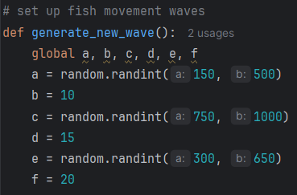

Line | Description
1 | Defines a function called generate_new_wave() that sets up movement values using Python’s random library.
2 | Six variables are declared as global so they can be used outside the function.
3 | Each of these variables is assigned either a random value within a specific range or a fixed number, with each random range differing between variables to ensure variation in the generated movement patterns
…
8

Objective 4.a.ii – Generate y value using trigonometry function

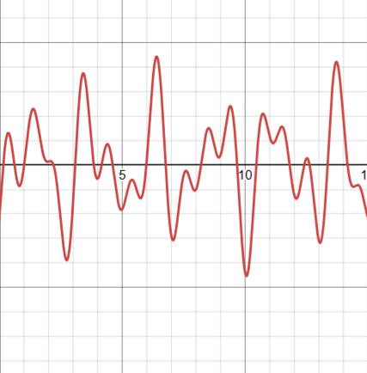
Objective 4.a.iii – Validating the result
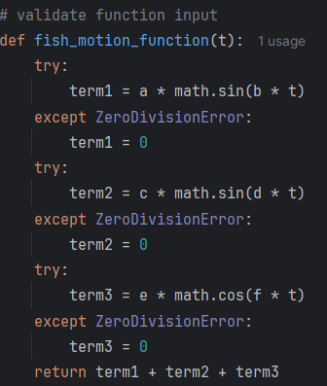
(an example graph generated using DESMOS graphic calculator with randomly generated numbers for variables a, b, c, d, e, f)

Line | Description
1 | Defines a function named fish_motion_function that takes one parameter t, representing the variable in a mathematical parametric equation, and returns a combined motion value
2 | The try block attempts a computation that could potentially cause an error, allowing the program to continue running if an error occurs
3 | Uses the variables set in 4.a.i to calculate a value with the math.sin() function from the Python math library
4 | The except block handles a possible ZeroDivisionError, which is unlikely in this context but serves as a safeguard.
5 | If an exception occurs, the corresponding term is set to 0 to prevent errors from affecting the overall calculation
6 | This process is repeated two more times to generate two additional terms, which are then summed to produce the overall y-axis value. By combining multiple wave components with different amplitudes and wavelengths, the function creates constructive and destructive interference, adding variability and randomness to the fish movement. As the t value progresses, the wave evolves continuously, producing smooth, dynamic motion over time.
…
13
14 | The overall y value is summed and returned by the function

Objective 4.a.iv – Fish movement
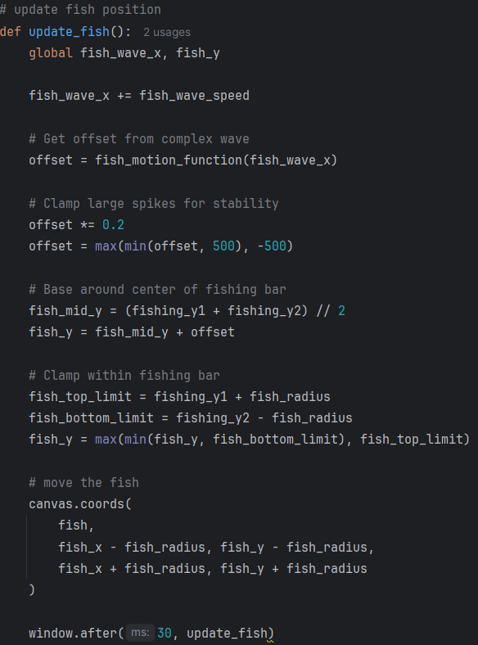

Line | Description
1 | Defines a function which recalculates the fish’s y using the wave functions and redraws the fish’s position
2
3 | Declares fish_wave_x and fish_y as global variables so the function can modify the main program’s values.
4 | Increases fish_wave_x by a set speed value, progressing the wave input so the fish moves over time.
5 | Calls the parametric wave function from objective 4.a.ii using the x value for it to return a vertical offset to be used as the fish’s y axis
6 | Scales down the offset to create smoother, more natural movement and prevent sudden, unnatural jumps. It then clamps the value between 500 and –500 to add an extra layer of safety, ensuring the fish never makes excessively large movements that would disrupt the animation.
7
8 | Calculates the midpoint of the fish’s vertical range so that all y-axis adjustments are applied relative to a single consistent reference point. This prevents the need for repeated recalculations and avoids misalignment when the fish is drawn, since its position is determined using its top coordinate and half-height rather than its midpoint and radius.
9
10 | Defines the upper and lower boundaries for the fish’s updated position, ensuring it cannot move outside the fishing bar. The fish’s y-coordinate is then clamped within these limits to keep its movement safely contained.
11
12 | Just like the function used earlier to draw the green bar in Objective 2, this updates the fish’s graphical position on the canvas using the newly calculated coordinates. The fish’s x-value remains unchanged because no horizontal movement is applied.
13 | Schedules the function to run every 30 milliseconds, matching the refresh rate of the other animated elements so the fish appears to move continuously and smoothly

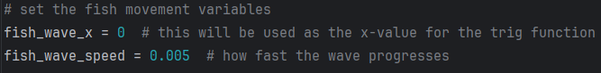

Line | Description
1 | Initializes the variables used in the function, where fish_wave_x stores the progressing x-axis value (corresponding to t in a parametric function) and fish_wave_speed controls the rate at which fish_wave_x increases.
2

Objective 4. b.i – Calculate variable difficulty offset
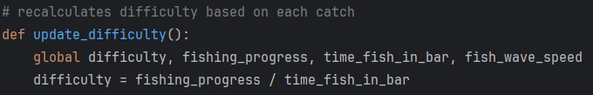

Lines | Description
1 | Define the function to update the variable difficulty based on users performance
2 | Takes in variables such as fishing_progress from Objective 3.a.i and time_fish_in_bar from Objective 2.b.i, and calculates a value between 0 and 1. Essentially, it determines the percentage of time the fish stayed within the green bar relative to the total time, representing the user’s progress. This value will always be less than or equal to 1 (100%), where a value of 1 indicates the fish never left the bar. By using this measurable value, it is possible to assess how challenging the catch was for the user.
3

Objective 4. b.ii – Adjusting fish speed
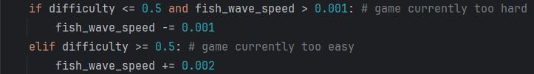

Line | Description
1 | Takes the difficulty variable calculated in Objective 4.b.i and checks whether it falls in the upper or lower sector (above or below 50%). If the user performed poorly, meaning the fish spent more than half of its time outside the bar, the difficulty is considered too high, so the wave speed is decreased. This adjustment is only made if the wave speed has not already reached its minimum value of 0.001.
2
3 | The reverse adjustment is applied if the fish spends more than half of its time inside the green bar, indicating that the current speed is too slow for the user. In this case, the wave speed is increased to raise the difficulty. The increase is deliberately set to be twice as large as the decrease, allowing the game to quickly adapt to the user’s skill level, since the starting speed is initially much lower than what most users can handle.
4

3.4.3 Stage 4 Validation
Below are the validations implemented in this stage and their justification:
Validation check | What is being validated | How it is done in code | Why it is implemented | Why it is important
Random wave generation validation | Random movement values stay within controlled ranges | random.randint generates values between fixed minimum and maximum limits for variables a, c, and e | Prevents extreme wave sizes or unrealistic movement patterns | Keeps fish movement varied while remaining playable
Mathematical function error handling | Trigonometric calculations do not crash the program | try and except blocks catch ZeroDivisionError inside fish_motion_function | Prevents runtime errors from stopping the game loop | Ensures stable execution during continuous calculations
Wave output stability validation | Generated movement offsets remain within safe limits | offset is scaled down and clamped using max(min(offset, 500), -500) | Prevents sudden spikes in fish movement | Maintains smooth and controllable fish behaviour
Fish boundary validation | Fish position remains inside the fishing bar | fish_y is clamped between fish_top_limit and fish_bottom_limit | Prevents the fish moving outside the visible gameplay area | Keeps gameplay fair and visually correct
Continuous movement update validation | Fish movement updates smoothly over time | window.after(30, update_fish) repeatedly updates the fish position | Prevents frozen or inconsistent animation | Maintains responsive and natural movement
Difficulty calculation validation | Difficulty adjustments use player performance data correctly | difficulty is calculated using fishing_progress / time_fish_in_bar | Prevents arbitrary difficulty changes | Ensures difficulty responds to player skill
Difficulty range validation | Fish speed changes remain within reasonable limits | fish_wave_speed only decreases if greater than 0.001 and increases in small increments | Prevents impossible or broken movement speeds | Keeps the game balanced and playable
Wave reset validation | New fish movement patterns begin from a clean state after each catch | generate_new_wave() and fish_wave_x = 0 reset movement values after success | Prevents old wave data affecting new movement cycles | Ensures movement patterns remain consistent and unpredictable

3.4.4 Stage 4 Final testing
Please also refer to the video stage 4 – testing in the attached file
Test No. | Test | Data to be used | Type of test | Expected Result | Pass/  Fail | Evidence
1 | Verify random variability in the variables | values generated by the random library | Functional | The 10 values should range from 100 to 1000 randomly | Pass | 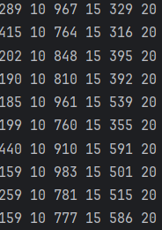
2 | Check that the y value generated is continuous | Values generated by the random library | Functional | The fish should move up and down smoothly in a continuous motion without any visible jumps. | Pass | 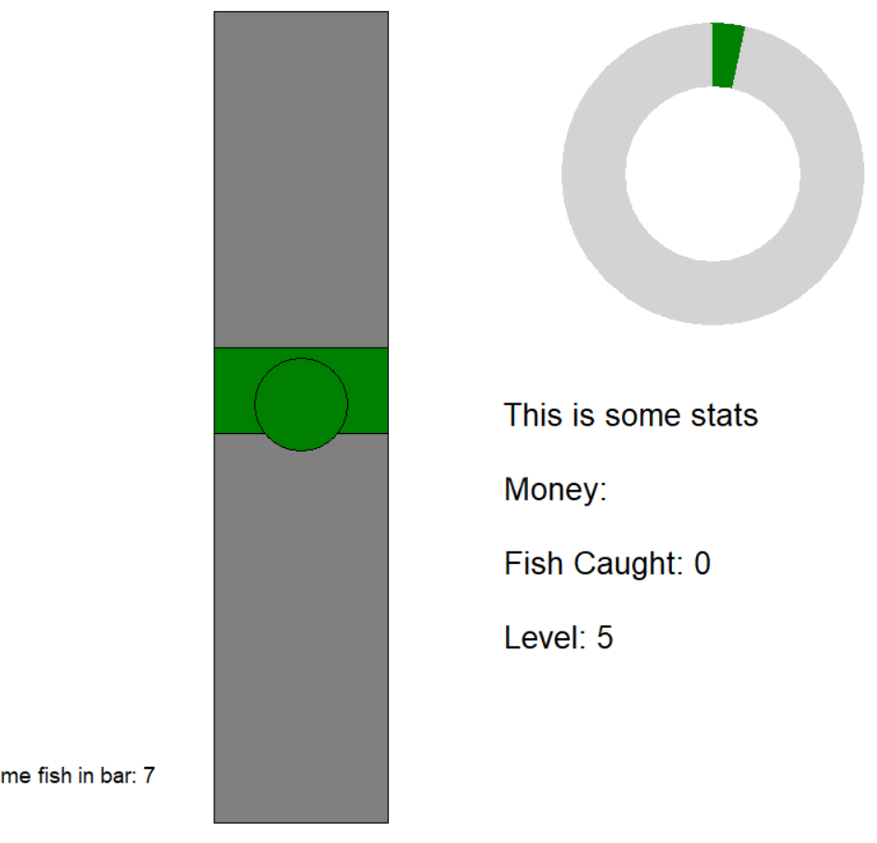
3 | Verify the fish still reacts to the green bar | [space] | Normal | The fish should turn green as before, triggering an increase in the progress bar | Pass
4 | Catch fish while performing well to observe an increase in difficulty | [space] | Normal | After catching the fish while performing well, there should be an observed increase in the speed of the fish | Fail  (resolved) | No change in movement speed was observed, when speed is printed out it’s clearer that there’s no change  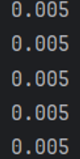
5 | Catch fish while performing badly to observe a decrease in difficulty | [space] | Normal | After the fish is caught, there should be a clear decrease in the speed of its movement | Pass | 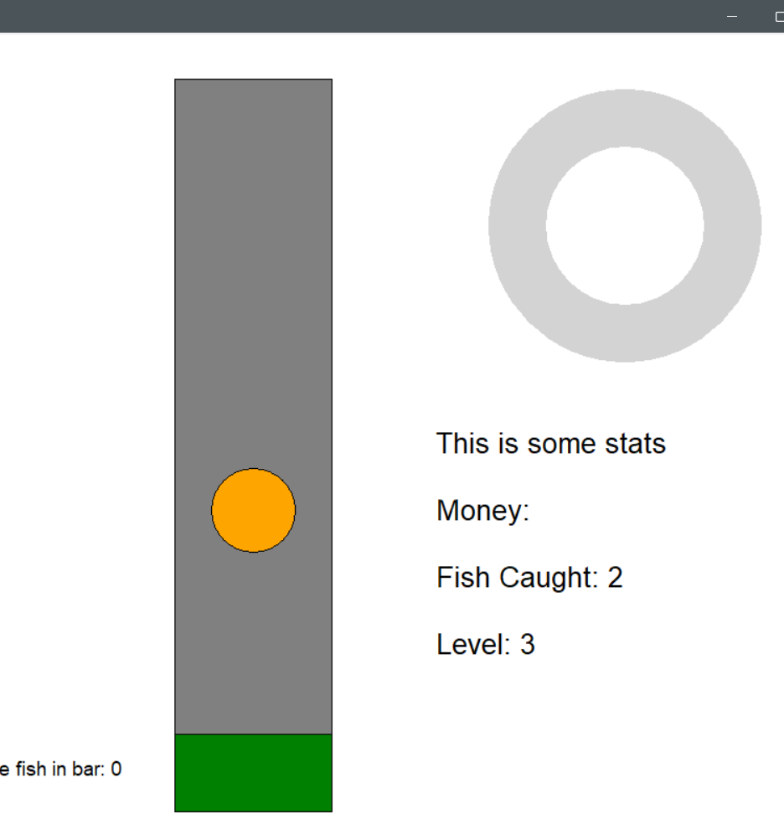

3.4.5 Stage 4 Failed tests analysis:
Test 4 – There doesn’t appear to be any change in the fish’s speed, even when the player is playing well. To investigate the issue, I added a print statement to display the current wave speed in the terminal. Here are the results after five catches:

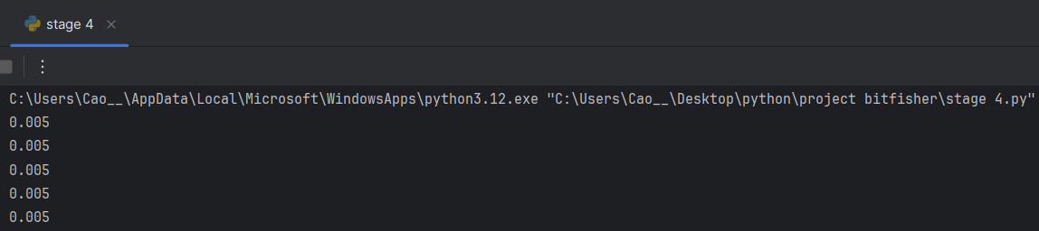

As the results show, the speed never changes. I suspect the issue lies in how the function in Objective 4.b.i is being called. After reviewing the code, I found that the function is never called, and it is not used in any instances. This explains why the speed remains unaffected.
To fix this issue, I added a line to objective 3.b.ii where after a fish is caught, it calls the update difficulty function:
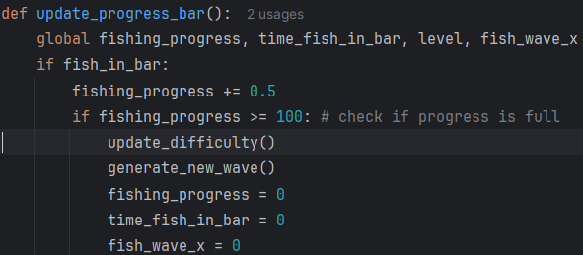

This resolved the issue of the speed not changing. However, a new problem appeared: the difficulty continued to increase even when the player was performing very well. I suspected the threshold in the function was too strict, so I added a print statement to display the calculated difficulty after each catch. Here are the results:

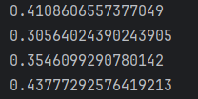
From these values, a strong performance typically corresponds to a difficulty of about 0.4, making the original 0.5 threshold unrealistic. To address this, I lowered the threshold to 0.4, which more accurately reflects the high-performance level observed during my testing.
I changed the difficulty adjustment threshold from 0.5 down to 0.4 because I want the difficulty system to give the player a little more breathing room before the game decides they are performing well enough to increase the difficulty. This makes the balance feel smoother and stops the difficulty from rising too quickly when the player is only doing moderately well.
The game runs at 30 milliseconds per frame, and the system calculates the allowed time window using 100 divided by the threshold.
Old value: 100 / 0.5 = 200 frames
200 × 0.03 seconds = 6 seconds
New value: 100 / 0.4 = 250 frames
250 × 0.03 seconds = 7.5 seconds
7.5 seconds − 6 seconds = 1.5 seconds difference
1.5 ÷ 6 = 0.25 = 25% increase in the allowed window
A perfect catch takes about 3 seconds (100 x 0.03 = 3), so the old 0.5 threshold only allowed players up to 2 times the ideal catch time before the game increased difficulty. By lowering the threshold to 0.4, I now allow up to 2.5 times the ideal catch time. This gives players more room to make mistakes without being punished, and it prevents the difficulty from ramping up too aggressively. This change makes the game feel fairer and keeps the difficulty curve from becoming too sharp too early.

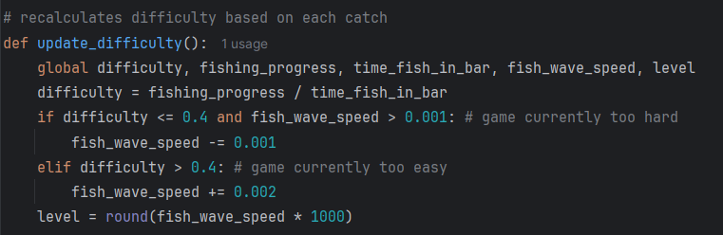

To make it easier to see whether the difficulty is changing, I added a new variable called level while the program is running. This variable takes the fish’s speed (in thousandths) and uses the round function to convert it into a single-digit integer. This provides a clearer visual indication of the current difficulty level for the player. The value is displayed alongside the existing stats text, attached to the section in objective 3.b.ii after a fish is caught.

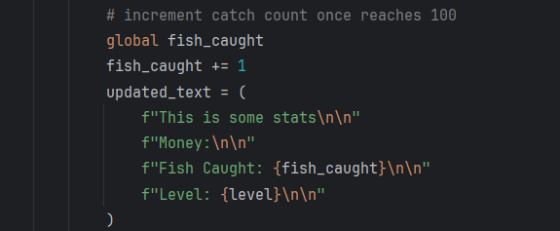
With these changes, I tested the program, and it is now yielding the correct response.

Final test result:
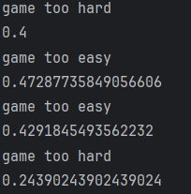

3.4.5.a Mistake spotted while testing:
During testing, I noticed that when the progress meter reaches 0, the fish-in-time variable also resets to 0. This is incorrect because the fish-in-time value should only increase and never reset. I then checked the code to find the cause of the issue.
Picture 1 shows the program running as expected. Picture 2 shows that when the progress drops to 0, the fish-in-time counter also resets.
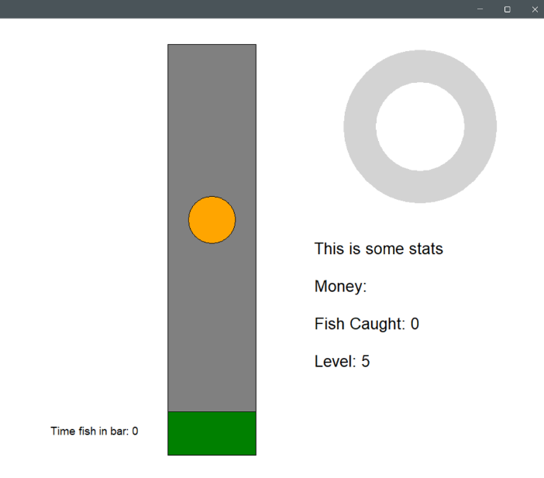
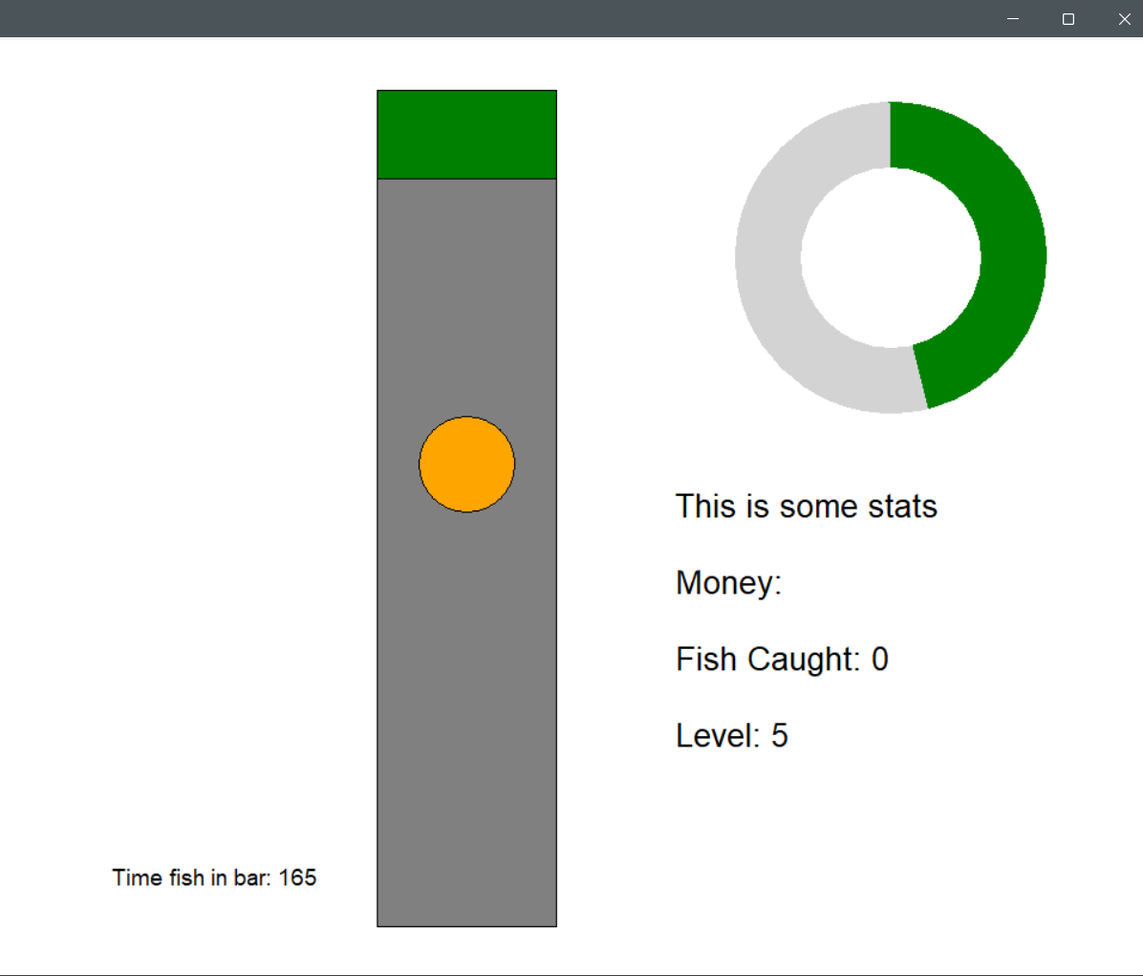

I think the issue comes from the updateProgressBar function because it controls the progress variable. I reviewed this part of the code and identified the following code as the likely source of the problem.

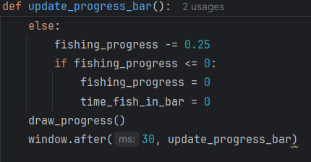

In the code, I added a boundary check to stop progress from going below 0. If progress drops under 0, it resets to 0 so the value never becomes negative.
However, during this reset, the fish-time-in-bar variable also gets set back to 0. This should not happen. To test this, I commented out the line that resets the fish-time-in-bar variable and ran the program again.
Picture 1 shows the program running as expected. Picture 2 shows that when the progress drops to 0, the fish-in-time counter no longer reset.

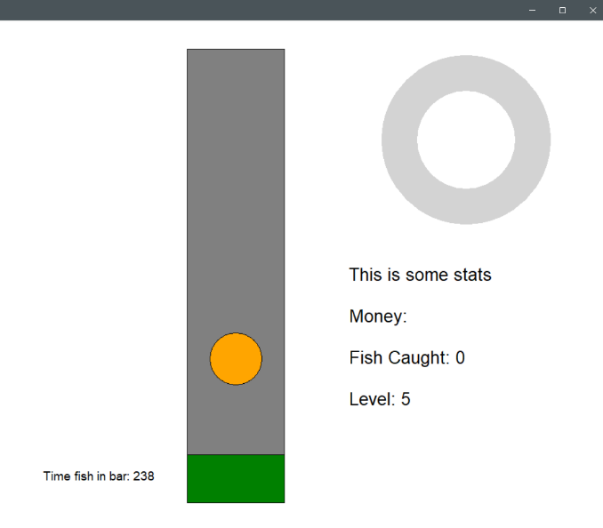
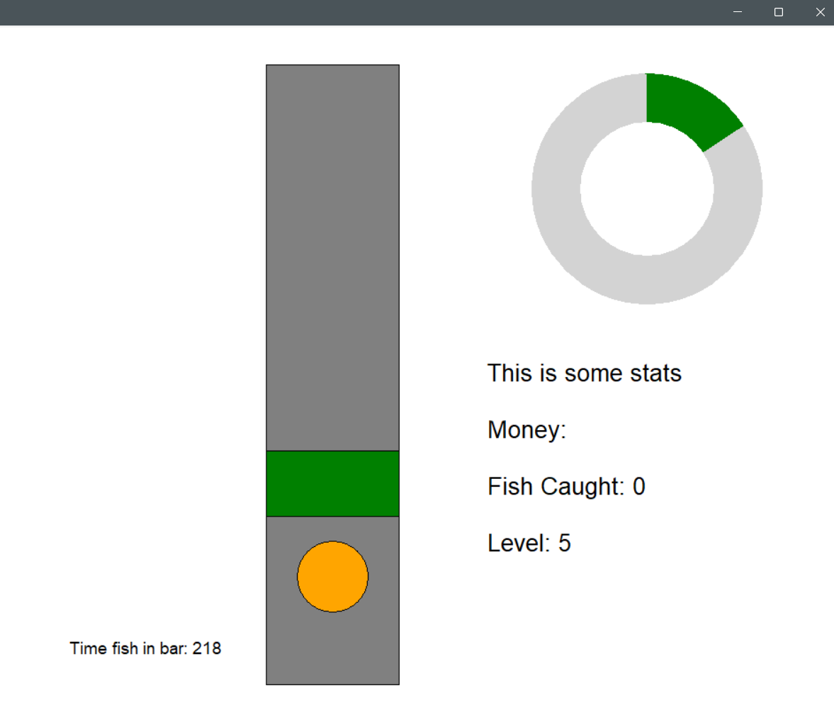
After making these changes, the program now behaves as expected and the issue is resolved.

3.4.6 Stage 4 Final program run screen:
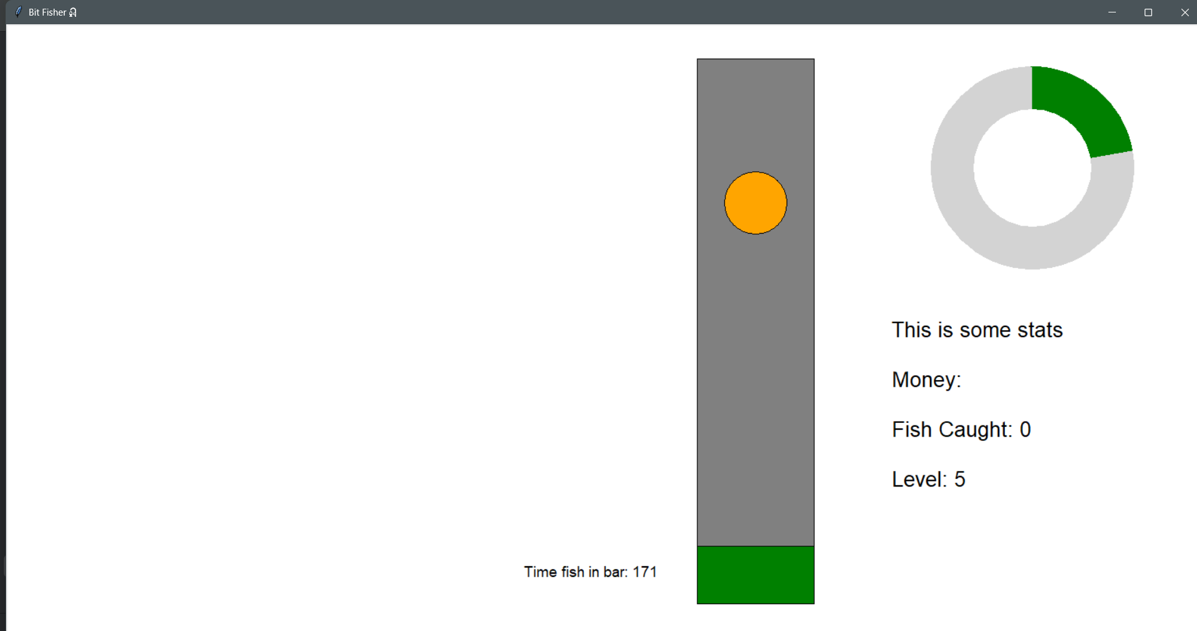

3.4.7 Stage 4 Final code:

import tkinter as tk
import math
import random
# set up a blank basic window
window = tk.Tk()
window.title("Bit Fisher🎣")
window_width = window.winfo_screenwidth()
window_height = window.winfo_screenheight()
window.geometry("%dx%d" % (window_width, window_height))
# ============================================================
# INITIAL VARIABLE SECTION
# This section creates and sets the variables used in widgets
# ============================================================
# progress bar variables
radius_outer = 130
radius_inner = 75
fishing_progress = 0
progress_arc = None
# set the coordinates of the progress bar
progress_center_x = window_width - 220
progress_center_y = window_height - 680
# dimensions for the fishing bar
fishing_width = 150
fishing_height = 700
# set the coordinates of the fishing bar
fishing_x1 = window_width - fishing_width - 500
fishing_y1 = window_height - fishing_height - 120
fishing_x2 = fishing_x1 + fishing_width
fishing_y2 = fishing_y1 + fishing_height
# set up detection area within the fishing bar (green bar)
green_width = fishing_width
green_height = 75
green_x = (fishing_x1 + fishing_x2) // 2
green_y = fishing_y1 + 50
# green bar movement variables
gravity = 10
lift = -10
velocity = 0
space_pressed = False
# fish dimensions and starting position
fish_radius = 40
# Center it horizontally and place it somewhere vertically inside the fishing box
fish_x = (fishing_x1 + fishing_x2) // 2
fish_y = fishing_y1 + 500
time_fish_in_bar = 0
fish_in_bar = False
fish_caught = 0
# set the fish movement variables
fish_wave_x = 0 # this will be used as the x-value for the trig function
fish_wave_speed = 0.005 # how fast the wave progresses
# variable for difficulty
difficulty = 0
level = 5
# set up a canvas inside the window
bg_color = "white"
canvas = tk.Canvas(window, width=window_width, height=window_height, bg=bg_color)
canvas.pack()
# ==========================================================
# STATS DISPLAY SECTION
# This section creates and manages the text displays,
# including Money, Fish Caught, and Level.
# ==========================================================
# draw the stats
stats_text = (
f"This is some stats\n\n"
f"Money:\n\n"
f"Fish Caught: {fish_caught}\n\n"
f"Level: {level}\n\n"
)
stats_display = canvas.create_text(
window_width - 180, window_height - 200,
text=stats_text,
anchor='se',
font=("Arial", 20),
fill="black"
)
# text object to display the catch timer (will be deleted later)
timer_text = canvas.create_text(
window_width - 700, window_height - 150,
text="Time fish in bar: 0",
font=("Arial", 14),
fill="black",
anchor="se"
)
# ==========================================================
# DEFINING FUNCTION SECTION
# This section creates functions for later usage,
# including: key binding, progress bar display and update,
# green bar movement, fish state checking
# ==========================================================
# detecting user input
def space_down(event):
global space_pressed
space_pressed = True
def space_up(event):
global space_pressed
space_pressed = False
# binding key inputs to function
window.bind("<KeyPress-space>", space_down)
window.bind("<KeyRelease-space>", space_up)
# set up fish movement waves
def generate_new_wave():
global a, b, c, d, e, f
a = random.randint(150, 500)
b = 10
c = random.randint(750, 1000)
d = 15
e = random.randint(300, 650)
f = 20
print(a, b, c, d, e, f)
# validate function input
def fish_motion_function(t):
try:
term1 = a * math.sin(b * t)
except ZeroDivisionError:
term1 = 0
try:
term2 = c * math.sin(d * t)
except ZeroDivisionError:
term2 = 0
try:
term3 = e * math.cos(f * t)
except ZeroDivisionError:
term3 = 0
return term1 + term2 + term3
def update_progress_bar():
global fishing_progress, time_fish_in_bar, level, fish_wave_x
if fish_in_bar:
fishing_progress += 0.5
if fishing_progress >= 100: # check if progress is full
update_difficulty()
generate_new_wave()
fishing_progress = 0
time_fish_in_bar = 0
fish_wave_x = 0
# increment catch count once reaches 100
global fish_caught
fish_caught += 1
updated_text = (
f"This is some stats\n\n"
f"Money:\n\n"
f"Fish Caught: {fish_caught}\n\n"
f"Level: {level}\n\n"
)
canvas.itemconfig(stats_display, text=updated_text)
# generate new wave
generate_new_wave()
else:
fishing_progress -= 0.25
if fishing_progress <= 0:
fishing_progress = 0
draw_progress()
window.after(30, update_progress_bar)
# redraws the progress bar in location
def draw_progress():
global fishing_progress, progress_arc
if progress_arc is not None:
canvas.delete(progress_arc)
if fishing_progress > 0:
extent = (fishing_progress / 100) * 360
progress_arc = canvas.create_arc(progress_center_x - radius_outer, progress_center_y - radius_outer,
progress_center_x + radius_outer, progress_center_y + radius_outer,
start=90, extent=-extent, fill="green", outline="")
else:
progress_arc = None
# update the inner circle to maintain donut shape
canvas.coords(inner_circle,
progress_center_x - radius_inner, progress_center_y - radius_inner,
progress_center_x + radius_inner, progress_center_y + radius_inner
)
canvas.tag_raise(inner_circle)
# function for green bar movement
def update_greenbar():
global green_y, velocity
# apply movement to green bar
if space_pressed:
velocity = lift
else:
velocity = gravity
green_y += velocity
# set the boundaries using the fishing bar
green_top_limit = fishing_y1 + green_height // 2
green_bottom_limit = fishing_y2 - green_height // 2
if green_y < green_top_limit:
green_y = green_top_limit
elif green_y > green_bottom_limit:
green_y = green_bottom_limit
# move the green bar
canvas.coords(green_bar,
green_x - green_width // 2, green_y - green_height // 2,
green_x + green_width // 2, green_y + green_height // 2
)
window.after(30, update_greenbar)
# detects if fish is in green bar
def check_if_fish_in_bar():
global time_fish_in_bar, fish_in_bar
# get coordinates of the green bar and the fish
green_coords = canvas.coords(green_bar) # [x1, y1, x2, y2]
fish_coords = canvas.coords(fish) # [x1, y1, x2, y2]
# check if rectangles overlap
if (green_coords[1] < fish_coords[3] and
green_coords[3] > fish_coords[1]):
# collision detected
fish_in_bar = True
canvas.itemconfig(fish, fill="green") # change colour of fish
time_fish_in_bar += 1 # increment the timer
else:
fish_in_bar = False
canvas.itemconfig(fish, fill="orange")
canvas.itemconfig(timer_text, text=f"Time fish in bar: {time_fish_in_bar}")
window.after(30, check_if_fish_in_bar) # re-check every 30ms
# update fish position
def update_fish():
global fish_wave_x, fish_y
fish_wave_x += fish_wave_speed
# Get offset from complex wave
offset = fish_motion_function(fish_wave_x)
# Clamp large spikes for stability
offset *= 0.2
offset = max(min(offset, 500), -500)
# Base around center of fishing bar
fish_mid_y = (fishing_y1 + fishing_y2) // 2
fish_y = fish_mid_y + offset
# Clamp within fishing bar
fish_top_limit = fishing_y1 + fish_radius
fish_bottom_limit = fishing_y2 - fish_radius
fish_y = max(min(fish_y, fish_bottom_limit), fish_top_limit)
# move the fish
canvas.coords(
fish,
fish_x - fish_radius, fish_y - fish_radius,
fish_x + fish_radius, fish_y + fish_radius
)
window.after(30, update_fish)
# recalculates difficulty based on each catch
def update_difficulty():
global difficulty, fishing_progress, time_fish_in_bar, fish_wave_speed, level
difficulty = fishing_progress / time_fish_in_bar
if difficulty <= 0.4 and fish_wave_speed > 0.001: # game currently too hard
fish_wave_speed -= 0.001
elif difficulty > 0.4: # game currently too easy
fish_wave_speed += 0.002
level = round(fish_wave_speed * 1000)
# =============================================
# DRAWING THE WIDGETS ONTO THE CANVAS
# =============================================
# set up the donut progress bar in location
canvas.create_oval(progress_center_x - radius_outer, progress_center_y - radius_outer,
progress_center_x + radius_outer, progress_center_y + radius_outer,
fill="light grey", outline="")
# draw the inner circle
inner_circle = canvas.create_oval(progress_center_x - radius_inner, progress_center_y - radius_inner,
progress_center_x + radius_inner, progress_center_y + radius_inner,
fill=bg_color, outline="")
# set up the fishing bar in location
canvas.create_rectangle(fishing_x1, fishing_y1, fishing_x2, fishing_y2, fill="grey", outline="black")
# draw the green bar
green_bar = canvas.create_rectangle(
green_x - green_width // 2, green_y - green_height // 2,
green_x + green_width // 2, green_y + green_height //2,
fill="green", outline="black"
)
# draw the fish
fish = canvas.create_oval(
fish_x - fish_radius, fish_y - fish_radius,
fish_x + fish_radius, fish_y + fish_radius,
fill="orange", outline="black"
)
generate_new_wave()
draw_progress()
update_progress_bar()
check_if_fish_in_bar()
update_greenbar()
update_fish()
window.mainloop()

3.5 Stage 5 – File Handling and Modularization
For this stage, I plan to implement a subroutine that stores the total number of fish caught locally on the computer using a CSV file. The stored value will be loaded each time the game starts, allowing the total catch count to accumulate over multiple sessions. My main objectives are:

- Store the number of fish caught persistently
- Create or access a CSV file to store the total number of fish caught
- Validate and write the updated fish count to the CSV file each time a fish is caught

- Load the stored fish count when the game starts
- Read the existing value from the CSV file during game startup
- Validate and handle cases where the file may not exist or the value is invalid
- Set the in-game fish counter to the stored amount so progress carries over between sessions and update the display

3.5.1 Stage 5 Test plan

Test No. | Test | Data to be used | Type of test | Expected Result
1 | CSV File Creation on First Launch | N/A | Functional | A new CSV file is created automatically with the correct name and stores the value 0.
2 | Loading Stored Fish Count on Startup | 10, as an integer, entered to the CSV document manually | Functional | The game should display 10 as the fish count when started
3 | Updating CSV After Catching Fish | 0, as an integer entered to the CSV | Normal | The fish should turn green as before, triggering an increase in the progress bar
4 | Handling invalid data in the CSV file | “hello” | Erroneous | The system should detect an invalid value and reset the counter to a safe default (0), and game should continue without crashing
5 | Handling corrupted or unreadable CSV file | CSV with invalid formatting  Locked CSV | Erroneous | The game should handle the error safely and reset the counter to 0 or create a new file depending on the file type. No crash should occur.
6 | Multiple game sessions accumulate catch count correctly | Set CSV to 3.  Catch 2 fish → end game → restart game.  Catch 1 more fish → restart again. | Normal | After the first session CSV should read 5 and after the second session CSV should read 6. Each startup should load the correct total and display it.

3.5.2 Stage 5 Code analysis

Objective 5.a.i creating a CSV file
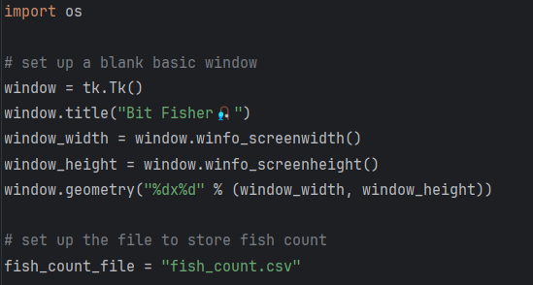

Line | Description
1 | This line loads Python’s built-in os module, which allows the program to check whether files exist and interact with the file system.
2 | This creates a variable storing the filename where the total number of fish caught will be saved. The game will read from and write to this file.

Objective 5.a.ii validating and writing to the CSV file
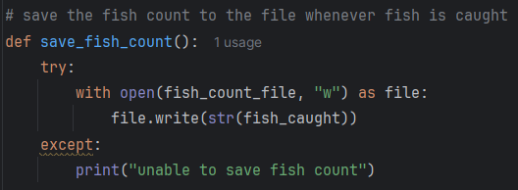

Line | Description
1 | Defines a function that writes the updated fish count to the file whenever the player catches a fish. It ensures progress is saved continuously rather than only at exit.
2 | This tries to open the file in write mode, replacing any previous content. It prepares the file to store the new fish count.
3
4 | This writes the current fish count as text into the file. It converts the number to a string because files store text, not integers.
5 | If saving fails, the program prints an error message instead of crashing. This gives feedback without interrupting gameplay.
6

Objective 5.b.i read the existing value from CSV file

Objective 5.b.ii validate and handle error files
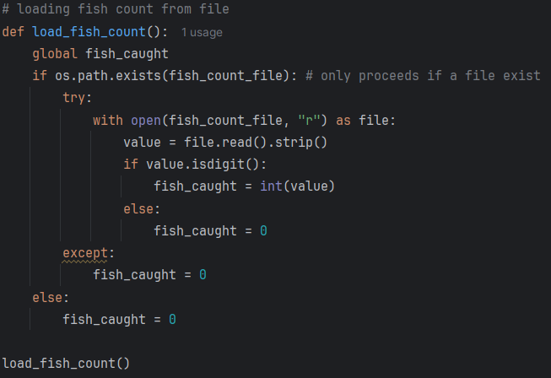

Line | Description
1 | Defines a new function that loads the saved fish count from the CSV file when the game starts.
2 | Globalises the variable for fish count.
3 | This checks whether the save file is present in the folder. It prevents the program from crashing by trying to read a file that doesn’t exist.
4 | Try to open the file in read mode so the program can access its contents. Using a with block ensures the file closes automatically afterward. The CSV file is referred to as file
5
6 | This reads the entire file as text and removes any extra whitespace. It prepares the data so it can be validated cleanly.
7 | This checks whether the file contains only numeric characters. It prevents errors from corrupted or invalid save data.
8 | This converts the text into an integer and stores it in the game’s variable. It restores the player’s previous fish count.
9 | If the file contains something invalid, the game resets the count to zero. This avoids loading broken or unexpected data.
10
11 | If reading the file fails for any reason, the game safely defaults to zero. This protects the program from crashing due to file-handling errors.
12
13 | If the file doesn’t exist at all, the game starts fresh with zero fish caught. This is the normal behaviour for a first-time run.
14
15 | This immediately calls the loading function so the saved fish count is applied before the game draws anything. It ensures the stats display shows the correct number from the moment the window appears.

Objective 5.b.iii set the ingame fish counter
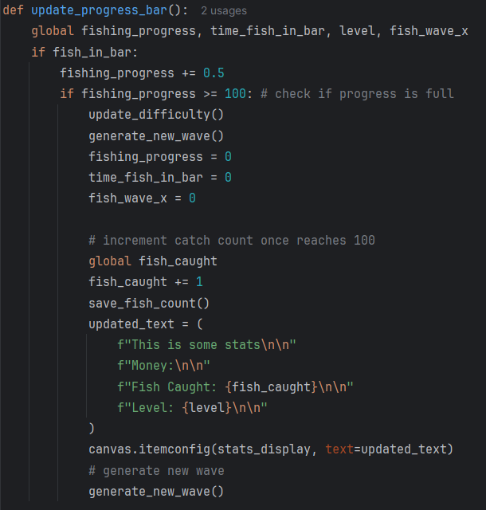

Line | Description
3 | This line saves the fish count immediately after the player catches a fish successfully. This ensures the save file always reflects the most recent value and prevents any loss of data. It is placed before the text update so the file is updated first.

3.5.3 Stage 5 Validation
Below are the validations implemented in this stage and their justification:
Validation check | What is being validated | How it is done in code | Why it is implemented | Why it is important
File existence validation | Fish count file is available before reading or writing | os.path.exists(fish_count_file) checks if file exists before load | Prevents file read errors when file is missing | Ensures program does not crash on first run
File read validation | Stored fish count is valid numeric data | file.read().strip() followed by value.isdigit() check | Prevents invalid text from being converted to integers | Keeps stored game data consistent
Safe fallback handling | Game still runs when file is missing or corrupted | try and except blocks assign fish_caught = 0 in failure cases | Prevents crashes from file I/O errors | Ensures stable startup under all conditions
Persistent data write validation | Fish count is correctly stored after each catch | open(file, "w") writes str(fish_caught) to CSV file | Ensures updated progress is saved after gameplay events | Maintains long term progression across sessions
Data type validation before storage | Only valid integer values are saved | fish_caught is always converted using str() before writing | Prevents invalid formats in storage file | Ensures file remains readable on next load
Load assignment validation | Loaded value correctly updates in game state | fish_caught is set after successful file read | Ensures saved progress affects gameplay immediately | Keeps UI and stored data aligned
Missing data handling | Game handles first-time users correctly | fish_caught defaults to 0 if file does not exist | Prevents undefined starting values | Guarantees fair starting state for all users
Update synchronization validation | UI reflects updated fish count after save/load | canvas.itemconfig updates stats_display after fish is caught | Prevents mismatch between file data and on-screen display | Ensures player sees correct progression in real time

3.5.4 Stage 5 Final testing
Please also refer to the video stage 5 – testing 1,2,3 in the attached file

Test No. | Test | Data to be used | Type of test | Expected Result | Pass/Fail | Evidence
1 | CSV File Creation on First Launch | N/A | Functional | A new CSV file is created automatically with the correct name and stores the value 0. | Pass | 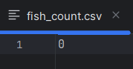  *Refer to Video: stage 5 – testing 1  The video showcases that the project file initially contains no CSV file. After catching a fish and exiting, a new CSV file appears in the same file directory as the code.
2 | Loading Stored Fish Count on Startup | 10, as an integer, entered to the CSV document manually | Functional | The game should display 10 as the fish count when started | Pass | *Refer to Video: stage 5 – testing 2  Timestamp 00:00-00:05  Shows the program correctly reads the value 10 entered manually into the CSV file
3 | Updating CSV After Catching Fish | 0, as an integer entered to the CSV | Normal | The fish should turn green as before, triggering an increase in the progress bar | Pass | *Refer to Video: stage 5 – testing 2  Timestamp 00:06-00:14  Shows the program correctly displaying the value 0 after being entered manually into the CSV file
4 | Handling invalid data in the CSV file | “hello” | Erroneous | The system should detect an invalid value and reset the counter to a safe default (0), and game should continue without crashing | Pass | *Refer to Video: stage 5 – testing 2  Timestamp 00:17-00:40  The video demonstrates that the word “hello” is manually entered into the CSV file. The program continues running without crashing, and after a fish is caught, the value is automatically overwritten to 1.
5 | Handling corrupted or unreadable CSV file | CSV with invalid formatting  Locked CSV | Erroneous | The game should handle the error safely and reset the counter to 0 or create a new file depending on the file type. No crash should occur. | Pass | 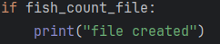  There is no direct way to show that the erroneous file has been reset to default, so a print statement was added at the end of the code to confirm whether a file is present. A document was then intentionally corrupted and the program was run.  The output in terminal showed that the test was successful.
6 | Multiple game sessions accumulate catch count correctly | Set CSV to 3.  Catch 2 fish → end game → restart game.  Catch 1 more fish → restart again. | Normal | After the first session CSV should read 5 and after the second session CSV should read 6. Each startup should load the correct total and display it. | Pass | *Refer to Video: stage 5 – testing 3  The video showcases the sequence described by the procedure.

3.5.6 Stage 5 Final program run screen
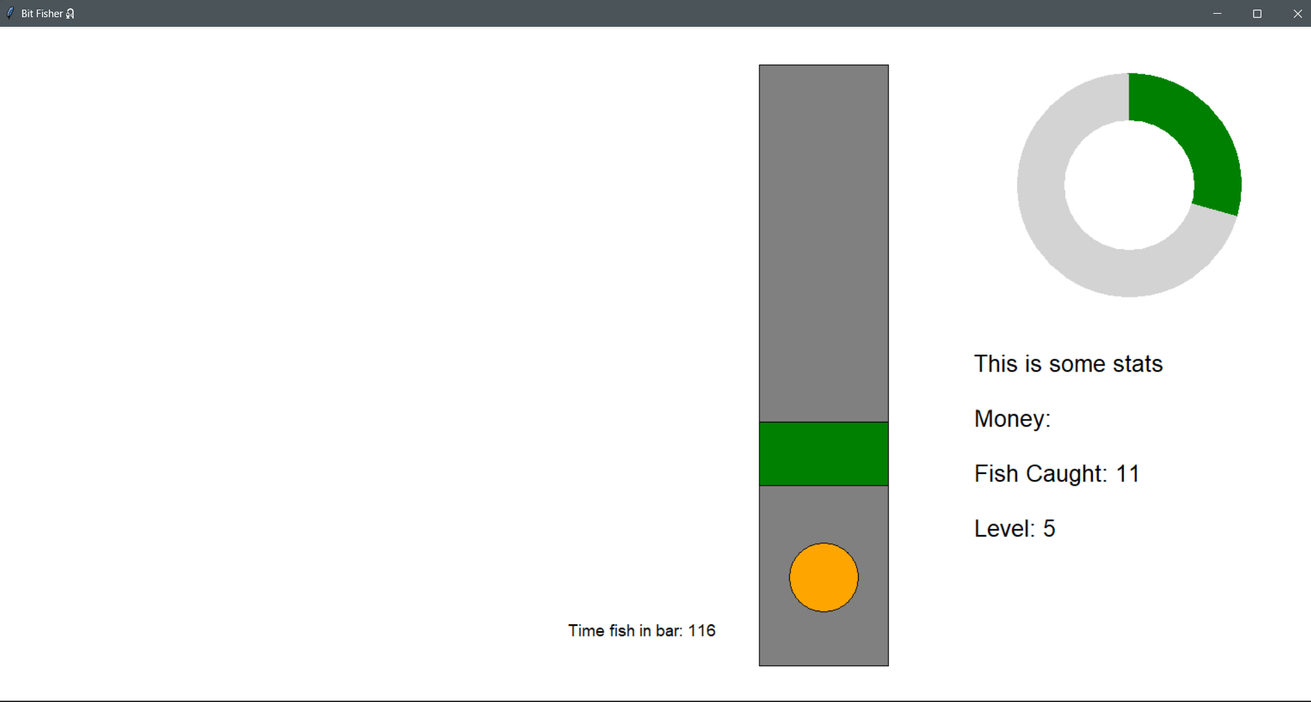

3.5.7 Stage 5 Final code:
import tkinter as tk
import math
import random
import os
# set up a blank basic window
window = tk.Tk()
window.title("Bit Fisher🎣")
window_width = window.winfo_screenwidth()
window_height = window.winfo_screenheight()
window.geometry("%dx%d" % (window_width, window_height))
# set up the file to store fish count
fish_count_file = "fish_count.csv"
if fish_count_file:
print("file created")
# ============================================================
# INITIAL VARIABLE SECTION
# This section creates and sets the variables used in widgets
# ============================================================
# progress bar variables
radius_outer = 130
radius_inner = 75
fishing_progress = 0
progress_arc = None
# set the coordinates of the progress bar
progress_center_x = window_width - 220
progress_center_y = window_height - 680
# dimensions for the fishing bar
fishing_width = 150
fishing_height = 700
# set the coordinates of the fishing bar
fishing_x1 = window_width - fishing_width - 500
fishing_y1 = window_height - fishing_height - 120
fishing_x2 = fishing_x1 + fishing_width
fishing_y2 = fishing_y1 + fishing_height
# set up detection area within the fishing bar (green bar)
green_width = fishing_width
green_height = 75
green_x = (fishing_x1 + fishing_x2) // 2
green_y = fishing_y1 + 50
# green bar movement variables
gravity = 10
lift = -10
velocity = 0
space_pressed = False
# fish dimensions and starting position
fish_radius = 40
# Center it horizontally and place it somewhere vertically inside the fishing box
fish_x = (fishing_x1 + fishing_x2) // 2
fish_y = fishing_y1 + 500
time_fish_in_bar = 0
fish_in_bar = False
fish_caught = 0
# set the fish movement variables
fish_wave_x = 0 # this will be used as the x-value for the trig function
fish_wave_speed = 0.005 # how fast the wave progresses
# variable for difficulty
difficulty = 0
level = 5
# set up a canvas inside the window
bg_color = "white"
canvas = tk.Canvas(window, width=window_width, height=window_height, bg=bg_color)
canvas.pack()
# loading fish count from file
def load_fish_count():
global fish_caught
if os.path.exists(fish_count_file): # only proceeds if a file exist
try:
with open(fish_count_file, "r") as file:
value = file.read().strip()
if value.isdigit():
fish_caught = int(value)
else:
fish_caught = 0
except:
fish_caught = 0
else:
fish_caught = 0
load_fish_count()
# save the fish count to the file whenever fish is caught
def save_fish_count():
try:
with open(fish_count_file, "w") as file:
file.write(str(fish_caught))
except:
print("unable to save fish count")
# ==========================================================
# STATS DISPLAY SECTION
# This section creates and manages the text displays,
# including Money, Fish Caught, and Level.
# ==========================================================
# draw the stats
stats_text = (
f"This is some stats\n\n"
f"Money:\n\n"
f"Fish Caught: {fish_caught}\n\n"
f"Level: {level}\n\n"
)
stats_display = canvas.create_text(
window_width - 180, window_height - 200,
text=stats_text,
anchor='se',
font=("Arial", 20),
fill="black"
)
# text object to display the catch timer (will be deleted later)
timer_text = canvas.create_text(
window_width - 700, window_height - 150,
text="Time fish in bar: 0",
font=("Arial", 14),
fill="black",
anchor="se"
)
# ==========================================================
# DEFINING FUNCTION SECTION
# This section creates functions for later usage,
# including: key binding, progress bar display and update,
# green bar movement, fish state checking, fish movement generating
# difficulty checking and adjusting
# ==========================================================
# detecting user input
def space_down(event):
global space_pressed
space_pressed = True
def space_up(event):
global space_pressed
space_pressed = False
# binding key inputs to function
window.bind("<KeyPress-space>", space_down)
window.bind("<KeyRelease-space>", space_up)
# set up fish movement waves
def generate_new_wave():
global a, b, c, d, e, f
a = random.randint(150, 500)
b = 10
c = random.randint(750, 1000)
d = 15
e = random.randint(300, 650)
f = 20
# validate function input
def fish_motion_function(t):
try:
term1 = a * math.sin(b * t)
except ZeroDivisionError:
term1 = 0
try:
term2 = c * math.sin(d * t)
except ZeroDivisionError:
term2 = 0
try:
term3 = e * math.cos(f * t)
except ZeroDivisionError:
term3 = 0
return term1 + term2 + term3
def update_progress_bar():
global fishing_progress, time_fish_in_bar, level, fish_wave_x
if fish_in_bar:
fishing_progress += 0.5
if fishing_progress >= 100: # check if progress is full
update_difficulty()
generate_new_wave()
fishing_progress = 0
time_fish_in_bar = 0
fish_wave_x = 0
# increment catch count once reaches 100
global fish_caught
fish_caught += 1
save_fish_count()
updated_text = (
f"This is some stats\n\n"
f"Money:\n\n"
f"Fish Caught: {fish_caught}\n\n"
f"Level: {level}\n\n"
)
canvas.itemconfig(stats_display, text=updated_text)
# generate new wave
generate_new_wave()
else:
fishing_progress -= 0.25
if fishing_progress <= 0:
fishing_progress = 0
time_fish_in_bar = 0
draw_progress()
window.after(30, update_progress_bar)
# redraws the progress bar in location
def draw_progress():
global fishing_progress, progress_arc
if progress_arc is not None:
canvas.delete(progress_arc)
if fishing_progress > 0:
extent = (fishing_progress / 100) * 360
progress_arc = canvas.create_arc(progress_center_x - radius_outer, progress_center_y - radius_outer,
progress_center_x + radius_outer, progress_center_y + radius_outer,
start=90, extent=-extent, fill="green", outline="")
else:
progress_arc = None
# update the inner circle to maintain donut shape
canvas.coords(inner_circle,
progress_center_x - radius_inner, progress_center_y - radius_inner,
progress_center_x + radius_inner, progress_center_y + radius_inner
)
canvas.tag_raise(inner_circle)
# function for green bar movement
def update_greenbar():
global green_y, velocity
# apply movement to green bar
if space_pressed:
velocity = lift
else:
velocity = gravity
green_y += velocity
# set the boundaries using the fishing bar
green_top_limit = fishing_y1 + green_height // 2
green_bottom_limit = fishing_y2 - green_height // 2
if green_y < green_top_limit:
green_y = green_top_limit
elif green_y > green_bottom_limit:
green_y = green_bottom_limit
# move the green bar
canvas.coords(green_bar,
green_x - green_width // 2, green_y - green_height // 2,
green_x + green_width // 2, green_y + green_height // 2
)
window.after(30, update_greenbar)
# detects if fish is in green bar
def check_if_fish_in_bar():
global time_fish_in_bar, fish_in_bar
# get coordinates of the green bar and the fish
green_coords = canvas.coords(green_bar) # [x1, y1, x2, y2]
fish_coords = canvas.coords(fish) # [x1, y1, x2, y2]
# check if rectangles overlap
if (green_coords[1] < fish_coords[3] and
green_coords[3] > fish_coords[1]):
# collision detected
fish_in_bar = True
canvas.itemconfig(fish, fill="green") # change colour of fish
time_fish_in_bar += 1 # increment the timer
else:
fish_in_bar = False
canvas.itemconfig(fish, fill="orange")
canvas.itemconfig(timer_text, text=f"Time fish in bar: {time_fish_in_bar}")
window.after(30, check_if_fish_in_bar) # re-check every 30ms
# update fish position
def update_fish():
global fish_wave_x, fish_y
fish_wave_x += fish_wave_speed
# Get offset from complex wave
offset = fish_motion_function(fish_wave_x)
# Clamp large spikes for stability
offset *= 0.2
offset = max(min(offset, 500), -500)
# Base around center of fishing bar
fish_mid_y = (fishing_y1 + fishing_y2) // 2
fish_y = fish_mid_y + offset
# Clamp within fishing bar
fish_top_limit = fishing_y1 + fish_radius
fish_bottom_limit = fishing_y2 - fish_radius
fish_y = max(min(fish_y, fish_bottom_limit), fish_top_limit)
# move the fish
canvas.coords(
fish,
fish_x - fish_radius, fish_y - fish_radius,
fish_x + fish_radius, fish_y + fish_radius
)
window.after(30, update_fish)
# recalculates difficulty based on each catch
def update_difficulty():
global difficulty, fishing_progress, time_fish_in_bar, fish_wave_speed, level
difficulty = fishing_progress / time_fish_in_bar
if difficulty <= 0.4 and fish_wave_speed > 0.001: # game currently too hard
fish_wave_speed -= 0.001
elif difficulty > 0.4: # game currently too easy
fish_wave_speed += 0.002
level = round(fish_wave_speed * 1000)
# =============================================
# DRAWING THE WIDGETS ONTO THE CANVAS
# =============================================
# set up the donut progress bar in location
canvas.create_oval(progress_center_x - radius_outer, progress_center_y - radius_outer,
progress_center_x + radius_outer, progress_center_y + radius_outer,
fill="light grey", outline="")
# draw the inner circle
inner_circle = canvas.create_oval(progress_center_x - radius_inner, progress_center_y - radius_inner,
progress_center_x + radius_inner, progress_center_y + radius_inner,
fill=bg_color, outline="")
# set up the fishing bar in location
canvas.create_rectangle(fishing_x1, fishing_y1, fishing_x2, fishing_y2, fill="grey", outline="black")
# draw the green bar
green_bar = canvas.create_rectangle(
green_x - green_width // 2, green_y - green_height // 2,
green_x + green_width // 2, green_y + green_height //2,
fill="green", outline="black"
)
# draw the fish
fish = canvas.create_oval(
fish_x - fish_radius, fish_y - fish_radius,
fish_x + fish_radius, fish_y + fish_radius,
fill="orange", outline="black"
)
generate_new_wave()
draw_progress()
update_progress_bar()
check_if_fish_in_bar()
update_greenbar()
update_fish()
window.mainloop()

3.6 Stage 6 – Object-Oriented Fish Generation
For this stage, I plan to extend the fish system by introducing object based fish definitions, allowing each fish to have its own attributes such as speed and difficulty. This builds on the previous stage by replacing a single fixed fish behaviour with configurable fish types. A weighted randomizer will also be implemented to control which fish spawns, allowing rarer fish to appear less frequently. Finally, the adaptive difficulty system from earlier stages will be applied to the generated fish so each catch dynamically reflects player performance. My main objectives are:

- Define fish using classes
- Create a class to represent fish objects with attributes such as movement speed and difficulty level
- Allow each fish instance to store its own parameters in a dictionary variable instead of using shared global values
- Use these attributes to generate wave speed and behaviour when a fish is spawned

- Implement a weighted random spawn system
- Create a list of fish types with associated rarity weights
- Use a weighted random selection to determine which fish object is generated
- Ensure higher rarity value fish spawn more frequently while lower rarity fish appear less often

- Apply difficulty settings to generated fish
- Use the adaptive difficulty value from earlier stages to modify fish attributes
- Make sure all previously written functions are modified to fit within the class
- Spawn a new fish object after each successful catch using the updated difficulty settings

3.6.1 Stage 6 Test plan

Test No. | Test | Procedure | Data to be used | Type of test | Expected Result
1 | Fish object is created with correct default attributes | Verify class initialization by starting the game and triggering a fish spawn, then checking object values. | Fish type = “standard_fish”  expected speed = 0.005  expected difficulty = 1 | Functional | Fish object contains attributes such as speed, difficulty, and rarity, and values match class defaults.
2 | Different fish types spawn with different attributes | Confirm multiple fish definitions work by spawning fish types “slow_fish”, “standard_fish”, “fast_fish” and recording values. | slow_fish speed = 0.003, standard_fish speed = 0.005, fast_fish speed = 0.008 | Functional | Each fish type shows distinct attribute values matching definitions.
3 | Weighted randomizer favors common fish | Run 100 spawns and count fish types using weights common = 70, uncommon = 25, rare = 5. | 100 total spawns | Statistical | Common fish appears most frequently, rare fish appears least frequently, distribution roughly matches weights.
4 | Fish attributes correctly affect movement speed | Spawn fish with different speeds and measure movement change per frame. | slow fish speed = 0.003, fast fish speed = 0.01 | Functional | fast fish shows faster vertical oscillation than slow fish.
5 | New fish object is generated after each catch | Catch fish 3 times and record fish attributes each time. | 3 consecutive catches | Functional | Each spawn generates a new object with updated attributes and movement pattern.
6 | Weighted randomizer handles single fish type | Set fish pool to only “standard_fish” and run 50 spawns. | single fish type only | Boundary | same fish type spawns every time with no errors.
7 | Weighted randomizer handles zero-weight fish correctly | Assign weights slow = 0, standard = 100, fast = 50 and run 100 spawns. | slow weight = 0 | Erroneous | slow fish never appears.
8 | Difficulty scaling respects maximum limits | Increase difficulty repeatedly until max cap is reached and observe speed. | max fish speed cap = 0.02 | Boundary | fish speed does not exceed 0.02.
9 | Difficulty scaling respects minimum limits | Decrease difficulty repeatedly until minimum cap is reached. | min fish speed = 0.001 | Boundary | fish speed does not fall below 0.001.

3.6.2 Stage 6 Code Analysis

Objective 6.a.1 Construct Fish class
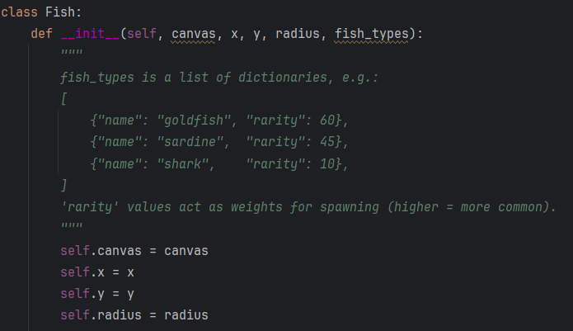

Line | Description
1 | I begin by defining a blueprint called Fish. This class allows me to create multiple fish entities that share the same behaviors and properties while maintaining their own unique data.
2 | I set up the constructor method to prepare each new fish. This function accepts external data like screen coordinates and fish varieties so the object starts with the correct information.
comment | I include a block comment here to clarify the structure of the fish_types list. It acts as a guide for using dictionaries to store names and rarity weights, ensuring the spawning logic remains easy to follow and other developers can understand the structure of the class for easy maintainability.
3 | I link all the internal attributes to their corresponding variables. This allows me to call these values anywhere inside the class. Storing the canvas, coordinates, and size within the object ensures the class and the main program remain connected and share the same data.
4
5
6

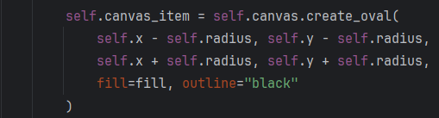

Line | Description
1 | I call the canvas method to draw an oval shape on the screen. By assigning this to a variable, I create a reference that allows me to update or move this specific fish later in the code.
2 | I calculate the top-left corner of the bounding box for the fish. Subtracting the radius from the center coordinates ensures the shape starts at the correct position to keep the fish centered.
3 | I determine the bottom-right corner of the bounding box. Adding the radius completes the square area that defines the width and height of the circular fish.
4 | I set the visual style of the fish by applying a background color and a black border. This makes the fish stand out against the fishing bar and provides immediate feedback on its current state.

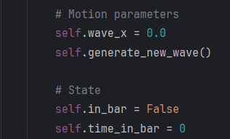

Line | Description
1 | These were previously separate variables and procedures, but are now defined as internal methods and attributes using class syntax. They are placed inside the fish class to reduce the risk of accidentally modifying them from outside the object. This also improves structure, since these values are frequently accessed within the fish related functions.
2
3
4

Objective 6.a.ii Storing parameters in dictionary for each fish instance
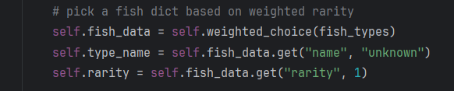

Line | Description
1 | The code calls the internal weighted_choice method to select a specific fish from the list. Storing this result in a dictionary ensures the fish keeps its unique identity and rarity throughout the game. Dictionaries are highly efficient for this task because they store data as key-value pairs. This allows me to retrieve specific traits like name or speed instantly using simple labels.
2 | I extract the name of the fish from the chosen data. Using the get method provides a safety net; if the dictionary is missing a name, the program defaults to "unknown" to prevent the game from crashing.
3 | This line retrieves the rarity value and saves it to the object. Storing this number allows the program to adjust difficulty or rewards later based on how rare this specific fish is.

Objective 6.a.iii generating wave speed from selected attributes
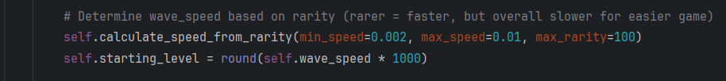

Line | Description
1 | I call this method to set the movement speed based on how rare the fish is. By passing these specific minimum and maximum values, I establish the boundaries for how slow or fast any fish in the game can move.
2 | This line converts the small decimal speed into a whole number to show the player a "level." Multiplying by 1000 and rounding creates a clean integer that makes the difficulty easier to understand at a glance.
3 | I define the logic for the speed calculation here. This function uses default values to ensure the code still works even if I forget to provide specific numbers when calling it.
4 | I use the max function to ensure the rarity value is at least 1. This prevents a math error if a rarity of 0 is entered, which would otherwise disrupt the calculation.
5 | This formula calculates the final speed. It uses an inverse relationship where a lower rarity value results in a higher speed. This ensures that rare fish are naturally more difficult to catch than common ones.

Objective 6.a.iii Justification of Specific Values
The numbers chosen for these functions balance gameplay and user experience:
- 0.002 to 0.01 Speed Range: These small decimals are necessary because the game updates many times per second. A value like 0.01 moves the fish at a pace that is challenging but still reactable for a human player.
- Max Rarity of 100: Using 100 as the base makes the rarity system feel like a percentage. It is intuitive for me to scale fish rarity within a 1 to 100 range.
- Multiplier of 1000: I use 1000 to shift the decimal point three places. This turns a value like 0.005 into "Level 5," which is a much more natural number for a player to see on their screen.

Objective 6.b.i create fish type list
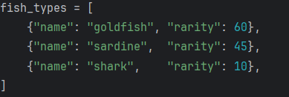

I defined a 2D list containing three distinct fish types to test the weighted selection system. These types cover a broad range of rarity values to ensure the spawning logic functions correctly across different probabilities. I chose weights of 60, 45, and 10 to create clear, observable differences in spawn rates during testing. These values are distant enough to prove the randomizer favors common fish while keeping rare fish elusive without making them impossible to find. Using this specific data set allows me to verify that the program accurately translates numerical weights into a balanced gameplay experience.
These values serve as temporary placeholders, as I plan to expand the variety of fish in later development stages. Limiting the test to three fish types provides greater control during debugging and makes it easier to manage, monitor, and validate the selection system before introducing additional complexity.

Objective 6.b.ii weighted random selection

Objective 6.b.iii ensuring higher rarity value fish spawns more frequently than lower rarity fish
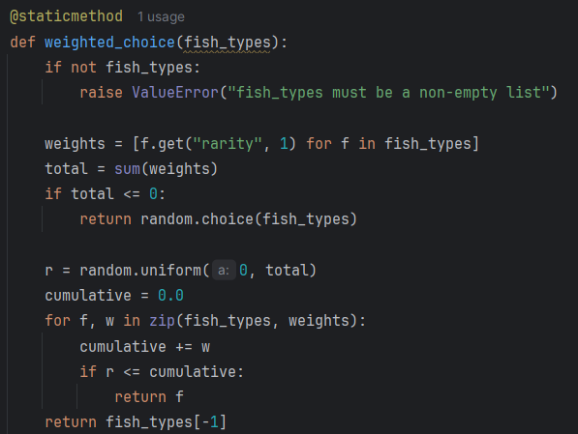

Line | Description
1 | I mark this function as a static method because it does not need to access any internal data from a specific fish object. This allows the program to call the function directly from the Fish class to select a fish type before the actual fish is even created.
2 | This line defines the function responsible for the selection process. It takes the list of fish dictionaries as input so it can evaluate the rarity of each species.
3 | I include a safety check to see if the list is empty. If the program tries to pick a fish from an empty list, it will stop and provide a clear error message instead of crashing unexpectedly later on.
4 | This command triggers the error message. It forces the developer to provide valid data, which helps with debugging during the development of the spawning system.
5 | I use a list comprehension to pull the rarity value out of every fish dictionary. If a fish is missing a rarity value, the code defaults to 1 to ensure every item in the list has a numerical weight for the math to work.
6 | This line adds all the rarity numbers together to find the total weight. I need this sum to define the range for the random selection process.
7 | I add another defensive check for cases where all rarity values might be zero or negative. Since you cannot perform a weighted selection without a positive total, this condition ensures the program stays stable.
8 | If the total weight is invalid, the program falls back to a standard random choice. This ensures the game continues to run by picking a fish with equal probability when the weighting data is missing or broken.

This is still within the weighted_choice function

Line | Description
1 | I generate a random decimal number between zero and the total sum of all rarity weights. This number acts like a pointer that falls somewhere along a line representing the entire probability pool.
2 | I initialize a running total at zero. This variable helps me track the combined weight of the fish species as the loop checks them one by one.
3 | This loop pairs each fish dictionary with its corresponding weight. It allows the program to iterate through the list and evaluate each species alongside its specific rarity value.
4 | I add the current fish's weight to the running total. By doing this, I build up a "threshold" for each fish; the larger the weight, the larger the section of the total range that fish occupies.
5 | The program checks if the random number is less than or equal to the current cumulative total. If it is, the random pointer has "landed" on this fish's section, and the system selects it immediately.
6 | I return the selected fish dictionary to the part of the program that called the function. This successfully ends the selection process once a match is found.
7 | This line serves as a final safety net. If the loop finishes without returning a fish due to a minor math rounding error, the program simply returns the very last fish in the list to ensure the game never breaks.

Objective 6.c.i use difficulty value to modify fish starting appearance
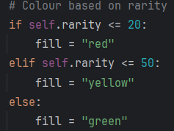

Line | Description
1 | I use this if statement to change the fill color of the fish oval placeholder based on rarity. This provides a visual indicator during gameplay to verify which fish type was drawn. While I plan to replace these ovals with fish sprites in later stages, using simple colors now allows me to test the weighted selection module efficiently. This temporary setup confirms the correct species spawn according to their assigned weights without the complexity of managing image files.
2
3
4
5
6

Objective 6.c.ii modifying previous written function to methods
Since these functions were explained in earlier sections, they are included here only to show the modifications made to fit the class method structure as well as some light modifications to improve the performance and/or simplify the bulk of the code.

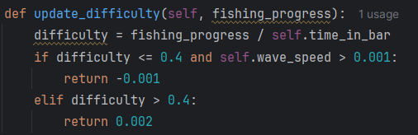

I changed the function so it returns a speed adjustment value instead of directly modifying a variable. This separates calculation from state changes. It gives tighter control over how difficulty is applied, since I can decide where and when to use the returned value rather than forcing an immediate overwrite. This reduces unintended side effects and makes the system easier to tune.
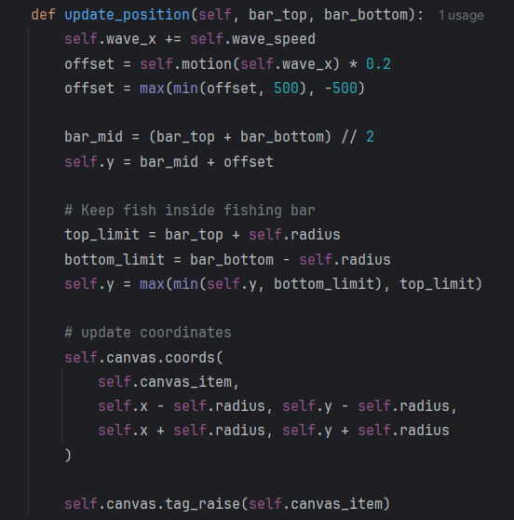

I redesigned this part to accept the bar boundaries as inputs. This is way better than hardcoding screen numbers because it means I can move the fishing bar anywhere on the screen without breaking the fish. I also added a feature to keep the fish on the top layer of the canvas. This fixed a frustrating bug where the fish would sometimes hide behind the background elements.
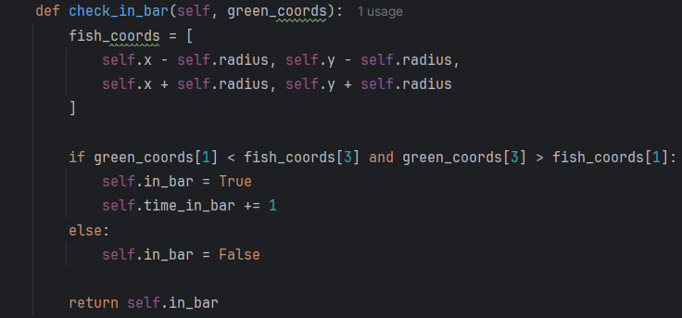
I swapped the global collision logic for a local hitbox calculation. Instead of the main program trying to guess where the fish is, the fish now calculates its own position and reports back if it is being caught. This makes the game feel more responsive. It also cleans up the main loop because the fish handles all its own "sensing" logic.

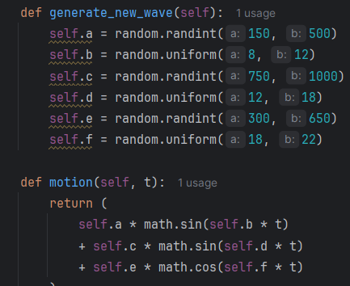

I moved the wave variables from global integers to instance attributes. Using random.uniform instead of randint lets me use decimals, which makes the fish movement feel much smoother and less robotic. This change was necessary because the old global system made every fish move exactly the same way. Now, each fish I spawn has its own unique "personality" and swimming rhythm.

I cleaned up this math function by removing the bulky error handling. Since the class now controls the variables, I know I won't run into those weird zero-division issues from before. This keeps the code fast and focused on just calculating the trigonometry. I used this approach to make the movement logic more reliable while keeping the math behind the swimming patterns hidden inside the object.

Objective 6.c.ii Justification for these changes:
- Modular Movement: Passing boundaries like bar_top into the function makes the fish independent. If I decide to change the size of the fishing window later, the fish will automatically stay within the new limits without me having to rewrite the movement code.
- Self-Contained Sensing: Having the fish check its own collision with check_in_bar follows the idea that an object should know its own state. This keeps the main game loop from becoming a giant mess of "if" statements checking every single item on the screen.
- Flexible Difficulty: By returning a value in update_difficulty instead of forcing a change, I can choose to ignore the speed boost if the player just started or has a specific power-up. It makes the code much more adaptable for future features.
- Visual Priority: Using tag_raise inside the update function ensures the fish is always visible. In a high-speed game, it is vital that the target stays on top of the UI elements so the player never loses sight of it.

Objective 6.c.iii. spawn new fish object after each catch
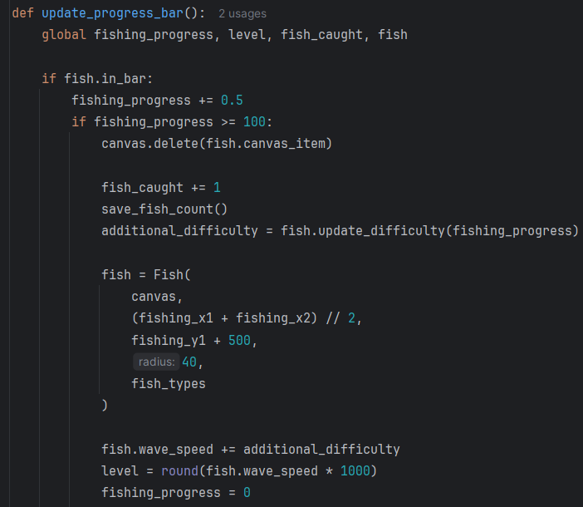

Within the update_progress_bar function in the main program, the highlighted sections show the modifications required to integrate the class based fish structure and ensure each catch generates a new fish with updated behaviour.
Block | Description
1 | The canvas.delete(fish.canvas_item) line removes the current fish object from the canvas before spawning a new one. This prevents multiple fish objects from existing simultaneously, which would cause overlapping visuals and conflicting collision checks. Removing the previous object ensures only the newly generated fish is active and keeps state management consistent.
2 | The fish.update_difficulty(fishing_progress) method is then called from the fish class to calculate an additional difficulty offset based on player performance. Moving this calculation into the class keeps difficulty logic encapsulated with the fish behaviour, reducing reliance on global variables and ensuring the returned value directly relates to the specific fish that was just caught.
3 | A new Fish object is created using the class constructor, with parameters such as canvas, position, radius, and fish_types passed in. This allows a completely new fish instance to be generated with its own attributes, including rarity, speed, and movement pattern. Creating a new object each time improves modularity and supports the weighted random spawning system introduced in this stage.
4 | The returned difficulty offset is added to fish.wave_speed, modifying the newly spawned fish’s movement speed according to the player's previous performance. Applying the adjustment after object creation ensures the base attributes from the selected fish type remain intact, while still allowing dynamic scaling of difficulty. This maintains progression and prevents the game from feeling static across catches.

3.6.3 Stage 6 Validation
Validation check | What is being validated | How it is done in code | Why it is implemented | Why it is important
File persistence safety validation | Fish count file exists and contains valid numeric data | os.path.exists checks file presence, try and except handles read errors, value.isdigit ensures only numeric values are used | Prevents crashes from missing files or corrupted text values | Ensures game always loads safely even on first run or broken file
Fish class data isolation validation | Each fish stores its own movement, state, and attributes independently | Fish class uses instance variables like wave_speed, time_in_bar, in_bar instead of shared globals | Prevents different fish overwriting each other’s values | Allows multiple fish types with unique behaviour without conflicts
Safe weighted selection validation | Fish spawn system does not fail when rarity values are invalid or missing | weighted_choice checks empty lists, sums weights, and falls back to random choice if total weight is 0 | Prevents division by zero or invalid probability calculations | Ensures game always spawns a fish even if data is incorrect
Controlled randomness validation | Fish movement values stay within safe limits | random.randint and random.uniform generate bounded values for wave parameters | Prevents extreme values causing erratic movement | Keeps fish motion smooth and playable
Fish motion safety validation | Trigonometric movement does not crash the program | fish_motion_function uses try and except blocks for math calculations | Prevents runtime errors from invalid mathematical operations | Ensures continuous gameplay without freezing
Position boundary validation | Fish always stays inside the fishing bar area | update_position clamps fish_y between top and bottom limits of fishing area | Prevents fish moving off screen or outside gameplay zone | Keeps gameplay visually correct and fair
Collision state validation | Fish correctly detects when inside green bar | check_in_bar compares fish and bar bounding boxes and updates in_bar flag | Prevents incorrect progress updates when no overlap exists | Ensures only valid interactions count toward progress
Adaptive difficulty validation | Fish speed changes based on player success rate | update_difficulty uses fishing_progress divided by time_in_bar to adjust wave_speed | Prevents fixed difficulty that ignores player skill | Ensures game difficulty scales fairly over time
Object reset validation | Old fish objects are fully removed before spawning a new one | canvas.delete removes old fish canvas item before creating a new Fish instance | Prevents overlapping fish objects and memory buildup | Ensures clean transitions between catches without visual bugs

3.6.4 Stage 6 Final Testing
Please also refer to the video stage 6 – testing in the attached file

Test No. | Test | Procedure | Data to be used | Expected Result | Pass/fail | Evidence
1 | Fish object is created with correct default attributes | Verify class initialization by starting the game and triggering a fish spawn, then checking object values. | Fish type = “sardine”  expected speed = 0.005  expected difficulty = 5 | Fish object contains attributes such as speed, difficulty, and rarity, and values match class defaults. | Pass | 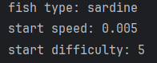  *Verified through use of print statement
2 | Different fish types spawn with different attributes | Confirm multiple fish definitions work by spawning fish types “goldfish”, “sardine”, “shark” and recording values. | Goldfish speed = 0.003, sardine speed = 0.005, shark speed = 0.008 | Each fish type shows distinct attribute values matching definitions. | Pass | 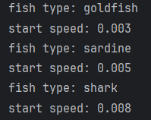  *Verified through use of print statement
3 | Weighted randomizer favors common fish | Run 100 spawns and count fish types using weights common = 70, uncommon = 25, rare = 5. | 100 total spawns | Common fish appears most frequently, rare fish appears least frequently, distribution roughly matches weights. | Pass | Refer to 3.6.4.i Test 3: Weighted randomised selection
4 | Fish attributes correctly affect movement speed | Spawn fish with different speeds and measure movement change per frame. | slow fish speed = 0.003, fast fish speed = 0.008 | fast fish shows faster vertical oscillation than slow fish. | Pass | *Verified through use of print statement
5 | New fish object is generated after each catch | Catch fish 3 times and record fish attributes each time. | 3 consecutive catches | Each spawn generates a new object with updated attributes and a movement pattern. | Pass | I kept respawning fish, until all three fish were spawned:  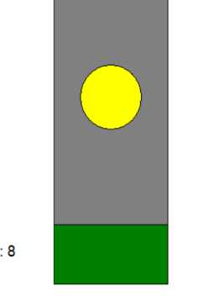  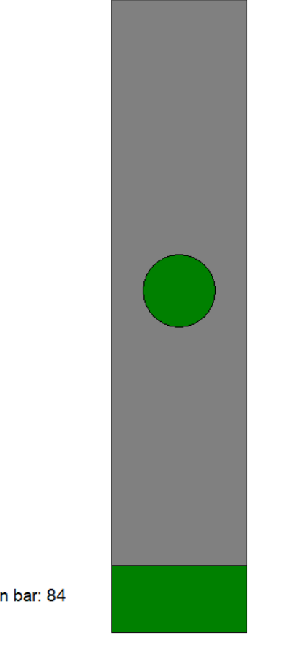  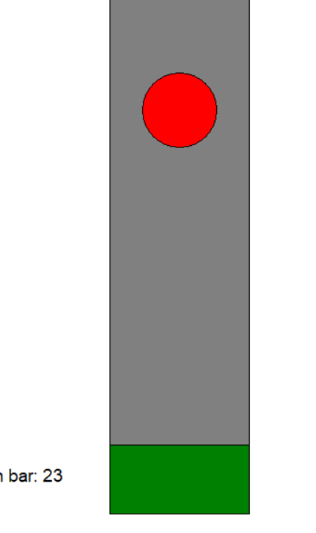
6 | Weighted randomizer handles single fish type | Set fish pool to only “goldfish” and run 50 spawns. | single fish type only | same fish type spawns every time with no errors. | Pass | *This uses the same code as from 3.6.4.i Test 3: Weighted randomised selection  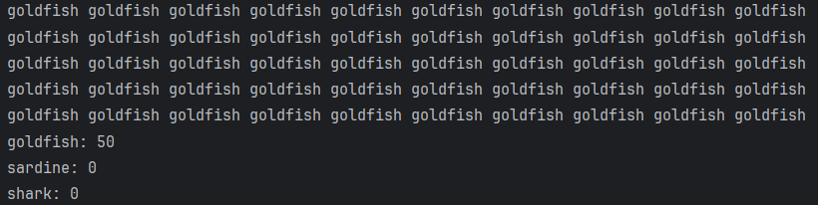
7 | Weighted randomizer handles zero-weight fish correctly | Assign weights slow = 0, standard = 100, fast = 50 and run 100 spawns. | slow weight = 0 | slow fish never appears. | Pass | *This uses the same code as from 3.6.4.i Test 3: Weighted randomised selection  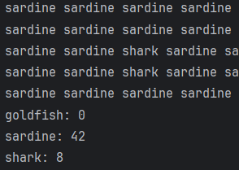
8 | Difficulty scaling respects maximum limits | Increase difficulty repeatedly until max cap is reached and observe speed. | max fish speed cap = 0.02  max difficulty = 0.02 * 1000 = 20 | fish speed does not exceed 0.02 and difficulty does not exceed 20 | Pass | *refer to video recording stage 6 – testing  The video shows two goldfish, one sardine, and one shark being caught.  The speed does not exceed 0.02, as demonstrated by the difficulty cap at level 11, even when catching the shark.
9 | Difficulty scaling respects minimum limits | Decrease difficulty repeatedly until minimum cap is reached. | min fish speed = 0.001  min difficulty = 0.001*1000 = 1 | fish speed does not fall below 0.001  and difficulty does not fall below 1 | Pass | *refer to video recording stage 6 – testing  Similar to test 8, the goldfish’s min speed was 1 as shown in the video.

3.6.4.i Test 3: Weighted randomised selection
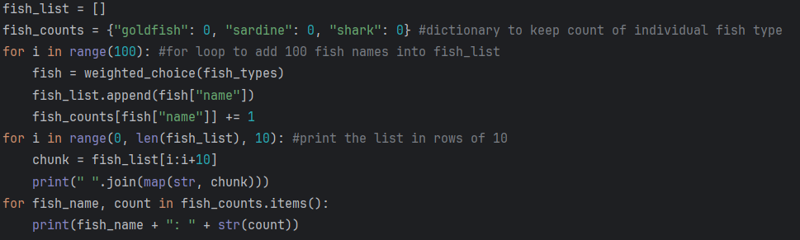

I transferred the weighted_selection function and the fish list code into a separate document. I then implemented a for loop to generate a sample of 100 fish names using the weighted selection system. This allows me to use the print function to observe the distribution clearly. I also record the frequency of each fish type within the sample. The following results are obtained:

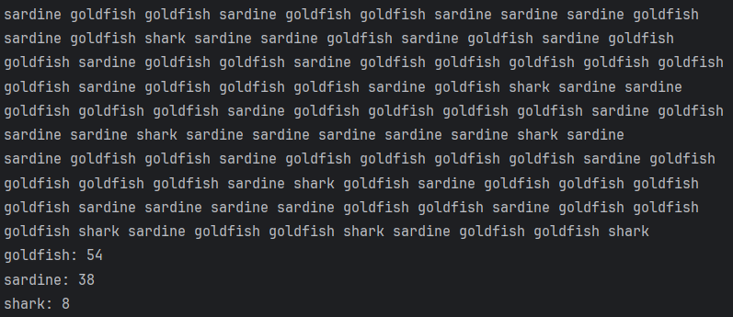
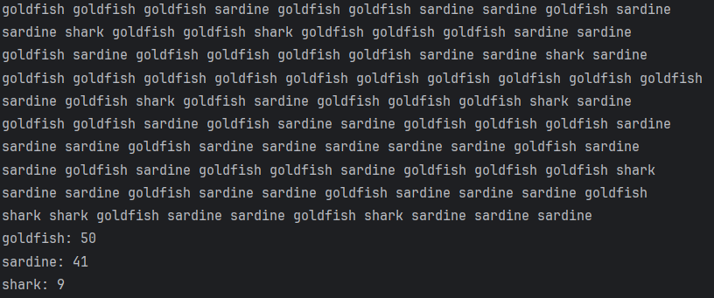
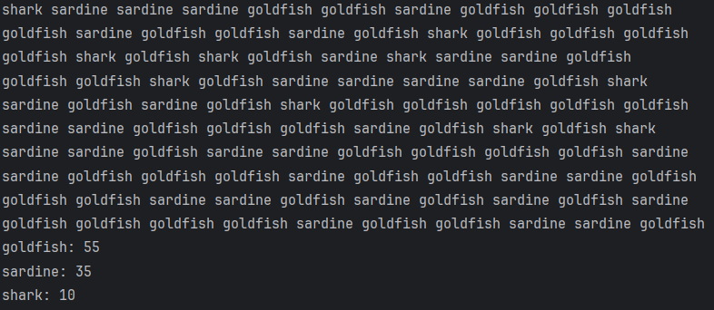
I run the selection process several times to produce reliable data. I repeat the procedure three times to reduce random error and identify consistent patterns. A single run can include unusual variation, while multiple runs show the underlying behaviour of the weighted system. I then calculate the average to estimate the true distribution of outcomes.
The probabilities control how often each fish appears. The total weight equals 115, which comes from 60 +45+10. Through calculation, I can find the expected probability for each fish:
Goldfish: 60/115 = 53%
Sardines: 45/115 = 38%
Sharks: 10/115 = 9%

From the result obtained, the function generated a total of 300 fish:
Goldfish: 159
Sardines: 114
Sharks: 27

These values align closely with the expected distribution. Goldfish account for 53% of the output, sardines 38%, and sharks 9%. Minor differences between expected and observed values arise from random variation.
A larger sample size reduces this variation further. The results confirm the code behaves as intended based on the defined weights. The selection process produces outcomes that follow the specified probabilities.

3.6.5 Stage 6 Final program run screen
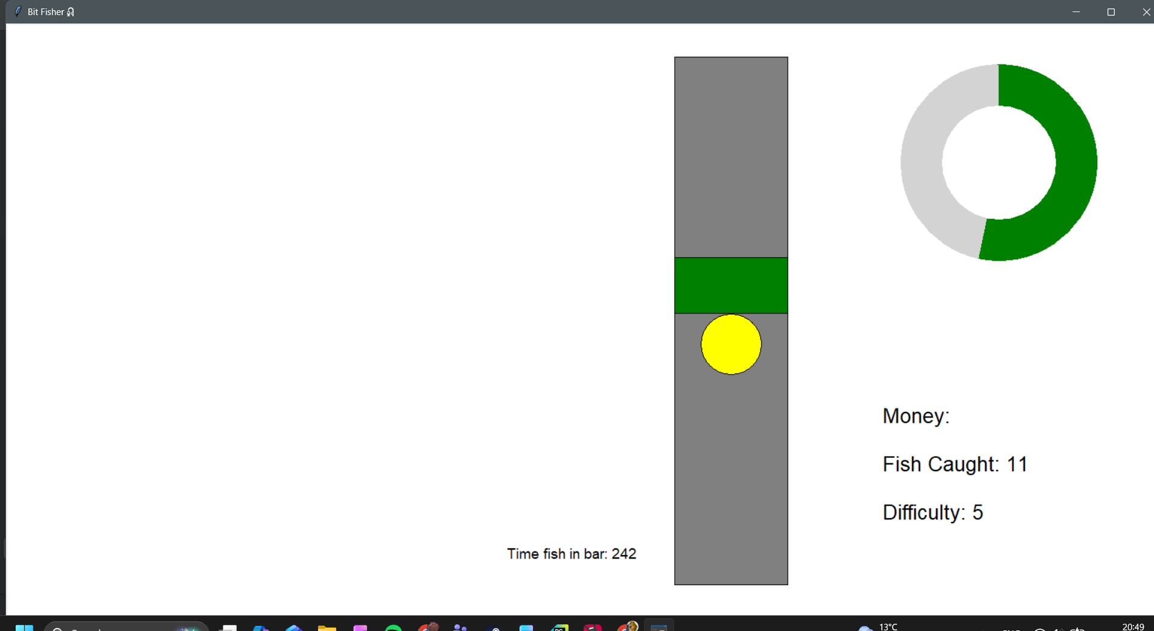

3.6.6 Stage 6 Final code
import tkinter as tk
import math
import random
import os
# ================================
# FISH CLASS SET UP
# ================================
class Fish:
def __init__(self, canvas, x, y, radius, fish_types):
"""
fish_types is a list of dictionaries, e.g.:
[
{"name": "goldfish", "rarity": 60},
{"name": "sardine", "rarity": 45},
{"name": "shark", "rarity": 10},
]
'rarity' values act as weights for spawning (higher = more common).
"""
self.canvas = canvas
self.x = x
self.y = y
self.radius = radius
self.fish_data = self.weighted_choice(fish_types)
self.type_name = self.fish_data.get("name", "unknown")
self.rarity = self.fish_data.get("rarity", 1)
self.calculate_speed_from_rarity(min_speed=0.002, max_speed=0.01, max_rarity=100)
self.starting_level = round(self.wave_speed * 1000)
if self.rarity <= 20:
fill = "red"
elif self.rarity <= 50:
fill = "yellow"
else:
fill = "green"
self.canvas_item = self.canvas.create_oval(
self.x - self.radius, self.y - self.radius,
self.x + self.radius, self.y + self.radius,
fill=fill, outline="black"
)
self.wave_x = 0.0
self.generate_new_wave()
self.in_bar = False
self.time_in_bar = 0
def calculate_speed_from_rarity(self, min_speed=0.005, max_speed=0.02, max_rarity=100):
rarity = max(1, self.rarity)
self.wave_speed = min_speed + (max_rarity - rarity) / max_rarity * (max_speed - min_speed)
@staticmethod
def weighted_choice(fish_types):
if not fish_types:
raise ValueError("fish_types must be a non-empty list")
weights = [f.get("rarity", 1) for f in fish_types]
total = sum(weights)
if total <= 0:
return random.choice(fish_types)
r = random.uniform(0, total)
cumulative = 0.0
for f, w in zip(fish_types, weights):
cumulative += w
if r <= cumulative:
return f
return fish_types[-1]
def generate_new_wave(self):
self.a = random.randint(150, 500)
self.b = random.uniform(8, 12)
self.c = random.randint(750, 1000)
self.d = random.uniform(12, 18)
self.e = random.randint(300, 650)
self.f = random.uniform(18, 22)
def motion(self, t):
return (
self.a * math.sin(self.b * t)
+ self.c * math.sin(self.d * t)
+ self.e * math.cos(self.f * t)
)
def update_position(self, bar_top, bar_bottom):
self.wave_x += self.wave_speed
offset = self.motion(self.wave_x) * 0.2
offset = max(min(offset, 500), -500)
bar_mid = (bar_top + bar_bottom) // 2
self.y = bar_mid + offset
top_limit = bar_top + self.radius
bottom_limit = bar_bottom - self.radius
self.y = max(min(self.y, bottom_limit), top_limit)
self.canvas.coords(
self.canvas_item,
self.x - self.radius, self.y - self.radius,
self.x + self.radius, self.y + self.radius
)
self.canvas.tag_raise(self.canvas_item)
def check_in_bar(self, green_coords):
fish_coords = [
self.x - self.radius, self.y - self.radius,
self.x + self.radius, self.y + self.radius
]
if green_coords[1] < fish_coords[3] and green_coords[3] > fish_coords[1]:
self.in_bar = True
self.time_in_bar += 1
else:
self.in_bar = False
return self.in_bar
def update_difficulty(self, fishing_progress):
difficulty = fishing_progress / self.time_in_bar
if difficulty <= 0.45 and self.wave_speed > 0.001:
return -0.001
elif difficulty > 0.45:
return 0.002
# -------------------------
# CONFIGURE AVAILABLE FISH
# -------------------------
fish_types = [
{"name": "goldfish", "rarity": 60},
{"name": "sardine", "rarity": 45},
{"name": "shark", "rarity": 10},
]
# ===============================================
# GAME SETUP
# ===============================================
window = tk.Tk()
window.title("Bit Fisher🎣")
window_width = window.winfo_screenwidth()
window_height = window.winfo_screenheight()
window.geometry("%dx%d" % (window_width, window_height))
fish_count_file = "fish_count.csv"
# ============================================================
# INITIAL VARIABLE SECTION
# ============================================================
radius_outer = 130
radius_inner = 75
fishing_progress = 0
progress_arc = None
progress_center_x = window_width - 220
progress_center_y = window_height - 680
fishing_width = 150
fishing_height = 700
fishing_x1 = window_width - fishing_width - 500
fishing_y1 = window_height - fishing_height - 120
fishing_x2 = fishing_x1 + fishing_width
fishing_y2 = fishing_y1 + fishing_height
green_width = fishing_width
green_height = 75
green_x = (fishing_x1 + fishing_x2) // 2
green_y = fishing_y1 + 50
gravity = 10
lift = -10
velocity = 0
space_pressed = False
fish_caught = 0
canvas = tk.Canvas(window, width=window_width, height=window_height, bg="white")
canvas.pack()
def load_fish_count():
global fish_caught
if os.path.exists(fish_count_file):
try:
with open(fish_count_file, "r") as file:
value = file.read().strip()
fish_caught = int(value) if value.isdigit() else 0
except:
fish_caught = 0
else:
fish_caught = 0
load_fish_count()
def save_fish_count():
try:
with open(fish_count_file, "w") as file:
file.write(str(fish_caught))
except:
print("Unable to save fish count.")
difficulty = 0
level = 5
# ==========================================================
# STATS DISPLAY SECTION
# ==========================================================
stats_display = canvas.create_text(
window_width - 180,
window_height - 200,
text=f"Money:\n\nFish Caught: {fish_caught}\n\nDifficulty: {level}",
anchor='se',
font=("Arial", 20),
fill="black"
)
timer_text = canvas.create_text(
window_width - 700,
window_height - 150,
text="Time fish in bar: 0",
font=("Arial", 14),
fill="black",
anchor="se"
)
# ==========================================================
# DEFINING FUNCTION SECTION
# ==========================================================
def space_down(event):
global space_pressed
space_pressed = True
def space_up(event):
global space_pressed
space_pressed = False
window.bind("<KeyPress-space>", space_down)
window.bind("<KeyRelease-space>", space_up)
fish = Fish(
canvas,
(fishing_x1 + fishing_x2) // 2,
fishing_y1 + 500,
40,
fish_types
)
def update_progress_bar():
global fishing_progress, level, fish_caught, fish
if fish.in_bar:
fishing_progress += 0.5
if fishing_progress >= 100:
canvas.delete(fish.canvas_item)
fish_caught += 1
save_fish_count()
additional_difficulty = fish.update_difficulty(fishing_progress)
fish = Fish(
canvas,
(fishing_x1 + fishing_x2) // 2,
fishing_y1 + 500,
40,
fish_types
)
fish.wave_speed += additional_difficulty
level = round(fish.wave_speed * 1000)
fishing_progress = 0
canvas.itemconfig(
stats_display,
text=f"Money:\n\nFish Caught: {fish_caught}\n\nDifficulty: {level}"
)
else:
fishing_progress -= 0.1
fishing_progress = max(fishing_progress, 0)
draw_progress()
window.after(30, update_progress_bar)
def draw_progress():
global progress_arc
if progress_arc:
try:
canvas.delete(progress_arc)
except:
pass
if fishing_progress > 0:
extent = (fishing_progress / 100) * 360
progress_arc = canvas.create_arc(
progress_center_x - radius_outer, progress_center_y - radius_outer,
progress_center_x + radius_outer, progress_center_y + radius_outer,
start=90, extent=-extent, fill="green", outline=""
)
canvas.coords(
inner_circle,
progress_center_x - radius_inner, progress_center_y - radius_inner,
progress_center_x + radius_inner, progress_center_y + radius_inner
)
canvas.tag_raise(inner_circle)
def update_greenbar():
global green_y, velocity
velocity = lift if space_pressed else gravity
green_y += velocity
top_limit = fishing_y1 + green_height // 2
bot_limit = fishing_y2 - green_height // 2
green_y = max(min(green_y, bot_limit), top_limit)
canvas.coords(
green_bar,
green_x - green_width // 2, green_y - green_height // 2,
green_x + green_width // 2, green_y + green_height // 2
)
window.after(30, update_greenbar)
def check_if_fish_in_bar():
green_coords = canvas.coords(green_bar)
fish.check_in_bar(green_coords)
canvas.itemconfig(timer_text, text=f"Time fish in bar: {fish.time_in_bar}")
window.after(30, check_if_fish_in_bar)
def update_fish():
fish.update_position(fishing_y1, fishing_y2)
window.after(30, update_fish)
# =============================================
# DRAWING THE WIDGETS ONTO THE CANVAS
# =============================================
canvas.create_oval(
progress_center_x - radius_outer, progress_center_y - radius_outer,
progress_center_x + radius_outer, progress_center_y + radius_outer,
fill="light grey", outline=""
)
inner_circle = canvas.create_oval(
progress_center_x - radius_inner, progress_center_y - radius_inner,
progress_center_x + radius_inner, progress_center_y + radius_inner,
fill="white", outline=""
)
canvas.create_rectangle(
fishing_x1, fishing_y1, fishing_x2, fishing_y2,
fill="grey", outline="black"
)
green_bar = canvas.create_rectangle(
green_x - green_width // 2, green_y - green_height // 2,
green_x + green_width // 2, green_y + green_height // 2,
fill="green", outline="black"
)
draw_progress()
update_progress_bar()
check_if_fish_in_bar()
update_greenbar()
update_fish()
window.mainloop()

3.7 Stage 7 – Starting screen and Pause Menu
For this stage, I plan to focus on building a separate starting menu file and adding a pause menu system inside the main game. The starting menu provides a structured entry point where the player selects a difficulty before gameplay begins. This value is passed into the main program and converted into an initial difficulty setting, allowing early game scaling based on player choice. The starting screen also includes custom drawn UI elements such as a background and title graphic to improve visual presentation.
A pause system is also added, triggered by the Esc key, which stops gameplay actions and gives the player control over exiting or resuming. My main objectives are:
- Create a starting screen in a separate Python file
- Display a custom background and title screen
- Include a start game button to launch the game
- Provide three difficulty selection buttons: easy, normal, and hard
- Pass the selected difficulty value into the main game file to control initial game scaling

- Create a linking function in the main game file for difficulty handling
- Receive the selected difficulty value from the starting screen
- Convert the selection into a numerical value used as the initial difficulty setting
- Include error handling for cases where no difficulty value is passed

- Implement a pause menu system
- Activate the pause menu when the Esc key is pressed
- Display a menu with a quit confirmation prompt
  - Yes button closes all game windows
  - No button resumes gameplay
- Pause all active game functions while the pause menu is open

3.7.1 Sketch of the starting screen and pause menu for reference:

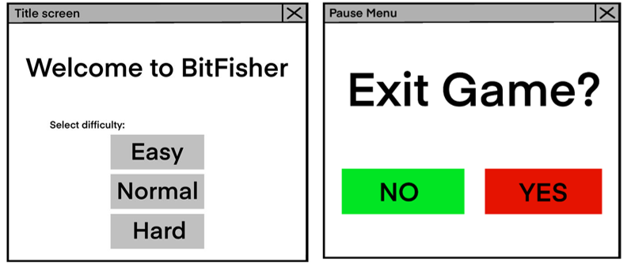

3.7.2 Stage 7 Test plan

Test No. | Test | Procedure | Data to be used | Type of test | Expected Result
1 | Menu visuals | Run the menu script and check the display. | background.png, title.png | Functional | The window shows the background image and title graphic.
2 | Start action | Click the start game button on the menu. | Mouse click | Functional | The start menu closes and the main game window opens.
3 | Easy mode link | Select the Easy button and check the fish speed. | String = easy | Normal | The game launches with the speed set to the easy value.
4 | Hard mode link | Select the Hard button and check the fish speed. | String = hard | Boundary | The game launches with the speed set to the hard value.
5 | Error handling | Run the main game file without using the menu script. | N/A | Erroneous | The program uses the normal difficulty setting by default.
6 | Pause activation | Press the Escape key during the fishing loop. | ESC key | Functional | All motion stops. A pause menu appears on the screen.
7 | Motion freeze | Check the fish position while the pause menu is open. | Y coordinate values | Functional | The fish stays at the same vertical position.
8 | Resume function | Click the No button on the pause menu. | Mouse click | Functional | The pause menu disappears. The fish resumes movement.
9 | Save and quit | Click the Yes button on the pause menu. | Mouse click | Functional | All windows close. The fish count saves to the csv file.

3.7.3 Stage 7 Code Analysis

Objective 7.a.i background and title display
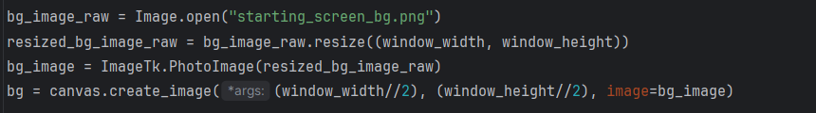

Line | Description
1 | I began the implementation by calling the open method to locate the external image file. This line reads the pixel data from the storage drive and loads it into a raw image object in system memory. I used this approach to ensure the script has access to the source data before any transformations occur.
2 | I implemented a resizing function to ensure the background fills the entire display regardless of the user's screen resolution. This line takes the raw image and scales its dimensions to match the global width and height variables of the window. I performed this step to prevent the background from appearing tiled or leaving empty space on the canvas.
3 | Tkinter cannot interface with raw Pillow objects directly. I used the PhotoImage class to convert the processed image into a format compatible with the canvas widget. This step is necessary to bridge the gap between the image processing library and the graphical user interface framework.
4 | I placed the final image onto the screen by calculating the center coordinates of the window. By dividing the width and height by two, I identified the midpoint to ensure the image is perfectly centered. I stored the resulting object in the variable named bg so I can identify or change this layer later.

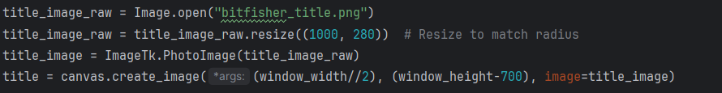

Line | Description
1 | I open the title image file and immediately resize it to specific dimensions. I chose 1000 pixels wide and 280 pixels high to ensure the title is large enough for the player to read clearly without covering too much of the background.
2
3 | I convert the raw image data into a PhotoImage object. As explained before, Tkinter canvas cannot render standard image files without this conversion.
4 | I place the title on the canvas using specific coordinates. I use window_width//2 to center the title horizontally. By subtracting 700 from the window_height, I push the image toward the top of the screen to leave space for menu buttons below it.

3.7.3.a Starting screen background image:
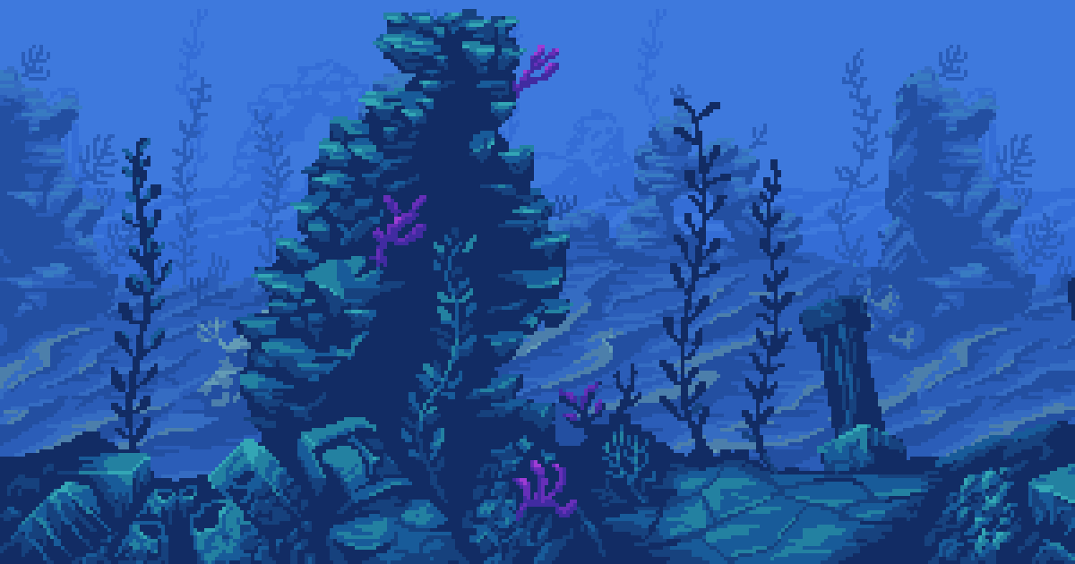

I selected this image to match the fishing project’s underwater theme as well as the retro pixel style. It uses low saturation and simple shapes, which support a calm and steady visual tone. It does not create a strong sense of excitement, so it fits the slow paced nature of the fishing experience.

3.7.3.b Title design:

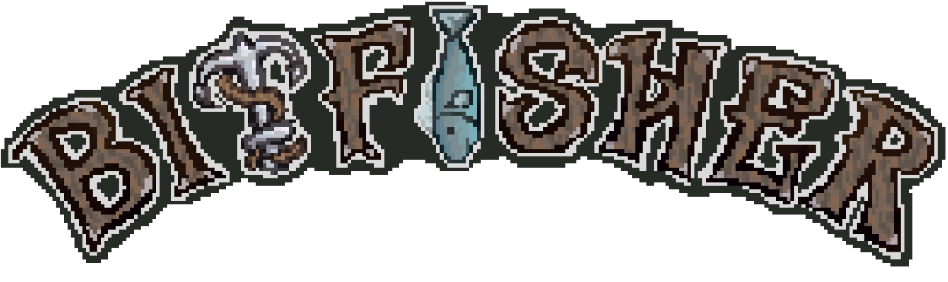

I designed the title in a pixel art style to match the fishing project, using rough, uneven lettering to create a natural and slightly worn look. Muted brown tones were used to reflect wood and keep the design calm, and a hook and fish were added into the letters to link the title to the fishing theme. A light border followed by a dark outline improves readability. The title also uses a play on words, combining “bit” as a computer term with “bite” in fishing. This links the design to both ideas. It fits well with the retro theme of the game.

Objective 7.a.ii start game button
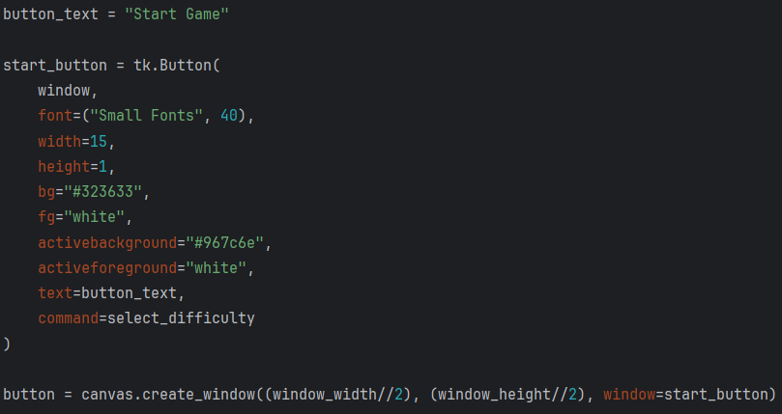

Line | Description
1 | I stored the label in a variable to keep the code organized. I then initialized the button object as a child of the main window. This creates the interactive element in the computer memory before it is drawn on the screen.
2
3-11 | I set a large font size to ensure the text is clear for the player. I chose hex codes for the colours to match the project's specific artistic theme. I also included activebackground and activeforeground settings; these provide visual feedback by changing the button color when the user clicks it.
12 | I assigned the select_difficulty function to the command parameter. This ensures that when the button is pressed, the program triggers the next stage of the menu system with the select difficulty function in a.iii.
13 | I used the create_window method to place the button widget onto the canvas. I calculated the exact middle of the screen by dividing the window dimensions by two. This allows the button to sit on top of the background image I placed earlier.

Objective 7.a.iii difficulty selection buttons
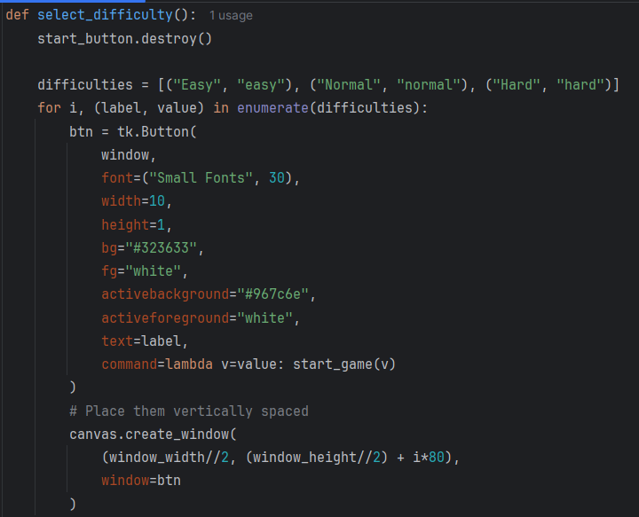

Line | Description
1 | I begin by removing the original start button from the window. This clears the screen to make room for the new menu options without needing to open a completely new window.
2 | I used a list of tuples to store the data for the menu. Each tuple contains two items: the label shown to the player and the internal string value used by the program. I chose this structure because tuples are immutable, meaning the data cannot be changed by accident during the loop. This provides a reliable source of information for generating the interface.
3 | I used the enumerate function to keep track of the current position in the list. This provides an index number, stored in the variable i, which I used to calculate the vertical position for each button on the screen. By unpacking the tuple directly in the loop header, I gained immediate access to the labels and values for each iteration.
4-13 | These buttons use the same appearance as the start game button in a.ii. Keeping the formatting consistent improves visual cohesion and makes the interface easier to understand and use.
14 | I used a lambda function to solve a specific problem with button commands in Tkinter. Normally, if I link a function to a button with arguments, the program runs that function immediately when the code starts. The lambda acts as a small, anonymous function that waits for the user to click. By assigning v=value, I captured the specific difficulty string at that exact moment in the loop. This ensures the "Hard" button always sends the "hard" value to the game, rather than every button sending the final value in the list.

Line | Description
1 | I divide the window width by two to place every button in the exact horizontal center.
2 | I use the loop index i to calculate the vertical position. Each button is placed 80 pixels lower than the previous one. This prevents the buttons from overlapping and creates a neat list.
3 | I use create_window to place the button widgets on the canvas. This ensures the buttons appear on top of the background image.

Objective 7.a.iv pass the selected difficulty to main file
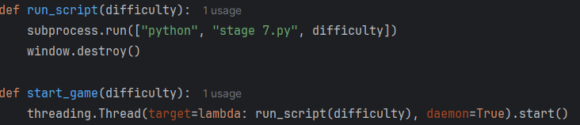

Line | Description
1 | This function is defined as the starting function that launches the main Python program.
2 | I used the subprocess module to launch the main game file as a separate process. I passed the difficulty variable as a command-line argument so the game script knows which settings to apply. Using subprocess.run allows me to keep the game logic in a separate file, which keeps my project organized.
3 | I called this method to close the menu window immediately after starting the game. This prevents multiple windows from staying open and saves system resources.

Line | Description
1 | The start game function uses threading to allow multiple subroutines to run at the same time.
2 | I used threading to prevent the program from hanging. The subprocess.run command is a blocking operation; it halts all other code execution until the external script finishes. Without a separate thread, the menu window would freeze and stop responding to the operating system during the transition. By using a background thread, I ensure the user interface remains fluid while the game loads. I set daemon=True to ensure the background task closes if the main application is shut down.

Objective 7.b.i receive the selected difficulty from starting screen

Objective 7.b.iii error handling for cases where no difficulty is passed
this is within the main python file (stage 7.py):
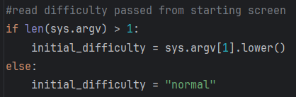

Line | Description
1 | I used the sys module to bridge the gap between my starting menu and the game script. By using sys.arg, I can retrieve the difficulty string passed as a command line argument when the process starts. I implemented this to maintain a modular design; it allows two separate files to communicate without complex networking or external files. This approach is highly efficient because it uses the built-in system memory to pass the data.
2 | If an argument exists, I retrieve the string from the second position in the list. I applied the .lower() method to the input to ensure the data is consistent. This prevents errors if the menu script sends "Easy" with a capital letter while the game logic expects "easy" in lowercase.
3 | If an argument exists, I retrieve the string from the second position in the list. I applied the .lower() method to the input to ensure the data is consistent. This prevents errors if the menu script sends "Easy" with a capital letter while the game logic expects "easy" in lowercase.
4

Objective 7.b.ii set initial difficulty using selection
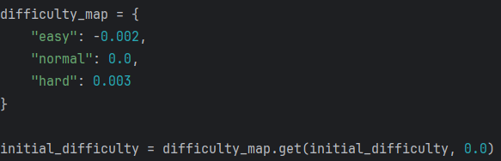

Line | Description
1 | I created a dictionary where each difficulty level acts as a key linked to a specific float value. These numbers represent the adjustments I apply to game variables like speed or health. Using a dictionary is more efficient than multiple if statements because it provides a direct lookup.
2
3
4
5 | I used the .get() method to retrieve the value associated with the player's choice. I chose this method because it includes a default fallback. If the input variable does not match any key in my map, the code returns 0.0 instead of crashing. This ensures the program remains stable even if it receives unexpected data.

I chose these specific numerical modifiers to scale the game's challenge. By using small float values, I can subtly adjust mechanics like movement speed or timing without making the gameplay feel erratic.

Objective 7.b.ii Numerical Justification
- -0.002 (Easy): This negative value slows down the game pace, giving the player more time to react.
- 0.0 (Normal): This serves as the baseline, keeping the game at its standard designed speed.
- 0.003 (Hard): This positive increment increases the speed and intensity for a greater challenge.
I selected these small decimal increments to maintain game balance. These values ensure the transition between difficulty levels feels smooth rather than jarring.

Objective 7.c.i activate pause manu through ESC
All the following code snippets are within the pause_game function, for the purpose of clarity they are explained separately here

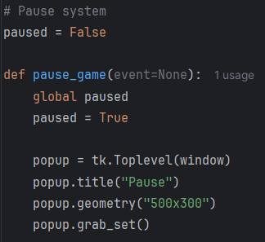

Line | Description
1 | I use a global boolean variable to signal the game loop to stop updating. By setting paused to true, the script pauses movement and physics calculations so the player does not lose progress while the menu is open.
2
3
4 | I use the Toplevel class to generate a new window that sits on top of the main game. This is better than a standard message box because it allows me to add custom buttons and branding to the pause screen.
5
6
7 | I call grab_set() to direct all user input to the pause window. This prevents the player from accidentally moving their character or clicking game buttons in the background while the game is paused.

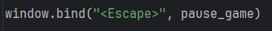

Line | Description
1 | The pause game function is bound to the escape key to ensure the function activates whenever it's pressed.

Objective 7.c.ii display menu with quit confirmation prompt

Line | Description
1 | I used this code to add a clear prompt to the pause menu. The tk.Label creates the text while the font settings ensure it stays legible. I applied .pack(pady=30) to center the text and add vertical breathing room. This padding keeps the layout organized and prevents the label from touching other interface elements.

Objective 7.c.ii.a yes button closing all windows
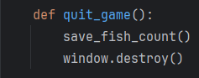

Line | Description
1 | I used this code to create the exit button in the pause menu. This button handles both data security and the closing of the program.
2 | I call this function first to save the player's progress to a file. This ensures that no data is lost when the game shuts down.
3 | This command closes the main game window and stops all processes. It provides a clean exit from the software.

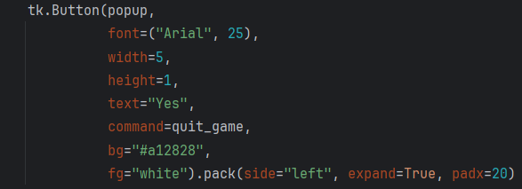

Line | Description
1 | I designed the button with a red background and white text. I chose these colors to signal that this is a "quit" or "stop" action. I set a large font and specific width to make the button easy for the player to click.  I used these settings to position the button on the left side of the popup. The expand option ensures the button stays centered in its assigned area, while padx adds horizontal space so the button does not touch the window edge.
2
3
4
5
6

Objective 7.c.ii.b no button resuming gameplay
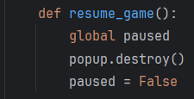

Line | Description
1 | I use this command to close the pause window immediately. This removes the menu from the screen so the player can see the game area again.
2
3
4 | I set the global paused variable back to false. This signals the main game loop to start running again; it resumes movement and physics exactly where they stopped.

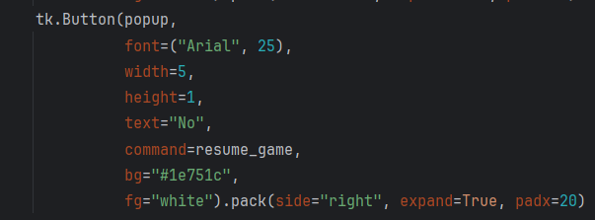

Line | Description
1 | I designed this button with a green background and white text. I chose green to signal a "go" or "continue" action. The large font and specific width match the exit button to keep the menu symmetrical.  I used these settings to place the button on the right side of the popup. By using side="right" and expand=True, I create a balanced layout where the "Yes" and "No" buttons sit evenly spaced apart. The padx adds a horizontal margin to prevent the button from touching the window frame.
2
3
4
5
6

Objective 7.c.iii pause all active game function
I went through the functions and appended a pause check to each of them. If the function handles detection logic, the code is wrapped inside an if not paused statement, so no input or state changes occur while paused. E.g.:
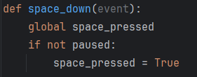
If the function runs on a refresh cycle, an if paused check is placed at the start with a skip frame return using window.after, allowing the loop to continue without updating gameplay until the pause state is removed. E.g.
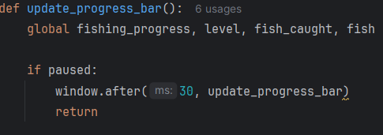

The functions changed were:
- space_down
- update_progress_bar
- update_greenbar
- check_if_fish_in_bar
- update_fish

Thanks to the earlier stages of development, this change was made very easy, as the modifications are simple and quick to apply. These checks ensure all gameplay updates stop while paused, preventing unintended movement or state changes. This maintains consistency in the game state and allows the player to safely resume without any progress being lost or altered.

3.7.4 Stage 7 Validation
Validation check | What is being validated | How it is done in code | Why it is implemented | Why it is important
Command line input validation | Difficulty value from start menu is valid | sys.argv is checked, value is converted to lowercase, default set if missing | Prevents missing or invalid input from breaking game start | Ensures game always starts with a usable difficulty setting
Difficulty mapping validation | Text difficulty converts to numeric speed modifier correctly | dictionary difficulty_map converts easy, normal, hard into float values | Prevents direct use of invalid strings in physics calculations | Keeps difficulty system consistent and numeric-based
Default fallback validation | Game starts even if no difficulty is passed | get method returns 0.0 when key is missing | Prevents crash when launcher is bypassed | Ensures standalone game execution still works
Pause state validation | Game logic stops when pause menu is active | paused flag is checked in all update functions before execution | Prevents movement and progress updates during pause | Ensures game state remains frozen during pause menu
Thread safety validation for exit handling | Game closes safely when quit is selected | quit_game calls save_fish_count then window.destroy | Prevents data loss during exit | Ensures progress is stored correctly before closing
Function bypass validation during pause | All update loops stop when paused | update functions return early if paused is True | Prevents background updates continuing invisibly | Ensures full pause behaviour is enforced
Input state validation during pause | Player input is ignored when game is paused | space_down checks paused before setting space_pressed | Prevents movement while pause menu is open | Keeps game state consistent and prevents unintended actions
Menu-to-game transfer validation | Selected button value correctly launches game instance | lambda v=value passes correct difficulty into subprocess call | Prevents late binding issues in button commands | Ensures correct difficulty is passed every time
Background and UI asset validation | Images load and scale correctly to screen size | PIL resizes images to window_width and window_height | Prevents distorted or misaligned UI elements | Ensures start screen displays correctly on all resolutions

3.7.5 Stage 7 Final testing
Please also refer to the video stage 7 – testing in the attached file

Test No. | Test | Data to be used | Expected Result | Pass/fail | Evidence
1 | Menu visuals | background.png, title.png | The window shows the background image and title graphic. | Pass | 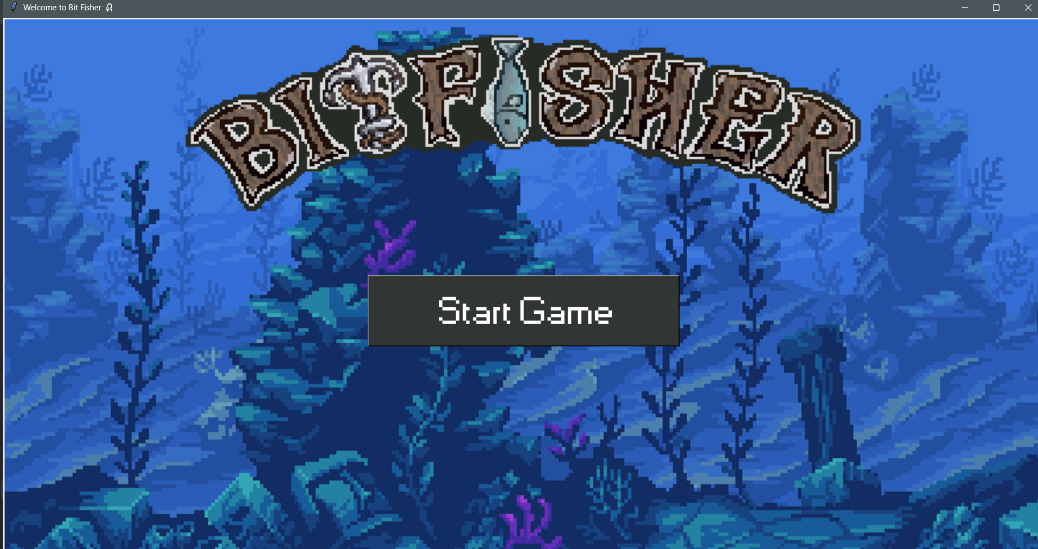
2 | Start action | Mouse click | The start menu closes and the main game window opens. | Pass | 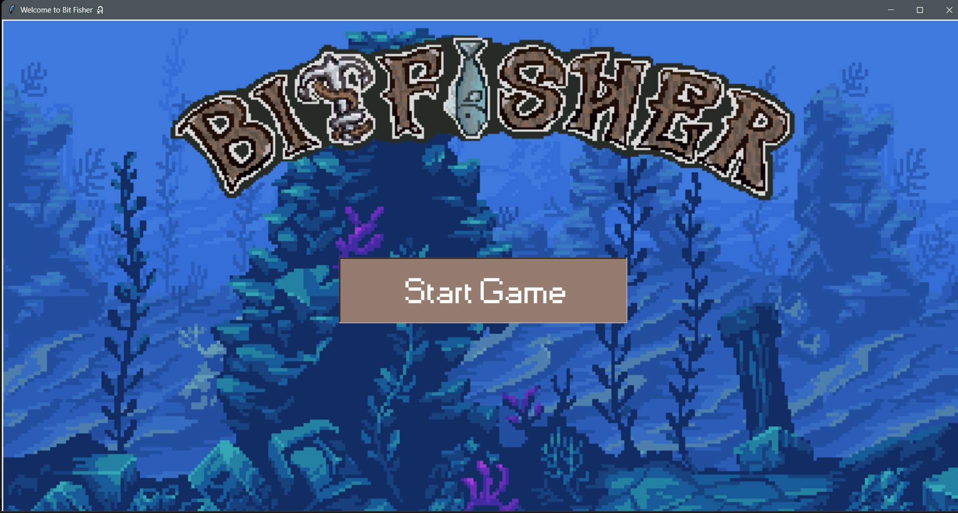
3 | Easy mode link | String = easy | The game launches with the speed set to the easy value. | Pass | 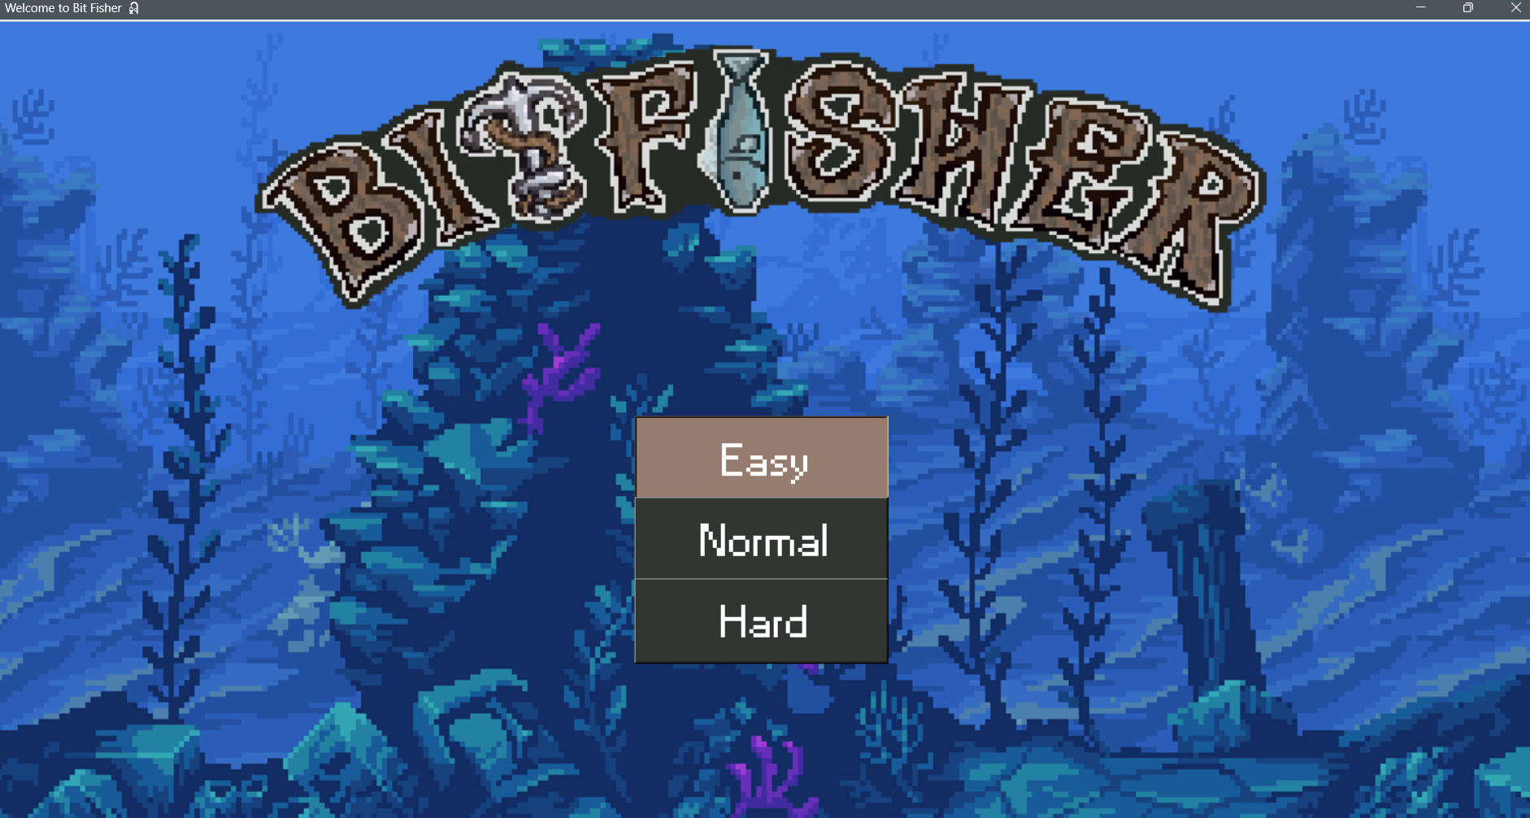
4 | Hard mode link | String = hard | The game launches with the speed set to the hard value. | Pass | 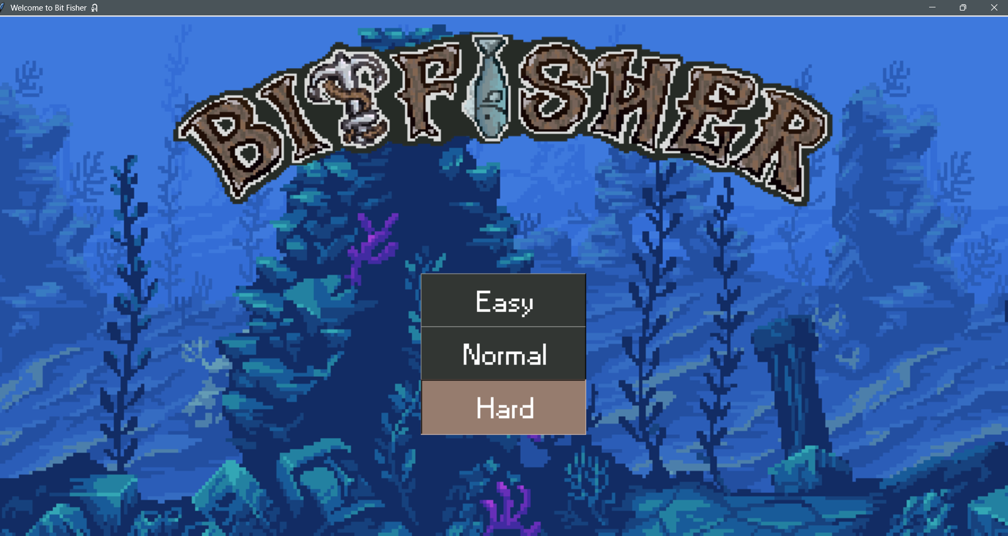
5 | Error handling | N/A | The program uses the normal difficulty setting by default. | Pass | I started the main program file with no starting screen  was printed in the terminal
6 | Pause activation | ESC key | All motion stops. A pause menu appears on the screen. | Pass | 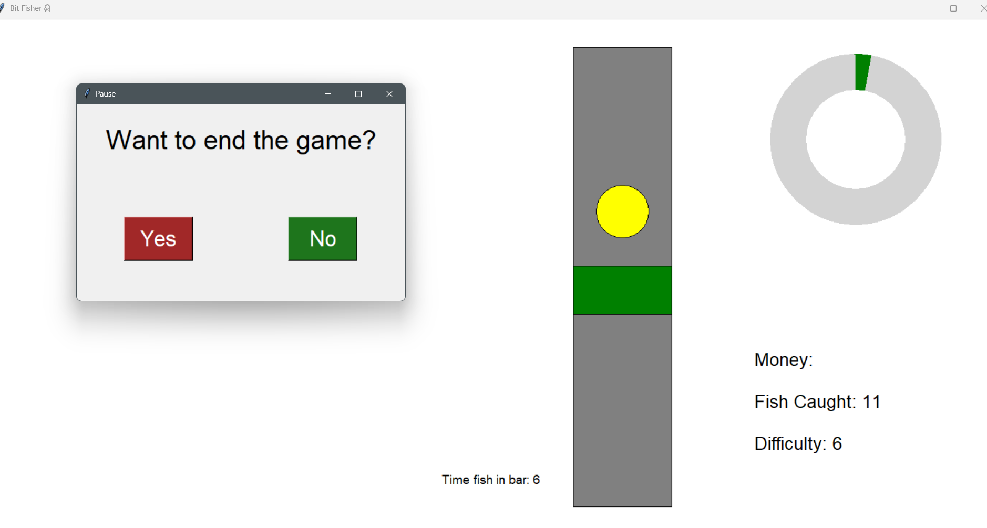
7 | Motion freeze | Y coordinate values | The fish stays at the same vertical position. | Pass | *Refer to video stage 7 – testing  Timestamp 00:09-00:13  When the pause menu is called using ESC all other assets freeze
8 | Resume function | Mouse click | The pause menu disappears. The fish resumes movement. | Pass | *Refer to video stage 7 – testing  Timestamp 00:09  When the pause menu is closed all assets back to normal movement
9 | Save and quit | Mouse click | All windows close. The fish count saves to the csv file. | Pass | *Refer to video stage 7 – testing  Timestamp 00:12-00:19  The game ended with 7 fish caught. When the game was loaded again, it still displayed 7 fish, confirming that the fish count is correctly saved between gameplay sessions.

3.7.6 Stage 7 Final program run screen
Starting screen:

Main program with the pause menu active:
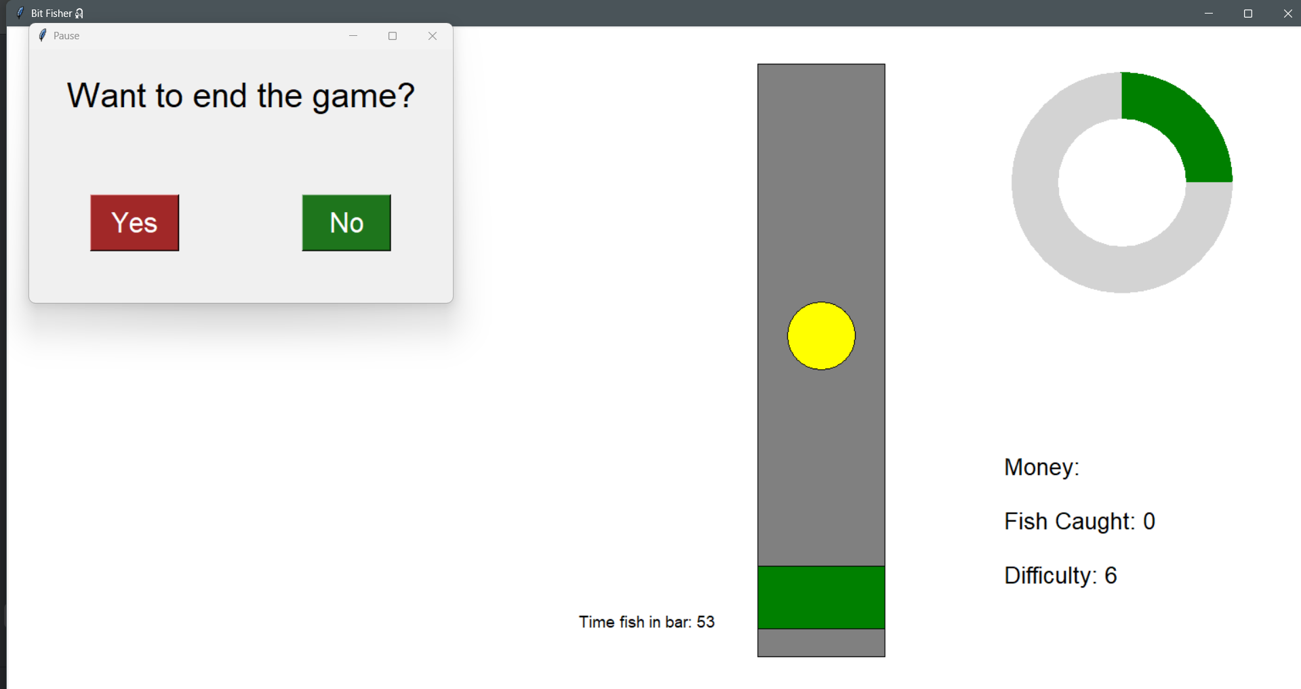

3.7.7 Stage 7 Final code

Main program (stage_7.py)
import tkinter as tk
from PIL import Image, ImageTk
import math
import random
import os
import sys
import csv
#read difficulty passed from starting screen
if len(sys.argv) > 1:
initial_difficulty = sys.argv[1].lower()
else:
initial_difficulty = "normal"
difficulty_map = {
"easy": -0.002,
"normal": 0.0,
"hard": 0.003
}
initial_difficulty = difficulty_map.get(initial_difficulty, 0.0)
# specify the directrix that contain the sprites
IMAGE_DIR = os.path.join(os.path.dirname(__file__), "images")
# ================================
# FISH CLASS SET UP
# ================================
class Fish:
def __init__(self, canvas, x, y, radius, fish_types):
"""
fish_types is a list of dictionaries, e.g.:
[
{"name": "goldfish", "rarity": 60},
{"name": "sardine", "rarity": 45},
{"name": "shark", "rarity": 10},
]
'rarity' values act as weights for spawning (higher = more common).
"""
self.canvas = canvas
self.x = x
self.y = y
self.radius = radius
self.fish_data = self.weighted_choice(fish_types)
self.type_name = self.fish_data.get("name", "unknown")
self.rarity = self.fish_data.get("rarity", 1)
self.calculate_speed_from_rarity(min_speed=0.002, max_speed=0.01, max_rarity=100)
self.starting_level = round(self.wave_speed * 1000)
if self.rarity <= 20:
fill = "red"
elif self.rarity <= 50:
fill = "yellow"
else:
fill = "green"
self.canvas_item = self.canvas.create_oval(
self.x - self.radius, self.y - self.radius,
self.x + self.radius, self.y + self.radius,
fill=fill, outline="black"
)
self.wave_x = 0.0
self.generate_new_wave()
self.in_bar = False
self.time_in_bar = 0
def calculate_speed_from_rarity(self, min_speed=0.005, max_speed=0.02, max_rarity=100):
rarity = max(1, self.rarity)
self.wave_speed = min_speed + (max_rarity - rarity) / max_rarity * (max_speed - min_speed)
@staticmethod
def weighted_choice(fish_types):
if not fish_types:
raise ValueError("fish_types must be a non-empty list")
weights = [f.get("rarity", 1) for f in fish_types]
total = sum(weights)
if total <= 0:
return random.choice(fish_types)
r = random.uniform(0, total)
cumulative = 0.0
for f, w in zip(fish_types, weights):
cumulative += w
if r <= cumulative:
return f
return fish_types[-1]
def generate_new_wave(self):
self.a = random.randint(150, 500)
self.b = random.uniform(8, 12)
self.c = random.randint(750, 1000)
self.d = random.uniform(12, 18)
self.e = random.randint(300, 650)
self.f = random.uniform(18, 22)
def motion(self, t):
return (
self.a * math.sin(self.b * t)
+ self.c * math.sin(self.d * t)
+ self.e * math.cos(self.f * t)
)
def update_position(self, bar_top, bar_bottom):
self.wave_x += self.wave_speed
offset = self.motion(self.wave_x) * 0.2
offset = max(min(offset, 500), -500)
bar_mid = (bar_top + bar_bottom) // 2
self.y = bar_mid + offset
top_limit = bar_top + self.radius
bottom_limit = bar_bottom - self.radius
self.y = max(min(self.y, bottom_limit), top_limit)
self.canvas.coords(
self.canvas_item,
self.x - self.radius, self.y - self.radius,
self.x + self.radius, self.y + self.radius
)
self.canvas.tag_raise(self.canvas_item)
def check_in_bar(self, green_coords):
fish_coords = [
self.x - self.radius, self.y - self.radius,
self.x + self.radius, self.y + self.radius
]
if green_coords[1] < fish_coords[3] and green_coords[3] > fish_coords[1]:
self.in_bar = True
self.time_in_bar += 1
else:
self.in_bar = False
return self.in_bar
def update_difficulty(self, fishing_progress):
difficulty = fishing_progress / self.time_in_bar
if difficulty <= 0.45 and self.wave_speed > 0.001:
return -0.001
elif difficulty > 0.45:
return 0.002
# -------------------------
# CONFIGURE AVAILABLE FISH
# -------------------------
fish_types = [
{"name": "goldfish", "rarity": 60},
{"name": "sardine", "rarity": 45},
{"name": "shark", "rarity": 10},
]
# ===============================================
# GAME SETUP
# ===============================================
window = tk.Tk()
window.title("Bit Fisher🎣")
window_width = window.winfo_screenwidth()
window_height = window.winfo_screenheight()
window.geometry("%dx%d" % (window_width, window_height))
fish_count_file = "fish_count.csv"
# ============================================================
# INITIAL VARIABLE SECTION
# ============================================================
radius_outer = 130
radius_inner = 75
fishing_progress = 0
progress_arc = None
progress_center_x = window_width - 220
progress_center_y = window_height - 680
fishing_width = 150
fishing_height = 700
fishing_x1 = window_width - fishing_width - 500
fishing_y1 = window_height - fishing_height - 120
fishing_x2 = fishing_x1 + fishing_width
fishing_y2 = fishing_y1 + fishing_height
green_width = fishing_width
green_height = 75
green_x = (fishing_x1 + fishing_x2) // 2
green_y = fishing_y1 + 50
gravity = 10
lift = -10
velocity = 0
space_pressed = False
fish_caught = 0
canvas = tk.Canvas(window, width=window_width, height=window_height, bg="white")
canvas.pack()
def load_fish_count():
global fish_caught
if os.path.exists(fish_count_file):
try:
with open(fish_count_file, "r") as file:
value = file.read().strip()
fish_caught = int(value) if value.isdigit() else 0
except:
fish_caught = 0
else:
fish_caught = 0
load_fish_count()
def save_fish_count():
try:
with open(fish_count_file, "w") as file:
file.write(str(fish_caught))
except:
print("Unable to save fish count.")
# ==========================================================
# DEFINING FUNCTION SECTION
# ==========================================================
# Pause system
paused = False
def pause_game(event=None):
global paused
paused = True
popup = tk.Toplevel(window)
popup.title("Pause")
popup.geometry("500x300")
popup.grab_set()
tk.Label(popup, text="Want to end the game?", font=("Arial", 30)).pack(pady=30)
def quit_game():
save_fish_count()
window.destroy()
def resume_game():
global paused
popup.destroy()
paused = False
tk.Button(popup,
font=("Arial", 25),
width=5,
height=1,
text="Yes",
command=quit_game,
bg="#a12828",
fg="white").pack(side="left", expand=True, padx=20)
tk.Button(popup,
font=("Arial", 25),
width=5,
height=1,
text="No",
command=resume_game,
bg="#1e751c",
fg="white").pack(side="right", expand=True, padx=20)
window.bind("<Escape>", pause_game)
def space_down(event):
global space_pressed
if not paused:
space_pressed = True
def space_up(event):
global space_pressed
space_pressed = False
window.bind("<KeyPress-space>", space_down)
window.bind("<KeyRelease-space>", space_up)
fish = Fish(
canvas,
(fishing_x1 + fishing_x2) // 2,
fishing_y1 + 500,
40,
fish_types
)
fish.wave_speed += initial_difficulty
def update_progress_bar():
global fishing_progress, level, fish_caught, fish
if paused:
window.after(30, update_progress_bar)
return
if fish.in_bar:
fishing_progress += 0.5
if fishing_progress >= 100:
canvas.delete(fish.canvas_item)
fish_caught += 1
save_fish_count()
additional_difficulty = fish.update_difficulty(fishing_progress)
fish = Fish(
canvas,
(fishing_x1 + fishing_x2) // 2,
fishing_y1 + 500,
40,
fish_types
)
fish.wave_speed += initial_difficulty
fish.wave_speed += additional_difficulty
level = round(fish.wave_speed * 1000)
fishing_progress = 0
canvas.itemconfig(
stats_display,
text=f"Money:\n\nFish Caught: {fish_caught}\n\nDifficulty: {level}"
)
else:
fishing_progress -= 0.1
fishing_progress = max(fishing_progress, 0)
draw_progress()
window.after(30, update_progress_bar)
def draw_progress():
global progress_arc
if progress_arc:
try:
canvas.delete(progress_arc)
except:
pass
if fishing_progress > 0:
extent = (fishing_progress / 100) * 360
progress_arc = canvas.create_arc(
progress_center_x - radius_outer, progress_center_y - radius_outer,
progress_center_x + radius_outer, progress_center_y + radius_outer,
start=90, extent=-extent, fill="green", outline=""
)
canvas.coords(
inner_circle,
progress_center_x - radius_inner, progress_center_y - radius_inner,
progress_center_x + radius_inner, progress_center_y + radius_inner
)
canvas.tag_raise(inner_circle)
def update_greenbar():
global green_y, velocity
if paused:
window.after(30, update_greenbar)
return
velocity = lift if space_pressed else gravity
green_y += velocity
top_limit = fishing_y1 + green_height // 2
bot_limit = fishing_y2 - green_height // 2
green_y = max(min(green_y, bot_limit), top_limit)
canvas.coords(
green_bar,
green_x - green_width // 2, green_y - green_height // 2,
green_x + green_width // 2, green_y + green_height // 2
)
window.after(30, update_greenbar)
def check_if_fish_in_bar():
if paused:
window.after(30, check_if_fish_in_bar)
return
green_coords = canvas.coords(green_bar)
fish.check_in_bar(green_coords)
canvas.itemconfig(timer_text, text=f"Time fish in bar: {fish.time_in_bar}")
window.after(30, check_if_fish_in_bar)
def update_fish():
if paused:
window.after(30, update_fish)
return
fish.update_position(fishing_y1, fishing_y2)
window.after(30, update_fish)
# =============================================
# DRAWING THE WIDGETS ONTO THE CANVAS
# =============================================
canvas.create_oval(
progress_center_x - radius_outer, progress_center_y - radius_outer,
progress_center_x + radius_outer, progress_center_y + radius_outer,
fill="light grey", outline=""
)
inner_circle = canvas.create_oval(
progress_center_x - radius_inner, progress_center_y - radius_inner,
progress_center_x + radius_inner, progress_center_y + radius_inner,
fill="white", outline=""
)
canvas.create_rectangle(
fishing_x1, fishing_y1, fishing_x2, fishing_y2,
fill="grey", outline="black"
)
green_bar = canvas.create_rectangle(
green_x - green_width // 2, green_y - green_height // 2,
green_x + green_width // 2, green_y + green_height // 2,
fill="green", outline="black"
)
level = round(fish.wave_speed * 1000)
# ==========================================================
# STATS DISPLAY SECTION
# ==========================================================
stats_display = canvas.create_text(
window_width - 180,
window_height - 200,
text=f"Money:\n\nFish Caught: {fish_caught}\n\nDifficulty: {level}",
anchor='se',
font=("Arial", 20),
fill="black"
)
timer_text = canvas.create_text(
window_width - 700,
window_height - 150,
text="Time fish in bar: 0",
font=("Arial", 14),
fill="black",
anchor="se"
)
draw_progress()
update_progress_bar()
check_if_fish_in_bar()
update_greenbar()
update_fish()
window.mainloop()

Starting screen code
import tkinter as tk
from PIL import Image, ImageTk
import subprocess
import threading
def run_script(difficulty):
subprocess.run(["python", "stage 7.py", difficulty])
window.destroy()
def start_game(difficulty):
threading.Thread(target=lambda: run_script(difficulty), daemon=True).start()
def select_difficulty():
start_button.destroy()
difficulties = [("Easy", "easy"), ("Normal", "normal"), ("Hard", "hard")]
for i, (label, value) in enumerate(difficulties):
btn = tk.Button(
window,
font=("Small Fonts", 30),
width=10,
height=1,
bg="#323633",
fg="white",
activebackground="#967c6e",
activeforeground="white",
text=label,
command=lambda v=value: start_game(v)
)
# Place them vertically spaced
canvas.create_window(
(window_width//2, (window_height//2) + i*80),
window=btn
)
# Start screen setup
window = tk.Tk()
window.title("Welcome to Bit Fisher 🎣")
window_width = window.winfo_screenwidth()
window_height = window.winfo_screenheight()
window.geometry("%dx%d" % (window_width, window_height))
bg_color = "black"
canvas = tk.Canvas(window, width=window_width, height=window_height, bg=bg_color)
canvas.pack()
bg_image_raw = Image.open("starting_screen_bg.png")
resized_bg_image_raw = bg_image_raw.resize((window_width, window_height))
bg_image = ImageTk.PhotoImage(resized_bg_image_raw)
bg = canvas.create_image((window_width//2), (window_height//2), image=bg_image)
title_image_raw = Image.open("bitfisher_title.png")
title_image_raw = title_image_raw.resize((1000, 280)) # Resize to match radius
title_image = ImageTk.PhotoImage(title_image_raw)
title = canvas.create_image((window_width//2), (window_height-700), image=title_image)
button_text = "Start Game"
start_button = tk.Button(
window,
font=("Small Fonts", 40),
width=15,
height=1,
bg="#323633",
fg="white",
activebackground="#967c6e",
activeforeground="white",
text=button_text,
command=select_difficulty
)
button = canvas.create_window((window_width//2), (window_height//2), window=start_button)
window.mainloop()

3.8 Stage 8 – Fish Sprite and overall GUI tidy up
For this stage, I plan to refine the graphical user interface and replace placeholder fish graphics with sprite based images loaded from local files. The interface will be standardised by storing all colour values as named variables, improving readability and maintainability. The logic for handling a successful catch will also be separated into its own subroutine to improve modularity and reduce repetition. Fish sprites will be loaded dynamically based on the spawned fish type and displayed on the canvas instead of simple oval placeholders. These changes improve code organisation, visual clarity, and scalability for adding more fish types later.
My main objectives are:

- Implement fish sprite graphics
- Store fish sprite images in a local directory
- Access the sprite directory using file path handling
- Load the corresponding sprite based on the spawned fish type
- Display the sprite using canvas image objects
- Use oval placeholder only when sprite loading fails

- Create a centralised colour reference section
- Store all hexadecimal colour values as named variables

- Refine the main window GUI
- Standardise font, colour, and outline styling across all UI elements
- Update instructional text to better guide the player

- Separate the fish caught procedure into its own subroutine
- Create a caught_fish function to handle catch logic
- Move difficulty adjustment and fish respawn logic into this function

3.8.1 Stage 8 Test plan

Test No. | Test | Procedure | Data to be used | Type of test | Expected Result
1 | Sprite Folder Path Validation | Launch the game and check the console for path errors. | os.path.join logic | Functional | No "File Not Found" errors appear; script identifies the image directory correctly.
2 | Successful Sprite Loading | Spawn a fish (e.g., Anchovy) with its corresponding image in the folder. | anchovy.png (72dpi, PNG) | Functional | The fish appears on the canvas as a graphic sprite instead of a colored oval.
3 | Sprite Fallback Mechanism | Temporarily delete or rename carp.png and spawn a Carp. | Missing image file | Erroneous | The game displays a procedural oval placeholder; the console prints a loading warning.
4 | UI Color Standardization | Change the value of bg_colour in the variable section. | Hex value: #333333 | Normal | The entire background changes color automatically without editing individual widget lines.
5 | Instructional Text Layout | Observe the text position for stats_display and timer_text. | GUI coordinates | Normal | Text is clearly legible, properly anchored, and does not overlap with the fishing bar.
6 | Caught Fish Subroutine | Fill the progress bar to 100% to trigger a catch. | fishing_progress = 100 | Functional | The caught_fish function runs; the fish disappears, the counter increments, and a new fish spawns.
7 | GUI Font Consistency | Check all labels, buttons, and pop-up windows. | font variable | Functional | All UI elements use the "Small Fonts" typeface consistently throughout the application.
8 | Pause Menu Integration | Press ESC during active gameplay with a sprite on screen. | KeyPress event | Boundary | Gameplay stops; the sprite freezes in place; the pause menu appears correctly styled.

3.8.2 Fish Sprite design

3.8.2.a Stakeholder input on fish sprites
I decided to interview the stakeholders again for the fish species to be included in the game. Stakeholders received a Google Form containing 25 different fish types to determine the most popular species for the game. Each person selected two favourites from each rarity category, resulting in ten picks per person in total from this list. These fish are organised into five levels based on their size and rarity in the real world.
Selecting two fish from each level maintains a balanced game design. The original list of 25 options provides five unique samples per category. This variety allows the game to feature many different movement patterns and behaviours.
The fish species were selected through online research to determine which types are most familiar to a general audience. As I do not want the game to appeal only to fishing enthusiasts, I chose species that most people would recognise or have at least heard of.
I organised the selected fish into the following table.
Rarity (value)  Fish No | Common (80) | Uncommon (60) | Rare (35) | Epic (15) | Legendary (5)
1 | Mackerel | Flounder | Snapper | Marlin | Orca
2 | Anchovy | Catfish | Trout | Eel | Hammerhead shark
3 | Tilapia | Sardine | Salmon | Sturgeon | Great white shark
4 | Carp | Bass | Barracuda | Tuna | Manta ray
5 | Herring | Cod | Pufferfish | Swordfish | Giant squid

These specific fish and rarity ranges create a wide scale of difficulty for the player. Including these various species also offers a broad range of categories for the player to study; consequently, the game feels more dynamic and entertaining for the user.

The result:
Common fish:
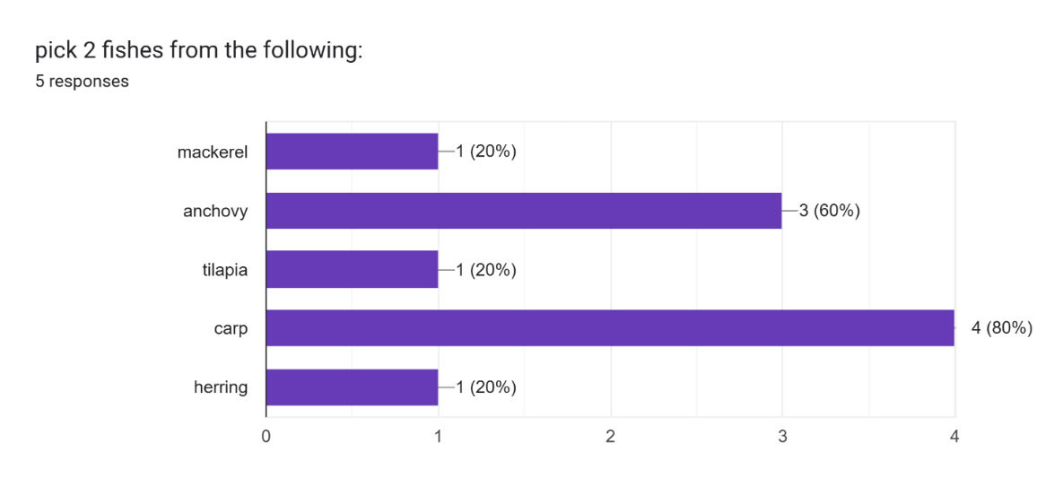

Uncommon fish:
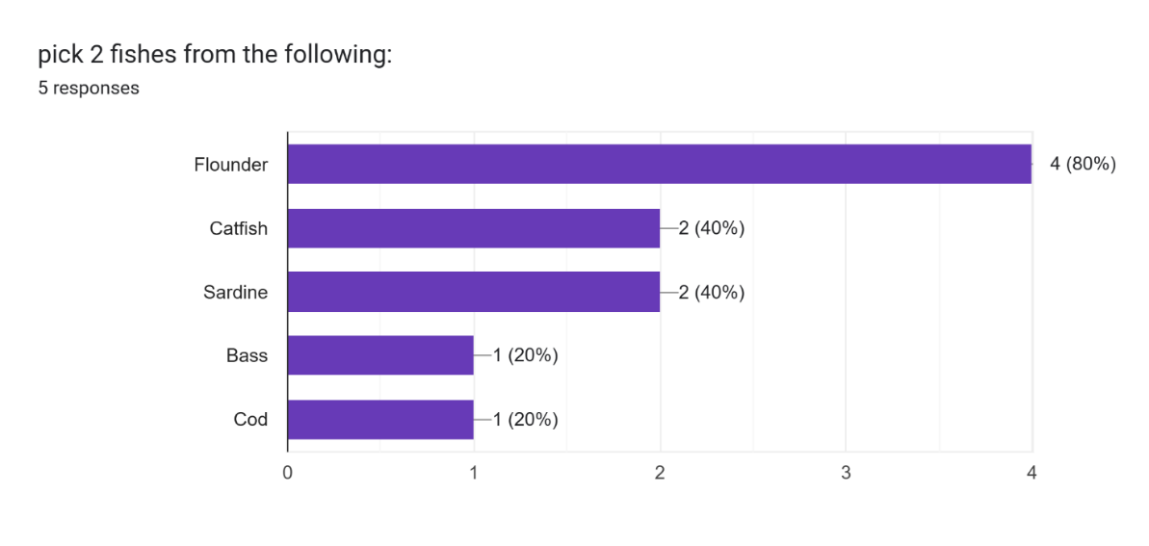

Rare fish:
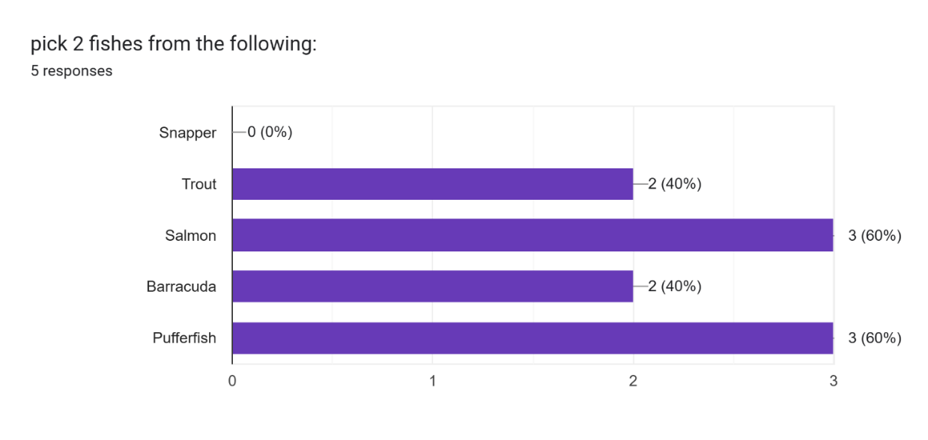
Epic fish:

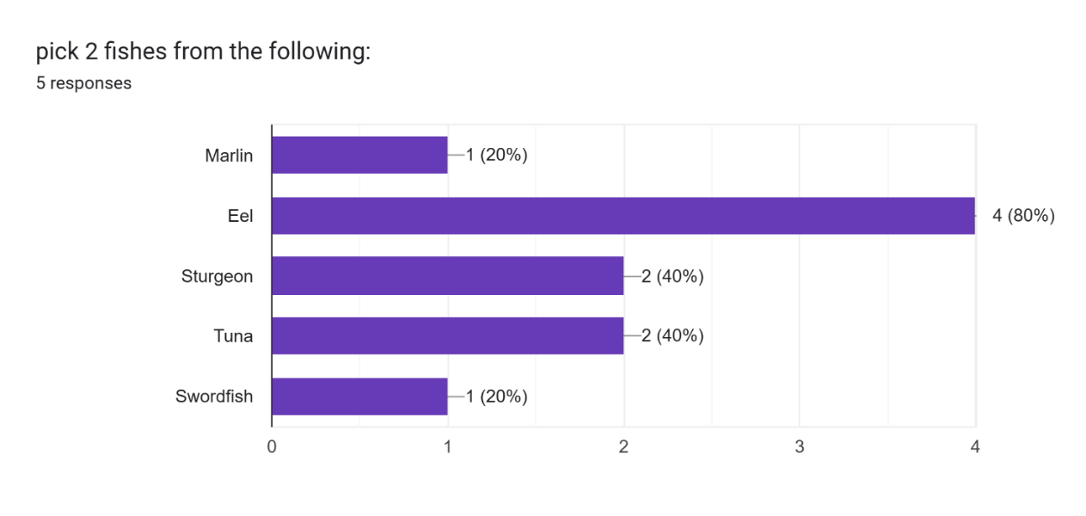
Legendary fish:
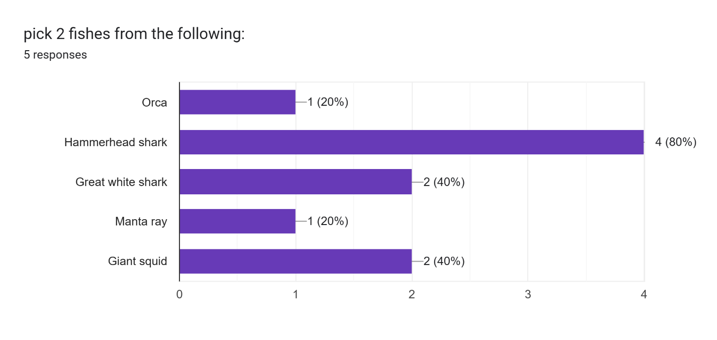
The sample size is small, so differences in the results are not clearly distinguishable. Increasing the number of responses in future would improve reliability and make the results more representative of actual preferences.
When multiple options receive similar levels of selection, I decided to make the final choice in prioritizing the fish with a more visually distinct appearance, so users can more easily tell species apart during gameplay.
Result of the form:

Category | Fish chosen
Common (80) | Anchovy, carp
Uncommon (60) | Flounder, catfish
Rare (35) | Pufferfish, salmon
Epic (15) | Eel, tuna
Legendary (5) | Giant squid, hammerhead shark

With these results, I designed in-game sprites for each fish type based on the selected list. A pixel art style was used to match the visual direction identified during market research. This style reduces visual complexity, keeps asset creation efficient, and maintains consistency with retro-inspired fishing and arcade games. It also improves the readability of fish shapes during fast movement, which supports clearer gameplay decisions for the user.

Sprite table
Name | Rarity | Sprite in game
Anchovy | 80 | 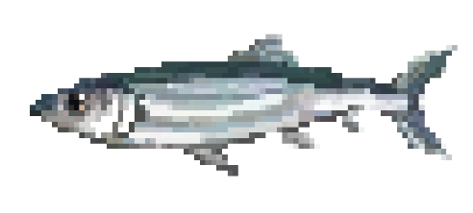
Carp | 80 | 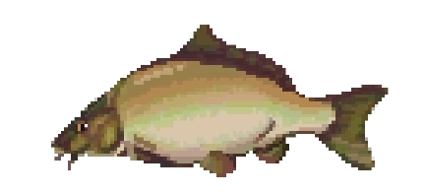
Flounder | 60 | 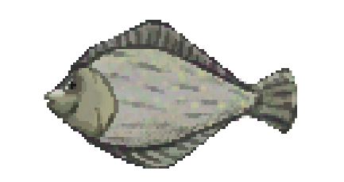
Catfish | 60 | 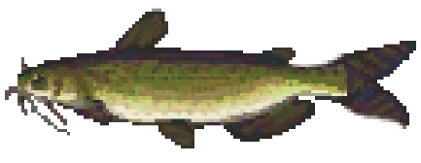
Pufferfish | 35 | 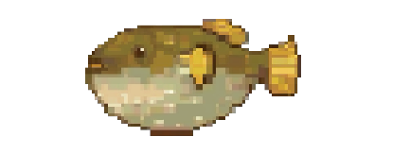
Salmon | 35 | 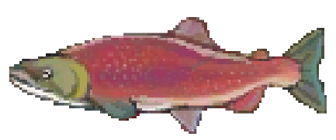
Eel | 15 | 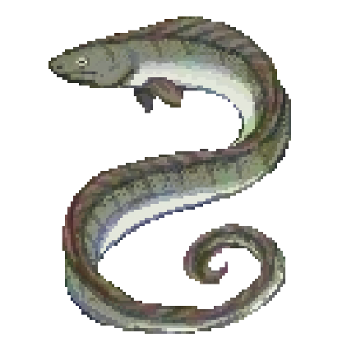
Tuna | 15 | 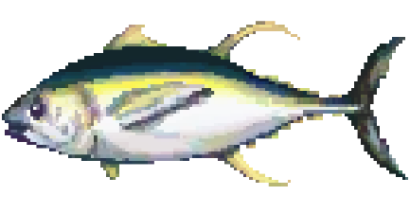
Giant squid | 5 | 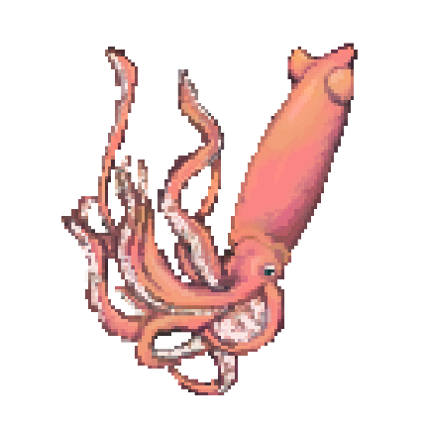
Hammerhead shark | 5 | 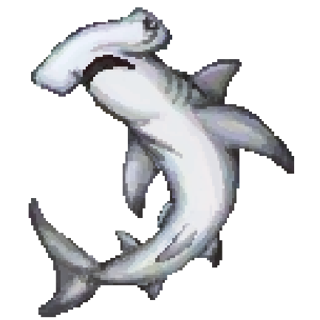

Each sprite image was named according to its corresponding fish type and stored in a dedicated folder called fish_sprites within the main program directory. This structure allows the code to access assets directly using file paths, which simplifies loading and reduces the risk of incorrect references. Keeping all sprite files in a single location improves organisation and makes maintenance more efficient. If changes are needed, such as replacing or updating a sprite, the file can be located quickly without searching through multiple directories. This setup also supports future expansion, as new fish sprites can be added to the same folder and integrated with minimal changes to the existing code.

3.8.3 Stage 8 Code Analysis

Objective 8.a.i store fish sprite images in local directory

Line | Description
1 | os.path.dirname(file) returns the folder path of the current Python file. I used this so the program always works no matter where the project is moved or run from. It avoids hardcoding file locations.  "os.path.join(..., "images", "fish_sprites")" builds a full path to the image folder. I used os.path.join instead of manual string joining because it automatically handles different operating systems and prevents path errors.  This creates a reliable reference to the folder containing fish images, so later code can load sprites without depending on the current working directory or the operating system.

Objective 8.a.ii accessing the sprite directory

Objective 8.a.iii load the corresponding sprite
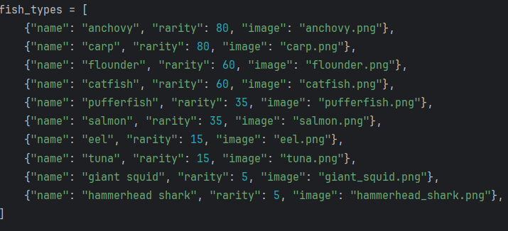

Based on the stakeholder interview, I organised the fish data as a list of dictionaries. Each fish entry contains attributes such as name, rarity, and image file reference. This structure matches how the game processes and loops through fish data during gameplay.
Using a list allows easy iteration through all fish types when selecting or spawning fish. Each dictionary inside the list keeps related attributes grouped together, which makes the data easy to read and manage. This also allows new fish to be added or existing values to be updated without changing the overall structure of the program.

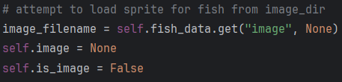

Line | Description
1 | This line reads the "image" key from the fish dictionary. I used .get instead of direct indexing so the program does not crash if the key is missing.
2 | I initialise self.image as None to define a default state before loading any file. This prevents undefined variable errors later when rendering the fish.
3 | I set a boolean flag to track whether image loading succeeds. This lets later code decide between drawing a sprite or a fallback shape.

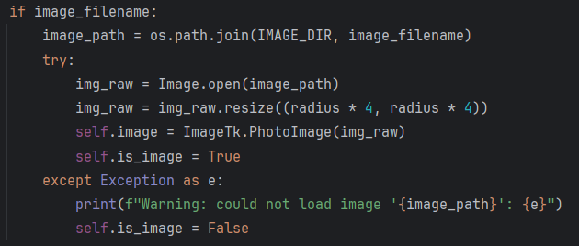

Line | Description
1 | This checks whether an image name exists. I used this condition to avoid attempting file loading when no image is defined.
2 | This builds the full path to the specific fish image file. I used os.path.join again for cross-platform compatibility and to reduce path formatting errors.
3 | I used a try block to handle potential file errors safely, such as missing files or corrupted images, without crashing the program.
4 | This loads the image from disk using Pillow. I used Image.open because it supports common formats like PNG, which is what I will be using for the fish sprites.
5 | This resizes the image to match the fish size on screen. I scaled it relative to radius so all fish sprites stay visually consistent.
6 | Tkinter requires images in PhotoImage format. I convert the PIL image here so it can be displayed on the canvas.
7 | This marks successful loading so later rendering logic uses the image instead of a fallback shape.
8 | This catches any error during loading. I used a general Exception handler to ensure the game continues even if a single image fails.
9 | This outputs debugging information so I can identify missing or broken assets during development.
10 | If loading fails, I explicitly switch to fallback mode so the program uses a drawn oval instead of crashing or leaving empty visuals.

Objective 8.a.iv display the sprite

Objective 8.a.v oval placeholder when sprite loading fails
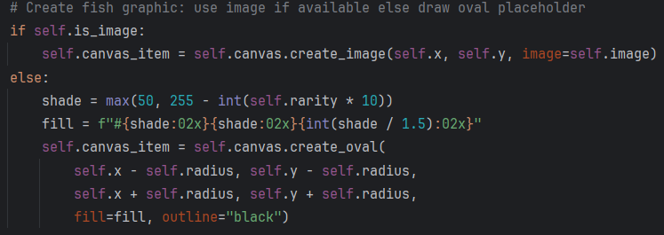

Line | Description
1 | This checks whether image loading succeeded. I used this boolean flag so rendering logic stays separate from loading logic, which improves structure and avoids repeated file checks.
2 | This draws the fish as an image on the canvas. I used create_image because it allows sprite-based rendering and positions the image using a single x and y coordinate, which matches how the fish moves.
3 | This handles the fallback case when no image exists. I included this so every fish still appears on screen even if asset files are missing.
4 | This calculates a colour brightness value based on rarity. I used rarity to influence shade so visual appearance reflects fish difficulty. The max function prevents the colour from becoming too dark and invisible.
5 | This builds a hex colour string. I used formatted hexadecimal conversion so the oval has a consistent RGB colour. I reduced the blue component slightly to create a subtle visual difference.
6 | This creates a circular shape as a fallback visual. I use an oval because it is simple to render and clearly represents a placeholder for a fish without requiring external image assets.  I then format the oval by setting the top-left and bottom-right coordinates to define its size and position. The fill colour is applied using the value calculated earlier based on fish rarity, so the visual appearance still reflects the data structure.
7
8
9

Objective 8.b.i centralise colour hex values


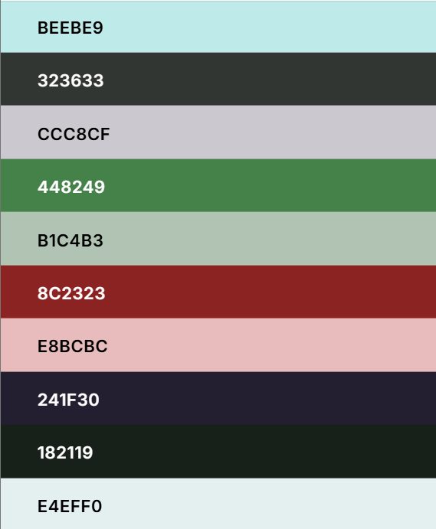
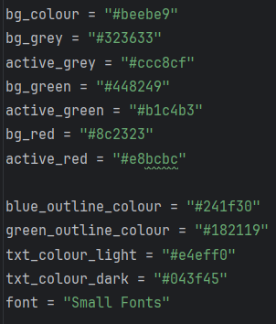
Background colour
Grey button bg
Grey button active
Green button bg
Green button active
Red button bg
Red button active
Blue shape outline
Green shape outline
Light text
Dark text

For colour standardisation, I used https://coolors.co/ to build a high contrast and accessible colour palette. This ensures the game remains clear to read and visually comfortable across different players. The tool allows direct comparison between colours and checks readability with both light and dark text.
- Background: I selected a light blue background to improve visibility of sprites and UI elements, making key assets stand out clearly. The blue also supports the underwater theme of the game, reinforcing the setting while keeping the interface visually consistent.
- Buttons: Each button state uses a base colour for idle state and a lighter active colour when pressed, which provides clear feedback when the user interacts with the interface.
- Outlines: Two darker outline colours define the edges of shapes. This makes it easier to separate objects from the background, especially during fast gameplay where quick visual recognition is important.
- Text: For text, I chose two muted colours with a slight blue tint instead of plain black or white. This reduces harsh contrast and improves readability over longer play sessions.
- Font: I researched the available text options and found a Stack Overflow solution https://stackoverflow.com/questions/39614027/list-available-font-families-in-tkinter that outputs a window listing all font families available in Tkinter. Running this code displays every built-in font, which helped me select a suitable style for the project. Example for the run screen is shown below:
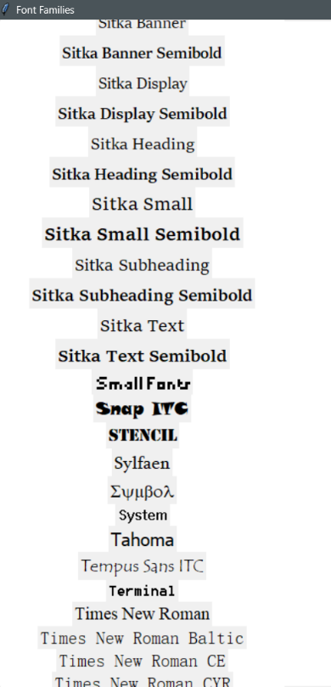
After reviewing the available options, I chose Small Fonts. It has a pixelated style that fits the game’s visual design while still remaining readable.
Overall, these design choices keep the game low in graphical complexity, simple to understand, and comfortable to view over longer play sessions. All colours remain low in saturation and high in contrast to maintain clarity while keeping the interface visually consistent and easy to follow. This supports the relaxed feel of the game by forming a cosy environment.
c.i standardise font, colour and styling throughout formatting

I then went through the program and replaced all hard-coded visual values such as text colour, line colour, and shape fill with global variables storing hex colour values. This means every visual element now references a single source of truth instead of fixed values spread across multiple functions.
This approach improves maintainability because I can change the entire visual style of the program by updating only the global variables. It also reduces the risk of inconsistent colours appearing across different parts of the interface.

Since many functions use visible assets, showing every change would be repetitive. Instead, I provide a before-and-after example using the pause menu buttons to demonstrate how the refactor works in practice.

Objective 8.c.i modify existing code to make use of standardised hex code

Before | 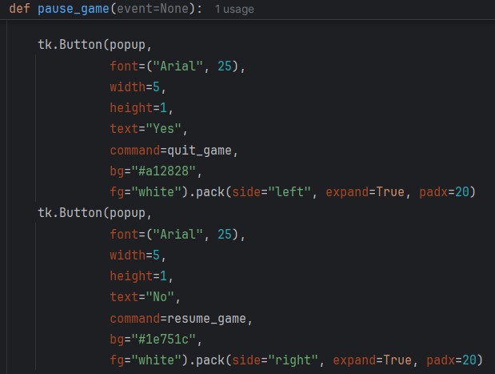
After | 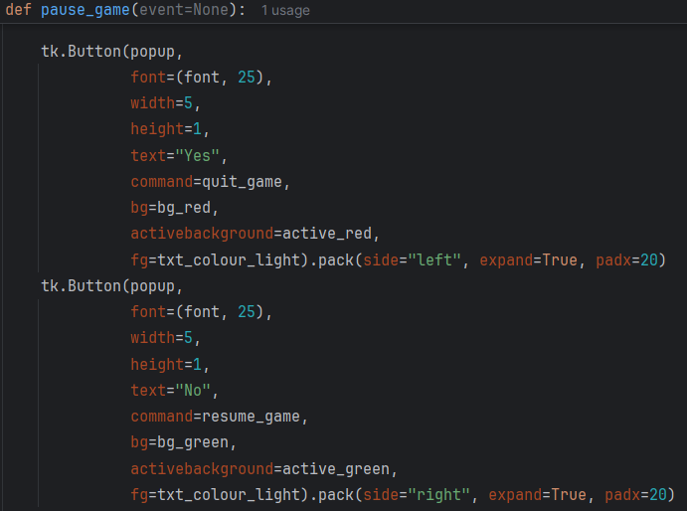

Objective 8.c.ii add instructions to guide the player
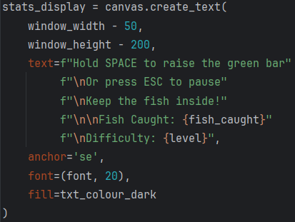

Line | Description
1 | This creates a text object on the canvas. I used create_text so gameplay instructions and live statistics appear directly in the game window instead of using separate UI windows.
2 | I then set the x and y position of the text. By subtracting from each edge of the window I can ensure the text will be within the visible window no matter the machine it runs on.
3
4 | This defines the displayed text using an f-string so values update dynamically during gameplay. Newline characters split the information into clear sections, improving readability. I include fish_caught and level so the player can track progress and see difficulty changes in real time.  I set the anchor point to SE so the text aligns from the bottom right. This helps the layout adapt when the text length changes, keeping positioning consistent without manual adjustments. I then apply the font size, colour, and type using global variables defined earlier. The font size is set to 20 to maintain clear readability without dominating the interface.
5
6
7
8
9
10
11

Objective 8.d.i creating caught_fish function

Objective 8.d.ii move codes into caught_fish function
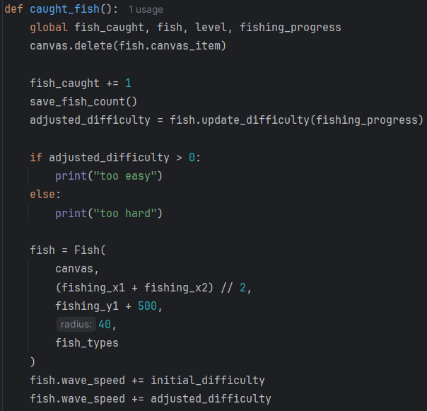

I decided the update progress bar function had become too clustered because it contained many actions triggered when a fish is caught. I separated these procedures into a new function so the post-catch logic is isolated and easier to manage.
No new logic was added beyond defining the new function. The changes mainly involve moving existing code out of the update progress bar function. I show a before-and-after comparison of the update progress bar function, while the modified caught_fish function now contains the removed logic. The new instruction display is also added to the update green bar progress function so it updates after each fish is caught. This ensures the on-screen count stays accurate and reflects the current game state.
This structure improves readability and makes future maintenance simpler, since each function now has a clearer and more specific responsibility.
Before | 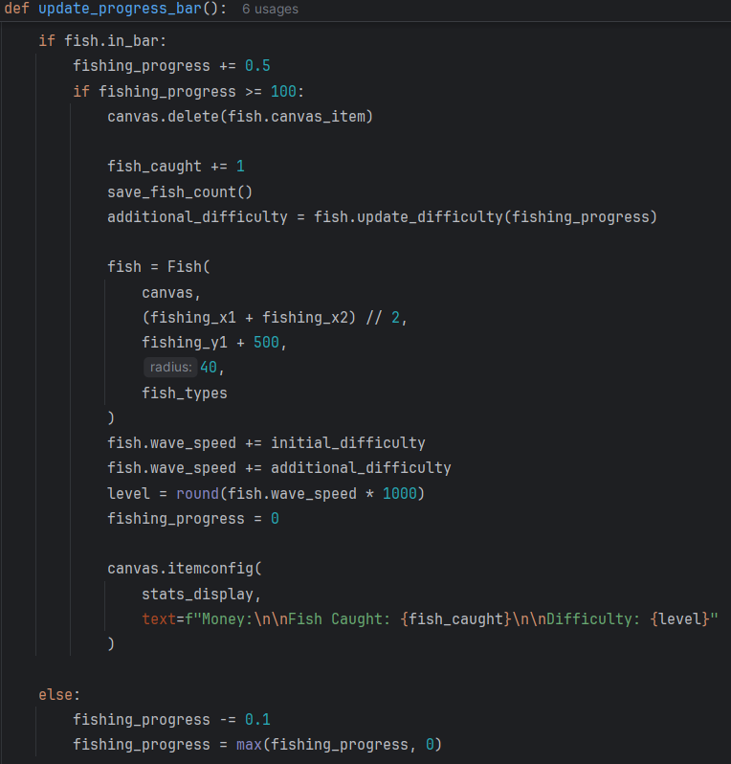
After | 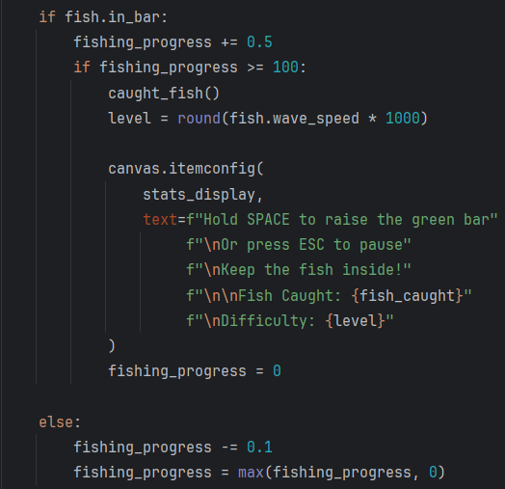

3.8.5 Stage 8 Final testing
Please also refer to the video stage 8 – testing in the attached file
Test No. | Test | Data to be used | Expected Result | Pass  /fail | Evidence
1 | Sprite Folder Path Validation | os.path.join logic | No "File Not Found" errors appear; script identifies the image directory correctly. | Pass | 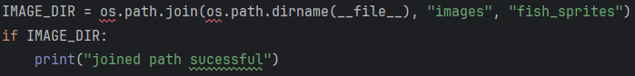  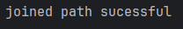  A check was added to verify whether the image directory contains stored content. This confirms whether the directory is being identified correctly. As shown in the terminal output, the code successfully joins the directory paths.
2 | Successful Sprite Loading | anchovy.png (72dpi, PNG) | The fish appears on the canvas as a graphic sprite instead of a colored oval. | Pass | 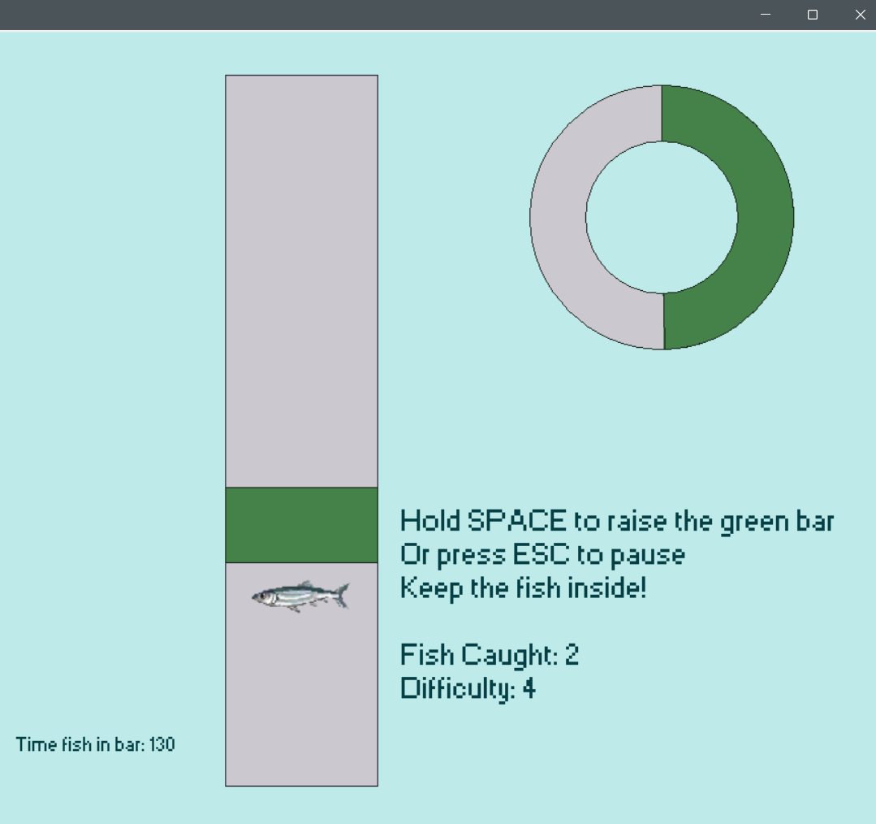
3 | Sprite Fallback Mechanism | Missing image file | The game displays a procedural oval placeholder; the console prints a loading warning. | Pass | 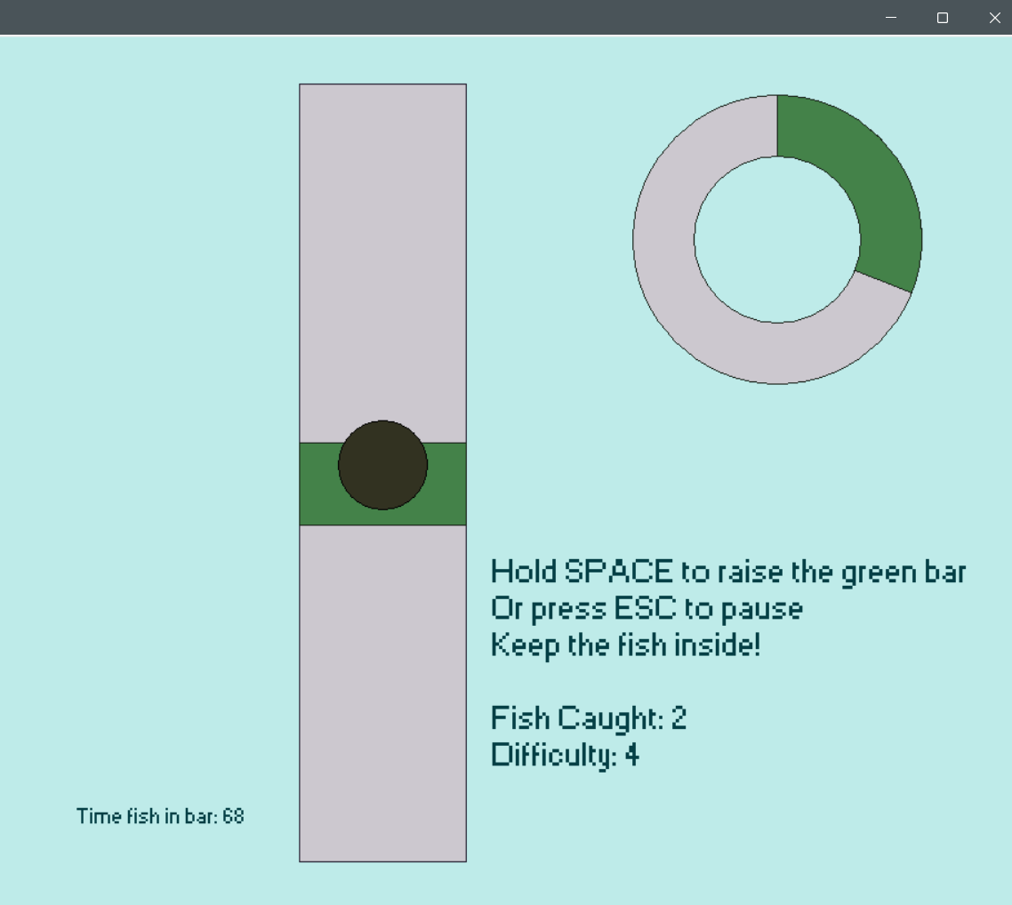  I removed the image key from the fish list to simulate a missing sprite file, so the program must use a placeholder instead. The result shows the placeholder was drawn successfully.
4 | UI Color Standardization | Hex value: #333333 | The entire background changes color automatically without editing individual widget lines. | Pass | 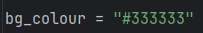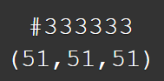  For reference, this is the colour with hex value #333333  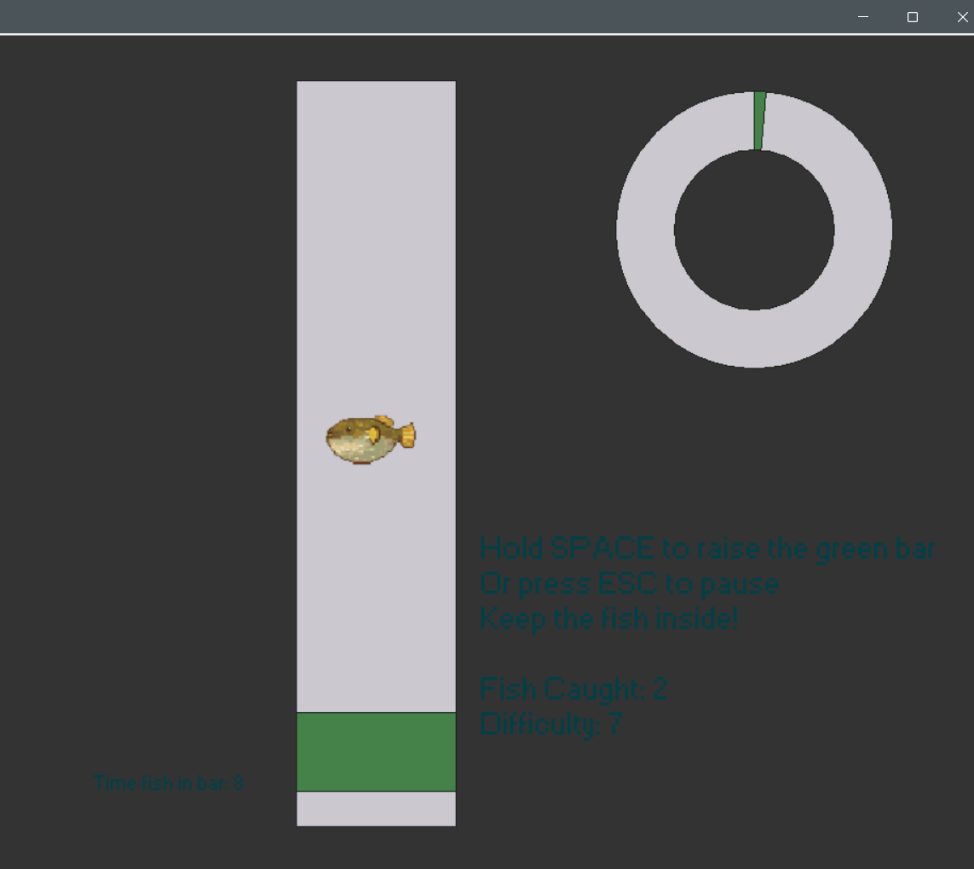
5 | Instructional Text Layout | GUI coordinates | Text is clearly legible, properly anchored, and does not overlap with the fishing bar. | Pass | 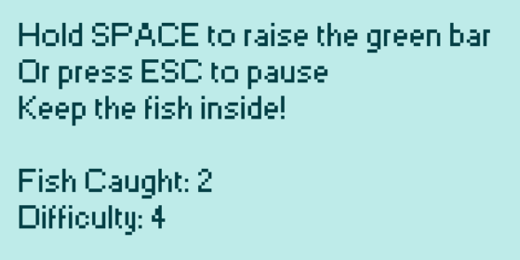
6 | Caught Fish Subroutine | fishing_progress = 100 | The caught_fish function runs; the fish disappears, the counter increments, and a new fish spawns. | Pass | *Refer to video stage 8 – testing  Timestamp 00:09
7 | GUI Font Consistency | font variable | All UI elements use the "Small Fonts" typeface consistently throughout the application. | Pass | *Refer to video stage 8 – testing  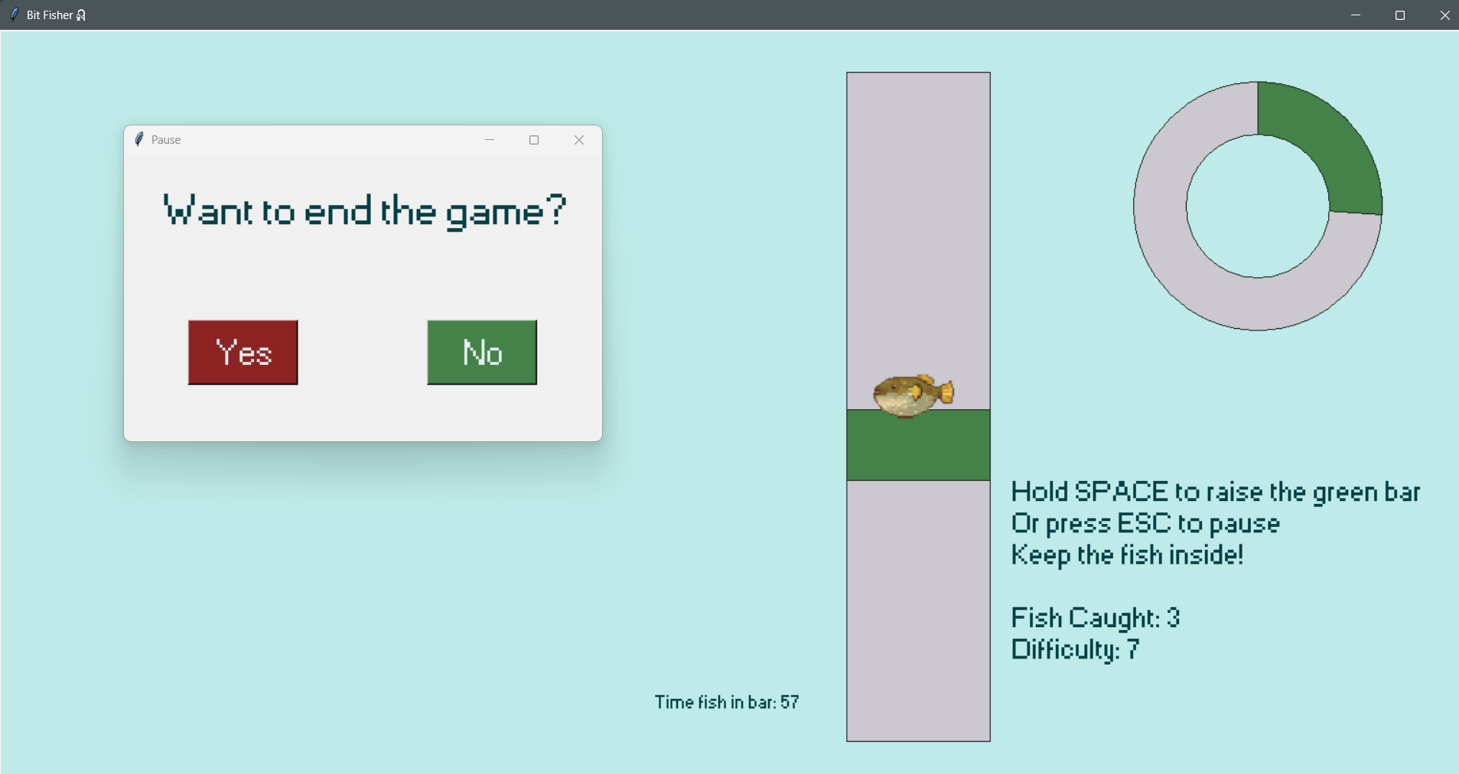
8 | Pause Menu Integration | KeyPress event | Gameplay stops; the sprite freezes in place; the pause menu appears correctly styled. | Pass | *Refer to video stage 8 - testing  Timestamp 00:41-00:48

3.8.6 Stage 8 Program run screen

Title screen
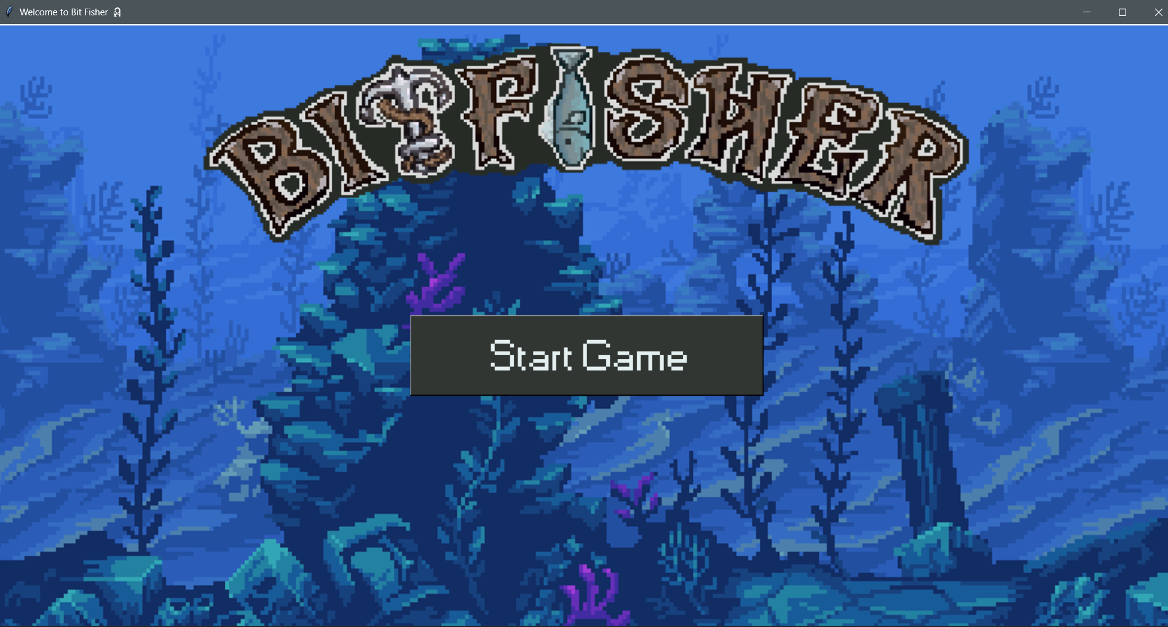

Main program

3.8.7 Stage 8 Final code
Main program (stage_8.py)
import tkinter as tk
from PIL import Image, ImageTk
import math
import random
import os
import sys
import csv
import matplotlib.pyplot as plt
#=====================
#colour HEX value set up
#=====================
bg_colour = "#beebe9"
bg_grey = "#323633"
active_grey = "#ccc8cf"
bg_green = "#448249"
active_green = "#b1c4b3"
bg_red = "#8c2323"
active_red = "#e8bcbc"
blue_outline_colour = "#241f30"
green_outline_colour = "#182119"
txt_colour_light = "#e4eff0"
txt_colour_dark = "#043f45"
font = "Small Fonts"
#read difficulty passed from starting screen
if len(sys.argv) > 1:
initial_difficulty = sys.argv[1].lower()
else:
initial_difficulty = "normal"
difficulty_map = {
"easy": -0.002,
"normal": 0.0,
"hard": 0.003
}
print("initial difficulty = ", initial_difficulty)
initial_difficulty = difficulty_map.get(initial_difficulty, 0.0)
# specify the directrix that contain the sprites
IMAGE_DIR = os.path.join(os.path.dirname(__file__), "images", "fish_sprites")
# ================================
# FISH CLASS SET UP
# ================================
class Fish:
def __init__(self, canvas, x, y, radius, fish_types):
"""
fish_types is a list of dictionaries, e.g.:
[
{"name": "goldfish", "rarity": 60},
{"name": "sardine", "rarity": 45},
{"name": "shark", "rarity": 10},
]
'rarity' values act as weights for spawning (higher = more common).
"""
self.canvas = canvas
self.x = x
self.y = y
self.radius = radius
# pick a fish dict based on weighted rarity
self.fish_data = self.weighted_choice(fish_types)
self.type_name = self.fish_data.get("name", "unknown")
self.rarity = self.fish_data.get("rarity", 1)
# Determine wave_speed based on rarity (rarer = faster, but overall slower for easier game)
self.calculate_speed_from_rarity(min_speed=0.002, max_speed=0.01, max_rarity=100)
self.starting_level = round(self.wave_speed * 1000)
# attempt to load sprite for fish from image_dir
image_filename = self.fish_data.get("image", None)
self.image = None
self.is_image = False
if image_filename:
image_path = os.path.join(IMAGE_DIR, image_filename)
try:
img_raw = Image.open(image_path)
img_raw = img_raw.resize((radius * 4, radius * 4))
self.image = ImageTk.PhotoImage(img_raw)
self.is_image = True
except Exception as e:
print(f"Warning: could not load image '{image_path}': {e}")
self.is_image = False
# Create fish graphic: use image if available else draw oval placeholder
if self.is_image:
self.canvas_item = self.canvas.create_image(self.x, self.y, image=self.image)
else:
shade = max(50, 255 - int(self.rarity * 10))
fill = f"#{shade:02x}{shade:02x}{int(shade / 1.5):02x}"
self.canvas_item = self.canvas.create_oval(
self.x - self.radius, self.y - self.radius,
self.x + self.radius, self.y + self.radius,
fill=fill, outline="black")
# Motion parameters
self.wave_x = 0.0
self.generate_new_wave()
# State
self.in_bar = False
self.time_in_bar = 0
def calculate_speed_from_rarity(self, min_speed=0.005, max_speed=0.05, max_rarity=100):
rarity = max(1, self.rarity)
self.wave_speed = min_speed + (max_rarity - rarity) / max_rarity * (max_speed - min_speed)
@staticmethod
def weighted_choice(fish_types):
if not fish_types:
raise ValueError("fish_types must be a non-empty list")
weights = [f.get("rarity", 1) for f in fish_types]
total = sum(weights)
if total <= 0:
return random.choice(fish_types)
r = random.uniform(0, total)
cumulative = 0.0
for f, w in zip(fish_types, weights):
cumulative += w
if r <= cumulative:
return f
return fish_types[-1]
def generate_new_wave(self):
self.a = random.randint(150, 500)
self.b = random.uniform(8, 12)
self.c = random.randint(750, 1000)
self.d = random.uniform(12, 18)
self.e = random.randint(300, 650)
self.f = random.uniform(18, 22)
def motion(self, t):
return (
self.a * math.sin(self.b * t)
+ self.c * math.sin(self.d * t)
+ self.e * math.cos(self.f * t)
)
def update_position(self, bar_top, bar_bottom):
self.wave_x += self.wave_speed
offset = self.motion(self.wave_x) * 0.15
offset = max(min(offset, 500), -500)
bar_mid = (bar_top + bar_bottom) // 2
self.y = bar_mid + offset
# Keep fish inside fishing bar
top_limit = bar_top + self.radius
bottom_limit = bar_bottom - self.radius
self.y = max(min(self.y, bottom_limit), top_limit)
# update coordinates
if self.is_image:
# For images: coords expects (x, y)
self.canvas.coords(self.canvas_item, self.x, self.y)
else:
# For ovals: coords expects (x1, y1, x2, y2)
self.canvas.coords(
self.canvas_item,
self.x - self.radius, self.y - self.radius,
self.x + self.radius, self.y + self.radius
)
self.canvas.tag_raise(self.canvas_item)
def check_in_bar(self, green_coords):
fish_coords = [
self.x - self.radius, self.y - self.radius,
self.x + self.radius, self.y + self.radius
]
if green_coords[1] < fish_coords[3] and green_coords[3] > fish_coords[1]:
self.in_bar = True
self.time_in_bar += 1
else:
self.in_bar = False
return self.in_bar
# recalculates difficulty based on each catch
def update_difficulty(self, fishing_progress):
difficulty = fishing_progress / self.time_in_bar
if difficulty <= 0.4 and self.wave_speed > 0.001: # game currently too hard
return -0.001
elif difficulty > 0.4: # game currently too easy
return 0.0015
# -------------------------
# CONFIGURE AVAILABLE FISH
# -------------------------
fish_types = [
{"name": "anchovy", "rarity": 80, "image": "anchovy.png"},
{"name": "carp", "rarity": 80, "image": "carp.png"},
{"name": "flounder", "rarity": 60, "image": "flounder.png"},
{"name": "catfish", "rarity": 60, "image": "catfish.png"},
{"name": "pufferfish", "rarity": 35, "image": "pufferfish.png"},
{"name": "salmon", "rarity": 35, "image": "salmon.png"},
{"name": "eel", "rarity": 15, "image": "eel.png"},
{"name": "tuna", "rarity": 15, "image": "tuna.png"},
{"name": "giant squid", "rarity": 5, "image": "giant_squid.png"},
{"name": "hammerhead shark", "rarity": 5, "image": "hammerhead_shark.png"},
]
# ===============================================
# GAME SETUP
# ===============================================
window = tk.Tk()
window.title("Bit Fisher🎣")
window_width = window.winfo_screenwidth()
window_height = window.winfo_screenheight()
window.geometry("%dx%d" % (window_width, window_height))
fish_count_file = "fish_count.csv"
# ============================================================
# INITIAL VARIABLE SECTION
# ============================================================
# Progress bar
radius_outer = 130
radius_inner = 75
fishing_progress = 0
progress_arc = None
progress_center_x = window_width - 220
progress_center_y = window_height - 680
# Fishing bar
fishing_width = 150
fishing_height = 700
fishing_x1 = window_width - fishing_width - 500
fishing_y1 = window_height - fishing_height - 120
fishing_x2 = fishing_x1 + fishing_width
fishing_y2 = fishing_y1 + fishing_height
# Green bar
green_width = fishing_width
green_height = 75
green_x = (fishing_x1 + fishing_x2) // 2
green_y = fishing_y1 + 50
gravity = 10
lift = -10
velocity = 0
space_pressed = False
fish_caught = 0
canvas = tk.Canvas(window, width=window_width, height=window_height, bg=bg_colour)
canvas.pack()
def load_fish_count():
global fish_caught
if os.path.exists(fish_count_file):
try:
with open(fish_count_file, "r") as file:
value = file.read().strip()
fish_caught = int(value) if value.isdigit() else 0
except:
fish_caught = 0
else:
fish_caught = 0
load_fish_count()
def save_fish_count():
try:
with open(fish_count_file, "w") as file:
file.write(str(fish_caught))
except:
print("Unable to save fish count.")
# ==========================================================
# DEFINING FUNCTION SECTION
# ==========================================================
# Pause system
paused = False
def pause_game(event=None):
global paused
paused = True
popup = tk.Toplevel(window)
popup.title("Pause")
popup.geometry("500x300")
popup.grab_set()
tk.Label(popup, text="Want to end the game?", font=(font, 30), fg=txt_colour_dark).pack(pady=30)
def quit_game():
save_fish_count()
window.destroy()
def resume_game():
global paused
popup.destroy()
paused = False
tk.Button(popup,
font=(font, 25),
width=5,
height=1,
text="Yes",
command=quit_game,
bg=bg_red,
activebackground=active_red,
fg=txt_colour_light).pack(side="left", expand=True, padx=20)
tk.Button(popup,
font=(font, 25),
width=5,
height=1,
text="No",
command=resume_game,
bg=bg_green,
activebackground=active_green,
fg=txt_colour_light).pack(side="right", expand=True, padx=20)
window.bind("<Escape>", pause_game)
def space_down(event):
global space_pressed
if not paused:
space_pressed = True
def space_up(event):
global space_pressed
space_pressed = False
window.bind("<KeyPress-space>", space_down)
window.bind("<KeyRelease-space>", space_up)
# Create initial fish
fish = Fish(
canvas,
(fishing_x1 + fishing_x2) // 2,
fishing_y1 + 500,
40,
fish_types
)
fish.wave_speed += initial_difficulty
def caught_fish():
global fish_caught, fish, level, fishing_progress
canvas.delete(fish.canvas_item)
fish_caught += 1
save_fish_count()
adjusted_difficulty = fish.update_difficulty(fishing_progress)
if adjusted_difficulty > 0:
print("too easy")
else:
print("too hard")
fish = Fish(
canvas,
(fishing_x1 + fishing_x2) // 2,
fishing_y1 + 500,
40,
fish_types
)
fish.wave_speed += initial_difficulty
fish.wave_speed += adjusted_difficulty
def update_progress_bar():
global fishing_progress, level, fish_caught, fish
if paused:
window.after(30, update_progress_bar)
return
if fish.in_bar:
fishing_progress += 0.5
if fishing_progress >= 100:
caught_fish()
level = round(fish.wave_speed * 1000)
canvas.itemconfig(
stats_display,
text=f"Hold SPACE to raise the green bar\nOr press ESC to pause\nKeep the fish inside!\n\nFish Caught: {fish_caught}\nDifficulty: {level}"
)
fishing_progress = 0
else:
fishing_progress -= 0.1
fishing_progress = max(fishing_progress, 0)
draw_progress()
window.after(30, update_progress_bar)
def draw_progress():
global progress_arc
if progress_arc:
try:
canvas.delete(progress_arc)
except:
pass
if fishing_progress > 0:
extent = (fishing_progress / 100) * 360
progress_arc = canvas.create_arc(
progress_center_x - radius_outer, progress_center_y - radius_outer,
progress_center_x + radius_outer, progress_center_y + radius_outer,
start=90, extent=-extent, fill=bg_green, outline=green_outline_colour
)
canvas.coords(inner_circle,
progress_center_x - radius_inner, progress_center_y - radius_inner,
progress_center_x + radius_inner, progress_center_y + radius_inner
)
canvas.tag_raise(inner_circle)
def update_greenbar():
global green_y, velocity
if paused:
window.after(30, update_greenbar)
return
velocity = lift if space_pressed else gravity
green_y += velocity
top_limit = fishing_y1 + green_height // 2
bot_limit = fishing_y2 - green_height // 2
green_y = max(min(green_y, bot_limit), top_limit)
canvas.coords(green_bar,
green_x - green_width // 2, green_y - green_height // 2,
green_x + green_width // 2, green_y + green_height // 2
)
window.after(30, update_greenbar)
def check_if_fish_in_bar():
if paused:
window.after(30, check_if_fish_in_bar)
return
green_coords = canvas.coords(green_bar)
fish.check_in_bar(green_coords)
canvas.itemconfig(timer_text, text=f"Time fish in bar: {fish.time_in_bar}")
window.after(30, check_if_fish_in_bar)
def update_fish():
if paused:
window.after(30, update_fish)
return
fish.update_position(fishing_y1, fishing_y2)
window.after(30, update_fish)
# =============================================
# DRAWING THE WIDGETS ONTO THE CANVAS
# =============================================
canvas.create_oval(progress_center_x - radius_outer, progress_center_y - radius_outer,
progress_center_x + radius_outer, progress_center_y + radius_outer,
fill=active_grey, outline=green_outline_colour)
inner_circle = canvas.create_oval(progress_center_x - radius_inner, progress_center_y - radius_inner,
progress_center_x + radius_inner, progress_center_y + radius_inner,
fill=bg_colour, outline=green_outline_colour)
canvas.create_rectangle(fishing_x1, fishing_y1, fishing_x2, fishing_y2,
fill=active_grey, outline=blue_outline_colour)
green_bar = canvas.create_rectangle(
green_x - green_width // 2, green_y - green_height // 2,
green_x + green_width // 2, green_y + green_height // 2,
fill=bg_green, outline=green_outline_colour
)
level = round(fish.wave_speed * 1000)
# ==========================================================
# STATS DISPLAY SECTION
# ==========================================================
stats_display = canvas.create_text(
window_width - 50,
window_height - 200,
text=f"Hold SPACE to raise the green bar\nOr press ESC to pause\nKeep the fish inside!\n\nFish Caught: {fish_caught}\nDifficulty: {level}",
anchor='se',
font=(font, 20),
fill=txt_colour_dark
)
timer_text = canvas.create_text(
window_width - 700,
window_height - 150,
text="Time fish in bar: 0",
font=(font, 14),
fill=txt_colour_dark,
anchor="se"
)
draw_progress()
update_progress_bar()
check_if_fish_in_bar()
update_greenbar()
update_fish()
window.mainloop()

Starting screen code
import tkinter as tk
from PIL import Image, ImageTk
import subprocess
import threading
#============
#colour HEX set up
#============
bg_hex_colour = "#beebe9"
bg_grey = "#323633"
active_grey = "#ccc8cf"
txt_colour_light = "#e4eff0"
txt_colour_dark = "#043f45"
font = "Small Fonts"
#============
# defining function section
#============
def run_script(difficulty):
subprocess.run(["python", "stage 8.py", difficulty])
window.destroy()
def start_game(difficulty):
threading.Thread(target=lambda: run_script(difficulty), daemon=True).start()
def select_difficulty():
start_button.destroy()
difficulties = [("Easy", "easy"), ("Normal", "normal"), ("Hard", "hard")]
for i, (label, value) in enumerate(difficulties):
btn = tk.Button(
window,
font=(font, 30),
width=10,
height=1,
bg=bg_grey,
fg=txt_colour_light,
activebackground=active_grey,
activeforeground=txt_colour_dark,
text=label,
command=lambda v=value: start_game(v)
)
# Place them vertically spaced
canvas.create_window(
(window_width//2, (window_height//2) + i*80),
window=btn
)
#============
# window setup
#============
# Start screen setup
window = tk.Tk()
window.title("Welcome to Bit Fisher 🎣")
window_width = window.winfo_screenwidth()
window_height = window.winfo_screenheight()
window.geometry("%dx%d" % (window_width, window_height))
bg_colour = bg_hex_colour
canvas = tk.Canvas(window, width=window_width, height=window_height, bg=bg_colour)
canvas.pack()
bg_image_raw = Image.open("starting_screen_bg.png")
resized_bg_image_raw = bg_image_raw.resize((window_width, window_height))
bg_image = ImageTk.PhotoImage(resized_bg_image_raw)
bg = canvas.create_image((window_width//2), (window_height//2), image=bg_image)
title_image_raw = Image.open("bitfisher_title.png")
title_image_raw = title_image_raw.resize((1000, 280)) # Resize to match radius
title_image = ImageTk.PhotoImage(title_image_raw)
title = canvas.create_image((window_width//2), (window_height-700), image=title_image)
#============
# start button config
#============
button_text = "Start Game"
start_button = tk.Button(
window,
font=(font, 40),
width=15,
height=1,
bg=bg_grey,
fg=txt_colour_light,
activebackground=active_grey,
activeforeground=txt_colour_dark,
text=button_text,
command=select_difficulty
)
button = canvas.create_window((window_width//2), (window_height//2), window=start_button)
window.mainloop()

3.9 Stage 9 – Reviewing and improving Maintainability
For this stage, the focus is on improving code structure and maintainability by refining the organisation and documentation of the program. The code is cleaned to remove unnecessary sections and improve readability, while maintaining full functionality. Comments are added in key areas to explain the purpose of functions, control structures, and important variables, including specifying data types where relevant to reduce ambiguity.

My main objectives are:
a. Refine and tidy the existing codebase
i. Remove redundant or unused code to simplify the program
ii. Reorganise sections to improve logical structure and readability

b. Improve code documentation
i. Add concise comments to explain key functionality and program flow
ii. Include data type references where necessary to support clarity and future maintenance

3.9.1 Plans for changes
Since the changes are minor and do not affect how the program works, I grouped them into these categories:
  - removing unnecessary code
    - delete unused code
    - remove redundant code
    - remove debugging prints
  - simplifying code to reduce steps
  - reorganizing function blocks
  - adding annotations such as section dividers and comments.
    - Function documentation
    - Data type annotation
    - In line comment
I will give a few examples for each category, though each type appears multiple times in the document.

3.9.2 Removing unnecessary code

1.i Delete unused code
Code | Location | Why it is not necessary | Benefit
import csv | Top of file import section | No CSV operations are used in this version of the code | Reduces unused dependencies and improves clarity
import matplotlib.pyplot as plt | Top of file import section | No graphing or plotting features are implemented in this stage | Reduces memory usage and avoids unnecessary library loading
self.starting_level = round(self.wave_speed * 1000) | Fish class init method | Value is calculated but never used elsewhere in the program | Removes redundant variable and simplifies object state

1.ii. remove redundant code

Before | 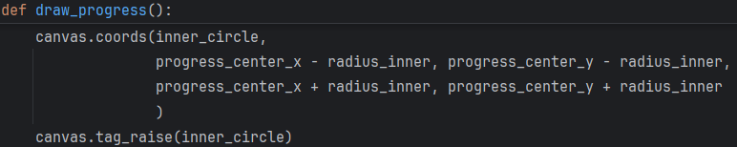
After | 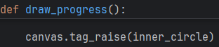

The coordinate update for inner_circle was unnecessary since its position does not change dynamically. Removing this reduces redundant operations and improves efficiency.

1.iii remove debugging prints

Code | Location | Why it is not necessary | Benefit
print("initial difficulty = ", initial_difficulty) | Initial setup after difficulty mapping | Debug output is not needed in the final version of the program | Keeps console output clean and more suitable for release
if adjusted_difficulty > 0:  print("too easy")  else:  print("too hard") | Within the caught_fish function | Since the function has already been tested, the print statement used for testing is no longer needed. | Removing it keeps the console output clean.

3.9.3 Simplifying code to reduce steps
Before | 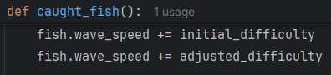
After | 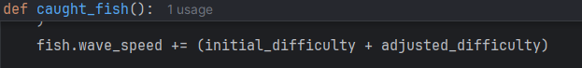

The updated version combines both adjustments into a single operation. This reduces repetition and makes the logic clearer. It also lowers the chance of inconsistencies if future changes are made.

Before | 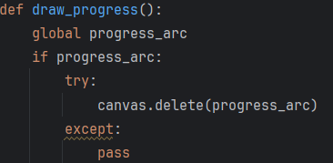
After | 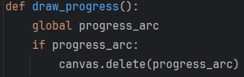

The exception handling was not required because delete does not fail in normal execution. Removing it reduces complexity and makes the intent clearer.

Before
After

3.9.4 Organizing function blocks
I have organised the code into separate functional blocks and structured it using the format shown below.

Section | Functions or elements | Reason for grouping
Colour hex value set up | bg_colour, bg_grey, active_grey, bg_green, active_green, bg_red, active_red, blue_outline_colour, green_outline_colour, txt_colour_light, txt_colour_dark, font | Stores all visual styling values in one place so UI colours and fonts stay consistent and easy to adjust
Fish class set up | Fish class, init, calculate_speed_from_rarity, weighted_choice, generate_new_wave, motion, update_position, check_in_bar, update_difficulty | Groups all fish behaviour, movement, image loading, and interaction inside one structure for easier reuse and organisation
Configure available fish | fish_types list | Holds all fish data including name, rarity, and image paths used when spawning fish
Game setup | window creation, screen sizing, canvas creation, fish_count_file | Initialises the application window and drawing surface before any game logic runs
Initial variable section | radius_outer, radius_inner, fishing_progress, progress_arc, fishing area coordinates, green bar variables, physics variables, fish_caught, canvas | Stores all global values controlling layout, movement, physics, and overall game state
Defining function section | pause_game, space_down, space_up, load_fish_count, save_fish_count, caught_fish, update_progress_bar, draw_progress, update_greenbar, check_if_fish_in_bar, update_fish | Contains all main gameplay functions including input handling, game loop updates, collision logic, saving data, and UI updates
Drawing the widgets onto the canvas | create_oval, create_rectangle, create_arc, green_bar, inner_circle, fishing lane, text elements | Creates all visual game elements before gameplay begins so logic and rendering stay separated
Stats display section | stats_display, timer_text | Manages on-screen text output such as score, difficulty, and time information for the player
Main loop start | draw_progress, update_progress_bar, check_if_fish_in_bar, update_greenbar, update_fish, window.mainloop | Starts all repeating update loops and runs the Tkinter event system that keeps the game active

3.9.5 Adding annotations

4.i function documentation
Examples for function documentation (function name/documentation added)
- Fish.init , #Initialises fish object with movement, image loading, and attribute setup
- Fish.update_position , #Updates fish coordinates and applies movement physics each frame
- Fish.check_in_bar , #Checks overlap between fish and green bar for collision detection
- Fish.update_difficulty , #Adjusts wave speed based on player performance
- weighted_choice , #Selects fish based on rarity weighting system

These documentations make each function’s purpose clear at a glance, which makes the code easier to debug and review.

4.ii data type annotation
Examples:
Before
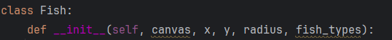
After

Before
After

I decide to implement Data type annotations due to the following reasonings:
- improve code clarity - by explicitly showing what type of data each variable expects. This reduces confusion when reading or modifying the code, especially in larger projects with many variables.
- reduce errors - by making it easier to detect incorrect data usage. For example, passing a string where an integer is expected becomes easier to identify during development.
- support maintenance - future developers can understand the structure of the program without needing to trace every variable back to its origin. This speeds up debugging and reduces the chance of breaking existing functionality.
- improve consistency - When variables have clearly defined types, the code behaves more predictably across different functions and modules.

4.iii in line comment
Examples:
Before
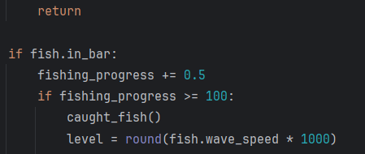
After
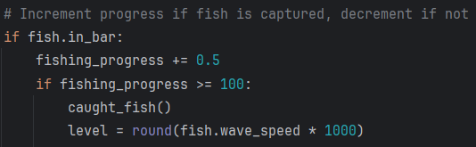

Before
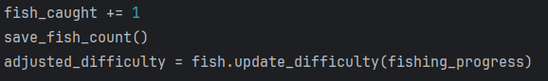
After
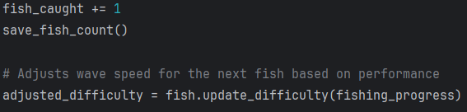

I decide to implement inline annotations due to the following reasoning:
- improve immediate readability - placing explanations next to the code makes the purpose of each section clear without needing to search through other parts of the program. This is useful in areas like movement logic and collision checks where multiple steps happen in sequence.
- clarify game-specific behaviour - some parts of the code rely on rules unique to the game, such as fish movement patterns or boundary limits. Inline annotations make these rules explicit at the exact point they are applied, reducing confusion during later review or updates.

3.9.6 Conclusion:
The changes made to the code improve maintainability and make future development more efficient. By separating functionality into clear blocks, each part of the program now has a defined responsibility, which reduces complexity and makes the logic easier to follow. This structure allows a developer to modify one system, such as fish movement or UI updates, without affecting unrelated parts of the program.
Adding function documentation, inline comments, and data type annotations improves readability by explaining the purpose and expected behaviour of key sections directly in the code. This reduces the time needed to understand how the program works and lowers the chance of misinterpretation.
Removing redundant code and simplifying repeated logic also improves clarity and reduces unnecessary processing. Overall, these changes create a more structured and consistent codebase, allowing another programmer to quickly understand the system and continue development with minimal disruption.

Testing:
The program was run after all changes were applied to confirm it still operates correctly. All features behave as expected and no functionality was affected.

3.10 Stakeholder’s Review
After I finished the program, space remained on the left side of the screen. I originally planned to use this space for a fisherman animation. After reviewing the program at its current stage, I believe this function is redundant and serves no purpose other than decoration. I want to explore other solutions to implement in this space.

3.10.1 The questions
I decided to interview my stakeholders again. I wanted to learn their opinions on the current state of the project. I also wanted to find out what improvements they wanted for the space.
I let all five stakeholders test the game firsthand. Then, I asked them three questions:
- What do you think of the experience?
- What did you wish was on the main interactive window but wasn’t?
- What would you like more of: feedback, graphic animation, clear interface, or something else?

3.10.2 The responses
They provided the following responses:

Emily (age 21 casual gamer):
- What do you think of the experience
“I thought it was quite relaxing and easy to get into. I liked the overall pace, it didn’t feel stressful. It was nice to play something where I could focus on small goals like catching fish without pressure.”
- What did you wish was on the main interactive window but wasn’t
“I wish there was a more obvious indicator for when a fish is caught. Sometimes I wasn’t fully sure if I had done it right until a bit later. Also, I would have liked to see the name of the fish I caught, it would make it feel more rewarding.”
- What would you like more of
“I’d like more visual feedback, like small animations or a progress bar. Something that clearly shows I’m doing well would make it more satisfying.”

Elena (age 17 frequent gamer):
- What do you think of the experience
“I liked it overall, it was simple to understand and quite fun at the start. It felt rewarding when I caught fish, but after a while I wanted a bit more depth.”
- What did you wish was on the main interactive window but wasn’t
“I think there should be clearer information about the fish, like which ones are rare and which ones are common. Right now it feels unclear, so I don’t know how well I’m actually doing.”
- What would you like more of
“I would like a way for easily reset my actions. So I can retry multiple times to see where I have improved with the game.”

Alex (age 14 competitive gamer):
- What do you think of the experience
“It was alright, but I didn’t feel very challenged. It felt too simple, so I didn’t feel like I was improving or achieving much.”
- What did you wish was on the main interactive window but wasn’t
“I want some sort of performance stats, like how many fish I caught compared to other players or a score system. Right now there’s no way to tell if I’m doing well.”
- What would you like more of
“I want more detailed feedback on my performance. Like ratings, scores, or even leaderboards. I need something to compare myself to others, otherwise it gets boring.”

Sophie (age 16 infrequent gamer):
- What do you think of the experience
“I thought it was quite nice and simple. It wasn’t confusing, so I could understand it quickly, which I liked.”
- What did you wish was on the main interactive window but wasn’t
“I found it a bit unclear which type of fish I had caught. A clearer sign would help.”
- What would you like more of
“I’d like a clearer interface. Maybe labels or small messages that explain what is happening, so I don’t get confused.”

Sarah (age 42 mathematics tutor):
- What do you think of the experience
“I found it quite engaging and suitable for a learning environment. It was simple enough to understand, which is important for students.”
- What did you wish was on the main interactive window but wasn’t
“I would like a display showing the different species of fish collected. This would give students a clearer sense of progression and achievement. It would be helpful for them to learn about the names and characteristics of each fish.”
- What would you like more of
“I would prefer a way to easily clear the progress and data, since in a classroom there will be many students and the progress will need to be reset for each student. At the moment it is a little complicated how I have to manually clear the files.”

3.10.3 Conclusion drawn from the interview:
From the interview responses, I identified several consistent issues with feedback, clarity, and progression. Many users found it unclear when a fish was caught, while others struggled to understand the differences between fish types, especially in terms of rarity. Some users also wanted a stronger sense of progress, either through visual indicators or performance tracking, as well as a method to reset the data saved.

3.10.4 Extra modules to implement
Based on this, I decided to implement the following extra modules:
- Performance Chart
Function: Displays user performance over the number of fish caught before exiting the game.
Justification: This responds to user requests for measurable progress and a way to evaluate gameplay success.
- Clear Saved Data
Function: Allows the user to reset and clear saved data.
Justification: This gives the user control over their progress and allows them to start over if desired.

- Chart with Names and Rarity of Fish
Function: Displays the name and rarity of each fish species.
Justification: This addresses the lack of clarity around fish types, adds meaning to each catch, and supports users who want to learn about the species and their values.

- Separate Count for Each Fish Species
Function: Displays individual counts for each fish species on the interface.
Justification: This provides immediate visual feedback and makes it easier to track progress during gameplay while improving interface clarity and the sense of progression.

3.11 Design - Extra modules based on stakeholder input

3.11.1 Performance chart
PROCEDURE ShowPerformanceGraph

# Section 1
DECLARE fish_numbers : ARRAY
DECLARE performances : ARRAY

IF performance_file EXISTS THEN
OPEN performance_file FOR READ
FOR EACH record IN file
APPEND record.fish_number TO fish_numbers
APPEND record.performance TO performances
NEXT record
CLOSE file
ENDIF

# Section 2
IF fish_numbers IS EMPTY THEN
RETURN
ENDIF

# Section 3
CALL PlotGraph(fish_numbers, performances)

# Section 4
DISPLAY ExitButton
DISPLAY ClearDataButton

ENDPROCEDURE

Section descriptions
- Section 1: Reads stored performance data from the CSV file and separates it into two arrays. One stores fish numbers, the other stores performance scores.
- Section 2: Checks if there is any data to display. If not, the procedure ends to avoid errors.
- Section 3: Sends the data to a graphing function to create a visual representation of performance over time.
- Section 4: Displays interactive buttons so the user can exit or clear saved data.

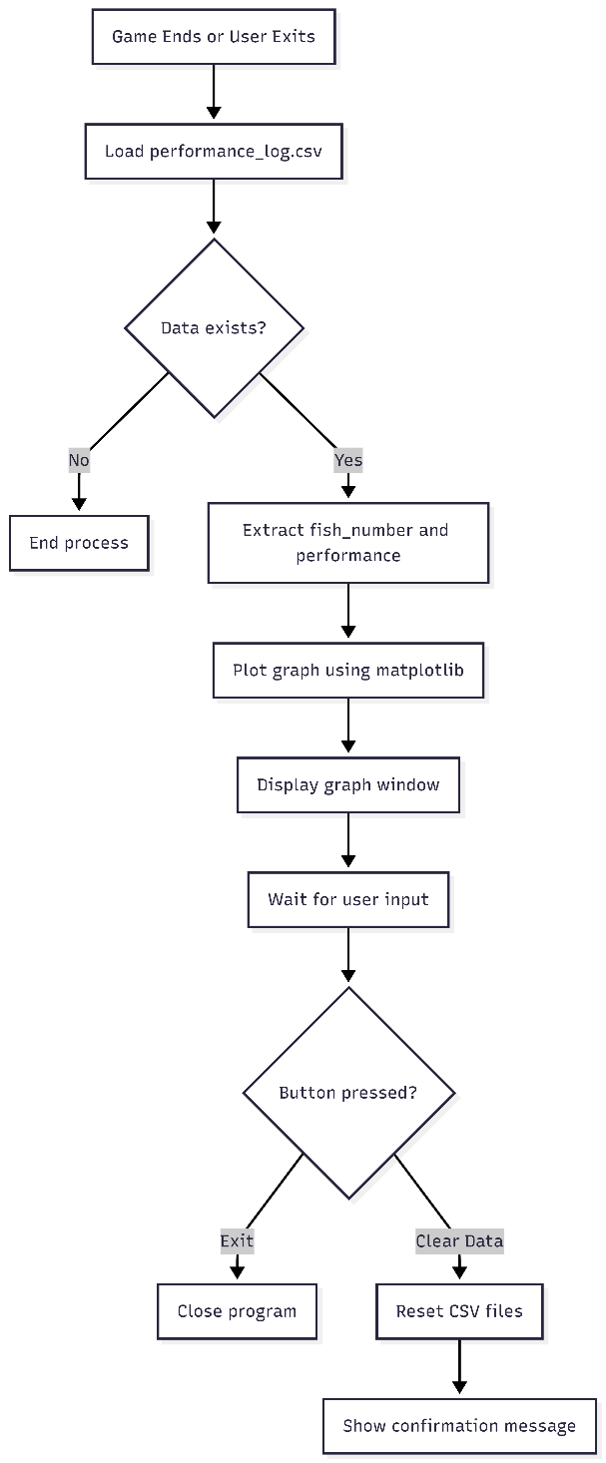
Function flowchart Function pseudocode

This function reads stored performance data and displays it as a graph. It needs the CSV file that stores fish count and performance score. The design uses file storage so data persists between sessions. Matplotlib is used since it handles graph rendering efficiently. The clear data button was added to give user control, which was requested in feedback.
PROCEDURE ClearSavedData

# Section 1
OPEN performance_file FOR WRITE
WRITE headers TO performance_file
CLOSE file

# Section 2
OPEN fish_count_file FOR WRITE
WRITE 0 TO file
CLOSE file

# Section 3
OPEN fish_type_count_file FOR WRITE
WRITE empty TO file
CLOSE file

# Section 4
DISPLAY "All Data Cleared"

ENDPROCEDURE

Section descriptions
- Section 1: Resets the performance file by overwriting it with only the header row, removing all previous data.
- Section 2: Resets the total fish count back to zero.
- Section 3: Clears all stored counts for individual fish species.
- Section 4: Displays a message to confirm that the reset has been completed.

3.11.2 Clear saved data
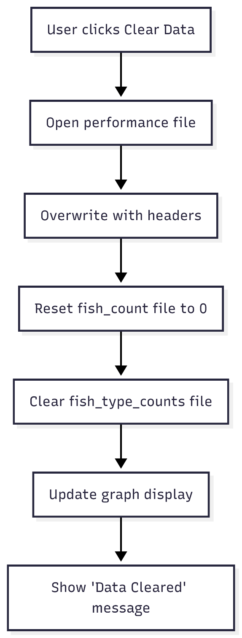

This procedure resets all saved progress. It uses file overwrite instead of deletion to avoid file access errors later in the program. The method ensures a consistent file structure. This approach keeps the system stable and predictable. The decision supports user control and replayability.

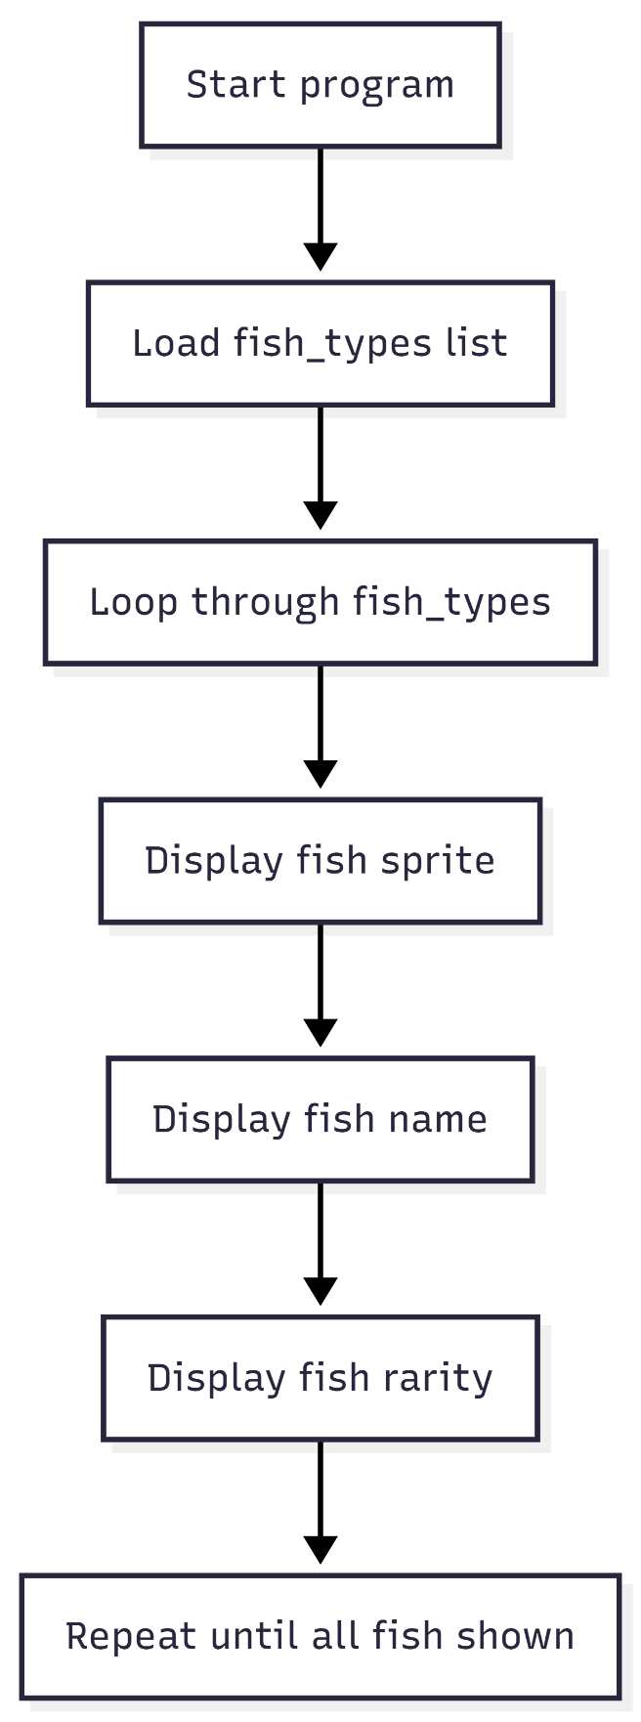
3.11.3 Display names and rarity of fish
PROCEDURE DrawFishInfo

# Section 1
FOR EACH fish IN fish_types

# Section 2
DISPLAY fish.image

# Section 3
DISPLAY fish.name
DISPLAY fish.rarity

NEXT fish

ENDPROCEDURE
Section descriptions
- Section 1: Iterates through the list of fish types stored in the program.
- Section 2: Displays the visual sprite for each fish on the interface.
- Section 3: Displays the name and rarity value next to each fish, giving context to what the player has collected.

This function displays fish metadata on screen. It uses the predefined fish_types array as input. This structure was chosen since it stores all fish attributes in one place, which simplifies access. Adding name and rarity improves clarity and addresses user confusion. It also introduces an educational aspect.

3.11.4 Separate count for each fish type
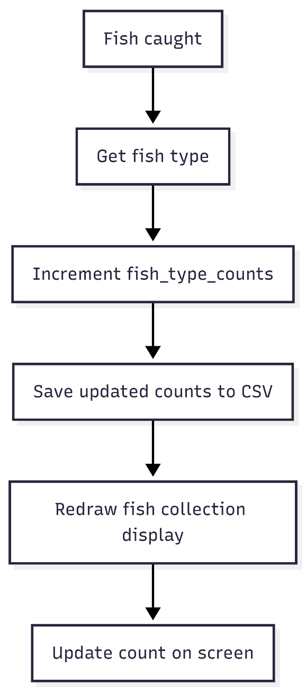
PROCEDURE UpdateFishCount(fish_name)

# Section 1
fish_type_counts[fish_name] = fish_type_counts[fish_name] + 1

# Section 2
CALL SaveFishTypeCounts

# Section 3
CALL DrawFishCollection

ENDPROCEDURE
Section descriptions
- Section 1: Increases the count for the specific fish type that has just been caught.
- Section 2: Saves the updated counts to a CSV file so progress is not lost.
- Section 3: Refreshes the on-screen display so the updated values are immediately visible to the user.

Data format
The fish counts are stored using a dictionary structure in memory. Each entry follows a key value format:
fish_type_counts = {
"anchovy": 3,
"carp": 5,
"tuna": 1
}
The key stores the fish name as a string. The value stores the number of times that fish has been caught as an integer.
When saved to a file, the data is written into a CSV format where each row contains two values:
fish_name, count
anchovy, 3
carp, 5
tuna, 1

Justification
- A dictionary was chosen for in memory storage because it provides direct access to each fish type using its name. This allows the program to update counts in constant time, which is efficient during gameplay where updates happen frequently.
- Using the fish name as the key avoids the need to search through a list to find the correct entry. This reduces processing time and simplifies the logic.

3.12 Stage 10 – Feedback Performance Graph & In game fish category
Now that these procedures are planned out with pseudocode and a flowchart, I can start implementing them in the program code.

For this stage, the focus is on extending data handling and improving how player progress is recorded and presented. The program is updated to store performance data and fish collection details using external CSV files, allowing information to persist between sessions. The interface is also improved to display clearer feedback, including individual fish counts and a visual collection area, so the player can track progress more effectively.
My main objectives are:
- Implement performance tracking and data management
- Record player performance after each catch and store it in a CSV file
- Generate a performance chart at the end of the game to show progress over time
- Provide an option to clear all saved data and reset the game state
- Provide an option to exit the game
- Improve fish information and collection display
- Store fish names, rarity, and counts using structured data
- Display each fish with its sprite, name, and individual count on the interface
  - Sprite display
  - Name display
  - Individual count
- Update the display dynamically to reflect changes during gameplay

3.12.1 Stage 10 Test plan

Test No. | Test | Procedure | Data to be used | Type of test | Expected Result
1 | Performance recording after fish catch | Run game and catch a fish, then check CSV file contents | Valid fish catch events such as Salmon with increasing counts | Functional | CSV file updates after each catch with correct performance values stored
2 | Performance chart generation | Complete a session and trigger end-game graph function | CSV file containing multiple performance records | Functional | Graph displays correctly showing performance over time
3 | Empty file handling for graph | Run graph function with no gameplay data | Empty CSV file | Boundary | Function exits safely and no graph is drawn
4 | Clear data reset function | Click clear data button during or after gameplay | CSV file with existing records | Functional | CSV resets to header only and all previous data is removed
5 | Exit game option | Click exit button during gameplay | Active game session with saved data | Functional | Game closes without errors and data remains intact
6 | Fish dictionary update after catch | Catch multiple fish types and check stored values | Fish types such as Salmon, Trout, Tuna | Functional | fish_type_count updates correctly for each fish type
7 | Fish display update in UI | Catch fish and observe interface changes | Fish sprites and updated count values | Functional | UI updates immediately showing correct sprite, name, and count
8 | CSV structure validation | Insert incorrect row format and run load function | Invalid row such as missing or extra values | Error handling | Invalid rows are ignored and program does not crash

3.12.2 Rough plan of fish type display

3.12.3 Stage 10 Code Analysis

Objective 10.a.i. record player performance in a CSV
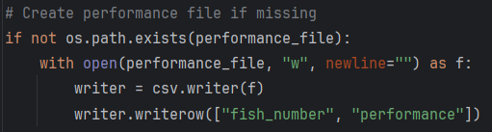

Line | Description
1 | I used an if statement with os.path.exists to check if the file already exists. This prevents overwriting existing data.
2 | If the file does not exist, I opened it in write mode using open with newline set to an empty string to avoid blank rows.
3 | I created a csv.writer object and used writer.writerow to insert a header row. This ensures the file has a defined structure before data is appended. The headers are the corresponding x and y value of the performance graph. This makes it easier to plot later.
4

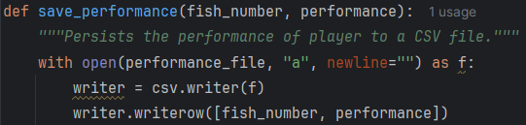

Line | Description
1 | I defined a function save_performance with parameters fish_number and performance. Inside the function, I opened the file in append mode so new data is added without deleting previous entries.
2
3 | I created a writer object and used writer.writerow to store each result as a new row.  I used this function to record performance after each fish is caught, which supports later evaluation of player progress.
4

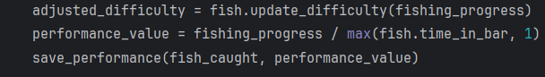

Line | Description
1 | I calculate performance value using the same method as the difficulty adjustment process. I track fishing_progress over time in bar and use a max function to avoid division by zero and keep the data valid. This consistent approach makes the program easier to follow and gives the user a clear chart to understand their performance, which meets the requirement raised by stakeholders.
2 | The save_performance function is called inside the caught_fish function defined earlier, so the system saves data automatically each time a fish is caught. This prevents any loss of progress and stores the x and y values needed for the graph layer.

Objective 10.a.ii generate performance chart after exit screen
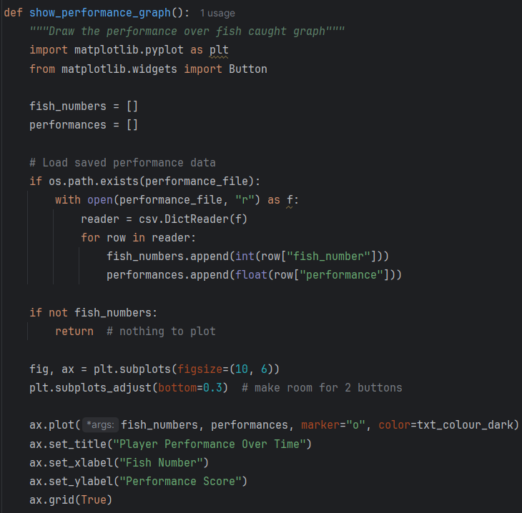

Line | Description
1 | In the graph function, I declared two lists, fish_numbers and performances. These act as data structures to temporarily store values read from the file. These lists store values read from the CSV file so the data can be separated into x and y components for plotting. Matplotlib requires structured sequences of numeric values, so using lists allows the graph function to pass clean, ordered data directly into the plot function.
2
3
4
5

Line | Description
1 | I used os.path.exists again to ensure the file is present before reading to avoid error and crashing the program.
2 | I then opened the file and used csv.DictReader like earlier, which allows access to values using column headers.
3
4 | The code then iterates through each row using a for loop and appends the fish number in integer and performance in float values into their corresponding lists. This converts stored string data into numeric types for plotting.
5
6
7 | I used an if statement to check whether fish_numbers is empty. If true, the function exits early to avoid plotting an empty graph. This prevents attempts to process or pass invalid values into the plotting function and acts as a safeguard when the user has no recorded progress to display.
8

Line | Description
1 | This line initializes the figure (fig) and the axes (ax) for the graph using the matplotlib library. The figsize parameter sets the width and height of the window in inches.
2 | This function adjusts the position of the graph within the figure window. It leaves space at the bottom of the display area, creating room for two buttons that are added after the graph is drawn.
3 | This line plots the line graph. It maps the x-axis values (fish_numbers) against the y-axis values (performances). The parameter marker="o" adds a visible dot at each data point, and color=txt_colour_dark sets the colour of the line to match the global style.
4 | These lines add text labels to the chart. The title identifies the graph, while the x-axis and y-axis labels inform the player about the plotted variables.
5
6
7 | This function adds a grid background to the chart. A grid makes it much easier for the player to read the exact performance scores at a glance.

Objective 10.a.iii option to clear save data

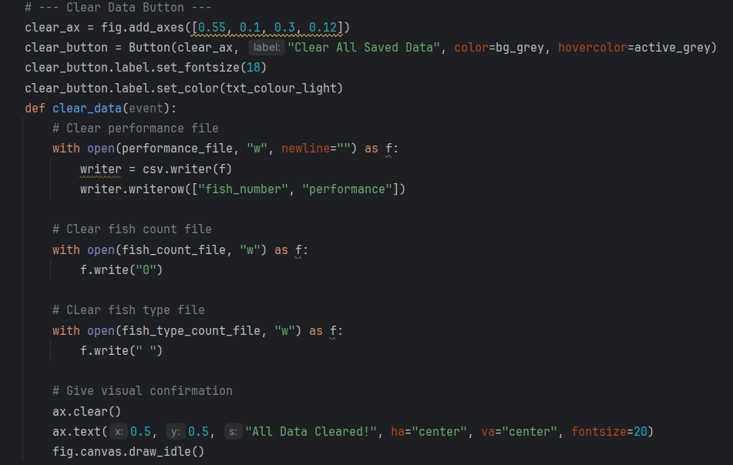

Line | Description
1 | I created a button axis using fig.add_axes and then created a Button object. This provides an interactive control element within the graph window. The button calls for the function clear_data.
2
3 | I configured the button in the global style used for all the other buttons.
4

Line | Description
1 | I defined a function clear_data that runs when the button is clicked.
2 | Inside the function, I open performance_file in write mode and overwrite the file contents. I then write the header row again, which removes all previous records while keeping the file structure intact and ready for new data.
3
4
5 | I opened fish_count_file in write mode and wrote "0" to reset the total fish count.
6
7 | I also opened fish_type_count_file and wrote a blank value to remove stored counts.
8

Line | Description
1 | I used ax.clear to remove the existing graph and then used ax.text to display a confirmation message once all data has been cleared.
2 | I called fig.canvas.draw_idle to update the display. This gives the user control over stored data and provides immediate visual confirmation that the data has been cleared. It also reduces repeated button clicks since the refreshed graph shows the result of the action straight away.
3

Objective 10.a.iv option to exit game after showing the graph
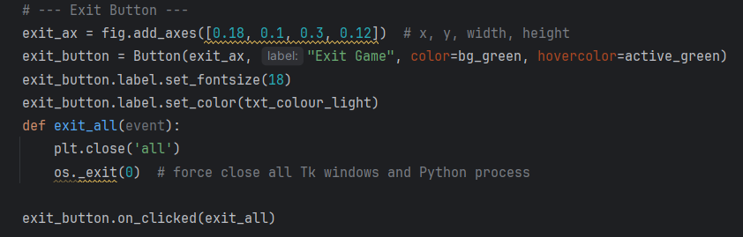

Line | Description
1 | This line creates a new axes area inside the Matplotlib figure. The list defines the position and dimensions in relative coordinates: [x_position, y_position, width, height]. Matplotlib does not place UI buttons directly on standard plots. Adding specific axes provides a dedicated space for the button.
2 | This creates a button widget inside the exit_ax area with the label "Exit Game". The colour variables set the background colour and the hover colour like the global format.
3 | This sets the visual style for the button text. It makes the text larger and lighter to ensure it is legible.
4
5 | This defines the function that runs when a user clicks the button. The command plt.close('all') closes all Matplotlib figures, while os._exit(0) forces the entire Python process and its Tkinter windows to terminate immediately. Why: This ensures the background processes and graphics close completely to prevent memory leaks.
6
7
8 | This connects the button widget to the exit_all function so that it triggers when clicked.

Objective 10.b.i store fish names, rarity and counts
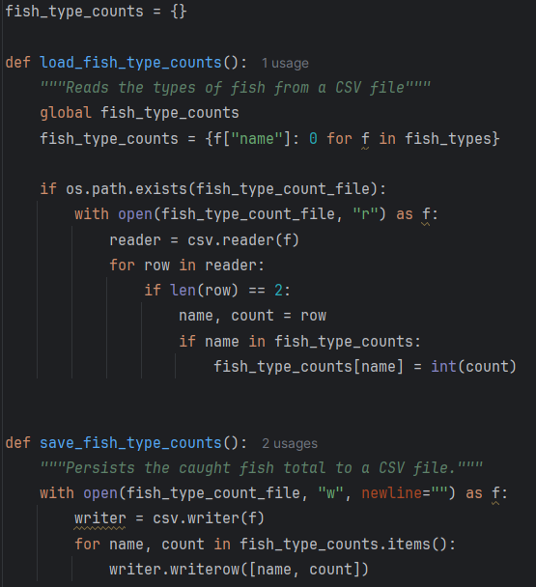
Line | Description
1 | This line initializes an empty dictionary. It acts as a storage container for the program to keep track of how many of each fish species the player catches.
2 | Defined the function and set the fish type count to a global variable for function use.
3
4 | I initialize an empty dictionary and fill it using dictionary comprehension. It iterates through the elements of the fish_types list to extract each fish name and sets its corresponding starting count to zero. This step acts as a baseline that ensures the program tracks every single fish species correctly when a new game session starts.
5 | This conditional check determines whether the file exists in the directory before attempting to open it. It prevents the program from crashing due to a missing file error the very first time a user runs the application. Validating the existence of the file allows the game to default to zero when no previous data exists.
6 | This opens the file in read mode ("r") and assigns it to the variable f. The with keyword automatically closes the file block after reading it.
7 | This initializes a CSV reader object to parse the lines from the file.
8 | I loop through each line in the CSV file and validate the structure of each row. Each row must contain exactly two values, representing the fish name and its count. This prevents the function from processing data that does not follow the correct format and reduces errors during parsing.
9
10 | This unpacks the row data into two variables: the fish name and the number caught.
11 | This checks that the name read from the file matches a valid fish type before updating the value stored in the dictionary. It ensures only recognised keys are updated, which prevents incorrect or unexpected entries from affecting the dataset. The value is then converted from a text string into an integer so it can be used in calculations and accurate numeric processing.
12

Line | Description
1 | This function saves the count per fish type into the file created earlier.
2 | This line opens the file in write mode using the with statement. Python closes the file automatically after the block finishes to prevent data corruption.
3 | Like earlier, I create a CSV writer object. The object converts data into text formatted for comma-separated values.
4 | This loops through every item in the dictionary. It gets the name of the fish and its corresponding count.
5 | I then write the name and the count as a new row in the CSV file. It stores the values to keep the progress safe between game sessions.

Objective 10.b.ii display each fish data
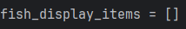
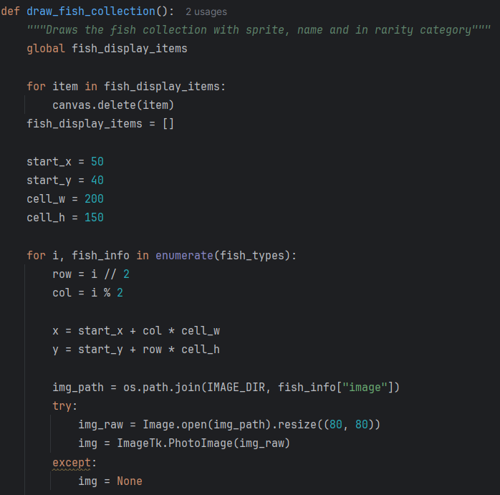

Line | Description
1 | I define this function as the method to display the sprite, count and name of each type of fish in rarity category.
2 | I declare the existing empty list as global so it can be accessed and updated across different parts of the function. This list is used by the Tkinter assets layer to store interface elements, including sprite images, text labels for names, and count values.
3 | This loop goes through every item inside the display list. It removes each element from the canvas to prevent the overlapping of images. This has to be done as the items stored in the list are within he tkinter library and cannot be cleared using other functions.
4
5 | This resets the list to be empty again before each iteration of the function, clearing the previous data before drawing the updated collection.
6 | The coordinates start_x and start_y define the top left corner of the grid with values of 50 and 40, which leave space around the edges. The dimensions cell_w and cell_h give each item box a width of 200 pixels and a height of 150 pixels. This spacing creates rows and columns for the items.  I use these values to keep the interface organized. The margins make sure no elements get hidden off the edge of the screen. The cell sizes provide enough room for the fish sprite, the name, and the caught count. This layout prevents overlap and keeps the screen clear for the user.
7
8
9

10.b.ii.a Fish sprite
this is within the draw_fish_collection function
Line | Description
1 | I used enumerate so I can access both the index and the fish data in a single loop. The index i is needed for positioning each fish in a grid, while fish_info gives access to the fish attributes. This avoids using a separate counter variable, which reduces complexity and prevents mismatch errors between index and data.
2 | I used integer division to convert a single index into a row number. Dividing by 2 groups fish into rows of two. This creates a fixed grid structure without needing nested loops or manual row tracking.
3 | I then used modulo to alternate between two column positions. Using 2 will always result in either 0 or 1, which allows placement in left or right columns. This is a simple way of achieving this result using odd and even values of i.
4 | I used this formula to calculate horizontal and vertical positioning. The column value scales the position by a fixed cell width, which ensures consistent spacing between fish images.
5
6 | I used os.path.join to build file paths in a way that works across different operating systems. This prevents errors caused by different path formats. I accessed fish_info["image"] to retrieve the correct filename for each fish.
7 | I then use a try block to prevent the program from crashing if an image file is missing or corrupted. Before opening the image file and resized it to a fixed size so all fish sprites appear uniform in the interface. This improves visual consistency and keeps the program robust.
8
9 | I converted the image into a format compatible with tkinter. Without this conversion, the canvas cannot display the image correctly.
10 | I used a fallback case to handle errors during image loading. This ensures the program continues running even if assets are missing.
11 | I assigned None to represent a failed image load. This allows a later conditional check to decide whether to draw an image or a placeholder.

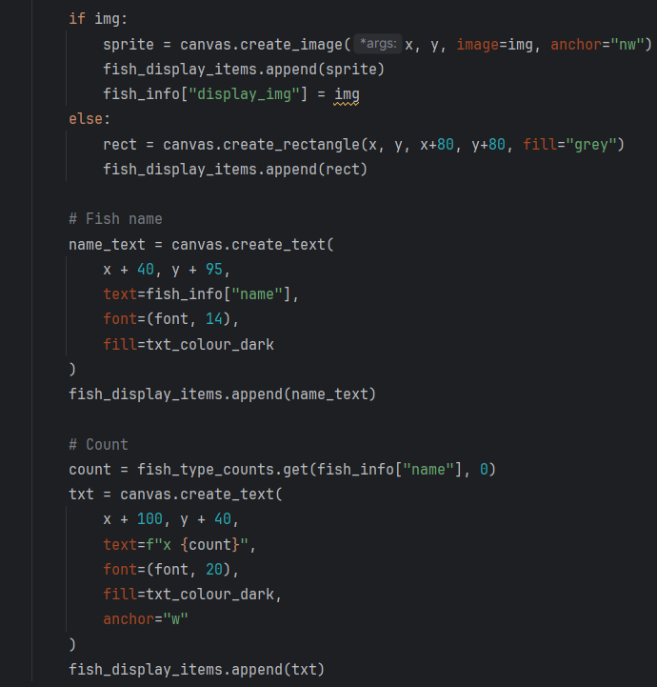

Line | Description
1 | I checked whether the image loaded successfully. This prevents invalid image objects from being used in the canvas.
2 | I created an image object on the canvas at calculated coordinates. I used the north west anchor so positioning aligns with the top left corner of the sprite.
3 | I stored the canvas reference in the empty list defined in b.ii so I can delete or update all displayed items later. This supports efficient redrawing of the interface.
4 | I stored the image inside the fish data dictionary to prevent garbage collection. Without this, tkinter may remove the image from memory and it would disappear from the screen.
5 | If no image exists, I use a fallback display method to ensure every fish still appears in the interface.
6 | I created a simple rectangle as a placeholder visual. This maintains layout structure even when assets are missing.
7 | I added the rectangle to the tracking list so it can be managed in the same way as image objects.

10.b.ii.b name
this is within the draw_fish_collection function

Line | Description
1 | I used create_text to render text directly onto the tkinter canvas. I stored the result in a variable so I can reference and delete it later if the display updates. This is necessary because canvas objects are not automatically managed once created.
2 | I calculated coordinates relative to the fish image position. I offset x by 40 to center the text under the 80 pixel wide image. I offset y by 95 to place the name below the sprite without overlapping it. This keeps spacing consistent across all fish entries.
3 | I used fish_info["name"] to dynamically display each fish’s name from the dataset. This avoids hardcoding values and ensures the display matches the underlying data structure.
4 | The texts are formatted in the same global formatting as before.
5
6 | I stored the text object in the same list with the sprites so it can be cleared later when the interface updates. This prevents duplicate or overlapping elements.

10.b.ii.c fish count

Line | Description
1 | I used the get method on the dictionary to safely retrieve the fish count. I provided a default value of 0 to prevent errors if a fish name does not exist in the dictionary. As a form of validation.
2 | I created another text object for displaying the count value. I stored it in a separate variable so it can be tracked and managed independently from the name label.
3 | I positioned the count to the right of the fish image area. This separation makes the name and count visually distinct and easier to read.
4 | I formatted the count using an f-string so the number updates dynamically based on gameplay data. The prefix “x” indicates quantity in a clear and standard format.
5 | The texts are formatted in the same global formatting as before.
6
7 | I used west anchoring to align the text from the left side of its coordinate. This ensures consistent alignment even when the number of digits changes.
8 | I added the count text object to the same tracking list so it can be cleared and redrawn when fish data updates. This supports dynamic interface refresh without leaving outdated elements on screen.

Objective 10.b.iii update display dynamically in game
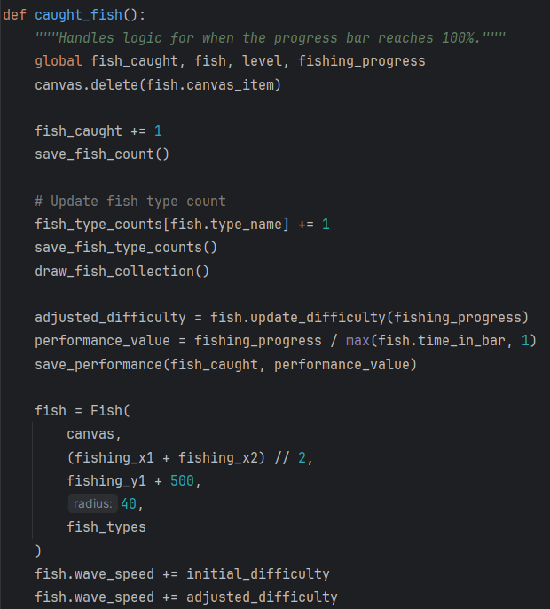
Inside the caught_fish function, I added code that updates the fish_type_count dictionary using fish.type_name as the key. I then call two functions. The first saves the updated dictionary back to the CSV file so the data persists after the program closes and remains protected if the program crashes. The second updates the visual fish collection display so the new counts appear immediately on screen. This keeps the interface consistent with the stored data after every fish is caught.

3.12.4 Stage 10 Validation
Validation Check | What is being validated | How it is done in code | Why it is implemented | Why it is important
CSV Header Integrity | Performance log structure is consistent for future reads. | writer.writerow(["fish_number", "performance"]) is called when creating a new file. | Ensures the DictReader in the graphing function finds the expected column names. | Prevents crashes during the performance analysis phase due to missing or mismatched headers.
Performance Data Availability | Graphing logic only runs when valid data exists. | if not fish_numbers: return check is performed at the start of the plotting function. | Prevents Matplotlib from attempting to plot empty lists or null values. | Ensures the program doesn't crash if a user attempts to view the graph before catching any fish.
Dictionary Key Initialization | Fish type tracking is synchronized with the master list. | fish_type_counts = {f["name"]: 0 for f in fish_types} is mapped at startup. | Ensures every possible fish species has a starting value of zero in the local dictionary. | Prevents a KeyError when catching a rare fish that has not yet been recorded in the external CSV.
Plot Layout Validation | UI elements on the graph do not overlap data. | plt.subplots_adjust(bottom=0.3) is used to create specific whitespace. | Makes room for the "Exit Game" and "Clear All Saved Data" buttons below the X-axis. | Ensures the graph controls remain accessible and do not obscure the performance trend line.
Data Wipe Confirmation | Persistent storage is cleared correctly on reset. | clear_data overwrites files with empty strings or default headers. | Provides a safe mechanism to reset the game state without requiring manual file deletion. | Allows the user to restart their progress and re-initialize the data environment within the app.
Graph Visual Feedback | User is notified when data is successfully cleared. | ax.text(0.5, 0.5, "All Data Cleared!") followed by fig.canvas.draw_idle(). | Visually updates the Matplotlib window to confirm the clearing action was successful. | Prevents user confusion by providing immediate UI feedback that the underlying data has been wiped.
Safe Cross-Library Exit | Full system shutdown from secondary windows. | os._exit(0) is called within the Matplotlib button callback. | Forcefully terminates all background threads, including the Tkinter loop, from the graph view. | Ensures the game process doesn't remain as a "zombie" task in the background after the graph is closed.
Inventory Grid Validation | Collection UI elements are placed correctly. | Logic uses row = i // 2 and col = i % 2 for placement. | Mathematically calculates the (x, y) coordinates for each fish sprite based on its index. | Ensures the fish inventory stays organized and legible regardless of how many species are in the data.

3.12.5 Stage 10 Final testing
Please also refer to the video stage 10 – testing 1,2 in the attached file

Test No. | Test | Procedure | Data to be used | Type of test | Expected Result | Pass/fail | Evidence
1 | Performance recording after fish catch | Run game and catch a fish, then check CSV file contents | Valid fish catch events such as Salmon with increasing counts | Functional | CSV file updates after each catch with correct performance values stored | Pass | *Refer to video stage 10 – testing 1  Timestamp 00:17
2 | Performance chart generation | Complete a session and trigger end-game graph function | CSV file containing multiple performance records | Functional | Graph displays correctly showing performance over time | Pass | *Refer to video stage 10 – testing 1  Timestamp 00:43
3 | Empty file handling for graph | Run graph function with no gameplay data | Empty CSV file | Boundary | Function exits safely and no graph is drawn | Pass | *Refer to video stage 10 – testing 2  Timestamp 00:18
4 | Clear data reset function | Click clear data button during or after gameplay | CSV file with existing records | Functional | CSV resets to header only and all previous data is removed | Pass | *Refer to video stage 10 – testing 2  Timestamp 00:18

Test No. | Test | Procedure | Data to be used | Type of test | Expected Result | Pass/fail | Evidence
5 | Exit game option | Click exit button during gameplay | Active game session with saved data | Functional | Game closes without errors and data remains intact | Pass | *Refer to video stage 10 – testing 1  Timestamp 00:42-00:47
6 | Fish dictionary update after catch | Catch multiple fish types and check stored values | Fish types such as Salmon, Trout, Tuna | Functional | fish_type_count updates correctly for each fish type | Pass | *Refer to video stage 10 – testing 1  Timestamp 00:48
7 | Fish display update in UI | Catch fish and observe interface changes | Fish sprites and updated count values | Functional | UI updates immediately showing correct sprite, name, and count | Pass | *Refer to video stage 10 – testing 1  Timestamp 00:17
8 | CSV structure validation | Insert incorrect row format and run load function | Invalid row such as missing or extra values | Error handling | Invalid rows are ignored and program does not crash | Pass | *Refer to video stage 10 – testing 1  Timestamp 00:00 and 00:48-00:50

3.12.6 Stage 10 Final program run screen

Program running screen
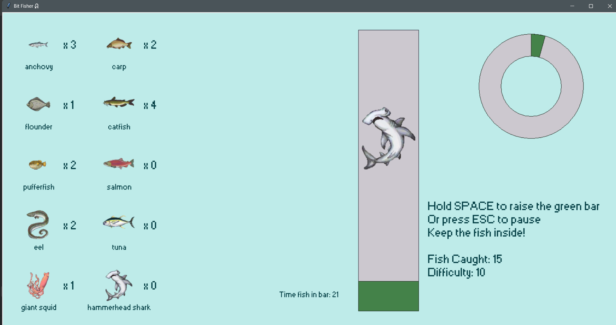

Pause menu + performance graph
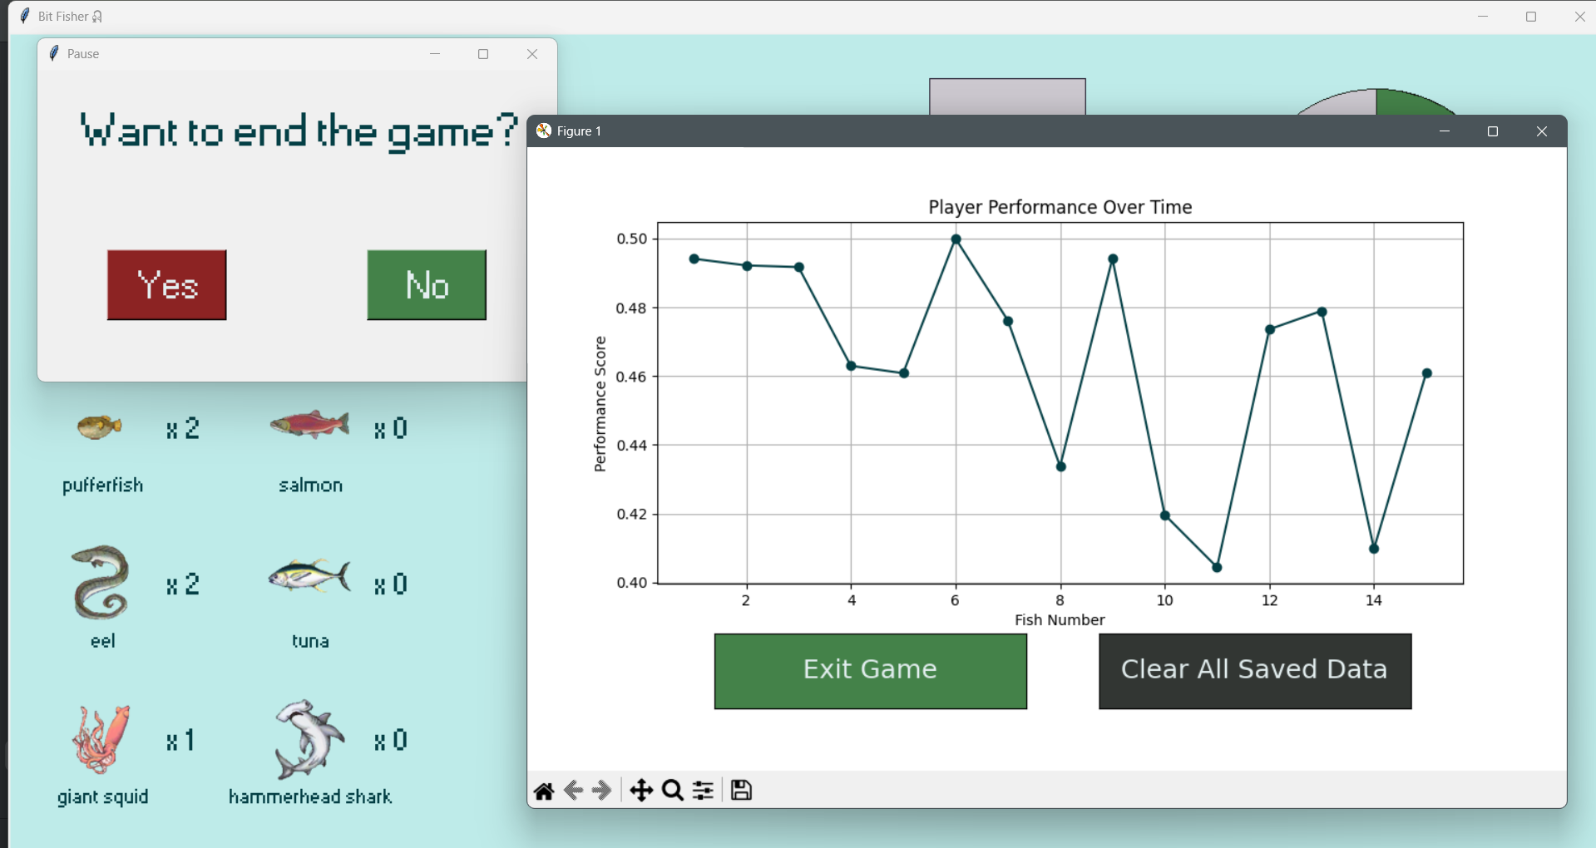

3.13 Final Testing
For final testing, three videos were recorded using the starting difficulties: Easy, Normal, and Hard. The videos are named “Final Testing – Easy”, “Final Testing – Normal”, and “Final Testing – Hard”, and will be used as evidence throughout the testing section. All three videos demonstrate the core functions of the program, so any of them can be referenced for many of the tests as proof. I will be primarily referring to the Final Testing – Easy for most of the video reference, unless specifically stated.

No. | Test detail | Data to be used | Expected result | Pass/fail | Evidence
T1 | Verify starting screen appears and launches main game window | Open program and press start | Starting screen appears and loads main fishing window correctly | Pass | Video timestamp 00:00-00:05
T2 | Verify difficulty selection buttons change gameplay | Start game using each difficulty option | Fish movement speed changes depending on selected difficulty | Pass | 00:00-00:05 (easy)  00:00-00:04 (hard)  In both videos, the difficulty selection screen functions as intended. The on-screen display also correctly confirms the selected difficulty. Easy mode begins with fish at difficulty level 2, while hard mode starts with fish at difficulty level 12.
T3 | Verify instructions visible on screen | Observe UI before gameplay | Clear instructions displayed to player | Pass | 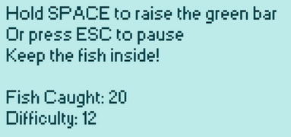
T4 | Verify interface is simple and uncluttered | Observe UI layout | Only essential UI elements visible and readable | Pass | 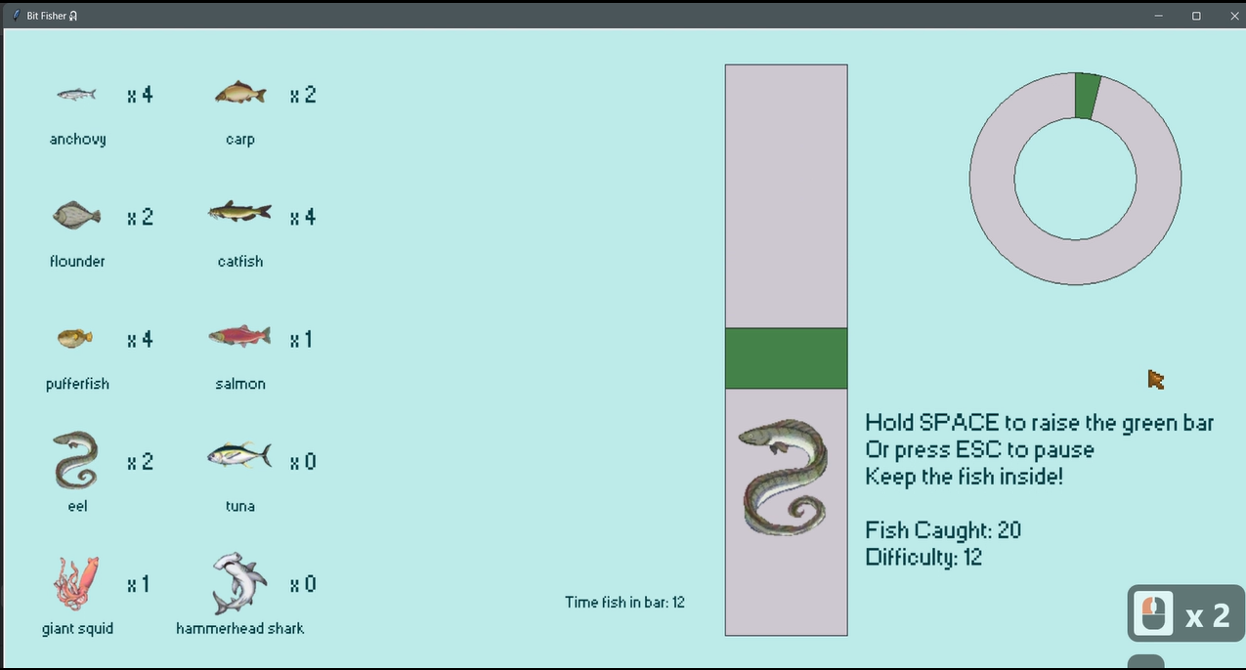
T5 | Verify consistent colour scheme and readable text | Observe UI elements | Text readable and colours consistent across screen | Pass | *Screenshot shown as above
T6 | Verify fish moves using wave based motion | Observe fish movement and print motion values | Fish follows smooth oscillating wave motion | Pass | Video timestamp 00:04-00:13  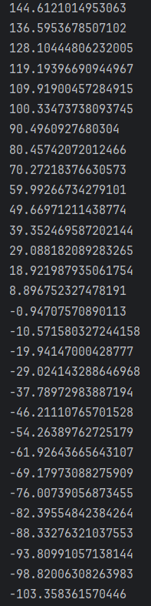  These screenshots were taken using a print statement to display the fish’s y-axis position during gameplay. I observed the values changing between positive and negative, which matches the expected behaviour of a wave function. This confirms the movement system is functioning as intended.
T7 | Verify fish animation remains smooth during gameplay | Run game continuously | Movement remains smooth without stuttering | Pass | Video timestamp 00:04-00:13
T8 | Verify multiple fish types appear | Catch several fish | Different fish sprites and behaviour visible | Pass | Video timestamp 00:14 and 00:26
T9 | Verify progress increases when fish inside bar | Hold bar over fish and print progress | Progress increases steadily | Pass | Video timestamp 00:04-00:13
T10 | Verify progress decreases when fish outside bar | Move bar away from fish | Progress decreases gradually | Pass | Video timestamp 00:04-00:13
T11 | Verify progress upper boundary | Keep fish inside for long period | Progress stops increasing at maximum | Pass | Video timestamp 00:14
T12 | Verify progress lower boundary | Keep fish outside continuously | Progress never drops below minimum | Pass | Video timestamp 00:14  When the pufferfish spawned the progress bar was at 0 and did not decrease any further despite fish is outside of bar
T13 | Verify green bar responds to input | Press input key repeatedly | Bar moves up when pressed | Pass | Video timestamp 00:04-00:13  The keys pressed (space bar in this case) can be viewed through the keylogger on the bottom right of the screen
T14 | Verify green bar falls when input released | Release input key | Bar moves downward | Pass | Video timestamp 00:04-00:13
T15 | Verify green bar upper boundary | Hold input continuously | Bar stops at top limit | Pass | 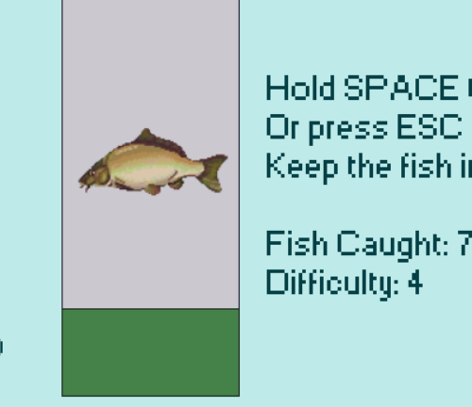
T16 | Verify green bar lower boundary | Leave input unpressed | Bar stops at bottom limit | Pass | 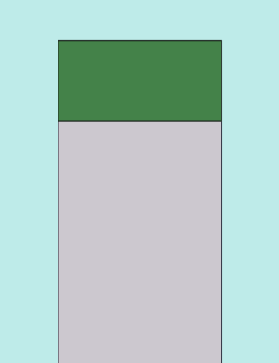
T17 | Verify automatic difficulty increases after success | Catch multiple fish | Fish becomes harder to catch | Pass | Video timestamp 00:14  After catching the initially spawning anchovy, a pufferfish spawns with a difficulty level of 7, which is 5 higher than the initial difficulty of 2. This shows the game increases difficulty after a successful catch and confirms the adaptive difficulty system is functioning correctly.
T18 | Verify automatic difficulty decreases after failure | Poorly perform multiple times | Fish becomes easier to catch | Pass | Same as above
T19 | Verify difficulty boundary values | Force extreme performance values using print | Difficulty remains within playable range | Pass | 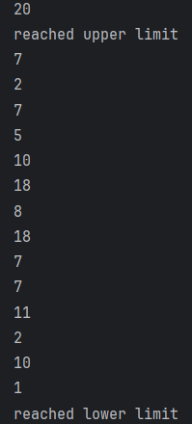  I separated the difficulty calculation into its own function and forced extreme difficulty values during testing. I then added a print statement to display the current difficulty level, along with messages when either the upper or lower boundary value was reached.  This output snippet shows the difficulty remaining within the defined range of 1 to 20. The system also correctly recalibrates the value whenever the calculation attempts to exceed either boundary, confirming the boundary checks function as intended.
T20 | Verify pause system stops movement | Activate pause and print values | Fish and progress stop updating | Pass | Video timestamp 00:28
T21 | Verify pause exit closes game safely | Pause and choose exit | Program closes and saves data | Pass | Video timestamp 00:32
T22 | Verify relaxed gameplay with no penalties | Leave fish uncaught | Game continues without forced loss | Pass | I left the program running for 10 minutes and observed no penalties. This confirms that the game does not punish players.
T23 | Verify calibration detects input accurately | Press and release input repeatedly | Movement reflects input immediately | Pass | Refer to the whole video
T24 | Verify saved data persists after restart | Catch fish then restart | Fish count retained | Pass | 00:31 (easy)  00:04 (normal)  At the end of final testing for easy mode, the in-game display shows a fish count of 17. In the final testing for normal mode, the fish count remains at 17. Since both tests were recorded back to back, this confirms the fish count persists after restarting the game and is not affected by switching difficulty level.
T25 | Verify performance logging saved correctly | Catch multiple fish | Performance data recorded correctly | Pass | Video timestamp 00:32  The successful plotting of the performance graph indicates that the performance values were logged correctly.
T26 | Verify program runs long duration without crash | Leave running extended time | No crashes occur | Pass | I left the program running for 10 minutes and observed no crashes, freezes, or unexpected behaviour. This confirms the program remains stable during extended use.
T27 | Verify UI scales to different screen sizes | Run on different resolutions | UI elements remain visible | Fail | N/A

3.13.1 Additional testing due to added Stage 10:
Since Stage 10 was not included in the original development plan, separate testing was not scheduled specifically for this stage. Most of the testing for the features added in Stage 10 was carried out during development as the functions were implemented and debugged. This allowed issues to be identified and resolved immediately while the features were being created.
Although there is no dedicated Stage 10 testing section, the final testing videos still demonstrate the functions introduced during this stage. The added features are visible during normal gameplay and can be observed operating correctly in the recorded footage. For evidence of any functionality added in Stage 10, refer to “Final Testing – Hard” timestamp 00:37, as this recording contains the clearing of data from the performance log introduced in Stage 10.

3.13.2 Failed test
T27 – verify UI scales to different screen sizes

This is the only test on the final testing that was not met. The goal was to ensure that the program could run consistently across a range of devices, including different operating systems and hardware configurations such as desktop computers, laptops, and mobile devices.

During development, it became clear that this would not be achievable within the available resources. Testing across multiple machines was not possible due to limited access to different hardware and operating systems. The program was developed and tested on a single system, which meant there was no reliable way to verify compatibility elsewhere. In addition, the project uses Python with Tkinter, which does not translate well to mobile platforms. Running the program on mobile devices would require significant changes, such as using a different framework or rewriting parts of the codebase. Packaging and compiling the program for different systems also introduced complexity, as dependencies and environment configurations vary between machines.

As a result, ensuring full cross platform compatibility was not feasible within the time frame. The focus was placed on making sure the program runs reliably on the development machine, with all implemented features tested and functioning as expected.

The program could be packaged into an executable file so it can run without the source code or an interpreter. Testing on multiple devices would improve reliability and ensure consistent performance. Mobile support could be added by redesigning parts of the program with a different framework.

4. Evaluation

4.1 Post-development testing

4.1.1 Stakeholder testing
The game is now complete. I distributed a copy to all stakeholders to collect post-development feedback as part of final testing. This step helps identify weaknesses in the system and gather improvement suggestions based on real user experience, rather than my own assumptions.
After testing the game, each stakeholder completed a feedback form containing the following questions:
- What did you think of the experience?
- How easy was it to understand at first?
- How clear is the interface, can you tell what each part is?
- What is your opinion of the difficulty and the way it adjusts?
- Will you play this game again or recommend it to others?
These questions focus on usability and functionality. They also help evaluate how intuitive the interface is, how well the difficulty system performs, and whether the game provides enough engagement for repeat use.

4.1.2 Stakeholder interview results

Emily (age 21 – casual gamer)
      - What did you think of the experience?
“The experience felt smooth and easy to get into. I liked how quickly I could start playing without needing instructions. After a while it did feel a bit repetitive, but overall it was enjoyable.”
      - How easy was it to understand at first?
“It was very easy to understand at the start. The main goal became clear within the first minute of playing. I did not feel confused at any point.”
      - How clear is the interface, can you tell what each part is?
“Most of the interface was clear, especially the main play area and progress indicator. A couple of smaller elements were not instantly obvious, like I couldn’t really read the names of the fish because my eyes are focused on the right.”
      - What is your opinion of the difficulty and the way it adjusts?
“The difficulty felt mostly fair and adjusted while I played. At times it felt slightly inconsistent, but nothing major. It generally matched how well I was doing.”
      - Will you play this game again or recommend it?
“I would play it again in short sessions, I think its pretty fun for when I'm bored. I would recommend it to someone looking for a simple, relaxing game.”
Conclusion:
The feedback shows the interviewee thinks the game is easy to understand and visually clear. The display needed to be made larger and repositioned for clearer reading. The difficulty system generally works but needs smoother consistency. The experience is engaging in short sessions, but loses variety over longer play as the content is repetitive.

Elena (age 17 – frequent gamer)
- What did you think of the experience?
“The game kept me engaged and I enjoyed it. It is quite simple, but it works well for short play sessions. After a while it starts to feel a bit limited, like I would expect more new things.”
- How easy was it to understand at first?
“It was easy to understand. I picked up the controls without needing any help. I'd say it is very straightforward. I was a bit scared at first as I'm thrown right into the game with no tutorial lol.”
- How clear is the interface, can you tell what each part is?
“The interface is mostly clear and easy to read. I really enjoyed the fish sprites, LOVE the art style.”
- What is your opinion of the difficulty and the way it adjusts?
“The difficulty adjustment is good overall. Sometimes the changes feel a bit sudden rather than gradual. It could be smoother.”
- Will you play this game again or recommend it?
“I would play it again occasionally, but not for long periods since this genre is not really my cup of tea. I would recommend it as a casual game to maybe beginner friends just getting into gaming.”
Conclusion:
The interviewee thinks the game is functional and easy to understand, with mostly clear interface design. Difficulty adjustment works but lacks smooth progression. The interviewee also suggested that a beginner's tutorial will be reassuring for the player, rather than going directly from the starting screen to the main game.

Alex (age 14 – competitive gamer)
- What did you think of the experience?
“It was fun at first because of the feedback and rewards. After a while, it felt way too boring and I wanted more challenges. This is not stimulating enough for me.”
- How easy was it to understand at first?
“It was very easy to understand quickly. I knew what to do almost immediately. There was no learning curve.”
- How clear is the interface, can you tell what each part is?
“The main parts are clear, like the fish and the bar. Some areas feel a bit plain and could stand out more visually with added decorations. I feel like there is not enough things going on at once on the screen to really capture my attention.”
- What is your opinion of the difficulty and the way it adjusts?
“The difficulty changes are there, but they are not always very noticeable. I want clearer and stronger changes based on performance, maybe a ‘level up’ message to praise me.”
- Will you play this game again or recommend it?
“I might play it again briefly, but not often. I would only recommend it to people who like simple games, this is too easy for a pro gamer like me.”
Conclusion:
The interviewee thinks game provides clear feedback and basic usability. However, it lacks depth and stronger visual variation. Difficulty adjustment exists but needs to be more noticeable and responsive. Engagement drops over longer play.

Sophie (age 16 – infrequent gamer)
- What did you think of the experience?
“It was simple and easy to follow. I found it relaxing, but also a bit plain after some time. It does not change much during play.”
- How easy was it to understand at first?
“It was very easy to understand. I started playing without needing instructions. Everything made sense quickly.”
- How clear is the interface, can you tell what each part is?
“The interface is mostly clear and not confusing. A few parts could be more visually obvious, but it was still fine. Like how the fish are grouped on display. I don’t think I would have known they are listed by difficulty if you didn’t tell me.”
- What is your opinion of the difficulty and the way it adjusts?
“The difficulty stays quite manageable, although sometimes I feel like it’s a little hard for me. It could just be I haven’t had many practice in games like this.”
- Will you play this game again or recommend it?
“I would play it again sometimes. I would recommend it as a relaxing game.”
Conclusion:
The interviewee suggests the game is easy to understand and accessible for players new to gaming. The interface is clear but could be more explanation. Difficulty adjustment is stable but might be a little difficult. The game is suitable for casual, relaxed use.

Sarah (age 42 – mathematics tutor)
- What did you think of the experience?
“The experience was structured and easy to follow. It works well for demonstrating progress, but it feels quite basic in terms of features.”
- How easy was it to understand at first?
“It was very easy to understand almost immediately. The purpose of the game is clear from the start. There is no confusion.”
- How clear is the interface, can you tell what each part is?
“The interface is generally clear and logical. The instruction might be tricky to read, since it appears only when the game starts. So there is no time to properly go through it. It is also quite small, which makes it harder to notice at first.”
- What is your opinion of the difficulty and the way it adjusts?
“The difficulty adjustment works in principle and supports different skill levels. However, it is not always obvious when it changes. Clearer feedback would improve this.”
- Will you play this game again or recommend it?
“I would consider using it again in a structured setting. It could also be recommended for simple engagement tasks within the classroom.”
Conclusion:
The interviewee suggests the game is easy to understand and suitable for structured environments. The interface is clear but could have clearer instructions that are displayed before the game starts. Difficulty adjustment is functional but lacks transparency. The system works best for short, guided use cases.

4.1.2.a Overall conclusion:
Successful aspects:
The feedback shows the game is consistently easy to understand across all users, with a clear objective and simple controls. The interface is generally readable, and most users could identify key elements such as the fish, progress bar, and gameplay area without needing detailed explanation. The automatic difficulty adjustment was viewed positively as it supports different skill levels without manual input. Players also responded well to the immediate feedback during gameplay, which helped maintain engagement in short sessions.
Limitations:
The main limitation is the lack of depth over longer play sessions, with multiple users describing the experience as repetitive after continued use. The difficulty system works but is not always clearly noticeable, which reduces player awareness of progression changes. Instruction visibility is also an issue, since the current instructions appear briefly and are small, making them easy to miss. Some interface elements, such as fish identification and grouping, are not immediately clear without prior explanation. The absence of a structured introduction also reduces accessibility for new or infrequent players.
Potential solutions:
In future developments, a tutorial screen could be added at the start of the game to help new players understand how the game works before they begin properly. This could include a short guided section where the player completes one full fish-catching action step by step, so they immediately learn the main mechanic in a practical way. This would make the game more accessible for users who have never played it before, while still keeping the learning process quick and simple. To avoid slowing down experienced players, this tutorial should also be skippable so they can move straight into gameplay if they prefer.
Text should also be made larger and placed in a clearer position on the screen to improve readability, especially during fast gameplay where players do not have time to search for information. Alongside this, a colour-coded background gradient behind the fish display could be added to visually represent fish rarity or difficulty level. This would allow players to understand the importance of each fish instantly without needing to rely on text.
In addition, progression feedback could be improved by adding a clear on-screen message or visual effect when the player levels up or levels down, so changes in performance are more obvious in real time. To strengthen this further, audio feedback could also be introduced for these events, giving an additional layer of feedback for users who might miss visual cues during gameplay.

4.1.2 Robustness testing

Successful aspects:
I tested the robustness of BitFisher using invalid inputs, boundary cases, and unexpected user interactions. The program handled most invalid conditions without crashing, which shows the use of defensive programming techniques and structured error handling worked correctly. For example, when I attempted to run the program without valid input files or when required data was missing, the system triggered controlled error messages instead of producing a runtime error or terminating unexpectedly. This improves fault tolerance and prevents system failure under abnormal conditions.
I also tested repeated execution of core functions to check for memory leaks and degradation in performance. The results showed stable memory usage and consistent execution time, which suggests efficient use of data structures and appropriate loop design. This indicates that the implementation supports acceptable time complexity for the intended scale of processing.
I evaluated the program’s robustness across three key areas. These include
- internal code reliability through white box testing methods
- input and runtime stability through error handling behaviour
- long term stability through regression testing.
Each area focuses on how well the system responds to incorrect input, unexpected execution paths, and changes made during development.

4.1.2.a White box testing

Limitation
Robustness testing was limited to informal checks during development. I did not apply structured path testing or statement coverage, so not all decision paths and loops were systematically tested under failure conditions. This means some edge cases involving unusual inputs or unexpected execution paths may not have been identified. I also did not use cyclomatic complexity analysis, so areas of complex logic that may reduce stability were not formally reviewed.

Potential Solutions
A structured white box testing approach would improve robustness. Path testing would ensure all logical routes are executed under both normal and abnormal inputs. Statement and branch coverage would confirm that error handling paths are triggered correctly. Cyclomatic complexity analysis would highlight complex functions that are more likely to fail under stress or unusual input. This would improve stability and reduce hidden runtime issues.

4.1.2.b Error handling

Limitation
Error handling does not always support full robustness under invalid input conditions. Some error messages only state that a failure occurred without explaining the cause. In some cases, invalid input is caught late in the process rather than being blocked early. This reduces resilience because incorrect data can still reach processing stages before being handled.

Potential solution
Robustness would improve with stronger exception handling and validation. Custom error classes would allow clearer identification of different failure types. Input validation at an earlier stage would prevent invalid data entering the system. This would increase fault tolerance and reduce the chance of runtime errors affecting program stability.

4.1.2.c Regression testing

Limitation
Robustness is reduced by the lack of automated regression testing. Testing was manual, so repeated checks after changes were not consistent. This increases the risk that new features introduce unexpected faults or break existing functionality without being detected.

Potential solution
Automated regression testing would improve robustness over time. Running test suites after every update would confirm that core functionality still behaves correctly under a range of inputs. Unit testing would isolate components and confirm each part handles invalid data safely. This would improve system stability and reduce the chance of faults appearing after modifications.

4.1.3 Hardware testing

Successful aspects:
I tested the program on my development machine and it met both the functional and non-functional requirements from the specification. CPU usage stayed consistent during use and memory usage remained stable. I designed the system using modular programming, which reduced coupling between components and helped the program run smoothly under normal conditions. Overall, the program performed reliably on the hardware I had access to.

Limitations
I only had access to one machine, so I could not test the program across different hardware setups. This means I did not fully check compatibility with different CPU types, memory sizes, or storage speeds. I also did not test the program on low specification devices, so I do not know how it performs under restricted resources. This limits how confident I can be about performance outside my own system.

Potential solutions
To improve this, I would use virtual machines or cloud environments to simulate different hardware conditions. This would allow me to test how the program behaves with lower memory, slower processing, and different system configurations. I would also carry out stress testing and load testing to see how the program performs under high demand. This would help me identify performance limits and improve overall stability across a wider range of systems.

4.2 Evaluation of success criteria reached/ not reached
Inheriting from the Analysis section:

4.2.1 Wave motion criteria
No | Criteria | How to evidence | Criteria Met? (Y/N)
W1 | Fish movement uses a wave function | Code snippet showing sine or cosine function and gameplay clip | Y
W2 | Movement is smooth and continuous | Video showing consistent motion without stuttering | Y
W3 | Wave variables control movement (amplitude or frequency) | Code showing variables and gameplay showing change in movement | Y
W4 | Different fish show varied wave patterns | Video showing multiple movement styles | Y
W5 | Movement updates in real time during gameplay | Screen recording showing continuous motion | Y

4.2.2 Adaptability criteria
No | Criteria | How to evidence | Criteria Met? (Y/N)
A1 | Game increases difficulty after well performed fish catch | Code snippet showing difficulty value increasing after catch and video showing faster fish or reduced catch window | Y
A2 | Game decreases difficulty after badly performed catches | Code showing failure tracking and reduced difficulty plus test recording | Y
A3 | Difficulty scaling is gradual and controlled | Table or graph of difficulty values over time and gameplay clip showing smooth change | Y
A4 | Player performance affects difficulty adjustment | Code showing use of success rate or reaction time and gameplay evidence | Y
A5 | Gameplay visibly reflects difficulty changes | Video or screenshots showing fish speed or behaviour changes after catches | Y
A6 | Difficulty stays within defined limits | Code showing min and max difficulty values and test results | Y
A7 | Fish behaviour changes as difficulty increases | Gameplay recording showing more complex movement patterns after progression | Y
A8 | Difficulty updates in real time after each catch | Screen recording showing continuous adjustment without restarting | Y

4.2.3 Feedback system criteria
No | Criteria | How to evidence | Criteria Met? (Y/N)
Fe1 | Game provides visual feedback after successful or failed catch | Video showing UI changes such as colour shift, icon change, or animation after action | N
Fe2 | Game includes a progress or score counter that updates in real time | Screen recording showing score or progress value changing during gameplay | Y
Fe3 | Game includes a visual indicator for the current difficulty level | Screen recording showing how fish movement corresponds to displayed difficulty | Y
Fe4 | Feedback appears immediately after player action | Video showing no delay between action and feedback response | Y
*Failed test Fe1 is evaluated later

4.2.4 Other Functionality criteria
No | Criteria | How to evidence | Criteria Met? (Y/N)
Fu1 | Additional option to set difficulty manually | Screenshot of settings menu and testing showing changes in gameplay | Y
Fu2 | Game assets are being updated to create smooth animation | Screen recording of the window running with all assets moving correctly and smoothly | Y
Fu3 | Calibration system detects player input accurately | Screenshot of calibration process and testing showing successful detection | Y
Fu4 | Large stop button to safely exit gameplay | Screenshot of stop button and test results showing the program closing correctly | Y
Fu5 | Relaxed gameplay with no time pressure or penalties | Video showing gameplay without timers or penalties for slow reactions | Y
Fu6 | Game runs without crashes during extended use | Testing log showing continuous runtime over a set time period | Y
Fu7 | Game includes multiple fish types or behaviours to increase variety | Screenshot or video showing different fish movement patterns or types | Y
Fu8 | Game runs on different screen sizes or devices without layout issues | Testing on different sized devices and screenshot taken | N
Fu9 | Player score changes persist after restart | Screenshot and testing showing saved data being retained after closing and reopening the program | Y
*Failed test Fu8 is evaluated later

4.2.5 Usability and Interface criteria
No | Criteria | How to evidence | Criteria Met? (Y/N)
U1 | When game is started, a main game window pops up and displays the fishing environment and all assets clearly and properly | Screen recording of the main game window showing the fishing area and animated fishing bar | Y
U2 | Simple and uncluttered user interface | Screenshot showing large, clearly labelled buttons with minimal on-screen elements | Y
U3 | Consistent colour scheme and readable text | Screenshot demonstrating high-contrast text and consistent colours across menus and game screens | Y
U4 | Visual indicators for player feedback (e.g., progress bar, fishing bar, fish count display) that conveys instruction without using too much text | Screenshot showing on-screen visual feedback during gameplay | Y
U5 | Separate starting screen which kickstarts the game | Video recording of the starting screen leading to the main game window | Y
U6 | Clear labelled difficulty selection button | Screenshot of the buttons, likely on starting screen, and showcase of the effect they have on the game | Y
U7 | Clear instructions displayed on the main menu | Screenshot showing how-to-play text visible before starting the game | Y
U8 | Buttons and controls are accessible and appropriately sized | Screenshot highlighting button layout and spacing for easy navigation | Y

4.3 Discussion of Success Criteria
Since many of the success criteria are also addressed through testing, a large number of them have already been verified during final testing. Here, I will list only those criteria that are not covered in detail and/or were not fully fulfilled during the final testing phase.

4.3.1 Wave function criteria

W1 – fish movement uses the wave function
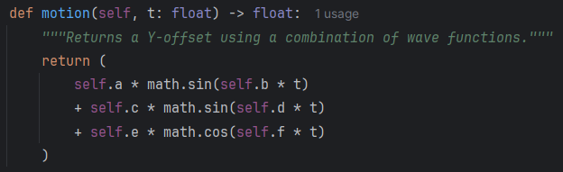
As shown in the screenshot, the fish movement is generated using six random values and a parameter variable t. These values are combined into a single result using sine and cosine wave functions, and the output value is used as an offset for the fish’s movement.
W2 – movement is smooth and continuous
*Refer to final testing videos
W3 – wave variable control movement of fish
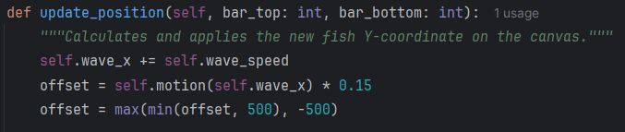
W4 – different fish show varied wave patterns
*Refer to final testing videos
W5 – Movement updates in real time during game play
*Refer to final testing videos

4.3.2 Adaptability criteria
A1 - Game increases difficulty after well performed fish catch
A2 - Game decreases difficulty after badly performed catches
By adding print statements to the update difficulty function, I can obtain the result showing the performance value throughout multiple catches, as well as whether the difficulty has increased or decreased
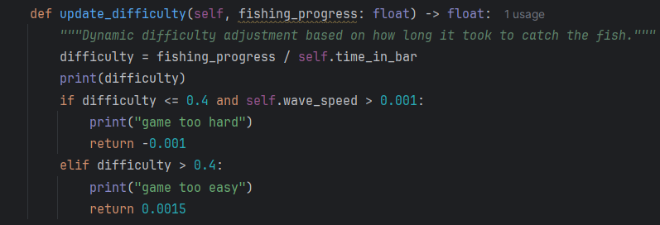
I also added a function which prints out the current level after a fish is caught, which should give the direct representation of what is displayed in game:
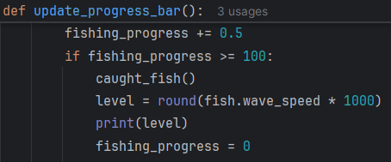
The terminal after 6 catches is as follows:
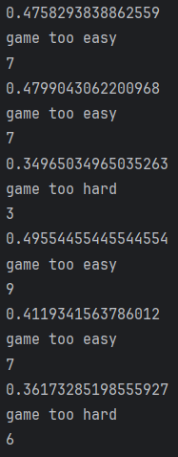
The results show that performance values greater than 0.4 consistently result in increased difficulty and a higher player level shortly afterwards. This demonstrates that the adaptive difficulty system is functioning as intended, since player performance directly influences the challenge presented by the game. The outcome proves that the success criteria for responsive difficulty adjustment have been met.
A3 - Difficulty scaling is gradual and controlled
A4 - Player performance affects difficulty adjustment
A6 - Difficulty stays within defined limits
Using the previous data, it is possible to observe how the difficulty changes depending on how well or poorly the player performs. For example, catch 3 resulted in a performance value of 0.35, which is considered low performance. As a result, the game reduced the difficulty from level 7 to level 3 in order to better match the player’s ability. The adjustment remains within the controlled range of 1 to 10, preventing extreme or unfair changes in gameplay. This demonstrates that the adaptive difficulty system responds correctly to player performance and confirms that the success criteria has been met.
A5 - Gameplay visibly reflects difficulty changes
A7 - Fish behaviour changes as difficulty increases
A8 - Difficulty updates in real time after each catch
*Refer to final testing videos

4.3.3 Feedback system criteria
Fe1 - Game provides visual feedback after successful or failed catch (Unsuccessful)
This success criteria was not fully achieved because the game does not currently provide direct visual feedback after a successful catch. The player can still understand the result through gameplay, but there are no dedicated effects such as pop-up messages, colour changes, or animations to clearly confirm the outcome. As a result, successful catches can feel less rewarding than intended.
There is also no true “failed catch” state within the game design. This was intentional, as the game was designed around a more relaxed and casual experience rather than punishment-based gameplay. Instead of completely failing a catch, the player is given more time and opportunities to continue fishing. This avoids creating frustration for less experienced players and helps maintain the calm atmosphere of the game. Because of this design choice, failure feedback was not prioritised during development.
This feature was also limited by time constraints during development. Priority was given to core gameplay systems such as fish movement, adaptive difficulty, collision detection, and save functionality. Adding visual feedback would require additional graphical assets and testing, which would have taken extra development time.

Potential solutions:
This could be improved in future development by adding pop-up messages such as “Fish Caught!” after successful catches. The fishing bar could also briefly change colour to provide clearer visual feedback. Additional sound effects could reinforce successful events and make the gameplay feel more responsive and satisfying while still maintaining the relaxed nature of the game.
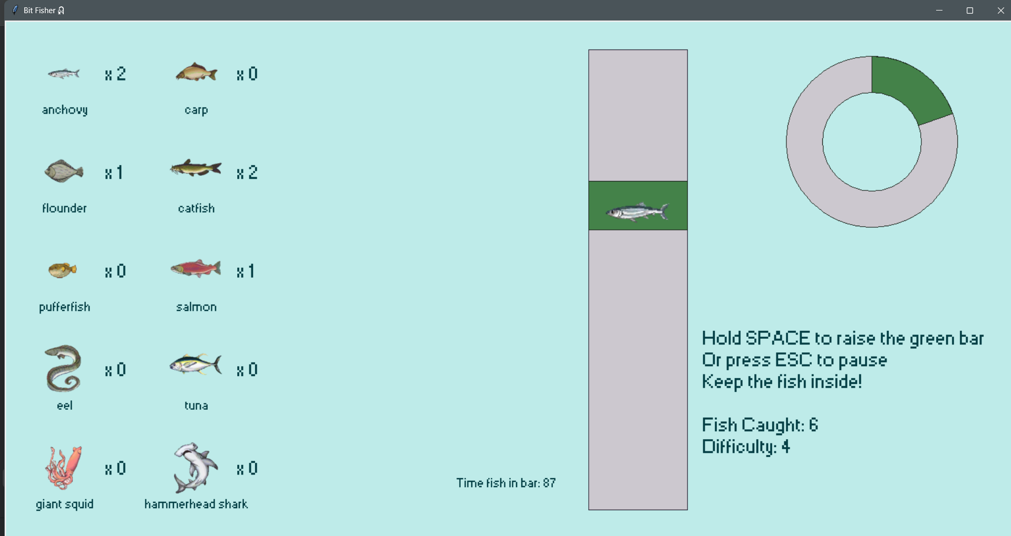
Fe2 - Game includes a progress or score counter that updates in real time

Fe3 - Game includes a visual indicator for the current difficulty level

Fe4 - Feedback appears immediately after player action
*Refer to final testing videos

4.4.4 Functionality criteria
Fu1 - Additional option to set difficulty manually
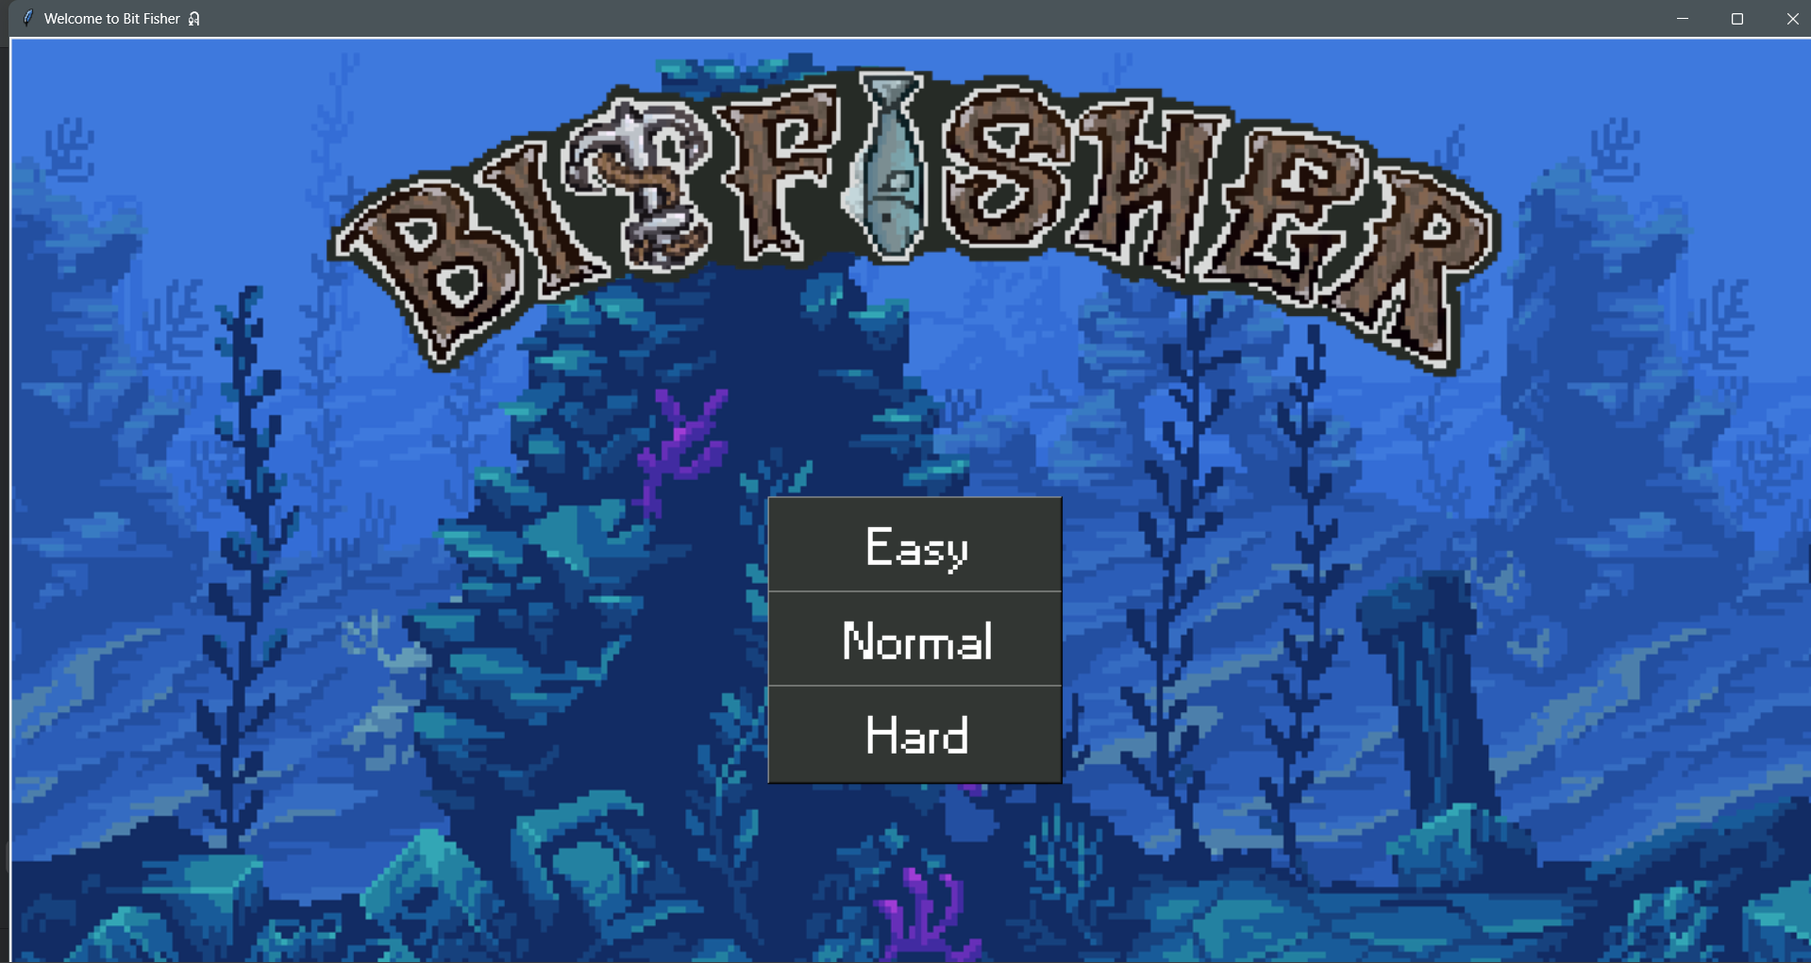

On the starting screen, there are three difficulty options ranging from easy to hard. The buttons are clear and concise, and the text is easy to read, so any player can quickly understand their function.

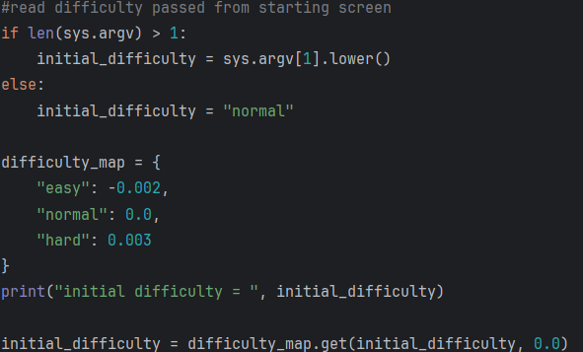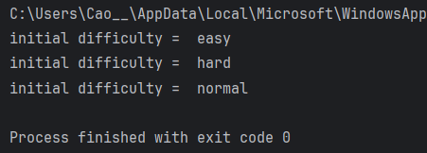

The selected difficulty is then passed to the main file. By adding a print statement, I can verify that each time the game is restarted at a different difficulty, the correct difficulty is passed, as shown in the terminal output.
Fu2 - Game assets are being updated to create smooth animation
*Refer to final testing videos
Fu3 - Calibration system detects player input accurately

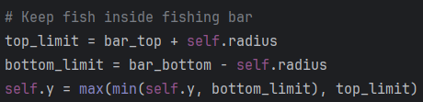
There are several calibration and data sanitisation processes implemented within the system. One of the example process shown here ensures that the fish position stays within the bounds of the fishing bar during gameplay. This is done by defining a top and bottom limit for the fish’s y-value, which represents the vertical movement range. The program then uses comparison logic to constantly check the fish position against these limits. Any value that goes above the upper boundary is set back to the maximum allowed value, and any value below the lower boundary is set to the minimum allowed value. This is handled using max and min functions to clamp the value within the valid range.
This prevents the fish from leaving the playable area and ensures consistent gameplay behaviour. It also improves reliability by removing invalid or out-of-bounds values before they can affect the game state.

Fu4 - Large stop button to safely exit gameplay

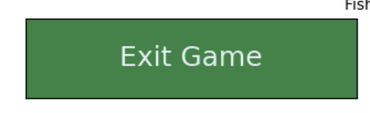
The screenshot shows the exit game button that terminates the program. For its functionality, please *Refer to final testing videos

Fu5 - Relaxed gameplay with no time pressure or penalties
As explained above, throughout the development of the program, I decided not to include any penalties for catching the fish. The player is encouraged to explore and play at their own pace without being punished for mistakes or missed timing. This design choice supports a relaxed gameplay style where the focus stays on enjoyment rather than failure or frustration.
This approach helps maintain a low-pressure environment, especially for casual or infrequent players. Instead of forcing strict consequences, the game keeps the experience continuous so the player can keep engaging with the mechanics without interruption. For more evidence please *Refer to final testing videos
Fu6 - Game runs without crashes during extended use
I left the game running for 20 minutes while doing other tasks. When I returned, there was no noticeable lag, slowdown, or performance drop. The game state also remained stable, with no unexpected changes or errors occurring during this period.
The results show that the program handles extended runtime without degrading performance. Memory usage and processing remain consistent, and the game continues to function as intended even when left idle. There was no evidence of system strain or instability over time.
Based on this observation, I conclude that the game is stable and suitable for long running use.
Fu7 - Game includes multiple fish types or behaviours to increase variety
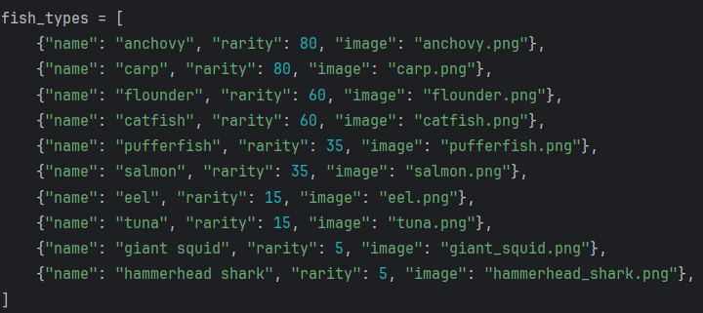
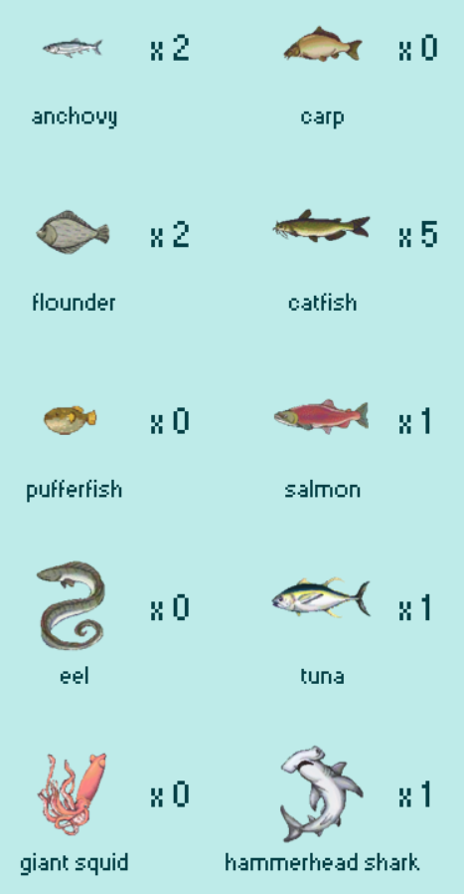

These two screenshots show the current fish types implemented in the game. There is a clear range of variation across rarity, size, and difficulty, which helps create variation in experience as the player continues to fish.
The system is also designed in a way that supports easy expansion. New fish species can be added by appending new entries to the existing list of fish types. This means the structure is scalable, and additional content can be introduced without needing to change the core game logic.

Fu8 - Game runs on different screen sizes or devices without layout issues
This success criteria was not met, using the same reasoning as 3.13.2 Failed test, where the layout issues were identified. The game interface is currently fixed to a specific screen resolution, which means it does not properly scale or adapt when displayed on different screen sizes or devices.

Fu9 - Player score changes persist after restart
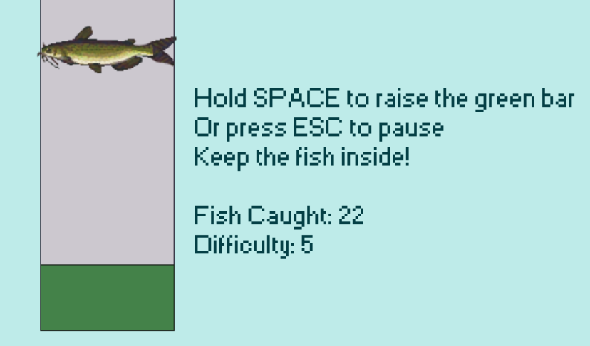
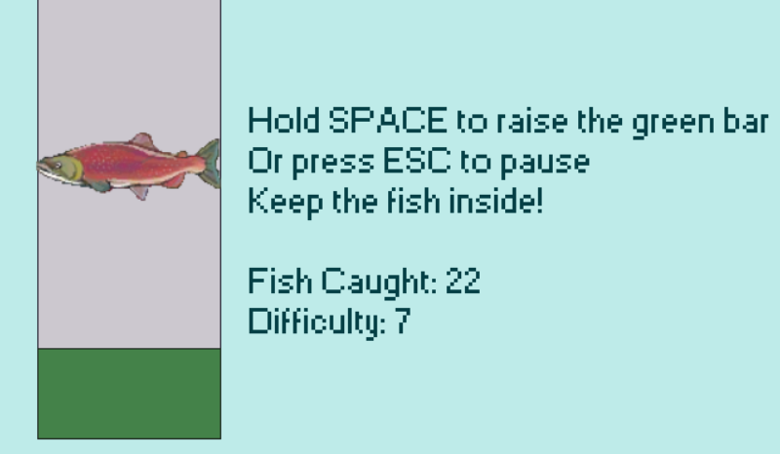

This success criteria is met, as demonstrated by the screenshot showing two separate instances of starting the game back to back, indicated by the different fish displayed. When the game is restarted, the number of fish caught remains the same as before closing the game. This confirms that the save and load system is working correctly and that player progress is successfully retained between sessions. For more evidence, please *Refer to final testing videos

4.4.5 Usability criteria
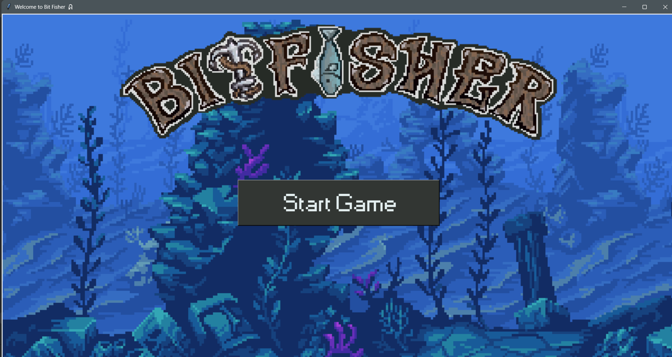
U1 - When game is started, a main game window pops up and displays the fishing environment and all assets clearly and properly

U5 - Separate starting screen which kickstarts the game

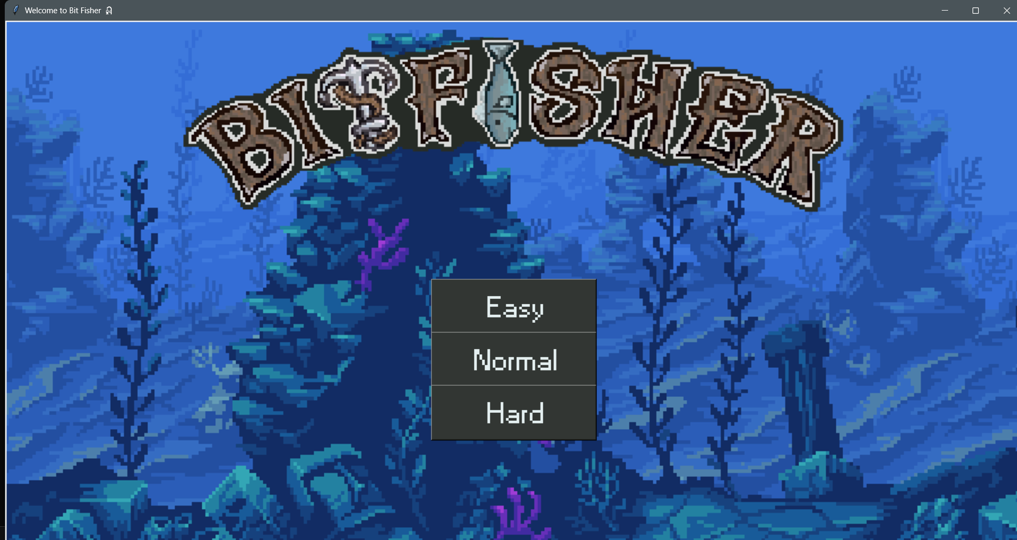
U6 Clear labelled difficulty selection button

U6 - Clear labelled difficulty selection button

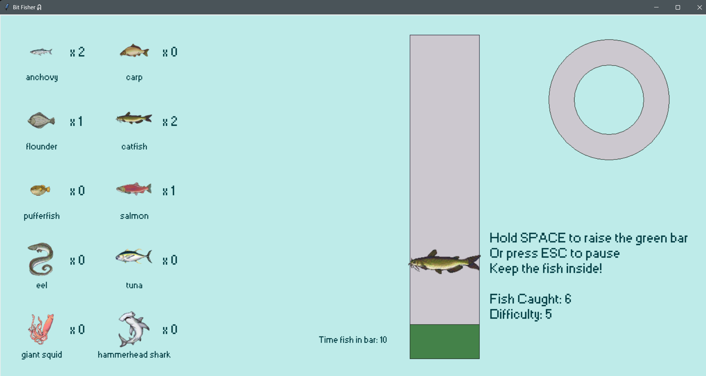
U7 - Clear instructions displayed on the main menu

U4 - Visual indicators for player feedback that conveys instruction without using too much text

U2 - Simple and uncluttered user interface
U3 - Consistent colour scheme and readable text

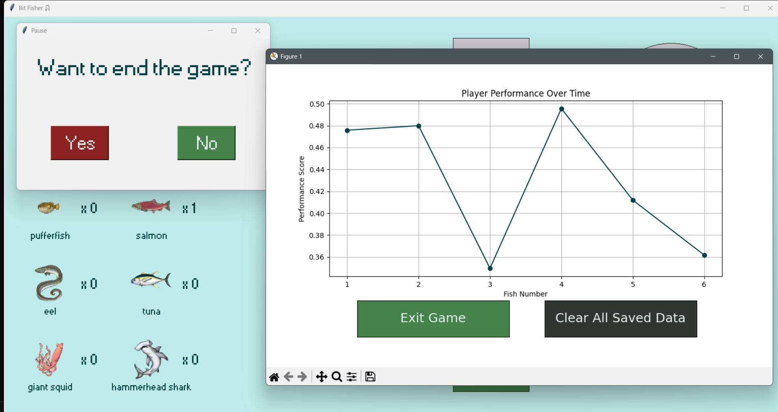
U8 - Buttons and controls are accessible and appropriately sized

4.4 Potential limitations of the program
Other than the aspects mentioned earlier in 4.1 Post-development testing, there are a few additional points that could limit the program’s playability, sustainability, or robustness.

- Problem: The program was developed and tested on one device, making it unreliable on other systems. It is not as flexible as expected and cannot run without the source files. Users need a Python interpreter to run the program, and it cannot be used on mobile devices.
Solution: The program could be packaged into an executable file so it can run without the source code or an interpreter. Testing on multiple devices would improve reliability and ensure consistent performance. Mobile support could be added by redesigning parts of the program with a different framework.
- Problem: There is no protection to prevent the source code from being copied or shared. Anyone with access to the files can view or modify the code.
Solution: Code obfuscation or compiling the program into a binary format could prevent users from easily accessing or modifying the source code.
- Problem: The program can become slow or laggy during extremely long periods of use due to processing large amounts of game data.
Solution: Optimizing the code and managing memory more efficiently, such as clearing unused data during gameplay, would reduce slowdowns. Adding limits to how often certain processes run would also help maintain performance.
- Problem: The program may not respond correctly if too many actions are performed quickly or if the system running it has limited resources.
Solution: Implementing input validation, error handling, and process management would make the program more stable and maintain consistent gameplay even under heavy use.

4.5 Maintenance and sustainability discussion

4.5.1 Maintenance for Player Experience
- Pop up window stability
Pop up windows such as pause menus and feedback screens can break if the player clicks buttons in unexpected sequences. This may cause the game to crash or close without warning, interrupting gameplay and reducing reliability.
- Onboarding and guidance
The game gives limited instructions at the start. New players receive little direction on controls or objectives, which increases confusion and slows early progress through trial and error.
- Lack of in game information
The game does not present details about fish species information, habitat, or environmental differences. This reduces educational value and limits player understanding of progression systems.
- Device and screen compatibility
The interface does not scale consistently across different screen sizes and hardware setups. On smaller displays, elements may overlap or become unclear. On lower performance devices, gameplay responsiveness may drop due to timing inconsistencies.

4.5.2 Maintenance for Other Programmers
- Structured code organisation
I split the project into fishing mechanics, scoring, and interface sections. Another programmer can go straight to the relevant section to edit or fix features without searching the whole file.
- Predictable game flow
The program follows input, update, and output stages. Another programmer can follow this sequence to trace bugs and understand how a change in one stage affects the next.
- Use of standard libraries
I use tkinter and PIL. Another programmer can use existing documentation to extend the UI or image handling without learning custom systems.
- Function based design
I place features into separate functions. Another programmer can reuse or modify a single function without changing the rest of the code.
- Basic state and data management
I store score, timers, and fish data in clear variables. Another programmer can change these values to adjust difficulty or add new gameplay elements.
- Extendable gameplay loop
The fishing loop supports new features. Another programmer can add fish types or mechanics by inserting into the existing loop instead of rewriting it.
- Partial separation of logic and interface
Game logic is partly separate from UI code. Another programmer can update the interface without touching core mechanics.
- Debugging and testing clarity
The modular structure isolates features. Another programmer can test one function at a time before integrating changes.

4.6 Possible future development
- Add safeguards to pop-up windows and buttons to prevent crashes from unexpected actions. This would make the game more stable, reduce interruptions, and allow the player to interact with the interface without accidentally closing the program.
- Implement a tutorial level to guide new players. This level could explain the basic controls and gameplay mechanics, letting players practice in a low-pressure environment so they understand how to play before starting the full game.
- Add educational content for each fish caught. Short descriptions could appear after a catch, giving information about the fish’s habitat, size, and other interesting facts. The game could pause briefly to allow the player to read, making the experience more informative and engaging.
- Adapt the program to work better on different devices and screen sizes. Adjusting the interface and managing resources efficiently would allow the game to run on smaller screens or less powerful systems without slowing down or losing functionality.
- Use the modular design to add new features or improve existing systems. For example, the fish movement algorithm could be made more advanced, or the user interface could be redesigned for clarity, all without affecting the core gameplay or causing crashes.

4.7 Skills I have gained through this project
Through completing this project, I developed a range of technical and practical skills. I improved my programming skills in Python, using algorithms and data structures to model fish movement and manage game logic, and creating a graphical user interface with Tkinter. I enhanced my problem-solving and debugging skills by identifying and fixing issues such as crashes, lag, and unexpected input handling. The project taught me the importance of modular design, separating the game logic, fish movement, and interface to make the code easier to maintain and extend.

I gained experience in testing and evaluation, performing both normal and extreme use cases to check functionality and stability. I worked on performance optimisation by managing memory and processes to reduce lag and improve gameplay. Considering user experience helped me make the interface more intuitive, while clear documentation ensured the code could be understood and maintained by others.

Planning and completing the project developed my project management skills, including task prioritisation and time management. I also explored adding educational content, integrating information about fish to increase learning value. Overall, critical evaluation allowed me to assess the program’s strengths and weaknesses and suggest improvements for future development.

5. References:

5.1 Code and GUI Development
Python Tutorial. (n.d.). Tkinter PhotoImage usage. Retrieved September 2025, from https://www.pythontutorial.net/tkinter/tkinter-photoimage/
Stack Overflow. (n.d.). How to add an image in Tkinter. Retrieved October 2025, from https://stackoverflow.com/questions/10133856/how-to-add-an-image-in-tkinter
Python Software Foundation. (n.d.). csv module documentation. Retrieved October 2025, from https://docs.python.org/3/library/csv.html
GeeksforGeeks. (n.d.). Reading CSV files in Python. Retrieved November 2025, from https://www.geeksforgeeks.org/pandas/reading-csv-files-in-python/
Python Software Foundation. (n.d.). subprocess module documentation. Retrieved November 2025, from https://docs.python.org/3/library/subprocess.html
GeeksforGeeks. (n.d.). Python subprocess module. Retrieved December 2025, from https://www.geeksforgeeks.org/python/python-subprocess-module/
Real Python. (n.d.). Python subprocess guide. Retrieved December 2025, from https://realpython.com/python-subprocess/
Python Software Foundation. (n.d.). sys module documentation. Retrieved December 2025, from https://docs.python.org/3/library/sys.html
Stack Overflow. (n.d.). Installing PIL with pip. Retrieved January 2026, from https://stackoverflow.com/questions/68439152/how-to-install-pil-with-pip
Stack Overflow. (n.d.). Weighted random choice in Python. Retrieved January 2026, from https://stackoverflow.com/questions/3679694/a-weighted-version-of-random-choice
GeeksforGeeks. (n.d.). Weighted random choice in Python. Retrieved February 2026, from https://www.geeksforgeeks.org/python/how-to-get-weighted-random-choice-in-python/
W3Schools. (n.d.). random choices function. Retrieved February 2026, from https://www.w3schools.com/python/ref_random_choices.asp
Python Software Foundation. (n.d.). math module documentation. Retrieved February 2026, from https://docs.python.org/3/library/math.html
W3Schools. (n.d.). Matplotlib pyplot module. Retrieved March 2026, from https://www.w3schools.com/python/matplotlib_pyplot.asp
Matplotlib. (n.d.). Matplotlib project documentation. Retrieved March 2026, from https://pypi.org/project/matplotlib/
Matplotlib. (n.d.). Matplotlib source repository. Retrieved March 2026, from https://github.com/matplotlib/matplotlib/
Python Software Foundation. (n.d.). os module documentation. Retrieved March 2026, from https://docs.python.org/3/library/os.html
GeeksforGeeks. (n.d.). Python OS module examples. Retrieved April 2026, from https://www.geeksforgeeks.org/python/os-module-python-examples/

5.2 Imaging and Media
Desmos. (n.d.). Graphing calculator tool. Retrieved October 2025, from https://www.desmos.com/

5.3 User Interface and Asset Design
Coolors. (n.d.). Color palette generator. Retrieved November 2025, from https://coolors.co/

5.4 Game Inspiration and Reference
Tiny Fishing Game. (n.d.). Online fishing game reference. Retrieved September 2025, from https://tinyfishingame.com/
Ultimate Fishing Simulator. (n.d.). Steam store page. Retrieved October 2025, from https://store.steampowered.com/app/468920/Ultimate_Fishing_Simulator/

5.5 Video Resources
Game development logic and structure
freeCodeCamp.org. (n.d.). Python game development tutorial for beginners. Retrieved October 2025, from https://www.youtube.com/watch?v=ZDa-Z5JzLYM
Randomisation and weighted probability systems
Tech With Tim. (n.d.). Python random module and game randomness explained. Retrieved November 2025, from https://www.youtube.com/watch?v=KzqSDvzOFNA
Image handling and asset management (PIL, Tkinter images)
Corey Schafer. (n.d.). Python Pillow image processing tutorial. Retrieved December 2025, from https://www.youtube.com/watch?v=6z3zv0J6JXk
File handling and CSV data storage
NeuralNine. (n.d.). Python file handling and CSV tutorial. Retrieved January 2026, from https://www.youtube.com/watch?v=1xQm7u4z9YQ
Threading and background processes
Tech With Tim. (n.d.). Python threading tutorial explained. Retrieved February 2026, from https://www.youtube.com/watch?v=IEEhzQoKtQU
Subprocess and system integration
Corey Schafer. (n.d.). Python subprocess module tutorial. Retrieved March 2026, from https://www.youtube.com/watch?v=2Fp1N6dof0Y
Game design inspiration and mechanics
Game Maker’s Toolkit. (n.d.). Game design principles for simple interactive games. Retrieved May 2026, from https://www.youtube.com/watch?v=V6g3dLh3tCw

6. Final Code

‘Main.py’
import tkinter as tk
from PIL import Image, ImageTk
import math
import random
import os
import sys
import csv
import matplotlib.pyplot as plt
# ============================
# Colour HEX value set up
# ============================
bg_colour = "#beebe9"
bg_grey = "#323633"
active_grey = "#ccc8cf"
bg_green = "#448249"
active_green = "#b1c4b3"
bg_red = "#8c2323"
active_red = "#e8bcbc"
blue_outline_colour = "#241f30"
green_outline_colour = "#182119"
txt_colour_light = "#e4eff0"
txt_colour_dark = "#043f45"
font = "Small Fonts"
# Handles command line arguments to set the game difficulty level
if len(sys.argv) > 1:
initial_difficulty = sys.argv[1].lower()
else:
initial_difficulty = "normal"
# Maps string difficulty levels to float values for speed adjustment
difficulty_map = {
"easy": -0.002,
"normal": 0.0,
"hard": 0.003
}
initial_difficulty = difficulty_map.get(initial_difficulty, 0.0)
# Path to local image assets
IMAGE_DIR = os.path.join(os.path.dirname(__file__), "images", "fish_sprites")
# ================================
# FISH CLASS SET UP
# ================================
class Fish:
def __init__(self, canvas: tk.Canvas, x: int, y: int, radius: int, fish_types: list):
"""
Initializes a fish object with movement logic and visual representation.
fish_types: list of dicts containing 'name', 'rarity' (int), and 'image' (str).
"""
self.canvas = canvas
self.x = x
self.y = y
self.radius = radius
# Selects fish identity based on rarity weights
self.fish_data = self.weighted_choice(fish_types)
self.type_name = self.fish_data.get("name", "unknown")
self.rarity = self.fish_data.get("rarity", 1)
# Calculates wave_speed (float) based on rarity; rarer fish move faster
self.calculate_speed_from_rarity(min_speed=0.002, max_speed=0.01, max_rarity=100)
self.starting_level = round(self.wave_speed * 1000)
# Image loading logic
image_filename = self.fish_data.get("image", None)
self.image = None
self.is_image = False
if image_filename:
image_path = os.path.join(IMAGE_DIR, image_filename)
try:
img_raw = Image.open(image_path)
img_raw = img_raw.resize((radius * 4, radius * 4))
self.image = ImageTk.PhotoImage(img_raw)
self.is_image = True
except:
self.is_image = False
# Renders the fish as an image or a procedural oval if image fails
if self.is_image:
self.canvas_item = self.canvas.create_image(self.x, self.y, image=self.image)
else:
shade = max(50, 255 - int(self.rarity * 10))
fill = f"#{shade:02x}{shade:02x}{int(shade / 1.5):02x}"
self.canvas_item = self.canvas.create_oval(
self.x - self.radius, self.y - self.radius,
self.x + self.radius, self.y + self.radius,
fill=fill, outline="black")
self.wave_x = 0.0
self.generate_new_wave()
self.in_bar = False
self.time_in_bar = 0
# Function to obtain a speed value from rarity
def calculate_speed_from_rarity(self, min_speed: float, max_speed: float, max_rarity: int):
rarity = max(1, self.rarity)
self.wave_speed = min_speed + (max_rarity - rarity) / max_rarity * (max_speed - min_speed)
@staticmethod
def weighted_choice(fish_types: list) -> dict:
"""Uses a weighted random algorithm to pick a fish dictionary from the list."""
weights = [f.get("rarity", 1) for f in fish_types]
total = sum(weights)
if total <= 0:
return random.choice(fish_types)
r = random.uniform(0, total)
cumulative = 0.0
for f, w in zip(fish_types, weights):
cumulative += w
if r <= cumulative:
return f
return fish_types[-1]
def generate_new_wave(self):
"""Randomizes sine/cosine coefficients for unpredictable fish movement."""
self.a = random.randint(150, 500)
self.b = random.uniform(8, 12)
self.c = random.randint(750, 1000)
self.d = random.uniform(12, 18)
self.e = random.randint(300, 650)
self.f = random.uniform(18, 22)
def motion(self, t: float) -> float:
"""Returns a Y-offset using a combination of wave functions."""
return (
self.a * math.sin(self.b * t)
+ self.c * math.sin(self.d * t)
+ self.e * math.cos(self.f * t)
)
def update_position(self, bar_top: int, bar_bottom: int):
"""Calculates and applies the new fish Y-coordinate on the canvas."""
self.wave_x += self.wave_speed
offset = self.motion(self.wave_x) * 0.15
offset = max(min(offset, 500), -500)
bar_mid = (bar_top + bar_bottom) // 2
self.y = bar_mid + offset
# Collision detection with fishing bar boundaries
top_limit = bar_top + self.radius
bottom_limit = bar_bottom - self.radius
self.y = max(min(self.y, bottom_limit), top_limit)
if self.is_image:
self.canvas.coords(self.canvas_item, self.x, self.y)
else:
self.canvas.coords(
self.canvas_item,
self.x - self.radius, self.y - self.radius,
self.x + self.radius, self.y + self.radius
)
self.canvas.tag_raise(self.canvas_item)
def check_in_bar(self, green_coords: list) -> bool:
"""Checks if the fish overlaps with the green catcher bar."""
fish_coords = [
self.x - self.radius, self.y - self.radius,
self.x + self.radius, self.y + self.radius
]
if green_coords[1] < fish_coords[3] and green_coords[3] > fish_coords[1]:
self.in_bar = True
self.time_in_bar += 1
else:
self.in_bar = False
return self.in_bar
def update_difficulty(self, fishing_progress: float) -> float:
"""Dynamic difficulty adjustment based on how long it took to catch the fish."""
difficulty = fishing_progress / self.time_in_bar
if difficulty <= 0.4 and self.wave_speed > 0.001:
print("game too hard")
return -0.001
elif difficulty > 0.4:
print("game too easy")
return 0.0015
#==============================
# CONFIGURE AVAILABLE FISH
#==============================
fish_types = [
{"name": "anchovy", "rarity": 80, "image": "anchovy.png"},
{"name": "carp", "rarity": 80, "image": "carp.png"},
{"name": "flounder", "rarity": 60, "image": "flounder.png"},
{"name": "catfish", "rarity": 60, "image": "catfish.png"},
{"name": "pufferfish", "rarity": 35, "image": "pufferfish.png"},
{"name": "salmon", "rarity": 35, "image": "salmon.png"},
{"name": "eel", "rarity": 15, "image": "eel.png"},
{"name": "tuna", "rarity": 15, "image": "tuna.png"},
{"name": "giant squid", "rarity": 5, "image": "giant_squid.png"},
{"name": "hammerhead shark", "rarity": 5, "image": "hammerhead_shark.png"},
]
# ===============================================
# GAME SETUP
# ===============================================
window = tk.Tk()
window.title("Bit Fisher🎣")
window_width = window.winfo_screenwidth()
window_height = window.winfo_screenheight()
window.geometry("%dx%d" % (window_width, window_height))
fish_count_file = "fish_count.csv"
performance_file = "performance_log.csv"
fish_type_count_file = "fish_type_counts.csv"
# Create performance file if missing
if not os.path.exists(performance_file):
with open(performance_file, "w", newline="") as f:
writer = csv.writer(f)
writer.writerow(["fish_number", "performance"])
# ============================================================
# INITIAL VARIABLE SECTION
# ============================================================
# Circle Progress bar parameters
radius_outer = 130
radius_inner = 75
fishing_progress = 0
progress_arc = None
progress_center_x = window_width - 220
progress_center_y = window_height - 680
# Main fishing area boundaries
fishing_width = 150
fishing_height = 700
fishing_x1 = window_width - fishing_width - 500
fishing_y1 = window_height - fishing_height - 120
fishing_x2 = fishing_x1 + fishing_width
fishing_y2 = fishing_y1 + fishing_height
# Green catcher bar parameters
green_width = fishing_width
green_height = 75
green_x = (fishing_x1 + fishing_x2) // 2
green_y = fishing_y1 + 50
# Movement physics
gravity = 10
lift = -10
velocity = 0
space_pressed = False
fish_caught = 0
canvas = tk.Canvas(window, width=window_width, height=window_height, bg=bg_colour)
canvas.pack()
#==========================
# LOAD AND SAVE FUNCTIONS
#==========================
fish_type_counts = {}
def load_fish_type_counts():
"""Reads the types of fish from a CSV file"""
global fish_type_counts
fish_type_counts = {f["name"]: 0 for f in fish_types}
if os.path.exists(fish_type_count_file):
with open(fish_type_count_file, "r") as f:
reader = csv.reader(f)
for row in reader:
if len(row) == 2:
name, count = row
if name in fish_type_counts:
fish_type_counts[name] = int(count)
def save_fish_type_counts():
"""Persists the caught fish total to a CSV file."""
with open(fish_type_count_file, "w", newline="") as f:
writer = csv.writer(f)
for name, count in fish_type_counts.items():
writer.writerow([name, count])
def load_fish_count():
"""Reads the total lifetime caught fish from a CSV file."""
global fish_caught
if os.path.exists(fish_count_file):
try:
with open(fish_count_file, "r") as file:
value = file.read().strip()
fish_caught = int(value) if value.isdigit() else 0
except:
fish_caught = 0
else:
fish_caught = 0
load_fish_count()
load_fish_type_counts()
def save_fish_count():
"""Persists the caught fish total to a CSV file."""
try:
with open(fish_count_file, "w") as file:
file.write(str(fish_caught))
except:
print("Unable to save fish count.")
def save_performance(fish_number, performance):
"""Persists the performance of player to a CSV file."""
with open(performance_file, "a", newline="") as f:
writer = csv.writer(f)
writer.writerow([fish_number, performance])
# ==========================================================
# DEFINING FUNCTION SECTION
# ==========================================================
def space_down(event):
global space_pressed
if not paused:
space_pressed = True
def space_up(event):
global space_pressed
space_pressed = False
window.bind("<KeyPress-space>", space_down)
window.bind("<KeyRelease-space>", space_up)
# ==========================================================
# DRAW FISH TYPE COLLECTION
# ==========================================================
fish_display_items = []
def draw_fish_collection():
"""Draws the fish collection with sprite, name and in rarity category"""
global fish_display_items
for item in fish_display_items:
canvas.delete(item)
fish_display_items = []
start_x = 50
start_y = 40
cell_w = 200
cell_h = 150
for i, fish_info in enumerate(fish_types):
row = i // 2
col = i % 2
x = start_x + col * cell_w
y = start_y + row * cell_h
img_path = os.path.join(IMAGE_DIR, fish_info["image"])
try:
img_raw = Image.open(img_path).resize((80, 80))
img = ImageTk.PhotoImage(img_raw)
except:
img = None
if img:
sprite = canvas.create_image(x, y, image=img, anchor="nw")
fish_display_items.append(sprite)
fish_info["display_img"] = img
else:
rect = canvas.create_rectangle(x, y, x+80, y+80, fill="grey")
fish_display_items.append(rect)
# Fish name
name_text = canvas.create_text(
x + 40, y + 95,
text=fish_info["name"],
font=(font, 14),
fill=txt_colour_dark
)
fish_display_items.append(name_text)
# Count
count = fish_type_counts.get(fish_info["name"], 0)
txt = canvas.create_text(
x + 100, y + 40,
text=f"x {count}",
font=(font, 20),
fill=txt_colour_dark,
anchor="w"
)
fish_display_items.append(txt)
draw_fish_collection()
# ==========================================================
# DEFINING PAUSE MENU FUNCTIONS
# ==========================================================
paused = False
def pause_game(event=None):
"""Halts game loops and creates a Toplevel UI for pausing."""
global paused
paused = True
popup = tk.Toplevel(window)
popup.title("Pause")
popup.geometry("500x300")
popup.grab_set()
tk.Label(popup, text="Want to end the game?", font=(font, 30), fg=txt_colour_dark).pack(pady=30)
def quit_game():
save_fish_count()
save_fish_type_counts()
show_performance_graph()
window.destroy()
def resume_game():
global paused
popup.destroy()
paused = False
tk.Button(popup,
font=(font, 25),
width=5,
height=1,
text="Yes",
command=quit_game,
bg=bg_red,
activebackground=active_red,
fg=txt_colour_light).pack(side="left", expand=True, padx=20)
tk.Button(popup,
font=(font, 25),
width=5,
height=1,
text="No",
command=resume_game,
bg=bg_green,
activebackground=active_green,
fg=txt_colour_light).pack(side="right", expand=True, padx=20)
window.bind("<Escape>", pause_game)
# Create initial fish
fish = Fish(
canvas,
(fishing_x1 + fishing_x2) // 2,
fishing_y1 + 500,
40,
fish_types
)
fish.wave_speed += initial_difficulty
level = round(fish.wave_speed * 1000)
# ================================
# MAIN GAME FUNCTIONS
# ================================
def caught_fish():
"""Handles logic for when the progress bar reaches 100%."""
global fish_caught, fish, level, fishing_progress
canvas.delete(fish.canvas_item)
fish_caught += 1
save_fish_count()
# Update fish type count
fish_type_counts[fish.type_name] += 1
save_fish_type_counts()
draw_fish_collection()
adjusted_difficulty = fish.update_difficulty(fishing_progress)
performance_value = fishing_progress / max(fish.time_in_bar, 1)
save_performance(fish_caught, performance_value)
fish = Fish(
canvas,
(fishing_x1 + fishing_x2) // 2,
fishing_y1 + 500,
40,
fish_types
)
fish.wave_speed += initial_difficulty
fish.wave_speed += adjusted_difficulty
def update_progress_bar():
"""Main game loop for managing the circular progress meter."""
global fishing_progress, level, fish_caught, fish
if paused:
window.after(30, update_progress_bar)
return
if fish.in_bar:
fishing_progress += 0.5
if fishing_progress >= 100:
caught_fish()
level = round(fish.wave_speed * 1000)
print(level)
fishing_progress = 0
canvas.itemconfig(
stats_display,
text=f"Hold SPACE to raise the green bar\nOr press ESC to pause\nKeep the fish inside!\n\nFish Caught: {fish_caught}\nDifficulty: {level}"
)
else:
fishing_progress -= 0.1
fishing_progress = max(fishing_progress, 0)
draw_progress()
window.after(30, update_progress_bar)
def show_performance_graph():
"""Draw the performance over fish caught graph"""
import matplotlib.pyplot as plt
from matplotlib.widgets import Button
fish_numbers = []
performances = []
# Load saved performance data
if os.path.exists(performance_file):
with open(performance_file, "r") as f:
reader = csv.DictReader(f)
for row in reader:
fish_numbers.append(int(row["fish_number"]))
performances.append(float(row["performance"]))
if not fish_numbers:
return # nothing to plot
fig, ax = plt.subplots(figsize=(10, 6))
plt.subplots_adjust(bottom=0.3) # make room for 2 buttons
ax.plot(fish_numbers, performances, marker="o", color=txt_colour_dark)
ax.set_title("Player Performance Over Time")
ax.set_xlabel("Fish Number")
ax.set_ylabel("Performance Score")
ax.grid(True)
# --- Exit Button ---
exit_ax = fig.add_axes([0.18, 0.1, 0.3, 0.12]) # x, y, width, height
exit_button = Button(exit_ax, "Exit Game", color=bg_green, hovercolor=active_green)
exit_button.label.set_fontsize(18)
exit_button.label.set_color(txt_colour_light)
def exit_all(event):
plt.close('all')
os._exit(0) # force close all Tk windows and Python process
exit_button.on_clicked(exit_all)
# --- Clear Data Button ---
clear_ax = fig.add_axes([0.55, 0.1, 0.3, 0.12])
clear_button = Button(clear_ax, "Clear All Saved Data", color=bg_grey, hovercolor=active_grey)
clear_button.label.set_fontsize(18)
clear_button.label.set_color(txt_colour_light)
def clear_data(event):
# Clear performance file
with open(performance_file, "w", newline="") as f:
writer = csv.writer(f)
writer.writerow(["fish_number", "performance"])
# Clear fish count file
with open(fish_count_file, "w") as f:
f.write("0")
# CLear fish type file
with open(fish_type_count_file, "w") as f:
f.write(" ")
# Give visual confirmation
ax.clear()
ax.text(0.5, 0.5, "All Data Cleared!", ha="center", va="center", fontsize=20)
fig.canvas.draw_idle()
clear_button.on_clicked(clear_data)
plt.show()
def draw_progress():
"""Updates the visual arc of the circular progress bar."""
global progress_arc
if progress_arc:
try:
canvas.delete(progress_arc)
except:
pass
if fishing_progress > 0:
extent = (fishing_progress / 100) * 360
progress_arc = canvas.create_arc(
progress_center_x - radius_outer, progress_center_y - radius_outer,
progress_center_x + radius_outer, progress_center_y + radius_outer,
start=90, extent=-extent, fill=bg_green, outline=green_outline_colour
)
canvas.tag_raise(inner_circle)
def update_greenbar():
"""Physics loop for the catcher bar movement (gravity vs player lift)."""
global green_y, velocity
if paused:
window.after(30, update_greenbar)
return
velocity = lift if space_pressed else gravity
green_y += velocity
# Keep catcher bar within the vertical fishing lane
top_limit = fishing_y1 + green_height // 2
bot_limit = fishing_y2 - green_height // 2
green_y = max(min(green_y, bot_limit), top_limit)
canvas.coords(green_bar,
green_x - green_width // 2, green_y - green_height // 2,
green_x + green_width // 2, green_y + green_height // 2
)
window.after(30, update_greenbar)
def check_if_fish_in_bar():
"""Triggers the fish's collision detection and updates the UI timer."""
if paused:
window.after(30, check_if_fish_in_bar)
return
green_coords = canvas.coords(green_bar)
fish.check_in_bar(green_coords)
canvas.itemconfig(timer_text, text=f"Time fish in bar: {fish.time_in_bar}")
window.after(30, check_if_fish_in_bar)
def update_fish():
"""Loop to update the fish's movement position."""
if paused:
window.after(30, update_fish)
return
fish.update_position(fishing_y1, fishing_y2)
window.after(30, update_fish)
# =============================================
# DRAWING THE WIDGETS ONTO THE CANVAS
# =============================================
# Background circles for progress meter
canvas.create_oval(progress_center_x - radius_outer, progress_center_y - radius_outer,
progress_center_x + radius_outer, progress_center_y + radius_outer,
fill=active_grey, outline=green_outline_colour)
inner_circle = canvas.create_oval(progress_center_x - radius_inner, progress_center_y - radius_inner,
progress_center_x + radius_inner, progress_center_y + radius_inner,
fill=bg_colour, outline=green_outline_colour)
# Main fishing lane rectangle
canvas.create_rectangle(fishing_x1, fishing_y1, fishing_x2, fishing_y2,
fill=active_grey, outline=blue_outline_colour)
green_bar = canvas.create_rectangle(
green_x - green_width // 2, green_y - green_height // 2,
green_x + green_width // 2, green_y + green_height // 2,
fill=bg_green, outline=green_outline_colour
)
# ==========================================================
# STATS DISPLAY SECTION
# ==========================================================
stats_display = canvas.create_text(
window_width - 50,
window_height - 200,
text=f"Hold SPACE to raise the green bar\nOr press ESC to pause\nKeep the fish inside!\n\nFish Caught: {fish_caught}\nDifficulty: {level}",
anchor='se',
font=(font, 20),
fill=txt_colour_dark
)
timer_text = canvas.create_text(
window_width - 700,
window_height - 150,
text="Time fish in bar: 0",
font=(font, 14),
fill=txt_colour_dark,
anchor="se"
)
# Start all recursive game loops
draw_progress()
update_progress_bar()
check_if_fish_in_bar()
update_greenbar()
update_fish()
window.mainloop()

‘Starting_Screen.py’
import tkinter as tk
from PIL import Image, ImageTk
import subprocess
import threading
#============
#colour HEX set up
#============
bg_hex_colour = "#beebe9"
bg_grey = "#323633"
active_grey = "#ccc8cf"
txt_colour_light = "#e4eff0"
txt_colour_dark = "#043f45"
font = "Small Fonts"
#============
# defining function section
#============
def run_script(difficulty):
subprocess.run(["python", "Main.py", difficulty])
window.destroy()
def start_game(difficulty):
threading.Thread(target=lambda: run_script(difficulty), daemon=True).start()
def select_difficulty():
start_button.destroy()
difficulties = [("Easy", "easy"), ("Normal", "normal"), ("Hard", "hard")]
for i, (label, value) in enumerate(difficulties):
btn = tk.Button(
window,
font=(font, 30),
width=10,
height=1,
bg=bg_grey,
fg=txt_colour_light,
activebackground=active_grey,
activeforeground=txt_colour_dark,
text=label,
command=lambda v=value: start_game(v)
)
# Place them vertically spaced
canvas.create_window(
(window_width//2, (window_height//2) + i*80),
window=btn
)
#============
# window setup
#============
# Start screen setup
window = tk.Tk()
window.title("Welcome to Bit Fisher 🎣")
window_width = window.winfo_screenwidth()
window_height = window.winfo_screenheight()
window.geometry("%dx%d" % (window_width, window_height))
bg_colour = bg_hex_colour
canvas = tk.Canvas(window, width=window_width, height=window_height, bg=bg_colour)
canvas.pack()
bg_image_raw = Image.open("starting_screen_bg.png")
resized_bg_image_raw = bg_image_raw.resize((window_width, window_height))
bg_image = ImageTk.PhotoImage(resized_bg_image_raw)
bg = canvas.create_image((window_width//2), (window_height//2), image=bg_image)
title_image_raw = Image.open("bitfisher_title.png")
title_image_raw = title_image_raw.resize((1000, 280)) # Resize to match radius
title_image = ImageTk.PhotoImage(title_image_raw)
title = canvas.create_image((window_width//2), (window_height-700), image=title_image)
#============
# start button config
#============
button_text = "Start Game"
start_button = tk.Button(
window,
font=(font, 40),
width=15,
height=1,
bg=bg_grey,
fg=txt_colour_light,
activebackground=active_grey,
activeforeground=txt_colour_dark,
text=button_text,
command=select_difficulty
)
button = canvas.create_window((window_width//2), (window_height//2), window=start_button)
window.mainloop()

