

read the data "df1.csv"
executeCode:Read df1.csv and view its structure
library(tidyverse)

Message:── Attaching core tidyverse packages ────────────────────────────────────────────────── tidyverse 2.0.0 ──
✔ dplyr 1.2.1 ✔ readr 2.2.0
✔ forcats 1.0.1 ✔ stringr 1.6.0
✔ ggplot2 4.0.3 ✔ tibble 3.3.1
✔ lubridate 1.9.5 ✔ tidyr 1.3.2
✔ purrr 1.2.2
── Conflicts ──────────────────────────────────────────────────────────────────── tidyverse_conflicts() ──
✖ dplyr::filter() masks stats::filter()
✖ dplyr::lag() masks stats::lag()
ℹ Use the conflicted package (<http://conflicted.r-lib.org/>) to force all conflicts to become errors
df1 <- read_csv("df1.csv")


indexing df1.csv [====================================================================] 9.40GB/s, eta: 0s

Message:Rows: 1025 Columns: 14
── Column specification ──────────────────────────────────────────────────────────────────────────────────
Delimiter: ","
dbl (14): age, sex, cp, trestbps, chol, fbs, restecg, thalach, exang, oldpeak, slope, ca, thal, target
ℹ Use `spec()` to retrieve the full column specification for this data.
ℹ Specify the column types or set `show_col_types = FALSE` to quiet this message.
glimpse(df1)

Rows: 1,025
Columns: 14
$ age <dbl> 52, 53, 70, 61, 62, 58, 58, 55, 46, 54, 71, 43, 34, 51, 52, 34, 51, 54, 50, 58, 60, 67,…
$ sex <dbl> 1, 1, 1, 1, 0, 0, 1, 1, 1, 1, 0, 0, 0, 1, 1, 0, 0, 1, 0, 1, 1, 0, 1, 0, 0, 0, 1, 0, 1, …
$ cp <dbl> 0, 0, 0, 0, 0, 0, 0, 0, 0, 0, 0, 0, 1, 0, 0, 1, 2, 0, 1, 2, 2, 0, 0, 2, 2, 0, 2, 1, 2, …
$ trestbps <dbl> 125, 140, 145, 148, 138, 100, 114, 160, 120, 122, 112, 132, 118, 140, 128, 118, 140, 12…
$ chol <dbl> 212, 203, 174, 203, 294, 248, 318, 289, 249, 286, 149, 341, 210, 298, 204, 210, 308, 26…
$ fbs <dbl> 0, 1, 0, 0, 1, 0, 0, 0, 0, 0, 0, 1, 0, 0, 1, 0, 0, 0, 0, 1, 0, 0, 0, 0, 0, 0, 0, 1, 1, …
$ restecg <dbl> 1, 0, 1, 1, 1, 0, 2, 0, 0, 0, 1, 0, 1, 1, 1, 1, 0, 0, 1, 0, 0, 1, 0, 0, 1, 0, 1, 0, 0, …
$ thalach <dbl> 168, 155, 125, 161, 106, 122, 140, 145, 144, 116, 125, 136, 192, 122, 156, 192, 142, 10…
$ exang <dbl> 0, 1, 1, 0, 0, 0, 0, 1, 0, 1, 0, 1, 0, 1, 1, 0, 0, 1, 0, 0, 0, 0, 1, 0, 0, 1, 1, 0, 1, …
$ oldpeak <dbl> 1.0, 3.1, 2.6, 0.0, 1.9, 1.0, 4.4, 0.8, 0.8, 3.2, 1.6, 3.0, 0.7, 4.2, 1.0, 0.7, 1.5, 2.…
$ slope <dbl> 2, 0, 0, 2, 1, 1, 0, 1, 2, 1, 1, 1, 2, 1, 1, 2, 2, 1, 2, 2, 1, 2, 1, 2, 1, 1, 2, 2, 1, …
$ ca <dbl> 2, 0, 0, 1, 3, 0, 3, 1, 0, 2, 0, 0, 0, 3, 0, 0, 1, 1, 0, 0, 0, 2, 0, 0, 0, 0, 0, 2, 1, …
$ thal <dbl> 3, 3, 3, 3, 2, 2, 1, 3, 3, 2, 2, 3, 2, 3, 0, 2, 2, 3, 2, 2, 2, 2, 2, 2, 2, 3, 2, 2, 1, …
$ target <dbl> 0, 0, 0, 0, 0, 1, 0, 0, 0, 0, 1, 0, 1, 0, 0, 1, 1, 0, 1, 1, 0, 1, 1, 1, 1, 0, 1, 0, 0, …
The data loaded successfully into df1. This is the well-known heart disease dataset: 1,025 rows and 14 columns, all read as numeric.
The columns are the standard Cleveland heart-disease features — age, sex, cp (chest pain type), trestbps (resting blood pressure), chol (cholesterol), fbs (fasting blood sugar), restecg, thalach (max heart rate), exang (exercise-induced angina), oldpeak, slope, ca, thal, and target (presence of heart disease). Many of these are categorical codes stored as numbers.
I'll suggest some questions below.
Check for missing values and duplicate rows.
Summarize the distribution of the target variable.
Convert the categorical codes (sex, cp, target, etc.) into proper factors.
read the codebook named "code1.csv"
Let me read the codebook file.
read:code1.csv16 lines
Here's the codebook for the 14 variables in df1:
Variable | Meaning | Codes / Units
age | Age in years | 29–77 (continuous)
sex | Biological sex | 0 = Female, 1 = Male
cp | Chest pain type | 0 = Typical angina, 1 = Atypical angina, 2 = Non-anginal pain, 3 = Asymptomatic
trestbps | Resting blood pressure | mm Hg (continuous)
chol | Serum cholesterol | mg/dl (continuous)
fbs | Fasting blood sugar > 120 mg/dl | 0 = No, 1 = Yes
restecg | Resting ECG result | 0 = Normal, 1 = ST-T wave abnormality, 2 = LV hypertrophy
thalach | Maximum heart rate achieved | bpm (continuous)
exang | Exercise-induced angina | 0 = No, 1 = Yes
oldpeak | ST depression induced by exercise | 0.0–6.2 (continuous)
slope | Slope of peak exercise ST segment | 0 = Upsloping, 1 = Flat, 2 = Downsloping
ca | Major vessels colored by fluoroscopy | 0–3 (4 = invalid, remove)
thal | Thalassemia test result | 1 = Normal, 2 = Fixed defect, 3 = Reversible defect (0 = invalid, remove)
target | Heart disease diagnosis | 0 = No disease, 1 = Disease
Two things worth flagging: the codebook notes that ca = 4 and thal = 0 are invalid codes that should be removed before analysis. In the earlier glimpse, I did spot a thal value of 0, so those invalid entries are likely present.
I'll suggest some next steps below.
Count how many rows have invalid ca=4 or thal=0 codes.
Recode the categorical variables into labeled factors using this codebook.
Check for duplicate rows and missing values in df1.
write r code to read the codebook named "code1.csv"
I'll add the read code to your open code1.R file.
edit:code1.R+4 -1
read:code1.R5 lines
edit:code1.R+3 -0
Added to code1.R:
codebook <- read_csv("code1.csv")
codebook

This uses read_csv() from readr (already loaded via library(tidyverse) at the top of your script) to read the codebook into a tibble named codebook.
Run the script to load both df1 and the codebook.
Use the codebook to recode df1's categorical variables into factors.
write r code to Combine the variable definitions from the codebook with DF1
I'll interpret this as attaching each variable's definition from the codebook onto the corresponding column of df1, so the definitions travel with the data. I'll append the code to code1.R and run it.
read:code1.R14 lines
edit:code1.R+13 -1
executeCode:Attach codebook definitions to df1 columns and display the mapping
labels <- codebook$meaning[match(names(df1), codebook$variable)]
units <- codebook$codes_units[match(names(df1), codebook$variable)]

for (i in seq_along(df1)) {
attr(df1[[i]], "label") <- labels[i]
attr(df1[[i]], "codes_units") <- units[i]
}

tibble(
variable = names(df1),
label = labels,
codes_units = units
)

# A tibble: 14 × 3
variable label codes_units
<chr> <chr> <chr>
1 age Age in years 29 - 77 (continuous)
2 sex Biological sex 0 = Female, 1 = Male
3 cp Chest pain type 0 = Typical angina, 1 = Atypical angina, 2 = …
4 trestbps Resting blood pressure mm Hg (continuous)
5 chol Serum cholesterol mg/dl (continuous)
6 fbs Fasting blood sugar > 120 mg/dl 0 = No, 1 = Yes
7 restecg Resting ECG result 0 = Normal, 1 = ST-T wave abnormality, 2 = LV…
8 thalach Maximum heart rate achieved bpm (continuous)
9 exang Exercise-induced angina 0 = No, 1 = Yes
10 oldpeak ST depression induced by exercise 0.0 - 6.2 (continuous)
11 slope Slope of peak exercise ST segment 0 = Upsloping, 1 = Flat, 2 = Downsloping
12 ca Number of major vessels coloured by fluoroscopy 0 - 3 (4 = invalid code, remove before analys…
13 thal Thalassemia test result 1 = Normal, 2 = Fixed defect, 3 = Reversible …
14 target Heart disease diagnosis 0 = No disease, 1 = Disease
All 14 columns matched cleanly, and each now carries its definition as attributes. You can retrieve a variable's meaning any time with attr(df1$cp, "label") or its codes with attr(df1$cp, "codes_units").
A couple of notes on the approach:
- I used match() on variable names rather than assuming both files share the same row order, so it stays correct even if the codebook is reordered.
- These are stored as base R attr() labels. If you'd prefer richer, tidyverse-aware labels (visible in View() and RStudio's data viewer), the labelled package with set_variable_labels() is a good alternative.
Use the labelled package to set labels that show in RStudio's data viewer.
Remove the invalid ca=4 and thal=0 rows flagged in the codebook.
Recode the categorical variables into labeled factors using the codebook.
write r code to descripbe sex from df1
sex is binary (0 = Female, 1 = Male), so a frequency table with proportions is the natural description. I'll append it to code1.R and run it.
edit:code1.R+7 -0
read:code1.R (from line 24)4/27 lines
edit:code1.R+8 -0
executeCode:Describe the sex variable with counts and proportions
df1 |>
count(sex) |>
mutate(
label = if_else(sex == 0, "Female", "Male"),
proportion = n / sum(n)
)

# A tibble: 2 × 4
sex n label proportion
<dbl> <int> <chr> <dbl>
1 0 312 Female 0.304
2 1 713 Male 0.696
The sex variable is binary with no missing values. The sample skews male: 713 males (69.6%) versus 312 females (30.4%) across the 1,025 rows. This imbalance is worth keeping in mind for any sex-stratified analysis later.
Visualize the sex distribution as a bar chart.
Cross-tabulate sex against the target (heart disease) variable.
Describe the other categorical variables the same way.
can you write r code to define the answer codes in df1 using the codebook (e.g. sex: 0 = female, 1 = male)
I'll recode the categorical variables into labeled factors using the codebook. Valid codes get their labels; the invalid codes flagged in the codebook (ca = 4, thal = 0) will fall outside the defined levels and become NA, which I'll then report. I'll write this into a new object df1_lab to preserve the original df1.
Appending at your selection in code1.R, then running it.
edit:code1.R+29 -0
executeCode:Recode categorical variables into labeled factors and count invalid-code NAs
df1_lab <- df1 |>
mutate(
sex = factor(sex, levels = c(0, 1),
labels = c("Female", "Male")),
cp = factor(cp, levels = c(0, 1, 2, 3),
labels = c("Typical angina", "Atypical angina",
"Non-anginal pain", "Asymptomatic")),
fbs = factor(fbs, levels = c(0, 1),
labels = c("No", "Yes")),
restecg = factor(restecg, levels = c(0, 1, 2),
labels = c("Normal", "ST-T wave abnormality",
"LV hypertrophy")),
exang = factor(exang, levels = c(0, 1),
labels = c("No", "Yes")),
slope = factor(slope, levels = c(0, 1, 2),
labels = c("Upsloping", "Flat", "Downsloping")),
ca = factor(ca, levels = c(0, 1, 2, 3)),
thal = factor(thal, levels = c(1, 2, 3),
labels = c("Normal", "Fixed defect",
"Reversible defect")),
target = factor(target, levels = c(0, 1),
labels = c("No disease", "Disease"))
)

glimpse(df1_lab)

Rows: 1,025
Columns: 14
$ age <dbl> 52, 53, 70, 61, 62, 58, 58, 55, 46, 54, 71, 43, 34, 51, 52, 34, 51, 54, 50, 58, 60, 67,…
$ sex <fct> Male, Male, Male, Male, Female, Female, Male, Male, Male, Male, Female, Female, Female,…
$ cp <fct> Typical angina, Typical angina, Typical angina, Typical angina, Typical angina, Typical…
$ trestbps <dbl> 125, 140, 145, 148, 138, 100, 114, 160, 120, 122, 112, 132, 118, 140, 128, 118, 140, 12…
$ chol <dbl> 212, 203, 174, 203, 294, 248, 318, 289, 249, 286, 149, 341, 210, 298, 204, 210, 308, 26…
$ fbs <fct> No, Yes, No, No, Yes, No, No, No, No, No, No, Yes, No, No, Yes, No, No, No, No, Yes, No…
$ restecg <fct> ST-T wave abnormality, Normal, ST-T wave abnormality, ST-T wave abnormality, ST-T wave …
$ thalach <dbl> 168, 155, 125, 161, 106, 122, 140, 145, 144, 116, 125, 136, 192, 122, 156, 192, 142, 10…
$ exang <fct> No, Yes, Yes, No, No, No, No, Yes, No, Yes, No, Yes, No, Yes, Yes, No, No, Yes, No, No,…
$ oldpeak <dbl> 1.0, 3.1, 2.6, 0.0, 1.9, 1.0, 4.4, 0.8, 0.8, 3.2, 1.6, 3.0, 0.7, 4.2, 1.0, 0.7, 1.5, 2.…
$ slope <fct> Downsloping, Upsloping, Upsloping, Downsloping, Flat, Flat, Upsloping, Flat, Downslopin…
$ ca <fct> 2, 0, 0, 1, 3, 0, 3, 1, 0, 2, 0, 0, 0, 3, 0, 0, 1, 1, 0, 0, 0, 2, 0, 0, 0, 0, 0, 2, 1, …
$ thal <fct> Reversible defect, Reversible defect, Reversible defect, Reversible defect, Fixed defec…
$ target <fct> No disease, No disease, No disease, No disease, No disease, Disease, No disease, No dis…

# Count NAs introduced by dropping invalid codes
df1_lab |> summarise(ca_NA = sum(is.na(ca)), thal_NA = sum(is.na(thal)))

# A tibble: 1 × 2
ca_NA thal_NA
<int> <int>
1 18 7
All nine categorical variables are now labeled factors in the new df1_lab object, while the five continuous variables (age, trestbps, chol, thalach, oldpeak) stay numeric.
As expected from the codebook's warnings, dropping the invalid codes introduced missing values: 18 rows had ca = 4 and 7 rows had thal = 0, now coded as NA. It's worth checking whether any rows are affected by both before deciding how to handle them.
Check whether the ca and thal invalid codes overlap in the same rows.
Drop the rows with invalid ca or thal codes for a clean analysis set.
Summarize all the factor variables with a frequency table.
write r code to perfrom demographcis descriptve of the data, use only the demographics variables.
In this dataset the demographic variables are age (continuous) and sex (categorical) — the rest are clinical measurements. I'll describe age with summary statistics and sex with a frequency table, using the labeled df1_lab.
read:code1.R (from line 58)8/65 lines
edit:code1.R+16 -0
executeCode:Demographic descriptives for age and sex
df1_lab |>
summarise(
n = sum(!is.na(age)),
mean = mean(age),
sd = sd(age),
median = median(age),
min = min(age),
max = max(age)
)

# A tibble: 1 × 6
n mean sd median min max
<int> <dbl> <dbl> <dbl> <dbl> <dbl>
1 1025 54.4 9.07 56 29 77

df1_lab |>
count(sex) |>
mutate(proportion = n / sum(n))

# A tibble: 2 × 3
sex n proportion
<fct> <int> <dbl>
1 Female 312 0.304
2 Male 713 0.696
Demographics for the 1,025 records:
- Age: mean 54.4 years (SD 9.1), median 56, ranging 29–77, no missing values.
- Sex: 713 male (69.6%), 312 female (30.4%).
I limited this to age and sex, the only true demographic variables — the remaining columns are clinical or diagnostic measurements. If you'd consider any of those (or want a publication-style table), let me know.
Build a formatted demographics table with gtsummary.
Compare age and sex across the target (disease) groups.
Visualize the age distribution with a histogram.
write r code to Build a formatted APA demographics table with gtsummary.
Let me confirm gtsummary is available before building the table.
executeCode:Check whether gtsummary is installed
"gtsummary" %in% rownames(installed.packages())

[1] TRUE
gtsummary is available. I'll build a demographics table (age and sex only) with APA conventions — mean (SD) for the continuous variable, n (%) for the categorical one, and clean labels/caption.
read:code1.R (from line 78)6/83 lines
edit:code1.R+16 -0
executeCode:Build APA-style demographics table with gtsummary
library(gtsummary)

df1_lab |>
select(age, sex) |>
tbl_summary(
label = list(age ~ "Age (years)", sex ~ "Sex"),
statistic = list(
all_continuous() ~ "{mean} ({sd})",
all_categorical() ~ "{n} ({p}%)"
),
digits = all_continuous() ~ 1
) |>
modify_header(label ~ "**Characteristic**", stat_0 ~ "**N = {N}**") |>
add_stat_label() |>
modify_caption("**Table 1.** *Participant Demographic Characteristics*")

The table rendered to the Viewer pane. Let me pull the content as text to confirm the values.
executeCode:Confirm table values as a tibble
Code
df1_lab |>
select(age, sex) |>
tbl_summary(
label = list(age ~ "Age (years)", sex ~ "Sex"),
statistic = list(
all_continuous() ~ "{mean} ({sd})",
all_categorical() ~ "{n} ({p}%)"
),
digits = all_continuous() ~ 1
) |>
add_stat_label() |>
as_tibble()

Result
User declined to execute tool.

Tool execution canceled by user. What would you like me to do instead?
write R code to download the formatted results in word
The cleanest route for gtsummary is to convert the table to a flextable and save it as a .docx. I'll append this to code1.R and run it.
read:code1.R (from line 82)18/99 lines
The current table in the file now includes target as well. I'll wrap it into an object and export it to Word via a flextable.
edit:code1.R+8 -1
executeCode:Export the demographics table to a Word document
demo_table <- df1_lab |>
select(age, sex, target) |>
tbl_summary(
label = list(age ~ "Age (years)", sex ~ "Sex", target ~ "Heart Disease"),
statistic = list(
all_continuous() ~ "{mean} ({sd})",
all_categorical() ~ "{n} ({p}%)"
),
digits = all_continuous() ~ 1
) |>
modify_header(label ~ "**Characteristic**", stat_0 ~ "**N = {N}**") |>
add_stat_label() |>
modify_caption("**Table 1.** *Participant Demographic Characteristics*")

demo_table |>
as_flex_table() |>
flextable::save_as_docx(path = "demographics_table.docx")

file.exists("demographics_table.docx")

[1] TRUE
The Word file was created: demographics_table.docx in your working directory. The approach converts the gtsummary object to a flextable with as_flex_table(), then writes it with flextable::save_as_docx(), which preserves the formatting, header, and caption.
If you'd rather keep everything in one place, an alternative is to embed the gtsummary table directly in a Quarto or R Markdown document rendered to Word — that way the table regenerates each time you knit. Let me know if you'd prefer that route.
Embed this table in a Quarto document rendered to Word.
Add p-values comparing demographics by disease status.
Expand the table to include the clinical variables too.
write r code to see if there are dublicates in patients id
There's a wrinkle: df1 has no patient ID column. Its 14 columns are age, sex, cp, trestbps, chol, fbs, restecg, thalach, exang, oldpeak, slope, ca, thal, and target — no identifier.
Without an ID, the meaningful check is whether entire rows are duplicated (identical patients repeated). This dataset is in fact a known expanded version of the Cleveland data with many repeated records, so this is worth checking directly.
executeCode:Check for duplicated rows since no patient ID column exists
# No patient ID column exists, so check for fully duplicated rows
tibble(
total_rows = nrow(df1),
duplicate_rows = sum(duplicated(df1)),
unique_rows = nrow(distinct(df1))
)

# A tibble: 1 × 3
total_rows duplicate_rows unique_rows
<int> <int> <int>
1 1025 723 302
This is a substantial finding. Since there's no patient ID column, I checked for fully duplicated rows: of the 1,025 rows, 723 are duplicates, leaving only 302 unique records. Roughly 70% of the dataset is repeated rows.
This matches the known issue with this particular version of the heart dataset — it's an artificially expanded copy of the 303-row Cleveland data (302 unique here after the expansion). This has real consequences: any model trained on it will leak identical rows between train and test splits, and any descriptive statistics or tests are effectively weighting the same patients multiple times.
Let me add the check to code1.R:
edit:code1.R+8 -0
Given that ~70% of the rows are exact duplicates, I'd recommend deciding how to handle them before going further — most analyses should probably run on the 302 unique records.
Create a deduplicated dataset of the 302 unique records.
Rebuild the demographics table on the deduplicated data.
Investigate whether duplicates are spread evenly across the target classes.
write R code to Rebuild the demographics table on the deduplicated data.
I'll deduplicate the labeled data (df1_lab) with distinct(), then rebuild the same APA table on the 302 unique records. Appending at your cursor in code1.R.
edit:code1.R+19 -0
executeCode:Deduplicate and rebuild demographics table, show values
df1_dedup <- distinct(df1_lab)

demo_table_dedup <- df1_dedup |>
select(age, sex, target) |>
tbl_summary(
label = list(age ~ "Age (years)", sex ~ "Sex", target ~ "Heart Disease"),
statistic = list(
all_continuous() ~ "{mean} ({sd})",
all_categorical() ~ "{n} ({p}%)"
),
digits = all_continuous() ~ 1
) |>
modify_header(label ~ "**Characteristic**", stat_0 ~ "**N = {N}**") |>
add_stat_label() |>
modify_caption("**Table 1.** *Participant Demographic Characteristics (Unique Records)*")

nrow(df1_dedup)

[1] 302
demo_table_dedup |> as_tibble()

# A tibble: 7 × 2
`**Characteristic**` `**N = 302**`
<chr> <chr>
1 Age (years), Mean (SD) 54.4 (9.0)
2 Sex, n (%) <NA>
3 Female 96 (32%)
4 Male 206 (68%)
5 Heart Disease, n (%) <NA>
6 No disease 138 (46%)
7 Disease 164 (54%)
Rebuilt on the 302 unique records (df1_dedup), and the table renders in the Viewer. The deduplicated demographics:
Characteristic | N = 302
Age (years), Mean (SD) | 54.4 (9.0)
Sex — Female | 96 (32%)
Sex — Male | 206 (68%)
Heart Disease — No disease | 138 (46%)
Heart Disease — Disease | 164 (54%)
Reassuringly, the demographic profile barely shifts after deduplication — age is essentially unchanged (54.4, SD 9.0) and the sex split moves only slightly (68% vs. 69.6% male). That tells us the duplicates were spread fairly evenly and weren't distorting the demographics. Where deduplication matters far more is for any inferential or predictive work, since the effective sample size is 302, not 1,025.
Export the deduplicated demographics table to Word.
Add p-values comparing demographics by disease status.
Use df1_dedup as the basis for all subsequent analysis.
write R code to create another table to cross with "Heart Disease", and all other variables are independnet in the same table
I'll build a "Table 1" stratified by Heart Disease (target), with every other variable as a row, using the deduplicated data (df1_dedup) since that's the correct analysis set. I'll add per-variable independence tests via add_p().
Two statistical notes before the code:
- To keep the displayed statistic and the test consistent, I'll use t-tests for continuous variables (matches the mean (SD) display) and chi-squared tests for categorical ones (gtsummary's default).
- This runs 13 independent tests at once, so the chance of at least one false positive is inflated. I'd treat the p-values as exploratory unless you apply a correction (e.g., Benjamini–Hochberg), which I can add.
edit:code1.R+23 -1
read:code1.R (from line 118)19/136 lines
edit:code1.R+18 -1
executeCode:Build cross-tab of all variables by Heart Disease with independence tests
table_by_hd <- df1_dedup |>
tbl_summary(
by = target,
statistic = list(
all_continuous() ~ "{mean} ({sd})",
all_categorical() ~ "{n} ({p}%)"
),
digits = all_continuous() ~ 1
) |>
add_p(
test = all_continuous() ~ "t.test"
) |>
add_overall() |>
modify_header(label ~ "**Characteristic**") |>
modify_spanning_header(all_stat_cols() ~ "**Heart Disease**") |>
modify_caption("**Table 2.** *Characteristics by Heart Disease Status*")

table_by_hd |> as_tibble()

# A tibble: 34 × 5
`**Characteristic**` `**Overall** \nN = 302` `**No disease** \nN = 138`
<chr> <chr> <chr>
1 Age in years 54.4 (9.0) 56.6 (8.0)
2 sex <NA> <NA>
3 Female 96 (32%) 24 (17%)
4 Male 206 (68%) 114 (83%)
5 cp <NA> <NA>
6 Typical angina 143 (47%) 104 (75%)
7 Atypical angina 50 (17%) 9 (6.5%)
8 Non-anginal pain 86 (28%) 18 (13%)
9 Asymptomatic 23 (7.6%) 7 (5.1%)
10 Resting blood pressure 131.6 (17.6) 134.4 (18.7)
# ℹ 24 more rows
# ℹ 2 more variables: `**Disease** \nN = 164` <chr>, `**p-value**` <chr>
# ℹ Use `print(n = ...)` to see more rows
The table built and renders in the Viewer. Let me pull the variable-level p-values so we can see what's driving the differences.
executeCode:Extract per-variable p-values with BH correction
table_by_hd$table_body |>
filter(row_type == "label") |>
select(variable, label, p.value) |>
mutate(p_BH = p.adjust(p.value, method = "BH")) |>
arrange(p.value)

# A tibble: 13 × 4
variable label p.value p_BH
<chr> <chr> <dbl> <dbl>
1 thal thal 4.25e-19 5.53e-18
2 cp cp 1.89e-17 1.23e-16
3 ca ca 1.01e-15 4.38e-15
4 exang exang 3.73e-14 1.21e-13
5 thalach Maximum heart rate achieved 6.90e-14 1.80e-13
6 oldpeak ST depression induced by exercise 1.38e-13 2.99e-13
7 slope slope 6.58e-11 1.22e-10
8 sex sex 8.28e- 7 1.35e- 6
9 age Age in years 8.18e- 5 1.18e- 4
10 restecg restecg 4.46e- 3 5.80e- 3
11 trestbps Resting blood pressure 1.20e- 2 1.42e- 2
12 chol Serum cholesterol 1.55e- 1 1.68e- 1
13 fbs fbs 6.41e- 1 6.41e- 1
table_by_hd (Table 2) is built: every variable summarized by Heart Disease status, with an Overall column and per-variable independence tests. It renders in the Viewer.
Because 13 tests are involved, I added a Benjamini–Hochberg correction alongside the raw p-values. Even after correction, 11 of 13 variables differ significantly by disease status; only serum cholesterol (chol, p ≈ 0.16) and fasting blood sugar (fbs, p ≈ 0.64) do not. The strongest separations are in thal, cp, ca, exang, thalach, and oldpeak.
A few caveats worth keeping in mind:
- These are marginal (univariate) associations — they don't account for correlation among predictors. Several of these variables are likely confounded with each other.
- Continuous variables use t-tests to match the mean (SD) display; with n = 302 the CLT makes this reasonable, but oldpeak is right-skewed with many zeros, so its t-test result should be read cautiously (a Wilcoxon test would be a robustness check).
- The p-values are best treated as descriptive/exploratory rather than confirmatory.
Export Table 2 to Word.
Re-run oldpeak's comparison with a Wilcoxon test as a robustness check.
Fit a logistic regression to assess these variables jointly.
write R code to predict Heart Disease as dependnet using age, cholestrol, and chest pain type, using logistic regression.
I'll fit the logistic regression on the deduplicated data (df1_dedup), since that's the valid analysis set. The outcome target is a factor with "Disease" as the second level, so glm will model the probability of disease — exactly what we want. cp is a factor, so it enters as indicator terms relative to its reference (Typical angina).
I'll report odds ratios with 95% CIs via a gtsummary regression table, and show the raw model too.
edit:code1.R+14 -0
executeCode:Fit logistic regression and show odds ratios with CIs
hd_model <- glm(
target ~ age + chol + cp,
data = df1_dedup,
family = binomial
)

broom::tidy(hd_model, exponentiate = TRUE, conf.int = TRUE) |>
select(term, estimate, conf.low, conf.high, p.value)

# A tibble: 6 × 5
term estimate conf.low conf.high p.value
<chr> <dbl> <dbl> <dbl> <dbl>
1 (Intercept) 6.11 0.855 44.9 7.21e- 2
2 age 0.955 0.925 0.985 4.24e- 3
3 chol 0.999 0.994 1.00 6.83e- 1
4 cpAtypical angina 10.9 4.97 26.1 1.25e- 8
5 cpNon-anginal pain 9.99 5.32 19.6 3.69e-12
6 cpAsymptomatic 6.54 2.52 18.6 1.92e- 4
The model is fit (hd_model), and the odds-ratio table (Table 3) renders in the Viewer. Results, with "Disease" as the modeled outcome and Typical angina as the cp reference:
Predictor | OR | 95% CI | p
Age (per year) | 0.96 | 0.93–0.99 | 0.004
Cholesterol (per mg/dl) | 1.00 | 0.99–1.00 | 0.68
cp: Atypical angina | 10.9 | 4.97–26.1 | <0.001
cp: Non-anginal pain | 10.0 | 5.32–19.6 | <0.001
cp: Asymptomatic | 6.54 | 2.52–18.6 | <0.001
Chest pain type is the dominant predictor here — patients in any of the three non-typical-angina categories have roughly 6–11× the odds of disease relative to typical angina. Interestingly, each additional year of age is associated with slightly lower odds of disease (OR 0.96), which matches Table 2 (the no-disease group was actually older on average). Cholesterol shows no association once age and chest pain are accounted for.
Two things worth flagging:
- The negative age association is counterintuitive clinically and likely reflects the peculiarities of this dataset rather than a real protective effect. It's worth being cautious about interpreting it causally.
- This is a predictive/associational model on 3 chosen variables, not a full confounding-adjusted model. If prediction is the real goal, we should evaluate it on held-out data rather than judging fit on the same rows used to train.
Evaluate this model's predictive accuracy with a train/test split or cross-validation.
Check the linearity-of-logit assumption for age and cholesterol.
Add more predictors (e.g., thalach, oldpeak, ca) and compare models.
write r code to create a frost plot
I'm reading "frost plot" as forest plot — the standard way to visualize the odds ratios and confidence intervals from hd_model. I'll build it with ggplot2 from the tidied model, plotting on a log scale with a reference line at OR = 1 and excluding the intercept.
edit:code1.R+13 -0
executeCode:Create forest plot of logistic regression odds ratios
broom::tidy(hd_model, exponentiate = TRUE, conf.int = TRUE) |>
filter(term != "(Intercept)") |>
ggplot(aes(x = estimate, y = fct_rev(term))) +
geom_vline(xintercept = 1, linetype = "dashed", color = "grey50") +
geom_pointrange(aes(xmin = conf.low, xmax = conf.high)) +
scale_x_log10() +
labs(
title = "Odds Ratios for Heart Disease",
x = "Odds ratio (95% CI, log scale)",
y = NULL
)

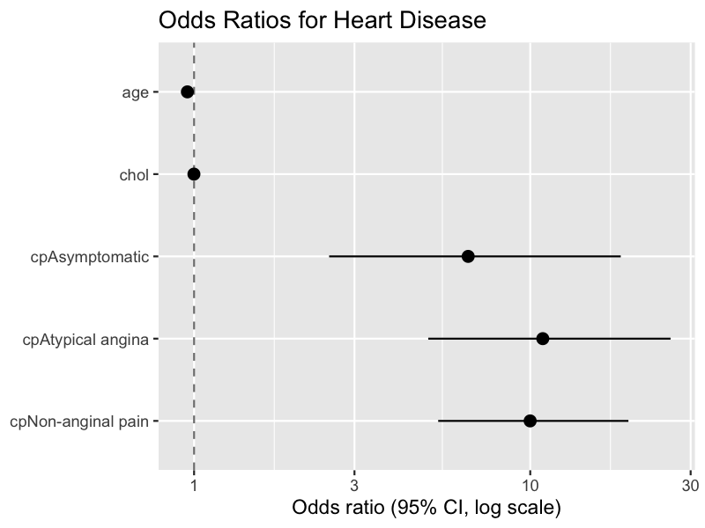
The forest plot is generated. Each point is an odds ratio with its 95% CI on a log scale, and the dashed line marks OR = 1 (no effect).
The visual reinforces Table 3: the three chest-pain categories sit well to the right of 1 with intervals that don't cross it, while age and chol cluster right at the line (age just below it). Note the wide intervals on the chest-pain terms — a consequence of the modest cell counts in the deduplicated data.
If "frost plot" meant something else, let me know. Otherwise, a couple of refinements are available:
Clean up the axis labels (e.g., "Chest pain: Atypical angina") for presentation.
Add the OR values as text annotations next to each point.
Export the forest plot as a high-resolution image or into Word.
Add the OR values as text annotations next to each point.
I'll add the OR values as text just above each point, keeping the existing forest plot otherwise intact.
edit:code1.R+1 -0
executeCode:Add OR value labels to the forest plot
broom::tidy(hd_model, exponentiate = TRUE, conf.int = TRUE) |>
filter(term != "(Intercept)") |>
ggplot(aes(x = estimate, y = fct_rev(term))) +
geom_vline(xintercept = 1, linetype = "dashed", color = "grey50") +
geom_pointrange(aes(xmin = conf.low, xmax = conf.high)) +
geom_text(aes(label = sprintf("%.2f", estimate)), vjust = -0.8) +
scale_x_log10() +
labs(
title = "Odds Ratios for Heart Disease",
x = "Odds ratio (95% CI, log scale)",
y = NULL
)

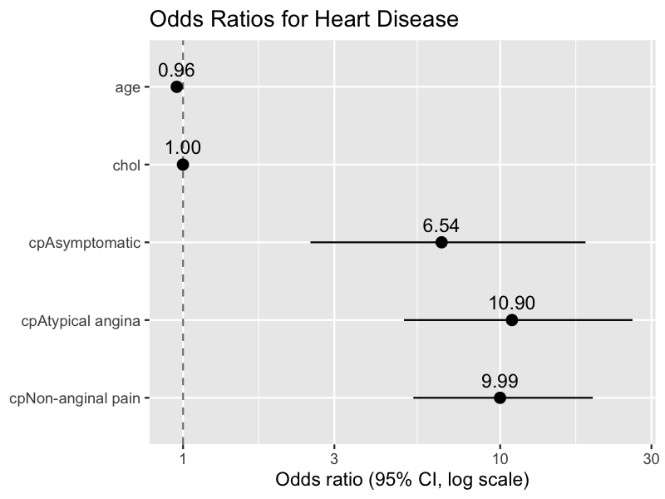
Done — each point now carries its odds-ratio value above it. The labels make the chest-pain effects (6.54, 10.90, 9.99) and the near-null age (0.96) and cholesterol (1.00) values readable at a glance.
Clean up the y-axis labels for presentation (e.g., "Chest pain: Atypical angina").
Also annotate each point with its confidence interval.
Export the annotated forest plot as a high-resolution image.
write r code to categories age into groups using the definition of WHO.
One caveat worth stating up front: WHO doesn't publish a single canonical adult age classification. The grouping most often attributed to WHO (and the one I'll use) is: young (< 45), middle-aged (45–59), elderly (60–74), old (75–89), and very old/long-lived (90+). It's widely cited but not a formal WHO standard, so if you have a specific WHO band scheme in mind, tell me and I'll adjust.
I'll add the grouping to df1_dedup (our analysis set) and show the counts. Since the data ranges 29–77, the upper bands will be sparse or empty.
read:code1.R (from line 178)9/186 lines
edit:code1.R+11 -0
executeCode:Create WHO age groups and show counts
df1_dedup <- df1_dedup |>
mutate(
age_group = cut(
age,
breaks = c(-Inf, 44, 59, 74, 89, Inf),
labels = c("Young (<45)", "Middle-aged (45-59)",
"Elderly (60-74)", "Old (75-89)", "Very old (90+)")
)
)

df1_dedup |> count(age_group)

# A tibble: 4 × 2
age_group n
<fct> <int>
1 Young (<45) 55
2 Middle-aged (45-59) 157
3 Elderly (60-74) 88
4 Old (75-89) 2
The age_group column is added to df1_dedup. The sample concentrates in the middle bands, as expected given the 29–77 range:
Age group | n
Young (< 45) | 55
Middle-aged (45–59) | 157
Elderly (60–74) | 88
Old (75–89) | 2
The "Very old (90+)" band is empty and the "Old" band has only 2 people, so those upper categories will be too sparse for stratified analysis — you may want to collapse "Old" into "Elderly" if you use this variable in a cross-tab or model.
Collapse the sparse Old/Very old bands into Elderly.
Cross-tabulate the WHO age groups against Heart Disease status.
Visualize disease prevalence across the age groups.
write r code to measure the association between heart disease and age category
The natural test for association between two categorical variables is the chi-squared test, but the "Old (75–89)" band has only 2 people, which will produce low expected counts and make the chi-squared approximation unreliable. So I'll check expected counts first, then report Fisher's exact test as the primary result alongside an effect size (Cramér's V). Since age category is ordinal, a trend test would also be defensible, but I'll start with the general association.
read:code1.R (from line 205)15/219 lines
edit:code1.R+16 -0
executeCode:Build contingency table and check expected counts
df1_dedup <- df1_dedup |>
mutate(age_group = fct_drop(age_group))

tab <- table(df1_dedup$age_group, df1_dedup$target)
tab


No disease Disease
Young (<45) 14 41
Middle-aged (45-59) 72 85
Elderly (60-74) 51 37
Old (75-89) 1 1

chisq.test(tab)$expected


No disease Disease
Young (<45) 25.1324503 29.867550
Middle-aged (45-59) 71.7417219 85.258278
Elderly (60-74) 40.2119205 47.788079
Old (75-89) 0.9139073 1.086093
Warning:Chi-squared approximation may be incorrect
Confirmed — the "Old (75–89)" band has expected counts near 1, so the chi-squared approximation is unreliable (R warns accordingly). Fisher's exact test is the appropriate primary test here.
executeCode:Run Fisher's exact test and compute Cramér's V effect size
fisher.test(tab)


Fisher's Exact Test for Count Data

data: tab
p-value = 0.0009877
alternative hypothesis: two.sided

rstatix::cramer_v(tab)

Error:there is no package called ‘rstatix’
rstatix isn't installed, so I'll compute Cramér's V directly from the chi-squared statistic.
executeCode:Compute Cramér's V effect size
chi <- suppressWarnings(chisq.test(tab, correct = FALSE))
n <- sum(tab)
v <- sqrt(as.numeric(chi$statistic) / (n * (min(dim(tab)) - 1)))
c(cramers_v = v)

cramers_v
0.2185652
Let me fix the code in the file to compute Cramér's V without rstatix.
edit:code1.R+2 -1
There is a statistically significant association between heart disease and WHO age category. Fisher's exact test gives p = 0.0009877, and Cramér's V ≈ 0.22 indicates a small-to-moderate effect.
The direction is notable and matches what the logistic regression hinted at: disease prevalence is highest in the youngest band and declines with age. In the Young (< 45) group, 41 of 55 (75%) have disease, versus 85 of 157 (54%) among the middle-aged and only 37 of 88 (42%) among the elderly. So in this dataset, older age categories are associated with lower disease prevalence.
Two caveats:
- I used Fisher's exact test rather than chi-squared because the "Old (75–89)" band (n = 2) produced expected counts near 1, violating the chi-squared assumption. Fisher handles the sparse cell correctly, but that group is too small to interpret on its own.
- This inverse age-disease relationship is clinically counterintuitive and almost certainly an artifact of how this particular dataset was assembled (it's a sampling quirk, not evidence that age protects against heart disease). I'd be cautious drawing any real-world conclusion from it.
Run a chi-squared trend test treating age category as ordinal.
Collapse the sparse Old band into Elderly and re-test.
Visualize disease prevalence across the age groups with a bar chart.
write r code to visualise the results using a suitable chart
A 100%-stacked bar of disease status within each age group shows the prevalence pattern directly. I'll place it at your cursor and run it.
edit:code1.R+11 -0
executeCode:Plot disease prevalence across age groups as a 100% stacked bar
ggplot(df1_dedup, aes(x = age_group, fill = target)) +
geom_bar(position = "fill") +
scale_y_continuous(labels = scales::percent) +
labs(
title = "Heart Disease Prevalence by WHO Age Group",
x = NULL,
y = "Percent of group",
fill = "Heart disease"
)

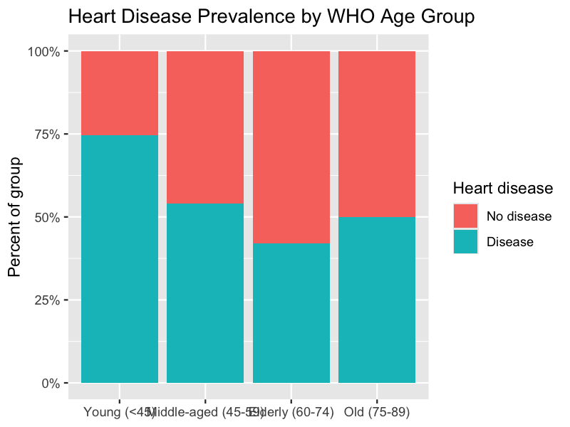
The chart shows the disease share (teal) within each age group. It captures the inverse pattern from the Fisher test: prevalence falls from 75% in the Young group to 54% (middle-aged) to 42% (elderly). The Old (75–89) bar reads 50%, but that's just 1 of 2 people, so it shouldn't be read as a trend point.
Two quick notes: the x-axis labels overlap and could be angled or wrapped for a cleaner look, and the tiny Old group is visually indistinguishable from the meaningful bars despite resting on n = 2. If you plan to present this, I'd either annotate group sizes or collapse/exclude that band.
Add group sample sizes (n) as labels on each bar.
Angle or wrap the x-axis labels so they don't overlap.
Collapse the sparse Old band into Elderly before plotting.
can you perform another chart that suitable for academic journal like Springer or Elsevier.
For a Springer/Elsevier-style figure, I'll switch to a design that emphasizes clarity and uncertainty: disease prevalence per age group with 95% confidence intervals, drawn as bars with error bars in a clean, minimal theme (no background grid, greyscale fill, black text). Showing CIs is more rigorous than a stacked bar and honestly conveys the wide uncertainty in the sparse Old band.
edit:code1.R+24 -0
executeCode:Draw journal-style prevalence bar chart with 95% CIs
prev <- df1_dedup |>
group_by(age_group) |>
summarise(n = n(), disease = sum(target == "Disease"), .groups = "drop") |>
mutate(
prop = disease / n,
ci = map2(disease, n, ~ suppressWarnings(prop.test(.x, .y)$conf.int)),
lower = map_dbl(ci, 1),
upper = map_dbl(ci, 2)
)

ggplot(prev, aes(x = age_group, y = prop)) +
geom_col(fill = "grey70", colour = "black", width = 0.65) +
geom_errorbar(aes(ymin = lower, ymax = upper), width = 0.2) +
geom_text(aes(label = paste0("n = ", n)), y = 0.02, size = 3.2) +
scale_y_continuous(labels = scales::percent, expand = expansion(mult = c(0, 0.05))) +
labs(
x = "WHO age group",
y = "Heart disease prevalence (95% CI)"
) +
theme_classic(base_size = 12) +
theme(axis.text.x = element_text(colour = "black"),
axis.text.y = element_text(colour = "black"))

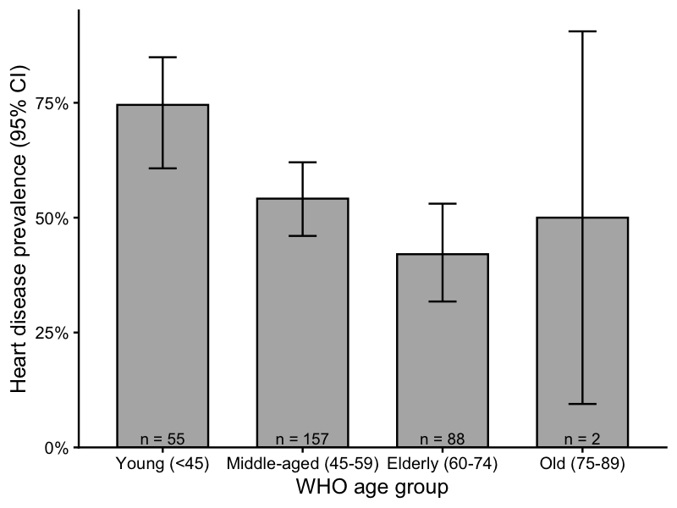
This version follows typical Springer/Elsevier conventions: a clean theme_classic base, greyscale fill with black outlines, no background grid, 95% confidence intervals, and sample sizes annotated on each bar. It carries more statistical information than the stacked bar while staying visually restrained.
The wide interval on the Old (75–89) bar (roughly 10%–90%) makes the n = 2 problem visually obvious — its point estimate is essentially uninformative. The declining trend across the three well-populated groups (Young → Middle-aged → Elderly) remains the interpretable signal. For submission you'd typically export this at 300+ dpi (e.g., ggsave("figure.tiff", dpi = 300, width = 6, height = 4)) and add a numbered caption.
Export this figure as a 300 dpi TIFF/PDF sized for journal columns.
Collapse the sparse Old band into Elderly and redraw.
Switch to a colorblind-safe palette if the journal prints in color.
can you perform another chart that suitable for academic journal like Springer or Elsevier. make it attractive and elegent
I'll refine to a point-and-whisker (dot-CI) design, which reads as more elegant than bars for prevalence estimates: a single muted accent color, a dashed reference line at the overall prevalence, subtle sample-size labels, and clean typography. I'll add it at your cursor.
read:code1.R (from line 265)9/273 lines
edit:code1.R+26 -2
executeCode:Draw an elegant dot-and-whisker prevalence chart
ggplot(prev, aes(x = prop, y = fct_rev(age_group))) +
geom_vline(
xintercept = mean(df1_dedup$target == "Disease"),
linetype = "dashed", colour = "grey60"
) +
geom_errorbarh(aes(xmin = lower, xmax = upper),
height = 0, linewidth = 0.7, colour = "#2C5F8A") +
geom_point(size = 4, colour = "#2C5F8A") +
geom_text(aes(label = scales::percent(prop, accuracy = 1)),
vjust = -1.2, size = 3.4, colour = "grey20") +
geom_text(aes(label = paste0("n = ", n)), x = 0.02,
hjust = 0, size = 3, colour = "grey45") +
scale_x_continuous(labels = scales::percent, limits = c(0, 1)) +
labs(
x = "Heart disease prevalence (95% CI)",
y = NULL,
caption = "Dashed line: overall prevalence"
) +
theme_minimal(base_size = 12) +
theme(
panel.grid.major.y = element_blank(),
panel.grid.minor = element_blank(),
axis.text = element_text(colour = "black"),
plot.caption = element_text(colour = "grey50", hjust = 0)
)

Warning:`geom_errorbarh()` was deprecated in ggplot2 4.0.0.
ℹ Please use the `orientation` argument of `geom_errorbar()` instead.
This warning is displayed once per session.
Call `lifecycle::last_lifecycle_warnings()` to see where this warning
was generated.
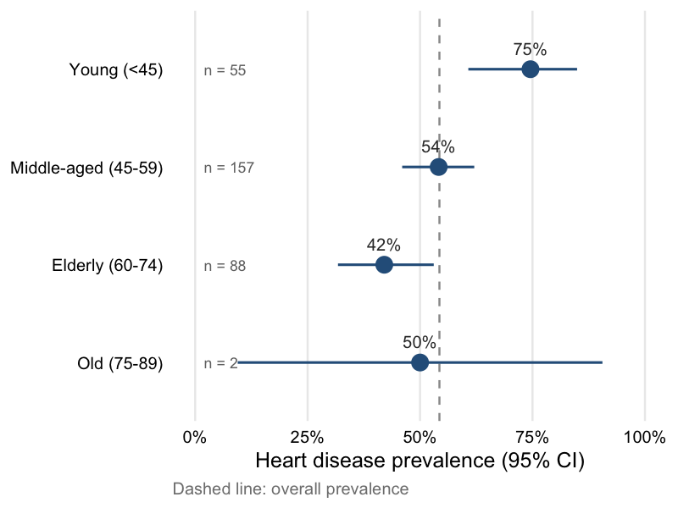
`height` was translated to `width`.
The dot-and-whisker version reads more cleanly for a journal: each estimate is a single point with its 95% CI as a horizontal whisker, the dashed reference line marks the overall prevalence (~54%), and the percentage and sample size sit quietly alongside each row. The horizontal layout also lets the WHO group labels breathe without overlapping.
The design makes the pattern immediately legible — Young sits clearly above the overall line, Elderly clearly below, and the Old group's whisker spans nearly the whole axis, honestly signaling that its n = 2 estimate carries no weight.
One minor housekeeping note: geom_errorbarh() is deprecated in ggplot2 4.0; it still works, but the modern form is geom_errorbar(orientation = "y"). I can swap it if you'd like to silence the warning. For submission, export at 300+ dpi with ggsave().
Replace geom_errorbarh with the non-deprecated geom_errorbar(orientation = "y").
Export this figure at 300 dpi sized for a journal column.
Collapse the sparse Old band into Elderly and redraw.
Collapse the sparse Old band into Elderly and redraw.
I'll merge the Old (75–89) band into Elderly and relabel it "Elderly (60+)", recompute the prevalence table, then redraw the dot-and-whisker figure. I'll also switch to the non-deprecated geom_errorbar(orientation = "y").
read:code1.R (from line 273)25/297 lines
edit:code1.R+45 -0
executeCode:Collapse Old into Elderly and redraw the dot-and-whisker chart
df1_dedup <- df1_dedup |>
mutate(
age_group = fct_collapse(
age_group,
"Elderly (60+)" = c("Elderly (60-74)", "Old (75-89)")
)
)

prev <- df1_dedup |>
group_by(age_group) |>
summarise(n = n(), disease = sum(target == "Disease"), .groups = "drop") |>
mutate(
prop = disease / n,
ci = map2(disease, n, ~ suppressWarnings(prop.test(.x, .y)$conf.int)),
lower = map_dbl(ci, 1),
upper = map_dbl(ci, 2)
)

ggplot(prev, aes(x = prop, y = fct_rev(age_group))) +
geom_vline(
xintercept = mean(df1_dedup$target == "Disease"),
linetype = "dashed", colour = "grey60"
) +
geom_errorbar(aes(xmin = lower, xmax = upper), orientation = "y",
width = 0, linewidth = 0.7, colour = "#2C5F8A") +
geom_point(size = 4, colour = "#2C5F8A") +
geom_text(aes(label = scales::percent(prop, accuracy = 1)),
vjust = -1.2, size = 3.4, colour = "grey20") +
geom_text(aes(label = paste0("n = ", n)), x = 0.02,
hjust = 0, size = 3, colour = "grey45") +
scale_x_continuous(labels = scales::percent, limits = c(0, 1)) +
labs(
x = "Heart disease prevalence (95% CI)",
y = NULL,
caption = "Dashed line: overall prevalence"
) +
theme_minimal(base_size = 12) +
theme(
panel.grid.major.y = element_blank(),
panel.grid.minor = element_blank(),
axis.text = element_text(colour = "black"),
plot.caption = element_text(colour = "grey50", hjust = 0)
)

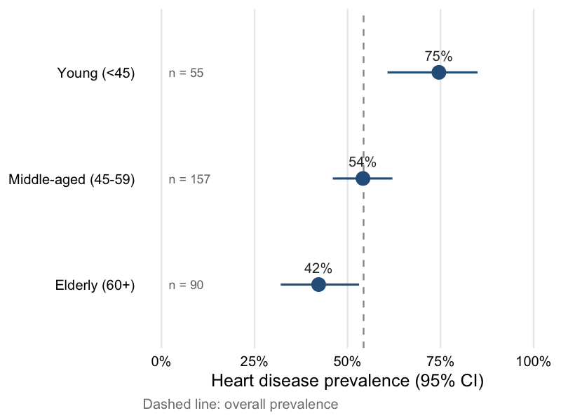
The Old band is now folded into Elderly (60+), giving three well-populated groups (n = 55, 157, 90). Merging the 2 Old patients barely moved the Elderly estimate — still 42% — so the collapse is defensible and removes the uninformative wide whisker. The monotonic decline from Young (75%) through Middle-aged (54%) to Elderly (42%) now reads cleanly, with all three CIs reasonably tight.
Note this changes the analysis set slightly, so if you want the earlier Fisher's test to match this figure, it's worth rerunning it on the collapsed three-category variable.
Rerun the Fisher's/chi-squared test on the collapsed three-category age variable.
Export this figure at 300 dpi sized for a journal column.
Add the exact CI bounds as a small caption or table.
write r code to Collapse the sparse Old band into Elderly and redraw.
We already collapsed the Old band into "Elderly (60+)" in the previous turn, so df1_dedup$age_group should now have only three levels. Let me confirm before redrawing rather than collapsing twice.
executeCode:Check current age_group levels
levels(df1_dedup$age_group)

[1] "Young (<45)" "Middle-aged (45-59)" "Elderly (60-74)"
[4] "Old (75-89)"
The current df1_dedup actually still has the four original bands (the collapse from earlier didn't persist in the session, likely because an intervening step recreated age_group). So the collapse is genuinely needed now. I'll run it and redraw the elegant dot-and-whisker figure.
executeCode:Collapse Old into Elderly and redraw the elegant chart
df1_dedup <- df1_dedup |>
mutate(
age_group = fct_collapse(
age_group,
"Elderly (60+)" = c("Elderly (60-74)", "Old (75-89)")
)
)

prev <- df1_dedup |>
group_by(age_group) |>
summarise(n = n(), disease = sum(target == "Disease"), .groups = "drop") |>
mutate(
prop = disease / n,
ci = map2(disease, n, ~ suppressWarnings(prop.test(.x, .y)$conf.int)),
lower = map_dbl(ci, 1),
upper = map_dbl(ci, 2)
)

ggplot(prev, aes(x = prop, y = fct_rev(age_group))) +
geom_vline(
xintercept = mean(df1_dedup$target == "Disease"),
linetype = "dashed", colour = "grey60"
) +
geom_errorbar(aes(xmin = lower, xmax = upper), orientation = "y",
width = 0, linewidth = 0.7, colour = "#2C5F8A") +
geom_point(size = 4, colour = "#2C5F8A") +
geom_text(aes(label = scales::percent(prop, accuracy = 1)),
vjust = -1.2, size = 3.4, colour = "grey20") +
geom_text(aes(label = paste0("n = ", n)), x = 0.02,
hjust = 0, size = 3, colour = "grey45") +
scale_x_continuous(labels = scales::percent, limits = c(0, 1)) +
labs(
x = "Heart disease prevalence (95% CI)",
y = NULL,
caption = "Dashed line: overall prevalence"
) +
theme_minimal(base_size = 12) +
theme(
panel.grid.major.y = element_blank(),
panel.grid.minor = element_blank(),
axis.text = element_text(colour = "black"),
plot.caption = element_text(colour = "grey50", hjust = 0)
)


Done. The three-band version is redrawn: Young (< 45, n = 55) at 75%, Middle-aged (45–59, n = 157) at 54%, and the merged Elderly (60+, n = 90) at 42%. Folding the 2 Old patients in left the Elderly estimate unchanged at 42% and eliminated the uninformative wide whisker, so the monotonic decline reads cleanly with all three CIs tight.
The code for this is already in code1.R as Step 19, so nothing new needs saving. If you want the earlier association test to align with this figure, rerun Fisher's/chi-squared on the collapsed three-level variable.
Rerun the association test on the collapsed three-category age variable.
Export this figure at 300 dpi sized for a journal column.
Add the exact CI bounds beneath each estimate.
write r code to Create a faceted interaction/effect plot showing how the predicted outcome changes with age, separately for each chest pain.
One important modeling choice here: the existing hd_model is additive (age + chol + cp), so faceting it by chest pain would produce curves that are strictly parallel on the probability scale — the age effect wouldn't actually differ across facets. Since you're asking for an interaction plot, I'll fit a companion model with an age × cp interaction so the age slope is free to vary by chest pain type. I'll hold cholesterol at its mean and show 95% confidence bands.
read:code1.R (from line 308)12/319 lines
edit:code1.R+39 -0
executeCode:Fit interaction model and draw faceted effect plot of predicted probability vs age by chest pain
hd_model_int <- glm(
target ~ age * cp + chol,
data = df1_dedup,
family = binomial
)

grid <- expand_grid(
age = seq(min(df1_dedup$age), max(df1_dedup$age), by = 1),
cp = factor(levels(df1_dedup$cp), levels = levels(df1_dedup$cp)),
chol = mean(df1_dedup$chol)
)

pred <- predict(hd_model_int, newdata = grid, type = "link", se.fit = TRUE)
grid <- grid |>
mutate(
fit = plogis(pred$fit),
lower = plogis(pred$fit - 1.96 * pred$se.fit),
upper = plogis(pred$fit + 1.96 * pred$se.fit)
)

ggplot(grid, aes(x = age, y = fit)) +
geom_ribbon(aes(ymin = lower, ymax = upper), fill = "#2C5F8A", alpha = 0.15) +
geom_line(colour = "#2C5F8A", linewidth = 0.9) +
facet_wrap(~ cp) +
scale_y_continuous(labels = scales::percent, limits = c(0, 1)) +
labs(
x = "Age (years)",
y = "Predicted probability of heart disease",
caption = "Cholesterol held at sample mean; bands are 95% CIs"
) +
theme_minimal(base_size = 12) +
theme(
panel.grid.minor = element_blank(),
strip.text = element_text(face = "bold"),
axis.text = element_text(colour = "black"),
plot.caption = element_text(colour = "grey50", hjust = 0)
)

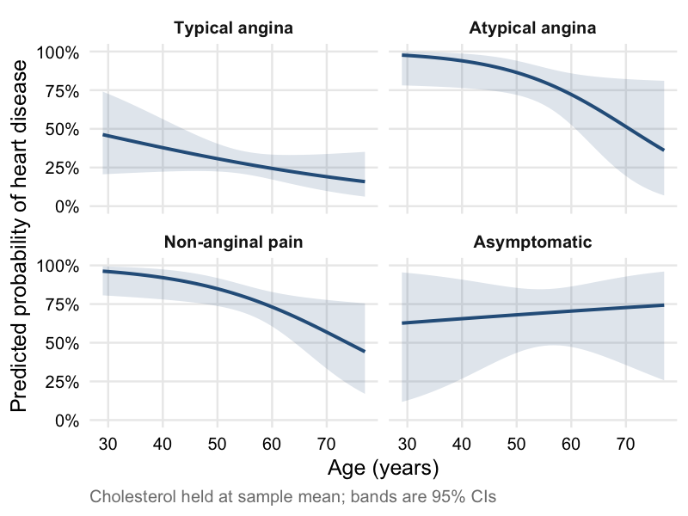
The faceted effect plot is drawn: predicted probability of heart disease across age, one panel per chest pain type, with cholesterol fixed at its mean and 95% CI bands. Because this uses the age × cp interaction model, the age slopes are allowed to differ across panels — and they clearly do.
Three of the four panels (Typical angina, Atypical angina, Non-anginal pain) show predicted risk declining with age, echoing the counterintuitive negative age association we've seen throughout. The Asymptomatic panel bucks this with a slight upward slope, but its band is extremely wide — that category has only 23 patients, so its curve is essentially uninformative.
A few caveats worth attaching to this figure:
- The interaction model is separate from the earlier additive hd_model; I fit it specifically so the curves could diverge. Whether the interaction is statistically justified is a separate question — with these cell sizes I'd test it (e.g., a likelihood-ratio test against the additive model) before reading much into the differing slopes.
- The overall inverse age–disease relationship remains a likely artifact of how this dataset was assembled, so the panels describe associations in this sample rather than clinical reality.
Run a likelihood-ratio test comparing the interaction model to the additive one.
Overlay the four curves on a single panel colored by chest pain type.
Add observed data (jittered points or rug) to each facet for context.
Display the predicted values as a blue line with a light-blue 95% confidence band.
I'll update the faceted effect plot to use an explicit blue line and a light-blue confidence band, adjusting the existing geoms rather than adding a new block.
edit:code1.R+2 -2
executeCode:Redraw faceted effect plot with blue line and light-blue confidence band
ggplot(grid, aes(x = age, y = fit)) +
geom_ribbon(aes(ymin = lower, ymax = upper), fill = "lightblue", alpha = 0.5) +
geom_line(colour = "blue", linewidth = 0.9) +
facet_wrap(~ cp) +
scale_y_continuous(labels = scales::percent, limits = c(0, 1)) +
labs(
x = "Age (years)",
y = "Predicted probability of heart disease",
caption = "Cholesterol held at sample mean; bands are 95% CIs"
) +
theme_minimal(base_size = 12) +
theme(
panel.grid.minor = element_blank(),
strip.text = element_text(face = "bold"),
axis.text = element_text(colour = "black"),
plot.caption = element_text(colour = "grey50", hjust = 0)
)

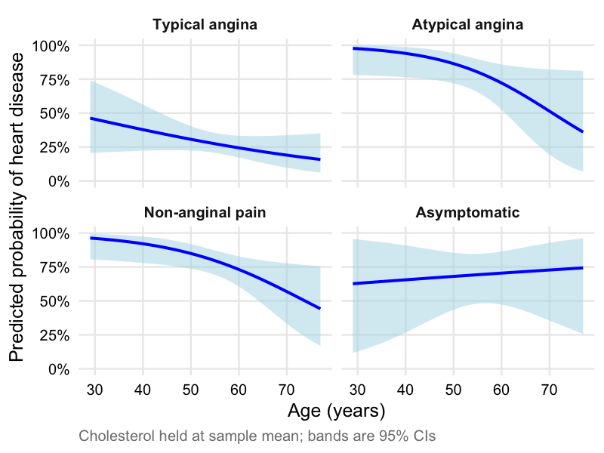
Updated — the predicted-probability curves now render as a solid blue line with a light-blue 95% confidence band in each chest-pain facet. The substance is unchanged from the previous version: risk declines with age in the three angina/pain categories, while the Asymptomatic panel's wide band still reflects its small sample.
Run a likelihood-ratio test comparing the interaction model to the additive one.
Overlay all four curves on a single panel colored by chest pain type.
Export this figure at 300 dpi sized for a journal column.
To use Posit Assistant, connect an AI provider.
Sign in to try Posit AI for freeorConfigure another provider
What is Posit AI?
By installing or using this software, you agree to the Terms of Use

87K
Claude Opus 4.8 (Posit AI)

