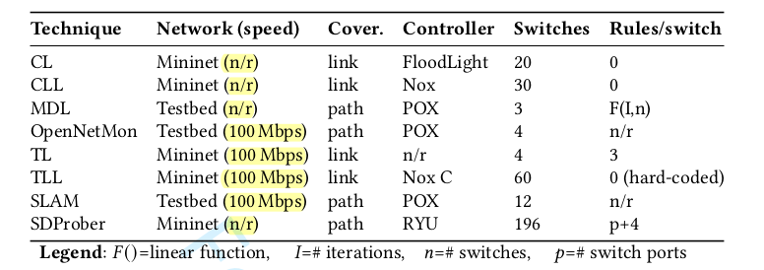
TABLE 8
Mininet(n/r) | link | ONOS(?) | 4 | 4-8
TABLE 9
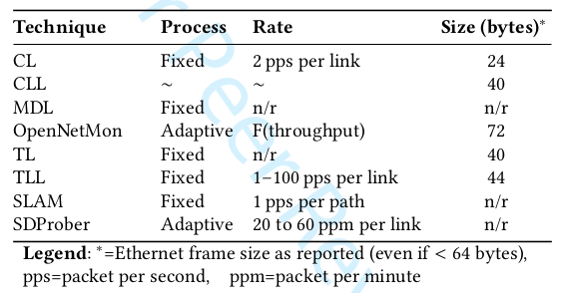
Fixed | 2 ppD (D = measured delay) | 62

TABLE 10

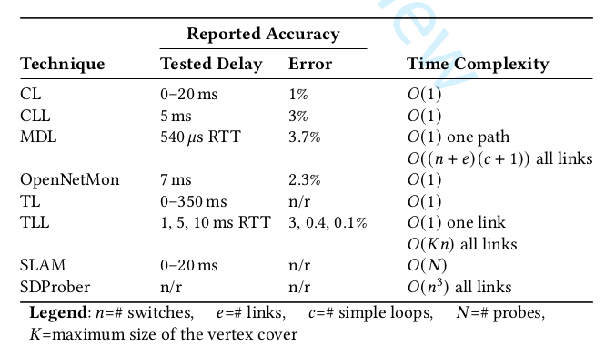
10,20,30 ms | 2.7%,0.9%,0.5% | O(1)

