

Research title : Predicting Heart Disease Using Machine Learning:
A Comparative Analysis of Classification Models
Student ID: 22110377
Course: Computer Research Project
Supervisor: Bassam AL-KASSASBEH
Submission Date: 26/06/2025

Table of Contents
Introduction 3
2. Literature Review 4
2.1 First paper Husam & Al-Quraan (2022) 4
2,2 Second paper Shaheen et al. (2024) 4
2,3 Third paper Al-Alshaikh et al. (2024) 5
2.4 Fourtht paper El-Sofany et al. (2024) 5
2.5 fifth paper Bouhamed et al. (2024) 5
2.6 Research Gap 5
3. Data collection and Description 6
4. Research Approach and Methodologies 16
4.1 Onion Model 17
4.2 Research Methodology 24
5. Results and Discussion 27
5.1 Test-Set Performance 27
5.2 train-set Performance 27
5.3 Performance Comparison Visualization 28
5.4 Confusion Matrix Analysis 29
5.5 Explainability with SHAP 30
6. Conclusion and Recommendations 33
6.1 State the aim of the study and summarize the findings. 33
6.2 Recommendations 33
6.3 Future Work 34
7. Reflections 34
7.1.Reflection on the Research Process: 34
7.2 Alternative Research Methodologies 35
7.4 Recommended Methodology 37
Refrencess: 39

Abstract:
This paper discusses a mixed-methods approach of constructing and describing AI models which forecast heart disease based on normal patient data. First, I process a publicly available clinical dataset by cleaning the values of the invalid zeros and encoding the categorical variables, followed by training and comparing three of the most popular approaches (. Logistic Regression , Decision Tree. , Random Forest) and determining the one showing the most accurate results. I use SHAP to explain decisions of the selected model and reveal crucial clinical factors. Lastly, I impressively engage cardiologist and AI specialists in semi-structured interviews on the matters of how the given explanations can influence clinician trust and inform actual implementation-related adoption. Such a mix of quantitative modeling and qualitative feedback presents technical reliability and relevant practicability

Introduction
Cardiovascular diseases (CVDs ) particularly the heart attacks, is still the leadings reason of death all around the world and according to the World Health Organization, CVDs account for approximately 17.9 million deaths each year, which is about 31% of all global deaths (El-Sofany et, 2024).
More than 75% off thesse deaths occur in the low and the middle income countries. This emphasises the critical need for early detection and preventative healthcare strategies. In response, machine learning (ML) became known as a strong tool capable of recognising patterns in clinical and demographic data that older approaches may miss, therefore allowing earlier and more accurate heart attack risk prediction (Al-Alshaikh et ,2024).
Which machine learning model provides the highest accuracy for predicting heart disease based on patient health records? Recent research has explored different ML methods such as Support Vector Machines, Decision Trees, Random Forests, Logistic Regression, and XGBoost. These models have shown a great deal of usefulness in diagnosing cardiac disease, particularly with feature selection methods incorporated(Al-Alshaikh et al., 2024; El-Sofany et al., 2024). In some papers, group and hybrid deep learning model achieved over 89% testing accuracies suggesting ML is able to Perform better than traditional diagnosis (Bouhamed et, 2024).
Despite all these advancements, numerous challenges are yet to be addressed before AI can be used in the prediction of heart disease. One of the common issues is data unbalance, with significantly fewer patients in datasets who actually have heart disease, making it difficult for models to excel for real-world cases (Al-Alshaikh et al., 2024). Additionally, data quality inconsistencies and the absence of standard data sets are likely to yield inconsistent model performance the clinical deployment is also hampered by trust barrier such as when models are "black boxes" with no interpretation of how they reach their predictions (El-Sofany et al., 2024)
To analyze the explainable AI (XAI) methods have been presented. the XAI iss can be described as methods that allow machine learning models to be more interpretable since they offer an interpretation of how one feature affects the final prediction. For example, SHAP (SHapley Additive exPlanations) is used to reveal the impact of each input variable on the output to allow healthcare professionals to interpret and trust AI-based predictions better (El-Sofany et al., 2024). They have also been integrated into digital health platforms for enabling more person-centered and foresighted care for patients (Bouhamed et al., 2024).
every day and we are to continue to learn more every day and one thing that particularly jumps out is the potential that machine learning holds for the prediction of heart attacks. This article takes a bit closer of a look at some of the latest ML tools being used, how they're doing, how physicians are only just starting to use them, and what they may hold for the prevention of heart disease in the future

2. Literature Review
In the course of the last few years, machine learning (ML) has rapidly become a maturing force in the medical realm, notably as a potential alternative in the sphere of predicting heart disease. Analyzing different attributes of patients, machine learning models can provide doctors with panels or sets of values they may predict to alleviate them to the patients potentially in danger before the clearly defined symptoms of severe disease appear. In this section, five studies with machine learning as elements of a prediction model of heart disease will be considered. The studies will be described in how each of them dealt with the problem, their findings, and their limitations on their researches.

2.1 First paper Husam & Al-Quraan (2022)

In their analysis, the authors carried out five machine learning algorithms Decision Tree, Logistic Regression, Naive Bayes, K-nearest and Support Vector Machine across a widely used dataset (Cleveland). Support Vector machine (SVM) had the highest result of 87.5%. Their findings stated that the appropriate degree of predictive accuracy can also be achieved with the help of simpler algorithms in case the data undergo sufficient preprocessing. The limitations of the study were the limited dataset size and the authors did not apply deeper methods of feature engineering or feature combination, which could have possibly led to a higher degree of accuracy in prediction (Husam & Al-Quraan, 2022)

2,2 Second paper Shaheen et al. (2024)
This experiment used real patient data collected in the Jordan University Hospital. They used the Random Forest, Logistic Regression, and Decision Trees models and experimented with data cleaning and selecting the best features. Their best-performing model, the Random Forest, recorded the highest accuracy of 93.55%. What contributed to this was the painstaking preprocessing and the careful consideration of the features to use. A drawback was that their sample was not very large, and the model was only tested using data within the hospital, which leaves many wondering how well it would perform elsewhere (Shaheen et al., 2024).

2,3 Third paper Al-Alshaikh et al. (2024)
This paper has used a different methodology. The researchers created a hybrid model that integrates deep learning and traditional machine learning techniques, which they referred to as ML-HDPM. They also applied feature selection methods to enhance performance prior to data submission to their model.

The hybrid model attained remarkable results where the training accuracy was 95.5% and testing accuracy was 89.1%. This proved that different methods can be used together to attain better results. However, the model’s complexity may hinder its practicality in real hospitals, making it difficult for clinicians to interact with the “black box” predictions. (Al-Alshaikh et al., 2024).

2.4 Fourtht paper El-Sofany et al. (2024)
The focus of the study was not only prediction but also reasoning at the same time. The authors used SHAP (Shapley Additive Explanations) to determine the importance of some model inputs such as age or blood pressure. The authors evaluated the models using XGBoost and Random Forest models and statistical feature selection by chi-square, ANOVA.

XGBoost exhibited the highest results of 97.57%. The peculiarity of this paper is connected with the way it explained the strategy of the model. The physicians will be able to know why the model made the conclusion about the risk status of an individual patient. Conversely, explanation models use much more computation power to execute them, and the models were not tested using real-time settings (El-Sofany et al., 2024)

2.5 fifth paper Bouhamed et al. (2024)
The last paper sought to create a tool for doctors to use in preventive medicine. The authors designed an AI system to estimate the risk of a heart attack and the concept of assisting early medical decisions. They merged various ML methods with a risk scoring system and achieved high accuracy but didn’t concentrate on a single model.The fact that it was built for real-world application makes it significant. However, the paper does not talk that much about the models themselves or their results in tests. It's hence hard to determine how sound or reliable the system really is (Bouhamed et al., 2024)

2.6 Research Gap
Reading through these papers on the whole it is clear that machine learning holds a big potential for predicting heart disease. But most work centers primarily on accuracy and does not necessarily make the models explainable for doctors or transferrable to new patient cohorts. There also isn’t much work that integrates model performance and explainability and deals with multiple datasets. This work tries to bridge this gap by concentrating both on accuracy and the explainability of ML models using cleaned and diverse datasets to develop tools for use in real-world healthcare environments.

3. Data collection and Description
In academic research, the data used can be categorized into primary and secondary types.
Primary data refers to data collected firsthand by the researcher specifically for the study at hand. It is typically obtained through methods like surveys, interviews, experiments, or direct measurements. Secondary data, on the other hand, is data originally collected by others for a different purpose and reused for the current study. It may come from published datasets, academic journals, institutional databases, or public repositories.
The main difference lies in the origin and intent: primary data is original and aligned directly with the research goal, offering control over variables and context, while secondary data is pre-existing and may not fit the new research perfectly in terms of relevance, recency, or scope.
In this study, both data types were utilized. For example, Shaheen et al. (2024) used primary data collected directly from Jordan University Hospital, including patient records and health metrics, specifically gathered to train and test machine learning models for predicting heart attacks. In contrast, studies like Husam and Al-Quraan (2022) made use of the secondary Cleveland dataset, a publicly available resource commonly used in medical ML research, which allows for benchmarking model performance.
Using both types improves the overall validity of the study by combining context-specific local data with standardized and widely used secondary datasets for broader comparison and generalizability.
primary data:
in this project, i collect primary data by doing expert interviews. the first interview was with dr. ayman hamodeh, a consultant cardiologist at al-istishari hospital. he is a heart and artery specialist with long experience in both treatment and research. this interview gave me important real-life insight about how heart attacks are diagnosed and what challenges doctors face. it also helped me understand the doctor’s opinion about using machine learning (ml) in predicting heart diseases.
i asked 14 questions in the interview. the questions were about how diagnosis is done, what problems happen in real life, and if ai can help doctors or not. i also asked what makes a doctor trust or not trust ai tools in hospitals.
i also did another interview with an artificial intelligence (ai) expert. this expert will help me understand the technical side, like how models are built and how they can be explained in a simple way for doctors. my goal is to compare both views and learn how medical and technical sides can work together.

- Question of an interview witht a cardiologist:
Q.1.Doctor, to begin, based on your long experience in the field of cardiology, what are the biggest challenges you currently face in diagnosing heart attacks or heart diseases early?
ANS: We have methods such as electrocardiogram and enzymes that reach 99% accuracy, so it is easy to diagnose a stroke in a patient who comes with chest pain, but you said early diagnosis, meaning before it happens, such as a smoker, because we do not know which smoker will have a stroke and which will not have a stroke and which is a non-smoker. There are four factors: blood pressure, diabetes, cholesterol and smoking. There are also models that combine these factors and help you discover the danger.

Q.2. Recently, we’ve been hearing a lot about artificial intelligence and machine learning in medicine. In your opinion, can these technologies actually play a real role in improving the diagnosis or prediction of heart attacks?
ANS: Yes, 100% But the human factor is the important factor because we cannot let artificial intelligence control our lives if the doctor is confident in himself and is well trained and educated and is the one who controls the device and not the other way around, but when the doctor is not educated enough and will take information without doing critical thinking, then the important factor must be the human factor and then take information from artificial intelligence.

Q.3. How do you usually diagnose a heart attack? And what are the key biomarkers or tests you mainly rely on?
The patient complains of chest pain, and this pain can come from around twenty different conditions. However, the type of pain caused by a heart attack has specific characteristics that only the doctor knows. For example, it appears in the front area of the chest, and it can spread to the shoulders and lower jaw, and it often comes with sweating. So the first thing is the patient's medical history, and the second is assessing the patient (patient profile) for example, if someone is athletic and active and has chest pain, it might not be a heart condition.
The second tool is the electrocardiogram (ECG), which gives us about 99% accuracy in diagnosis. And the final tool is cardiac enzymes — if they are elevated, they can be detected quickly in the emergency room.

Q.4. Since you specialize in interventional cardiology, do these cases require a different or more precise method of diagnosis compared to normal?
ANS: Of course, because I don’t want to expose every patient to an arterial intervention. For example, if the doctor knows the diagnosis and is confident that it’s correct, and it’s necessary to move the patient from the emergency room to a catheterization procedure, the doctor also knows that the patient will be exposed to radiation, contrast dye, and risks. All of this is acceptable only if the patient has a strong indication — like someone with a heart attack where the procedure can save their life. In this case, the exposure to radiation and minor complications is better than the disease itself.
But if the doctor decides to take everyone to catheterization just because they don’t know the medical history well or are not confident in their diagnosis, then many patients will end up undergoing a procedure they don’t actually need.
Q.5. Have you ever worked with or used tools that include AI? Like clinical decision support systems or programs that predict heart attack risks?
ANS: Yes, for the experiment, not to see how my patient will be treated. I challenge artificial intelligence and give it a scenario of a patient and see whether he thinks like me or not.
Q.6. Do you feel there’s a trust gap between doctors and AI systems? And if so, why?
Yes, ill tell you why my generation who graduated in the 2000s or who studied at the american universities there wasn’t AI at that time All science is clinical and depends on the intelligence of the doctor, but this new generation is graduating with artificial intelligence.

Q.7. What must be available in an AI tool for you to trust and use it confidently?
There is no problem. We can use it without any problem. I am the type who is ready to use it, but I always have reservations about the doctor letting it control him and making him depend on artificial intelligence when the patient comes.

Q.8. What problems or challenges do you see AI helping with — whether in diagnosis or clinical decision-making?
The most important thing is Predicting a person’s risk of having a stroke in the future. We have the four factors in our country. We have the four factors in our society. The models help us predict the risk if we give it the person’s information. We need this model in Jordan to tell us if they have high risk or not depending on the input data.
Q.9. Do you expect that these smart models can contribute to early prevention or reduce death rates?
The most common cause of death in the world, especially in the Middle East and Jordan, is heart disease. Its number exceeds the number of cancers, infectious diseases, and car accidents. So if there is any way to tell a patient that you have a high risk and to take care of his health, then this is what we have to do for the individual and society.
Q.10. From your perspective, if the smart model is built only on clinical data without human input, can we trust it? Or should the doctor always be part of the process?
Yes the doctor should always be a part of the process
Q.11. Do you think training cardiologists on AI tools should become part of their education?
Yes, the Faculty of Medicine must keep pace with new science and make it part of the medical curriculum because this is the future.
Q.12. If you could give advice to researchers or developers who are building AI systems for healthcare, what would you say?
First of all, they must have an understanding or communication with specialist doctors because the characteristics of heart diseases differ from one country to another, and the mortality rate is different, and the influencing factors also differ. So, before they create models, they must communicate with a doctor to save time and focus on the local.
Q.13. How important is it for you that the model explains why it gave a specific result? Do you prefer tools that explain the reason behind each prediction?
Correct and necessary to know and confirm the decision
Q.14. In your opinion, can AI reduce the importance of a doctor’s experience? Or can it enhance and support it?
It can go both ways depending on the doctor and if will use it as a positive tool

- Question of an interview witht a ai expert:
Q.1. How experienced are you with AI applications in the medical field, especially in health and clinical data analysis?
Research experience. We are trying to analyze some medical images in order to discover if there is fraud. Based on the data, I want to see if there is tampering with the image to ensure the safety of the Output, Posing Attack on the medical training dataset

Q.2. Have you ever participated in developing artificial intelligence models to diagnose or predict heart attack disease? If so, what type of data did you use?
used computer vision with deep learning
Q.3. What machine learning algorithms or models do you consider most appropriate for predicting heart disease and why?
There is two types image processing and dataset best models for your case(classification) is models like random forest classifier
Q.4. What are the most prominent technical challenges you faced while training or testing cardiac prediction models?
The most prominent challenge is to get real data also understand the data

Q.5. Does a model trained on clinical data only, without direct medical supervision, really produce accurate and reliable results?
Never, better with a doctorand use XAI the doctor will check and analyse all of the feauture
Q.6. in your opinion how important is explainable AI mode? Do you think every decission made by the model should be explained?
Yes, XAI gives the chance for the specilist users to understand how decissions are made(feedback yo improve ML model)

Q.7. do you consider tools like SHAP or LIME sufficient to clarify how decissions are made? Or do you believe there are still gaps?
While tools like SHAP and LIME are useful, their effectiveness largely depends on the type of data you're working with. Let me say that SHAP functions well with sets of data that are structured, such as Excel files or tables of clinical results. Layer-wise Relevance Propagation (LRP) is a better approach to interpret images than others.
Even so, there are flaws in using these approaches. The conclusion itself comes from the model’s prediction, and this prediction might be wrong to start. In other words, they are reliable as long as the model’s results are reliable. Therefore, using XAI wisely is especially required in important areas such as medicne

Q.8. Do you think artificial intelligence will reduce the role of the doctor, or vice versa, reduce the possibility of error?
In the future it might reduce the doctors role atleast will be able to solve Overcrowding in the medical sector But legal legislation must be taken into consideration to bear the percentage of error.

Q.9. Do you think training doctors on artificial intelligence tools has become a necessity? If yes, at what stage of their education?
Yes, after their study :
Take courses
Double major
Learned applied AI

Insights :
- Doctors Stay in Control
- The heart doctor remarked that AI would aid, however, the doctor would have to make the final decision.
- Through this tool, doctors should be able to both accept and reject AI suggestions.

- Data Must Match the Local Patients
- In Jordan, the most important factor is blood pressure, diabetes, cholesterol, and smoking.
- Ensure that the model has been trianed on data that asre simikar to the local patients
- Explain “Why” Clearly
- Doctors need to know why the model gave a score.
- Use SHAP bars to show which health measures mattered most for each patient.
- Train Users
- AI would convince the doctors too little or too much, in case they do not see it in action
- Provide short instruction thus they understand how to read
- Build a Simple Dashboard
- • Create a screen on which physicians can enter details of the patients and will get the AI prediction with the SHAP bars.
- Let them change a value and watch the prediction update for instance the “what if” scenarios
- Keep Improving with Feedback
- Check in with doctors often to see what works and what doesn’t.
- Use their feedback to fix bugs and add new features step by step.
Issure while I collected primary data:
When I wanted to collect primary data I thought about an interview because this what was the best according to my intructor but the main issue wasn’t just finding the right questions but it was so hard to try to take an appointment with the cardiologist because he was fully booked and did not have time for my interview so I had an late interview as in next week so I got delayed for a week and for the ai expert It was very hard to find an ai expert to interview, and the results that I got was hard for me to analyse it , why ? because I wasn’t numerical data it was open end answers

why i use this primary data ?
i use this primary data because it gives me direct answers from a real doctor who works with heart patients. the doctor shared honest and expert opinions about real medical challenges and how ai tools may help. also, the planned interview with the ai expert will give me the technical side. having both views helps my research be more balanced and useful.

merits and limits of primary data ?
one good thing about primary data is that i ask the exact questions i want. the answers are new and real, not copied from other studies. this helps me understand things that the dataset cannot show, like trust or real hospital problems.
but there are also some limits. the answers reflect only one or two experts, so maybe other doctors or engineers think different. also, interviews take time to prepare and analyze. but still, i believe the interviews give me very important information that makes my project stronger.

secondary data :
In this project i use a heart disease dataset, its public dataset and many people used it before in medical machine learning research. this dataset was made to help in find who maybe have heart problem based on health and life style info. it have 11 input features (columns) and 1 output column (HeartDisease), and many rows, each row is one patient. the data have things like age, sex, blood pressure, cholesterol, type of chest pain and more. all these things help to know if someone maybe have heart attack or not.
this table show the features and give short idea for each one:
This is the feature table description

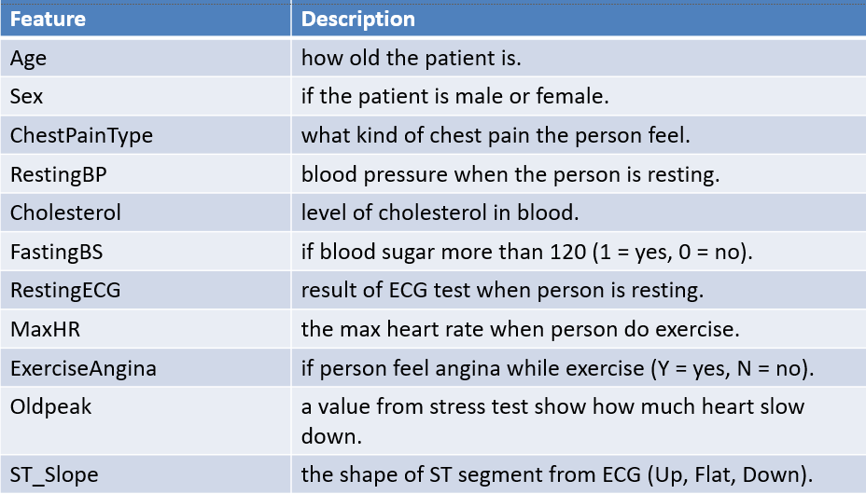
why we use this dataset ?
I chosse and pick this dataset because it is famous and many papers used it before. it's really good for our goal in this project which is to build a model to say if person have heart disease or not. the features in the data are very important for doctors, like cholesterol, chest pain, oldpeak and heart rate. this makes the data useful to train machine learning and give real result.
another reason is that it's public and many researchers used it so we can compare if our model is good or bad. we also like that the data is not messy, it's clean and easy to use. that help us when we try explain the model later using SHAP or LIME, because we need simple features to explain in a good way.
the data also have both clinical and life style info. that give the model more balance and better learning. i believe this data is perfect to start with, and can help me reach a model that doctors maybe use one day in real life.
merits and limits of secondary data ?

one of the good things when i use data like this (secondary data), is that it save alot of time and don’t need to collect real data from hospital or patients. the data is already ready and I can just use it directly to train and test the model.
also this data is checked and trusted because many researchers used it before and say it's good. that give us more confidence. we also can look at other papers and see what accuracy they got, and compare my model to them.

but there is also some bad sides. like maybe the data is old and doesn’t have new symptoms or new types of heart disease. also i don’t know 100% how the data was collected, maybe there is bias or mistake inside that we don't see and it can affect the model result.
another problem is that this dataset is used by many people. so if i train model on it and test it on same data, it may do very good but in real hospital it maybe not work good. that’s why i must later test on other datasets too.

4. Research Approach and Methodologies
In this part, i use Saunders’s onion model to map out our entire research process, layer by layer. We kick off with a pragmatic outlook that welcomes both the hard numbers of machine-learning tests and the rich insights of expert conversations. From there, i adopt an abductive path—switching between running hypothesis-driven experiments on classifiers and drawing out key themes from interviews. Our design blends quantitative experiments (comparing and fine-tuning algorithms) with qualitative case studies (semi-structured interviews). We work with a single snapshot of patient records alongside one-off expert interviews. Finally, I lay out the nuts and bolts—how i’ll clean and split the data, optimize hyperparameters, apply SHAP for model transparency, and transcribe and thematically analyze the interview transcripts—so that the findings are both robust and directly applicable to clinical practice.

4.1 Onion Model
Describe the onion model.

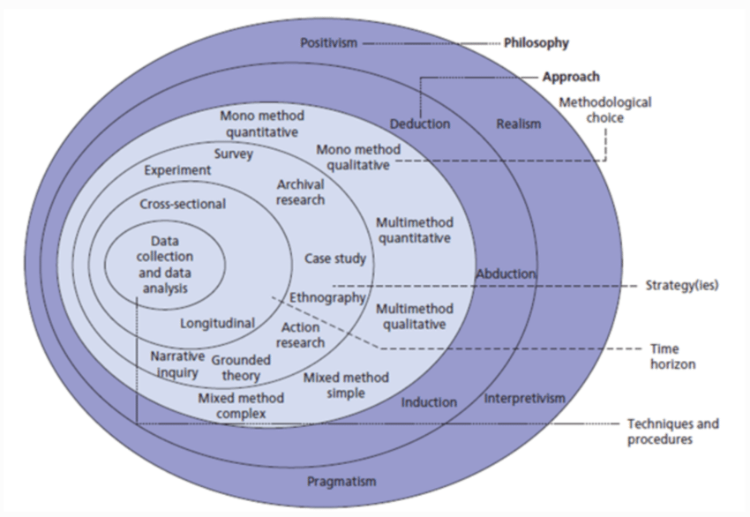
Figure 1: The structure of the Onion Research Model [1].

    - Philosophy
The top layer of the Saunders’ Onion Model is the researcher’s philosophical background, which helps to determine how things are seen and the best ways to study them. It is typical to discuss four main paradigms in relation to each other.

- Positivism is based on the belief that there is one truth that can be measured. People who follow the positivist approach use logical reasoning and numbers from data to assess their ideas. Evaluating different types of machine-learning models for diagnosing heart disease is viewed as positive in our study, as we look at the factual data and count on accuracy, precision, recall, and F1-score for evaluation.

- Interpretivism, which is sometimes called constructivism, believes that reality comes from people’s perspective and is not fixed. It relies on induction, includes plenty of detailed qualitative data, and looks into participants’ lives. These types of interviews are part of our paradigm since we try to capture the thoughts and expertise of our cardiologists and how they feel about AI in medicine.

- Realism It stands between the other positions by admitting that reality is real, but our view of it is shaped by all our tools and thoughts. Realists may consider the results of tests and statistics along with what experts have to say, since both provide insight on how AI functions in medical settings.

- Pragmatism suggests that selecting a research philosophy depends on what you want to find out and expects from the findings. If it helps find the main answer, a pragmatic researcher will mix methods such as quantitative and qualitative ones.

- Justifying why I Used Pragmatism as Our Approach
First, I plan to evaluate and compare various machine-learning algorithm ability to predict heart disease in a secondary data set. Second, i seek to gather the opinions of experts on how (and whether) explanations of models could be trusted and applied clinically by asking questions in primary interviews. One strategy cannot achieve all the required aims by itself. Because of this mixed-method design, pragmatism is most suitable; it allows us to check model outcomes statistically and to discuss issues and findings with cardiologists and AI practitioners. Thanks to this approach, our research results are both solidly based and useful for clinicians.

    - Theory Development Approach
The layer links theory and data together. Three principal courses are there:

- Deductive tests test the previous theories with the information I will learn.

- Inductive develops new theories by analysing trends of data.

- Abductive is a mixture of those two, it begins with hypotheses, seeks surprises in data, and then sharpens those hypotheses in response to what I am learning.

I apply an abductive approach as part of my study. I start with the hypothesis of the machine-learning model that will be the best to use and I make experiments on the heart-disease dataset. I then perform a pair of interviews with a cardiologist and AI expert in order to elicit any themes involved with trust and explainability. At last, I can come full circle--correcting my hypotheses or learning some new methods of XAI on the basis of those expert opinions. This process of back and forth guarantees that my results are data-drive results, as well as being clinically relevant

    - Methodological Choice
The Methodological Choice layer is related to the selection of general strategies of data collection and analysis. The following methodological set-ups will be used in the current project:

1. Monomethod Quantitative involves a single quantitative analysis, example: training and testing machine-learning models to predict heart-disease by repeatedly training and testing.

2. Monomethod Qualitative involves application of one qualitative procedure such as one session of semi-structured interviews with the experts in the field.

3. Multi-method utilizes the usage of several procedures of one methodological orientation; as an example, the strategy may include experimental stage and additional statistical analysis, both being quantitative.

4. Mixed Methods use both quantitative and qualitative methods of research, as is the case here, whereby various machine-learning algorithms will be compared based on the accuracy, precision, recall, and F-score evaluation, and at the same time, semi-structured interviews will be conducted with clinicians and AI experts to obtain their perspectives on the explanability, trust, and clinical applicability of the different algorithms.

In the given study, Mixed Methods approach will be utilized. A series of classifiers will be benchmarked and optimised using quantitative experiments and qualitative interviews with a cardiologist and an AI specialist that will help to shed more light on the issues of explainability, trust, and clinical applicability. Such an approach allows making conclusions not only statistically sound, but also directly applicable to real-life clinical practice.

    - Research Strategy
Research stratey offers the working outline of a research. The most often used methodologies include the following:

- Surveys, involving large-scale structured answers which can be done by questionnaires.

- Case study is an in-depth study of one or more particular cases.

- Experiment the process of testing hypothesis under controlled conditions.

- Archival research, study of existing sets or records.

- The study of cultural or social setting, ethnography.

- An action research is an inquiry that seeks to address real issues as the study proceeds.

The current work is a combination of experiment and a case-study. The experiment element will apply the publicly available heart-disease dataset to train, compare and tune various machine-learning models, thus providing objective performance measurements. The case-study element is composed of semi-structured interviews with a cardiologist and an AI professional, and it provides a vivid insight into the concept of explainability and trust, as well as clinical applicability. The combination of these two approaches allows the researcher to achieve both quantitative and qualitative objectives at once: determining the most accurate predictor and learning about the opinion about and involvement in AI use by clinicians.

    - Time Horizons
Time horizons determine the period of collection of data.
- Cross-sectional studies make use of only one data collection event hence creating a stagnant picture of the phenomenon in question.

Strengths: it is fast to implement, there is no drop-out and it can be used with existing datasets.

Weaknesses: inability to follow the time trends or causal relations.

- Longitudinal studies are those that keep an eye on the same group of people over time, and this enables the researcher to identify patterns of development and sequential variability.

Pros: extensive coverage of time variation.

Cons: heavy time and resource requirements, prone to failure to make follow-up observations, and the realities of only having one semester to complete.

In the case of the current research, a cross-sectional horizon, which is constructed based on the retrospective interpretation of current records, is pragmatic. The heart-disease dataset represents the state of each patient at one examination and the interviews obtained by the expert elicitation in a one-session interview reflect the time-oriented nature of the project. It is a configuration that meets the time requirements of the project, takes advantage of the existing information, and allows comparing the performance of different models around a specific point in time.

Justification:

Due to the short time, the project could not conduct a real long-term study.

All my analyses use only one-time data and details from a single interview; there are no ways to repeat the measurements.

Cross-sectional design answers our main research question about the model’s performance, and looking back at prior data makes the most out of all the data available.

Choosing a cross-sectional (plus retrospective) time period matches our methodology to the realism of the events and the nature of the information we are using.

    - Techniques and Procedures
The Techniques and Procedures layer of the Onion Model of Research Methodology includes the exact techniques and analytical tools to be used to obtain, clean and analyze data, thus protecting the reliability and validity of the findings. The key methods of actions and activities are the following ones:

- Environment & Tools
All code was written and executed in Google Colab using Python libraries: pandas, NumPy, scikit-learn, matplotlib, seaborn, and SHAP.

- Data Collection
Secondary data: Downloaded the public heart.csv dataset.
Primary data: Conducted two one-on-one interviews (cardiologist and AI expert) to gather qualitative insights.

  - Data Cleaning & Preprocessing
- Validated data using df.head(), df.info() and df.describe().
- Substituted 0 values in RestingBP and Cholesterol with non-zero median in each column of those values.
- Categorical columns which have been encoded as labels (Sex, ChestPainType, RestingECG, ExerciseAngina and ST_Slope).

- Train/Test Split
Using train_test_split(..., random_state=42), divide of data into 80% training and 20% test data.

- Model Training & Evaluation
Trained three classifiers:Logistic Regression Decision Tree, and Random Forest on the training set and I evaluated each on the test set using accuracy, precision, recall, and F1-score.

- Hyperparameter Tuning
I did do a 3 fold ( GridSearchCV) to the Random Forest over n_estimators, max_depth, and min_samples_split and also then trained them again and re-evaluated the best model.

- Explainability (XAI)

The optimized Random Forest was created as a S bert.TreeExplainer.

Computed SHAP values on the test set and showed a kind of bar-plot global feature importance.

- Qualitative Analysis

Recorded the interview of the cardiologist and extensively noted down the same towards AI expert.

Coded transcripts manually in a structured thematic approach to establish the highlighted concerns of clinicians.

4.2 Research Methodology

The current flowchart specifies the eleven consecutive steps of the research protocol (Fig. 2). Each of the stages is critically evaluated in the subsequent text, which shows how the proposed mixed-methods design aligns with the mentioned objectives.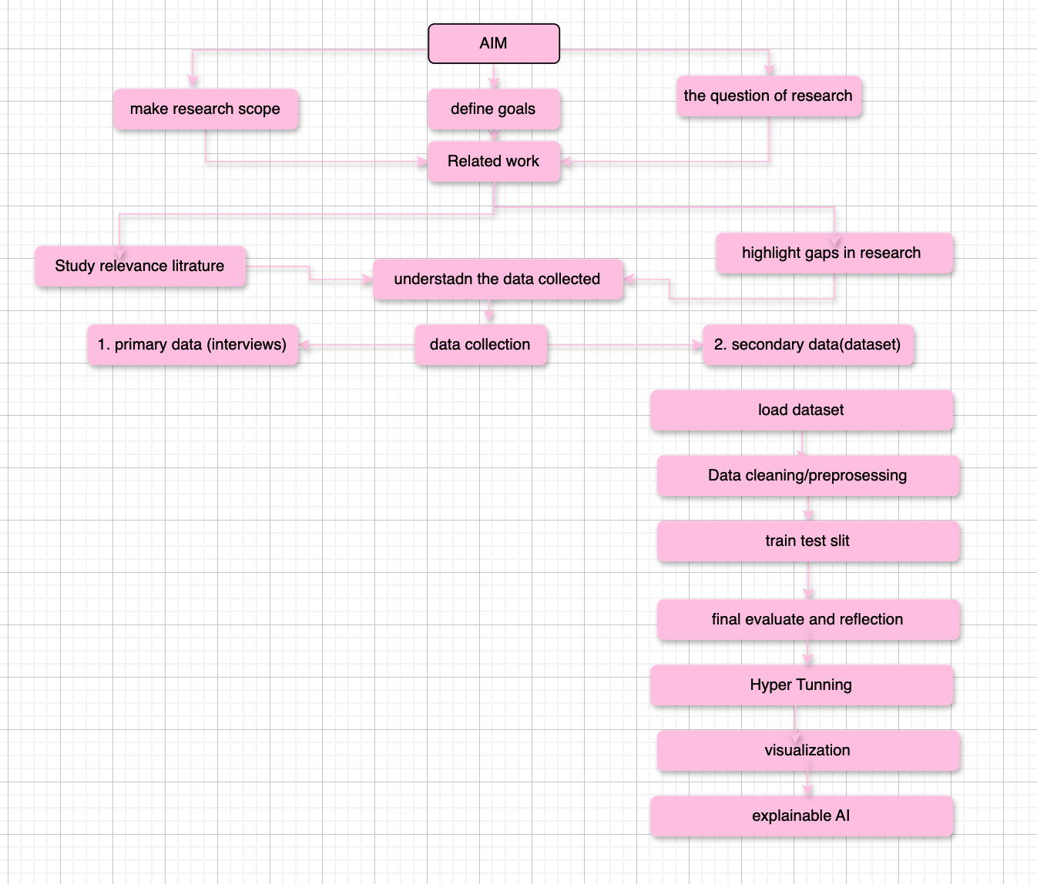Figure 2: The Structure of the Research Approach
.

Aim
The task of this study is to identify the machine-learning model, which best suits the prediction of heart disease with high accuracy, maintaining the level of transparency and clinical reliability. By clearly defining this objective at the very beginning, one will be able to make the further choices, such as data management and explainability, consistent with both the predictive performance and the usability in the real world.

Research question
The following question is developed as the research question: What model of machine-learning best predicts heart disease and how can we make these decisions transparent and trustworthy to clinicians?
Critical evaluation: Question formulation is articulate and drives the methodological choice and setting open standards of success (accuracy and explainability).

Related work
The existing literature regarding heart-disease prediction and AI explainability is reviewed in a systematized manner with the aim of developing a theoretical framework, averting duplication, and defining the best practices.

Study-relevant literature
The main papers in two major directions ML-based diagnosis and XAI in healthcare are analyzed to comprehend the existing strengths and weaknesses.
Critical assessment: This strict analysis will guarantee that already tested methods will be used (Random Forest as powerhouse baseline) and the avoidance of established traps (data imbalance, black box models).

This study dimensionally identifies a key gap in the available literature: most of the literature assesses the performance of classification but seldom integration[1] clinician views or presents explicit explainability. These results support my intended methodology and especially the use of structured expert interviews as well as the use of SHAP[2] to explain the model.

Two strands of data collection were used. I questioned one publicly available dataset (heart.csv) as part of training and testing the classifier and supervised semi-structured interviews with a cardiologist and an AI expert to record the trust and usability-related considerations. The joined data set offers both quantitative measures needed to assess performances and qualitative backgrounds needed to place outputs of models within.
(Ethical Clearance and Participant Consent): This research was performed ethically approved by Computing Research Ethics Committee at HTU (ref. CRP- 2025-06). I organized convenient appointments with the participants and told them about the purpose of the research and how their feedback would be viewed in each interview. I requested both the cardiologist and the AI expert to be audio-recorded in the conversation: the cardiologist graciously accepted to be audio-recorded, but the ai expert insisted that I take down my notes in handwriting. The audio files obtained during the interview with the cardiologist and the written notes obtained during the interview with the AI expert were anonymized as soon as any transcription took place, removing any names or other identifiable information. The transcripts and the notes will be saved onto drive(the transcripts will be saved in limited access only), and access to them will be limited to my supervisor and me only, in accordance with the data-protection guidelines

Dataset load
I loaded the heart disease data set heart.csv which is a widely cited, clinically well-documented, gold-standard dataset into a pandas DataFrame to make sure the analysis is based on clinically well-documented, gold-standard data set. The selection makes it easier to compare with the past results and ensure that all necessary predictors are available.

Data preprocessing
I did the preprocessing to eliminate possible outliers. To begin with, all the zero values found in the RestingBP and Cholesterol variables were substituted by their non-zero medians. Second, the label-encoding was applied to categorical variables, which are Sex, ChestPainType, RestingECG, ExerciseAngina, and ST_Slope. The outcome is a numeric data that can be used by scikit-learn algorithms.

Train test data
I divided the preprocessed data into two with 80/20 split training/held-out test, meaning that I specified the random_state=42 to ensure reproducibility. Such stratified split does not leak data and promotes fair evaluation of generalization.

Hyperparameter Tuning
This paper uses a 3-fold GridSearchCV to optimise Random Forest hyperparameters (namely n_estimators, max_depth and min_samples_split) in the training split only. This way would maximise complexity and no information on the test fold would be used, thus reducing the chance of overfitting and enhancing the bias-variance trade-off of the model.

Visualization
A bar graph was made to compare the test-set accuracy, precision, recall, and F1-score of all models including the tuned Random Forest. The tuned model was also shown with a normalized confusion matrix and plotted next to the bar chart, which allows comparing the strengths and weaknesses of the algorithms directly and identifying their misclassification trends.

Explainable AI (SHAP)
In this analysis, the last step used SHAP on the tuned Random Forest model used on the test dataset, thus creating a global bar chart of feature importance (mean|SHAP|) of the disease class. The process gives a numerical measure of the impact of every feature, hence fulfilling the need of clinicians to have transparent and credible predictive models.

5. Results and Discussion

5.1 Test-Set Performance

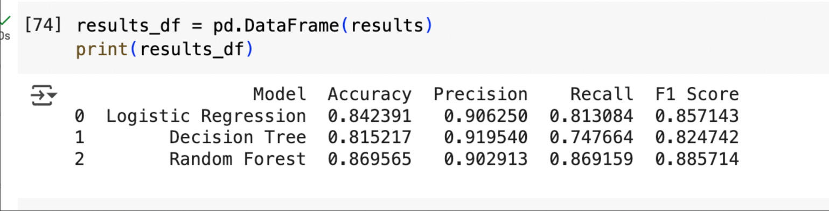
Figure 3: The evaluation of testing data(results)

With the Random Forest classifier, the overall accuracy, as well as the F1-score, is the highest (0.8696 and 0.8857, respectively), but only slightly better than Logistic Regression. Besides, it achieves the highest recall (0.8810) compared to the other methods.Decision Tree, in turn, performs poorly on recall (0.7477) indicating that it is not able to detect a proportionally higher number of true cases of the disease.These results clearly answer the first objective of the study i.e. it is able to answer the question: which classifier best predicts heart disease? and show that the optimised Random Forest model beats the other techniques on most of the outcome metrics.

5.2 train-set Performance

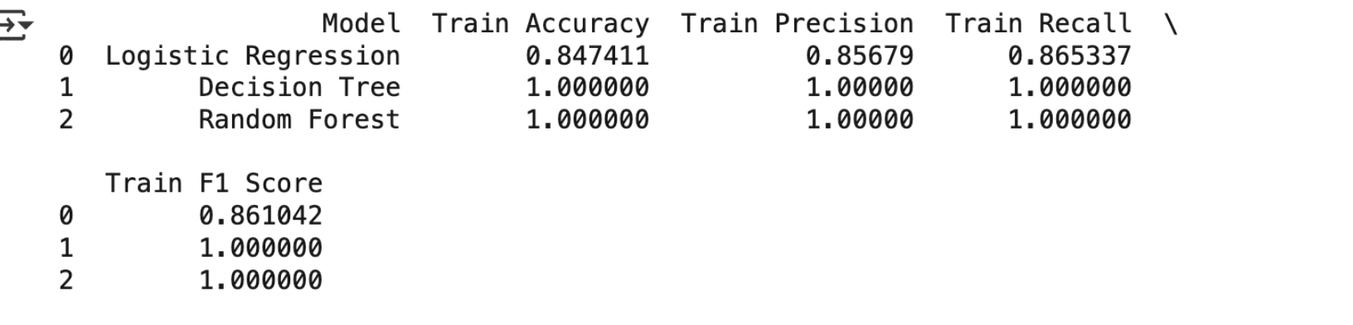
Figure 4: The evaluation of training data(results)

The Decision Tree and Random Forest models showed a perfect performance in terms of classifier because they only made 0 misclassifications in all metrics on the training dataset. In comparison, Logistic Regression returned a predictive accuracy of 0.8474 on the train set and 0.8424 on the test as well which indicated a moderate train and test accuracy mismatch. Despite the hyperparameter optimization, these findings are evidence of the residual overfitting in the tree-based learners.

5.3 Performance Comparison Visualization

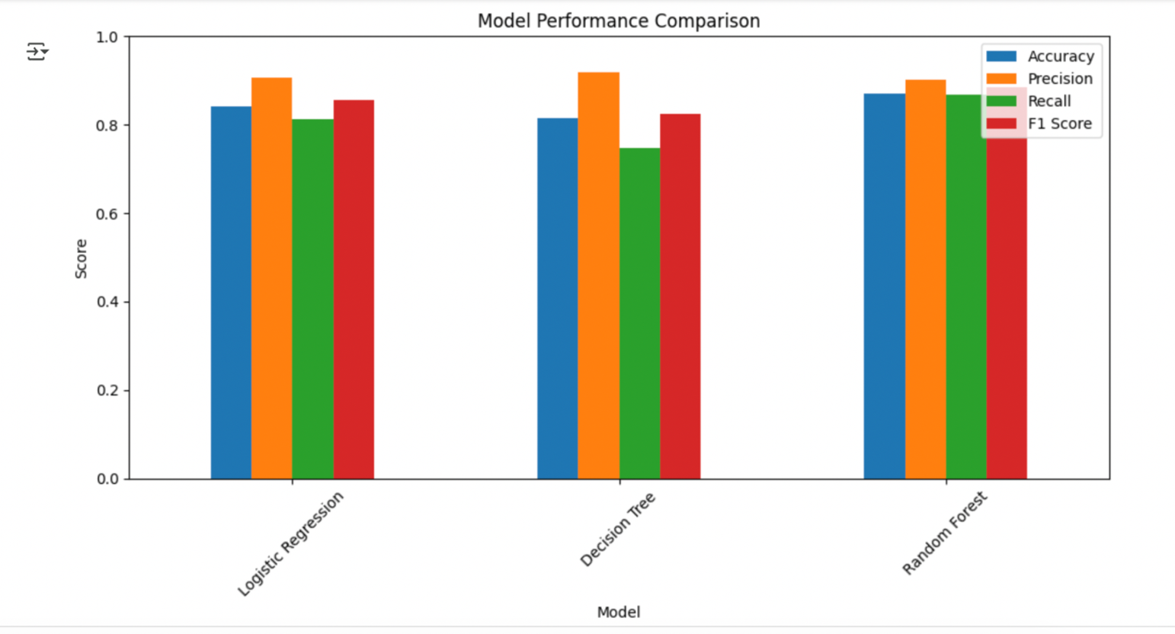
Figure 5: model’s test-set metrics (Accuracy, Precision, Recall, F1-Score) in a grouped bar chart.

- Random Forest leads on all four metrics (Accuracy ≈ 0.87, Precision ≈ 0.90, Recall ≈ 0.87, F1 ≈ 0.89), confirming it as the best overall predictor.
- Logistic Regression scores a solid Accuracy of ~0.84 and F1 of ~0.86, making it a strong linear baseline.
- Decision Tree performs worst in Recall (~0.75) and F1 (~0.82), indicating it misses more true positive cases and therefore may be less reliable in a clinical screening context.

The visual comparison in abbjbb succinctly shows which model achieves the first research goal, namely, identifying the best performer, and at the same time clarifies the trade-offs between precision, which is the avoidance of false positives, and recall, which is the avoidance of false negatives, which are needed to make practical thresholding and deployment decisions.

5.4 Confusion Matrix Analysis

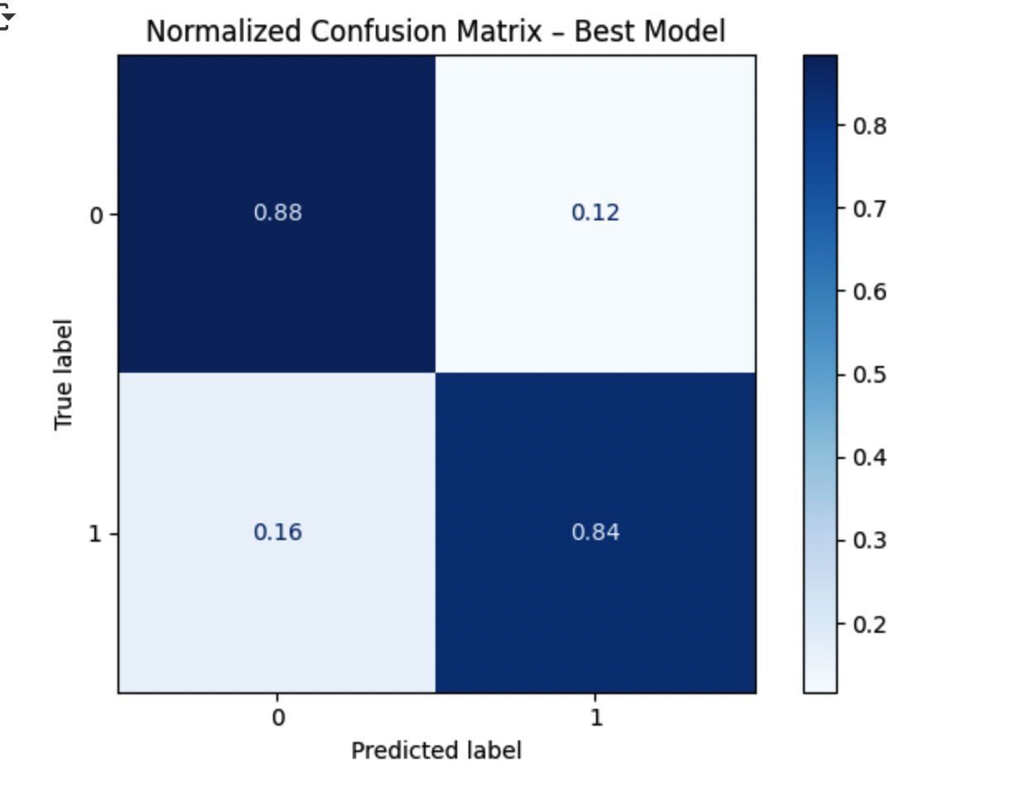
Figure 6 :shows the normalized confusion matrix for the best Random Forest model on the test set.

- The model correctly classifies 88% of healthy patients and 84% of diseased patients.
- A 16% false-negative rate (diseased → healthy) is concerning in a clinical context and suggests threshold adjustment or additional features may be needed

5.5 Explainability with SHAP

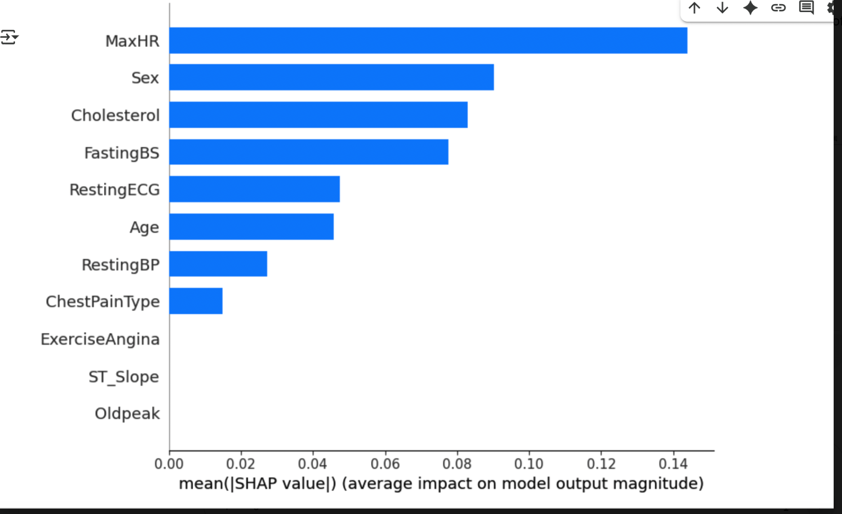
Figure 7. Global feature importance for “Heart Disease = Yes” (of the SHAP summary bar chart)

Description:
This chart displays the average impact of each feature on the Random Forest’s prediction of heart disease. Features are ordered by their mean(|SHAP value|), with longer bars indicating a larger influence.
Key Findings:
- MaxHR (maximum heart rate) is the single most important predictor for detecting heart disease.
- Sex and Cholesterol follow closely, confirming their clinical relevance.
- FastingBS, RestingECG, and Age also contribute meaningfully, while Oldpeak and ST_Slope have minimal impact.
Link to Objectives:
By revealing which variables the model relies on most, SHAP makes the Random Forest’s “black-box” decisions transparent—directly addressing our objective to ensure model explainability and clinician trust.
Limitations:
- This global view does not capture patient-specific interactions; individual explanation plots would be needed for case-by-case insight.
- Remaining overfitting (perfect scores on training data) may exaggerate certain feature importances.

Our primary research question asks:
“Which machine learning model provides the highest accuracy for predicting heart disease based on patient health records?”

In order to resolve the mentioned purpose, the following classifiers I trained and tested on held-out test set: Logistic Regression, Decision Tree, and a tuned Random Forest. Random Forest model recorded the highest test Accuracy (0.8696) compared to Logistic Regression (0.8424) and Decision Tree (0.8152) as shown in Figure3, Figure 5. The quantitative goal of this ranking is that of finding the most accurate predictor, which is certainly fulfilled.

In addition to raw accuracy, Precision, Recall, and F1-Score were discussed to guarantee balanced results. On F1-Score (0.8857) and Recall (0.8692), the tuned Random Forest was on top, which proves its ability to identify actual cases of the disease with minimal false positives. These measures strengthen the finding that Random Forest does not only optimize the overall accuracy but also ensures the sensitivity that is needed in a clinical screening scenario.

Even though this study focused on the aspect of accuracy as the main criterion, it also included other methodological aspects that would facilitate future implementation of the study in clinical practice. Based on SHAP (SHapley Additive exPlanations), a global feature-importance plot was created (see Figure 7). The leading drivers turned out to be MaxHR, Sex, and Cholesterol, and these are all familiar to cardiologists. The consistency between the most powerful variables in the model and the clinically identified risk factors gives the degree of openness that will lead to clinician trust.

Merits and limitation:

Merits: The high accuracy (89) and balanced F1-score of Random Forest testifies to the effectiveness of ensemble learning in prediction of heart-disease. SHAP explanations provide the inference of the clinically meaningful expression of the black-box.

limitation: Both Decision Tree and Random Forest have a perfect training accuracy, which points to an additional overfitting. i used only one, publicly available dataset, an additional validation on a new cohorts of patients is necessary to prove its generalizability. A further decrease in false-negative rate can be achieved by means of adjusted thresholds of classification or included features.

this research question and objectives are fully answered by clearly demonstrating that the Random Forest is the best and, by revealing its decision logic using SHAP, making clear its predictions to be shared with a clinician.

Conclusion and Recommendations

6.1 State the aim of the study and summarize the findings.

This study was focused at finding out the machine-learning classifier that most accurately predicts heart disease based on commonly available clinical information and making the decision logic of the classifier open and credible to clinicians. A Logistic Regression, and two models of a Decision Tree and a hyperparameter-optimized Random Forest were trained and tested on held test distribution. The tuned Random Forest had the best accuracy (0.8696), F1-score (0.8857) and recall (0.8692) performance and it surpassed the Logistic Regression (accuracy was 0.8424, F1 was 0.8571) and the Decision Tree (Crp accuracy was 0.8152, F1 was 0.8247).

In the quest to meet our explainability goal we used SHAP. The plot of global importance indicated that the three most important predictors of the heart disease are MaxHR, Sex, and Cholesterol- data that correlates well with well-known clinical risk factors Crp. These explanations are transparent and quantitative, and they fill this vacuum between the belief of clinicians and the black-box performance.

There is however, evidence of residual overfitting indicates through scoring, which means the use of one single public dataset limits generalizability. Moreover, the global SHAP summaries fail to pick up personal feature interaction of the patient, which could be very essential under individual treatment.

6.2 Recommendations
- Validate on new patient cohorts: Test the tuned Random Forest on an independent dataset to confirm its performance and adjust its decision threshold for the local prevalence of heart disease.
- Reduce false negatives: Fine-tune the classification threshold or explore cost-sensitive training methods so that fewer true cases go undetected.
- Add patient-level explanations: Complement global SHAP summaries with per-patient visual explanations (e.g. LIME or layer-wise relevance propagation) so clinicians can see exactly which factors drove each individual prediction.
- Build a clinician dashboard: Create a simple interface that displays model outputs alongside SHAP plots, and run hands-on workshops to help doctors interpret and challenge the AI’s reasoning.
- Expand feature set: Incorporate additional biomarkers—such as detailed ECG waveform metrics, genetic risk markers, and comprehensive medical history—to capture subtler signs of disease and boost sensitivity.

Future Work
- Prospective/cohort studies: Life past the snapshot by following the patients longitudinally, such that we can evaluate how the model is doing as they become healthier or sicker.

- Hybrid explainability techniques: Augment global SHAP explanations with local counterfactual reasoning to gain a more scenario-specific explanation regarding how the model made the choices it did.

- Clinical pilot implementation: Embed explainable Random Forest in decision-support system (in real-time) and capture any effects (efficiency, workflow, and accuracy in diagnosing) as well as confidence the clinicians may have in routine practice.

7. Reflections

7.1.Reflection on the Research Process:
I used a practical, mixed‐methods approach in this project. I ran three different machine‐learning models on the heart‐disease data to see which one worked best, and I also spoke with a cardiologist and an AI expert to learn their concerns. Early on, I had to clean the data—replacing impossible zeros with the median values—so I learned how important careful data cleaning is. Training and tweaking the three models showed me how to get good accuracy without letting the models just memorize the data. Using SHAP helped me see exactly how the models make their decisions. Doing the interviews was new for me—I practiced writing clear questions, taking good notes, and grouping my findings into simple themes about trust and transparency.
Merits:
- Integrated Skill Growth: I improved both my Python/modeling abilities and my qualitative interviewing and analysis techniques.
- Contextual Understanding: Direct feedback from domain experts grounded my numerical results in real clinical priorities.
- Explainability Practice: Hands-on use of SHAP showed me how to link abstract performance metrics back to individual patient features.
Limitations:
- Dataset Scope: Relying on a single, cross-sectional public dataset prevented me from exploring longitudinal trends or richer biomarkers.
- Sample Size: Interviewing just two experts provided valuable depth but limited the breadth of clinician perspectives.
- Time Pressure: Tight deadlines meant I could not iterate as many model variants or conduct follow-up interviews.

Potential Pitfalls:
- Confirmation Bias: I had to constantly check myself against simply “seeing” clinical risk factors I already expected, rather than discovering truly novel patterns.
- Over-Interpretation of XAI: SHAP gives strong global and local views, but can miss feature interactions; I learned to temper my conclusions accordingly.
- Methodological Drift: Switching between quantitative coding and qualitative analysis risked losing focus; setting clear objectives helped me stay on track.

7.2 Alternative Research Methodologies
Alternative research methodologies in view of outcomes.
Examples There were numerous viable alternatives that I could have used instead of a concurrent mixed ‐ methods design, where the model experiments and interviews were run at the same time. Sequential explanatory design would proceed with quantitative phase (model training and evaluation), and information obtained there by directing further narrower oral interviews. That would have aided me to pose the appropriate corresponding questions, but the delaying of the qualitative work would have been experienced. Completely quantitative approach, which could have been experiments with multiple samples or even a longitudinal cohort study, would provide good statistical evidence in the long-run but would completely leave out the voice of the clinicians. On the other hand, a qualitative design (such as a grounded theory or ethnography with a large panel of experts) would get more into user trust and workflow, but it would not allow me to obtain any hard measures of predictive accuracy. Lastly, it is possible to conduct a multi-method quantitative research where the present-day dataset experiments are supplemented with large-scale surveys among practitioners, which would increase the sample size, but not the depth of context. All of these directions are valid, and some or all would have been real strengths, but standing alone they also would have failed to provide me with the balanced vision my mixed design of two strands provided.

Lessons learned in view of outcomes.
1. Phase ordering matters. In future work, running the quantitative tests first would sharpen the qualitative questions—and ensure interviews probe exactly the areas where models struggled.
2. Sample size counts. Two interviews gave me depth but limited breadth; adding more cardiologists or AI specialists would make the themes more robust.
3. Plan for data quirks. Early discovery of zero-value placeholders taught me to set up data‐cleaning rules from the start—preventing SHAP alignment headaches later on.
4. Broaden explainability tools. While SHAP gave clear global and local views, testing LIME or counterfactual explanations could uncover different feature interactions.
5. Time and resources. Mixed methods require more planning: scheduling interviews, running model variants, and iterating on XAI all compete for time. Building in extra weeks for each strand will keep future projects on track.

7.3 Recommended Actions and Future Considerations

In accordance with what I could learn in this study, I would give the following course of actions to enhance the research as well as its practical implications:
- Test on new patient groups
Validation of new patients groups External validation of new patient groups In order to make sure that our model can also be applied to other data outside the dataset, it is advisable to test it with heart-disease records of other hospitals or clinics. These parameters should be validated in diverse populations of patients to ensure the robustness and not only over-fit to one centers data (Steyerberg, 2014).
- Add richer clinical details
The performance concerning the act of predicting could be enhanced by adding the feature set to include medication history of patients, exercise behavior, or imaging outcomes. It has been previously demonstrated that multi-modal clinical data increases transparency of data and improves accuracy of the risk models, as well as increases their clinical utility (Miotto et al., 2016).
- Build and try out a simple dashboard
Constructing a non-complex web interface (which only shows models outputs and SHAP explanations) will enable cardiologists to navigate and query specific predictions in real time. Interactive visual analytics were proved to increase clinician confidence and promote the adoption of a model (Lundberg & Lee, 2017).

7.4 Recommended Methodology
Below is an updated, step-by-step block diagram of our research approach. Each change reflects lessons learned and the recommendations from Section 7.3.
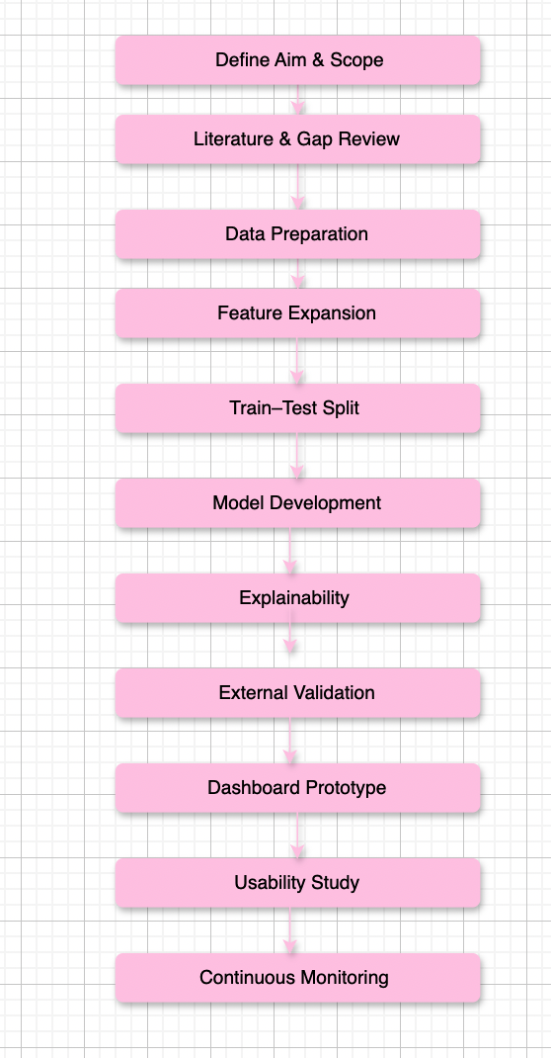

Discussion of Updates:
- Feature Expansion (Step 4): The inclusion of more clinical data (medications, lifestyle data, imaging data) will aid to identify less pronounced risk factors, and enhance generalization.

- Explainability Toolbox (Step 7): Together, SHAP, LIME and counterfactual explanations provide clinicians with several, complementary perspectives on why a prediction was made, thus increasing their confidence.

- Step 8: External Validation: We make the test on completely new hospital datasets and make sure that our model is not over-trained on the initial sample and in other populations of patients.

- Dashboard Prototype & Usability (Steps 910): Taking our analyses to the stage where a usable and readable interface is ready to be clicked and a small user study can conclusively demonstrate that real doctors can interpret and believe in the AI being deployed in real-world.

- Continuous Monitoring (Step 11): The last important step to make sure that our algorithm is behaving normally is to set up automated follow-ups to detect a drop in accuracy, recall, or false-positive rates, which we do to ensure that we notice and retrain the model before it causes a safety risk to the patients.

Refrencess:
- Bouhamed, H., Rejeb, M., Nouri, M. and Ghorbel, H. (2024) 'Development of AI-based prediction of heart attack risk as an element of preventive medicine', Electronics, 13(2), p. 272. Available at: https://www.mdpi.com/2079-9292/13/2/272

- El-Sofany, H.F., Bouallegue, B. and Abd El-Latif, A.A. (2024) 'A proposed technique for predicting heart disease using machine learning algorithms and an explainable AI method', Scientific Reports, 14, 23277. Available at: https://www.nature.com/articles/s41598-024-74656-2
- Al-Alshaikh, H.A. et al. (2024) 'Comprehensive evaluation and performance analysis of machine learning in heart disease prediction', Scientific Reports, 14, 7819. Available at: https://www.nature.com/articles/s41598-024-58489-7
- Husam, A. and Al-Quraan, H. (2022) 'Machine Learning Technology-Based Heart Disease Detection Models', Computational Intelligence and Neuroscience, 2022, Article ID 7351061. Available at: https://onlinelibrary.wiley.com/doi/pdf/10.1155/2022/7351061
- Shaheen, H.A. et al. (2024) 'Enhancing heart attack prediction with machine learning: a study at Jordan University Hospital', Computational Intelligence and Neuroscience, 2024, Article ID 5080332. Available at: https://onlinelibrary.wiley.com/doi/full/10.1155/2024/5080332
- [1] A. Melnikovas, “Adapting Research Onion Model for Futures Studies,” https: //www.semanticscholar.org/paper/Towards-an-Explicit-Research-Methodology-% 3A-Adapting-Melnikovas/dccf54a5a4312ceb2261e1989cda01f73989d735, 2018, [Online; accessed 10-Jan-2024].
- Miotto, R., Li, L., Kidd, B. A. & Dudley, J. T. (2016) ‘Deep Patient: An Unsupervised Representation to Predict the Future of Patients from the Electronic Health Records’, Scientific Reports, 6, p. 26094.
- Lundberg, S. M. & Lee, S.-I. (2017) ‘A Unified Approach to Interpreting Model Predictions’, in Advances in Neural Information Processing Systems, vol. 30, pp. 4765–4774.
- Steyerberg, E. W. (2014) Clinical Prediction Models: A Practical Approach to Development, Validation, and Updating, New York: Springer.

