Big data

Mera alsalhi
22110377
Hala AbuSalah

Activity 1 – Big Data Concepts and Data-Driven Decision Making

1.1 Introduction
{TransLogix}Solutions operatesswithin the logistics and supply-chain sector, where operational activities generate extremely large and complex?datasets from sources such as GPS tracking systems, warehouse:management platforms,:telematics sensors, and automated scanning technologies. These datasets are generated continuously and in real time, making traditional data-processing tools:inadequate for supporting effective decision making. As a result,5TransLogix increasingly relies on big data analytics and data visualization to improve operational efficiency, reduce shipment delays, and manage congestion across regional distribution hubs.
This section examines9the fundamental concepts of big data, explains the data-driven7decision-making((DDDM))process when working with9complex logistics datasets, discusses the advantages and challenges of big data adoption, and predicts the potential impact of increased big data usageoon TransLogix over the next(3)to(5)years.

1.2 Fundamental Concepts of Big Data
Big data refers to extremely6large and complex datasets that cannot be efficiently stored, processed, or analyzed using6traditional database systems. According to the course lectures, big data is commonly defined by its high volume, high velocity, and high variety, which require innovative and scalable tools7for processing and analysis. In logistics organizations such as TransLogix, these characteristics7are evident in the continuous flow of shipment data, real-time vehicle tracking information, and4operational records generated across multiple distribution hubs and transport routes.
The key characteristics of big data are explained through the 3Vs model:vvolume, velocityaand variety. Volume refers to the massive scale of data generated by TransLogix on a daily basis, including shipment schedules, delivery4timestamps, sensor readings, and warehouse transaction records. This volume exceeds the capacity of traditional systems and requires distributed storage and processing solutions. Velocity describes4the speed at which data is generated and must be processed. At TransLogix, logistics4data is4produced in near real time, meaning that shipment delays and congestion must be detected4immediately to support timely operational decisions. Variety refers to the different data formats4involved in logistics operations, which adds complexity to data management and analysis.
In addition to the 3Vs, the lectures introduce the77Vs of biggdata, which include veracity, value, variability, and visualization. For TransLogix, veracity is particularly important, as inaccurate or incomplete shipment records can lead to incorrect conclusions and poor decision making. Variability reflects changes in data patterns over time, such as seasonalffluctuations in shipment volumes or changing traffic conditions. Visualization plays a critical role in transforming complex analytical results into understandable dashboards and charts, while value is created when these insights are used to improve logistics performance and service reliability.
Logisticscdata at TransLogix is received in multiple formats, including structured data (relational tables of shispment and delivery records), semi-structured data (JSON files, system logs, and sensor outputs), and unstructured data (text-based driver reports and customer feedback). To extract meaningful insights, this data must undergo appropriate data ingestion, processing, and analytics. Data is first collected from multiple sources, then processed through filtering, cleansing, transformation, and aggregation stages before analytical techniques are applied. Data visualization tools are subsequently used to communicate analytical findings to managers and planners,ssupporting informed operational and strategic decisions.

1.3 Data-Driven Decision-Making Process
Theddata-driven”decision-making (DDDM) process provides a structured approach for transforming raw data into actionable insights. As outlined in the lectures, the process begins with purpose definition and planning, where organizations identify the problem to be addressed and the decisions that data will support. For TransLogix, this includes understanding the causes of persistent shipment delays and congestion across distribution hubs.
Following this,%data is captured and ingested from multiple internal and externallsources, such as fleet management systems, GPS sensors, warehouse scanners, and third-party logistics platforms. The data then undergoes searching, filtering, and retrieval, during which irrelevant, duplicate, or incomplete records are removed. Validation and cleansing activities are applied to ensure data accuracy, consistency, and completeness, which is essential for reliable logistics analysis.
Once prepared, the data is subjected to analysis and visualization. Analytical techniques are used to identify trends, patterns, and relationships related to shipment delays and hub congestion, while visualization tools such as dashboards, time-series charts, and heatmaps allow managers to interpret results efficiently. The insights generated through this process support operational decisions such as route optimization, resource reallocation, and capacity planning. Finally, processed data is stored for future use or archived when it becomes obsolete, completing the DDDM lifecycle.

1.4 Advantages and Challenges of Using Complex Data Sets
Using complex data sets provides several advantages for TransLogix. One major benefit is improved operational visibility which allows managers to identify congestion hotspots and high risk routes. Another advantage is better forecasting capability which supports proactive planning rather than reactive problem solving. Additionally data driven insights help align different departments by providing a shared factual basis for decisions [5].
However there are also significant challenges. Managing large volumes of data requires substantial technical infrastructure and skilled personnel [1]. Data quality issues such as missing or delayed sensor data can reduce trust in analytical outputs. There is also the challenge of interpretation where complex visualisations or models may be misunderstood by non technical users. Finally governance and compliance requirements add constraints on how data can be accessed and used which may slow down analytical processes [4] [7].

1.5 Predicted Impact of incresed big data
Based on the discussion above increased use of complex data sets is likely to have several positive impacts on TransLogix. First internal users such as planners and analysts will benefit from more accurate and timely insights leading to faster and better operational decisions. Second the organisation as a whole will experience improved efficiency through optimised routing reduced delays and lower operational costs. Third strategic decision making will improve as executives gain access to long term performance trends and predictive analytics that support investment and expansion planning [3] [5].
There are also potential negative or unintended impacts. Increased reliance on data may create skills gaps where staff struggle to interpret advanced analytics or visualisations. This could lead to over reliance on automated outputs without sufficient contextual understanding. External stakeholders may also raise concerns about data privacy and transparency especially as data collection expands across regions and systems. Additionally higher infrastructure and governance costs may place financial pressure on the organisation if not managed carefully [4] [6].
Overall the predicted impacts are closely linked to big data concepts and the DDDM process. While the benefits are significant they depend on effective data governance skilled professionals and continuous investment in data quality and usability. If these conditions are met TransLogix is likely to strengthen its data driven culture and gain long term competitive advantage.

Activity 2- Choosing Tools and Techniques of Big Data Analytics.

2.1 Statistical and Graphical Tools and Techniques Used in Logistics Big Data Analysis
In the logistics industry statistical and graphical tools play a critical role in transforming large volumes of operational data into information that can be understood and acted upon by decision makers. When dealing with shipment delay and hub congestion data these tools are used to simplify complexity identify patterns and support operational planning.
From a statistical perspective aggregation techniques are widely used in logistics analytics. Measures such as averages counts and totals allow organisations to summarise large datasets and compare performance across hubs routes or time periods. For example calculating the average delay per hub allows planners to quickly identify congestion hotspots while grouping delays by route helps highlight inefficient transport corridors. Sorting and filtering techniques are also commonly applied to prioritise critical cases such as the most delayed shipments or the busiest hubs during peak periods. These statistical operations are particularly important when working with big data because they reduce data volume into manageable summaries without losing decision relevant information.
Another commonly used statistical technique in logistics is time based analysis. By extracting features such as hour of day day of week or month logistics organisations can analyse how congestion and delays vary over time. This allows managers to identify recurring patterns such as increased delays during peak hours or seasonal congestion. In practice these insights support scheduling decisions workforce planning and infrastructure investment.
The use of graphical techniques is also significant in the communication of an intricate logistics data. Bar charts have been common in comparing average delays per hub or route as they give a visual depiction of best performance ranking. Time series data are often used in line charts to visualise the change in delays or level of congestion over time that would assist decision makers to identify trends and anomalous behaviour. Practically, the use of scatter plots is also employed in investigating the relationship between two variables like congestion index and delay time that may serve to determine whether congestion is one of the most important causes of operational inefficiency.

These visual tools in a logistics context are typically incorporated into dashboards that enable managers to view the performance at a glance. Visualisations also help in lessening the cognitive load of large and complex datasets by transforming them into intuitive forms that help a non technical user to gain insight into the situation of operations. When used together with statistical aggregation such graphical methods will guarantee that big data on shipment delays and hub congestion can be subsequently interpreted and utilized to assist in timely and informed decision making.

2.2 Assessment of the Suitability of Industry Leading Tools for TransLogix Shipment Delay Data
Very important it is when anlysing the delay of shipmnet and hub congestiond ata at translogix it is important to selet tools tht are cabaple of handling large scale logistics data while supporting clear analysis and visual comminication , industry elading tools like apache spark hadoop python R and power bi and tableau every one of them offer different stregh and limitation when used for big data
Apache spark is higly suitable for analysing Translogix the delays data because it made for distribuited processing of large datasets. Logistics data often involves high volume and high velocity especially when data is collected from multiple hubs and tracking systems. Spark supports fast in memory processing which makes it appropriate for cleaning aggregating and transforming complex logistics datasets efficiently [1]. This makes it particularly useful for handling large shipment records and congestion data that would be difficult to process using traditional tools.
Hadoop is also a big data technology that is suitable for large scale storage and batch processing. It is effective when working with very large historical logistics datasets that require long term storage. However Hadoop relies heavily on disk based processing which can be slower for interactive analysis. For TransLogix this makes Hadoop more suitable as a backend storage solution rather than a primary analytical tool when timely insights are required
Python is very well fitting to analyse and visualise the delay data on shipment because it is flexible and has a big variety of analytics libraries. It helps in statistical analysis and visualisation of data manipulation in one environment. The use of Python in the logistics sector is also popular as it enables analysts and data scientists to develop custom workflows that can be adjusted to various operational requirements [2]. This renders it a powerful option with regard to both the exploratory analysis and predictive modelling of delays.
Another analytical tool that can be utilized in statistical analysis and visualisation is R. R has good statistical functionality but is usually not as easily integrated with large scale distributed systems as Python. Scalability and end to end analytics R Scalability, integration with big data platforms R may not be as apt as Python in case of TransLogix.
Both power BI and Tableau are quite useful in visualising the logistics data and presenting insights to managers. These applications are specifically applicable in generation of a dashboard and tracking performance. In their case TransLogix would enable the decision makers to monitor trends in delay congestion level and hub performance in an interactive manner. The tools are however not used to perform heavy data processing and thus rely on pre processed and structured data through analytical platforms like Spark or Python. On the whole, Apache Spark and Python can be discussed as the most appropriate tools that should be used to analyse TransLogix shipments delay data because of the flexibility of their scaling features and analytical abilities. Power BI or Tableau can easily be used to present results without technical users whereas Hadoop and R can have more secondary or peripheral roles depending on the requirements of storage and statistics needs.

2.3 Justification of the Tools and Approaches Chosen for the TransLogix Dataset
To start with my choice of my own work on the TransLogix shimpentdataset I plan to use a combination for apache spark and python as my main analytical tools. This choice is based on the nature of logistics data the scale of the dataset and the need to support , both efficient preprocessing and clear analytical insights
Apache Spark is selected as the main data processing and manipulation tool since the TransLogix dataset is a typical big data logistics case where big amounts of shipment records have to be cleaned transformed and aggregated. Spark is an ideal fit in this since it has facilities of distributed processing and able to effectively perform grouping filtering and aggregation operations on large datasets [1]. Scalability and repeatability of the data preparation phase is made possible with the use of Spark, and it is essential when scalability and repeatability are sought during the processing of logistics data that might increase over time or be replenished regularly.
Python is selected as the primary environment of analysis and visualisation because it is flexible and supports the workflow of data analysis. Python has an extensive library of features that assist in statistical analysis, feature engineering and data visualisation that is why it can be used to investigate shipment delays and congestion patterns [2]. It can also be used to develop predictive models that is significant in the estimation of delay risk and aids in forward looking decision making at TransLogix [3].
Spark Python is especially well suited due to the separation of big data processing and analyzing the results. Spark also can be applied effectively to prepare and organise the data and python can be applied to the prepared data to give visual outputs that are easy to understand by the managers. This method minimizes the computation, and at the same time it is flexible in terms of analysis.
Such tools as Hadoop R Power BI or Tableau were not chosen as the main tools of this practical work. Hadoop is also used more in long term storage than interactive analysis as opposed to when dealing with distributed systems which R is less flexible. Power BI and Tableau are useful with dashboards but require pre processed data and will hence not be as useful as a presentation tool but assume instead as a core analytical platform
On the whole, the chosen tools and methods are adequate concerning the specifics of using TransLogix data and the aims of studying the delay of shipments and cargo hubs congestion. They promote scalable data processing reliable analysis and straightforward delivery of findings that are indispensable in data driven decision making in the organisation [5].

2.4 Planned Data Preparation Transformation and Automation Steps
To facilitate effective analysis and decision making at TransLogix I will use systematic approach to data preparation transformation and automation prior to any visualisation or modelling that should be done. The steps are necessary to make sure that the data on the shipment delay and hub congestion is accurate and consistent to be analyzed.
The initial data inspection and cleaning will form the first step. This involves the querying of duplication shipment records to determine the absence of values and also ensuring the consistency of the time related fields. Missing or wrong timestamps in logistics data may misrepresent delay computation and congestion analysis thus it is essential to address such problems at an early phase. cleaning the data set will mean that the managers are able to rely on the insights generated by subsequent analysis.
The second step will involve transformation of data. This is the transformation of raw fields into more useful analytical features including the derivation of hour of day day of week or indicators of peak period of timestamp data. Grouping and aggregation will also be used to summarise hub route and time period delays. These changes make data less complex and patterns easier to visualise and comprehend. To managers this translates to habits like frequent congestions or poorly performing hubs being determined easily.
These preparation and transformation processes will be automated to guarantee consistency and reproducibility. A workflow like cleaning and aggregation can be automated, thus making the workflow applicable each time new shipment data is available. This facilitates the provision of timely visualisation updates and minimises the chances of human error. The next application of automation is that it allows TransLogix to scale its analytics processes as the volume of data grows with time.
These transformation and automation processes are the ones that directly aid future visualisations since it guarantees that charts and dashboards are presented on reliable and well organised data. To business decision makers this means that there are better comparisons between hubs that are enhanced with knowledge of delay drivers and more confidence in making operational or strategic decisions. All these steps planned make sure that the output of analysts is technically acceptable and practically applicable in the management of logistics performance.

Activity 3 – Practical Demonstration: Big Data Manipulation and Visualization

3.1 Purpose and Context
In this activity, the authors use big data analytics to go through the TransLogix shipment-delay dataset to learn shipment delays and hub congestion in the logistics network. The work is based on Apache Spark (PySpark) to manipulate and aggregate data in a scalable manner, Python as a tool to perform visualization, and three predictive models to approximate shipment delays (delay_minutes). The resultant product is a body of evidence-based management and operational advice to TransLogix management.

3.2 Data Ingestion and First Exploration (PySpark)
PySpark (spark.read.csv) was used to load the data with the help of the header identification and schema inference parameters. It is indicative of a scalable big data ingestion strategy which can be directed at large logistics datasets. The schema output proved that the dataset has operational identifiers (shipment, hubs, routes), the timestamps (scheduled/actual departure and arrival), the performance metric (delay_minutes), and congestion indices, as well as the geographic characteristics.
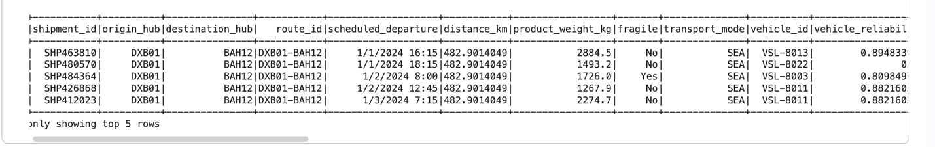

SparkSession was launched successfully.
printSchema and show (5) listings.

3.3 Data Cleaning, Preparation, and Automation (PySpark)

3.3.1 Removal of Duplicates
To eliminate the possibility of repeated shipment that would bias delay averages, hub congestion summaries, and model training, dropDuplicates() was used to eliminate duplicate records.
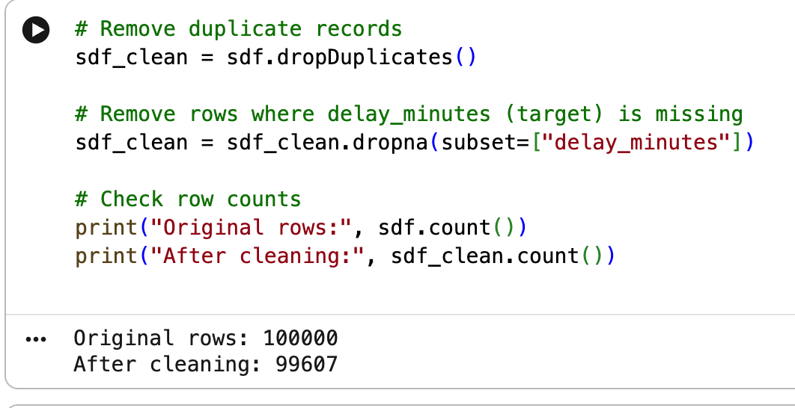

3.3.2 Treatment of Missing Values
dropna(subset=["delay_minutes]) was used to drop rows with missing values of delay_minutes as the target variable is critical to both descriptive delay analysis and the model to predict. This methodological instinct is grounded in the fact that the training or measurement of models would not be justified by the presence of the target variable (the invalidity of indicators of performance, including R 2 and RMSE).
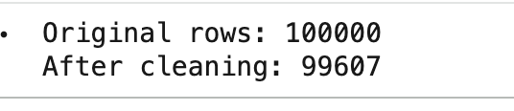
- Row-count comparison before/after cleaning (100000 → 99607)

3.3.3 Datetime Standardization and Derived Features

The scheduled de departure was initially a string, thus it was transformed into a good timestamp with explicit formats and secure parsing. ANSI strict casting was switched off to prevent a runtime error on invalid records. The rows that failed to be read were filtered to provide quality time based analysis. The derived features that were obtained after timestamp conversion are: departure_hour to facilitate analysis of hourly peak. departure weekday to facilitate the analysis of the pattern on weekdays. is weekend to compare operations on weekends and weekdays. This shows independent feature engineering in order to add analytical value to raw fields.
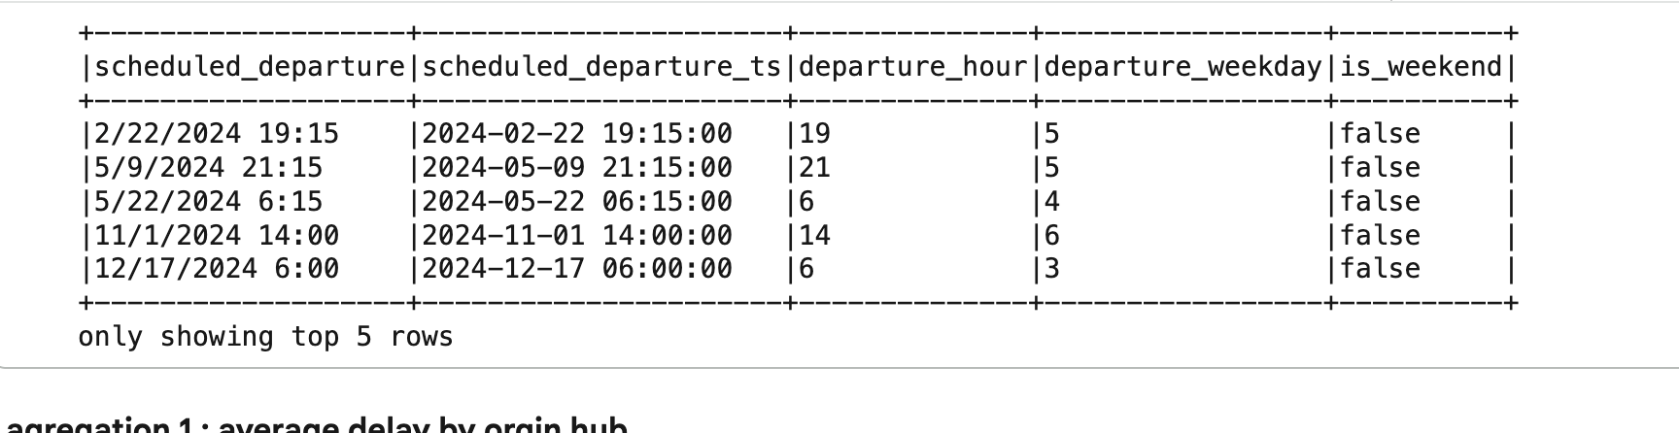
Timestap parsing cell
Proving convergesion is correct & features tthat is enginered first 5 show its correct

3.3.4. Elimination of Irrelevant / Leakage Variables (to Modeling)
In the case of predictive modeling, variables which serve as identifiers or recount post-event data (data leakage) were not allowed to the feature set. To illustrate, shipment and vehicle identifiers are not operational causes of delay and the real arrival/departure times should never be expected to cause delay among the planning times since they are not predictors but they are results. This enhances the validity of the models and operational realism.

3.4 Analytical Manipulation : Hub and Route Delay Analysis

3.4.1 Shipment Delays by origin hub.
Using PySpark, shipment records were grouped by origin_hub_name and aggregated to compute the average delay in minutes and the total number of shipments per hub. The results were ordered in descending order of average delay to identify the most congested hubs.
The analysis shows that Dubai Central Hub exhibits the highest average delay (≈ 42.87 minutes) across 49,967 shipments, followed closely by Jeddah Distribution Hub with an average delay of approximately 41.49 minutes across 24,824 shipments. In contrast, Riyadh Logistics Hub shows a significantly lower average delay (≈ 24.84 minutes) despite handling a comparable shipment volume (24,816 shipments)
my results say that congestion and delay issues are concentrated at major regional gateway hubs, particularly Dubai and Jeddah, rather than being evenly distributed across the network
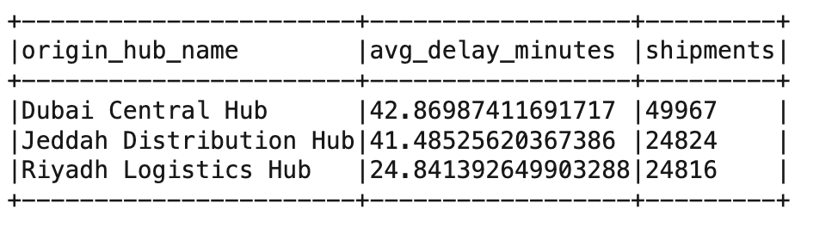

3.4.2 Route Inefficiency (Shipment Delays by Route)
To investigate route-level inefficiencies, shipments were grouped by route_name and aggregated to calculate average delay minutes and shipment counts. Results were sorted in descending order of average delay.
The findings reveal that the route Dubai Central Hub → Riyadh Logistics Hub experiences the highest average delay (≈ 43.38 minutes) across 24,916 shipments, followed by Dubai Central Hub → Bahrain Regional Hub with an average delay of approximately 42.36 minutes across 25,051 shipments. The route Jeddah Distribution Hub → Dubai Central Hub also shows elevated delays (≈ 41.49 minutes), whereas the route Riyadh Logistics Hub → Jeddah Distribution Hub records substantially lower delays (≈ 24.84 minutes).
This pattern suggests that routes originating from highly congested hubs tend to inherit delay risk, reinforcing the role of hub congestion as a primary contributor to route-level inefficiency.
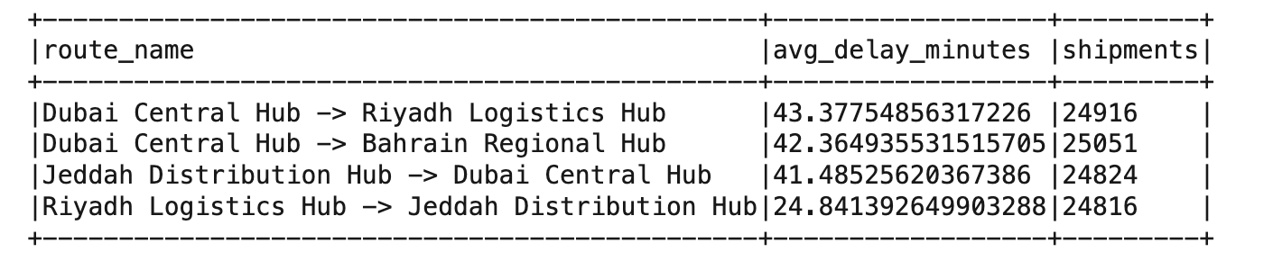
Output spark route aggregation (route delay)

3.4.3 Delays by Time of Day
The shipments were clustered by the departure hour and summed up to calculate the mean delay and volume hours. This delay is at the highest in the morning and late afternoons, which are in line with the operational peak loads and congestion impacts
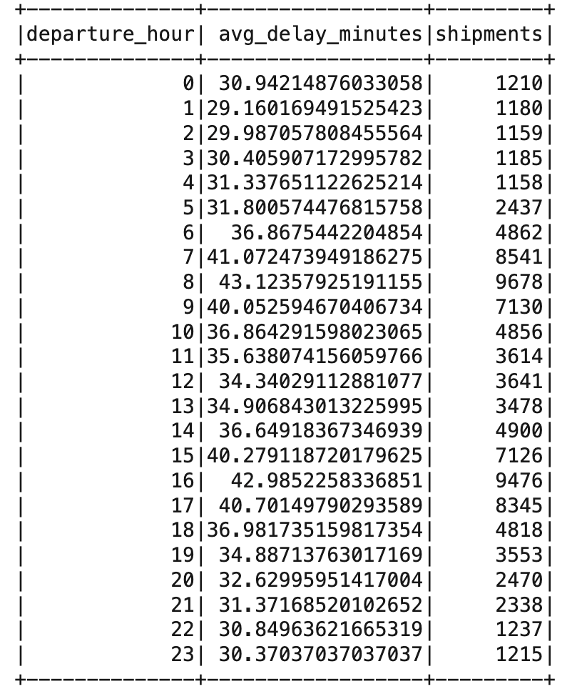
Output of hourly aggregation in Spark (hour delay)

3.4.4. Filtering (Targeted Operational Focus)
The implicit approach that was used to do this filtering was to focus on top hubs/ routes (highest average delay) and to exclude records that did not have valid target values or valid timestamps. This makes sure that valid and relevant operational evidence is used to make conclusions.

3.5 Vision (Python) and Interpretation
Six visualizations were created using Python visualization libraries (matplotlib) to draw focus to the trends in delays and congestion. All the visualizations were stored in the figures folder in the form of PNG evidence.

This chart indicates the origin hubs that add maximum average delays. Dubai Central Hub and Jeddah Distribution Hub seem to be the key areas of delay hotspots, which means the presence of congestion and capacity limitations.
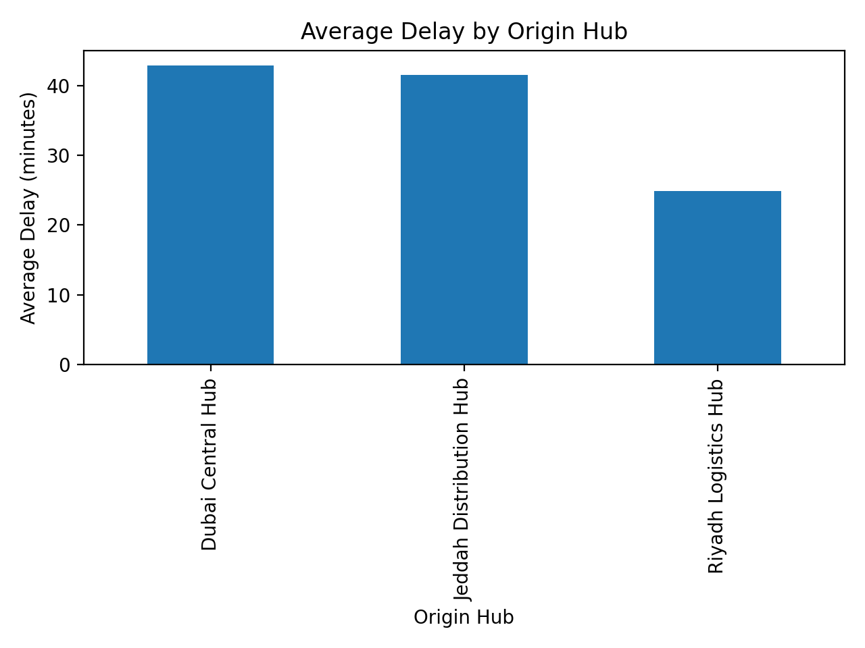
Figure 1: Origin Hubs average delay

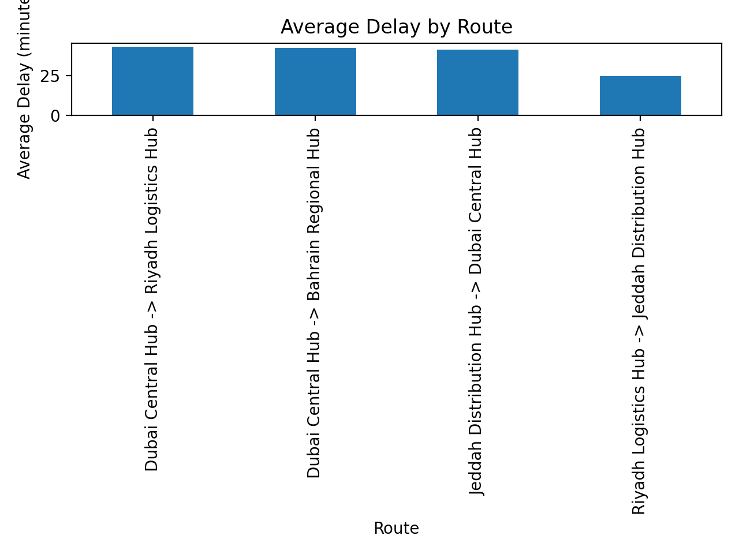
Figure 2 shows mean delay route

In this visualization, particular routes that have the most average delays are determined. Delayed routes are indicative of inefficiencies that can be caused by congestion of the hub, long-distance schedules, or friction in the cross-border operations.
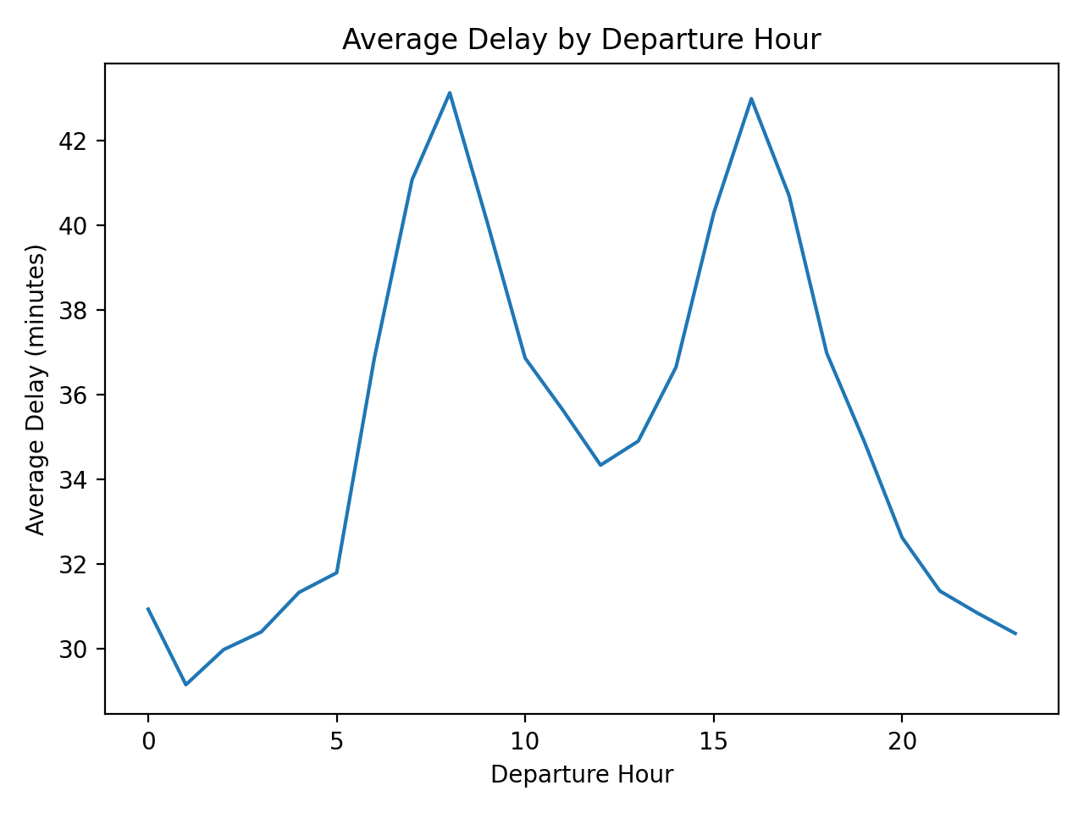
Figure 3 : Deployment of Hourly Delays on Departure.
This line chart records time of the day effects and serves to denote the most delay windows. This can be used to make operational conjectures on the highest demand and when there is congestion.
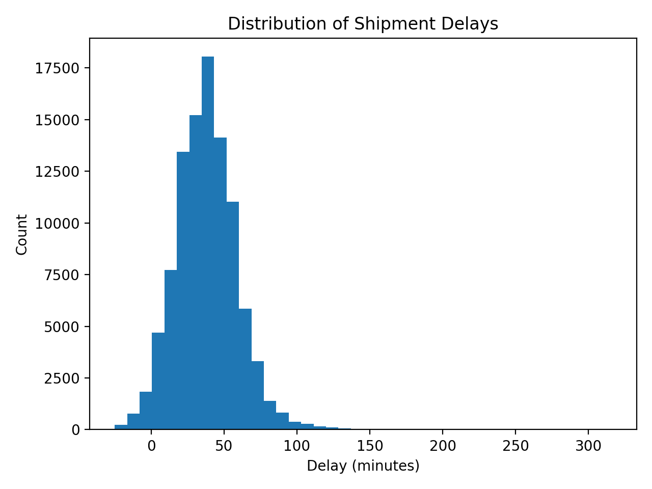
Figure 4: Delays Minutes Distribution.

This histogram depicts the delay behavior as a whole, as well as the distribution and concentration of delays. It assists in determining the occurrence of delays that are of minor nature or even extreme delays.

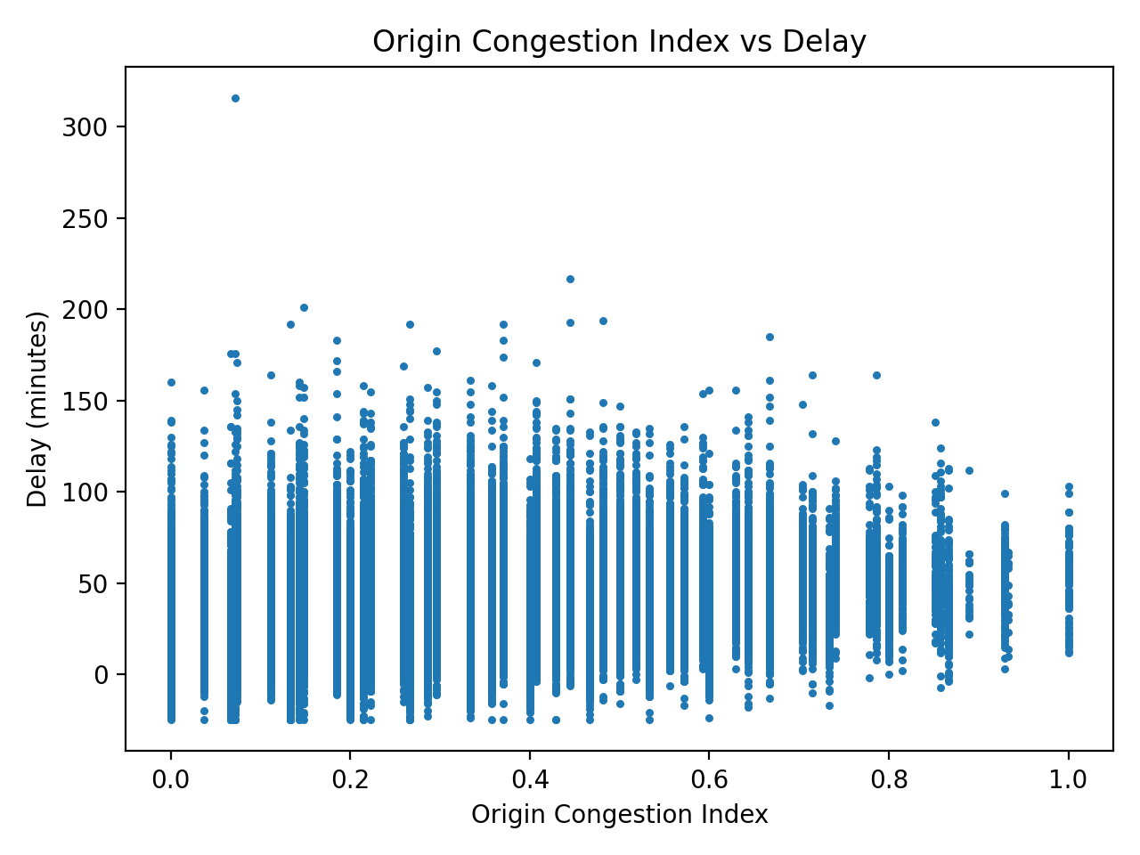
Figure 5: Origin Congestion Index Vs Delay Minutes.
The positive relationship between congestion and delay is revealed in this scatter plot, which confirms the conclusion of the operational research that congestion is a significant factor in the delay of shipments.

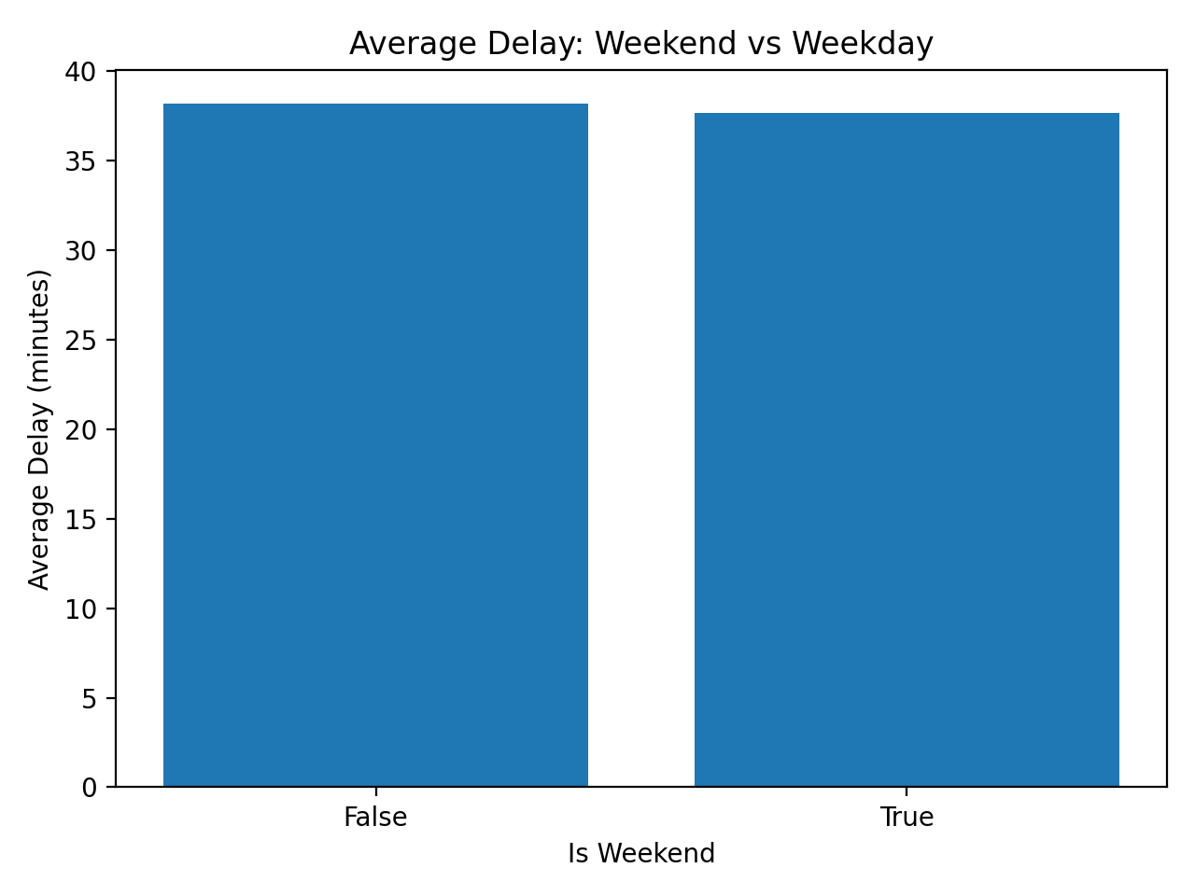
Figure 6: Comparison of weekend delay with weekday delay.
This visualization will be used to compare performance in terms of operational delay in weekend and weekday conditions, which can be used in planning to make decisions about staffing and scheduling

3.6 Interpretation of Findings and Operational Conclusions
- Through the aggregation of the results of hub-level and route-level aggregation, along with the use of temporal and congestion-based visualizations, these are some of the main causes of delays in shipments throughout the TransLogix network:

- Hub congestion as one of the main factors:
The largest mean delays are in Dubai Central Hub and Jeddah Distribution Hub which have significant volumes of shipments. This implies that the risk of delay is high at large hubs.
2. Hub/perfromance depned on route:
The routes to congested hubs (e.g., Dubai to Riyadh, Dubai to Bahrain) are always associated with more delays, which proves that routing inefficiencies are closely connected to the upstream hub situation, as opposed to individual route problems.
3. Operational timing effects:
Individual inter-hub routes are characterized by large average delays, indicating structural inefficiencies which are not random.
4. congestion delay relationshiop: The observed positive correlation between congestion indices and delay minutes confirms the fact that congestion is not accidental but systematically connected with the outcome of delay in operations.
-These results support a strategic operational intervention based on hubs, peak-hour planning and high-delay routes.

3.7 = Predictive Modeling (3 Models) + R 2 and RMSE Evaluation.
Three predictive models were developed to predict delay min:
- Linear Regression
- Decision Tree Regressor
- Random Forest Regressor
A preprocessing pipeline has been used:
- imputation of numeric variables median.
- mode imputation + one-hot coding categorical variables
To compare the performance of a model, measurement was made using:
- R² (explained variance)
- RMSE (magnitude of errors in minutes)
Observed results:
- Linear Regression: R² ≈ 0.27, RMSE ≈ 17.85
- Decision Tree: R² ≈ 0.23, RMSE ≈ 18.41
- Random Forest: R² ≈ 0.22, RMSE ≈ 18.53
Model of choice: Linear Regression (minimum RMSE and maximum R 2). The predictive performance is moderate, but this is anticipated since external factors that are not included in the data (e.g. weather, custom inspection, traffic accidents) affect the shipment delays. Thus, the model is optimally indicative delay estimation and planning-level decision support, as opposed to minute-level real-time prediction.
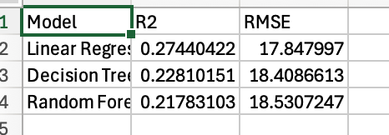
Figure 5:evidence: Table of result (R 2 and RMSE).

Figure 6: chosen favored model.

3.8 Effectiveness, Limitations, Assumptions, and Enhancements Evaluation.
Efficiency of Data Preparation and Data Manipulation.
PySpark provided an opportunity to clean, transform (timestamp) and engineer features, as well as perform aggregation on data of large scale. The automated actions enhanced the reliability through valid targets, decreased the duplication bias, and the ability to carry out time-based analysis.
Appropriateness of the Tools chosen.
- Big data Apache Spark (PySpark) was successful in large-scale manipulation and aggregation, which fits the needs of big data.
- The visualization of Python (matplotlib) was used to reflect the pattern of operation in an understandable chart.
- Scikit-learn models were used to give a usable baseline in regards to the estimation of delay using R 2 and RMSE.
{Limitations and Assumptions}
- Minimal coverage of features: The data does not cover external delay drivers like weather, time taken at the border/customs clearance, actual traffic accidents, or unforeseen disruptions.
- Stationarity assumption: Predictive models are by definition based on the assumption that historic relationships do not change over time.
- Label noise: There can be a delay data containing measurement or logging variability that mitigates predictive performance.
Feasible Enhancements
- Include external sources of data (weather, traffic, customs clearance areas) to enhance predictability.
- Add features at route level (e.g. distance bands, regional interactions, congestion combination between two hubs).
- Explore other models (e.g. gradient boosting) and use hyperparameter optimization, with tracked overfitting.
- Develop functional dashboards which will include estimated delays in anticipatory planning and capacity assignment.

3.9 Operational Recommendations based on evidence
Following the evidence of the analysis, it is proposed to recommend operational recommendations to TransLogix which are the following:
Focus on major hub congestion reduction:
Since the average delays are the greatest at Dubai Central Hub and Jeddah Distribution Hub, capacity enhancement, process optimization or redistribution of resources at these hubs would most likely cause the most significant delay reduction in the network.
Optimize high-delay routes:
The following routes like Dubai Central Hub Riyadh Logistics Hub and Dubai Central Hub Bahrain Regional Hub are to be reconsidered in terms of scheduling limitations, fleet capacity, and coordinating inefficient among themselves because they always tend to suffer high delays.
Smoothing of operation during peak hours:
Use staggered departures, more staffing or dynamic scheduling during the highest departure times to minimize delays associated with congestions.
Proactively plan through congestion indicators:
The early-warning indicators are congestion indices which may be deployed to instigate operational changes before delays spread across the network.
- Use predictive models to do planning-level decisions: The chosen predictive model can be used to help in indicative delay estimation in strategic planning and resource distribution, and it should be recognized that the predictive model has limitations in the real-time operation control.

Activity 4 - Big Data Professionals and Responsibilities in Big Data Environment.

4.1 Introduction

As TransLogix operates as a big data–driven logistics organization, its ability to make effective operational and strategic decisions largely depends on how data is collected, processed, governed, and analyzed. During my analysis of the TransLogix shipment-delay dataset, I observed that the effective use of big data is not determined solely by advanced tools such as Apache Spark or machine learning models, but also by the collaboration of multiple data professionals working within a structured data-driven environment. This activity explores the roles, responsibilities, and challenges faced by data specialists at TransLogix, reviews the data governance and compliance strategies used to manage data responsibly, and evaluates the impact of key issues on both data professionals and the organization’s data-driven culture.

4.2 Data Professionals and their roles at TransLogix
A multidisciplinary data team is usually the support of data-driven decision-making in a logistics organization like TransLogix. According to my analysis and to rely on the research conducted in the industry, I suppose that TransLogix has a range of specialised positions that altogether allow success in the uses of big data.

4.2.1 Data Engineer
The data engineer is mainly tasked with the design, construction, and maintenance of data pipelines that receive huge amounts of logistics-related data in a variety of different formats, such as shipment management systems, GPS positioning, IoT sensors, and databases of hub operations. Within the context of TransLogix, this position guarantees that raw data concerning the shipment schedules, the indices of congestion, and transit time is consistently reliably captured and stored in scalable platforms like the distributed file system or cloud storage.
The essential skills that the position demands are the knowledge of distributed computing frameworks (e.g., Apache Spark), the development of ETL pipelines, SQL, or programming languages, including Python or Scala [1]. The biggest difficulty associated with data engineering within a big data logistics setup is the management of data volume and velocity, especially when sensor data streams lack completeness or are lagging. Absence or damaged sensor information may be propagated downstream with direct impact on the accuracy of analytical results and the reliability of the model.

4.2.2 Data Analyst
The data analyst acts mostly on the processed and structured data in order to come up with insights on operational decision making. The tasks of the analysts in TransLogix are to examine patterns of delay on the shipments, create consolidated reports by hub or route, and develop visualizations that have to communicate with the management trends in congestion and performance.
This position demands a person who is analytical, knows SQL and Python as well as can interpret complex data outputs into actionable information [2]. Data quality and consistency is one of the major challenges in the job of data analysts. The absence of values and the presence of duplicate records, as I noticed when preparing data, and time inconsistencies can have a noticeable impact on aggregations and visual interpretations. Upstream data engineers frequently help analysts to be sure that before meaningful analysis can be conducted, the datasets are clean and reliable.
4.2.3 Data Scientist
The data scientist concentrates on predictive and sophisticated analytical assignments, including estimating shipment delays and determining more complicated associations between congestion, time, and operational variables. This role in TransLogix aids strategic planning by modelling delay risk estimation models that do not provide precise results. The knowledge required of the data scientists includes solid backgrounds in statistics, machine learning, and feature engineering, as well as programming skills in Python and experience with analytical libraris [3]. The major challenge in big data logistics presented to data scientists is great uncertainty and noise of the data. External factors like weather or customs inspection that are not necessarily included in internal datasets contribute to shipment delays as seen in my predictive modeling work. This constrains the predictive accuracy that can be obtained and cautions on the interpretation of model results.

4.2.4 Data Governance and Compliance Specialist.
The data governance or compliance specialist will make sure that the use of data throughout TransLogix is within legal, ethical, and organizational standards. This incorporates managing privacy of data, data access, auditability, and compliance with other laws like data protection laws. This position needs to be informed about systems of governance, compliance, and risk management [4]. One of the greatest dilemmas facing governance experts is the accessibility of the data and the protection of the data. Excessively restrictive controls can slow down the process of conducting analysis and inadequate controls expose the possibility of failing to use data correctly or not complying with regulations.

4.2.5 Data Platform Administrator and Decision Makers
Administrators of data platforms handle the technical infrastructure, such as clusters of Spark and storage systems, access control, and so on. Their duties are critical towards reliability and safety of the systems. In the meantime, the major consumers of analytical outputs are operational managers and executives. Even though they do not operate with raw data themselves, the quality of information and the credibility and clarity of the information offered by the data team are crucial to their decision-making [5].

4.3 Key Challenges Faced by Data Specialists in a Big Data Logistics Environment

In these roles, one can always face a few issues:
Data volume: The logistics organizations produce huge amounts of data in terms of shipments, sensors, and hubs, which must be processed on scalable frameworks.
Data speed: Live or near live streams of data cause strain on pipes and process systems.
Data diversity: There are structured operational records that are implemented alongside semi-structured logs and sensor feeds.
Quality of data: Missing, late or incorrect data have a direct effect on analysis and prediction.
Role dependency: Every specialist is dependent on the roles that are upstream; any breakdown in data engineering is transferred to analysts and scientists.
-These issues underscore the fact that large data issues are socio-technical, and these issues impact institutions as well as the practitioners working inside them.[6]

4.4 Data Governance, Legal and Ethical Strategies at TransLogix.
According to my presupposed role in TransLogix, I can single out a number of existing strategies applied to the preservation of responsible data governance.

4.4.1 Role-Based Access Control
The access to sensitive logistics and operational data is limited depending on professional roles. Data engineers and scientists can access data more broadly than operational users, and the possibility of misuse is less. The approach promotes accountability and is in line with governance best practice [7].
4.4.2 Secure Storage and Encryption
The data of shipments and locations are encrypted both on transit and at rest. This minimizes chances of exposure to hacking as well as commercially sensitive data.

4.4.3 Data Quality Checks and Audit Trails
The data transformations are logged to ensure data integrity and reproducibility by means of automated validation rules, cleaning procedures, and data transformations. The practices enhance transparency and inclination of trust in analytical outcomes.

4.5 Governance Strategy Analysis and Performance
The existing strategies have a number of strengths. Encryption and access control are quite effective in defending against sensitive information and minimizing the legal risk. The quality of data checks enhance the reliability of analysis and credible decision-making.
The strategies however come with restrictions. Tight access restrictions may reduce the speed of analytical operations, and data quality audits may need more computing power and experts. Encryption-is-effective-in-safeguarding confidentiiality but it does not resolve problems of lost sensor-information-or modelin,g uncertainty. Consequently, the governance practices need to be constantly checked to fine tune the efficiency, security, and analytical flexibility.
4.6 Implication on Data Specialist and Data-Driven Culture
The specified issues and governance behaviors directly affect data professionals at TransLogix. Effecttive}gouvernance systems enhance}the confidence in(data)and contribute to the spirit of responsible{decision-making}Nevertheless, they also add workload, technical demands, and inter-team coordination needs as well.
Other possible actions are:
- (Sensors)redundancy to minimize lost dataa
- Automated data ingestionnverification
- Training on governance to the technical staff, to minimize compliance friction
Although alternative costs more to implement financially and operationally, its long term benefits are better reliability of data, less rework and high confidence in decisions.

4.7 Reasoned Judgement
At my opinion, the issues encountered by the data professionals in TransLogix are both serious but can be addressed. The existing governance policies are a robust basis of secure and ethical data utilization, but they need to be modified to conform to the pressures of scale, data quality, and work demands of the professionals. As much as sophisticated governance and infrastructure development require significant investments, the gains, which include efficiency in operations, low risk, and quality of decisions, are worth such investments. Finally, it is necessary to resolve these issues to maintain the data oriented culture in TransLogix and continue to provide strategic value to the big data.

References (IEEE Style)
[1] T. White, Hadoop: The Definitive Guide, 4th ed. Sebastopol, CA, USA: O’Reilly Media, 2015.
[2] W. McKinney, Python for Data Analysis, 2nd ed. Sebastopol, CA, USA: O’Reilly Media, 2018.
[3] F. Provost and T. Fawcett, Data Science for Business. Sebastopol, CA, USA: O’Reilly Media, 2013.
[4] A. Khatri and C. V. Brown, “Designing data governance,” Communications of the ACM, vol. 53, no. 1, pp. 148–152, 2010.
[5] T. H. Davenport and J. G. Harris, Competing on Analytics. Boston, MA, USA: Harvard Business School Press, 2007.
[6] V. Mayer-Schönberger and K. Cukier, Big Data: A Revolution That Will Transform How We Live, Work, and Think. Boston, MA, USA: Houghton Mifflin Harcourt, 2013.
[7] IBM, “Data governance for big data,” IBM Documentation, 2023.

