**Aldo S.**

**MANUAL TEST PLAN 1.3 CS242SP18**

1. Open Chess1.0 Project
2. Run All Junit test (under the Tests package) and make sure all functionality works perfectly
3. To check for GUI, go to Table.Java
4. Run the main function
5. You should see the following prompt that enables you to choose which chess pieces to use. Custom chess pieces include Prince(Hovers exactly 2 tiles cross-way) and Princess (Moves 1 tiles cross-way).

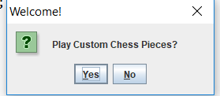

1. If you click yes, the following chess board will pop up. 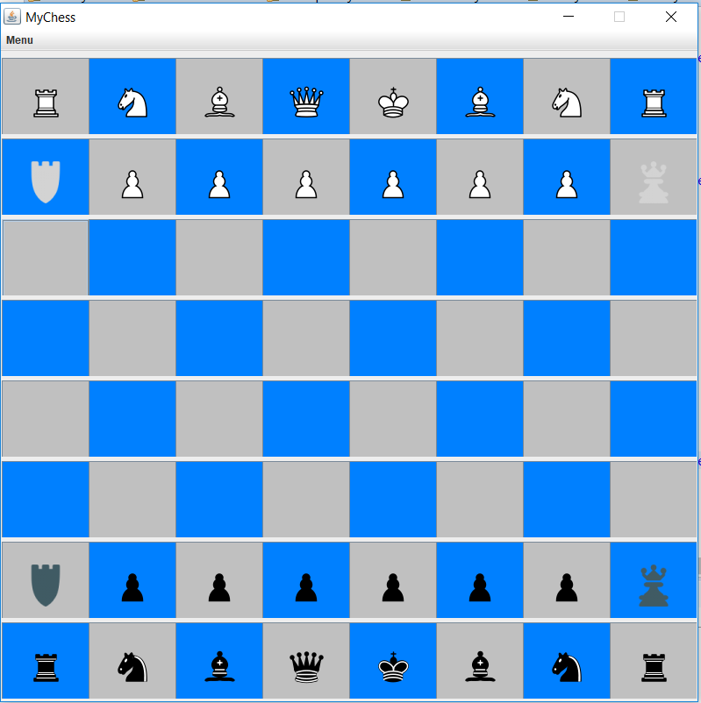
2. Otherwise, the normal chess board will appear

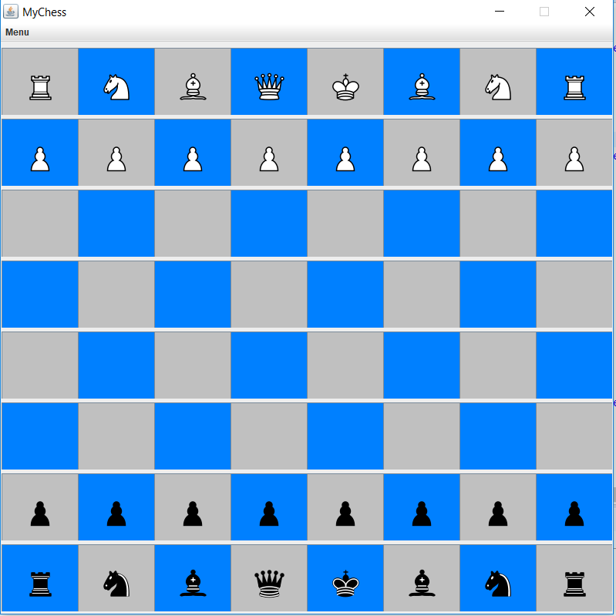

1. Before you begin, please insert each players name. You can find it in a different window. It will appears like the following:

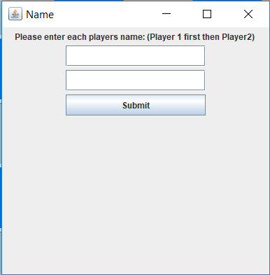

1. Type each name in the box and click submit.

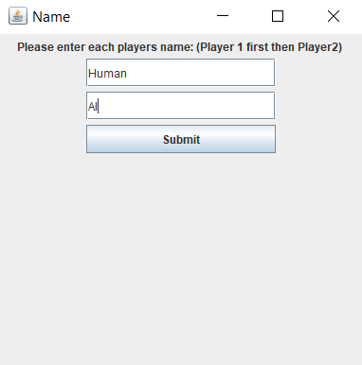

1. To check if it’s saved, go to Menu 🡪 Scores. The following window should appear:

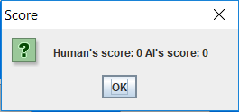

1. Player 1 will be assigned as White, and Player 2 will be assigned as Black. And White will go first.

1. If you think you made a mistake and wanted to Undo, you can go to Menu🡪 Undo.

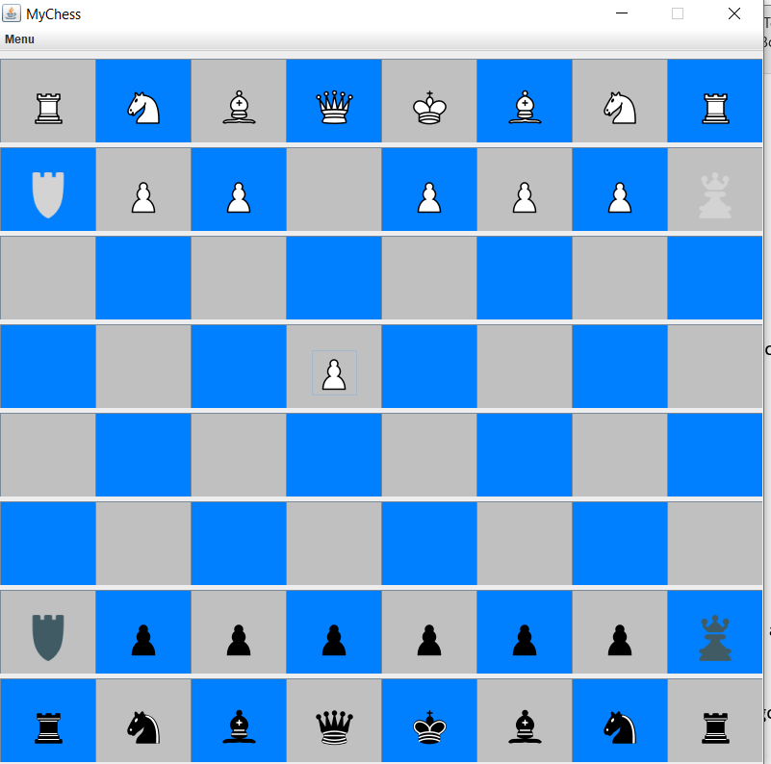

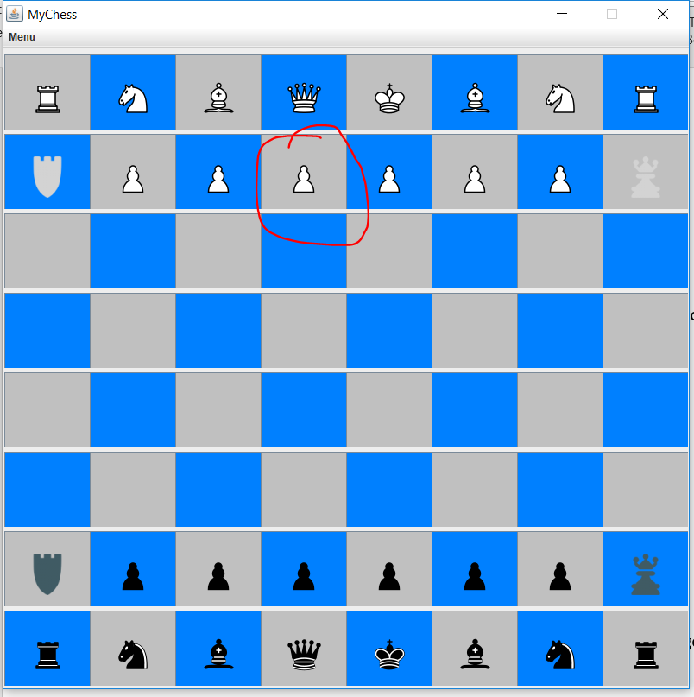

1. To forfeit a game, go to menu->Forfeit game and check if your score is increased. And name stays the same.
2. To start a new game, go to menu->New game
3. To quit the game, go to menu->Quit and you’re all done!