ANALYSIS PHASE DIAGRAMS

*of*

WEB BASED MUSIC COMPOSING SOFTWARE

*By*

**TEAM 2:** *Musical Knights*

10IT02 Abhay Ramesh Chennagiri

10IT13 Aniruddha R C

10IT62 Prajwal R Prasad

10IT75 Remya Kannan

10IT106 Suresh Alse

**CONTENTS**

Analysis Overview……………………………………………………………………….…..3

Diagram depicting functionalities provided………………………………….…..4

Login……………………………………………………………………………………………….5

Sound Creation………………………………………………………………………………..6

Record…………………………………………………………………………………………….7

Play….....................................................................................................8

Save………………………………………………………………………………………………..9

Share…………………………………………………………………………………………….10

Unshare…………………………………………………………………………………………11

Search……………………………………………………………………………………………12

Delete……………………………………………………………………………………………13

Tutorial………………………………………………………………………………………….14

E-R diagram……………………………………………………………………………………15

**ANALYSIS OVERVIEW**

This project involves a procedural approach for both front end and back end. We mainly use Javascript at the back end. We also use PHP, MySQL, AJAX and YQL languages. Though we follow a procedural structure, Javascript is a language which treats all elements on the client side as objects of predefined classes like buttons,images,etc..We do not define any custom classes.

In this document, a schematic diagram representing the various functionalities provided to the user is shown. Flow chart diagrams for the events and functions are shown subsequently. The entity relationship diagram(E-R diagram ) is given at the end.

**Diagram depicting various functionalities provided to the user**

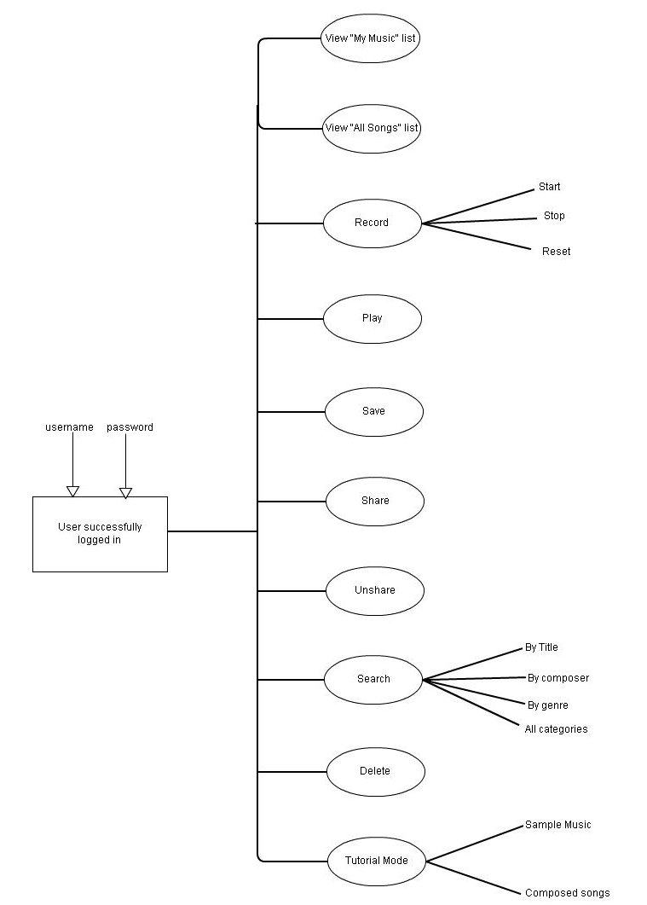

*The following flow chart diagrams represent various events and functions of the software:*

**LOGIN**

A new user needs to sign up and register himself. A registered user can log in by entering his ‘username’ and a valid password.

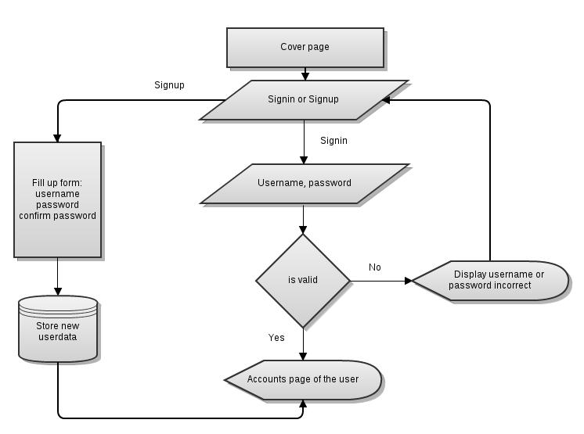

**SOUND CREATION:**

Upon pressing a suitable key on the keyboard, the corresponding key on the virtual piano is highlighted and the corresponding musical note is played.

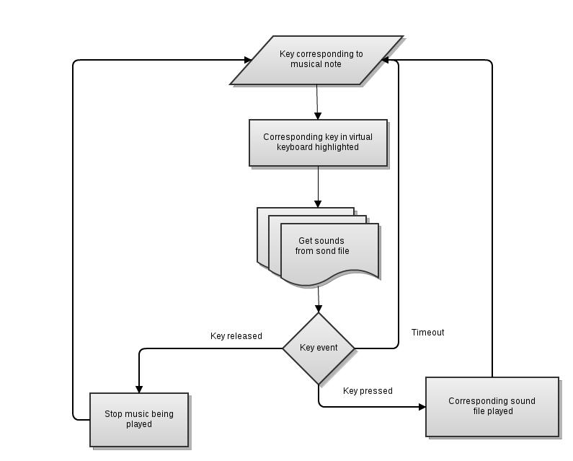

**RECORD:** The user clicks on the RECORD button to start recording his song. The series of key presses he takes is stored in the ‘music variable’. To stop recording the user clicks on the STOP button.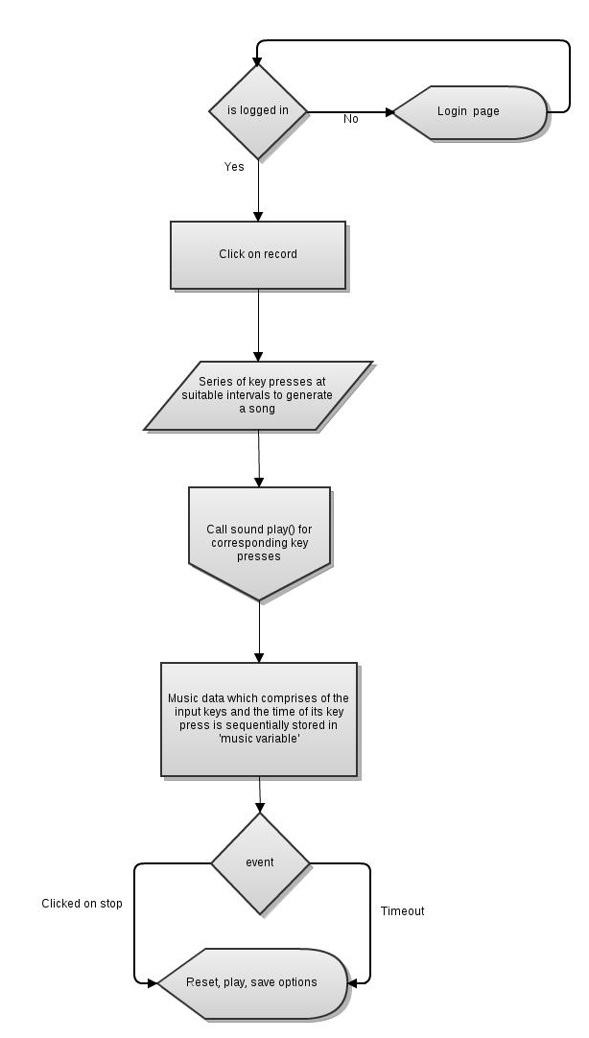

**PLAY**

The user can play the recently recorded song by clicking on the PLAY option which appears after stopping of the recording. The user can click on a particular song in the Music lists to play them.

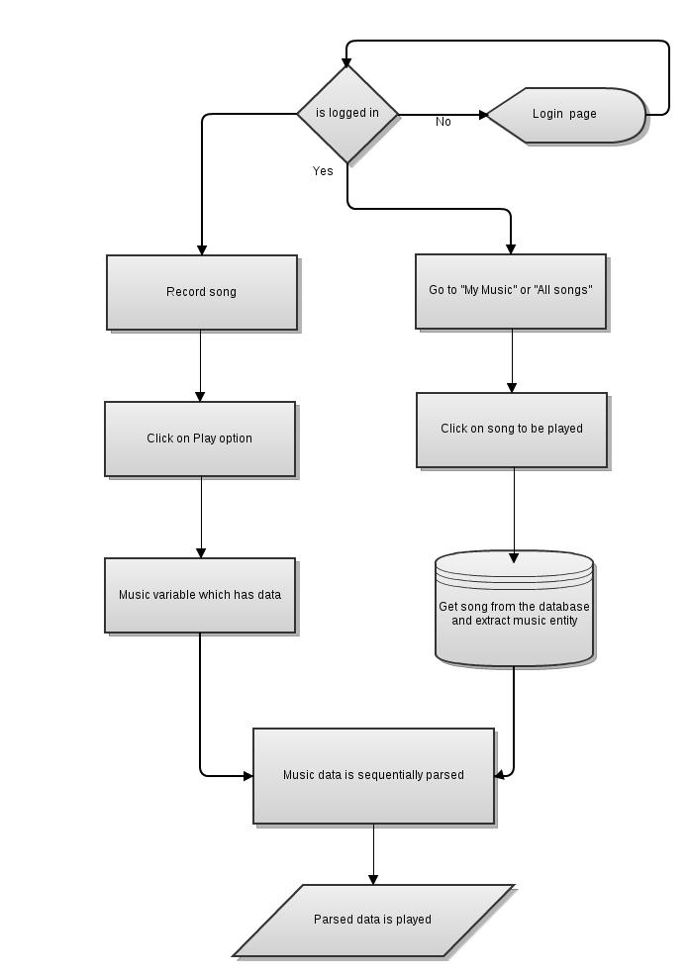

**SAVE**

Once the recording of a song is stopped, a SAVE button appears. By clicking on this button, the user can save the song composed by filling details such as title, genre, etc.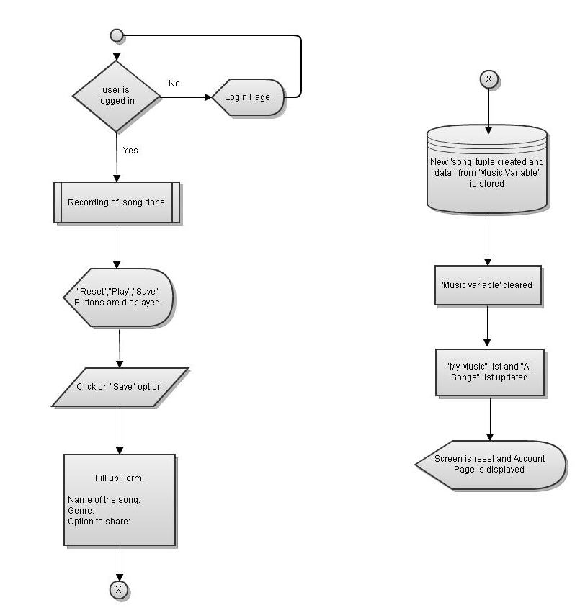

**SHARE :**

The user can share the songs he has composed and make it accessible to other users either by clicking on the SHARE button corresponding to the song in “My Music” list or by chosing the option to share while saving the song composed. 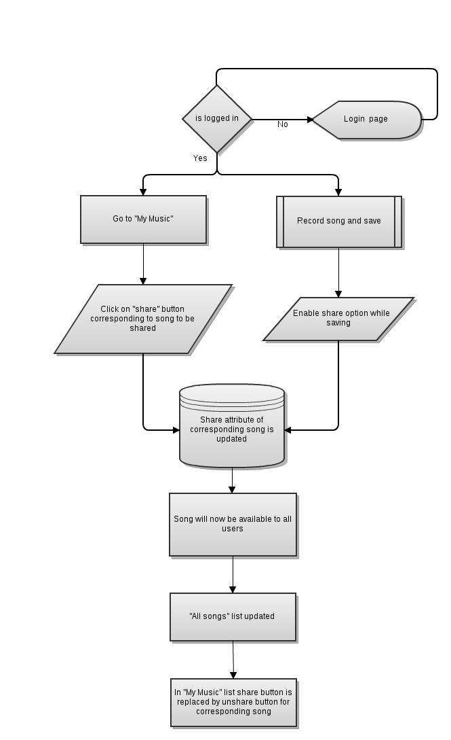

**UNSHARE:**

The user can unshare the songs he has shared and deny access to other users by clicking on the UNSHARE button corresponding to the song in “My Music” list. 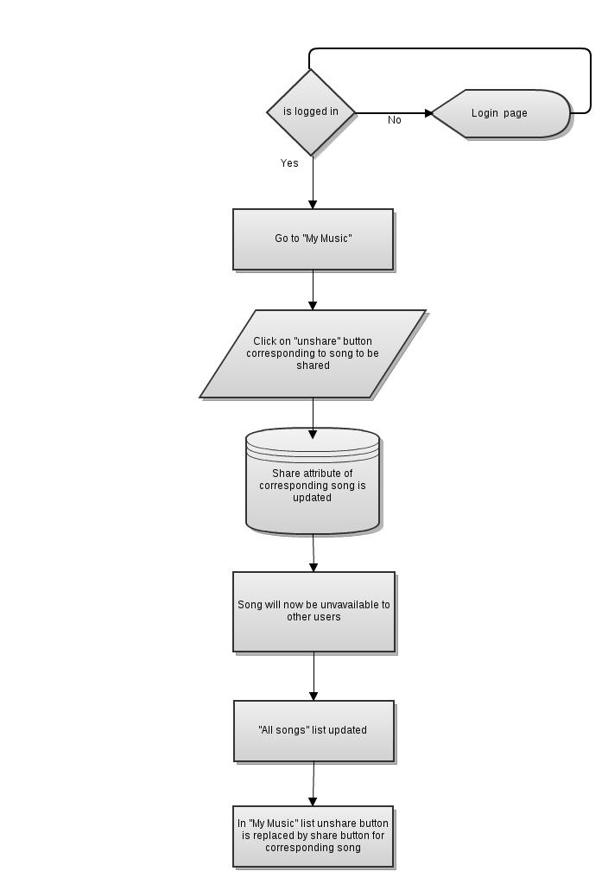

**SEARCH:** The user can search either in the “My Music” list or in the “All Songs” list by title, composer, genre or all categories by entering a keyword. The corresponding results are displayed.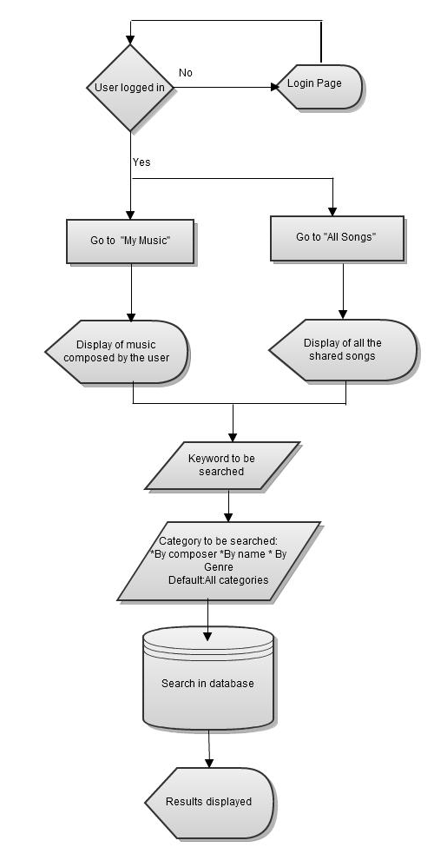

**DELETE:**

The user selects the songs to be deleted from the “My Music” List where a list of songs composed by him are displayed. Upon clicking on the DELETE option the selected songs are removed from the Music Database and hence do not appear in the “My Music” list or the “All Songs” list.

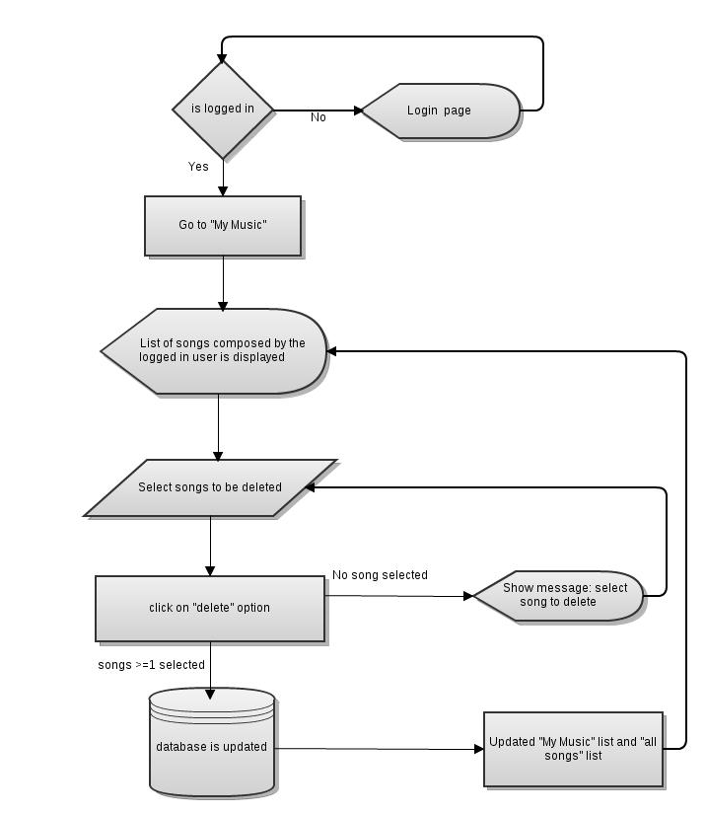

**TUTORIAL:**

The user can go to the TUTORIAL mode where he can learn to compose existing songs.

The user can either chose a song from the “Sample Music” or from the “All Songs” list or from the “My Music” list. Which key and when it has to be pressed is indicated hence providing help for the user to learn the selected song.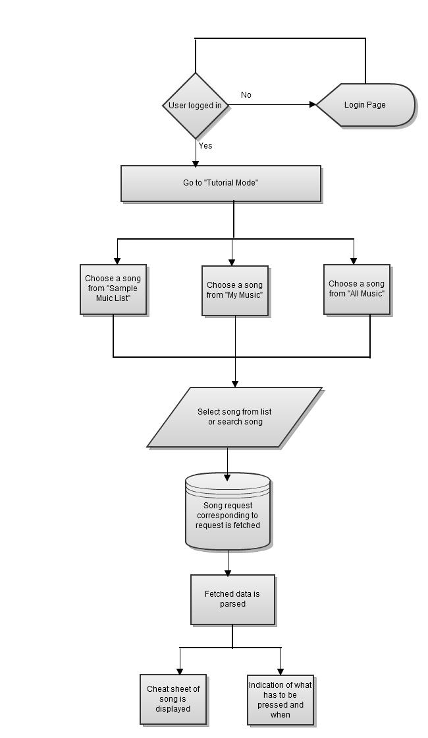

**Entity-Relationship(E-R) Diagram of the Music Database**

