User model:
- User model derived from a given task T, such that:
- total number of functions = 5 * number of function in the task.
- Total number of edges (relations) = 3 * number of function in the task.
- Total number of devices selected such that at least each device can do one function and satisfy number of alternative for each function.
- BN (G,P) where G(F,E) F total number of functions, E number of edges. P is the probability model randomly generated except for nodes(functions) that are in user preference is set to be
  - p=(maxP, 1/task_len)

Experiment Settings:
- GA settings: iterations: 1000, populations= 100, CXPB=0.5, MUTPB=0.2
- SA settings: Steps: 10000, tempMax=25000, tempMin=2.5

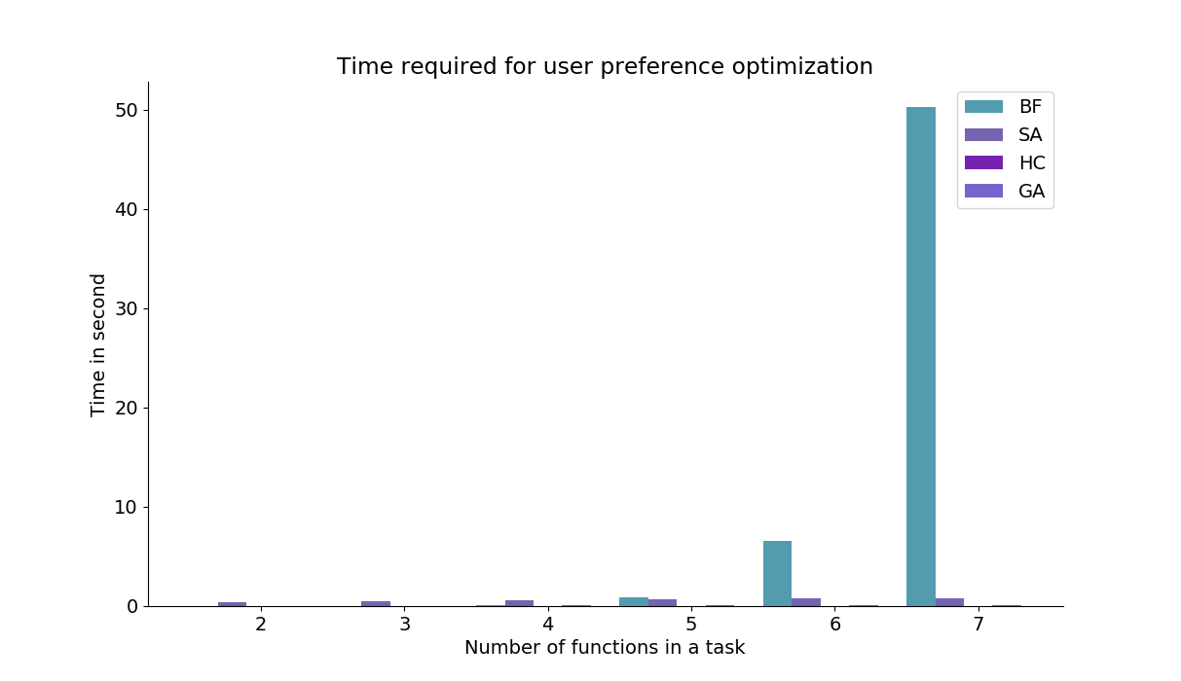
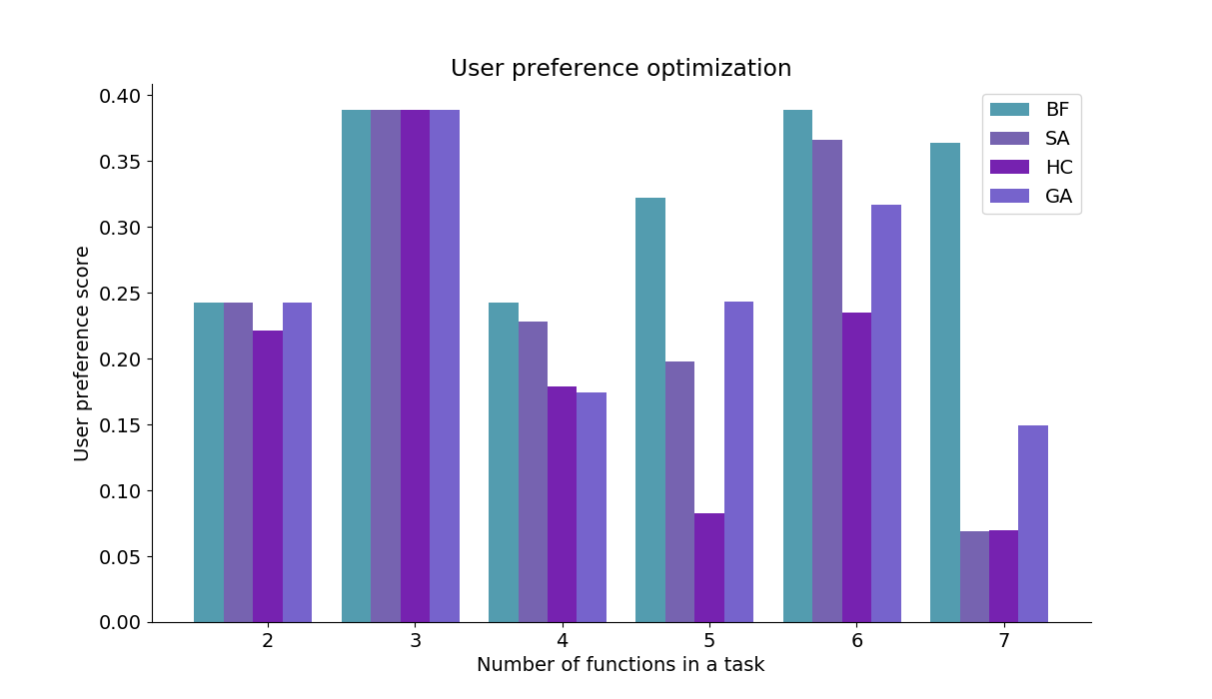

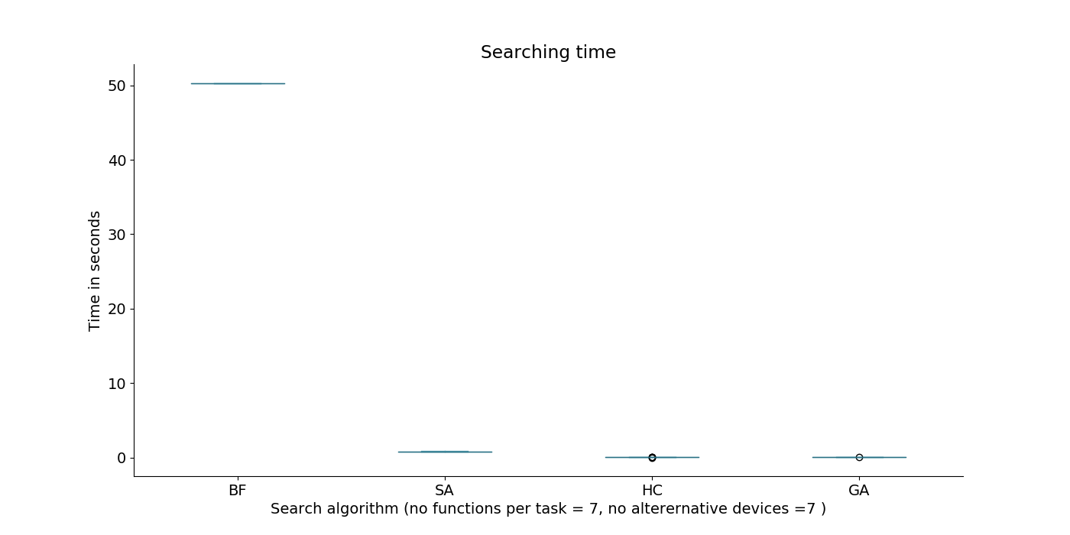
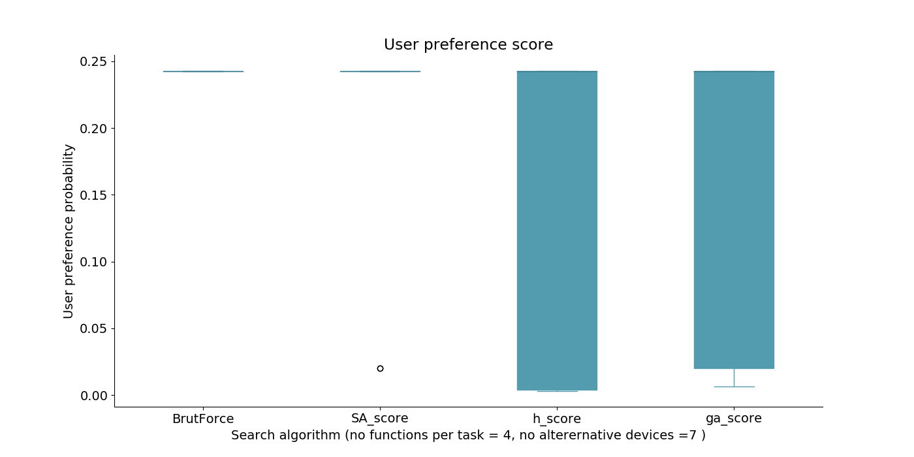
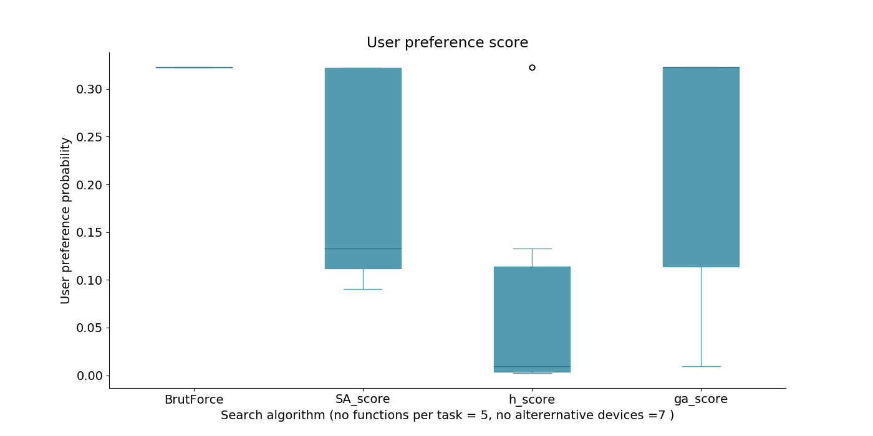

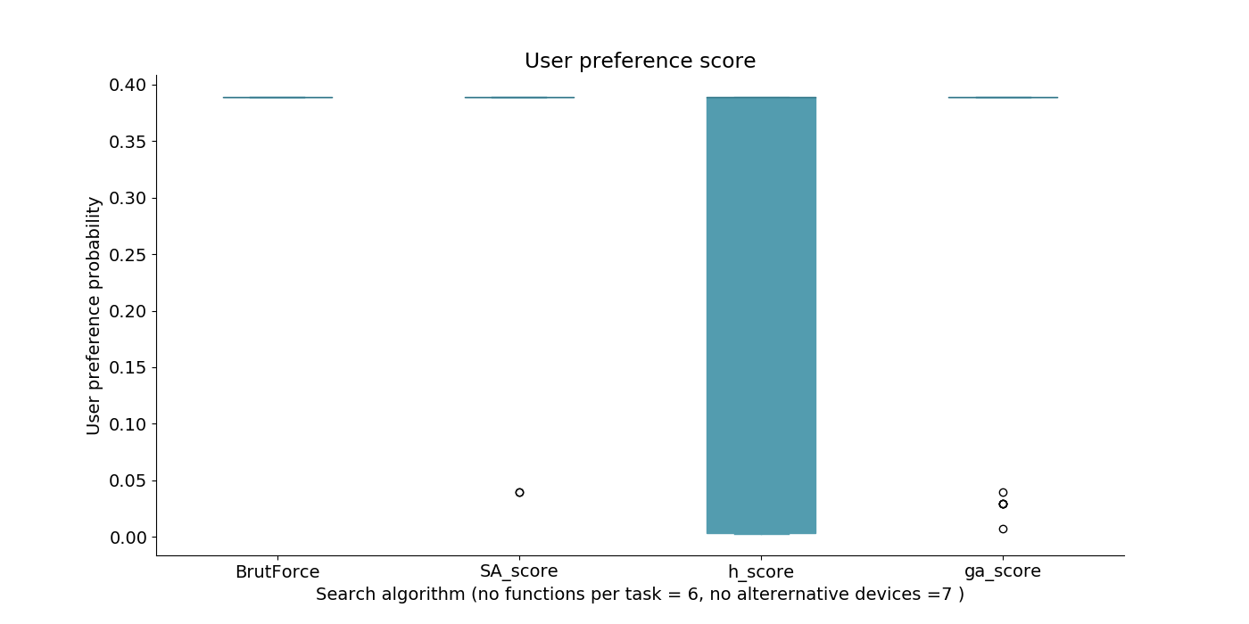

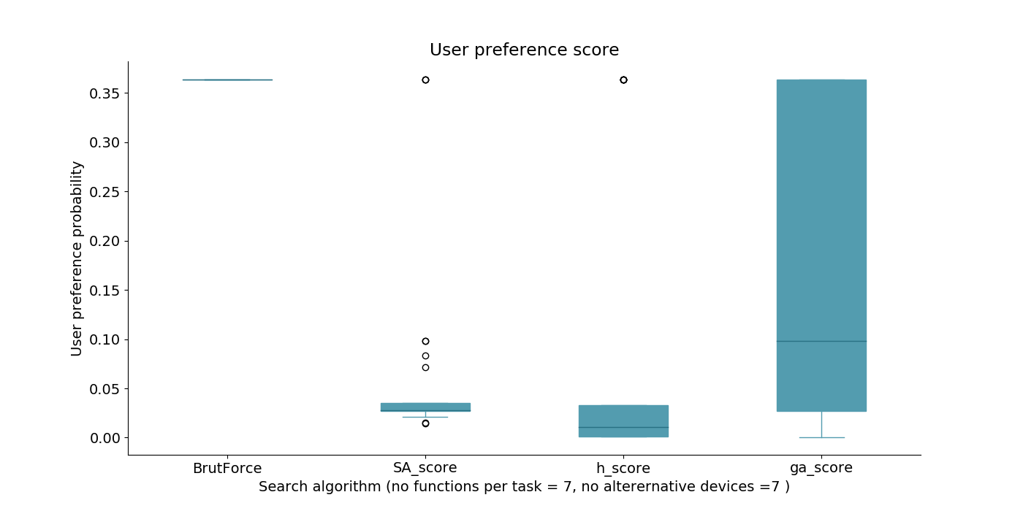

Simulated Annealing
sa_schedule ={'tmax': 3, 'tmin': 0.001, 'steps': 200000, 'updates': 0}

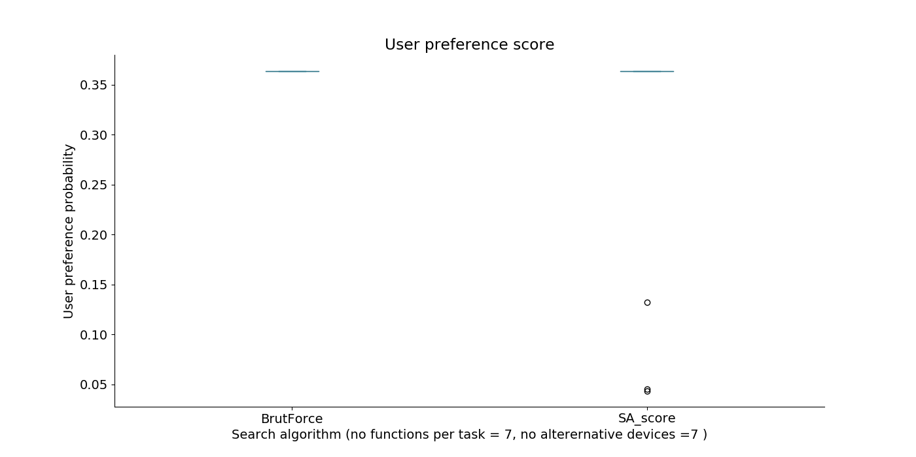

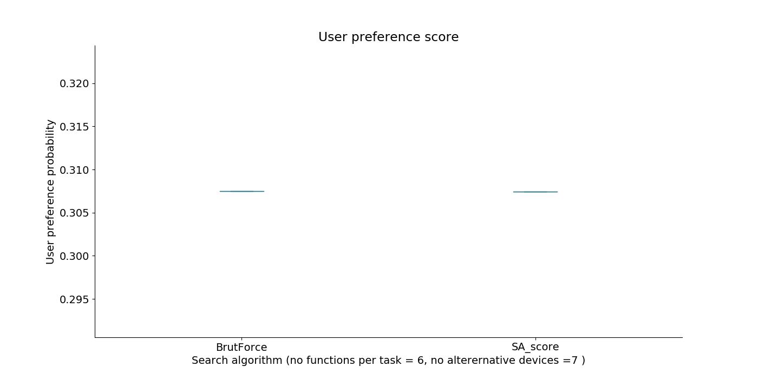

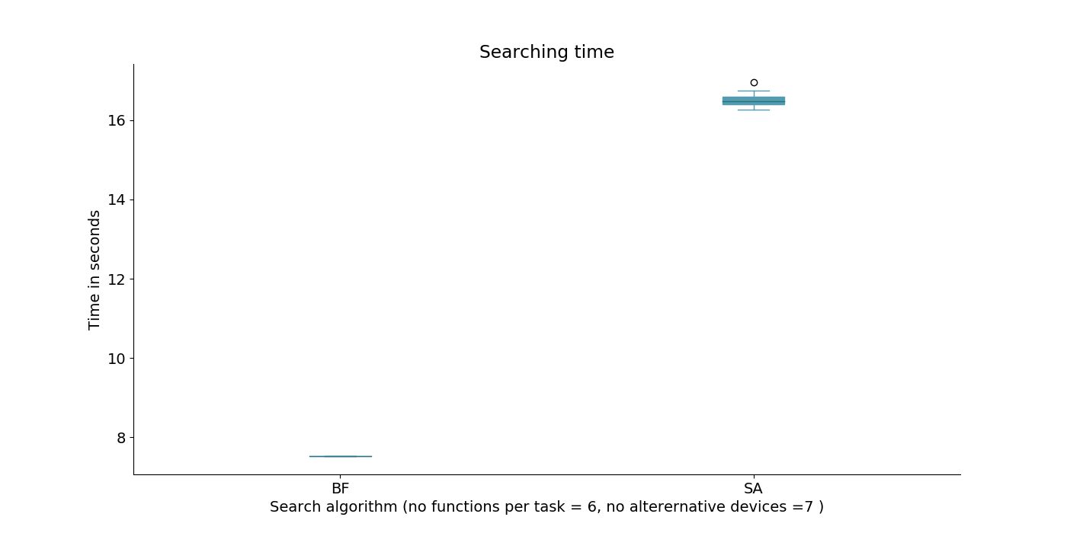

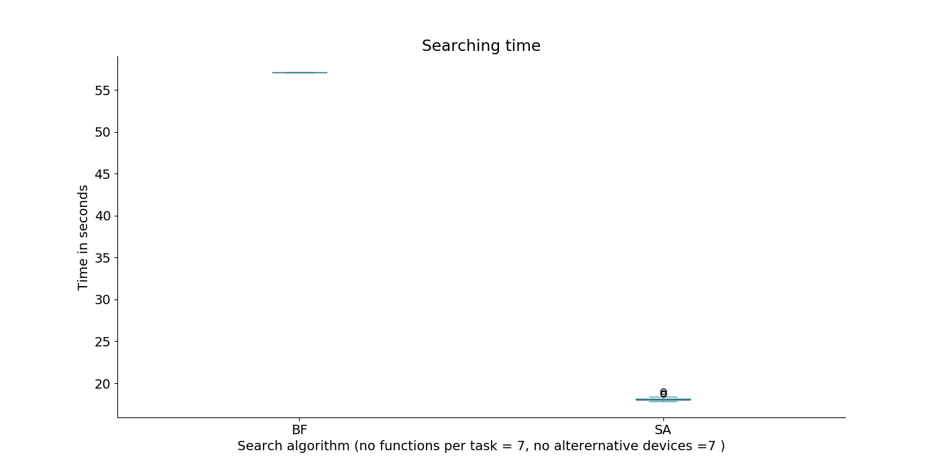

GA
generations=task_len*100,
max_iteration=1000
CXPB, MUTPB = 0.7, 0.2
CX= cxTwoPoint
eliti= 0.1
select: Tournament, tournsize=3
mute= 0.05
