Class Diagram:

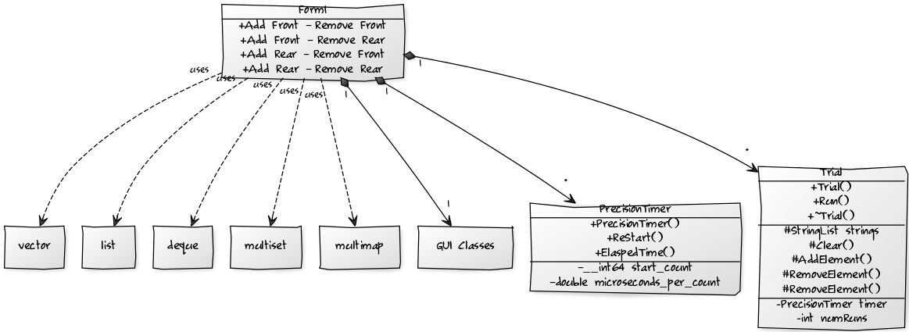

GUI Design:

