# Release Information

|  |  |
| --- | --- |
| *Release* | *0* |
| *Leader* | *Scott Schroeder* |
| *SVN Revision Number* | *N* |

Release 0 is our preplanning stage. In release 0 we will combine story cards and architectural spike design information to form guiding release and iteration plans. The release plan will incorporate what dates the releases will occur, as well as which user stories will be satisfied.

# Progress Summary

|  |  |  |  |
| --- | --- | --- | --- |
| **Stories and spike solutions developed** | | | |
| **Story, Spike** | **Description** | **% Impl.** | **Notes, plan for completion** |
| *R1.1* | *Filter Based Search* | *0* |  |
| *R1.2* | *Administrative Access* | *0* |  |
| *R1.3* | *Reserve Items* | *0* |  |
| *R2.1* | *Receipt* | *0* |  |
| *R2.2* | *Generate Itinerary* | *0* |  |
| *R2.3* | *Cancel Reservation* | *0* |  |

|  |  |  |
| --- | --- | --- |
| **Accomplishments by engineer** | | |
| **Team Member** | **Total Time (hrs)** | **Stories, Spikes implemented** |
| *John Hunter* | *9.9* | *Worked on the story cards and class diagram* |
| *Peter Emery* | *10.25* | *Organized and applied all data to the story book and class diagram* |
| *Nathan Blaubach* | *10.18* | *Worked towards spike 0, story cards, and class diagram* |
| *Scott Schroeder* | *10* | *Worked on Gui pictures, story cards, and readme.txt* |
| TEAM TOTAL | ***40.33*** |  |

|  |  |
| --- | --- |
| **Document updates** | |
| **Document** | **Changes** |
| *Readme.txt* | *Created and description added* |
| *Group4StoryBook.xlsx* | *Created and organized* |
| *ClassDiagram.docx* | *Started, needs to be refined later* |

# Plan for Next Release

Give a one to two sentence description of functionality planned for the next release.

|  |  |  |  |
| --- | --- | --- | --- |
| **Stories and spike solutions planned for upcoming release** | | | |
| **Story, Spike** | **Description** | **Est. Hours** | **Notes, plan for completion** |
| *R1.1* | *Filter Based Search* | *12* | *Intended to be the first task*  *As well as the subtask of creating the database structure* |
| *R1.2* | *Administrative Access* | *8* | *Allow for access to data and use of administrative functionality* |
| *R1.3* | *Reserve Items* | *10* | *Allow a user to reserve a room/seat and view that reservation later* |
|  |  | ***30*** | Total |

|  |  |  |  |
| --- | --- | --- | --- |
| **Assignments** | | | |
| **Team Member** | **Stories, Spikes implemented** | | **Tot. Hrs.** |
| *John Hunter* | *R1.3a, Class Diagram* | *Finish class diagram, reserving items* | *8* |
| *Peter Emery* | *R1.2a, R1.1b, R1.3b*  *Class Diagram* | *Start and complete the database search and admin functions* | *8* |
| *Nathan Blaubach* | *R1.1a, Database*  *Implementation* | *Design and implement database and features* | *8* |
| *Scott Schroeder* | *Spike 0, R1.2b, R1.3c*  *Class Diagram* | *Help complete class diagram, finish spike 0, and help with reserving items* | *8* |
|  |  | **Total** | **32** |

# Issues

Document anything that is not decided yet and needs to be resolved at some point.

|  |  |  |  |  |
| --- | --- | --- | --- | --- |
| **Issue Number** | **Discovery**  **Date** | **Resolution**  **Date (Est.–Act.)** | **Responsible Person** | **Description (Prob / Resolution)** |
| 1 | 1-29-15 | 2-3-15 | All | Resolve the implementation conflict, how the database will be structured. |

# Screen Shots

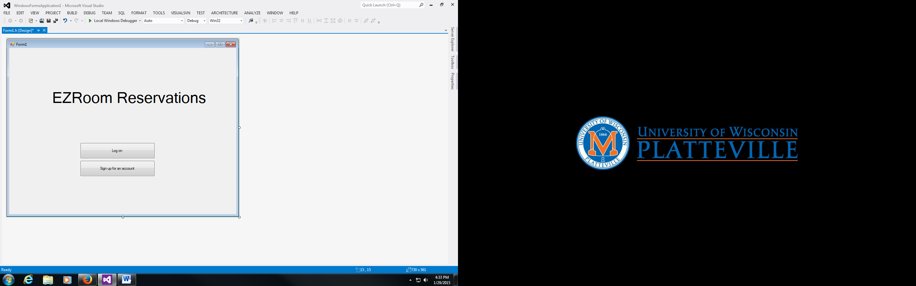

*Basic log in screen, with simple user interface and minimal choices

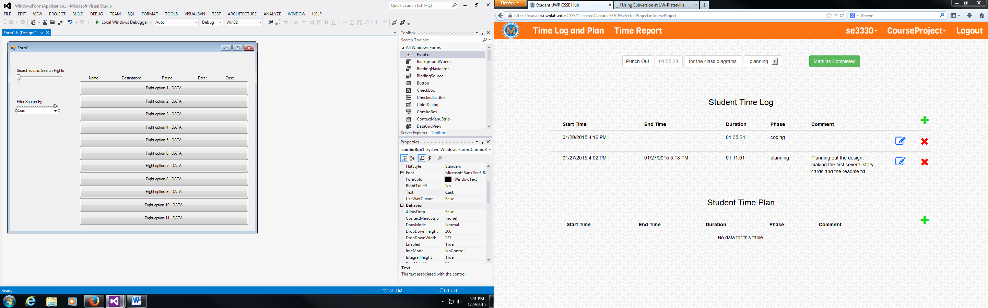

*Searching/Filtering screen: multiple filter parameters are accepted

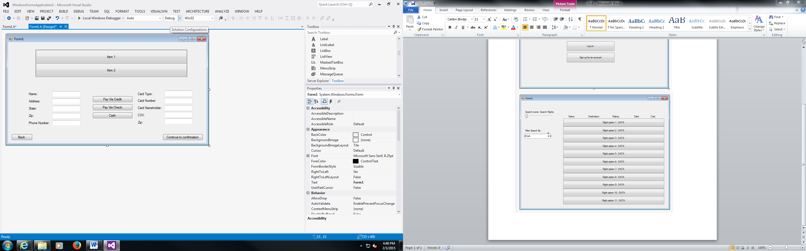

*Payment Screen 1

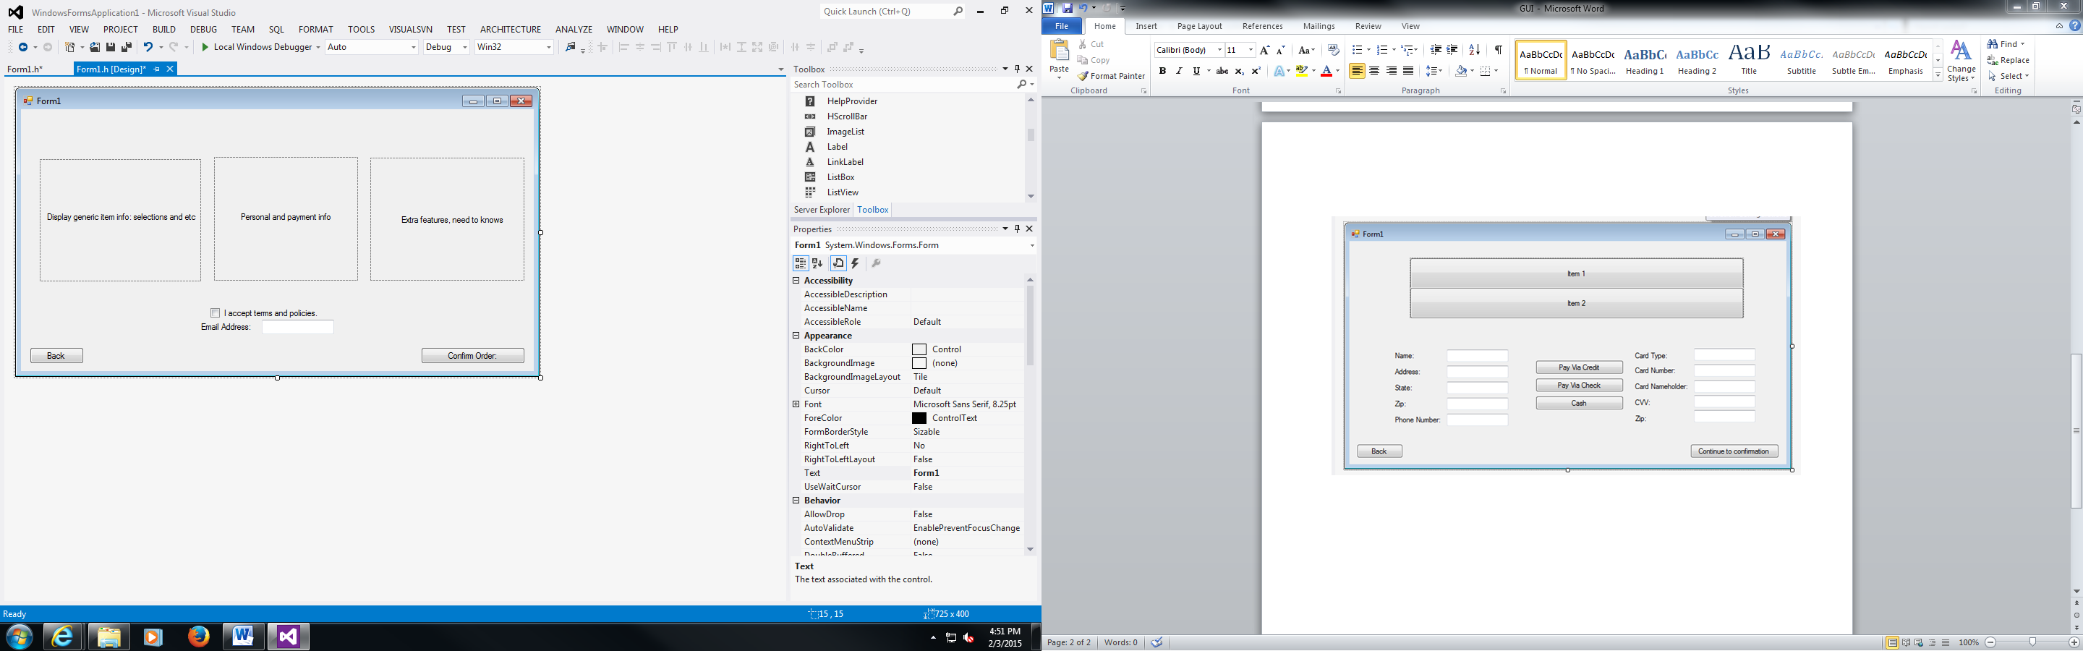

*Payment Screen 2