# Release Information

|  |  |
| --- | --- |
| Release | 3 |
| Leader | Nathan Blaubach |
| SVN Revision Number | 21696 |

Release 3 will consist of the ability to cancel reservations, print receipts, print itineraries, and have administrator access to the system.

# Progress Summary

|  |  |  |  |
| --- | --- | --- | --- |
| **Stories and spike solutions planned for this release** | | | |
| **Story, Spike** | **Description** | **% Impl.** | **Notes, plan for completion** |
| S.SO.3 | Multistage Flight | 90% | Method Decomposition |
| S.UI.5 | Undo Actions | 100% | Completed |

|  |  |  |
| --- | --- | --- |
| **Accomplishments by engineer** | | |
| **Team Member** | **Total Time (hrs)** | **Stories, Spikes implemented** |
| John Hunter | 27 | Refactoring, Multistage Flight |
| Peter Emery | 25 | Refactoring, Multistage Flight |
| Scott Schroeder | 24.75 | Refactoring, Command Pattern, Multistage Flight |
| Nathan Blaubach | 24.5 | Refactoring, Command Pattern, Multistage Flight |
| **Total Hours** | **101.25** |  |

|  |  |
| --- | --- |
| **Document updates** | |
| **Document** | **Changes** |
| Group4StoryBook | Updated Storybook for Release 3 |
| Group4ClassDiagram | Updated Class Diagram for Release 3 |

# Plan for Next Release

|  |  |  |  |
| --- | --- | --- | --- |
| **Stories and spike solutions planned for upcoming release** | | | |
| **Story, Spike** | **Description** | **Est. Hours** | **Notes, plan for completion** |
| S.UI.4 | Administrative Access | 10 | Implement Story |
| S.SO.3 | Multistage Flights | 2 | Method Decomposition |
| **Total** | | **12** |  |

|  |  |  |
| --- | --- | --- |
| **Assignments** | | |
| **Team Member** | **Stories, Spikes implemented** | **Tot. Hrs.** |
| Scott Schroeder | Subgroup 1 - S.UI.4 (Administrative Access) | 11 |
| John Hunter | Subgroup 1 - S.UI.4 (Administrative Access) | 12 |
| Peter Emery | Subgroup 2 - S.SO.3 (Multistage Flight), S.UI.4 (Administrative Access) | 12 |
| Nathan Blaubach | Subgroup 2 - S.SO.3 (Multistage Flight), S.UI.4 (Administrative Access) | 11 |
| **Total** | | **46** |

# Issues

|  |  |  |  |  |
| --- | --- | --- | --- | --- |
| **Issue Number** | **Discovery**  **Date** | **Resolution**  **Date (Est.–Act.)** | **Responsible Person** | **Description (Prob / Resolution)** |
| R3.1 | 2015/04/18 | 2015/04/18 | Nathan Blaubach | Problem: Ran out of time to implement the Administrative Access story.  Solution: Pushed to the next release |

# Screen Shots

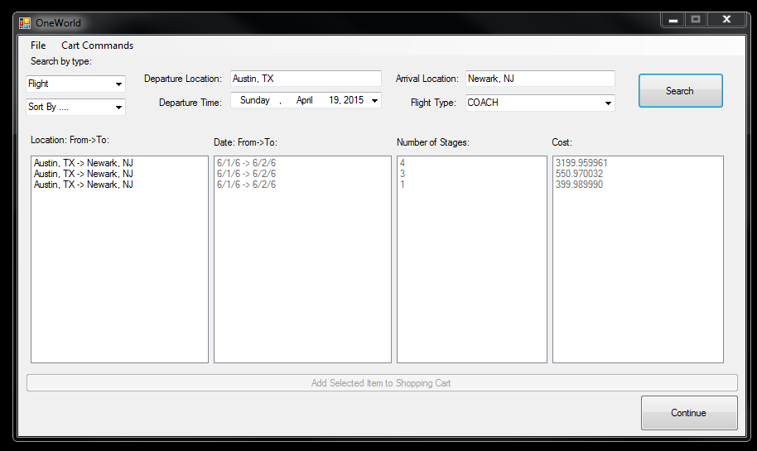

Search Flights/Hotels Screen (above)

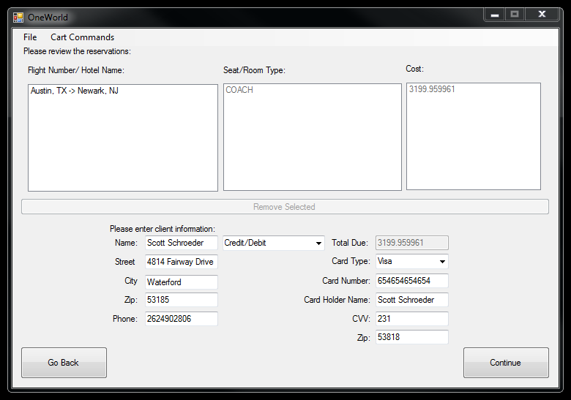

Review Reservations Screen (above)

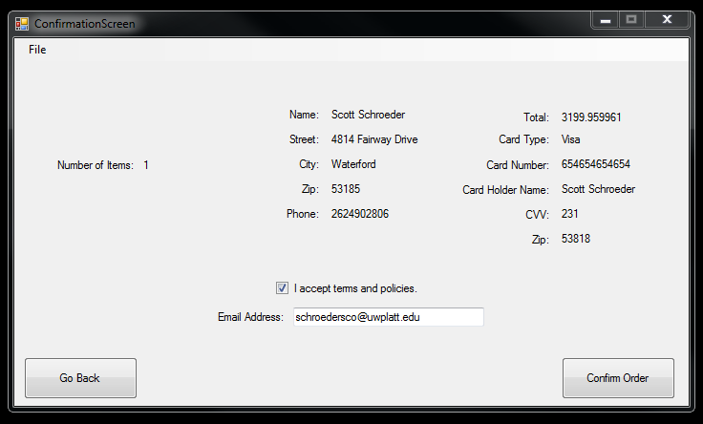

Confirmation Screen (above)

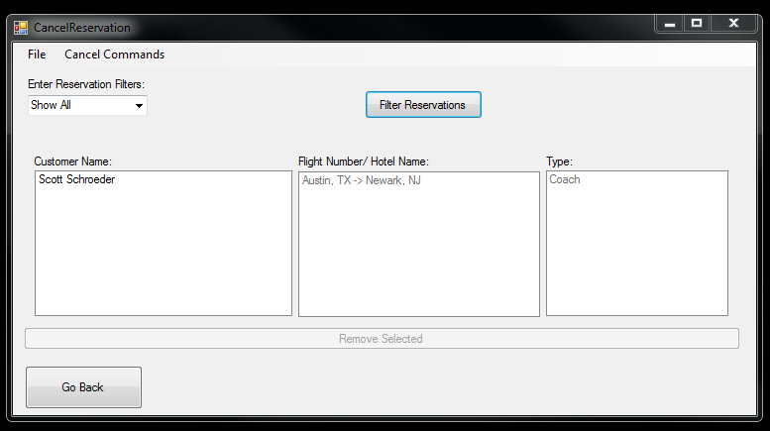

Cancel Reservation Screen (above)

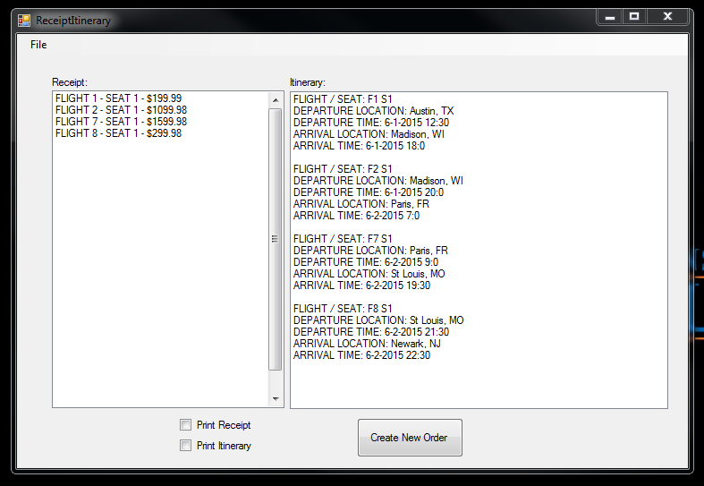

Reciept/Itinerary Screen (above)