# Release Information

|  |  |
| --- | --- |
| Release | 1 |
| Leader | Peter Emery |
| SVN Revision Number | N |

We have created the entire database being accessed by the program as well as implementing search and reservation functionality.

# Progress Summary

|  |  |  |  |
| --- | --- | --- | --- |
| **Stories and spike solutions planned for this release** | | | |
| **Story, Spike** | **Description** | **% Impl.** | **Notes, plan for completion** |
| S.UI.1 | Create Filter Based Search | 100% | Created Database, took longer than expected resulting in S.UI.3 being pushed back to release 2 |
| S.UI.2 | Create Reserve Item Functionality | 100% | Created ability to reserve items |
| S.UI.3 | Create Cancel Reservation Functionality | 0% | Ran out of time, will be pushed into release 2 |

|  |  |  |
| --- | --- | --- |
| **Accomplishments by engineer** | | |
| **Team Member** | **Total Time (hrs)** | **Stories, Spikes implemented** |
| John Hunter | 20.8 | Reserve Items Story (S.UI.2), worked on GUI and Controller |
| Scott Schroeder | 26.67 | Reserve Items Story (S.UI.2), worked on GUI and Controller |
| Nathan Blaubach | 37.33 | Filter Based Search Story (S.UI.1), worked on creating Database |
| Peter Emery | 36.65 | Filter Based Search Story (S.UI.1), worked on creating Database |
| TEAM TOTAL | **121.45** |  |

|  |  |
| --- | --- |
| **Document updates** | |
| **Document** | **Changes** |
| Group4StoryBook | Updated storybook for Release 2 |
| Group4ClassDiagram | Updated Class Diagram to reflect changes during Release 1 |
|  |  |

# Plan for Next Release

Release 2 will consist of the ability to cancel reservations, print receipts, print itineraries, and give the admin of the system the ability to modify reservations.

|  |  |  |  |
| --- | --- | --- | --- |
| **Stories and spike solutions planned for upcoming release** | | | |
| **Story, Spike** | **Description** | **Est. Hours** | **Notes, plan for completion** |
| S.UI.3 | Create Cancel Reservation Functionality | 6 |  |
| S.UI.4 | Create Administrative Access for editing reservations as well as read in file/write to file functionality for Database | 12 |  |
| S.SO.1 | Create Itinerary Generation | 4 |  |
| S.SO.2 | Create Receipt Generation | 4 |  |
|  |  | **26** | Total |

|  |  |  |  |
| --- | --- | --- | --- |
| **Assignments** | | | |
| **Team Member** | **Stories, Spikes implemented** | | **Tot. Hrs.** |
| Peter Emery | S.UI.4 | Create ability to edit current reservations, also create ability to save current database to a file and load a database from a file | 12 |
| Scott Schroeder | S.UI.4 | Create ability to edit current reservations, also create ability to save current database to a file and load a database from a file | 12 |
| John Hunter | S.UI.3, S.SO.1, S.SO.2 | Create ability to cancel reservations, generate receipts, generate itineraries | 14 |
| Nathan Blaubach | S.UI.3, S.SO.1, S.SO.2 | Create ability to cancel reservations, generate receipts, generate itineraries | 14 |
|  |  | **Total** | **52** |

# Issues

|  |  |  |  |  |
| --- | --- | --- | --- | --- |
| **Issue Number** | **Discovery**  **Date** | **Resolution**  **Date (Est.–Act.)** | **Responsible Person** | **Description (Prob / Resolution)** |
| N/A | N/A | N/A | N/A | N/A |

# Screen Shots

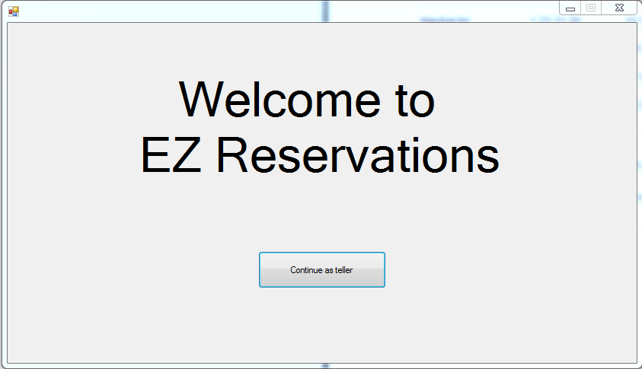

This is the current Welcome Screen

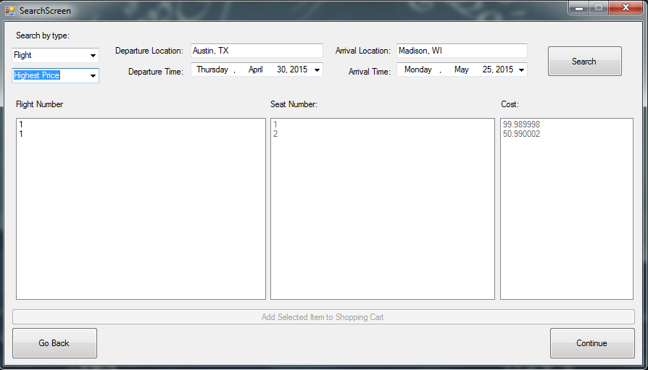

Above is a search of flights organized by highest cost flights first

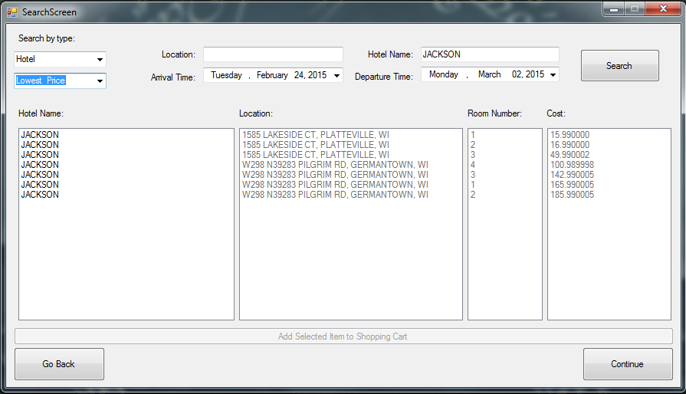

Above is a search of hotels organized by lowest cost hotels first

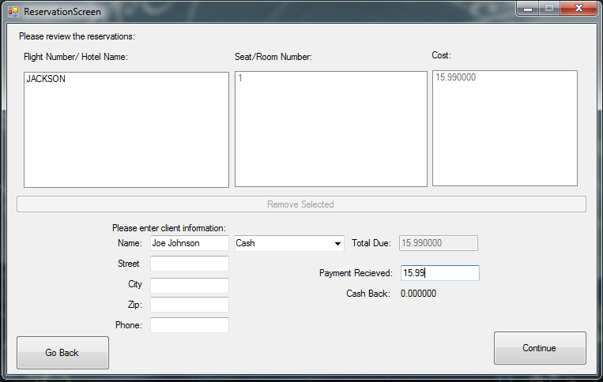

Above is the shopping cart screen, a user enters their personal data and confirms their purchase

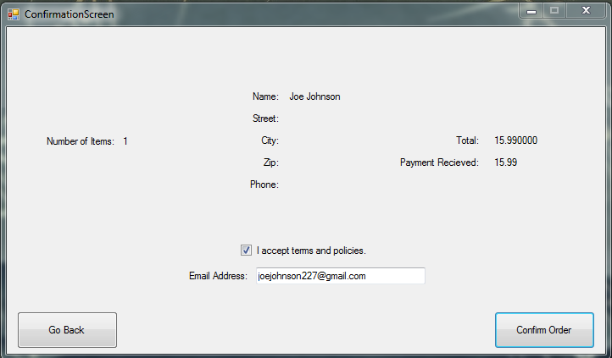

Above is the order confirmation screen

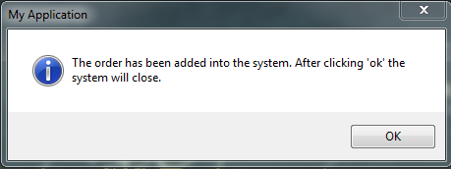

Above is the confirmation message after order is confirmed