# Release Information

|  |  |
| --- | --- |
| Release | 2 |
| Leader | John Hunter |
| SVN Revision Number | 20310 |

Release 2 will consist of the ability to cancel reservations, print receipts, print itineraries, and have administrator access to the system.

# Progress Summary

|  |  |  |  |
| --- | --- | --- | --- |
| **Stories and spike solutions planned for this release** | | | |
| **Story, Spike** | **Description** | **% Impl.** | **Notes, plan for completion** |
| S.UI.3 | Cancel Reservation | 100% | Complete |
| S.UI.4 | Administrator Access | 50% | Reading and writing to DB file functional |
| S.SO.1 | Generate Receipt | 100% | Complete |
| S.SO.2 | Generate Itinerary | 100% | Complete |

|  |  |  |
| --- | --- | --- |
| **Accomplishments by engineer** | | |
| **Team Member** | **Total Time (hrs)** | **Stories, Spikes implemented** |
| John Hunter | 18.8 | Refactoring, Cancel Res., Gen. Itinerary, Gen. Receipt |
| Scott Schroeder | 30.6 | Refactoring, Cancel/Itinerary/Receipt GUI, Admin Access (read/write from/to file) |
| Nathan Blaubach | 18.9 | Refactoring Cancel Res., Gen. Itinerary, Gen. Receipt, Class Diagram |
| Peter Emery | 22.3 | Refactoring, Cancel/Itinerary/Receipt GUI, Admin Access (read/write from/to file) |
| **Total Hours** | **90.6** |  |

|  |  |
| --- | --- |
| **Document updates** | |
| **Document** | **Changes** |
| Group4StoryBook | Updated Storybook for Release 2 |
| Group4ClassDiagram | Updated Class Diagram for Release 2 |

# Plan for Next Release

|  |  |  |  |
| --- | --- | --- | --- |
| **Stories and spike solutions planned for upcoming release** | | | |
| **Story, Spike** | **Description** | **Est. Hours** | **Notes, plan for completion** |
| S.UI.4 | Administrative Access | 6 | Finish work on story |
| S.SO.3 | Multistage Flight | 12 | Implement story |
| S.UI.5 | Undo Actions | 5 | Implement story |
| **Total** | | **23** |  |

|  |  |  |
| --- | --- | --- |
| **Assignments** | | |
| **Team Member** | **Stories, Spikes implemented** | **Tot. Hrs.** |
| Peter Emery | Subgroup 1 - S.SO.3 (Multistage Flight) | 12 |
| Scott Schroeder | Subgroup 2 - S.UI.4 (Administrative Access), S.UI.5 (Undo Actions) | 11 |
| John Hunter | Subgroup 1 - S.SO.3 (Multistage Flight) | 12 |
| Nathan Blaubach | Subgroup 2 - S.UI.4 (Administrative Access), S.UI.5 (Undo Actions) | 11 |
| **Total** | | **46** |

# Issues

|  |  |  |  |  |
| --- | --- | --- | --- | --- |
| **Issue Number** | **Discovery**  **Date** | **Resolution**  **Date (Est.–Act.)** | **Responsible Person** | **Description (Prob / Resolution)** |
| R2.1 | 2015/03/26 | 2015/03/26 | John Hunter | Problem: References to emailing in project storybook Resolution: Removed references from storybook as emailing is not included in the scope of the initial project description |
| R2.2 | 2015/03/26 | 2015/03/26 | John Hunter | Problem: Story missing for undo action (as discussed in class)  Solution: Added story to storybook |

# Screen Shots

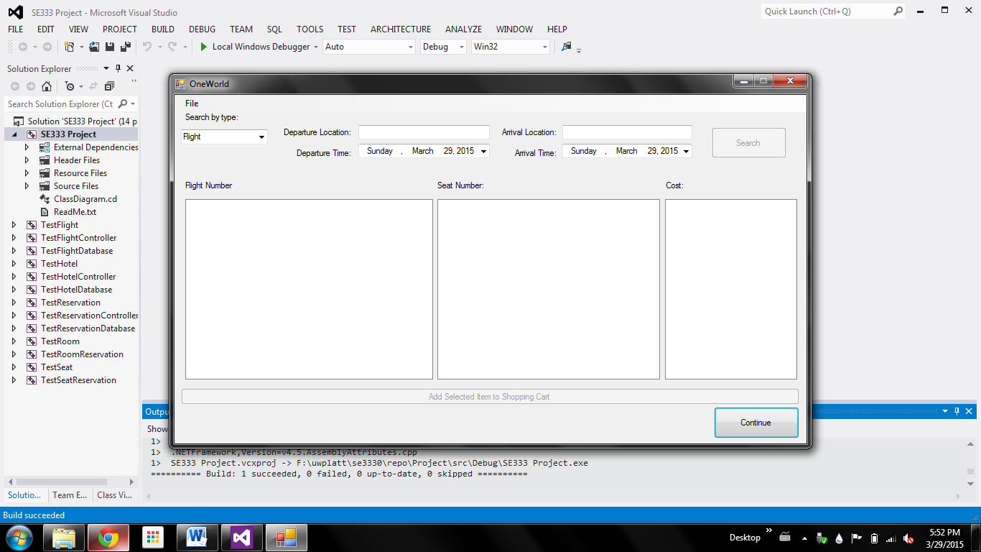

Search Flights/Hotels Screen (above)

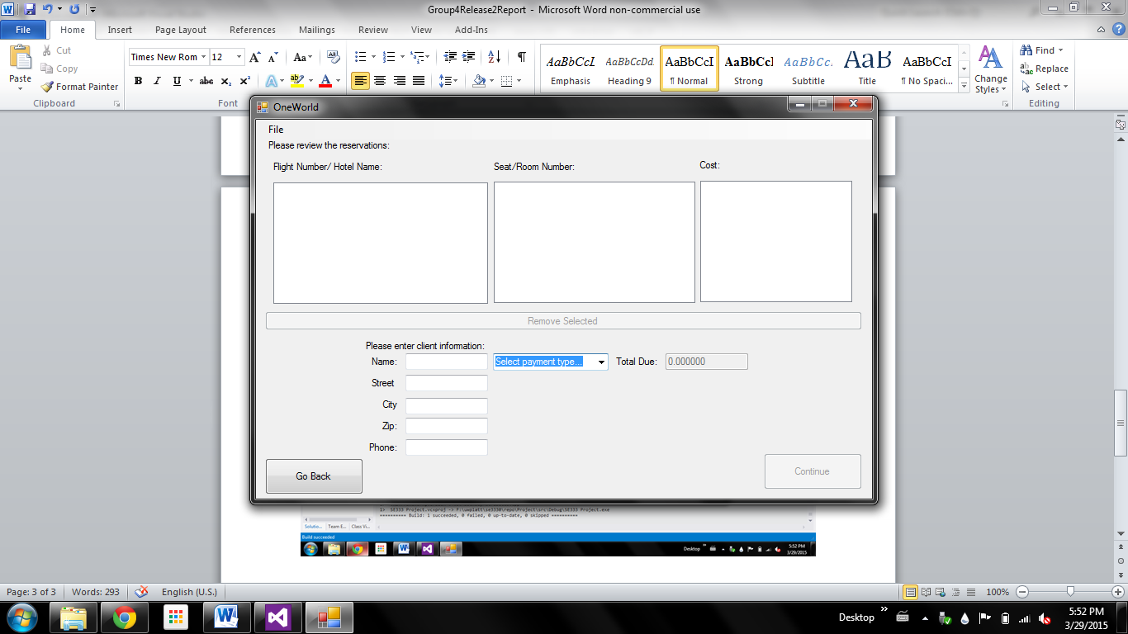

Review Reservations Screen (above)

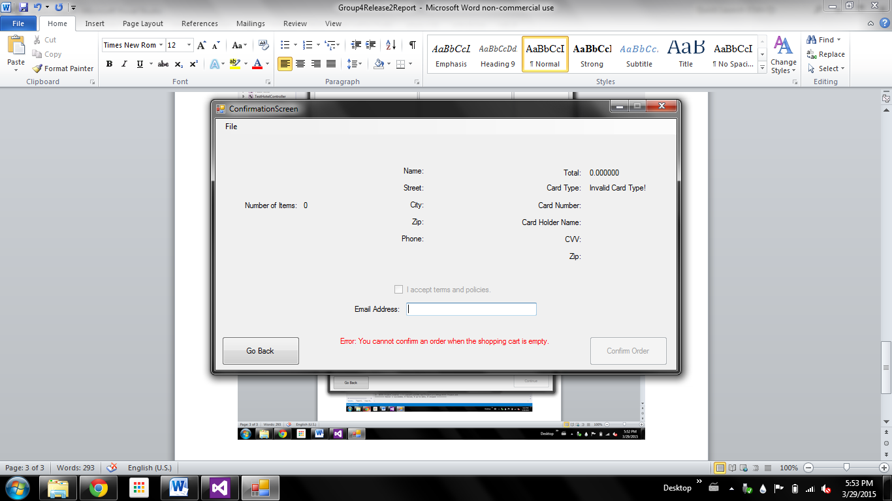

Confirmation Screen (above)

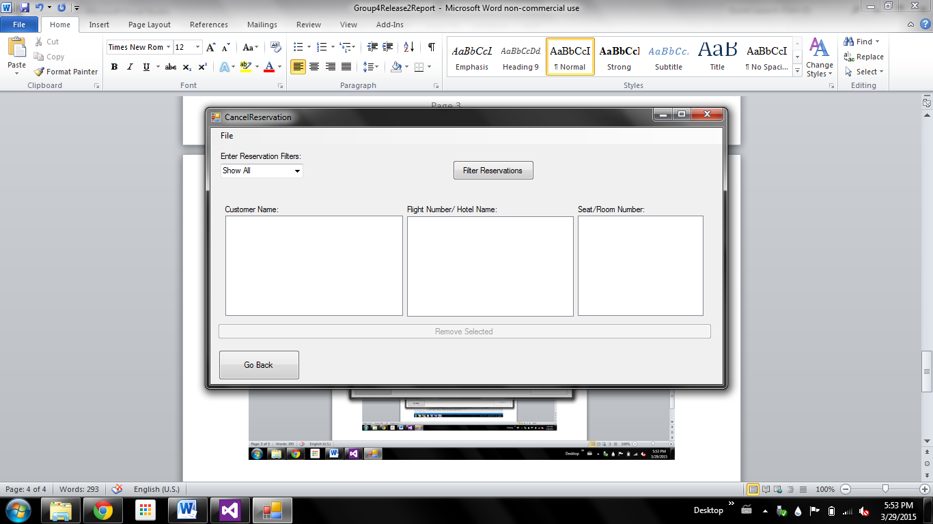

Cancel Reservation Screen (above)