

**Faculty of engineering - Shoubra**

**Benha University**

**Research Article / Research Project / Literature Review**

in fulfillment of the requirements of

|  |  |
| --- | --- |
| **Department** | **Engineering Mathematics and Physics** |
| **Division** |  |
| **Academic Year** | **2019-2020 Preparatory** |
| **Course name** | **Computer** |
| **Course code** | **ECE001** |

**Title: -**

Computer Engineering Role in COVID-19 Pandemic?

By:

|  |  |  |  |
| --- | --- | --- | --- |
|  | Name | Edu mail | B.N |
| 1 |  |  |  |

**Approved by:**

|  |  |
| --- | --- |
| Examiners committee | Signature |
| Dr.Ahmed Bayoumi |  |
| Dr.Shady Elmashad |  |
| Dr. Abdelhamid Attaby |  |
|  |  |
|  |  |

**Application topic:**

**The coronavirus disease 2019 (COVID-19) pandemic has exposed a number of weaknesses in the world’s healthcare systems and in the global economy. In a new editorial a team of engineers and computer scientists argue that the current pandemic moment ought to serve as a wake-up call for society and the public health community to embrace the opportunities of robotics. The editorial, which appeared in Science Robotics, was written by the journal’s founding editor, Guang-Zhong Yang, PhD, and colleagues from around the world. Yang is a professor and dean of the Institute of Medical Robotics at Shanghai Jiao Tong University, in China**.

**Github links**

[**https://github.com/alshimaa141/html.project.repository**](https://github.com/alshimaa141/html.project.repository)

Screen shot

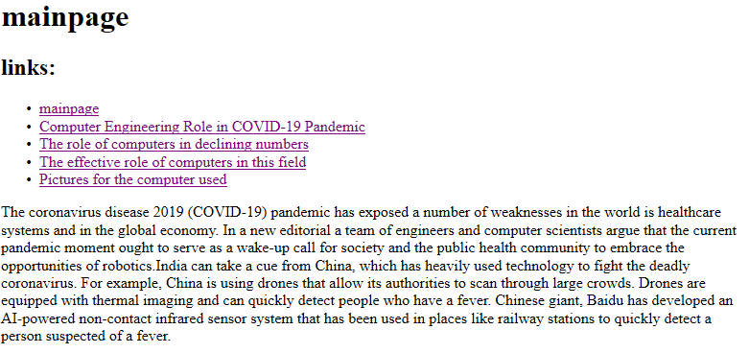

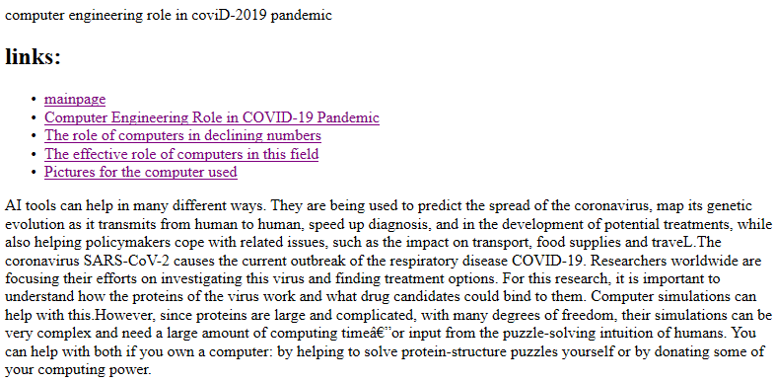

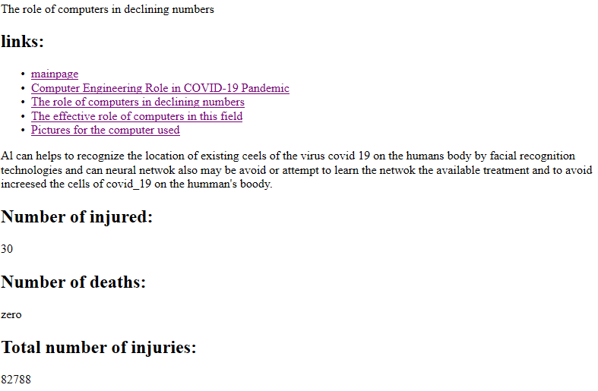

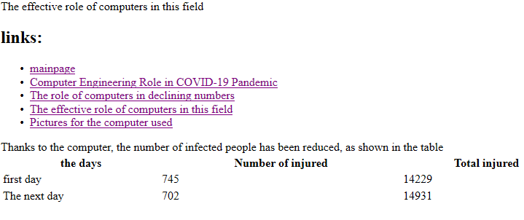

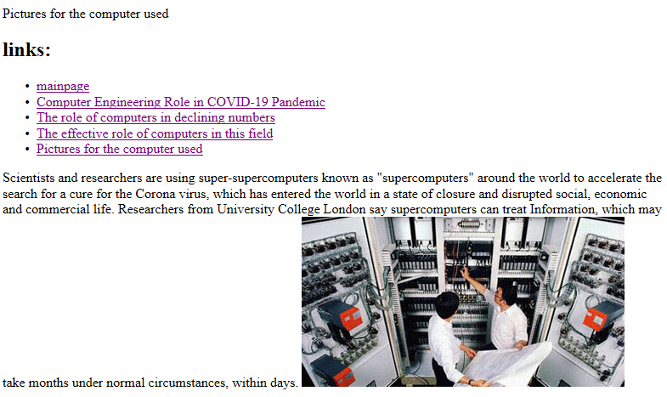

Source code

