**Dataset: Chicago city Crimes - 2001 to present**

This dataset reflects reported incidents of crime (with the exception of murders where data exists for each victim) that occurred in the City of Chicago from 2001 to present, minus the most recent seven days. Data is extracted from the Chicago Police Department's CLEAR (Citizen Law Enforcement Analysis and Reporting) system. In order to protect the privacy of crime victims, addresses are shown at the block level only and specific locations are not identified. he dataset contains 6,835,389 records/rows of data.

**Initial Analysis Questions**

1. Is Chicago becoming safer or more dangerous?
2. What is the safest time (month /day/hour) is Chicago city?
3. What are the safe districts?
4. What kind of crimes are popular in Chicago?

**Discoveries & Insights**

To minimize the crime rate in Chicago police can concentrate on the areas with high crimes knowing the times with high incident. Streets are the most dangerous locations and theft is the most popular crime.

**Graph 1**

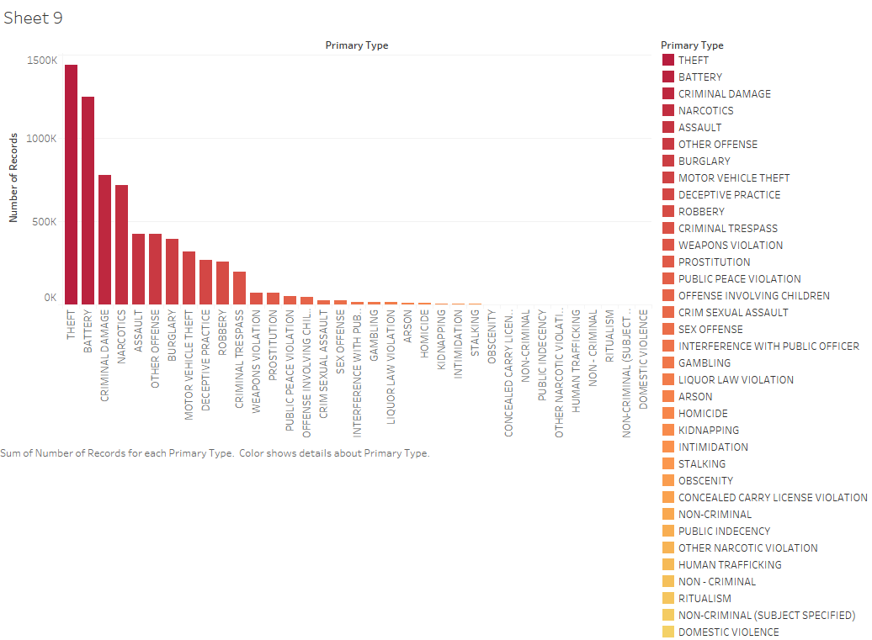

This graph shows the count of crimes for each primary type. The dataset has an uneven distribution, it’s clear that THEFT comes first with the greatest number of crimes and domestic violence comes last.

**Graph 2**

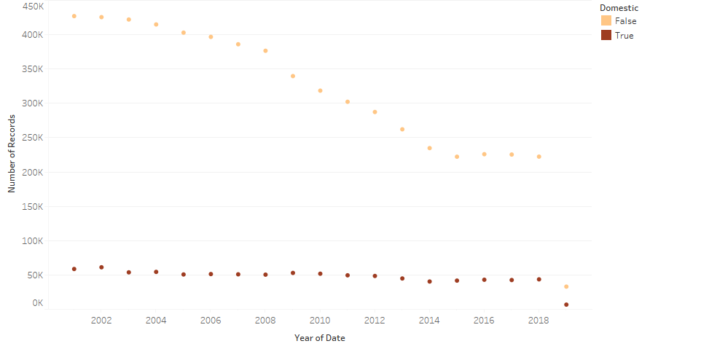

An animated graph showing the number of crimes per year, its obvious that the non-domestic crimes are decreasing from 2001 to 2015 and since its almost the same, for the domestic crimes it’s the same steady at 50K the 2001.

**Graph 3**

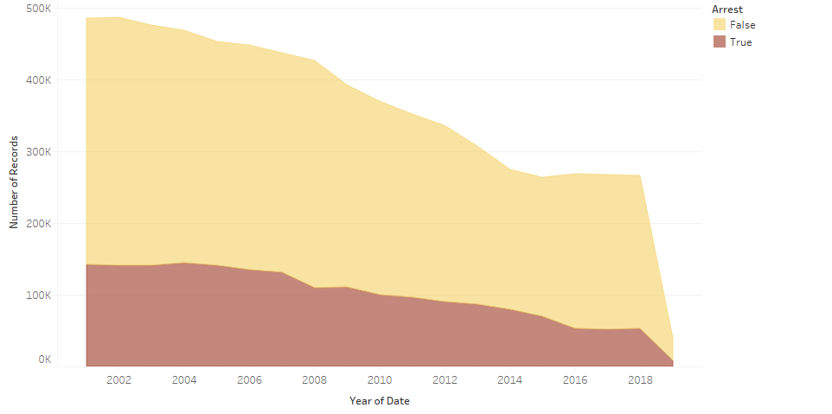

Area graph showing how the crime rates are decreasing for both crimes that ended with arrest or not its clear that the city of Chicago is becoming safer with time.

**Graph 4**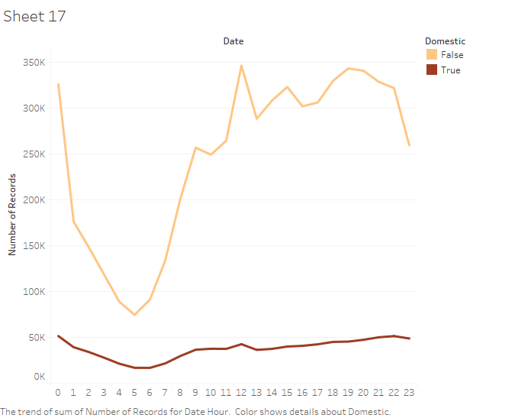

A line graph Showing the crime rate per hour we can say that 5 o’clock is the safest time in the day and the most dangerous hours are midnight and noon.

**Graph 5**

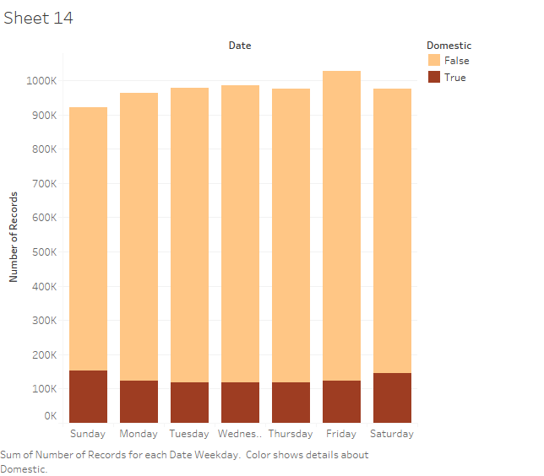

A bar graph showing the crime incident rate per weekday, Sunday is the safest day when the crime is nondomestic but the most dangerous day for domestic crimes while Friday is the most dangerous day in the week.

**Graph 6**

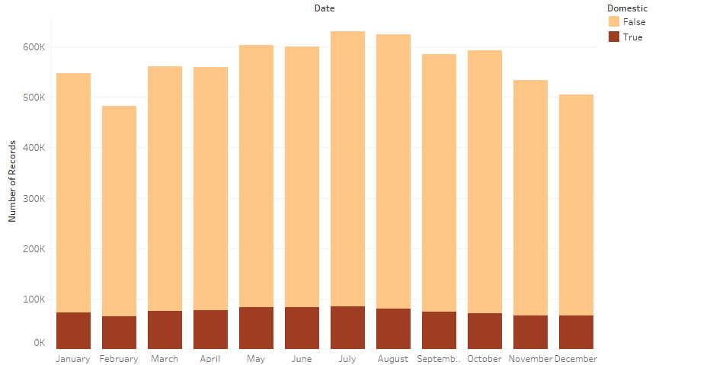

A bar graph showing the crime incident rate per months, July and August are the most dangerous months in the year while February and December are the safest days in the year.

**Note:**

From the above three time (month, day, hour) visualizations we can tell that The safest time in Chicago city is 5 AM Sunday February.

**Graph 7**

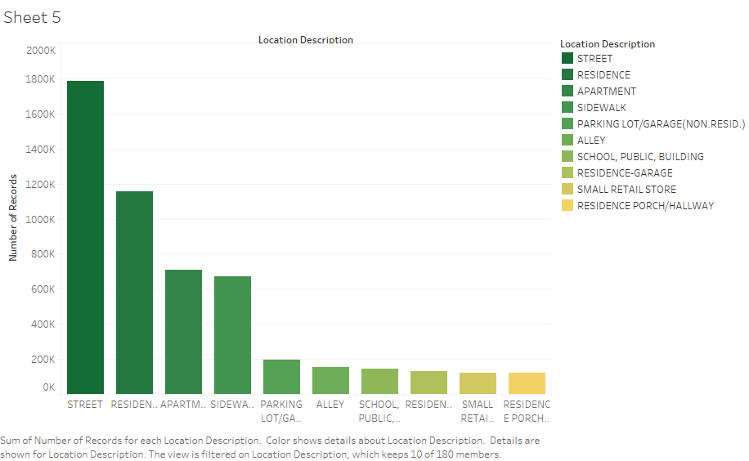

A bar graph showing Top 10 location description sorted descending order where crime incident is high, streets comes first with more than 1600K before residents with slightly less than 1200K.

**Graph 8**

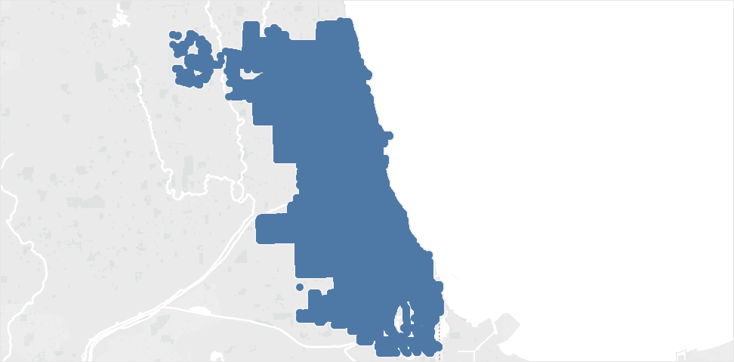

A map visualization using longitude and latitude showing the area of crimes in Chicago city. Below will be shown the districts in the map.

**Graph 9**

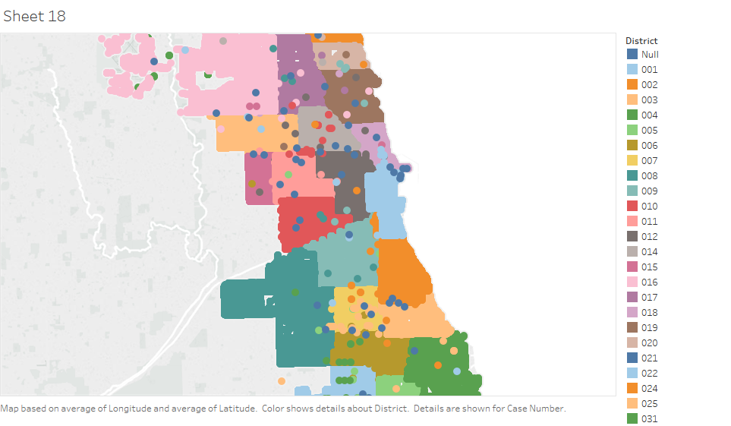

A map visualization using longitude and latitude showing the crime incidents per district its giving an insight about the null values, but it was mentioned earlier in dataset that some values are null due to privacy and security reasons but there are some values with the wrong district number as its clear in the above graph.

**Graph 10**

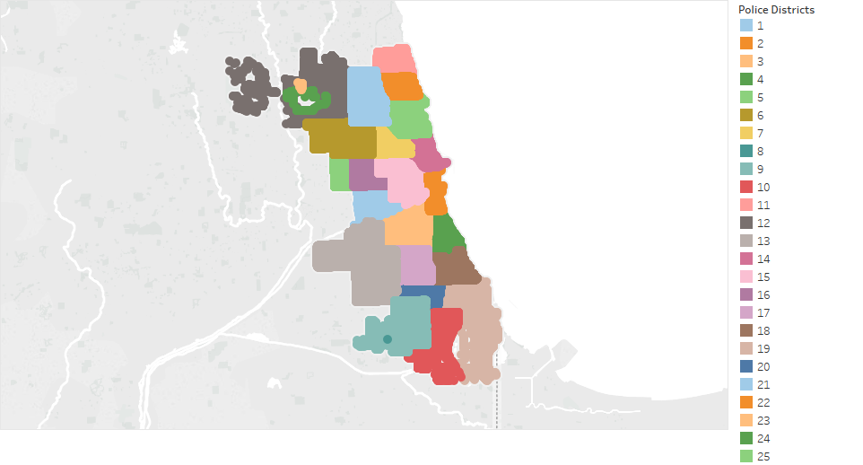

A map visualization using longitude and latitude showing the crime incidents in the police district, it’s obvious that district 12,13 and 19 has higher crime rate than the others. So the police admiration can assign more police men to the area.

**Summary**

Chicago city is getting safer by the day but since 2014 its in steady state when it comes to crimes, however visualizing this data is helping the authorities to decrease the crime rate for the next years. Below you’ll find a link to tableau public

<https://public.tableau.com/profile/mazin7686#!/>