**INFO 6205**

**Program Structure and Algorithms**

**Fall 2020**

**Final Project**

**COVID-19 Transmission Simulation**

* **Task**

The goal of this final project is to challenge students to apply their knowledge learned from class on doing simulations and draw conclusions based on observations. Students then are required to compare at least two viruses with different k/R factors. Students should also provide unit tests for all formulas and rules and have their code at least 60% coverage by line.

* **COVID-19 Pandemic**

COVID-19, also known as coronavirus, is a contagious disease caused by severe acute respiratory syndrome coronavirus 2 (SARS-CoV-2). It has spread worldwide, leading to an ongoing pandemic.

The virus spreads rapidly mainly because an infected person is in close contact with another person. When the infected person is coughing, speaking or sneezing, small droplets containing the virus will then get into another person’s mouth, nose or eyes and infect that person.

Wearing masks, social distancing and quarantining are three effective ways to minimize the risk of transmissions and prevent people from getting infected.

* **Model**

The model focuses on basic population interactions where we look at the spread of a disease throughout a fluid group of individuals. In the model, four agents are identified using susceptible, susceptible_with_masks, infected and recovered.

Susceptible agents indicate normal healthy people. They move randomly on the map and will be infected when contacting the infected people.

Susceptible_with_mask agents are added to simulate how protective the masks are when contacting infected people. Susceptible_with_mask have lower infection rate than normal susceptible agents.

Infected agents are individuals that are currently being affected by the disease. If an infected person and a susceptible person come within contact (looking at the Moore neighborhood including the center), then a random number is generated and compared against the infection rate to determine how the disease spreads. At each new iteration, there is also a random chance that an infected individual can become recovered.

Recovered agents are individuals that become recovered from infection, but they still have chances to get infected again because we established a rule that if a recovered individual interacts with at least three infected individuals, they can become sick again.

The population dynamics included in this model are people coming and going at adjustable rates. Dead people will get removed from the board. Viral mutations are not considered into this model specifically. Instead, let recovered people get infected again represent that a new strain can arise based on the need to transmit but inability to do so based on previous infections.

To better illustrate how other factors affect the spread of the virus, we defined a city area where it has high population density .In this area, people are in close contact with each other so that the infection rate in this area is higher than in other areas. On the other hand, the city area has more medical resources and did more testing, so it’s recovery rate will be higher.

The model will end when there are no more sick people because there is no longer an infection to spread and thus no reason to continue observing the agents.

* **GUI**

In this project, we use Mesa to visualize our model.

Mesa is a framework in Python used for building, analyzing and visualizing agent-based models. Agent-based models are computer simulations involving multiple agents acting and interacting with one another based on their programmed behavior. Agents can be used to represent living cells, animals, individual humans, even entire organizations.

The board with grids is used to visualize the spread of a virus. Four emojis are used to represent people with different status. A smile emoji represents a susceptible individual, a face with mask on emoji represents a susceptible_with_mask individual, a green face emoji represents an infected individual and an excited emoji represents a recovered individual.

There are 8 slide bars on the left to control the initial population of each agent group, population increase rate, population decrease rate, infection rate and recovery rate. On the top there is a slide bar to control the frames per second. At the bottom there is a scatter plot that shows the trend of each agent group.

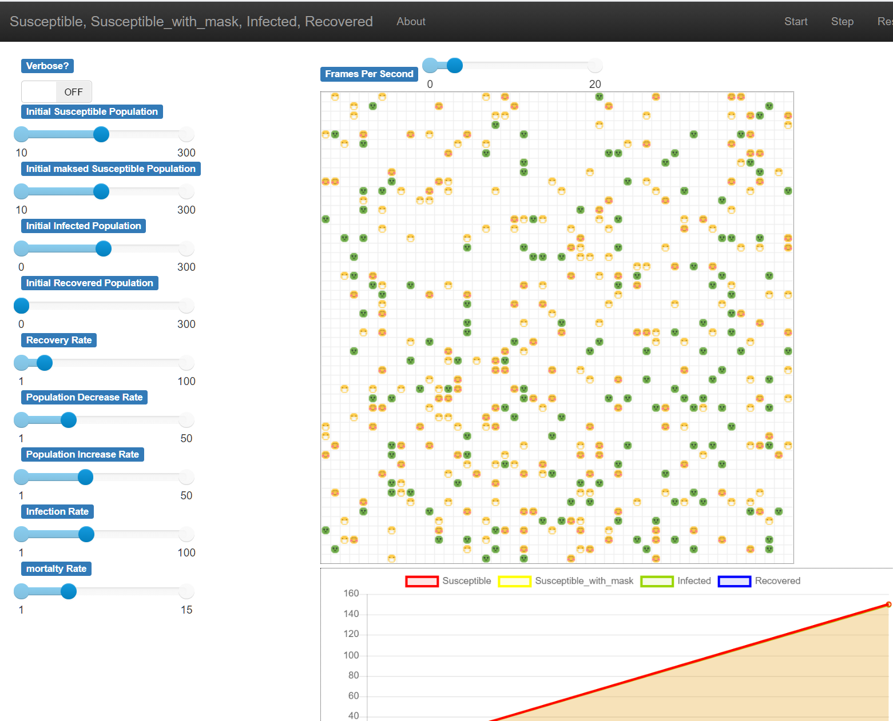

* **Graph**

Infection rate: 30 Recovery rate: 70

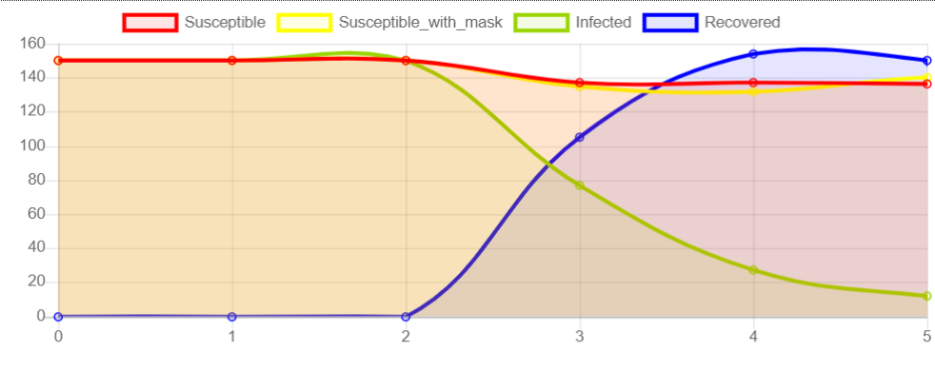

Infection rate: 70 Recovery rate: 70

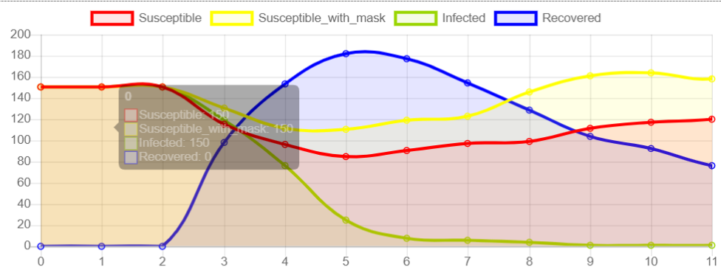

Infection rate: 30 Recovery rate: 30

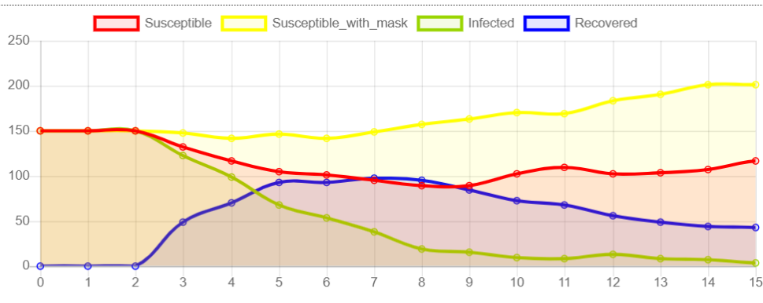

Infection rate: 70 Recovery rate: 30

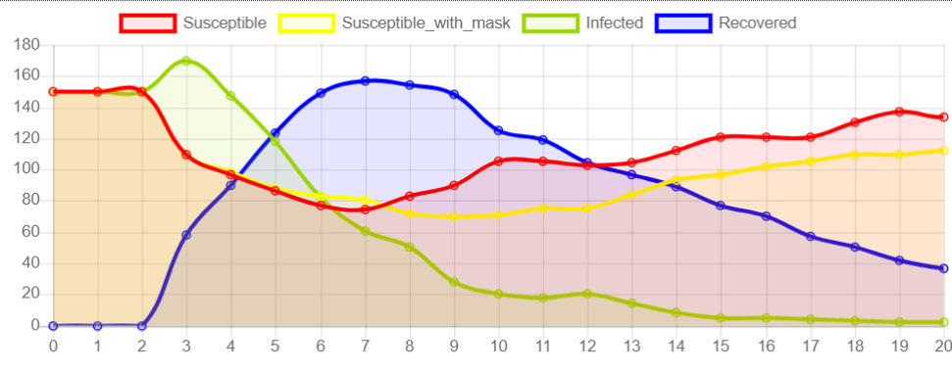

* **Comparison with “SARS”**

SARS is a virus that is similar to COVID-19. The mortality rate of SARS is 10.8% and COVID-19 is 4.6%. And the reproduction rate for SARS is 0.19-1.08, for COVID-19 is 2-6. From the data we can observe that COVID-19 has a higher reproduction rate but a lower mortality rate. But SARS has a lower reproduction rate and a higher mortality rate. Thus, we set different values for infection rate and recovery rate and run the simulation.

**COVID-19**

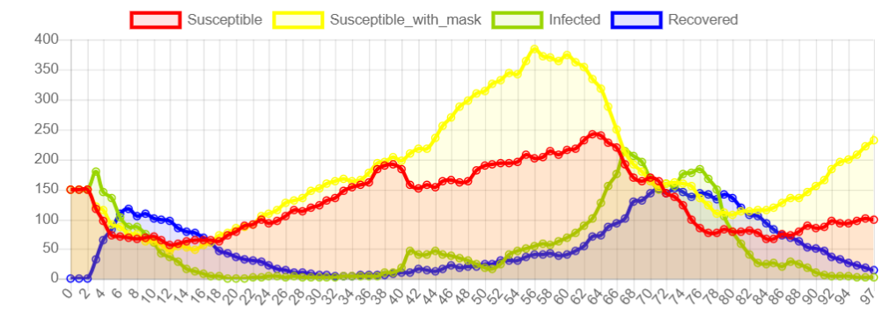

This graph shows that the yellow curve is higher than the red curve most of the time and reaches the climax in the middle. It indicates that with the rapid increase of the population, people are more likely to be infected if they do not wear masks because of the high reproduction feature of COVID-19.

**SARS**

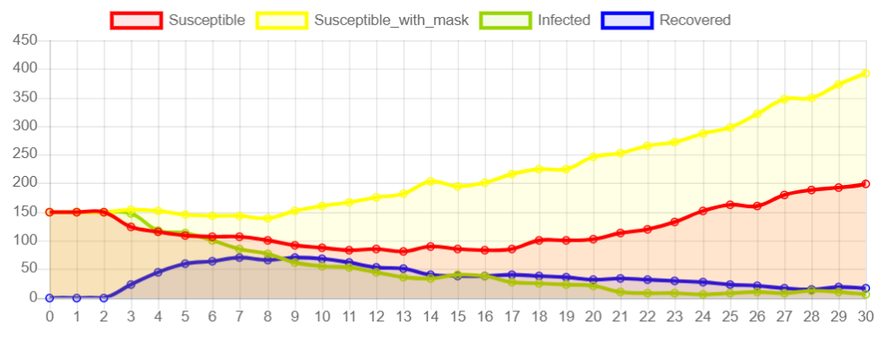

This graph shows that SARS does not spread as fast as COVID-19 because the red and yellow curve trends positively. But the blue curve trends negatively. Therefore, due to the lower reproduction rate, SARS spreads slower. But with the higher mortality rate, it cause more deaths than COVID-19.

* **Conclusion**

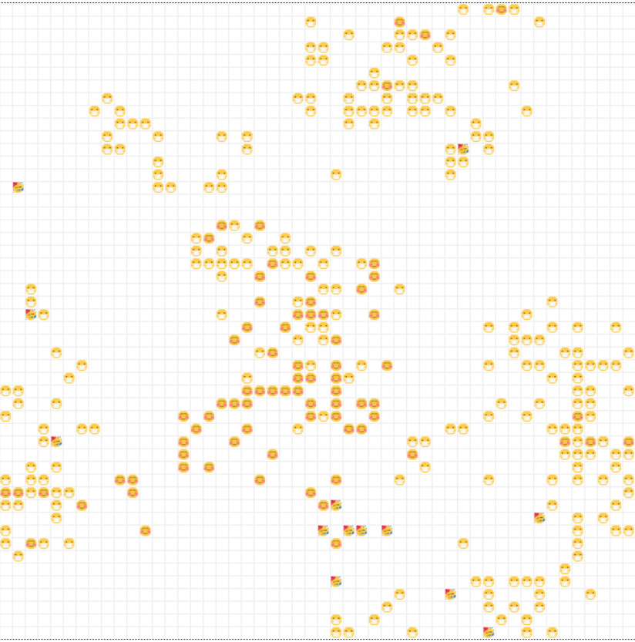

This graph is the end result of a simulation of COVID-19. It vividly shows that most normal susceptible people died without wearing a mask in rural areas. In the middle where the city area is, only a few susceptible people can live because of the city area’s substantial resources, quick testing, contact tracing and high recovery rate.

In general, COVID-19 is dangerous and it appears to transmit easily between people if no preventions are done. Although it has a low mortality rate, medical treatments are still needed and required for severe symptoms. Masks play an important role in this simulation, it effectively decreases the risk for people to be infected.

* **References**

<https://www.healthline.com/health/coronavirus-vs-sars#transmission>

<https://www.ncbi.nlm.nih.gov/pmc/articles/PMC7235519/>