Supervised learning

Exercise 1: A basic supervised problem

Introduction to Machine Learning

Authors: Pablo Martínez
Aleix Solanes
Date: November 2015
Contents

Question block 1 3
Question block 2 3
Question block 3 4
EXTRA 7
Question block 4 8
Question block 5 12
Question block 7 13

Question block 1
- Plot the training samples and their corresponding label
addpath('src');
load('./data/reg_data_set_1.mat');
scatter(x,y); % This generated image corresponds to 1)
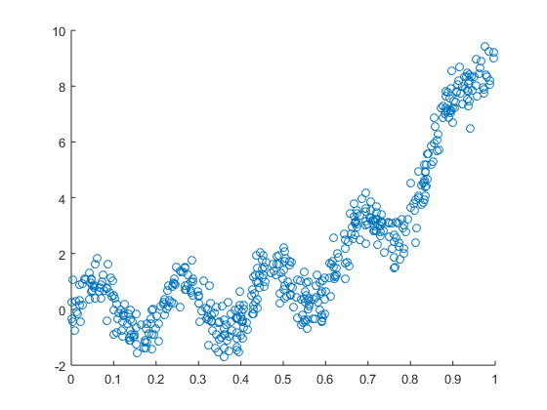

Question block 2
1) The optimal value of the regression is; [-2.047...;7.994...]
2) It looks like a quite good approximation really.
figure
b = x\y;
[w,X] = polireg(x,y,1);
scatter(x, y);
hold on
plot(x,X*w,'-');
hold off
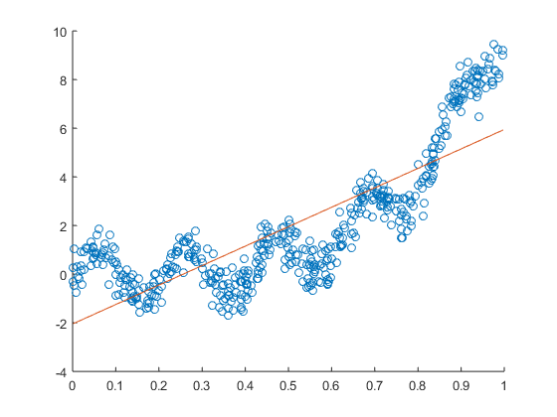

Question block 3
1) With an alpha of 0.1, the Theta values converge at:[-1,6; 7.4]
2) With an alpha of 0.1, in order to make the algorithm converge, 90 iterations are needed
3) Plot the convergence curve of the method
x_tmp = X;
stepsize = 0.1;
%Do the gradient descent
[theta, cost, hist] = grad2simple(x_tmp,y,[5; 5], stepsize, 90);
figure
plot(cost);
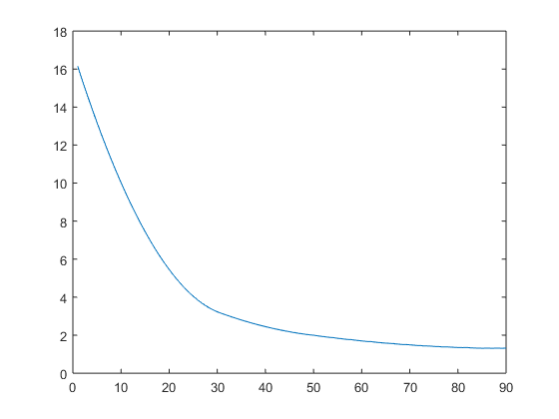
4) It does, because this method uses a fixed step size, and it can jump over the minimum
figure
plot(cost(80:83));
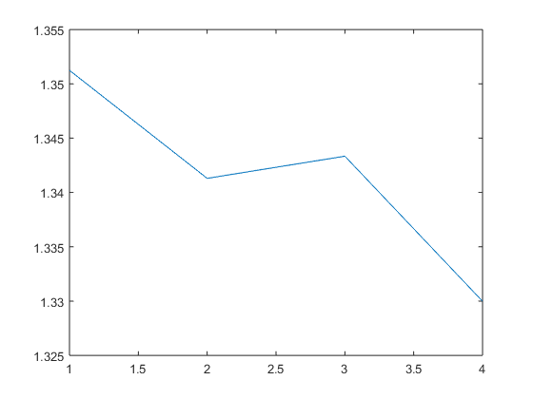
5) The alpha is already at 0.1, with the code below any parameters can be tested
stepsize = 0.1; % Define the step size on every dimension
num_iter = 90; % Define the number of iterations before it end
theta = [5; 5]; % Initial theta
X = x_tmp; % Initial X matrix
y = y; % Initial y matrix
[theta, cost, hist] = grad2simple(X,y,theta, stepsize, num_iter);
figure
plot(cost);

EXTRA
Show the movement of the function in a contour
res = lr_descent(x,y,[-5,10],[-5,10]);
figure
contour(res,8);
hold on
plot_dir(hist(:,1)+5,hist(:,2)+5)
hold off
%-------------------------------------------------------------------------%
ans =
Line with properties:
Color: [0 0.4470 0.7410]
LineStyle: '-'
LineWidth: 0.5000
Marker: '.'
MarkerSize: 6
MarkerFaceColor: 'none'
XData: [1x90 double]
YData: [1x90 double]
ZData: [1x0 double]
Use GET to show all properties
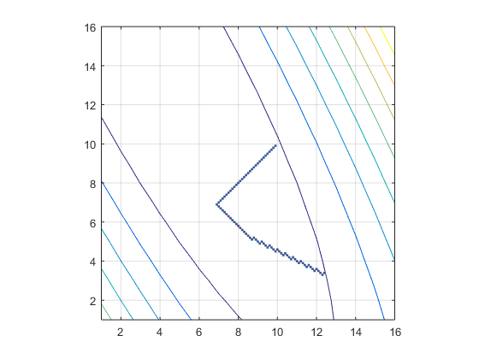

Question block 4
figure;
[~, cost, ~] = grad2(x_tmp,y,[0; 0], 1, 1000);
plot(cost);
hold on;
[~, cost, ~] = grad2(x_tmp,y,[0; 0], .1, 1000);
plot(cost);
[~, cost, ~] = grad2(x_tmp,y,[0; 0], .01, 1000);
plot(cost);
hold off;
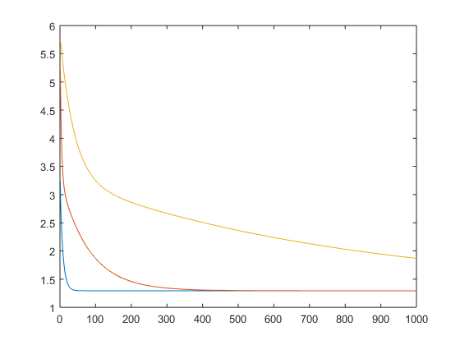
1) The optimal values are -2.0474 7.9948
2) The parameters used make the algorithm converge are: > Learning rate = 1 > Number of iterations = 200 > Starting theta = 5,5
3) Plot the convergence curve of the method
[theta, cost, hist] = grad2(x_tmp,y,[5; 5], 1, 200);
plot(cost);
hold off;
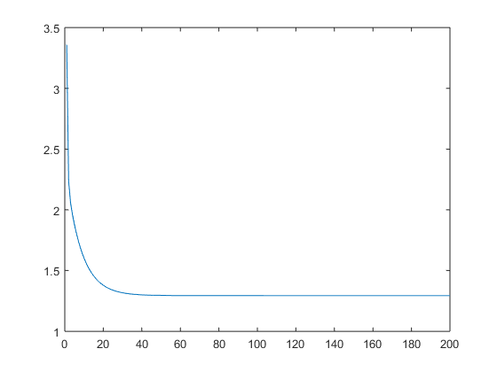
4) It does not oscilate because the direction and the step size is determined by the magnitude of the gradient, that does that when the method is close to the local minimum it moves really slowly and it needs a little ammount of iterations to get close to the center, but a lot to converge.
figure;
plot(cost(150:190));
res = lr_descent(x,y,[-5,10],[-5,10]);
%figure
%surf(res,'EdgeColor','none','LineStyle','none','FaceLighting','phong')
figure
contour(res);
hold on
plot_dir(hist(:,1)+5,hist(:,2)+5)
ans =
Line with properties:
Color: [0 0.4470 0.7410]
LineStyle: '-'
LineWidth: 0.5000
Marker: '.'
MarkerSize: 6
MarkerFaceColor: 'none'
XData: [1x200 double]
YData: [1x200 double]
ZData: [1x0 double]
Use GET to show all properties
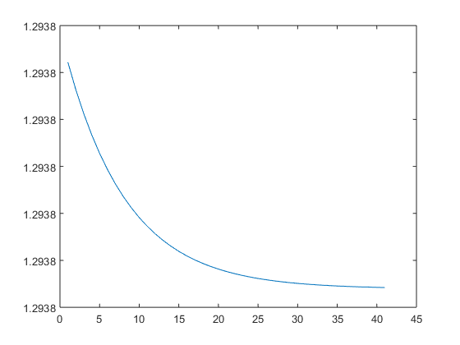
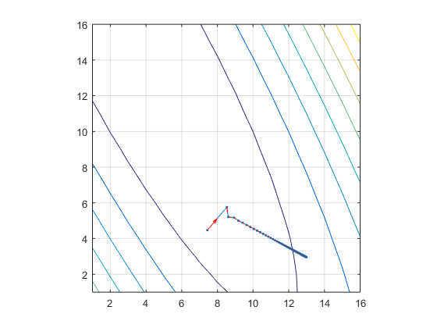

Question block 5
1) The optimal values found for a quadratic polynomial regression are: [18.2255681003074;-10.2344557665670;1.06732192318857]
2) A quadratic function is better than a linear function to approximate the function of the dataset because the original function has many curves.
figure
[w,X]=polireg(x,y,2);
scatter(x, y);
hold on
plot(sort(x),sort(X)*w,'-');
hold off
clear
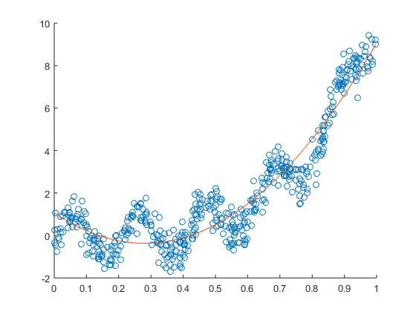

Question block 7
Points 1, 2, 3 in the following code:
load('data/reg_data_set_2.mat');
train_x = x(1:10);
train_y = y(1:10);
test_x = x(11:20);
test_y = y(11:20);
figure;
scatter(train_x, train_y);
hold on
scatter(test_x, test_y);
RMS_A_Train = zeros(6,1);
RMS_A_Test = zeros(6,1);
RMS_GD_Train = zeros(6,1);
RMS_GD_Test = zeros(6,1);
for i=1:6
deg = i; % Define the degree and execute the following code
% Calculate weights analytically
[w,X] = polireg(train_x,train_y,deg);
% Calculate weights with gradient descent
[w2,~, ~] = grad(train_x,train_y,(1:deg+1)',0.01, 1000);
tX = polimat(test_x,deg);
% RMS Analytical
RMS_A_Train(i) = sqrt(sum(tX*w-train_y).^2);
RMS_A_Test(i) = sqrt(sum(tX*w-test_y).^2);
% RMS Gradient descent
RMS_GD_Train(i) = sqrt(sum(tX*w2-train_y).^2);
RMS_GD_Test(i) = sqrt(sum(tX*w2-test_y).^2);
plot(sort(train_x),sort(X)*w,'-');
end
figure
scatter(train_x, train_y);
hold on
scatter(test_x, test_y);
plot(sort(train_x),sort(X)*w2,'-');
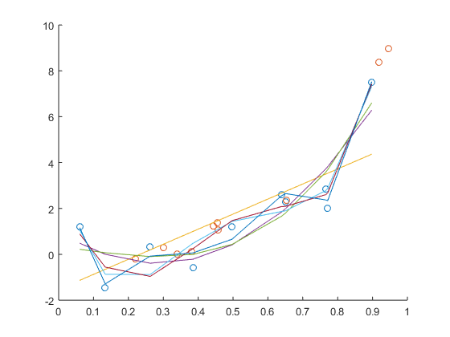
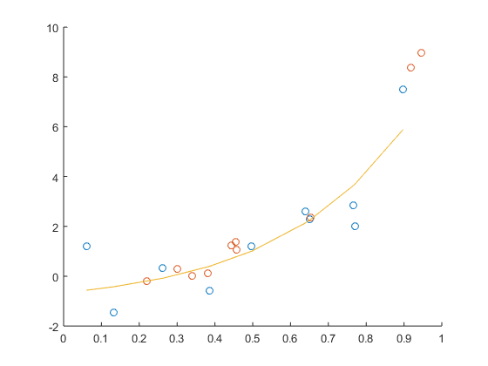
4) Plot on the error curves
figure
plot(RMS_A_Train);
hold on
plot(RMS_A_Test);
legend('Train','Test')
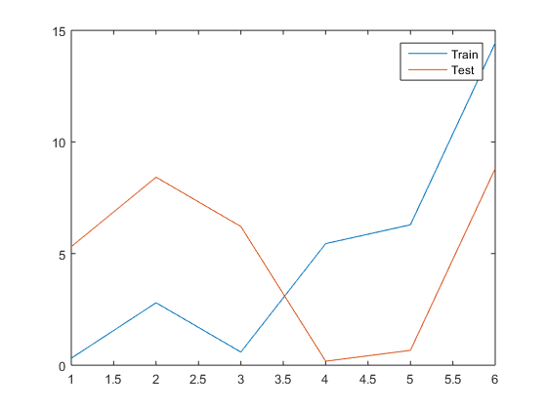
5) No they don’t agree, that’s because the number of samples is quite small. The training set, contains 10 samples, and the test set another 10 samples, so it’s really difficult to decide which is the best model to fit the original function.

