**User**(id_user, role, email, password, name, lastName)

**Student**(id_user ,total_points, **id_class**)

**Teacher**(id_user, count_of_tasks, **id_subject**)

**Certification**(id_certif, name_certif, point, flag_as_available, description, img_url)

**Subject**(id_subject, subject_name)

**Class folder**(id_classFolder, classFolder_name)

**Task(**id_task , task_name, create_date, task_inner, flag_is_done, count_points, **id_teacher**, **id_class, id_taskTemplate, id_category**)

**Task’s Folder**(id_tskFolder, tskFolder_name, **id_classFolder**)

**Class**(id_class, class_name, class_level, **id_teacher**)

**Category**(id_category, category_name, date_create, **id_subject**)

**TaskTemplate**(id_template, template_name, template_inner)

**Student_ Certification(**id_user, id_certif, data_get**)**

**Student_ Task(**id_user, id_task, is_task_done, date)

**Student_ Class(**id_user, id_class)

**Task_Task’sFolder**(id_task, id_tskFolder)

Activity diagram

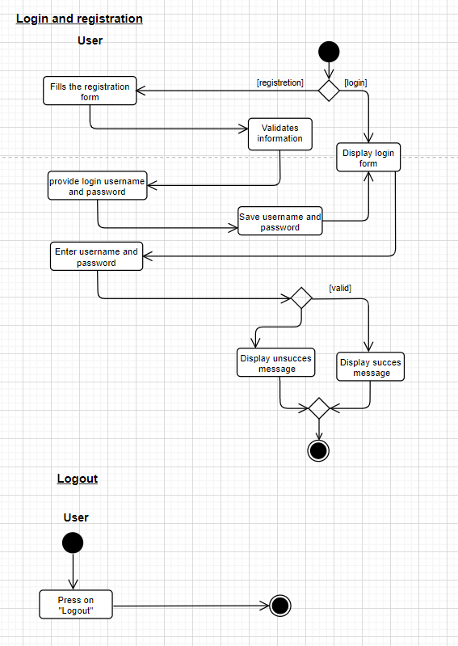

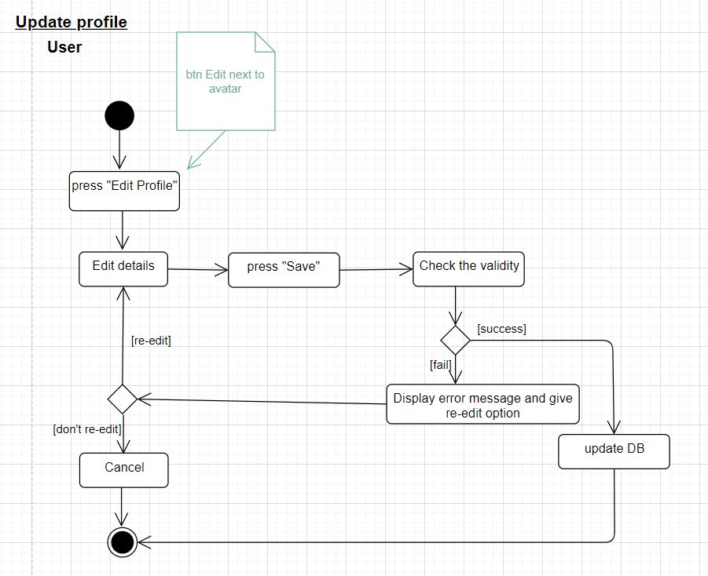

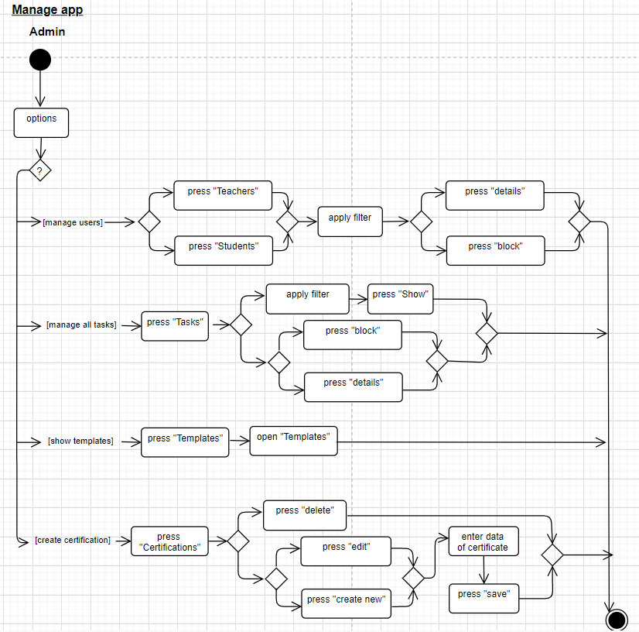

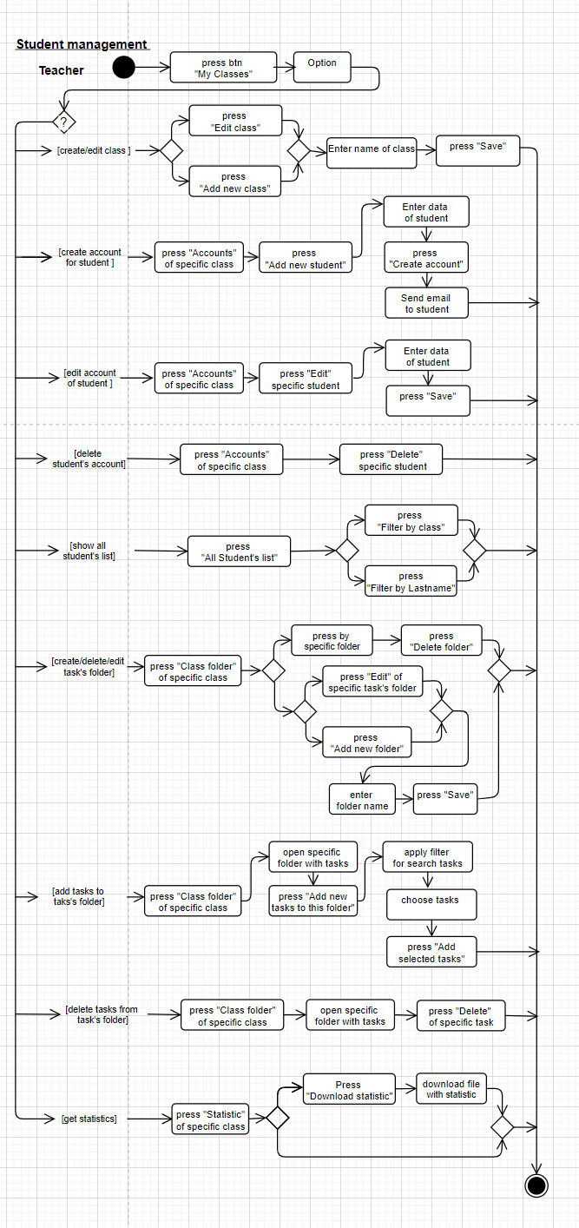

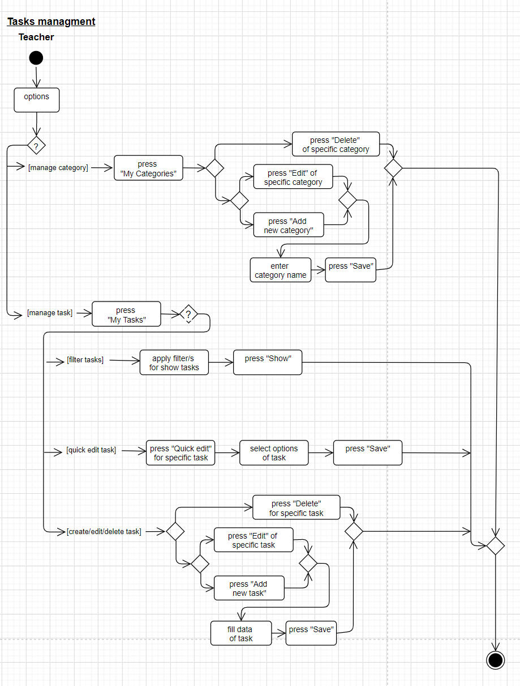

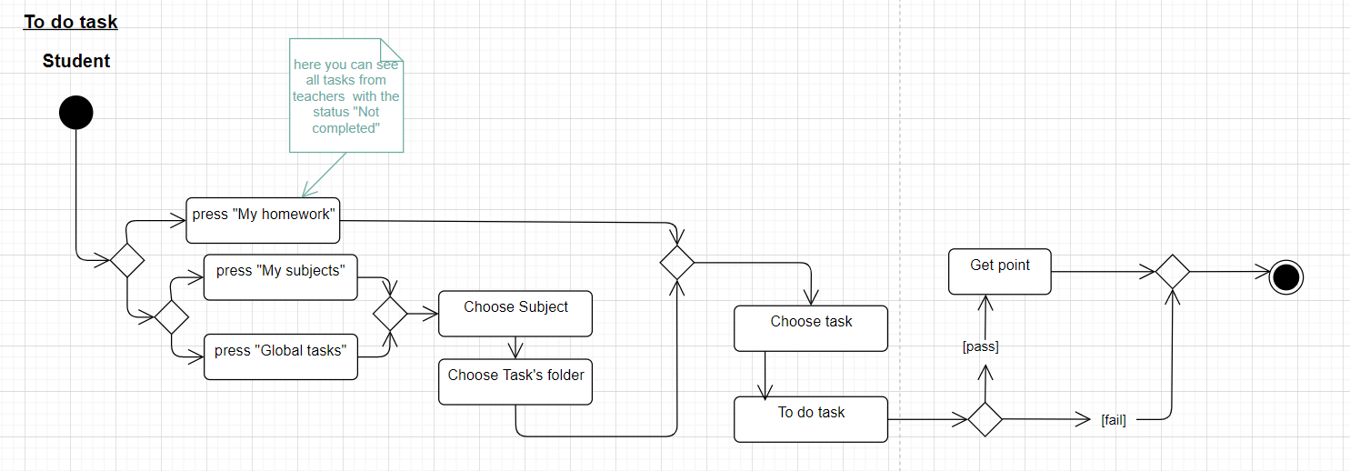

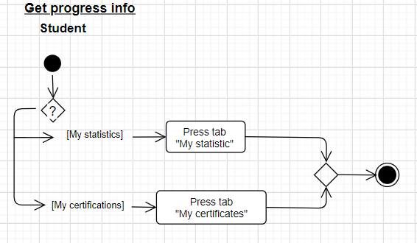

Sequence diagram

