NIST UNIVERSITY


A Project Report
On
SMART MART E-COMMERCE WEBSITE

SUBMITED BY:
Anita Kumari Sahu (202225460)
Alok Kumar Dash (202220246)
INTRODUCTION

In the digital era, e-commerce has revolutionized the way businesses operate and how consumers shop. Online platforms have become the backbone of modern retail, offering convenience, accessibility, and efficiency to users worldwide. However, managing online transactions, maintaining product inventories, and ensuring data security remain major challenges for both sellers and buyers.
The Smart Mart E-Commerce Website is developed to address these challenges by providing a centralized, secure, and user-friendly online shopping system. The platform allows users to browse products, add them to a shopping cart, make secure payments, and track their orders seamlessly. At the same time, administrators can efficiently manage products, categories, and orders through a dedicated dashboard. This project emphasizes automation, data security, and user satisfaction. It aims to simplify the traditional retail workflow by integrating digital technologies that minimize manual efforts, enhance transparency, and improve customer experience. With its scalable design, Smart Mart can be adapted for small businesses as well as large enterprises, making it a flexible and sustainable e-commerce solution.

SMART MART E-COMMERCE
1. Goal
The main goal of the Smart Mart E-Commerce Website is to design and develop a reliable, scalable, and user-friendly online shopping platform that allows customers to browse products, add them to a virtual cart, make secure payments, and track their orders easily . It aims to automate traditional retail operations by digitizing product management, order handling, and customer interaction through a centralized web-based system.

Key Goals:
- To build a responsive and accessible e-commerce website.
- To ensure secure user registration, login, and payment processing.
- To provide an easy-to-use admin dashboard for product and order management.
- To minimize manual effort in managing sales, stock, and customer data.

2. Objectives
The main objectives of the Smart Mart website are:
- User Convenience: Enable customers to purchase products anytime and anywhere.
- Automation: Automate inventory, order processing, and billing operations.
- Security: Ensure safe and secure user authentication and transaction processing.
- Efficiency: Reduce time and effort for both users and administrators.
- Scalability: Design the system to handle large volumes of products and customers.
- Data Management: Maintain organized records of users, products, and orders.
- Performance: Optimize the system for fast loading, quick search results, and smooth navigation.
3. Requirements
A. Functional Requirements
S.No | Function | Description
1 | User Registration | Users can register by providing details like name, email, and password.
2 | User Login | Users can securely log in to the system.
3 | Product Browsing | Users can browse and search products by category or name.
4 | Shopping Cart | Users can add/remove products to/from the cart.
5 | Checkout & Payment | Secure payment gateway integration for online transactions.
6 | Order Tracking | Users can track the status of their placed orders.
7 | Admin Dashboard | Admin can add, update, or delete products and view all orders.
8 | Feedback System | Users can rate and reviews products.

B. Non-Functional Requirements
Category | Description
Usability | The interface should be clean, intuitive, and easy to use.
Performance | Fast page loading, responsive design, and optimized database queries.
Security | Use of encryption, password hashing, and secure HTTPS connections.
Scalability | System should handle increasing number of users and transactions.
Availability | The website should be available 24/7.
C. Software Requirements
Component | Specification
Front-End | HTML, CSS, JavaScript, Bootstrap
Back-End | PHP / Python Flask / Node.js
Database | MySQL / MongoDB
Server | Apache / XAMPP / WAMP
IDE | Visual Studio Code
Browser | Google Chrome, Firefox
4. Data Flow Diagram (DFD)
Level 0 :

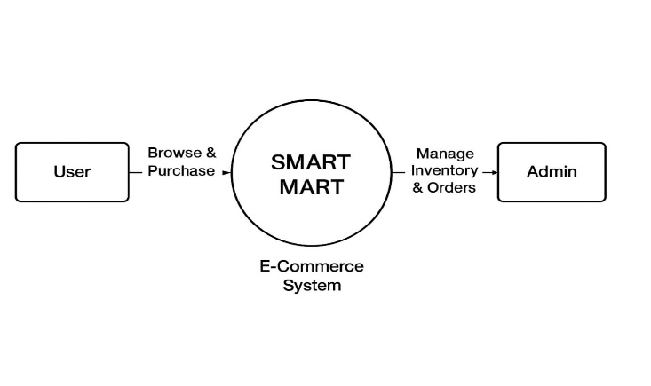

Level 1:

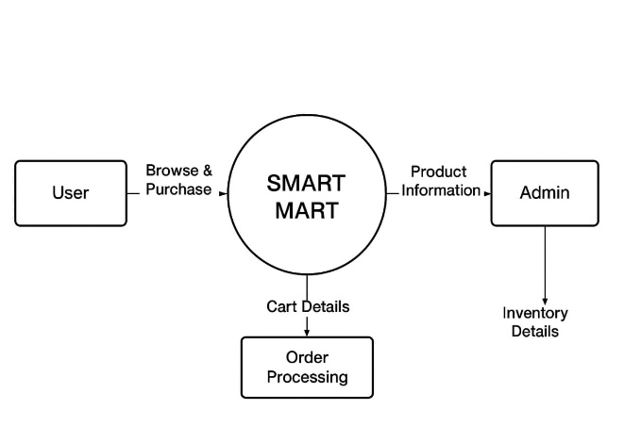

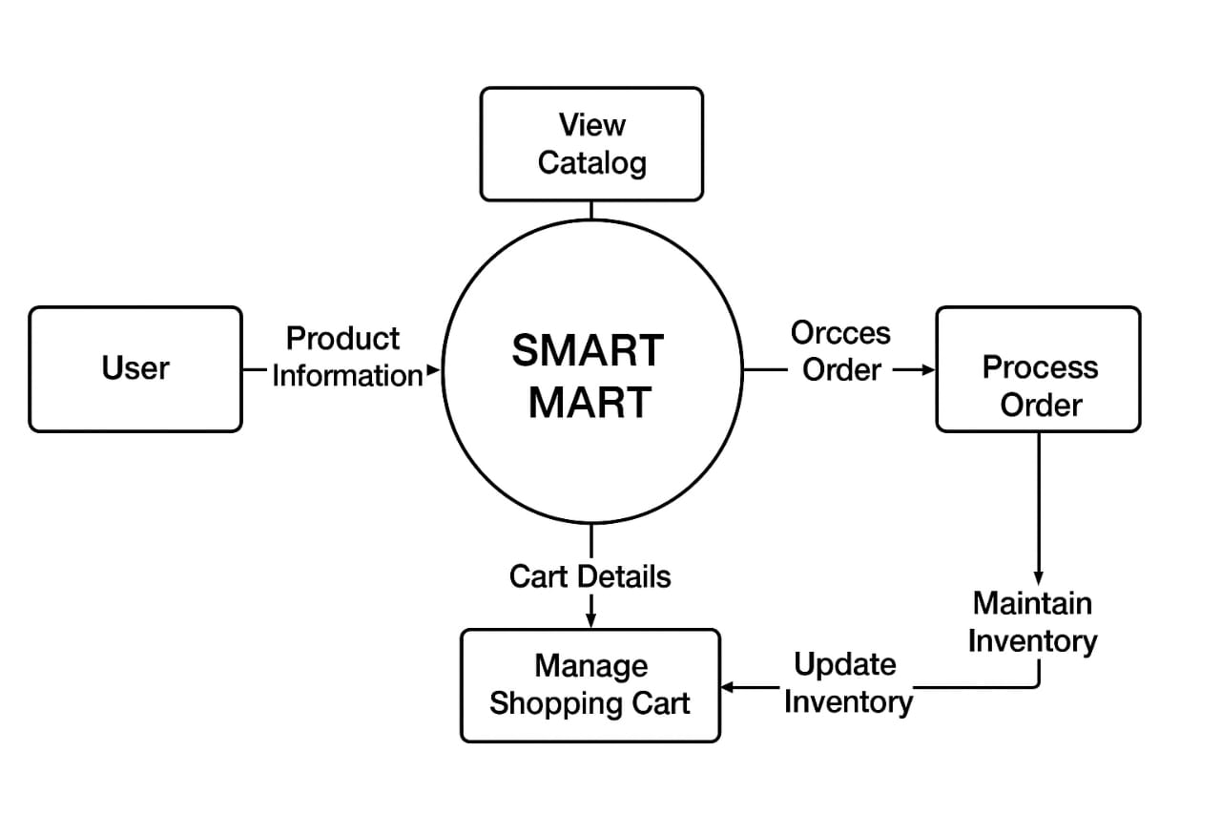
Level 2:

5.Sequence Diagram
Flow:
- User logs into system.
- System verifies credentials via database.
- User selects products → Adds to cart.
- User initiates checkout → System requests payment.
- Payment gateway verifies payments.
- System confirms order → Updates database → Sends confirmation to user.
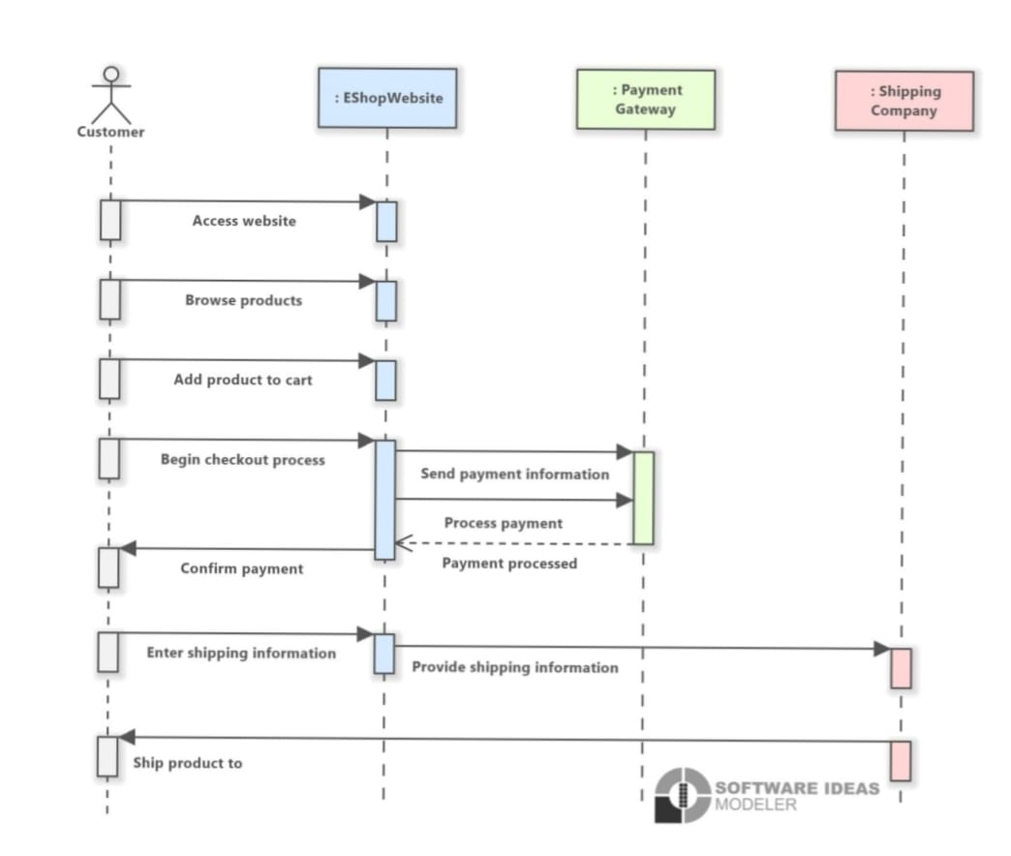
6. Data Dictionary
Table Name | Field | Data Type | Description
User | user_id | INT | Unique user ID
 | name | VARCHAR | User’s name
 | email | VARCHAR | User email address
 | password | VARCHAR | Encrypted password
Product | product_id | INT | Unique product ID
 | name | VARCHAR | Product name
 | price | FLOAT | Product price
 | stock | INT | Available quantity
 | description | TEXT | Product details
Order | order_id | INT | Unique order number
 | user_id | INT | Buyer’s ID
 | date | DATE | Order date
 | total_amount | FLOAT | Total cost
 | status | VARCHAR | Status (Pending/Delivered)

7. Process Flow
Step 1: User registers and logs in.
Step 2: User browses categories or searches for products.
Step 3: Adds desired products to cart.
Step 4: Proceeds to checkout.
Step 5: Makes payment using card or UPI.
Step 6: Order confirmation is displayed.
Step 7: Admin monitors and processes the order.
┌──────────────────────────┐
│ User Registration / │
│ Login │
└────────────┬─────────────┘
▼
┌──────────────────────────┐
│ Browse Products │
└────────────┬─────────────┘
▼
┌──────────────────────────┐
│ Add to Cart │
└────────────┬─────────────┘
▼
┌──────────────────────────┐
│ Checkout & Payment │
└────────────┬─────────────┘
▼
┌──────────────────────────┐
│ Order Confirmation │
└────────────┬─────────────┘
▼
┌──────────────────────────┐
│ Admin Manages Orders │
└──────────────────────────┘
▼
┌────────────────────┐
│ END │
└────────────────────┘
8.Snapshots
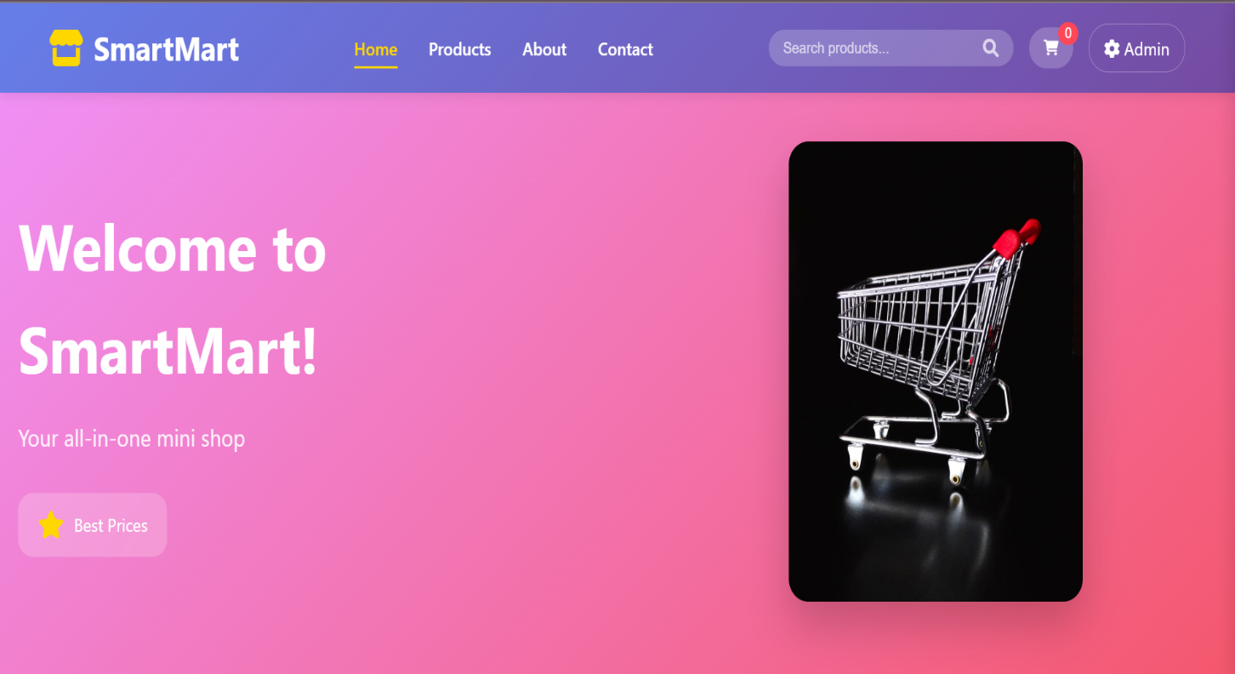

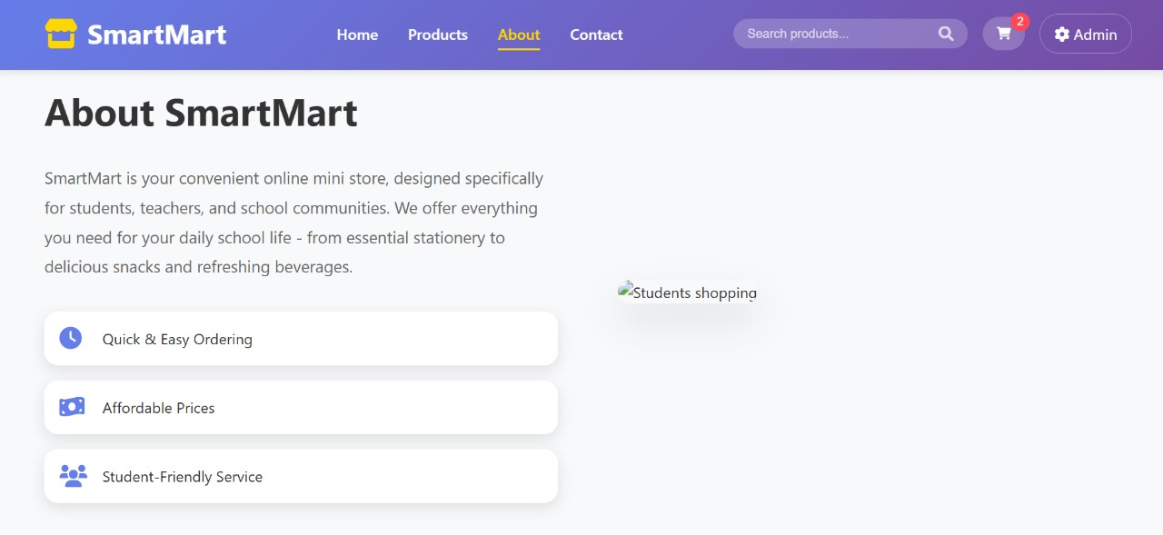
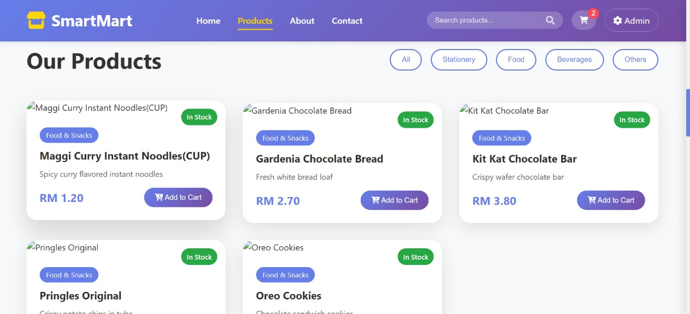

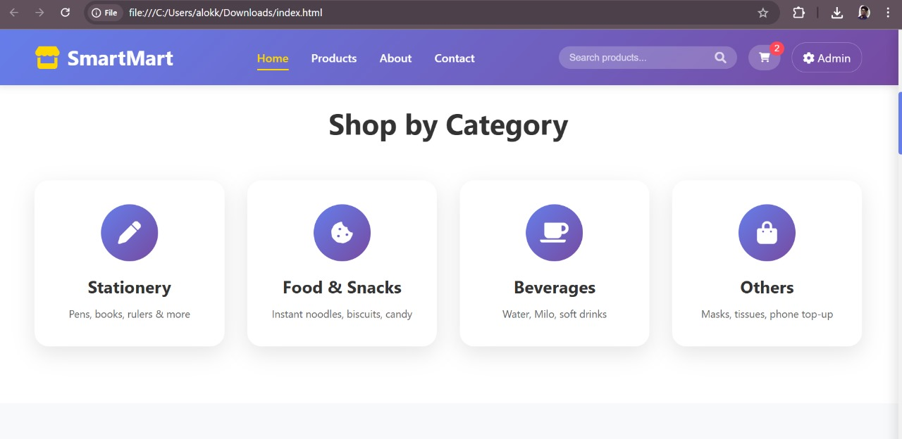

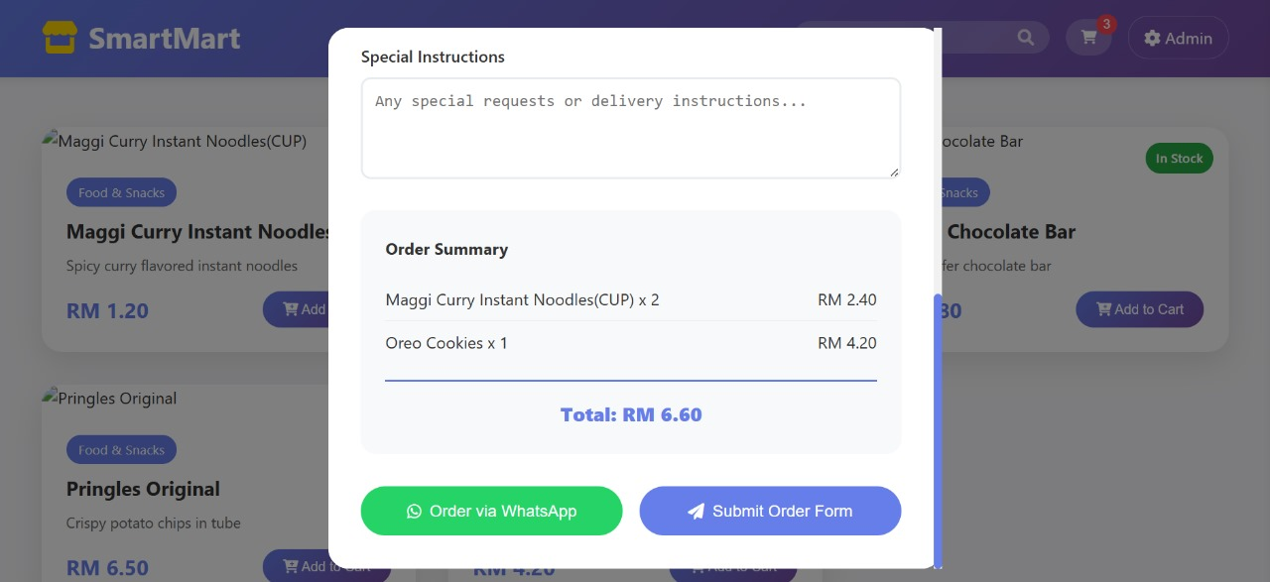

Conclusion
The Smart Mart E-Commerce Website successfully provides a digital platform for buying and selling products online. It simplifies business operations by automating sales, payment, and delivery processes.
Advantages:
- Reduces manual work for sellers.
- Offers a convenient shopping experience to users.
- Secure and organized management of customer and product data.
- Scalable for small to large businesses.
Future Enhancements:
- Integration of AI-based product recommendations.
- Mobile application support.
- Real-time delivery tracking system.
- Multiple language and currency support.

-------------0--------------

