Mksd system update instruction

This application is worked on windows platforms.

Step 1. Put rtx-q7-ltib-2017-6-26.zip to PC .

Step 2. Unzip it.

Step3. Prepare a blank sdcrad to update the system. Then insert it to PC. ( Disk F:)
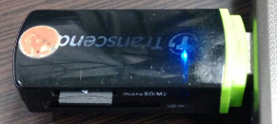
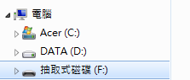

Step4. Execute mksd.exe
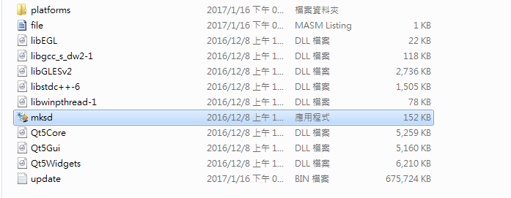

Step5. Select Target and Start
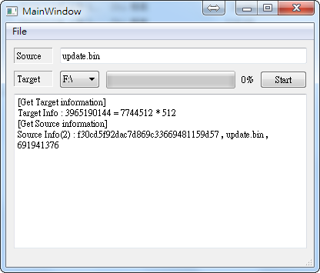

Step6. Finish an update sdcard.
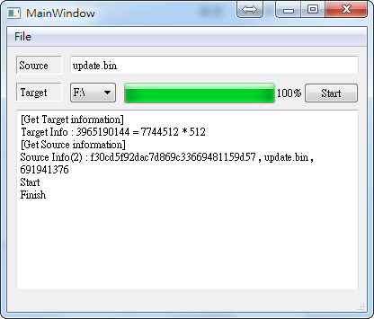

Step7. Insert sdcard and power on.
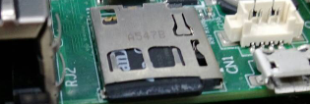

Step8. Start updating the system.
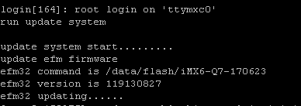

Update efm32 complete, Reboot

Step9. Verify & Complete the system update.
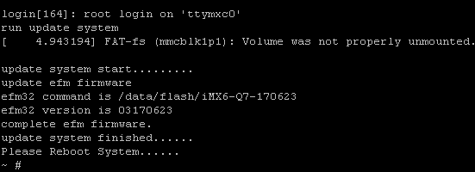

Stelp10. Power off, remove the sdcard, and restart system.

