ADLINK – PFT_161207_release (test result)

01 : Function test

PCBA Test Item | Test method | Test result
Ethernet | Ping | Pass
 | Server | Pass (圖一)
Wifi | Scan | Pass
 | Server | Pass (圖二)
Lvds | Picture display | Pass
Can Bus | Transfer & Receive | Pass
USB | Copy & Compare | Pass
SDCARD | Copy & Compare | Pass
EMMC | Copy & Compare | Pass

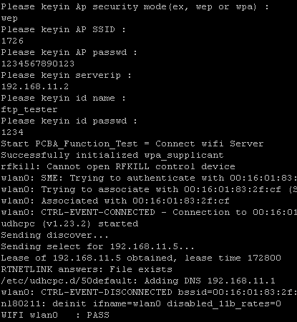

圖(一)如下 , 圖(二)如右

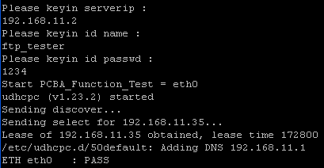

02 : Burn In test 03 : performance test
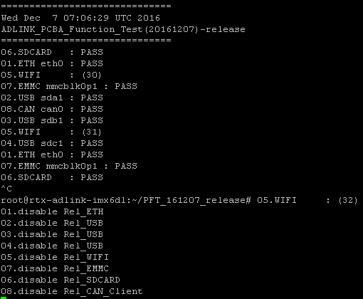
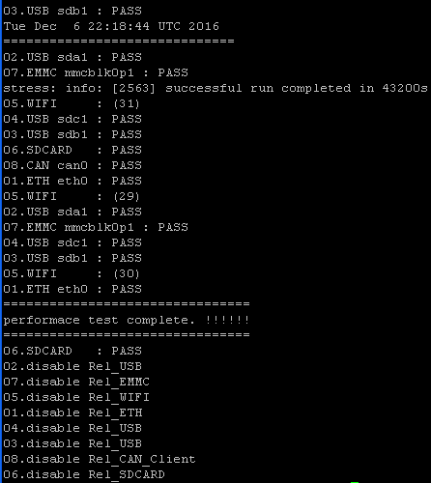

04 : Boot test

Start Boot test | Pass
Stop Boot test | Pass

