

DEPARTMENT OF COMPUTER ENGINEERING

DISCRETE STRUCTURES AND GRAPH THEORY

A REPORT ON

**HEALTH SERVICE AND MONITORING**

Submitted By

Aniket Sulke (SYCETB307)

Rushabh Bokade (SYSCETB308)

Gaurav Mahto (SYSCETB316)

**Course**: Discrete Structures and Graph Theory

**Faculty**: Mrs. R.M. GOUDAR

**Block**: B3

**Branch**: Computer Engineering

**Semister**: 4

**CONTENTS**

|  |  |  |  |
| --- | --- | --- | --- |
| **Sr No** |  | **Name of Topic** | **Page No.** |
| 1 |  | Introduction | 5 |
|  | 1.1 | Objectives | 5 |
|  | 1.2 | Advantages | 5 |
|  | 1.3 | Limitations | 6 |
|  | 1.4 | Applications |  |
| 2 |  | Diagrams | 7 |
|  | 2.1 | Use Case | 8 |
|  | 2.2 | Sequence State Diagram | 10 |
| 3 |  | Data Structure | 13 |
| 4 |  | Discrete Structures and Graph theory concepts |  |
|  | 4.1 | Principle of inclusion and exclusion |  |
|  | 4.2 | Dijkstra’s Algorithm |  |
| 5 |  | Algorithm | 14 |
| 6 |  | Outcomes | 15 |
| 7 |  | Conclusion | 16 |
|  |  | References |  |

1. **INTRODUCTION**
   1. **Objectives :**

To design a system that will help user to predict the disease based on the symptoms.

Describe the medicines based on the disease identified.

Provide a facility to redirect automatically to the webpage of online medicine store.

To determine the symptoms that are common between the diseases using principle of inclusion and exclusion.

To find a hospital that is nearest from the current location.

Store the record for future use.

* 1. **Advantages :**

Better access to healthcare

Improved quality of care

Low cost

Can be access easily by anyone

Visual tools helps to prescribe disease easily

Useful to find the nearest hospital and its website automatically

* 1. **Disadvantages :**

Accuracy is minimum in certain cases

Internet connections required to redirect to the webpage

* 1. **Applications :**

Shortest distance finding applications

Day-to-day health monitoring applications

1. **Diagrams**
   1. **Use Case :**

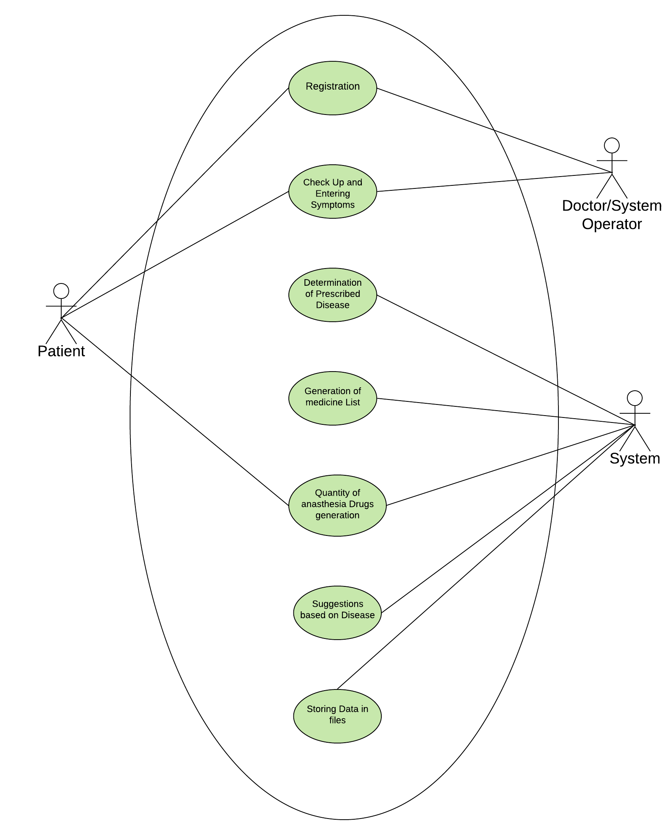

* 1. **Sequence State Diagram :**

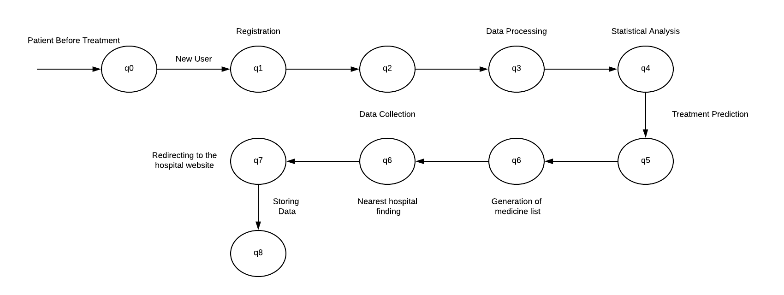

1. **Data Structure**

The most suitable data structure for our problem statement is array. Array is a container which can hold a fix number of items and these items should be of the same type. We can treat lists as a array in python 3.

There are several reasons for using an array one of is that it does not cannot allocate a runtime memory during runtime . Also when memory allocation is not dynamic it stored the data in contiguous memory locations. A list is ordered scaler data and array is a variable that holds the list. Arrays are useful while accessing any location. There are several built in methods such as append(), count(), index() which can be use on list or arrays.

We are storing record of diseases and its possible symptoms using array. This will help us to access to any record efficiently.

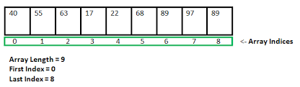

1. Discrete Structures and Graph theory concepts
   1. Principle of inclusion and exclusion:

The Principle of Inclusion and Exclusion (PIE) is a counting technique that computes the number of elements that satisfy at least one of several properties while guaranteeing that elements satisfying more than one property are not counted twice

An underlying idea behind PIE is that summing the number of elements that satisfy at least one of two categories and subtracting the overlap prevents double counting. For instance, the number of people that have at least one cat or at least one dog can be found by taking the number of people who own a cat, adding the number of people that have a dog, then subtracting the number of people who have both.

.4.2 Dijkstra’s Algorithm

Step 1**: Create a set sptSet (shortest path tree set) that keeps track of vertices included in shortest path tree, i.e., whose minimum distance from source is calculated and finalized. Initially, this set is empty.**

**Step 2: Assign a distance value to all vertices in the input graph. Initialize all distance values as INFINITE. Assign distance value as 0 for the source vertex so that it is picked first.**

**Step 3: While sptSet doesn’t include all vertices**

**a) Pick a vertex u which is not there in sptSet and has minimum distance value.**

**b) Include u to sptSet.**

**c) Update distance value of all adjacent vertices of u. To update the distance values, iterate through all adjacent vertices. For every adjacent vertex v, if sum of distance value of u (from source) and weight of edge u-v, is less than the distance value of v, then update the distance value of v.**

1. Outcomes
2. The system will predict the disease based on the possible symptoms that the can have The prediction is done using probability concept.
3. The results of the prediction can be analysed using visual technique of bar graph.
4. The patient can find the nearest hospital from his location. This can be done using Dijekstras algorithm which will help to find the minimum shortest path.
5. The quantity of different anaesthesia drugs such as Propofol, Hydromorphone, Midazolam, Morphine etc.