Nutritional Composition of Organically and Conventionally Produced Crops and Crop based Foods: A systematic Literature review and Meta-analyses

SUPPLEMENTARY DATA

**TABLE OF CONTENTS**

1. LITERATURE REVIEW 4

Supplementary Tables 1 to 8 and Supplementary Figures 1 to 2 provide detailed information on the comparison studies, types of data extracted, data sources and characteristics. 4

**Table 1.** List of relevant crops and foods used as terms of initial search of the literature 4

**Table 2.** List of comparison studies included in the meta-analysis. 4

**Figure 1.** Number of papers included in the meta-analysis by year of publication. 25

**Figure 2.** Number of papers included in the meta-analysis by location of the experiment (country). 26

**Table 3.** Study type, location and crop/product information of the comparison studies included in the meta-analysis. 27

**Table 4.** Information extracted from the papers and included in the database used for meta-analysis. 36

**Table 5.** Summary of inclusion criteria used in the standard weighted (analysis 1) and the standard unweighted (analysis 5) meta-analysis, and the 6 sensitivity analyses carried out. Detailed results of sensitivity analysis are shown on the Newcastle University website (http://research.ncl.ac.uk/nefg/QOF) 37

**Table 6.** List of composition parameters included in the statistical analyses. 38

**Table 7.** List of composition parameters excluded from the statistical analyses 39

2. ADDITIONAL METHODS DESCRIPTION, RESULTS AND DISCUSSION 43

METHODS 43

RESULTS 45

Supplementary Table 8 shows the basic information/statistics on the publications/data used for meta-analyses of composition parameters included in Fig. 3 and 4 in the main paper. 45

Supplementary Table 9 and 10 shows the mean percentage differences (MPD) and standard errors (SE) calculated using the data included in for standard unweighted and weighted meta-analyses of composition parameters shown in Fig. 3 and 4 of the main paper (MPDs are also shown as symbols in Fig. 3 and 4). 45

Supplementary Table 11 shows the meta-analysis results for addition composition parameters (volatiles, solids, titratable acidity, and the minerals Cr, Ga, Mg, Mn, Mo, Rb, Sr, Zn) for which significant differences were detected by the standard weighted and unweighted meta-analysis protocols. These were not included in the main paper, because there is very limited information on potential health impacts for these compounds from the relative changes in composition detected in this study. 45

Supplementary Figures 3 to 4 show the forest plot and the results of the standard unweighted and weighted meta-analysis mixed-effect model with study type as moderator, for data from studies which compared the composition of organic and conventional crops and crop based foods. 45

Supplementary Figures 5 to 40 show the forest plots comparing SMDs from standard weighted meta-analysis mixed-effect model for different products, for composition parameters for which significant difference between organic and conventional crops and crop based foods were found. 45

Supplementary Figures 41 shows results of the standard weighted meta-analysis mixed-effect model with publication as moderator, for data from studies which compared the frequency of occurance of pesticides in organic and conventional crops. 45

Supplementary Table 12 shows the results of the standard unweighted and weighted meta-analysis for parameters where none of the 8 meta-analysis protocols indentified significant effects. 45

Supplementary Table 13 shows the results of the statistical test for publication biasreported in Fig. 3 of the main paper. 45

DISCUSSION 45

Mineral composition 45

Additional references 46

**Table 8.** Basic information/statistics on the publications/data used for meta-analyses of composition parameters included in Fig. 3 and 4 in the main paper. 48

**Table 9.** Mean percentage differences (MPD) and confidence intervals (CI) calculated using the data included in for standard unweighted and weighted meta-analyses of composition parameters shown in Fig. 3 of the main paper (MPDs are also shown as symbols in Fig. 3). 50

**Table 10.** Mean percentage differences (MPD) and confidence intervals (CI) calculated using the data included in for standard unweighted and weighted meta-analyses of composition parameters shown in Fig. 4 of the main paper (MPDs are also shown as symbols in Fig. 4). 51

**Table 11.** Meta-analysis results for addition composition parameters (volatiles, solids, titratable acidity, and the minerals Cr, Ga, Mg, Mn, Mo, Rb, Sr, Zn) for which significant differences were detected by the standard weighted and unweighted meta-analysis protocols. 53

**Figure 3.** Results of the standard unweighted and weighted meta-analyses for different study types for antioxidant activity, plant secondary metabolites with antioxidant activity. 54

**Figure 4.** Results of the standard unweighted and weighted meta-analyses for different study types for plant secondary metabolites with antioxidant activity, volatile compounds, macronutrients, nitrogen compounds and cadmium. 55

**Figure 5.** Forest plot showing the results of the comparison of titratable acidity 56

**Figure 6.** Forest plot showing the results of the comparison of arginine (Arg) 57

**Figure 7.** Forest plot showing the results of the comparison of histidine (His) 58

**Figure 8.** Forest plot showing the results of the comparison of isoleucine (Ile) 58

**Figure 9.** Forest plot showing the results of the comparison of lysine (Lys) 59

**Figure 10.** Forest plot showing the results of the comparison of phenylalanine (Phe) 59

**Figure 11.** Forest plot showing the results of the comparison of proline (Pro) 60

**Figure 12.** Forest plot showing the results of the comparison of threonine (Thr) 60

**Figure 13.** Forest plot showing the results of the comparison of tyrosine (Tyr) 61

**Figure 14.** Forest plot showing the results of the comparison of valine (Val) 61

**Figure 15.** Forest plot showing the results of the comparison of antioxidant activity (TEAC) 62

**Figure 16.** Forest plot showing the results of the comparison of polyphenoloxidase (PPO) activity (towards chlorogenic acid) 62

**Figure 17.** Forest plot showing the results of the comparison of carbohydrates (total) 63

**Figure 18.** Forest plot showing the results of the comparison of fibre 64

**Figure 19.** Forest plot showing the results of the comparison of protein (total) 65

**Figure 20.** Forest plot showing the results of the comparison of solids (soluble) 66

**Figure 21.** Forest plot showing the results of the comparison of solids 67

**Figure 22.** Forest plot showing the results of the comparison of cadmium (Cd) 68

**Figure 23.** Forest plot showing the results of the comparison of chromium (Cr) 69

**Figure 24.** Forest plot showing the results of the comparison of manganese (Mn) 70

**Figure 25.** Forest plot showing the results of the comparison of molybdenum (Mo) 71

**Figure 26.** Forest plot showing the results of the comparison of nitrogen (N) 72

**Figure 27.** Forest plot showing the results of the comparison of rubidium (Rb) 73

**Figure 28.** Forest plot showing the results of the comparison of strontium (Sr) 73

**Figure 29.** Forest plot showing the results of the comparison of ascorbic acid 74

**Figure 30.** Forest plot showing the results of the comparison of vitamin E 75

**Figure 31.** Forest plot showing the results of the comparison of flavonoids (total) 76

**Figure 32.** Forest plot showing the results of the comparison of flavones 77

**Figure 33.** Forest plot showing the results of the comparison of kaempferol 78

**Figure 34.** Forest plot showing the results of the comparison of quercetin 3-rhamnoside 79

**Figure 35.** Forest plot showing the results of the comparison of phenolic acids (total) 79

**Figure 36.** Forest plot showing the results of the comparison of malic acid 80

**Figure 37.** Forest plot showing the results of the comparison of stilbenes 80

**Figure 38.** Forest plot showing the results of the comparison of other non-defense compounds (total) 81

**Figure 39.** Forest plot showing the results of the comparison of anthocyanins (total) 81

**Figure 40.** Forest plot showing the results of the comparison of anthocyanins 82

**Figure 41.** Results of the standard weighted meta-analysis comparing odds ratios with 95% confidence intervals for the frequency of pesticide residues in organic and conventional crops. A mixed-effect model with publication as moderator was used. 83

**Table 12.** Results of the standard unweighted and weighted meta-analysis for parameters where none of the 8 meta-analysis protocols indentified significant effects. 84

**Table 13.** Results of the statistical test for publication bias reported in Fig. 3 of the main paper. 88

# 1. LITERATURE REVIEW

### Supplementary Tables 1 to 8 and Supplementary Figures 1 to 2 provide detailed information on the comparison studies, types of data extracted, data sources and characteristics.

|  |
| --- |
| **Table 1.** List of relevant crops and foods used as terms of initial search of the literature |
| acerola, apple, apricot, arugula, asparagus, banana, barley, basil, bean, beet, beetroot, black currant, blueberry, broccoli, buckwheat, cabbage, canola, carrot, cauliflower, celeriac, celery, cereals, chard, chickpea, chicory, clementine, cocoa, coconut, coffee, collard, corn, courgettes, cucumber, diet, eggplant, endive, feed, fruit, garlic, grape, grapefruit, hop, kale, kiwifruit, leek, lemon, lentils, lettuce, lime, maize, mandarin, mango, marionberry, marjoram, melon, muskmelon, mustard, oat, olive, onion, orange, pac choi, papaya, parsley, parsnip, passion fruit, pea, peach, pear, pecan, pepper, persimmon, pineapple, plum, potato, pumpkin, radish, raspberry, rice, rocket, rye, savory, sesame, soybean, spinach, squash, strawberry, sunflower, tangerine, tea, thyme, tomato, triticale, vegetable, watercress, wheat, yedikule, zucchini |

|  |  |  |
| --- | --- | --- |
| **Table 2.** List of comparison studies included in the meta-analysis. | | |
| **ID** | **Reference** | **SA\*** |
| 9 | Abreu, P.; Relva, A.; Matthew, S.; Gomes, Z.; Morais, Z. High-performance liquid chromatographic determination of glycoalkaloids in potatoes from conventional, integrated, and organic crop systems. Food Control 2007, 18 (1), 40-44. |  |
| 313 | Acharya, T.; Bhatnagar, V. Quality assessment of organic and conventional Nagpur mandarins (Citrus reticulata). Indian J. Nutr. Diet. 2007, 44, 403-406. | + |
| 107 | Akcay, Y. D.; Yildirim, H. K.; Guvenc, U.; Sozmen, E. Y. The effects of consumption of organic and nonorganic red wine on low-density lipoprotein oxidation and antioxidant capacity in humans. Nutr. Res. 2004, 24 (7), 541-554. |  |
| 482 | Aldrich, H. T.; Salandanan, K.; Kendall, P.; Bunning, M.; Stonaker, F.; Kuelen, O.; Stushnoff, C. Cultivar choice provides options for local production of organic and conventionally produced tomatoes with higher quality and antioxidant content. J. Sci. Food Agric. 2010, 90 (15), 2548-2555. | + |
| 154 | Alvarez, C. E.; Carracedo, A. E.; Iglesias, E.; Martinez, M. C. Pineapples cultivated by conventional and organic methods in a soil from a banana plantation - a comparative study of soil fertility, plant nutrition and yields. Biol. Agric. Hortic. 1993, 9, 161-171. |  |
| 449 | Alvito, P.; Oliveira, L.; Alcobia, D.; Capucho, S.; Fonseca, C.; Vasconcelos, L.; Calhau, M. A. A comparative study on organic and conventional farming in Portugal - results on contaminant levels in vegetables. Rev. Aliment. Hum. 2004, 1, 27-32. |  |
| 124 | Amarante, C. V. T.; Steffens, C. A.; Mafra, A. L.; Albuquerque, J. A. Yield and fruit quality of apple from conventional and organic production systems. Pesqu. Agropecu. Bras. 2008, 43 (3), 333-340. |  |
| 29 | Amodio, M. L.; Colelli, G.; Hasey, J. K.; Kader, A. A. A comparative study of composition and postharvest performance of organically and conventionally grown kiwifruits. J. Sci. Food Agric. 2007, 87 (7), 1228-1236. |  |
| 104 | Amor, F. M. d.; Serrano-Martinez, A.; Fortea, I.; Nunez-Delicado, E. Differential effect of organic cultivation on the levels of phenolics, peroxidase and capsidiol in sweet peppers. J. Sci. Food Agric. 2008, 88 (5), 770-777. |  |
| ID, Paper unique identification number. *Papers included in standard weighted meta-analysis: +; †Paper included in meta-analysis of frequency of detectable pesticide residues. | | |

|  |  |  |
| --- | --- | --- |
| **Table 2 cont.** List of comparison studies included in the meta-analysis. | |  |
| **ID** | **Reference** | **SA\*** |
| 623† | Amvrazi, E. G.; Albanis, T. A., Pesticide residue assessment in different types of olive oil and preliminary exposure assessment of Greek consumers to the pesticide residues detected. In Food Chem., 2009; Vol. 113, pp 253-261. | + |
| 622c | Andersen, J. H.; Poulsen, M. E., Results from the monitoring of pesticide residues in fruit and vegetables on the Danish market, 1998-99. In Food Addit. Contam., 2001; Vol. 18, pp 906-931. | + |
| 306 | Andjelkovic, M.; Acun, S.; Van Hoed, V.; Verhe, R.; Van Camp, J. Chemical Composition of Turkish Olive Oil-Ayvalik. J. Am. Oil Chem. Soc. 2009, 86 (2), 135-140. |  |
| 108 | Annett, L. E.; Spaner, D.; Wismer, W. V. Sensory profiles of bread made from paired samples of organic and conventionally grown wheat grain. J. Food Sci. 2007, 72 (4), S254-S260. | + |
| 32 | Anttonen, M. J.; Hoppula, K. I.; Nestby, R.; Verheul, M. J.; Karjalainen, R. O. Influence of fertilization, mulch color, early forcing, fruit order, planting date, shading, growing environment, and genotype on the contents of selected phenolics in strawberry (Fragaria x ananassa Duch.) fruits. J. Agric. Food Chem. 2006, 54 (7), 2614-2620. | + |
| 30 | Anttonen, M. J.; Karjalainen, R. O. High-performance liquid chromatography analysis of black currant (Ribes nigrum L.) fruit phenolics grown either conventionally or organically. J. Agric. Food Chem. 2006, 54 (20), 7530-7538. | + |
| 307 | Arbos, K. A.; De Freitas, R. J. S.; Sterz, S. C.; Dornas, M. F. Influence of the Organic and Conventional Cultivation Systems on the Antioxidant Activity of Vegetables. Bol. CEPPA 2009, 27 (1), 53-58. |  |
| 14 | Asami, D. K.; Hong, Y. J.; Barrett, D. M.; Mitchell, A. E. Comparison of the total phenolic and ascorbic acid content of freeze-dried and air-dried marionberry, strawberry, and corn grown using conventional, organic, and sustainable agricultural practices. J. Agric. Food Chem. 2003, 51 (5), 1237-1241. |  |
| 110 | Bacchi, M. A.; Fernandes, E. A. D.; Tsai, S. M.; Santos, L. G. C. Conventional and organic potatoes: Assessment of elemental composition using k(0)-INAA. J. Radioanal. Nucl. Chem. 2004, 259 (3), 421-424. |  |
| 619† | Baker, B. P.; Benbrook, C. M.; Groth, E.; Benbrook, K. L., Pesticide residues in conventional, integrated pest management (IPM)-grown and organic foods: insights from three US data sets. In Food Addit. Contam. Part A: Chem., Anal., Control, 2002; Vol. 19, pp 427-446. | + |
| 15 | Barrett, D. M.; Weakley, C.; Diaz, J. V.; Watnik, M. Qualitative and nutritional differences in processing tomatoes grown under commercial organic and conventional production systems. J. Food Sci. 2007, 72 (9), C441-C451. |  |
| 290 | Basker, D. Comparison of taste quality between organically and conventionally grown fruits and vegetables. Am. J. Alternative Agr. 1992, 7, 129-136. |  |
| 484 | Bavec, M.; Turinek, M.; Grobelnik-Mlakar, S.; Slatnar, A.; Bavec, F. Influence of Industrial and Alternative Farming Systems on Contents of Sugars, Organic Acids, Total Phenolic Content, and the Antioxidant Activity of Red Beet (Beta vulgaris L. ssp. vulgaris Rote Kugel). J. Agric. Food Chem. 2010, 58 (22), 11825-11831. | + |
| 66 | Baxter, G. J.; Graham, A. B.; Lawrence, J. R.; Wiles, D.; Paterson, J. R. Salicylic acid in soups prepared from organically and non-organically grown vegetables. Eur. J. Nutr. 2001, 40 (6), 289-292. | + |
| 17 | Beltran-Gonzalez, F.; Perez-Lopez, A. J.; Lopez-Nicolas, J. M.; Carbonell-Barrachina, A. A. Effects of agricultural practices on instrumental colour, mineral content, carotenoid composition, and sensory quality of mandarin orange juice, cv. Hernandina. J. Sci. Food Agric. 2008, 88 (10), 1731-1738. | + |
| 308 | Bender, I.; Ess, M.; Matt, D.; Moor, U.; Tonutare, T.; Luik, A. Quality of organic and conventional carrots. Agron. Res. 2009, 7 (Sp. Iss. 2), 572-577. |  |
| 111 | Benge, J. R.; Banks, N. H.; Tillman, R.; De Silva, H. N. Pairwise comparison of the storage potential of kiwifruit from organic and conventional production systems. N. Z. J. Crop Hortic. Sci. 2000, 28 (2), 147-152. | + |
| ID, Paper unique identification number. *Papers included in standard weighted meta-analysis: +; †Paper included in meta-analysis of frequency of detectable pesticide residues. | | |

|  |  |  |
| --- | --- | --- |
| **Table 2 cont.** List of comparison studies included in the meta-analysis. | |  |
| **ID** | **Reference** | **SA\*** |
| 156 | Bicanova, E.; Capouchova, I.; Krejicova, L.; Petr, J.; Erhartova, D. The effect of growth structure on organic winter wheat quality. Zemdirb. Mokslo Darb. 2006, 93, 297-305. |  |
| 438 | Borguini, R. G.; da Silva, M. V. Nutrient contents of tomatoes from organic and conventional cultivation. Aliment. Nutr. 2007, 21, 41-46. |  |
| 276 | Borguini, R. G.; da Silva, M. V. Physical chemical and seasonal characteristics of organic tomato in comparison to the conventional tomato. Aliment. Nutr. 2005, 16, 355-361. |  |
| 254 | Borowczak, F.; Grzes, S.; Rebarz, K. Influence of irrigation and cultivation system of potatoes on the yields, chemical composition of tubers and uptake of nutrient components. J. Res. Appl. Agric. Eng. 2003, 48 (3), 33-37. |  |
| 67 | Briviba, K.; Stracke, B. A.; Rufer, C. E.; Watzl, B.; Weibel, F. P.; Bub, A. Effect of consumption of organically and conventionally produced apples on antioxidant activity and DNA damage in humans. J. Agric. Food Chem. 2007, 55 (19), 7716-7721. | + |
| 78 | Bursać Kovacevic, D.; Vahcic, N.; Levaj, B.; Uzelac, V. D. The effect of cultivar and cultivation on sensory profiles of fresh strawberries and their purees. Flavour Fragr. J. 2008, 23 (5), 323-332. |  |
| 580 | Camargo, L. K. P.; Resende, J. T. V.; Tominaga, T. T.; Kurchaidt, S. M.; Camargo, C. K.; Figueiredo, A. S. T. Postharvest quality of strawberry fruits produced in organic and conventional systems. Hortic. Bras. 2011, 29 (4), 577-583. |  |
| 16 | Camin, F.; Moschella, A.; Miselli, F.; Parisi, B.; Versini, G.; Ranalli, P.; Bagnaresi, P. Evaluation of markers for the traceability of potato tubers grown in an organic versus conventional regime. J. Sci. Food Agric. 2007, 87 (7), 1330-1336. |  |
| 524 | Camin, F.; Perini, M.; Bontempo, L.; Fabroni, S.; Faedi, W.; Magnani, S.; Baruzzi, G.; Bonoli, M.; Tabilio, M. R.; Musmeci, S.; Rossmann, A.; Kelly, S. D.; Rapisarda, P. Potential isotopic and chemical markers for characterising organic fruits. Food Chem. 2011, 125 (3), 1072-1082. | + |
| 38 | Carbonaro, M.; Mattera, M. Polyphenoloxidase activity and polyphenol levels in organically and conventionally grown peach (Prunus persica L., cv. Regina bianca) and pear (Pyrus communis L., cv. Williams). Food Chem. 2001, 72 (4), 419-424. | + |
| 39 | Carbonaro, M.; Mattera, M.; Nicoli, S.; Bergamo, P.; Cappelloni, M. Modulation of antioxidant compounds in organic vs conventional fruit (peach, Prunus persica L., and pear, Pyrus communis L.). J. Agric. Food Chem. 2002, 50 (19), 5458-5462. | + |
| 310 | Carcea, M.; Salvatorelli, S.; Turfani, V.; Mellara, F. Influence of growing conditions on the technological performance of bread wheat (Triticum aestivum L.). Int. J. Food Sci. Technol. 2006, 41, 102-107. |  |
| 525 | Cardoso, P. C.; Tomazini, A. P. B.; Stringheta, P. C.; Ribeiro, S. M. R.; Pinheiro-Sant'Ana, H. M. Vitamin C and carotenoids in organic and conventional fruits grown in Brazil. Food Chem. 2011, 126 (2), 411-416. | + |
| 40 | Caris-Veyrat, C.; Amiot, M. J.; Tyssandier, V.; Grasselly, D.; Buret, M.; Mikolajczak, M.; Guilland, J. C.; Bouteloup-Demange, C.; Borel, P. Influence of organic versus conventional agricultural practice on the antioxidant microconstituent content of tomatoes and derived purees. Consequences on antioxidant plasma status in humans. J. Agric. Food Chem. 2004, 52 (21), 6503-6509. | + |
| 283 | Caussiol, L. P.; Joyce, D. C. Characteristics of banana fruit from nearby organic versus conventional plantations: A case study. J. Hortic. Sci. Biotechnol. 2004, 79 (5), 678-682. |  |
| 12 | Cayuela, J. A.; Vidueira, J. M.; Albi, M. A.; Gutierrez, F. Influence of the ecological cultivation of strawberries (Fragaria x Ananassa Cv Chandler) on the quality of the fruit and on their capacity for conservation. J. Agric. Food Chem. 1997, 45 (5), 1736-1740. | + |
| 537 | Champagne, E. T.; Bett-Garber, K. L.; Grimm, C. C.; McClung, A. M. Effects of organic fertility management on physicochemical properties and sensory quality of diverse rice cultivars. Cereal Chem. 2007, 84 (4), 320-327. |  |
| ID, Paper unique identification number. *Papers included in standard weighted meta-analysis: +; †Paper included in meta-analysis of frequency of detectable pesticide residues. | | |

|  |  |  |
| --- | --- | --- |
| **Table 2 cont.** List of comparison studies included in the meta-analysis. | |  |
| **ID** | **Reference** | **SA\*** |
| 295 | Chang, P.; Salomon, M. Metals in grains sold under various label - organic, natural, conventional. J. Food Qual. 1977, 1, 373-377. |  |
| 13 | Chassy, A. W.; Bui, L.; Renaud, E. N. C.; Van Horn, M.; Mitchell, A. E. Three-year comparison of the content of antioxidant microconstituents and several quality characteristics in organic and conventionally managed tomatoes and bell peppers. J. Agric. Food Chem. 2006, 54 (21), 8244-8252. | + |
| 33 | Chinnici, F.; Bendini, A.; Gaiani, A.; Riponi, C. Radical scavenging activities of peels and pulps from cv. golden delicious apples as related to their phenolic composition. J. Agric. Food Chem. 2004, 52 (15), 4684-4689. | + |
| 490 | Citak, S.; Sonmez, S. Effects of conventional and organic fertilization on spinach (Spinacea oleracea L.) growth, yield, vitamin C and nitrate concentration during two successive seasons. Sci. Hortic. 2010, 126 (4), 415-420. | + |
| 489 | Citak, S.; Sonmez, S. Influence of Organic and Conventional Growing Conditions on the Nutrient Contents of White Head Cabbage (Brassica oleracea var. capitata) during Two Successive Seasons. J. Agric. Food Chem. 2010, 58 (3), 1788-1793. |  |
| 118 | Citak, S.; Sonmez, S. Mineral Contents of Organically and Conventionally Grown Spinach (Spinacea oleracea L.) during Two Successive Seasons. J. Agric. Food Chem. 2009, 57 (17), 7892-7898. |  |
| 294 | Clarke, R. P.; Merrow, S. B. Nutrient composition of tomatoes homegrown under different cultural procedures. Ecol. Food Nutr. 1979, 8, 37-49. | + |
| 119 | Colla, G.; Mitchell, J. P.; Joyce, B. A.; Huyck, L. M.; Wallender, W. W.; Temple, S. R.; Hsiao, T. C.; Poudel, D. D. Soil physical properties and tomato yield and quality in alternative cropping systems. Agron. J. 2000, 92 (5), 924-932. |  |
| 120 | Colla, G.; Mitchell, J. P.; Poudel, D. D.; Saccardo, F. In Impacts of farming systems and soil characteristics on processing tomato fruit quality, 7th International Symposium on the Processing Tomato, Sacramento, Ca, USA, June 10-13; Hartz, T. K., Ed. Sacramento, Ca, USA, 2001; pp 333-341. |  |
| 273 | Colla, G.; Mitchell, J. P.; Poudel, D. D.; Temple, S. R. Changes of tomato yield and fruit elemental composition in conventional, low input, and organic systems. J. Sustain. Agric. 2002, 20 (2), 53-67. | + |
| 624† | Collins, M.; Nassif, W., Pesticide residues in organically and conventionally grown fruit and vegetables in New South Wales, 1990-91. In Food Australia: official journal of CAFTA and AIFST, 1993; Vol. Sept 1993. v. 45 (9). | + |
| 526 | Cooper, J.; Sanderson, R.; Cakmak, I.; Ozturk, L.; Shotton, P.; Carmichael, A.; Haghighi, R. S.; Tetard-Jones, C.; Volakakis, N.; Eyre, M.; Leifert, C. Effect of Organic and Conventional Crop Rotation, Fertilization, and Crop Protection Practices on Metal Contents in Wheat (Triticum aestivum). J. Agric. Food Chem. 2011, 59 (9), 4715-4724. | + |
| 491 | Corrales, M.; Fernandez, A.; Vizoso Pinto, M. G.; Butz, P.; Franz, C. M. A. P.; Schuele, E.; Tauscher, B. Characterization of phenolic content, in vitro biological activity, and pesticide loads of extracts from white grape skins from organic and conventional cultivars. Food Chem. Toxicol. 2010, 48 (12), 3471-3476. | + |
| 259 | Dahlstedt, L.; Dlouhy, J. Other nutritional compounds in different foods. Var Foda 1995, 47 (8), 45-51. |  |
| 311 | Damatto, E. R.; Boas, R. L. V.; Leonel, S.; Cabrera, J. C.; Sauco, V. G. Banana Production under Different Conditions in Tenerife Island. Rev. Bras. Frutic. 2009, 31 (2), 596-601. |  |
| 6 | Dani, C.; Oliboni, L. S.; Vanderlinde, R.; Bonatto, D.; Salvador, M.; Henriques, J. A. P. Phenolic content and antioxidant activities of white and purple juices manufactured with organically- or conventionally-produced grapes. Food Chem. Toxicol. 2007, 45 (12), 2574-2580. |  |
| 279 | Danilchenko, H. Effect of growing method on the quality of pumpkins and pumpkin products. Folia Hortic. 2002, 14, 103-112. |  |
| ID, Paper unique identification number. *Papers included in standard weighted meta-analysis: +; †Paper included in meta-analysis of frequency of detectable pesticide residues. | | |

|  |  |  |
| --- | --- | --- |
| **Table 2 cont.** List of comparison studies included in the meta-analysis. | |  |
| **ID** | **Reference** | **SA\*** |
| 298 | Daood, H. G.; Tomoskozi-Farkas, R.; Kapitany, J. Antioxidant content of bio and conventional spice red pepper (Capsicum annuum L.) as determined by HPLC. Acta Agron. Hung. 2006, 54, 133-140. |  |
| 121 | De Martin, S.; Restani, P. Determination of nitrates by a novel ion chromatographic method: occurrence in leafy vegetables (organic and conventional) and exposure assessment for Italian consumers. Food Addit. Contam. Part A: Chem., Anal., Control 2003, 20 (9), 787-792. | + |
| 270 | DeEll, J. R.; Prange, R. K. Postharvest physiological disorders, diseases and mineral concentrations of organically and conventionally grown McIntosh and Cortland apples. Can. J. Plant Sci. 1993, 73 (1), 223-230. | + |
| 269 | DeEll, J. R.; Prange, R. K. Postharvest quality and sensory attributes of organically and conventionally grown apples. Hortscience 1992, 27 (10), 1096-1099. |  |
| 68 | Del Amor, F. M. Yield and fruit quality response of sweet pepper to organic and mineral fertilization. Renew. Agric. Food Syst. 2007, 22 (3), 233-238. | + |
| 253 | Demir, H.; Gölükcü, M.; Topuz, A.; Özdemr, F.; Polat, E.; Sahn, H. The effect of different organic fertilizers on the mineral contents of Yedikule and Iceberg lettuce types grown in organic farming. Zir. Fakult. Derg. Akd. Univ. 2003, 16 (1), 79-85. | + |
| 550 | Demirkol, O.; Cagri-Mehmetoglu, A. Biologically important thiols in various organically and conventionally grown vegetables. J. Food Nutr. Res. 2008, 47 (2), 77-84. | + |
| 431 | D'Evoli, L.; Tarozzi, A.; Hrelia, P.; Lucarini, M.; Cocchiola, M.; Gabrielli, P.; Franco, F.; Morroni, F.; Cantelli-Forti, G.; Lombardi-Boccia, G. Influence of Cultivation System on Bioactive Molecules Synthesis in Strawberries: Spin-off on Antioxidant and Antiproliferative Activity. J. Food Sci. 2010, 75 (1), 94-99. |  |
| 123 | Dimberg, L. H.; Gissen, C.; Nilsson, J. Phenolic compounds in oat grains (Avena sativa L.) grown in conventional and organic systems. Ambio 2005, 34 (4-5), 331-337. |  |
| 527 | do Carmo Carvalho, D.; Brigagao, M. R. P. L.; Dos Santos, M. H.; de Paula, F. B. A.; Giusti-Paiva, A.; Azevedo, L. Organic and Conventional Coffea arabica L.: A Comparative Study of the Chemical Composition and Physiological, Biochemical and Toxicological Effects in Wistar Rats. Plant Foods Hum. Nutr. 2011, 66 (2), 114-21. |  |
| 505 | dos Santos, J. S.; dos Santos, M. L. P.; Conti, M. M. Comparative Study of Metal Contents in Brazilian Coffees Cultivated by Conventional and Organic Agriculture Applying Principal Component Analysis. J. Braz. Chem. Soc. 2010, 21, 1468-1476. | + |
| 430 | Durazzo, A.; Azzini, E.; Foddai, M. S.; Nobili, F.; Garaguso, I.; Raguzzini, A.; Finotti, E.; Tisselli, V.; Del Vecchio, S.; Piazza, C.; Perenzin, M.; Plizzari, L.; Maiani, G. Influence of different crop management practices on the nutritional properties and benefits of tomato -Lycopersicon esculentum cv Perfectpeel-. Int. J. Food Sci. Technol. 2010, 45, 2637-2644. |  |
| 292 | Eltun, R. The Apelsvoll cropping system experiment III. Yield and grain quality of cereals. Nor. J. Agric. Sci. 1996, 10, 7-22. |  |
| 163 | Eurola, M.; Hietaniemi, V.; Kontturi, M.; Tuuri, H.; Kangas, A.; Niskanen, M.; Saastamoinen, M. Selenium content of Finnish oats in 1997-1999: effect of cultivars and cultivation techniques. Agr. Food Sci. 2004, 13, 46-53. |  |
| 126 | Eurola, M.; Hietaniemi, V.; Kontturi, M.; Tuuri, H.; Pihlava, J. M.; Saastamoinen, M.; Rantanen, O.; Kangas, A.; Niskanen, M. Cadmium contents of oats (Avena sativa L.) in official variety, organic cultivation, and nitrogen fertilization trials during 1997-1999. J. Agric. Food Chem. 2003, 51 (9), 2608-2614. |  |
| 492 | Faller, A. L. K.; Fialho, E. Polyphenol content and antioxidant capacity in organic and conventional plant foods. J. Food Compos. Anal. 2010, 23 (6), 561-568. | + |
| 70 | Faller, A. L. K.; Fialho, E. The antioxidant capacity and polyphenol content of organic and conventional retail vegetables after domestic cooking. Food Res. Int. 2009, 42 (1), 210-215. |  |
| 62 | Fauriel, J.; Bellon, S.; Plenet, D.; M.-J., A. In On-farm influence of production patterns on total polyphenol content in peach, 3rd QLIF Congress: Improving Sustainability in Organic and Low Input Food Production Systems, University of Hohenheim, Stuttgart, Germany, March 20-23; University of Hohenheim, Stuttgart, Germany, 2007. |  |
| ID, Paper unique identification number. *Papers included in standard weighted meta-analysis: +; †Paper included in meta-analysis of frequency of detectable pesticide residues. | | |

|  |  |  |
| --- | --- | --- |
| **Table 2 cont.** List of comparison studies included in the meta-analysis. | |  |
| **ID** | **Reference** | **SA\*** |
| 18 | Ferreres, F.; Valentao, P.; Llorach, R.; Pinheiro, C.; Cardoso, U.; Pereira, J. A.; Sousa, C.; Seabra, R. M.; Andrade, P. B. Phenolic compounds in external leaves of tronchuda cabbage (Brassica oleracea L. var. costata DC). J. Agric. Food Chem. 2005, 53 (8), 2901-2907. | + |
| 127 | Fischer, I. H.; De Arruda, M. C.; De Almeida, A. M.; Garcia, M.; Jeronim, E. M.; Pinott, R. N.; Bertani, R. Postharvest diseases and physical chemical characteristics of yellow passion fruit from organic and conventional crops in the midwest region of Sao Paulo State. Rev. Bras. Frutic. 2007, 29 (2), 254-259. |  |
| 19 | Fjelkner-Modig, S.; Bengtsson, H.; Stegmark, R.; Nystrom, S. The influence of organic and integrated production on nutritional, sensory and agricultural aspects of vegetable raw materials for food production. Acta Agric. Scand. Sect. B Soil Plant Sci. 2000, 50 (3-4), 102-113. |  |
| 312 | Flores, P.; Hellin, P.; Lacasa, A.; Lopez, A.; Fenoll, J. Pepper mineral composition and sensory attributes as affected by agricultural management. J. Sci. Food Agric. 2009, 89 (14), 2364-2371. |  |
| 128 | Forster, M. P.; Rodriguez, E. R.; Martin, J. D.; Romero, C. D. Statistical differentiation of bananas according to their mineral composition. J. Agric. Food Chem. 2002, 50 (21), 6130-6135. | + |
| 20 | Forster, M. P.; Rodriguez, E. R.; Romero, C. D. Differential characteristics in the chemical composition of bananas from Tenerife (Canary Islands) and Ecuador. J. Agric. Food Chem. 2002, 50 (26), 7586-7592. | + |
| 314 | Fuzfai, Z.; Katona, Z. F.; Kovacs, E.; Molnar-Perl, I. Simultaneous identification and quantification of the sugar, sugar alcohol, and carboxylic acid contents of sour cherry, apple, and ber fruits, as their trimethylsilyl derivatives, by gas chromatography-mass spectrometry. J. Agric. Food Chem. 2004, 52 (25), 7444-7452. |  |
| 315 | Garde-Cerdan, T.; Lorenzo, C.; Lara, J. F.; Pardo, F.; Ancin-Azpilicueta, C.; Salinas, M. R. Study of the Evolution of Nitrogen Compounds during Grape Ripening. Application to Differentiate Grape Varieties and Cultivated Systems. J. Agric. Food Chem. 2009, 57 (6), 2410-2419. | + |
| 72 | Gastoł, M.; Domagała-Swiatkiewicz, I.; Krosniak, M. Organic versus conventional – a comparative study on quality and nutritional value of fruit and vegetable juices. Biol. Agric. Hortic. 2011, 27 (3-4), 310-319. |  |
| 587 | Gasztonyi, M. N.; Farkas, R. T.; Berki, M.; Petróczi, I. M.; Daood, H. G. Content of phenols in wheat as affected by varietal and agricultural factors. J. Food Compos. Anal. 2011, 24 (6), 785-789. |  |
| 495 | Gilsenan, C.; Burke, R. M.; Barry-Ryan, C. A study of the physicochemical and sensory properties of organic and conventional potatoes (Solanum tuberosum) before and after baking. Int. J. Food Sci. Technol. 2010, 45 (3), 475-481. |  |
| 130 | Guadagnin, S. G.; Rath, S.; Reyes, F. G. R. Evaluation of the nitrate content in leaf vegetables produced through different agricultural systems. Food Addit. Contam. Part A: Chem., Anal., Control 2005, 22 (12), 1203-1208. | + |
| 131 | Gundersen, V.; Bechmann, I. E.; Behrens, A.; Sturup, S. Comparative investigation of concentrations of major and trace elements in organic and conventional Danish agricultural crops. 1. Onions (Allium cepa Hysam) and peas (Pisum sativum Ping Pong). J. Agric. Food Chem. 2000, 48 (12), 6094-6102. | + |
| 316 | Gutierrez, F.; Arnaud, T.; Albi, M. A. Influence of ecological cultivation on virgin olive oil quality. J. Am. Oil Chem. Soc. 1999, 76 (5), 617-621. |  |
| 262 | Haglund, A.; Johansson, L.; Dahlstedt, L. Sensory evaluation of wholemeal bread from ecologically and conventionally grown wheat. J. Cereal Sci. 1998, 27 (2), 199-207. |  |
| 21 | Hajslova, J.; Schulzova, V.; Slanina, P.; Janne, K.; Hellenas, K. E.; Andersson, C. Quality of organically and conventionally grown potatoes: Four-year study of micronutrients, metals, secondary metabolites, enzymic browning and organoleptic properties. Food Addit. Contam. Part A: Chem., Anal., Control 2005, 22 (6), 514-534. | + |
| ID, Paper unique identification number. *Papers included in standard weighted meta-analysis: +; †Paper included in meta-analysis of frequency of detectable pesticide residues. | | |

|  |  |  |
| --- | --- | --- |
| **Table 2 cont.** List of comparison studies included in the meta-analysis. | |  |
| **ID** | **Reference** | **SA\*** |
| 164 | Hakala, M.; Lapvetelainen, A.; Huopalahti, R.; Kallio, H.; Tahvonen, R. Effects of varieties and cultivation conditions on the composition of strawberries. J. Food Compos. Anal. 2003, 16, 67-80. | + |
| 5 | Hakkinen, S. H.; Torronen, A. R. Content of flavonols and selected phenolic acids in strawberries and Vaccinium species: influence of cultivar, cultivation site and technique. Food Res. Int. 2000, 33 (6), 517-524. | + |
| 166 | Hallmann, E.; Rembialkowska, E. Antioxidant compounds content in selected onion bulbs from organic and conventional cultivation. J. Res. Appl. Agric. Eng. 2006, 51, 42-46. |  |
| 165 | Hallmann, E.; Rembialkowska, E. Estimation of fruits quality of selected tomato cultivars (Lycopersicon esculentum Mill) from organic and conventional cultivation with special consideration of bioactive compounds content. J. Res. Appl. Agric. Eng. 2007, 52, 55-60. |  |
| 64 | Hallmann, E.; Rembialkowska, E. In Comparison of the Nutritive Quality of Tomato Fruits from Organic and Conventional Production in Poland, 3rd QLIF Congress: Improving Sustainability in Organic and Low Input Food Production Systems, University of Hohenheim, Stuttgart, Germany, March 20-23; University of Hohenheim, Stuttgart, Germany, 2007. |  |
| 345 | Hallmann, E.; Rembialkowska, E. Influence of thermal processing on bioactive compounds content in apple puree prepared from organic fruits of old and new apple cultivars. Pol. J. Nat. Sci. 2007, 4, 37-42. |  |
| 365 | Hallmann, E.; Rembialkowska, E. Selected nutrient content in red onions from organic and conventional production. Food Sci. Technol. Qual. 2007, 2 (51), 105-111. |  |
| 360 | Hallmann, E.; Rembialkowska, E. The content of bioactive substances in red pepper fruits from organic and conventional production. Pol. J. Hum. Nutr. Metab. 2007, 34, 538-543. |  |
| 361 | Hallmann, E.; Rembialkowska, E.; Szafirowska, A.; Grudzien, K. Significance of organic crops in health prevention illustrated by the example of organic paprika (Capsicum annuum). Rocz. Panstw. Zakl. Hig. 2007, 58 (1), 77-82. |  |
| 301 | Hallmann, E.; Sikora, M.; Rembialkowska, E. The comparison of the content of antioxidants in fresh and frozen pepper from organic and conventional production. Postepy Techn. Przetw. Spozyw. 2008, 1, 30-33. |  |
| 252 | Hamouz, K.; Lachman, J.; Cepl, J.; Vokal, B. Influence of locality and way of cultivation on the nitrate and glycoalkaloid content in potato tubers. Rostl. Vyroba 1999, 45 (11), 495-501. |  |
| 22 | Hamouz, K.; Lachman, J.; Dvořák, P.; Pivec, V. The effect of ecological growing on the potatoes yield and quality. Plant Soil Envion. 2005, 51 (9), 6. |  |
| 251 | Hamouz, K.; Lachman, J.; Pivec, V. Influence of environmental conditions and way of cultivation on the polyphenol and ascorbic acid content in potato tubers. Rostl. Vyroba 1999, 45 (7), 293-298. |  |
| 291 | Hamouz, K.; Lachman, J.; Pivec, V.; Orsak, M. The effect of the conditions of cultivation on the content of polyphenol compounds in the potato cultivars Agria and Karin. Rostl. Vyroba 1997, 43, 541-546. |  |
| 218 | Hanell, U.; L-Baeckstrom, G.; Svensson, G. Quality studies on wheat grown in different cropping systems: a holistic perspective. Acta Agric. Scand. Sect. B Soil Plant Sci. 2004, 54 (4), 254-263. |  |
| 536 | Hansen, H. Comparison of chemical composition and taste of biodynamically and conventionally grown vegetables. Qual. Plant. Foods Hum. Nutr. 1981, 30 (3/4), 203-211. | + |
| 233 | Harcz, P.; De Temmerman, L.; De Voghel, S.; Waegeneers, N.; Wilmart, O.; Vromman, V.; Schmit, J. F.; Moons, E.; Van Peteghem, C.; De Saeger, S.; Schneider, Y. J.; Larondelle, Y.; Pussemier, L. Contaminants in organically and conventionally produced winter wheat (Triticum aestivum) in Belgium. Food Addit. Contam. Part A: Chem., Anal., Control 2007, 24 (7), 713-720. | + |
| 132 | Hargreaves, J. C.; Adl, M. S.; Warman, P. R.; Rupasinghe, H. P. V. The effects of organic and conventional nutrient amendments on strawberry cultivation: Fruit yield and quality. J. Sci. Food Agric. 2008, 88 (15), 2669-2675. |  |
| ID, Paper unique identification number. *Papers included in standard weighted meta-analysis: +; †Paper included in meta-analysis of frequency of detectable pesticide residues. | | |

|  |  |  |
| --- | --- | --- |
| **Table 2 cont.** List of comparison studies included in the meta-analysis. | |  |
| **ID** | **Reference** | **SA\*** |
| 168 | Hasey, J. K.; Johnson, R. S.; Meyer, R. D.; Klonsky, K. In An organic versus a conventional farming system in kiwifruit, Third International Symposium on Kiwifruit, Thessaloniki, Greece, September 19-22; Sfakiotakis, E.; Porlingis, J., Eds. International Society Horticultural Science: Thessaloniki, Greece, 1995; pp 223-228. |  |
| 74 | Hecke, K.; Herbinger, K.; Veberic, R.; Trobec, M.; Toplak, H.; Stampar, F.; Keppel, H.; Grill, D. Sugar-, acid- and phenol contents in apple cultivars from organic and integrated fruit cultivation. Eur. J. Clin. Nutr. 2006, 60 (9), 1136-1140. |  |
| 75 | Heimler, D.; Isolani, L.; Vignolini, P.; Romani, A. Polyphenol content and antiradical activity of Cichorium intybus L. from biodynamic and conventional farming. Food Chem. 2009, 114 (3), 765-770. | + |
| 170 | Hernandez Suarez, M.; Rodriguez Rodriguez, E. M.; Romero, C. D. Chemical composition of tomato (Lycopersicon esculentum) from Tenerife, The Canary Islands. Food Chem. 2008, 106, 1046-1056. |  |
| 172 | Hernandez Suarez, M.; Rodriguez Rodriguez, E. M.; Romero, C. D. Mineral and trace element concentrations in cultivars of tomatoes. Food Chem. 2007, 104, 489-499. | + |
| 171 | Hernandez Suarez, M.; Rodriguez Rodriguez, E.; Romero, C. D. Analysis of organic acid content in cultivars of tomato harvested in Tenerife. Eur. Food Res. Technol. 2008, 226, 423-435. |  |
| 424 | Hildermann, I.; Thommen, A.; Dubois, D.; Boller, T.; Wiemken, A.; Maeder, P. Yield and baking quality of winter wheat cultivars in different farming systems of the DOK long-term trial. J. Sci. Food Agric. 2009, 89, 2477-2491. |  |
| 133 | Hogstad, S.; Risvik, E.; Steinsholt, K. Sensory quality and chemical composition in carrots: A multivariate study. Acta Agric. Scand. Sect. B Soil Plant Sci. 1997, 47 (4), 253-264. |  |
| 452† | Hoogenboom, L. A. P.; Bokhorst, J. G.; Northolt, M. D.; de Vijver, L.; Broex, N. J. G.; Mevius, D. J.; Meijs, J. A. C.; Van der Roest, J. Contaminants and microorganisms in Dutch organic food products: a comparison with conventional products. Food Addit. Contam. Part A: Chem., Anal., Control 2008, 25 (10), 1195-1207. | + |
| 175 | Huber, M.; van de Vijver, L. P. L.; Parmentier, H.; Savelkoul, H.; Coulier, L.; Wopereis, S.; Verheij, E.; van der Greef, J.; Nierop, D.; Hoogenboom, R. A. P. Effects of organically and conventionally produced feed on biomarkers of helath in a chicken model. Br. J. Nutr. 2010, 103, 663-676. | + |
| 282 | Igbokwe, P. E.; Huam, L. C.; Chukwuma, F. O.; Huam, J. Sweetpotato yield and quality as influenced by cropping systems. J. Veget. Sci. 2005, 11, 35-46. |  |
| 462 | Ingver, A.; Tamm, I.; Tamm, Ü. Effect of organic and conventional production on yield and the quality of spring cereals. Latv. J. Agron. 2008, 11, 61-67. |  |
| 76 | Ismail, A.; Fun, C. S. Determination of Vitamin C,β-carotene and Riboflavin Contents in Five Green Vegetables Organically and Conventionally Grown.". Malays. J. Nutr. 2003, 9 (1), 31-39. |  |
| 318 | Jarvan, M.; Edesi, L. The effect of cultivation methods on the yield and biological quality of potato. Agron. Res. 2009, 7 (Sp. Iss. 1), 289-299. |  |
| 531 | Jin, P.; Wang, S. Y.; Wang, C. Y.; Zheng, Y. Effect of cultural system and storage temperature on antioxidant capacity and phenolic compounds in strawberries. Food Chem. 2011, 124 (1), 262-270. |  |
| 500 | Jiwan, M. A.; Duane, P.; O'Sullivan, L.; O'Brien, N. M.; Aherne, S. A. Content and bioaccessibility of carotenoids from organic and non-organic baby foods. J. Food Compos. Anal. 2010, 23 (4), 346-352. | + |
| 446 | Jorgensen, H.; Brandt, K.; Lauridsen, C. Year rather than farming system influences protein utilization and energy value of vegetables when measured in a rat model. Nutr. Res. 2008, 28, 866-878. |  |
| 136 | Jorhem, L.; Slanina, P. Does organic farming reduce the content of Cd and certain other trace metals in plant foods? A pilot study. J. Sci. Food Agric. 2000, 80 (1), 43-48. | + |
| ID, Paper unique identification number. *Papers included in standard weighted meta-analysis: +; †Paper included in meta-analysis of frequency of detectable pesticide residues. | | |

|  |  |  |
| --- | --- | --- |
| **Table 2 cont.** List of comparison studies included in the meta-analysis. | |  |
| **ID** | **Reference** | **SA\*** |
| 23 | Juroszek, P.; Lumkin, H. M.; Yang, R. Y.; Ledesma, D. R.; Ma, C. H. Fruit Quality and Bioactive Compounds with Antioxidant Activity of Tomatoes Grown On-Farm: Comparison of Organic and Conventional Management Systems. J. Agric. Food Chem. 2009, 57 (4), 1188-1194. | + |
| 24 | Kahu, K.; Janes, H.; Luik, A.; Klaas, L. Yield and fruit quality of organically cultivated blackcurrant cultivars. Acta Agric. Scand. Sect. B Soil Plant Sci. 2009, 59 (1), 63-69. |  |
| 528 | Kalinova, J.; Vrchotova, N. The influence of organic and conventional crop management, variety and year on the yield and flavonoid level in common buckwheat groats. Food Chem. 2011, 127, 602-608. | + |
| 134 | Kallio, H.; Hakala, M.; Pelkkikangas, A. M.; Lapvetelainen, A. Sugars and acids of strawberry varieties. Eur. Food Res. Technol. 2000, 212 (1), 81-85. | + |
| 585 | Kapoulas, N.; Ilić, Z. S.; Đurovka, M.; Trajković, Z.; Milenković, L. Effect of organic and conventional production practices on nutritional value and antioxidant activity of tomatoes. Afr. J. Biotechnol. 2011, 10 (71), 15938-15945. |  |
| 346 | Karavoltsos, S.; Sakellari, A.; Dimopoulos, M.; Dassenakis, M.; Scoullos, M. Cadmium content in foodstuffs from the Greek market. Food Addit. Contam. Part A: Chem., Anal., Control 2002, 19 (10), 954-962. |  |
| 347 | Kelly, S. D.; Bateman, A. S. Comparison of mineral concentrations in commercially grown organic and conventional crops - Tomatoes (Lycopersicon esculentum) and lettuces (Lactuca sativa). Food Chem. 2010, 119 (2), 738-745. | + |
| 28 | Keukeleire, J.; Janssens, I.; Heyerick, A.; Ghekiere, G.; Cambie, J.; Roldan-Ruiz, I.; Van Bockstaele, E.; De Keukeleire, D. Relevance of organic farming and effect of climatological conditions on the formation of alpha-acids, beta-acids, desmethylxanthohumol, and xanthohumol in hop (Humulus lupulus L.). J. Agric. Food Chem. 2007, 55 (1), 61-66. | + |
| 319 | Kihlberg, I.; Johansson, L.; Kohler, A.; Risvik, E. Sensory qualities of whole wheat pan bread - influence of farming system, milling and baking technique. J. Cereal Sci. 2004, 39 (1), 67-84. |  |
| 261 | Kihlberg, I.; Ostrom, A.; Johansson, L.; Risvik, E. Sensory qualities of plain white pan bread: Influence of farming system, year of harvest and baking technique. J. Cereal Sci. 2006, 43 (1), 15-30. |  |
| 443 | Kim, G. D.; Lee, J. S.; Cho, J.-Y.; Lee, Y. H.; Choi, K. J.; Lee, Y.; Han, T.-H.; Lee, S.-H.; Park, K. Y.; Moon, J.-H. Comparison of the content of bioactive substances and the inhibitory effects against rat plasma oxidation of conventional and organic hot peppers J. Agric. Food Chem. 2010, 58, 12300-12306. | + |
| 463 | Klimankova, E.; Holadova, K.; Hajslova, J.; Cajka, T.; Poustka, J.; Koudela, M. Aroma profiles of five basil (Ocimum basilicum L.) cultivars grown under conventional and organic conditions. Food Chem. 2008, 107 (1), 464-472. |  |
| 77 | Koh, E.; Wimalasiri, K. M. S.; Renaud, E. N. C.; Mitchell, A. E. A comparison of flavonoids, carotenoids and vitamin C in commercial organic and conventional marinara pasta sauce. J. Sci. Food Agric. 2008, 88 (2), 344-354. | + |
| 185 | Kokornaczyk, M.; Kahl, J.; Roose, M.; Busscher, N.; Ploeger, A. In Organic wheat quality from a defined Italian field-trial, 16th IFOAM Organic World Congress, Modena, Italy, June 16-20; Modena, Italy, 2008. |  |
| 179 | Krejcirova, L.; Capouchova, I.; Bicanova, E.; Famera, O. Storage protein composition of winter wheat from organic farming. Sci. Agric. Boh. 2008, 39, 6-11. |  |
| 275 | Krejcirova, L.; Capouchova, I.; Petr, J.; Bicanova, E.; Famera, O. The effect of organic and conventional growing systems on quality and storage protein composition of winter wheat. Plant Soil Envion. 2007, 53 (11), 499-505. |  |
| 180 | Krejcirvoa, L.; Capouchova, I.; Petr, J.; Bicanova, E.; Kvapil, R. Protein composition and quality of winter wheat from organic and conventional farming. Zemdirb. Mokslo Darb. 2006, 93, 285-196. |  |
| ID, Paper unique identification number. *Papers included in standard weighted meta-analysis: +; †Paper included in meta-analysis of frequency of detectable pesticide residues. | | |

|  |  |  |
| --- | --- | --- |
| **Table 2 cont.** List of comparison studies included in the meta-analysis. | |  |
| **ID** | **Reference** | **SA\*** |
| 137 | Kristensen, M.; Ostergaard, L. F.; Halekoh, U.; Jorgensen, H.; Lauridsen, C.; Brandt, K.; Bugel, S. Effect of plant cultivation methods on content of major and trace elements in foodstuffs and retention in rats. J. Sci. Food Agric. 2008, 88 (12), 2161-2172. |  |
| 25 | Lamperi, L.; Chiuminatto, U.; Cincinelli, A.; Galvan, P.; Giordani, E.; Lepri, L.; Del Bubba, M. Polyphenol levels and free radical scavenging activities of four apple cultivars from integrated and organic farming in different Italian areas. J. Agric. Food Chem. 2008, 56 (15), 6536-6546. |  |
| 285 | Lanzanova, C.; Balconi, C.; Romani, M.; Vidotto, F.; Lupotto, E. Phytosanitary and quality evaluation of rice kernels organically and conventionally produced. Inf. Fitopatol. 2006, 56, 66-72. |  |
| 348 | Lauridsen, C.; Yong, C.; Halekoh, U.; Bugel, S. H.; Brandt, K.; Christensen, L. P.; Jorgensen, H. Rats show differences in some biomarkers of health when eating diets based on ingredients produced with three different cultivation strategies. J. Sci. Food Agric. 2008, 88 (4), 720-732. |  |
| 532 | Laursen, K. H.; Schjoerring, J. K.; Olesen, J. E.; Askegaard, M.; Halekoh, U.; Husted, S. Multielemental Fingerprinting as a Tool for Authentication of Organic Wheat, Barley, Faba Bean, and Potato. J. Agric. Food Chem. 2011, 59 (9), 4385-4396. | + |
| 272 | L-Baeckstrom, G.; Hanell, U.; Svensson, G. Baking quality of winter wheat grown in different cultivating systems, 1992-2001: A holistic approach. J. Sustain. Agric. 2004, 24 (1), 53-79. | + |
| 219 | L-Baeckstrom, G.; Hanell, U.; Svensson, G. Nitrogen use efficiency in an 11-year study of conventional and organic wheat cultivation. Commun. Soil Sci. Plant Anal. 2006, 37 (3-4), 417-449. |  |
| 323 | L-Baeckstrom, G.; Lundegardh, B.; Hanell, U. The interactions between nitrogen dose, year and stage of ripeness on nitrogen and trace element concentrations and seed-borne pathogens in organic and conventional wheat. J. Sci. Food Agric. 2006, 86 (15), 2560-2578. |  |
| 501 | Leccese, A.; Bureau, S.; Reich, M.; Renard, M. G. C. C.; Audergon, J.-M.; Mennone, C.; Bartolini, S.; Viti, R. Pomological and Nutraceutical Properties in Apricot Fruit: Cultivation Systems and Cold Storage Fruit Management. Plant Foods Hum. Nutr. 2010, 65 (2), 112-120. |  |
| 181 | Leclerc, J.; Miller, M. L.; Joliet, E.; Rocquelin, G. Vitamin and mineral contents of carrot and celeriac grown under mineral or organic fertilization. Biol. Agric. Hortic. 1991, 7, 339-348. | + |
| 260 | Lehesranta, S. J.; Koistinen, K. M.; Massat, N.; Davies, H. V.; Shepherd, L. V. T.; McNicol, J. W.; Cakmak, I.; Cooper, J.; Lueck, L.; Karenlampi, S. O.; Leifert, C. Effects of agricultural production systems and their components on protein profiles of potato tubers. Proteomics 2007, 7 (4), 597-604. |  |
| 34 | Lester, G. E.; Manthey, J. A.; Buslig, B. S. Organic vs conventionally grown rio red whole grapefruit and juice: Comparison of production inputs, market quality, consumer acceptance, and human health-bioactive compounds. J. Agric. Food Chem. 2007, 55 (11), 4474-4480. |  |
| 620† | Lesueur, C.; Gartner, M.; Knittl, P.; List, P.; Wimmer, S.; Sieler, V.; Fürhacker, M., Pesticide residues in fruit and vegetable samples: analytical results of 2 year’s pesticide investigations. In Ernährung/Nutrition, 2007; Vol. 31, pp 247-259. | + |
| 286 | Leszczynska, T. Nitrates and nitrites in vegetables from conventional and ecological cultures. Bromatol. Chem. Toksykol. 1996, 29, 289-293. |  |
| 65 | Lévite, D.; Adrian, M.; Tamm, L. In Preliminary Results on Contents of Resveratrol in Wine of Organic and Conventional Vineyards., 6th International Congress on Organic Viticulture, Basel, Switzerland, August 25-26; Willer, H.; Meier, U., Eds. Proceedings 6th International Congress on Organic Viticulture, Forschungsinstitut für biologischen Landbau (FiBL) und Stiftung Ökologie und Landbau: Basel, Switzerland, 2000; pp 256-257. | + |
| 79 | Lima, G. P. P.; Da Rocha, S. A.; Takaki, M.; Ramos, P. R. R.; Ono, E. O. Comparison of polyamine, phenol and flavonoid contents in plants grown under conventional and organic methods. Int. J. Food Sci. Technol. 2008, 43 (10), 1838-1843. |  |
| ID, Paper unique identification number. *Papers included in standard weighted meta-analysis: +; †Paper included in meta-analysis of frequency of detectable pesticide residues. | | |

|  |  |  |
| --- | --- | --- |
| **Table 2 cont.** List of comparison studies included in the meta-analysis. | |  |
| **ID** | **Reference** | **SA\*** |
| 80 | Lima, G. P. P.; Lopes, T. D. C.; Rossetto, M. R. M.; Vianello, F. Nutritional composition, phenolic compounds, nitrate content in eatable vegetables obtained by conventional and certified organic grown culture subject to thermal treatment. Int. J. Food Sci. Technol. 2009, 44 (6), 1118-1124. | + |
| 549 | Lima, J. D.; Moraes, W. d. S.; Modenese Gorla da Silva, S. H.; Ibrahim, F. N.; da Silva, A. C., Jr. Accumulation Of nitrogen Compounds and Nitrate Reductase Activity in Lettuce Cultivated in Different Cropping Systems. Pesqu. Agropecu. Trop. 2008, 38 (3), 180-187. |  |
| 324 | Lima-Pallone, J. A.; Catharino, R. R.; Godoy, H. T. In Folates in conventional and organic broccoli and losses during cooking, 31st Annual Meeting of the Sociedade-Brasileira-de-Quimica, Salvador, Brazil, Salvador, Brazil, 2008; pp 530-535. | + |
| 26 | Lombardi-Boccia, G.; Lucarini, M.; Lanzi, S.; Aguzzi, A.; Cappelloni, M. Nutrients and antioxidant molecules in yellow plums (Prunus domestica L.) from conventional and organic productions: A comparative study. J. Agric. Food Chem. 2004, 52 (1), 90-94. | + |
| 35 | Lumpkin, H. A comparison of lycopene and other phytochemicals in tomatoes grown under conventional and organic management systems. AVRDC 2005, (34). | + |
| 435 | Lundegardh, B.; Botek, P.; Schulzova, V.; Hajslova, J.; Stromberg, A.; Andersson, H. C. Impact of different green manures on the content of S-Alk(en)yl-L-cysteine sulfoxides and L-ascorbic acid in leek (Allium porrum). J. Agric. Food Chem. 2008, 56, 2102-2111. |  |
| 201 | Luthria, D.; Singh, A. P.; Wilson, T.; Vorsa, N.; Banuelos, G. S.; Vinyard, B. T. Influence of conventional and organic agricultural practices on the phenolic content in eggplant pulp: Plant-to-plant variation. Food Chem. 2010, 121 (2), 406-411. | + |
| 586 | Maciel, L. F.; Oliveira, C. d. S.; Bispo, E. d. S.; Miranda, M. d. P. S. Antioxidant activity, total phenolic compounds and flavonoids of mangoes coming from biodynamic, organic and conventional cultivations in three maturation stages. Br. Food J. 2011, 113 (8-9), 1103-1113. | + |
| 182 | Macit, I.; Koc, A.; Guler, S.; Deligoz, I. Yield, quality and nutritional status of organically and conventionally-grown strawberry cultivars. Asian J. Plant Sci. 2007, 6, 1131-1136. |  |
| 140 | Mader, P.; Pfiffner, L.; Niggli, U.; Balzer, U.; Balzer, F.; Plochberger; Velimirov, A.; Besson, J. M. Effect of three farming systems (bio-dynamic, bio-organic, conventional) on yield and quality of beetroot (Beta vulgaris L. var. Esculenta L.) in a seven year crop rotation. Acta Hortic. 1993, 339, 11-31. |  |
| 141 | Maggio, A.; Carillo, P.; Bulmetti, G. S.; Fuggi, A.; Barbieri, G.; De Pascale, S. Potato yield and metabolic profiling under conventional and organic farming. Eur. J. Agron. 2008, 28 (3), 343-350. |  |
| 471 | Malik, N. S. A.; Perez, J. L.; Lombardini, L.; Cornacchia, R.; Cisneros-Zevallos, L.; Braford, J. Phenolic compounds and fatty acid composition of organic and conventional grown pecan kernels. J. Sci. Food Agric. 2009, 89 (13), 2207-2213. | + |
| 36 | Malusa, E.; Laurenti, E.; Ghibaudi, E.; Rolle, L. In Influence of organic and conventional management on yield and composition of grape cv. 'Grignolino', XXVI International Horticultural Congress: Viticulture - Living with Limitations, 2004; pp 135-141. | + |
| 202 | Mansour, S. A.; Belal, M. H.; Abou-Arab, A. A. K.; Ashour, H. M.; Gad, M. F. Evaluation of some pollutant levels in conventionally and organically farmed potato tubers and their risks to human health. Food Chem. Toxicol. 2009, 47 (3), 615-624. | + |
| 203 | Mansour, S. A.; Belal, M. H.; Abou-Arab, A. A. K.; Gad, M. F. Monitoring of pesticides and heavy metals in cucumber fruits produced from different farming systems. Chemosphere 2009, 75 (5), 601-609. | + |
| 27 | Marin, A.; Gil, M. I.; Flores, P.; Hellin, P.; Selma, M. V. Microbial Quality and Bioactive Constituents of Sweet Peppers from Sustainable Production Systems. J. Agric. Food Chem. 2008, 56 (23), 11334-11341. |  |
| 448 | Martins, C.; Merces, A.; Alvito, P. Ocorrencia de cadmio em produtos a base de de cereais, de origem convencional e biologica, destinados a alimentacao infantil. Rev. Cientif. Escola Superior Tecnol. Saude Lisb. 2009, 3, 10-14. | + |
| ID, Paper unique identification number. *Papers included in standard weighted meta-analysis: +; †Paper included in meta-analysis of frequency of detectable pesticide residues. | | |

|  |  |  |
| --- | --- | --- |
| **Table 2 cont.** List of comparison studies included in the meta-analysis. | |  |
| **ID** | **Reference** | **SA\*** |
| 81 | Masamba, K. G.; Nguyen, M. Determination and comparison of vitamin C, calcium and potassium in four selected conventionally and organically grown fruits and vegetables. Afr. J. Biotechnol. 2008, 7 (16), 2915-2919. |  |
| 82 | Matallana González, M. C.; Hurtado, C.; Tomé, M. J. M. Study of water-soluble vitamins (thiamin, riboflavin, pyridoxine and ascorbic acid) in ecologically-grown lettuce (Lactuca sativa L.). Alimentaria 1998, 35 (293), 39-43. | + |
| 422 | Mazzoncini, M.; Barberi, P.; Belloni, P.; Cerrai, D.; Antichi, D. Sunflower under conventional and organic farming systems: results from a long term experiment in Central Italy. Aspects Appl. Biol. 2006, 79, 125-129. |  |
| 142 | Mazzoncini, M.; Belloni, P.; Risaliti, R.; Antichi, D. In Organic vs conventional winter wheat quality and organoleptic bread test, 3rd QLIF Congress: Improving Sustainability in Organic and Low Input Food Production Systems, University of Hohenheim, Stuttgart, Germany, March 20-23; University of Hohenheim, Stuttgart, Germany, 2007. |  |
| 37 | Mendez, C. D. V.; Forster, M. P.; Rodriguez-Delgado, M. A.; Rodriguez-Rodriguez, E. M.; Romero, C. D. Content of free phenolic compounds in bananas from Tenerife (Canary Islands) and Ecuador. Eur. Food Res. Technol. 2003, 217 (4), 287-290. | + |
| 143 | Mercadante, A. Z.; Rodriguez-Amaya, D. B. Carotenoid composition of a leafy vegetable in relation to some agricultural variables. J. Agric. Food Chem. 1991, 39, 1094-1097. | + |
| 83 | Meyer, M.; Adam, S. T. Comparison of glucosinolate levels in commercial broccoli and red cabbage from conventional and ecological farming. Eur. Food Res. Technol. 2008, 226 (6), 1429-1437. | + |
| 184 | Miceli, A.; Negro, C.; Tommasi, L.; de Leo, P. Polyphenols, resveratrol, antioxidant activity and ochratoxin A contamination in red table wines, controlled denomination of origin (DOC) wines and wines obtained from organic farming. J. Wine Res. 2003, 14, 115-120. | + |
| 31 | Mikkonen, T. P.; Maatta, K. R.; Hukkanen, A. T.; Kokko, H. I.; Torronen, A. R.; Karenlampi, S. O.; Karjalainen, R. O. Flavonol content varies among black currant cultivars. J. Agric. Food Chem. 2001, 49 (7), 3274-3277. | + |
| 433 | Mikulic Petkovsek, M.; Slatnar, A.; Stampar, F.; Veberic, R. The influence of organic/integrated production on the content of phenolic compounds in apple leaves and fruits in four different varieties over 2-year period. J. Sci. Food Agric. 2010. |  |
| 11 | Mitchell, A. E.; Hong, Y. J.; Koh, E.; Barrett, D. M.; Bryant, D. E.; Denison, R. F.; Kaffka, S. Ten-year comparison of the influence of organic and conventional crop management practices on the content of flavonoids in tomatoes. J. Agric. Food Chem. 2007, 55 (15), 6154-6159. | + |
| 41 | Mogren, L. M.; Caspersen, S.; Olsson, M. E.; Gertsson, U. Organically fertilized onions (Allium cepa L.): Effects of the fertilizer placement method on quercetin content and soil nitrogen dynamics. J. Agric. Food Chem. 2008, 56 (2), 361-367. | + |
| 42 | Moreira, M. D.; Roura, S. I.; Del Valle, C. E. Quality of Swiss chard produced by conventional and organic methods. LWT--Food Sci. Technol. 2003, 36 (1), 135-141. | + |
| 206 | Moyano, L.; Zea, L.; Villafuerte, L.; Medina, M. Comparison of Odor-Active Compounds in Sherry Wines Processed from Ecologically and Conventionally Grown Pedro Ximenez Grapes. J. Agric. Food Chem. 2009, 57 (3), 968-973. | + |
| 504 | Mulero, J.; Pardo, F.; Zafrilla, P. Antioxidant activity and phenolic composition of organic and conventional grapes and wines. J. Food Compos. Anal. 2010, 23 (6), 569-574. | + |
| 43 | Mulero, J.; Pardo, F.; Zafrilla, P. Effect of principal polyphenolic components in relation to antioxidant activity in conventional and organic red wines during storage. Eur. Food Res. Technol. 2009, 229 (5), 807-812. | + |
| 432 | Murayama, T.; Hasegawa, H.; Miyazawa, K.; Takeda, M.; Murayama, H. Differences of quality between organic and conventional cherry tomatoes grown in summer and autumn. J. Jpn. Soc. Food Sci. Technol. 2010, 57 (7), 314-318. | + |
| ID, Paper unique identification number. *Papers included in standard weighted meta-analysis: +; †Paper included in meta-analysis of frequency of detectable pesticide residues. | | |

|  |  |  |
| --- | --- | --- |
| **Table 2 cont.** List of comparison studies included in the meta-analysis. | |  |
| **ID** | **Reference** | **SA\*** |
| 144 | Murayama, T.; Miyazawa, K.; Hasegawa, H. Qualitative Differences of Spinach Grown under Organic or Conventional Farming in Autumn and Winter. J. Jpn. Soc. Food Sci. Technol. 2008, 55 (10), 494-501. | + |
| 271 | Nakagawa, S.; Tamura, Y.; Ogata, Y. Comparison of rice grain qualities as influenced by organic and conventional farming systems. Jpn. J. Crop Sci. 2000, 69 (1), 31-37. |  |
| 327 | Nakamura, Y. N.; Fujita, M.; Nakamura, Y.; Gotoh, T. Comparison of nutritional composition and histological changes of the soybean seeds cultivated by conventional and organic farming systems after long-term storage - Preliminary study. J. Fac. Agric. Kyushu Univ. 2007, 52 (1), 1-10. |  |
| 519 | Navarro, P.; Perez-Lopez, A. J.; Mercader, M. T.; Carbonell-Barrachina, A. A.; Gabaldon, J. A. Antioxidant Activity, Color, Carotenoids Composition, Minerals, Vitamin C and Sensory Quality of Organic and Conventional Mandarin Juice, cv. Orogrande. Food Sci. Technol. Int. 2011, 17 (3), 241-248. |  |
| 483 | Neacsu, A.; Serban, G.; Tuta, C.; Toncea, I. Baking Quality of Wheat Cultivars, Grown in Organic, Conventional and Low Input Agricultural Systems. Rom. Agric. Res. 2010, 27, 35-42. |  |
| 187 | Nguyen, M. L.; Haynes, R. J.; Goh, K. M. Nutrient budgets and status in three pairs of conventional and alternative mixed cropping farms in Canterbury, New Zealand. Agric. Ecosyst. Environ. 1995, 52, 149-162. | + |
| 328 | Ninfali, P.; Bacchiocca, M.; Biagiotti, E.; Esposto, S.; Servili, M.; Rosati, A.; Montedoro, G. A 3-year study on quality, nutritional and organoleptic evaluation of organic and conventional extra-virgin olive oils. J. Am. Oil Chem. Soc. 2008, 85 (2), 151-158. |  |
| 581 | Nitika, D. P.; Khetarpaul, N. Physico-chemical characteristics, nutrient composition and consumer acceptability of wheat varieties grown under organic and inorganic farming conditions. Int. J. Food Sci. Nutr. 2008, 59 (3), 224-245. | + |
| 44 | Nobili, F.; Finotti, E.; Foddai, M. S.; Azzini, E.; Garaguso, I.; Raguzzini, A.; Tisselli, V.; Piazza, C.; Durazzo, A.; Maiani, G. In Bioactive compounds in tomatoes: effect of organic vs conventional management in Parma in 2006, 16th IFOAM Organic World Congress, Modena, Italy, June 16-20; Modena, Italy, 2008. | + |
| 354 | Nunez-Delicado, E.; Sanchez-Ferrer, A.; Garcia-Carmona, F. F.; Lopez-Nicolas, J. M. Effect of organic farming practices on the level of latent polyphenol oxidase in grapes. J. Food Sci. 2005, 70 (1), 74-78. |  |
| 288 | Nyanjage, M. O.; Wainwright, H.; Bishop, C. F. H.; Cullum, F. J. A comparative study on the ripening and mineral content of organically and conventionally grown Cavendish bananas. Biol. Agric. Hortic. 2001, 18, 221-234. |  |
| 45 | Olsson, M. E.; Andersson, C. S.; Oredsson, S.; Berglund, R. H.; Gustavsson, K. E. Antioxidant levels and inhibition of cancer cell proliferation in vitro by extracts from organically and conventionally cultivated strawberries. J. Agric. Food Chem. 2006, 54 (4), 1248-1255. | + |
| 46 | Ordonez-Santos, L. E.; Arbones-Macineira, E.; Fernandez-Perejon, J.; Lombardero-Fernandez, M.; Vazquez-Oderiz, L.; Romero-Rodriguez, A. Comparison of physicochemical, microscopic and sensory characteristics of ecologically and conventionally grown crops of two cultivars of tomato (Lycopersicon esculentum Mill.). J. Sci. Food Agric. 2009, 89 (5), 743-749. | + |
| 533 | Ordonez-Santos, L. E.; Vazquez-Oderiz, M. L.; Romero-Rodriguez, M. A. Micronutrient contents in organic and conventional tomatoes (Solanum lycopersicum L.). Int. J. Food Sci. Technol. 2011, 46, 1561-1568. |  |
| 208 | Owsikowski, M.; Gronowska-Senger, A.; Predka, A. Antioxidants content in selected conventionally and organically cultivated vegetables. Rocz. Panstw. Zakl. Hig. 2008, 59 (2), 223-30. | + |
| 84 | Palit, S.; Ghosh, B. C.; Dutta Gupta, S.; Swain, D. K. Studies on tea quality grown through conventional and organic management practices: Its impact on antioxidant and antidiarrhoeal activity. Trans. ASAE 2008, 51 (6), 2227-2238. |  |
| ID, Paper unique identification number. *Papers included in standard weighted meta-analysis: +; †Paper included in meta-analysis of frequency of detectable pesticide residues. | | |

|  |  |  |
| --- | --- | --- |
| **Table 2 cont.** List of comparison studies included in the meta-analysis. | |  |
| **ID** | **Reference** | **SA\*** |
| 106 | Park, K. Y.; Bak, S. S.; Kim, B. K.; Son, A. R.; Seo, H. R.; Choi, K. B.; Lee, S. Y. Increased anticancer effects of organically- cultivated kale (Brassica oleracea Acephala group) in AGS human adenocarcinoma cells. Proc. Nutr. Soc. 2008. |  |
| 47 | Pascale, S. d.; Tamburrino, R.; Maggio, A.; Barbieri, G.; Fogliano, V.; Pernice, R. Effects of nitrogen fertilization on the nutritional value of organically and conventionally grown tomatoes. Acta Hortic. 2006, 107-110. |  |
| 48 | Peck, G. M.; Andrews, P. K.; Reganold, J. P.; Fellman, J. K. Apple orchard productivity and fruit quality under organic, conventional, and integrated management. Hortscience 2006, 41 (1), 99-107. |  |
| 426 | Peck, G. M.; Merwin, I. A.; Watkins, C. B.; Chapman, K. W.; Padilla-Zakour, O. I. Maturity and Quality of 'Liberty' Apple Fruit Under Integrated and Organic Fruit Production Systems Are Similar. Hortscience 2009, 44 (5), 1382-1389. |  |
| 277 | Perez-Llamas, F.; Navarro, I.; Marin, J. F.; Madrid, J. A.; Zamora, S. Comparative study on the nutritive quality of foods grown organically and conventionally. Alimentaria 1996, 34, 41-44. |  |
| 85 | Perez-Lopez, A. J.; del Amor, F. M.; Serrano-Martinez, A.; Fortea, M. I.; Nunez-Delicado, E. Influence of agricultural practices on the quality of sweet pepper fruits as affected by the maturity stage. J. Sci. Food Agric. 2007, 87 (11), 2075-2080. |  |
| 10 | Perez-Lopez, A. J.; Lopez-Nicolas, J. M.; Carbonell-Barrachina, A. A. Effects of organic farming on minerals contents and aroma composition of Clemenules mandarin juice. Eur. Food Res. Technol. 2007, 225 (2), 255-260. |  |
| 86 | Perez-Lopez, A. J.; Lopez-Nicolas, J. M.; Nunez-Delicado, E.; Del Amor, F. M.; Carbonell-Barrachina, A. A. Effects of agricultural practices on color, carotenoids composition, and minerals contents of sweet peppers, cv. Almuden. J. Agric. Food Chem. 2007, 55 (20), 8158-8164. |  |
| 189 | Perretti, G.; Finotti, E.; Adamuccio, S.; Sera, R. D.; Montanari, L. Composition of organic and conventionally produced sunflower seed oil. J. Am. Oil Chem. Soc. 2004, 81, 1119-1123. | + |
| 278 | Petr, J. Quality of triticale from ecological and intensive farming. Sci. Agric. Boh. 2006, 37, 95-103. |  |
| 428 | Petr, J.; Leibl, M.; Psota, V.; Langer, I. Spring barley varieties - yield and quality in ecological agriculture Sci. Agric. Boh. 2002, 33 (1), 1-9. |  |
| 265 | Petr, J.; Skerik, J.; Psota, V.; Langer, I. Quality of malting barley grown under different cultivation systems. Monatsschr. Brauwissen. 2000, 53, 90-94. |  |
| 289 | Petr, J.; Sr Petr, J.; Jr Skerik, J.; Horcicka, P. Quality of wheat from different growing systems. Sci. Agric. Boh. 1998, 29, 161-182. |  |
| 442 | Picchi, V.; Migliori, C.; Lo Scalzo, R.; Campanelli, G.; Ferrari, V.; Di Cesare, L. F. Phytochemical content in organic and conventionally grown Italian cauliflower. Food Chem. 2011. |  |
| 49 | Pieper, J. R.; Barrett, D. M. Effects of organic and conventional production systems on quality and nutritional parameters of processing tomatoes. J. Sci. Food Agric. 2009, 89 (2), 177-194. | + |
| 477 | Pinheiro Camargo, L. K.; Vilela de Resende, J. T.; Galvao, A. G.; Baier, J. E.; Faria, M. V.; Camargo, C. K. Chemical characterization of strawberry fruits in the organic and conventional cropping systems in pots. Semin.-Cinac. Agrar. 2009, 30, 993-998. |  |
| 434 | Polat, E.; Demir, H.; Erler, F. Yield and quality criteria in organically and convetionally grown tomatoes in Turkey. Sci. Agric. 2010, 67 (4), 424-429. | + |
| 330 | Polat, E.; Demir, H.; Onus, A. N. Comparison of some yield and quality criteria in organically and conventionally-grown lettuce. Afr. J. Biotechnol. 2008, 7 (9), 1235-1239. |  |
| 621† | Porretta, S., Qualitative comparison between commercial "traditional" and "organic" tomato products using multivariate statistical analysis. In Acta Hortic., 1994; Vol. 376, pp 259-270. | + |
| 460† | Poulsen, M. E.; Andersen, H. J. Results from the monitoring of pesticide residues in fruit and vegetables on the Danish market, 2000-01. Food Addit. Contam., Part A 2003, 20 (8), 742-757. | + |
| ID, Paper unique identification number. *Papers included in standard weighted meta-analysis: +; †Paper included in meta-analysis of frequency of detectable pesticide residues. | | |

|  |  |  |
| --- | --- | --- |
| **Table 2 cont.** List of comparison studies included in the meta-analysis. | |  |
| **ID** | **Reference** | **SA\*** |
| 331 | Predka, A.; Gronowska-Senger, A. Antioxidant Properties of Selected Vegetables from Organic and Conventional System of Cultivation in Reducing Oxidative Stress. Food Sci. Technol. Qual. 2009, 16 (4), 9-18. | + |
| 255 | Procida, G.; Pertoldi, M. G.; Ceccon, L. Heavy metal content of some vegetables farmed by both conventional and organic methods. Riv. Sci. Aliment. 1998, 27 (3), 181-189. |  |
| 517 | Rahman, M. H.; Holmes, A. W.; McCurran, A. G.; Saunders, S. J. Impact of Management Systems on Soil Properties and Their Relationships to Kiwifruit Quality. Commun. Soil Sci. Plant Anal. 2011, 42 (3), 332-357. |  |
| 486 | Raigon, M. D.; Rodriguez-Burruezo, A.; Prohens, J. Effects of Organic and Conventional Cultivation Methods on Composition of Eggplant Fruits. J. Agric. Food Chem. 2010, 58 (11), 6833-6840. |  |
| 50 | Rapisarda, P.; Calabretta, M. L.; Romano, G.; Intrigliolo, F. Nitrogen metabolism components as a tool to discriminate between organic and conventional citrus fruits. J. Agric. Food Chem. 2005, 53 (7), 2664-2669. |  |
| 488 | Reganold, J. P.; Andrews, P. K.; Reeve, J. R.; Carpenter-Boggs, L.; Schadt, C. W.; Alldredge, J. R.; Ross, C. F.; Davies, N. M.; Zhou, J. Fruit and soil quality of organic and conventional strawberry agroecosystems. PLoS ONE 2010, 5 (9), 1-14. | + |
| 333 | Reid, T. A.; Yang, R. C.; Salmon, D. F.; Spaner, D. Should spring wheat breeding for organically managed systems be conducted on organically managed land? Euphytica 2009, 169 (2), 239-252. | + |
| 87 | Rembialkowska, E. Comparison of the contents of nitrates, nitrites, lead, cadmium and vitamin C in potatoes from conventional and ecological farms. Pol. J. Food Nutr. Sci. 1999, 8 (4), 17-26. | + |
| 364 | Rembialkowska, E. In Organic farming as a system to provide better vegetable quality, International Conference on Quality in Chains, Wageningen, The Netherlands, Tijskens, L. M. M.; Vollebregt, H. M., Eds. Wageningen, The Netherlands, 2003; pp 473-479. | + |
| 122 | Rembialkowska, E.; Hallmann, E. Influence of cultivation method (organic vs. conventional) on selected quality attributes of carrots (Daucus carota). Pol. J. Hum. Nutr. Metab. 2007, 34 (1/2), 550-556. |  |
| 300 | Rembialkowska, E.; Hallmann, E. The changes of the bioactive compounds in pickled red pepper fruits from organic and conventional production. J. Res. Appl. Agric. Eng. 2008, 53 (4), 51-57. | + |
| 302 | Rembialkowska, E.; Hallmann, E.; Adamczyk, M.; Lipowski, J.; Jasinska, U.; Owczarek, L. The effects of technological processes on total polyphenols in & the antioxidant capacity of juice and mousse made of apples originating from the organic and conventional production. Food Sci. Technol. Qual. 2006, 1 (46 (Suppl.)), 121-126. |  |
| 51 | Rembialkowska, E.; Hallmann, E.; Rusaczonek, A. In Influence of processing on bioactive substances content and antioxidant properties of apple puree from organic and conventional production in Poland, 3rd QLIF Congress: Improving Sustainability in Organic and Low Input Food Production Systems, University of Hohenheim, Stuttgart, Germany, March 20-23; University of Hohenheim, Stuttgart, Germany, 2007. |  |
| 303 | Rembialkowska, E.; Hallmann, E.; Rusaczonek, A. Influence of pasteurization process on bioactive substances content and antioxidant activity of apple pomace from organic and conventional cultivation. J. Res. Appl. Agric. Eng. 2006, 51 (2), 144-149. |  |
| 88 | Ren, H. F.; Endo, H.; Hayashi, T. Antioxidative and antimutagenic activities and polyphenol content of pesticide-free and organically cultivated green vegetables using water-soluble chitosan as a soil modifier and leaf surface spray. J. Sci. Food Agric. 2001, 81 (15), 1426-1432. | + |
| 210 | Riahi, A.; Hdider, C.; Sanaa, M.; Tarchoun, N.; Kheder, M. B.; Guezal, I. Effect of conventional and organic production systems on the yield and quality of field tomato cultivars grown in Tunisia. J. Sci. Food Agric. 2009, 89 (13), 2275-2282. | + |
| ID, Paper unique identification number. *Papers included in standard weighted meta-analysis: +; †Paper included in meta-analysis of frequency of detectable pesticide residues. | | |

|  |  |  |
| --- | --- | --- |
| **Table 2 cont.** List of comparison studies included in the meta-analysis. | |  |
| 146 | Ribeiro, S. M. R.; Barbosa, L. C. A.; Queiroz, J. H.; Knodler, M.; Schieber, A. Phenolic compounds and antioxidant capacity of Brazilian mango (Mangifera indica L.) varieties. Food Chem. 2008, 110 (3), 620-626. |  |
| 89 | Riu-Aumatell, M.; Castellari, M.; Lopez-Tamames, E.; Galassi, S.; Buxaderas, S. Characterisation of volatile compounds of fruit juices and nectars by HS/SPME and GUMS. Food Chem. 2004, 87 (4), 627-637. | + |
| 52 | Robbins, R. J.; Keck, A. S.; Banuelos, G.; Finley, J. W. Cultivation conditions and selenium fertilization alter the phenolic profile, glucosinolate, and sulforaphane content of broccoli. J. Med. Food 2005, 8 (2), 204-214. |  |
| 493 | Rodrigues Ferreira, S. M.; de Quadros, D. A.; Lazzari Karkle, E. N.; de Lima, J. J.; Tullio, L. T.; Sossela de Freitas, R. J. Postharvest quality of conventional and organic tomatoes. Cienc. Tecnol. Aliment. 2010, 30 (4), 858-864. | + |
| 494† | Rodrigues Ferreira, S. M.; Sossela de Freitas, R. J.; Lazzari Karkle, E. N.; de Quadros, D. A.; Tullio, L. T.; de Lima, J. J. Quality of tomatoes cultivated in the organic and conventional cropping systems. Cienc. Tecnol. Aliment. 2010, 30 (1), 224-230. | + |
| 53 | Rodriguez, J.; Rios, D.; Rodriguez, D.; Romero, C. D. Physico-chemical changes during ripening of conventionally, ecologically and hydroponically cultivated Tyrlain (TY 10016) tomatoes. Int. J. Agric. Res. 2006, 1 (5), 452-461. | + |
| 334 | Roose, M.; Kahl, J.; Ploeger, A. Influence of the farming system on the xanthophyll content of soft and hard wheat. J. Agric. Food Chem. 2009, 57 (1), 182-188. |  |
| 147 | Rosenthal, S.; Jansky, S. Effect of production site and storage on antioxidant levels in specialty potato (Solanum tuberosum L.) tubers. J. Sci. Food Agric. 2008, 88 (12), 2087-2092. | + |
| 211 | Rossi, F.; Bertuzzi, T.; Comizzoli, S.; Turconi, G.; Roggi, C.; Pagani, M.; Cravedi, P.; Pietri, A. Preliminary survey on composition and quality of conventional and organic wheat. Ital. J. Food Sci. 2006, 18, 355-367. | + |
| 90 | Rossi, F.; Godani, F.; Bertuzzi, T.; Trevisan, M.; Ferrari, F.; Gatti, S. Health-promoting substances and heavy metal content in tomatoes grown with different farming techniques. Eur. J. Nutr. 2008, 47 (5), 266-272. | + |
| 357 | Roth, E.; Berna, A.; Beullens, K.; Yarramraju, S.; Lammertyn, J.; Schenk, A.; Nicolai, B. Postharvest quality of integrated and organically produced apple fruit. Postharv. Biol. Technol. 2007, 45 (1), 11-19. |  |
| 518 | Roussos, P. A. Phytochemicals and antioxidant capacity of orange (Citrus sinensis (l.) Osbeck cv. Salustiana) juice produced under organic and integrated farming system in Greece. Sci. Hortic. 2011, 129 (2), 253-258. | + |
| 358 | Roussos, P. A.; Gasparatos, D. Apple tree growth and overall fruit quality under organic and conventional orchard management. Sci. Hortic. 2009, 123 (2), 247-252. |  |
| 148 | Rutkoviene, V.; Stancevicius, A.; Rutkauskiene, G.; Gavenauskas, A. Farming practices and product quality in Lithuania. Agric. Prod. Nutr. 1997, 103-113. |  |
| 297 | Rutkowska, B. Nitrate and nitrite content in potatoes from ecological and conventional farms. Rocz. Panstw. Zakl. Hig. 2001, 52, 231-236. | + |
| 149 | Ryan, M. H.; Derrick, J. W.; Dann, P. R. Grain mineral concentrations and yield of wheat grown under organic and conventional management. J. Sci. Food Agric. 2004, 84 (3), 207-216. |  |
| 305 | Saastamoinen, M.; Hietaniemi, V.; Pihlava, J. M.; Eurola, M.; Kontturi, M.; Tuuri, H.; Niskanen, M.; Kangas, A. beta-glucan contents of groats of different oat cultivars in official variety, in organic cultivation, and in nitrogen ferilization trials in Finland. Agr. Food Sci. 2004, 13, 68-79. | + |
| 503 | Sablani, S. S.; Andrews, P. K.; Davies, N. M.; Walters, T.; Saez, H.; Syamaladevi, R. M.; Mohekar, P. R. Effect of thermal treatments on phytochemicals in conventionally and organically grown berries. J. Sci. Food Agric. 2010, 90 (5), 769-778. |  |
| 212 | Samman, S.; Chow, J. W. Y.; Foster, M. J.; Ahmad, Z. I.; Phuyal, J. L.; Petocz, P. Fatty acid composition of edible oils derived from certified organic and conventional agricultural methods. Food Chem. 2008, 109 (3), 670-674. | + |
| ID, Paper unique identification number. *Papers included in standard weighted meta-analysis: +; †Paper included in meta-analysis of frequency of detectable pesticide residues. | | |

|  |  |  |
| --- | --- | --- |
| **Table 2 cont.** List of comparison studies included in the meta-analysis. | |  |
| **ID** | **Reference** | **SA\*** |
| 150 | Sanchez, C. A.; Crump, K. S.; Krieger, R. I.; Khandaker, N. R.; Gibbs, J. P. Perchlorate and nitrate in leafy vegetables of North America. Environ. Sci. Technol. 2005, 39 (24), 9391-9397. |  |
| 91 | Schulzová, V.; Hajšlová, J. In Biologically active compounds in tomatoes from various fertilisation systems, 3rd QLIF Congress: Improving Sustainability in Organic and Low Input Food Production Systems, University of Hohenheim, Stuttgart, Germany, March 20-23; University of Hohenheim, Stuttgart, Germany, 2007. |  |
| 436 | Schulzova, V.; Peroutka, R.; Hajslova, J. Levels of furanocoumarins in vegetables from organic and conventional farming. Pol. J. Food Nutr. Sci. 2002, 11/52 (1), 25-27. |  |
| 264 | Seidler-Lozykowska, K.; Golcz, A.; Kozik, E.; Kucharski, W.; Mordalski, R.; Wojcik, J. Evaluation of quality of savory (Satureja hortensis L.) herb from organic cultivation. J. Res. Appl. Agric. Eng. 2007, 52, 48-51. |  |
| 543 | Seidler-Lozykowska, K.; Golcz, A.; Wojcik, J. Yield and quality of sweet basil, savory, marjoram and thyme raw materials from organic cultivation on the composted manure. J. Res. Appl. Agric. Eng. 2008, 53 (4), 63-66. |  |
| 359 | Seidler-Lozykowska, K.; Kazmierczak, K.; Kucharski, W. A.; Mordalski, R.; Buchwald, W. Yielding and quality of sweet basil and marjoram herb from organic cultivation. J. Res. Appl. Agric. Eng. 2006, 51 (2), 157-160. |  |
| 542 | Seidler-Lozykowska, K.; Kozik, E.; Golcz, A.; Mieloszyk, E. Macroelements and essential oil content in the raw material of the selected medicinal plant species from organic cultivation. J. Res. Appl. Agric. Eng. 2006, 51 (2), 161-163. |  |
| 545 | Seidler-Lozykowska, K.; Mordalski, R.; Kucharski, W.; Golcz, A.; Kozik, E.; Wojcik, J. Economic and qualitative value of the raw material of chosen species of medicinal plants from organic farming. Part I. Yield and quality of garden thyme herb (Thymus vulgaris L.). 2009, 8 (3), 23-28. |  |
| 546 | Seidler-Lozykowska, K.; Mordalski, R.; Kucharski, W.; Golcz, A.; Kozik, E.; Wojcik, J. Economic and qualitative value of the raw material of chosen species of medicinal plants from organic farming. Part II. Yield and quality of sweet basil herb (Ocimum basilicum L.). 2009, 8 (3), 29-35. |  |
| 544 | Seidler-Lozykowska, K.; Mordalski, R.; Kucharski, W.; Golcz, A.; Kozik, E.; Wojcik, J. Economic and qualitative value of the raw material of chosen species of medicinal plants from organic farming. Part III. Yield and quality of herb and seed yield of summer savory (Satureja hortensis L.). 2009, 8 (4), 47-53. |  |
| 541 | Seidler-Lozykowska, K.; Mordalski, R.; Kucharski, W.; Golcz, A.; Kozik, E.; Wojcik, J. Economic and qualitative value of the raw material of chosen species of medicinal plants from organic farming. Part IV. Yield and quality of herb and seed yield of sweet marjoram (Origanum majorana L.). 2009, 8 (4), 55-61. |  |
| 335 | Sheng, J. P.; Liu, C.; Shen, L. Comparative Study of Minerals and Some Nutrients in Organic Celery and Traditional Celery. Spectrosc. Spectr. Anal. 2009, 29 (1), 247-249. |  |
| 296 | Shier, N. W.; Kelman, J.; Dunson, J. W. A comparison of crude protein, moisture, ash and crop yield between organic and conventionally grown wheat. Nutr. Rep. Int. 1984, 30, 71-76. | + |
| 73 | Sikora, M.; Hallmann, E.; Rembialkowska, E. The content of bioactive compounds in carrots from organic and conventional production in the context of health prevention. Rocz. Panstw. Zakl. Hig. 2009, 60 (3), 217-220. |  |
| 215 | Singh, A. P.; Luthria, D.; Wilson, T.; Vorsa, N.; Singh, V.; Banuelos, G. S.; Pasakdee, S. Polyphenols content and antioxidant capacity of eggplant pulp. Food Chem. 2009, 114 (3), 955-961. |  |
| 520 | Soltoft, M.; Bysted, A.; Madsen, K. H.; Mark, A. B.; Bugel, S. G.; Nielsen, J.; Knuthsen, P. Effects of organic and conventional growth systems on the content of carotenoids in carrot roots, and on intake and plasma status of carotenoids in humans. J. Sci. Food Agric. 2011, 91 (4), 767-775. | + |
| ID, Paper unique identification number. *Papers included in standard weighted meta-analysis: +; †Paper included in meta-analysis of frequency of detectable pesticide residues. | | |

|  |  |  |
| --- | --- | --- |
| **Table 2 cont.** List of comparison studies included in the meta-analysis. | |  |
| **ID** | **Reference** | **SA\*** |
| 249 | Soltoft, M.; Eriksen, M. R.; Braendholt Traeger, A. W.; Nielsen, J.; Laursen, K. H.; Husted, S.; Halekoh, U.; Knuthsen, P. Comparison of Polyacetylene Content in Organically and Conventionally Grown Carrots Using a Fast Ultrasonic Liquid Extraction Method. J. Agric. Food Chem. 2010, 58 (13), 7673-7679. | + |
| 195 | Soltoft, M.; Nielsen, J. H.; Laursen, K. H.; Husted, S.; Halekoh, U.; Knuthsen, P. Effects of Organic and Conventional Growth Systems on the Content of Flavonoids in Onions and Phenolic Acids in Carrots and Potatoes. J. Agric. Food Chem. 2010, 58 (19), 10323-10329. | + |
| 336 | Song, S. W.; Lehne, P.; Le, J. G.; Ge, T. D.; Huang, D. F. Yield, Fruit Quality and Nitrogen Uptake of Organically and Conventionally Grown Muskmelon with Different Inputs of Nitrogen, Phosphorus, and Potassium. J. Plant Nutr. 2010, 33 (1), 130-141. | + |
| 92 | Sousa, C.; Pereira, D. M.; Pereira, J. A.; Bento, A.; Rodrigues, M. A.; Dopico-Garcia, S.; Valentao, P.; Lopes, G.; Ferreres, F.; Seabra, R. M.; Andrade, P. B. Multivariate analysis of tronchuda cabbage (Brassica oleracea L. var. costata DC) phenolics: Influence of fertilizers. J. Agric. Food Chem. 2008, 56 (6), 2231-2239. | + |
| 54 | Sousa, C.; Valentao, P.; Rangel, J.; Lopes, G.; Pereira, J. A.; Ferreres, F.; Seabra, R. A.; Andrade, P. B. Influence of two fertilization regimens on the amounts of organic acids and phenolic compounds of tronchuda cabbage (Brassica oleracea L. Var. costata DC). J. Agric. Food Chem. 2005, 53 (23), 9128-9132. |  |
| 337 | Stertz, S. C.; Rosa, M. I. S.; de Freitas, R. J. S. Nutritional quality and contaminants of conventional and organic potato (Solanum tuberosum L., Solanaceae) in metropolitan region of Curitiba - Parana - Brazil. Bol. CEPPA 2005, 23, 383-396. | + |
| 287 | Stopes, C.; Woodward, L.; Forde, G.; Vogtmann, H. The nitrate content of vegetable and salad crops offered to the consumer as from "organic" or "conventional" production systems. Biol. Agric. Hortic. 1988, 5, 215-221. |  |
| 338 | Stracke, B. A.; Eitel, J.; Watzl, B.; Mader, P.; Rufer, C. E. Influence of the Production Method on Phytochemical Concentrations in Whole Wheat (Triticum aestivum L.): A Comparative Study. J. Agric. Food Chem. 2009, 57 (21), 10116-10121. | + |
| 339 | Stracke, B. A.; RĂĽfer, C. E.; Bub, A.; Seifert, S.; Weibel, F. P.; Kunz, C.; Watzl, B. No effect of the farming system (organic/conventional) on the bioavailability of apple (Malus domestica Bork., cultivar Golden Delicious) polyphenols in healthy men: a comparative study. Eur. J. Nutr. 2009, 1-10. | + |
| 429 | Stracke, B. A.; Ruefer, C. E.; Watzl, B. Polyphenol and Carotenoid Content of Organically and Conventionally Produced Apples (Malus domestica Bork., Elstar Variety) and Carrots (Daucus carota L., Narbonne and Nerac Varieties). Ernahrungsumschau 2010, 57 (10), 526-531. | + |
| 93 | Stracke, B. A.; Rufer, C. E.; Bub, A.; Briviba, K.; Seifert, S.; Kunz, C.; Watzl, B. Bioavailability and nutritional effects of carotenoids from organically and conventionally produced carrots in healthy men. Br. J. Nutr. 2009, 101 (11), 1664-1672. |  |
| 55 | Stracke, B. A.; Rufer, C. E.; Weibel, F. P.; Bub, A.; Watzl, B. Three-Year Comparison of the Polyphenol Contents and Antioxidant Capacities in Organically and Conventionally Produced Apples (Malus domestica Bork. Cultivar 'Golden Delicious'). J. Agric. Food Chem. 2009, 57 (11), 4598-4605. | + |
| 220 | Strobel, E.; Ahrens, P.; Hartmann, G.; Kluge, H.; Jeroch, H. Contents of substances in wheat, rye and oats at cultivation under conventional and the conditions of organic farming. Bodenkultur 2001, 52 (4), 301-311. | + |
| 510 | Talavera-Bianchi, M.; Adhikari, K.; Chambers, E.; Carey, E. E.; Chambers, D. H. Relation between Developmental Stage, Sensory Properties, and Volatile Content of Organically and Conventionally Grown Pac Choi (Brassica rapa var. Mei Qing Choi). J. Food Sci. 2010, 75 (4), S173-S181. |  |
| ID, Paper unique identification number. *Papers included in standard weighted meta-analysis: +; †Paper included in meta-analysis of frequency of detectable pesticide residues. | | |

|  |  |  |
| --- | --- | --- |
| **Table 2 cont.** List of comparison studies included in the meta-analysis. | |  |
| **ID** | **Reference** | **SA\*** |
| 522 | Talavera-Bianchi, M.; Chambers, D. H.; Chambers, E.; Adhikari, K.; Carey, E. E. Sensory and chemical properties of organically and conventionally grown pac choi (Brassica rapa var. Mei Qing Choi) change little during 18 days of refrigerated storage. LWT--Food Sci. Technol. 2011, 44 (6), 1538-1545. | + |
| 342 | Tamaki, M.; Yoshimatsu, K.; Horino, T. Relationships between the duration of organic farming culture and amylographic characteristics and mineral contents of rice. Jpn. J. Crop Sci. 1995, 64 (4), 677-681. |  |
| 57 | Tarozzi, A.; Hrelia, S.; Angeloni, C.; Morroni, F.; Biagi, P.; Guardigli, M.; Cantelli-Forti, G.; Hrelia, P. Antioxidant effectiveness of organically and non-organically grown red oranges in cell culture systems. Eur. J. Nutr. 2006, 45 (3), 152-158. | + |
| 56 | Tarozzi, A.; Marchesi, A.; Cantelli-Forti, G.; Hrelia, P. Cold-storage affects antioxidant properties of apples in caco-2 cells. J. Nutr. 2004, 134 (5), 1105-1109. | + |
| 548† | Tasiopoulou, S.; Chiodini, A. M.; Vellere, F.; Visentin, S. Results of the monitoring program of pesticide residues in organic food of plant origin in Lombardy (Italy). J. Environ. Sci. Health. B. 2007, 42 (7), 835-841. | + |
| 94 | Tinttunen, S.; Lehtonen, P. Distinguishing organic wines from normal wines on the basis of concentrations of phenolic compounds and spectral data. Eur. Food Res. Technol. 2001, 212 (3), 390-394. | + |
| 340 | Tonutare, T.; Moor, U.; Molder, K.; Poldma, P. Fruit composition of organically and conventionally cultivated strawberry 'Polka'. Agron. Res. 2009, 7 (Sp. Iss. 2), 755-760. | + |
| 95 | Toor, R. K.; Savage, G. P.; Heeb, A. Influence of different types of fertilisers on the major antioxidant components of tomatoes. J. Food Compos. Anal. 2006, 19 (1), 20-27. | + |
| 571 | Triantafyllidis, V.; Papasavvas, A.; Hela, D.; Salahas, G. Comparison of nitrate content in leafy vegetables conventionally and organically cultivated in Western Greece. J. Environ. Protect. Ecol. 2008, 9 (2), 301-308. | + |
| 341 | Turra, C.; Fernandes, E. A. N.; Bacchi, M. A.; Tagliaferro, F. S.; Franca, E. J. Differences between elemental composition of orange juices and leaves from organic and conventional production systems. J. Radioanal. Nucl. Chem. 2006, 270 (1), 203-208. |  |
| 584 | Ulrichs, C.; Fischer, G.; Büttner, C.; Mewis, I. Comparison of lycopene, B-carotene and phenolic contents of tomato using conventional and ecological horticultural practices, and arbuscular mycorrhizal fungi (AMF). Agron. Colombiana 2008, 26 (1), 40-46. |  |
| 506 | Unlu, H.; Unlu, H. O.; Karakurt, Y.; Padem, H. Influence of organic and conventional production systems on the quality of tomatoes during storage. Afr. J. Agr. Res. 2011, 6 (3), 538-544. |  |
| 512 | Unlu, H.; Unlu, H. O.; Karakurt, Y.; Padem, H. Organic and conventional production systems, microbial fertilization and plant activators affect tomato quality during storage. Afr. J. Biotechnol. 2010, 9 (46), 7909-7914. |  |
| 497 | Vaher, M.; Matso, K.; Levandi, T.; Helmja, K.; Kaljurand, M. Phenolic compounds and the antioxidant activity of the bran, flour and whole grain of different wheat varieties. Proc. Chem. 2010, 2 (1), 76-82. | + |
| 7 | Valavanidis, A.; Vlachogianni, T.; Psomas, A.; Zovoili, A.; Siatis, V. Polyphenolic profile and antioxidant activity of five apple cultivars grown under organic and conventional agricultural practices. Int. J. Food Sci. Technol. 2009, 44 (6), 1167-1175. |  |
| 343 | Varis, E.; Pietila, L.; Koikkalainen, K. Comparison of conventional, integrated and organic potato production in field experiments in Finland. Acta Agric. Scand. Sect. B Soil Plant Sci. 1996, 46 (1), 41-48. | + |
| 96 | Veberic, R.; Trobec, M.; Herbinger, K.; Hofer, M.; Grill, D.; Stampar, F. Phenolic compounds in some apple (Malus domestica Borkh) cultivars of organic and integrated production. J. Sci. Food Agric. 2005, 85 (10), 1687-1694. |  |
| ID, Paper unique identification number. *Papers included in standard weighted meta-analysis: +; †Paper included in meta-analysis of frequency of detectable pesticide residues. | | |

|  |  |  |
| --- | --- | --- |
| **Table 2 cont.** List of comparison studies included in the meta-analysis. | |  |
| **ID** | **Reference** | **SA\*** |
| 97 | Versari, A.; Parpinello, G. P.; Mattioli, A. U.; Galassi, S. Characterisation of Italian commercial apricot juices by high-performance liquid chromatography analysis and multivariate analysis. Food Chem. 2008, 108 (1), 334-340. | + |
| 3 | Vian, M. A.; Tomao, V.; Coulomb, P. O.; Lacombe, J. M.; Dangles, O. Comparison of the anthocyanin composition during ripening of Syrah grapes grown using organic or conventional agricultural practices. J. Agric. Food Chem. 2006, 54 (15), 5230-5235. |  |
| 502 | Vilela De Resende, J. T.; Marchese, A.; Pinheiro Camargo, L. K.; Marodin, J. C.; Camargo, C. K.; Ferreira Morales, R. G. Yield and Postharvest Quality of Onion Cultivars in the Organic and Conventional Cropping Systems. Bragantia 2010, 69 (2), 305-311. |  |
| 508 | Vinkovic-Vrcek, I.; Bojic, M.; Zuntar, I.; Mendas, G.; Medic-Saric, M. Phenol content, antioxidant activity and metal composition of Croatian wines deriving from organically and conventionally grown grapes. Food Chem. 2011, 124 (1), 354-361. | + |
| 281 | Wang, G. Y.; Abe, T.; Sasahara, T. Concentrations of Kjeldahl-diogested nitrogen, amylose and amino acids in milled grains of rice (Oryza sativa L.) cultivated under organic and customary farming practices. Jpn. J. Crop Sci. 1998, 67, 307-311. | + |
| 4 | Wang, S. Y.; Chen, C. T.; Sciarappa, W.; Wang, C. Y.; Camp, M. J. Fruit quality, antioxidant capacity, and flavonoid content of organically and conventionally grown blueberries. J. Agric. Food Chem. 2008, 56 (14), 5788-5794. | + |
| 8 | Warman, P. R.; Havard, K. A. Yield, vitamin and mineral contents of organically and conventionally grown carrots and cabbage. Agric. Ecosyst. Environ. 1997, 61 (2-3), 155-162. | + |
| 2 | Warman, P. R.; Havard, K. A. Yield, vitamin and mineral contents of organically and conventionally grown potatoes and sweet corn. Agric. Ecosyst. Environ. 1998, 68 (3), 207-216. | + |
| 572 | Wawrzyniak, A.; Kwiatkowski, S.; Gronowska-Senger, A. Evaluation of nitrate, nitrite and total protein content in selected vegetables cultivated conventionally and ecologically. Rocz. Panstw. Zakl. Hig. 1997, 48 (2), 179-186. | + |
| 98 | Weibel, F. P.; Bickel, R.; Leuthold, S.; Alfoldi, T. Are organically grown apples tastier and healthier? A comparative field study using conventional and alternative methods to measure fruit quality. Acta Hortic. 2000, 517, 417-426. |  |
| 103 | Weibel, F. P.; Treutter, D.; Graf, U.; Haesseli, A. In Sensory and health-related fruit quality of organic apples. A comparative field study over three years using conventional and holistic methods to assess fruit quality, 11th International Conference on Cultivation Technique and Phytopathological Problems in Organic Fruit-Growing, University of Hohenheim, Germany, February 22-24; University of Hohenheim, Germany, 2004; pp 185-195. |  |
| 304 | Wisniewska, K.; Rembialkowska, E.; Hallmann, E.; Rusaczonek, A.; Lueck, L.; Leifert, C. In The antioxidant compounds in rat experimental diets based on plant materials from organic, low-input and conventional agricultural systems, 16th IFOAM Organic World Congress, Modena, Italy, June 16-20; Modena, Italy, 2008. |  |
| 299 | Wolfson, J. L.; Shearer, G. Amino acid composition of grain protein of maize grown with and without pesticides and standard commercial fertilizers. Agron. J. 1981, 73, 611-613. | + |
| 1 | Wszelaki, A. L.; Delwiche, J. F.; Walker, S. D.; Liggett, R. E.; Scheerens, J. C.; Kleinhenz, M. D. Sensory quality and mineral and glycoalkaloid concentrations in organically and conventionally grown redskin potatoes (Solanum tuberosum). J. Sci. Food Agric. 2005, 85 (5), 720-726. |  |
| 99 | Wunderlich, S. M.; Feldman, C.; Kane, S.; Hazhin, T. Nutritional quality of organic, conventional, and seasonally grown broccoli using vitamin C as a marker. Int. J. Food Sci. Nutr. 2008, 59 (1), 34-45. |  |
| 100 | Yanez, J. A.; Miranda, N. D.; Remsberg, C. A.; Ohgami, Y.; Davies, N. M. Stereospecific high-performance liquid chromatographic analysis of eriodictyol in urine. J. Pharm. Biomed. Anal. 2007, 43 (1), 255-262. |  |
| ID, Paper unique identification number. *Papers included in standard weighted meta-analysis: +; †Paper included in meta-analysis of frequency of detectable pesticide residues. | | |

|  |  |  |
| --- | --- | --- |
| **Table 2 cont.** List of comparison studies included in the meta-analysis. | |  |
| **ID** | **Reference** | **SA\*** |
| 101 | Yanez, J. A.; Remsberg, C. M.; Miranda, N. D.; Vega-Villa, K. R.; Andrews, P. K.; Davies, N. M. Pharmacokinetics of selected chiral flavonoids: Hesperetin, naringenin and eriodictyol in rats and their content in fruit juices. Biopharm. Drug Dispos. 2008, 29 (2), 63-82. | + |
| 102 | Yildirim, H. K.; Akcay, Y. D.; Guvenc, U.; Sozmen, E. Y. Protection capacity against low-density lipoprotein oxidation and antioxidant potential of some organic and non-organic wines. Int. J. Food Sci. Nutr. 2004, 55 (5), 351-362. |  |
| 509 | You, Q.; Wang, B.; Chen, F.; Huang, Z.; Wang, X.; Luo, P. G. Comparison of anthocyanins and phenolics in organically and conventionally grown blueberries in selected cultivars. Food Chem. 2011, 125 (1), 201-208. |  |
| 58 | Young, J. E.; Zhao, X.; Carey, E. E.; Welti, R.; Yang, S. S.; Wang, W. Q. Phytochemical phenolics in organically grown vegetables. Mol. Nutr. Food Res. 2005, 49 (12), 1136-1142. | + |
| 513 | Zaccone, C.; Di Caterina, R.; Rotunno, T.; Quinto, M. Soil - farming system - food - health: Effect of conventional and organic fertilizers on heavy metal (Cd, Cr, Cu, Ni, Pb, Zn) content in semolina samples. Soil Tillage Res. 2010, 107 (2), 97-105. | + |
| 59 | Zafrilla, P.; Morillas, J.; Mulero, J.; Cayuela, J. M.; Martinez-Cacha, A.; Pardo, F.; Nicolas, J. M. L. Changes during storage in conventional and ecological wine: Phenolic content and antioxidant activity. J. Agric. Food Chem. 2003, 51 (16), 4694-4700. |  |
| 60 | Zhao, X.; Carey, E. E.; Young, J. E.; Wang, W. Q.; Iwamoto, T. Influences of organic fertilization, high tunnel environment, and postharvest storage on phenolic compounds in lettuce. Hortscience 2007, 42 (1), 71-76. | + |
| 152 | Zhao, X.; Iwamoto, T.; Carey, E. E. Antioxidant capacity of leafy vegetables as affected by high tunnel environment, fertilisation and growth stage. J. Sci. Food Agric. 2007, 87 (14), 2692-2699. | + |
| 61 | Zhao, X.; Nechols, J. R.; Williams, K. A.; Wang, W. Q.; Carey, E. E. Comparison of phenolic acids in organically and conventionally grown pac choi (Brassica rapa L. chinensis). J. Sci. Food Agric. 2009, 89 (6), 940-946. |  |
| 475 | Zoerb, C.; Betsche, T.; Langenkaemper, G. Search for Diagnostic Proteins To Prove Authenticity of Organic Wheat Grains (Triticum aestivum L.). J. Agric. Food Chem. 2009, 57 (7), 2932-2937. | + |
| 363 | Zoerb, C.; Niehaus, K.; Barsch, A.; Betsche, T.; Langenkamper, G. Levels of compounds and metabolites in wheat ears and grains in organic and conventional agriculture. J. Agric. Food Chem. 2009, 57 (20), 9555-9562. | + |
| 511 | Zuchowski, J.; Jonczyk, K.; Pecio, L.; Oleszek, W. Phenolic acid concentrations in organically and conventionally cultivated spring and winter wheat. J. Sci. Food Agric. 2011, 91 (6), 1089-1095. | + |
| ID, Paper unique identification number. *Papers included in standard weighted meta-analysis: +; †Paper included in meta-analysis of frequency of detectable pesticide residues. | | |

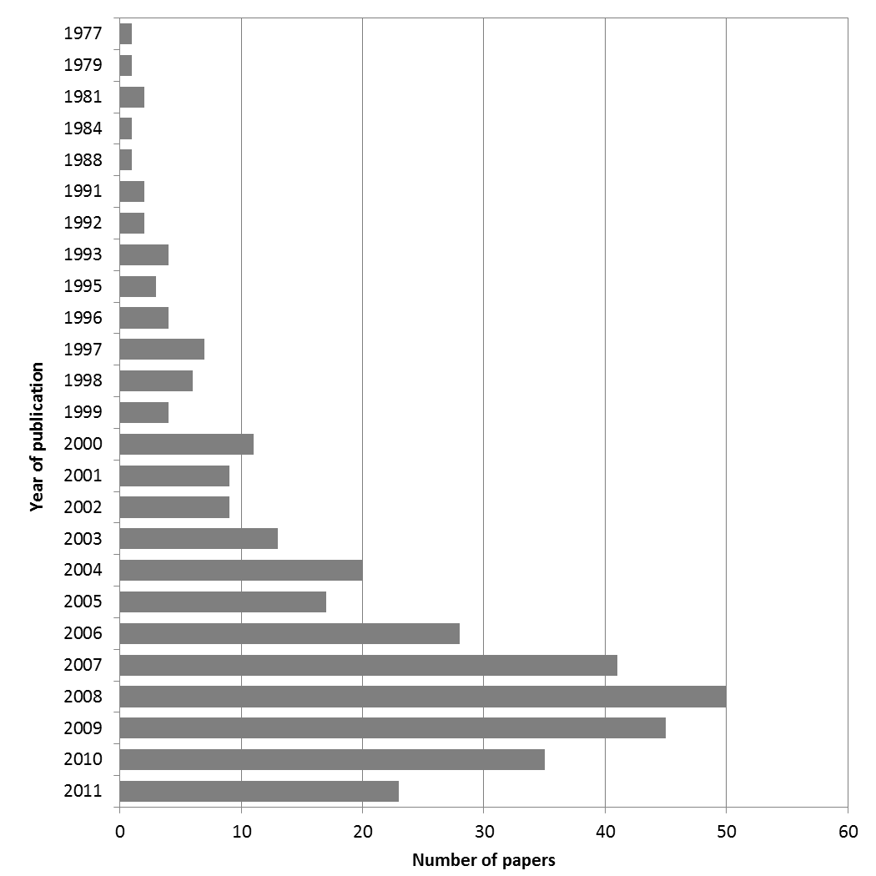

## **Figure 1.** Number of papers included in the meta-analysis by year of publication.

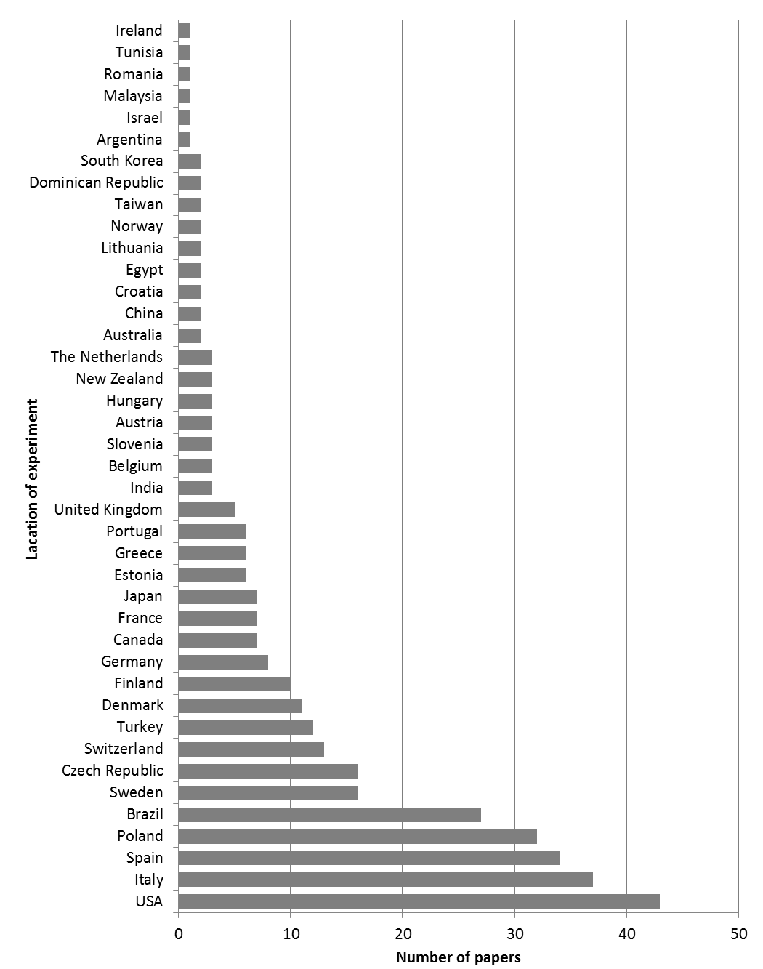

## **Figure 2.** Number of papers included in the meta-analysis by location of the experiment (country).

|  |  |  |  |  |
| --- | --- | --- | --- | --- |
| **Table 3.** Study type, location and crop/product information of the comparison studies included in the meta-analysis. | | | | |
| **ID** | **ST** | **Location** | **Crop/Product** | **Group** |
| 1 | EX | USA | potato (tuber) | Vegetables |
| 2 | EX | Canada | potato (tuber), sweet corn (kernel) | Vegetables |
| 3 | EX | France | grape (fruit) | Fruits |
| 4 | CF | USA | blueberry (fruit) | Fruits |
| 5 | CF | Finland | strawberry (fruit) | Fruits |
| 6 | BS | Brazil | grape (juice) | Fruits |
| 7 | CF | Greece | apple (fruit) | Fruits |
| 8 | EX | Canada | cabbage (leaves), carrot (root) | Vegetables |
| 9 | EX | Portugal | potato (tuber) | Vegetables |
| 10 | EX | Spain | mandarin (juice) | Fruits |
| 11 | EX | USA | tomato (fruit) | Vegetables |
| 12 | CF | Spain | strawberry (fruit) | Fruits |
| 13 | EX | USA | pepper (fruit), tomato (fruit) | Vegetables |
| 14 | CF | USA | blueberry (fruit), corn (grain) | Fruits, Cereals |
| 15 | CF | USA | tomato (fruit) | Vegetables |
| 16 | CF | Italy | potato (tuber) | Vegetables |
| 17 | EX | Spain | mandarin (juice) | Fruits |
| 18 | EX | Portugal | cabbage (Tronchuda) (leaves) | Vegetables |
| 19 | EX | Sweden | cabbage (leaves), carrot (root), onion (bulb), pea, pea (pod), potato (tuber) | Vegetables |
| 20 | CF | Spain | banana (fruit) | Fruits |
| 21 | CF | Czech Republic | potato (tuber) | Vegetables |
| 22 | EX | Czech Republic | potato (tuber) | Vegetables |
| 23 | EX | Taiwan | tomato (fruit) | Vegetables |
| 24 | EX | Estonia | black currant (fruit) | Fruits |
| 25 | CF | Italy | apple (fruit) | Fruits |
| 26 | EX | Italy | plum (fruit) | Fruits |
| 27 | CF | Spain | pepper (fruit) | Vegetables |
| 28 | CF | Belgium | hop (raw) | Other |
| 29 | EX | USA | kiwifruit (fruit) | Fruits |
| 30 | CF | Finland | black currant (fruit) | Fruits |
| 31 | CF | Finland | black currant (fruit) | Fruits |
| 32 | CF | Finland | strawberry (fruit) | Fruits |
| 33 | EX | Italy | apple (fruit) | Fruits |
| 34 | CF | USA | grapefruit (juice) | Fruits |
| 35 | CF | Taiwan | tomato (fruit) | Vegetables |
| 36 | CF | Italy | grape (berry skin), grape (must) | Fruits |
| 37 | CF | Spain | banana (fruit) | Fruits |
| 38 | EX | Italy | peach (fruit), pear (fruit) | Fruits |
| 39 | EX | Italy | peach (fruit), pear (fruit) | Fruits |
| 40 | EX | France | tomato (fruit), tomato (puree) | Vegetables |
| 41 | EX | Sweden | onion (bulb) | Vegetables |
| 42 | CF | Argentina | swiss chard (leaves) | Vegetables |
| 43 | EX | Spain | grape (wine, red) | Fruits |
| ID, Paper unique identification number (see Table 2 for references); ST, Study type (CF – Comparison of Farms, BS – Basket Study, EX – Controlled Experiment); *Paper included in meta-analysis of frequency of detectable pesticide residues. | | | | |

|  |  |  |  |  |
| --- | --- | --- | --- | --- |
| **Table 3 cont.** Study type, location and crop/product information of the comparison studies included in the meta-analysis. | | | | |
| **ID** | **ST** | **Location** | **Crop/Product** | **Group** |
| 44 | CF | Italy | tomato (fruit) | Vegetables |
| 45 | EX | Sweden | strawberry (fruit) | Fruits |
| 46 | CF | Spain | tomato (fruit) | Vegetables |
| 47 | EX | Italy | tomato (fruit) | Vegetables |
| 48 | EX | USA | apple (fruit) | Fruits |
| 49 | CF | USA | tomato (fruit), tomato (sauce) | Vegetables |
| 50 | CF | Italy | orange (fruit) | Fruits |
| 51 | CF | Poland | apple (puree) | Fruits |
| 52 | CF | USA | broccoli (flower) | Vegetables |
| 53 | EX | Spain | tomato (fruit) | Vegetables |
| 54 | CF | Portugal | cabbage (Tronchuda) (leaves) | Vegetables |
| 55 | CF | Switzerland | apple (fruit) | Fruits |
| 56 | CF | Italy | apple (fruit) | Fruits |
| 57 | BS | Italy | orange (red) (fruit) | Fruits |
| 58 | EX | USA | collard (leaves), lettuce (leaves), pac choi (leaves) | Vegetables |
| 59 | CF | Spain | grape (wine, red), grape (wine, white) | Fruits |
| 60 | EX | USA | lettuce (leaves) | Vegetables |
| 61 | EX | USA | pac choi (leaves) | Vegetables |
| 62 | CF | France | peach (fruit) | Fruits |
| 64 | CF | Poland | tomato (fruit) | Vegetables |
| 65 | CF | Switzerland | grape (wine) | Fruits |
| 66 | BS | United Kingdom (marketed) | carrot (soup), lentils (soup), tomato (soup), vegetable (soup) | Vegetables |
| 67 | CF | Switzerland | apple (fruit) | Fruits |
| 68 | EX | Spain | pepper (fruit) | Vegetables |
| 70 | BS | Brazil | broccoli (flower), cabbage (white) (leaves), carrot (root), onion (bulb), potato (tuber) | Vegetables |
| 72 | CF | Poland | apple (juice), black currant (juice), pear (juice), beetroot (juice), carrot (juice), celery (juice) | Fruits, Vegetables |
| 73 | CF | Poland | carrot (root) | Vegetables |
| 74 | CF | Austria | apple (fruit) | Fruits |
| 75 | EX | Italy | chicory (leaves) | Vegetables |
| 76 | BS | Malaysia (marketed) | cabbage (leaves), chinese kale (leaves), chinese mustard (leaves), lettuce (leaves), spinach (leaves) | Vegetables |
| 77 | BS | USA (marketed) | marinara pasta sauce (with vegetables) | Vegetables |
| 78 | CF | Croatia | strawberry (puree) | Fruits |
| 79 | CF | Brazil | broccoli (stalks), potato (peel), radish (skin), spinach (stalks), pumpkin (seeds) | Vegetables, Oil seeds and pulses |
| 80 | CF | Brazil | chinese cabbage (leaves), maize (bran) | Vegetables, Cereals |
| 81 | BS | Australia (marketed) | orange (fruit), cabbage (leaves), carrot (root), lettuce (leaves) | Fruits, Vegetables |
| 82 | BS | Spain | lettuce (leaves) | Vegetables |
| 83 | BS | Italy, Spain, Germany, France, The Netherlands | broccoli (flower), cabbage (red) (leaves) | Vegetables |
| ID, Paper unique identification number (see Table 2 for references); ST, Study type (CF – Comparison of Farms, BS – Basket Study, EX – Controlled Experiment); *Paper included in meta-analysis of frequency of detectable pesticide residues. | | | | |

|  |  |  |  |  |
| --- | --- | --- | --- | --- |
| **Table 3 cont.** Study type, location and crop/product information of the comparison studies included in the meta-analysis. | | | | |
| **ID** | **ST** | **Location** | **Crop/Product** | **Group** |
| 84 | EX | India | tea (leaves) | Other |
| 85 | EX | Spain | pepper (sweet) (fruit) | Vegetables |
| 86 | EX | Spain | pepper (sweet) (fruit) | Vegetables |
| 87 | CF | Poland | potato (tuber) | Vegetables |
| 88 | CF | Japan | chinese cabbage (leaves), pepper (fruit), qing-gen-cai (leaves), spinach (leaves), welsh onion (bulb) | Vegetables |
| 89 | BS | Italy, Spain | apricot (nectar), peach (nectar), pear (juice), pear (nectar) | Fruits |
| 90 | EX | Italy | tomato (fruit) | Vegetables |
| 91 | EX | Czech Republic | tomato (fruit) | Vegetables |
| 92 | EX | Portugal | cabbage (leaves) | Vegetables |
| 93 | CF | Germany | carrot (root) | Vegetables |
| 94 | BS | France | grape (wine, red), grape (wine, white) | Fruits |
| 95 | EX | Sweden | tomato (fruit) | Vegetables |
| 96 | CF | Austria, Slovenia | apple (fruit) | Fruits |
| 97 | BS | Italy | apricot (juice) | Fruits |
| 98 | CF | Switzerland | apple (fruit) | Fruits |
| 99 | BS | USA (marketed) | broccoli (flower) | Vegetables |
| 100 | BS | Not Specified | lemon (juice) | Fruits |
| 101 | BS | USA (marketed) | apple (juice), grapefruit (juice), lemon (juice), lime (juice), orange (juice), tomato (juice) | Fruits, Vegetables |
| 102 | BS | Turkey | grape (wine) | Fruits |
| 103 | CF | Switzerland | apple (fruit) | Fruits |
| 104 | EX | Spain | pepper (sweet) (fruit) | Vegetables |
| 106 | BS | South Korea | kale (leaves) | Vegetables |
| 107 | BS | Turkey | grape (wine, white) | Fruits |
| 108 | EX | Canada | wheat (grain) | Cereals |
| 110 | EX | Brazil | potato (tuber) | Vegetables |
| 111 | CF | New Zealand | kiwifruit (fruit) | Fruits |
| 118 | EX | Turkey | spinach (leaves) | Vegetables |
| 119 | EX | USA | tomato (fruit) | Vegetables |
| 120 | EX | USA | tomato (fruit) | Vegetables |
| 121 | CF | Italy | chicory (leaves), endive, prickly lettuce (leaves), rocket (leaves) | Vegetables |
| 122 | CF | Poland | carrot (root) | Vegetables |
| 123 | EX | Sweden | oat (grain) | Cereals |
| 124 | CF | Brazil | apple (fruit) | Fruits |
| 126 | EX | Finland | oat (grain) | Cereals |
| 127 | CF | Brazil | passion fruit (fruit) | Fruits |
| 128 | CF | Spain | banana (fruit) | Fruits |
| 130 | BS | Brazil | arugula (leaves), lettuce (leaves), watercress (leaves) | Vegetables |
| 131 | CF | Denmark | onion (bulb), pea, pea (raw) | Vegetables |
| 132 | EX | Canada | strawberry (fruit) | Fruits |
| ID, Paper unique identification number (see Table 2 for references); ST, Study type (CF – Comparison of Farms, BS – Basket Study, EX – Controlled Experiment); *Paper included in meta-analysis of frequency of detectable pesticide residues. | | | | |

|  |  |  |  |  |
| --- | --- | --- | --- | --- |
| **Table 3 cont.** Study type, location and crop/product information of the comparison studies included in the meta-analysis. | | | | |
| **ID** | **ST** | **Location** | **Crop/Product** | **Group** |
| 133 | EX | Norway | carrot (root) | Vegetables |
| 134 | CF | Finland | strawberry (fruit) | Fruits |
| 136 | BS, CF, EX | Sweden | carrot (root), potato (tuber), potato (tuber), rye (grain), wheat (grain) | Vegetables, Cereals |
| 137 | EX | Denmark | apple (fruit), carrot (root), kale (leaves), kale (leaves, dried), pea, pea (dried), potato (tuber) | Fruits, Vegetables |
| 140 | EX | Switzerland | beetroot (root) | Vegetables |
| 141 | EX | Italy | potato (tuber) | Vegetables |
| 142 | EX | Italy | wheat (winter) (flour), wheat (winter) (grain) | Cereals |
| 143 | CF | Brazil | kale (leaves) | Vegetables |
| 144 | CF | Japan | spinach (leaves) | Vegetables |
| 146 | BS | Brazil | mango (fruit) | Fruits |
| 147 | CF | USA | potato (tuber) | Vegetables |
| 148 | EX | Lithuania | cabbage (leaves), carrot (root), potato (tuber) | Vegetables |
| 149 | CF | Australia | wheat (grain) | Cereals |
| 150 | BS/CF | USA | leafy vegetables (leaves) | Vegetables |
| 152 | EX | USA | pac choi (leaves) | Vegetables |
| 154 | EX | Spain | pineapple (fruit) | Fruits |
| 156 | EX | Czech Republic | wheat (grain) | Cereals |
| 163 | EX | Finland | oat (grain) | Cereals |
| 164 | CF | Finland | strawberry (fruit) | Fruits |
| 165 | CF | Poland | tomato (fruit) | Vegetables |
| 166 | EX | Poland | onion (bulb) | Vegetables |
| 168 | EX | USA | kiwifruit (fruit) | Fruits |
| 170 | BS | Spain | tomato (fruit) | Vegetables |
| 171 | BS | Spain | tomato (fruit) | Vegetables |
| 172 | BS | Spain | tomato (fruit) | Vegetables |
| 175 | CF | The Netherlands, Austria, Denmark | animal feed (chicken feed) | Compound food |
| 179 | EX | Czech Republic | wheat (winter) (grain) | Cereals |
| 180 | EX | Czech Republic | wheat (winter) (grain) | Cereals |
| 181 | CF | France | carrot (root), celeriac (root) | Vegetables |
| 182 | EX | Turkey | strawberry (fruit) | Fruits |
| 184 | BS/CF | Italy | grape (wine, red) | Fruits |
| 185 | EX | Italy | wheat (hard) (grain), wheat (soft) (grain) | Cereals |
| 187 | CF | New Zealand | pea (raw), barley (grain), wheat (grain) | Vegetables, Cereals |
| 189 | BS | Italy (marketed) | sunflower (oil) | Oil seeds and pulses |
| 195 | EX | Denmark | carrot (root), onion (bulb), potato (tuber) | Vegetables |
| 201 | CF | USA | eggplant (fruit) | Vegetables |
| 202 | BS | Egypt | potato (tuber) | Vegetables |
| 203 | BS | Egypt | cucumber (fruit) | Vegetables |
| ID, Paper unique identification number (see Table 2 for references); ST, Study type (CF – Comparison of Farms, BS – Basket Study, EX – Controlled Experiment); *Paper included in meta-analysis of frequency of detectable pesticide residues. | | | | |

|  |  |  |  |  |
| --- | --- | --- | --- | --- |
| **Table 3 cont.** Study type, location and crop/product information of the comparison studies included in the meta-analysis. | | | | |
| **ID** | **ST** | **Location** | **Crop/Product** | **Group** |
| 206 | CF | Spain | grape (wine, white) | Fruits |
| 208 | BS | Poland | cabbage (leaves), carrot (root), onion (bulb), potato (tuber) | Vegetables |
| 210 | EX | Tunisia | tomato (fruit) | Vegetables |
| 211 | CF | Italy | wheat (grain) | Cereals |
| 212 | BS | Not Specified | coconut (oil), olive (oil), canola (oil), mustard seed (oil), sesame (oil) | Fruits, Vegetables, Oil seeds and pulses |
| 215 | CF | USA | eggplant (fruit) | Vegetables |
| 218 | EX | Sweden | wheat (spring) (grain), wheat (winter) (grain) | Cereals |
| 219 | EX | Sweden | wheat (spring) (grain), wheat (winter) (grain) | Cereals |
| 229 | CF | France | apple (fruit), bean (French) (pod), carrot (root), lettuce (leaves), spinach (leaves), tomato (fruit), barley (grain), wheat (grain), buckwheat (seeds) | Fruits, Vegetables, Cereals, Oil seeds and pulses |
| 233 | CF | Belgium | wheat (grain) | Cereals |
| 249 | EX | Denmark | carrot (root) | Vegetables |
| 251 | EX | Czech Republic | potato (tuber) | Vegetables |
| 252 | EX | Czech Republic | potato (tuber) | Vegetables |
| 253 | EX | Turkey | lettuce (Iceberg, Yedikule) (leaves) | Vegetables |
| 254 | EX | Poland | potato (tuber) | Vegetables |
| 255 | CF | Italy | chicory (leaves), lettuce (leaves), rocket (leaves) | Vegetables |
| 259 | CF | Sweden | carrot (root), tomato (fruit), wheat (grain) | Vegetables, Cereals |
| 260 | EX | United Kingdom | potato (tuber) | Vegetables |
| 261 | EX | Sweden | wheat (winter) (flour), wheat (winter) (grain) | Cereals |
| 262 | EX | Sweden | wheat (winter) (flour) | Cereals |
| 264 | EX | Poland | savory (leaves) | Herbs and spices |
| 265 | EX | Czech Republic | barley (grain), barley (wort) | Cereals |
| 269 | CF | Canada | apple (fruit) | Fruits |
| 270 | CF | Canada | apple (fruit) | Fruits |
| 271 | CF | Japan | rice (grain) | Cereals |
| 272 | EX | Sweden | wheat (winter) (grain) | Cereals |
| 273 | EX | USA | tomato (fruit) | Vegetables |
| 275 | EX | Czech Republic | wheat (winter) (grain) | Cereals |
| 276 | CF | Brazil | tomato (fruit) | Vegetables |
| 277 | BS | Spain | carrot (root), lettuce (leaves), pea (raw) | Vegetables |
| 278 | CF | Czech Republic | triticale (grain) | Cereals |
| 279 | EX | Lithuania | pumpkin (jam with apple), pumpkin (jam with black currant), pumpkin (sweetmeat with apple), pumpkin (sweetmeat with black currant), pumpkin (fruit) | Fruits, Vegetables |
| 281 | CF | Japan | rice (grain) | Cereals |
| 282 | EX | USA | sweet potato (root) | Vegetables |
| 283 | CF | Dominican Republic | banana (fruit) | Fruits |
| 285 | EX | Italy | rice (grain) | Cereals |
| 286 | BS | Poland | beetroot (root), cabbage (white) (leaves), carrot (root), parsley (root), potato (tuber) | Vegetables |
| ID, Paper unique identification number (see Table 2 for references); ST, Study type (CF – Comparison of Farms, BS – Basket Study, EX – Controlled Experiment); *Paper included in meta-analysis of frequency of detectable pesticide residues. | | | | |

|  |  |  |  |  |
| --- | --- | --- | --- | --- |
| **Table 3 cont.** Study type, location and crop/product information of the comparison studies included in the meta-analysis. | | | | |
| **ID** | **ST** | **Location** | **Crop/Product** | **Group** |
| 287 | BS | Germany | cabbage (leaves), carrot (root), lettuce (leaves), potato (tuber) | Vegetables |
| 288 | BS | Dominican Republic | banana (fruit) | Fruits |
| 289 | EX | Czech Republic | wheat (winter) (grain) | Cereals |
| 290 | BS, CF | Israel | banana (fruit), grape (fruit), grapefruit (juice), mango (fruit), orange (juice), carrot (root), spinach (leaves), tomato (fruit), sweet corn (kernel) | Fruits, Vegetables, Cereals |
| 291 | EX | Czech Republic | potato (tuber) | Vegetables |
| 292 | EX | Norway | barley (grain), oat (grain), wheat (grain) | Cereals |
| 294 | CF | USA | tomato (fruit) | Vegetables |
| 295 | BS | USA | barley (grain), maize (corn meal), maize (processed foods), rice (brown), rice (brown) (grain), lentils (grain), lentils (seeds) | Cereals, Oil seeds and pulses |
| 296 | CF | USA | wheat (grain) | Cereals |
| 297 | CF | Poland | potato (tuber) | Vegetables |
| 298 | EX | Hungary | pepper (red) (fruit) | Vegetables |
| 299 | CF | USA | maize (grain) | Cereals |
| 300 | CF | Poland | pepper (red) (fruit) | Vegetables |
| 301 | CF | Poland | pepper (fruit) | Vegetables |
| 302 | CF | Poland | apple (juice), apple (mousse) | Fruits |
| 303 | CF | Poland | apple (pomace) | Fruits |
| 304 | EX | United Kingdom | rat feed | Compound food |
| 305 | EX | Finland | oat (groat) | Cereals |
| 306 | BS | Turkey | olive (extra virgin oil) | Vegetables |
| 307 | EX | Brazil | chicory (leaves), lettuce (leaves), rocket (leaves) | Vegetables |
| 308 | EX | Estonia | carrot (root) | Vegetables |
| 310 | EX | Italy | wheat (grain) | Cereals |
| 311 | CF/EX | Spain | banana (fruit) | Fruits |
| 312 | CF | Spain | pepper (fruit) | Vegetables |
| 313 | CF | India | mandarin (nagpur) (fruit) | Fruits |
| 314 | EX | Hungary | apple (fruit) | Fruits |
| 315 | CF | Spain | grape (fruit) | Fruits |
| 316 | EX | Spain | olive (virgin oil) | Vegetables |
| 318 | EX | Estonia | potato (tuber) | Vegetables |
| 319 | EX | Sweden | wheat (winter) (flour), wheat (winter) (grain) | Cereals |
| 323 | EX | Sweden | wheat (grain), wheat (winter) (grain) | Cereals |
| 324 | BS | Brazil | broccoli (flower) | Vegetables |
| 327 | EX | Japan | soybean (seeds) | Oil seeds and pulses |
| 328 | CF | Italy | olive (extra virgin oil) | Vegetables |
| 330 | EX | Turkey | lettuce (iceberg) (leaves) | Vegetables |
| 331 | BS | Poland | cabbage (leaves), carrot (root), potato (tuber) | Vegetables |
| 333 | EX | Canada | wheat (spring) (grain) | Cereals |
| 334 | CF, EX | Germany, Italy, Switzerland | wheat (grain), wheat (hard) (grain), wheat (soft) (grain), wheat (grain) | Cereals |
| ID, Paper unique identification number (see Table 2 for references); ST, Study type (CF – Comparison of Farms, BS – Basket Study, EX – Controlled Experiment); *Paper included in meta-analysis of frequency of detectable pesticide residues. | | | | |

|  |  |  |  |  |
| --- | --- | --- | --- | --- |
| **Table 3 cont.** Study type, location and crop/product information of the comparison studies included in the meta-analysis. | | | | |
| **ID** | **ST** | **Location** | **Crop/Product** | **Group** |
| 335 | BS/CF | China | celeriac, celery (root) | Vegetables |
| 336 | EX | China | muskmelon (fruit) | Fruits |
| 337 | BS | Brazil | potato (tuber) | Vegetables |
| 338 | EX | Switzerland | wheat (grain) | Cereals |
| 339 | CF | Switzerland | apple (fruit) | Fruits |
| 340 | CF | Estonia | strawberry (fruit) | Fruits |
| 341 | CF | Brazil | orange (juice) | Fruits |
| 342 | CF | Japan | rice (grain) | Cereals |
| 343 | EX | Finland | potato (tuber) | Vegetables |
| 345 | BS | Poland | apple (puree) | Fruits |
| 346 | BS | Greece | peach (fruit), beetroot, French bean, lettuce (leaves), pepper (fruit), potato (tuber), tomato (fruit), lentils (seeds), amarantus blitum | Fruits, Vegetables, Oil seeds and pulses, Herbs and spices |
| 347 | BS | Not Specified | lettuce (leaves), tomato (fruit) | Vegetables |
| 348 | EX | Denmark | animal feed (rat feed) | Compound food |
| 354 | CF | Spain | grape (fruit) | Fruits |
| 357 | CF | Belgium | apple (juice) | Fruits |
| 358 | CF | Greece | apple (fruit) | Fruits |
| 359 | EX | Poland | basil (leaves), marjoram (leaves, dried) | Herbs and spices |
| 360 | CF | Poland | pepper (fruit) | Vegetables |
| 361 | EX | Poland | pepper (fruit) | Vegetables |
| 363 | EX | Switzerland | wheat (grain) | Cereals |
| 364 | CF, BS/CF | Poland | carrot (root), potato (tuber) | Vegetables |
| 365 | EX | Poland | onion (bulb) | Vegetables |
| 422 | EX | Italy | sunflower (seeds) | Oil seeds and pulses |
| 424 | EX | Switzerland | wheat (winter) (grain) | Cereals |
| 426 | EX | USA | apple (fruit) | Fruits |
| 428 | EX | Czech Republic | barley (grain) | Cereals |
| 429 | CF | Germany | apple (fruit), carrot (root) | Fruits, Vegetables |
| 430 | CF/EX | Italy | tomato (fruit) | Vegetables |
| 431 | CF/EX | Italy | strawberry (fruit) | Fruits |
| 432 | CF | Japan | tomato (fruit) | Vegetables |
| 433 | CF | Slovenia | apple (fruit) | Fruits |
| 434 | EX | Turkey | tomato (fruit) | Vegetables |
| 435 | EX | Sweden | leek (raw) | Vegetables |
| 436 | CF | Sweden | celeriac (root), parsnip (root) | Vegetables |
| 438 | CF | Brazil | tomato (fruit) | Vegetables |
| 442 | EX | Italy | cauliflower (curd) | Vegetables |
| 443 | EX | South Korea | pepper (hot) (fruit) | Vegetables |
| 446 | EX | Denmark | apple (fruit), carrot (root), kale (leaves), kale (leaves, cooked), pea (cooked), potato (tuber) | Fruits, Vegetables |
| ID, Paper unique identification number (see Table 2 for references); ST, Study type (CF – Comparison of Farms, BS – Basket Study, EX – Controlled Experiment); *Paper included in meta-analysis of frequency of detectable pesticide residues. | | | | |

|  |  |  |  |  |
| --- | --- | --- | --- | --- |
| **Table 3 cont.** Study type, location and crop/product information of the comparison studies included in the meta-analysis. | | | | |
| **ID** | **ST** | **Location** | **Crop/Product** | **Group** |
| 448 | BS | Portugal (marketed); Spain and Switzerland (produced) | cereals (baby food) | Compound food |
| 449 | BS | Portugal | cabbage (savoy) (leaves), carrot (root), lettuce (leaves), savoy cabbage (leaves), spinach (leaves) | Vegetables |
| 452* | BS/CF | The Netherlands | carrot (root), lettuce (iceberg) (leaves), lettuce (leaves) | Vegetables |
| 460* | BS | Denmark | apple (fruit), banana (fruit), beetroot, black currant (fruit), broccoli (flower), cabbage (leaves), carrot (root), chickpea (seeds), cucumber (fruit), grape (fruit), grapefruit (fruit), kale (leaves), leek, lemon (fruit), mandarin (fruit), mushroom, onion (bulb), orange (fruit), parsley (root), parsnip (root), pear (fruit), potato (tuber), raspberry (fruit), tea (dry leaves), tomato (fruit) | Fruits, Vegetables, Seeds, Other |
| 462 | EX | Estonia | barley (grain), oat (spring) (grain), wheat (spring) (grain) | Cereals |
| 463 | EX | Czech Republic | basil (leaves) | Herbs and spices |
| 471 | EX | USA | pecan (kernel) | Fruits |
| 475 | EX | Switzerland | wheat (grain) | Cereals |
| 477 | EX | Brazil | strawberry (fruit) | Fruits |
| 482 | EX | USA | tomato (fruit) | Vegetables |
| 483 | EX | Romania | wheat (grain) | Cereals |
| 484 | EX | Slovenia | red beet (root) | Vegetables |
| 486 | CF/EX, EX | Spain | eggplant (fruit) | Vegetables |
| 488 | CF | USA | strawberry (fruit) | Fruits |
| 489 | EX | Turkey | cabbage (white) (leaves) | Vegetables |
| 490 | EX | Turkey | spinach (leaves) | Vegetables |
| 491 | CF | Germany | grape (skin extract) | Fruits |
| 492 | BS | Brazil | apple (fruit), banana (fruit), mango (fruit), orange (fruit), papaya (fruit), tangerine (fruit), broccoli (flower), cabbage (white) (leaves), carrot (root), onion (bulb), potato (tuber), tomato (fruit) | Fruits, Vegetables |
| 493 | CF/EX | Brazil | tomato (fruit) | Vegetables |
| 494* | BS | Brazil | tomato (fruit) | Vegetables |
| 495 | CF | United Kingdom | potato (tuber) | Vegetables |
| 497 | EX | Estonia | wheat (spring) (bran), wheat (spring) (grain) | Cereals |
| 500 | BS | Ireland | baby food (berry-based dessert), baby food (chicken and vegetable dinner) | Compound food |
| 501 | EX | Italy | apricot (fruit) | Fruits |
| 502 | EX | Brazil | onion (bulb) | Vegetables |
| 503 | CF | USA | blueberry (fruit), raspberry (fruit) | Fruits |
| 504 | CF | Spain | grape (fruit), grape (wine) | Fruits |
| 505 | CF | Brazil | coffee (beans), coffee (green) | Other |
| ID, Paper unique identification number (see Table 2 for references); ST, Study type (CF – Comparison of Farms, BS – Basket Study, EX – Controlled Experiment); *Paper included in meta-analysis of frequency of detectable pesticide residues. | | | | |

|  |  |  |  |  |
| --- | --- | --- | --- | --- |
| **Table 3 cont.** Study type, location and crop/product information of the comparison studies included in the meta-analysis. | | | | |
| **ID** | **ST** | **Location** | **Crop/Product** | **Group** |
| 506 | EX | Turkey | tomato (fruit) | Vegetables |
| 508 | CF | Croatia | grape (red wine), grape (white wine), grape (wine, red), grape (wine, white) | Fruits |
| 509 | EX | USA | blueberry (fruit) | Fruits |
| 510 | EX | USA | pac choi (leaves) | Vegetables |
| 511 | EX | Poland | wheat (spring) (grain), wheat (winter) (grain) | Cereals |
| 512 | EX | Turkey | tomato (fruit) | Vegetables |
| 513 | EX | Italy | durum wheat (semolina) | Cereals |
| 517 | CF/EX | New Zealand | kiwifruit (fruit) | Fruits |
| 518 | CF/EX | Greece | orange (juice) | Fruits |
| 519 | CF/EX | Spain | mandarin (juice) | Fruits |
| 520 | EX | Denmark | carrot (root), food (whole diet) | Vegetables, Compound food |
| 522 | EX | USA | pac choi (leaves) | Vegetables |
| 524 | CF, EX, CF/EX | Italy | clementine (fruit), orange (fruit), peach (fruit), strawberry (fruit) | Fruits |
| 525 | EX | Brazil | acerola (fruit), persimmon (fruit), strawberry (fruit) | Fruits |
| 526 | EX | United Kingdom | wheat (grain) | Cereals |
| 527 | BS/EX | Brazil | coffee (roasted ground) | Other |
| 528 | EX | Czech Republic | buckwheat (groat) | Cereals |
| 531 | CF | USA | strawberry (fruit) | Fruits |
| 532 | EX | Denmark | potato (tuber), barley (grain), wheat (grain), wheat (winter) (grain), faba bean (seed), faba bean (seeds) | Vegetables, Cereals, Oil seeds and pulses |
| 533 | CF | Spain | tomato (fruit) | Vegetables |
| 536 | CF | Denmark | beetroot (root), carrot (root), cucumber (fruit), potato (tuber) | Vegetables |
| 537 | EX | USA | rice (grain) | Cereals |
| 541 | EX | Poland | sweet marjoram (leaves) | Herbs and spices |
| 542 | EX | Poland | marjoram (leaves, dried), savory (leaves, dried), sweet basil (leaves, dried), thyme (leaves, dried) | Herbs and spices |
| 543 | EX | Poland | marjoram (leaves, dried), savory (leaves, dried), sweet basil (leaves, dried), thyme (leaves, dried) | Herbs and spices |
| 544 | EX | Poland | savory (leaves) | Herbs and spices |
| 545 | EX | Poland | thyme (leaves) | Herbs and spices |
| 546 | EX | Poland | basil (leaves) | Herbs and spices |
| 548c | BS | EU countries (mostly Italy) | foods of a plant origin | Compound food |
| 549 | CF | Brazil | lettuce (leaves) | Vegetables |
| 550 | BS | USA | asparagus (stem), green beans (pod), pepper (red) (fruit), spinach (leaves) | Vegetables |
| 571 | CF | Greece | cabbage (leaves), celery (leaves), lettuce (leaves), spinach (leaves) | Vegetables |
| 572 | BS | Poland | beetroot (root), carrot (root), potato (tuber) | Vegetables |
| 580 | EX | Brazil | strawberry (fruit) | Fruits |
| ID, Paper unique identification number (see Table 2 for references); ST, Study type (CF – Comparison of Farms, BS – Basket Study, EX – Controlled Experiment); *Paper included in meta-analysis of frequency of detectable pesticide residues. | | | | |

|  |  |  |  |  |
| --- | --- | --- | --- | --- |
| **Table 3 cont.** Study type, location and crop/product information of the comparison studies included in the meta-analysis. | | | | |
| **ID** | **ST** | **Location** | **Crop/Product** | **Group** |
| 581 | EX | India | wheat (grain) | Cereals |
| 584 | EX | Germany | tomato (fruit) | Vegetables |
| 585 | EX | Greece | tomato (fruit) | Vegetables |
| 586 | CF | Brazil | mango (fruit) | Fruits |
| 587 | EX | Hungary | wheat (grain) | Cereals |
| 619* | BS | USA | apple (fruit), banana (fruit), muskmelon (fruit), grape (fruit), orange (fruit), peach (fruit), pear (fruit), strawberry (fruit), broccoli (flower), carrot (root), celery (root), cucumber (fruit), bean (raw), lettuce (leaves), potato (tuber), spinach (leaves), pepper (sweet) (fruit), sweet potato (tuber), tomato (fruit), squash (raw), foods of a plant origin, pepper (fruit) | Fruits, Vegetables, Compound food |
| 620* | BS | Austria | foods of a plant origin | Compound food |
| 621* | BS | Italy | tomato (fruit) | Vegetables |
| 622* | BS | Denmark | foods of a plant origin | Compound food |
| 623* | BS | Denmark | foods of a plant origin | Compound food |
| 624* | BS | Austria | foods of a plant origin | Compound food |
| ID, Paper unique identification number (see Table 2 for references); ST, Study type (CF – Comparison of Farms, BS – Basket Study, EX – Controlled Experiment); *Paper included in meta-analysis of frequency of detectable pesticide residues. | | | | |

|  |  |
| --- | --- |
| **Table 4.** Information extracted from the papers and included in the database used for meta-analysis. | |
| **Information  about the paper** | Paper ID, authors, publication year, title, journal/publisher, type of paper (journal article, conference proceedings, conference paper, report, book, thesis), corresponding author, language of publication, information if paper was peer-reviewed, source of paper (electronic databases, contact with authors, reference list of reviews and original publications). |
| **Study characteristics** | Study type (Controlled Experiment - EX, Comparison of Farms - CF, Basket Study - BS), product, species, cultivar or variety, production system description, experimental year(s), location of the study. |
| **Data** | Name of the compositional parameter, number of samples, mean, SE or SD, measurement unit, data type (numeric, graphical). |

|  |  |  |  |  |  |  |  |
| --- | --- | --- | --- | --- | --- | --- | --- |
| **Table 5.** Summary of inclusion criteria used in the standard weighted (analysis 1) and the standard unweighted (analysis 5) meta-analysis, and the 6 sensitivity analyses carried out. Detailed results of sensitivity analysis are shown on the Newcastle University website ([*http://research.ncl.ac.uk/nefg/QOF*](http://research.ncl.ac.uk/nefg/QOF)) | | | | | | | |
| **Analysis** | **Data available** | | **Cultivar or variety of the crop** | | **Experimental years** | | |
| **No** | Only papers with N, mean, SD/SE | All papers reporting means | Cultivar/variety averaged* | Each cultivar/variety as separate data point† | One data point from one paper‡ | Individual year as separate data point§ |
| **Weighted meta-analysis** | | | | | | |
| 1 standard|| | + |  | + |  | + |  |
| 2 | + |  | + |  |  | + |
| 3 | + |  |  | + | + |  |
| 4 | + |  |  | + |  | + |
| **Unweighted meta-analysis** | | | | | | |
| 5 standard|| |  | + | + |  | + |  |
| 6 |  | + | + |  |  | + |
| 7 |  | + |  | + | + |  |
| 8 |  | + |  | + |  | + |
| *If data from more than one cultivar or variety of the crop were presented separately in the paper, average was calculated and included in the analysis; †If data from more than one cultivar or variety of the crop were presented separately in the paper, they were analysed separately, as individual data points; ‡If data from more than one experimental years were presented separately in the paper, average was calculated and included in the analysis; §If data from more than one experimental years were presented separately in the paper, they were analysed separately, as individual data points; ||Results of the standard uwweighted and weighted meta-analysis are presented in the main paper. | | | | | | | |

|  |  |
| --- | --- |
| **Table 6.** List of composition parameters included in the statistical analyses.* | |
| **Category** | **Parameters** |
| **Major components** | Ash, Ash (total), Carbohydrates, Carbohydrates (total), Dry matter, Fat, Fat (crude), Fibre, Fibre (insoluble), Fibre (soluble), Fibre (total), Fructose, Glucose, Protein (total), Solids, Solids (soluble), Solids (total), Starch, Sucrose, Sugars (reducing), Water |
| **Amino acids** | Amino acids, Amino acids (total), Alanine (Ala), Arginine (Arg), Asparagine (Asn), Aspartic acid (Asp), Glutamic acid (Glu), Glutamine (Gln), Glycine (Gly), Histidine (His), Isoleucine (Ile), Leucine (Leu), Lysine (Lys), Methionine (Met), Phenylalanine (Phe), Proline (Pro), Serine (Ser), Threonine (Thr), Tyrosine (Tyr), Valine (Val) |
| **Fatty acids** | 16.0 fatty acid (palmitic acid), 18.0 fatty acid (stearic acid), 18.1 fatty acid (oleic acid), 18.2 fatty acid (linoleic acid), 18.3 fatty acid (linolenic acid), 20.0 fatty acid (arachidic acid), Monounsaturated fatty acids, Polyunsaturated fatty acids, Saturated fatty acids, Saturated fatty acids (total) |
| **Vitamins and antioxidants** | Alpha-carotene, Alpha-tocopherol, Anthocyanins, Antioxidant activity based on 2,2-  diphenyl-1-picrylhydrazyl (DPPH), Ferric reducing antioxidant power (FRAP), Trolox equivalent antioxidant capacity (TEAC), Oxygen radical antioxidant capacity (ORAC), Apigenin, Ascorbic acid, Beta-carotene, Beta-cryptoxanthin, Carotenes, Carotenoids, Carotenoids (total), Dehydroascorbic acid, Flavanols, Flavanones, Flavones, Flavones and flavonols, Flavones and flavonols (total), Flavonoids (total), Flavonols, Flavonols (total), Gamma-tocopherol, Kaempferol, Kaempferol 3-O-glucoside, Lutein, Luteolin, Luteolin-7-o-glucoside, Lycopene, Myricetin, Myricetin 3-o-glucoside, Polyphenoloxidase (PPO) activity (towards caffeic acid), Polyphenoloxidase (PPO) activity (towards chlorogenic acid), Quercetin, Quercetin 3-galactoside, Quercetin 3-glucoside, Quercetin 3-rhamnoside, Quercetin malonylglucoside, Quercetin-3-rutinoside (Rutin), Vitamin B, Vitamin B1, Vitamin C, Vitamin C (total), Vitamin E, Zeaxanthin |
| **Minerals and undesirable metals** | Aluminium (Al), Arsenic (As), Barium (Ba), Boron (B), Bromine (Br), Cadmium (Cd), Calcium (Ca), Carbon (C), Cerium (Ce), Chloride (Cl), Chromium (Cr), Cobalt (Co), Copper (Cu), Elements, Gallium (Ga), Indium (In), Iron (Fe), Lanthanum (La), Lead (Pb), Magnesium (Mg), Manganese (Mn), Molybdenum (Mo), Nickel (Ni), Nitrogen (N), Phosphorus (P), Potassium (K), Rhenium (Re), Rubidium (Rb), Selenium (Se), Sodium (Na), Strontium (Sr), Sulphur (S), Thallium (Tl), Tin (Sn), Vanadium (V), Wolfram (W), Zinc (Zn) |
| **Phenolic compounds** | 5-o-Caffeoylquinic acid (5-CQA), Caffeic acid, Chlorogenic acid, Ellagic acid, Ferulic acid, Gallic acid, Hydroxycinnamic acids (total), p-coumaric acid (pCA), Phenolic acids, Phenolic acids (total), Phenolic compounds, Phenolic compounds (total), Salicylic acid, Sinapic acid (SA) |
| **Volatile compounds** | Volatile compounds |
| **Other** | Acidity, Acidity (total), Acidity (volatile), Acids (total), Anthocyanins (total), Catechin, Chalcones, Citric acid, Dihydrochalcones, Energy, Epicatechin, Flavanols (total), Glucoraphanin, Glucosinolates, Malic acid, Naringenin, Naringenin (R-enantomer), Nitrates, Nitrites, Organic acids, Other defense compounds ,Other non-defense compounds, Other non-defense compounds (total), pH, Phloretin, Procyanidins, Resveratrol, Stilbenes, Titratable acidity, Xanthophylls |
| *Compounds for which number of comparisons organic vs. conventional was ≥ 3. | |

|  |  |
| --- | --- |
| **Table 7.** List of composition parameters excluded from the statistical analyses**.\*** | |
| **Category** | **Parameters** |
| **Major components** | Albumin, Amirose, Amylose, Ash (crude), Ash at 700°C, Brix degree, Essential oil, Fibre (crude), Galactose, Glutelin, Gluten, Gluten (dry), Gluten (wet), Glycerides (total), Maltose, Non-starch polysaccharides (soluble), Non-starch polysaccharides (total), Protein, Protein (soluble), Protein (true), Stachyose, Starch Index, Sugars (non-reducing), Sugars (soluble) |
| **Amino acids** | Amino acids (essential), Amino acids (free), Alanine (% of total EAA), Alanine (hydrolised), Alpha-aminobutyric acid, Arginine (% of total EAA), Arginine (hydrolised), Aspartic acid (% of total EAA), Aspartic acid (hydrolised), Beta-alanine, Cysteine (Cys), Cystine, Cystine (% of total EAA), Essential amino acids (total), Glutamic acid (% of total EAA), Glutamic acid (hydrolised), Glutamine (hydrolised), Glycine (% of total EAA), Histidine (% of total EAA), Histidine (hydrolised), Isoleucine (% of total EAA), Isoleucine (hydrolised), Leucine (% of total EAA), Leucine (hydrolised), Lysine (% of total EAA), Lysine (hydrolised), Methionine (% of total EAA), Methionine (hydrolised), Methionine + Cystine, Phenylalanine (% of total EAA), Phenylalanine (hydrolised), Proline (% of total EAA), Proline (hydrolised), Serine (% of total EAA), Serine (hydrolised), Threonine (% of total EAA), Threonine (hydrolised), Tryptophane (Trp), Tyrosine (% of total EAA), Tyrosine (hydrolised), Valine (% of total EAA), Valine (hydrolised) |
| **Fatty acids** | 12.0 fatty acid, 14.0 fatty acid, 14.1 fatty acid, 16.1 c9 fatty acid, 16.1 fatty acid (palmitoleic acid), 16.1 n-7 fatty acid, 17.0 fatty acid, 17.1 fatty acid, 18.1 cis fatty acid, 18.1 n-9 fatty acid, 18.2 n-6 fatty acid, 18:3 n-3 fatty acid (alpha-linolenic acid), 20.1 fatty acid, 20.1 n-9 fatty acid, 20.2 fatty acid, 20.3 (n-3) fatty acid, 20.3 (n-6) fatty acid, 20.4 fatty acid, 22.0 fatty acid, 22.1 fatty acid, 22.6 fatty acid, 24.0 fatty acid, 24.1 fatty acid, Fatty acids, Fatty acids (free), Fatty acids (total), Monounsaturated fatty acids (MUFA), Monounsaturated fatty acids (total), n-3 - n-6 fatty acids ratio, n-3 fatty acids, n-6 fatty acids, Polyunsaturated fatty acids (PUFA), Polyunsaturated fatty acids (total), Saturated fatty acids (SFA) |
| **Vitamins and antioxidants** | 13-cis-lycopene, 13-cis-β-carotene, 15-cis-lycopene, 5-formyltetrahydrofolate (5-formylTHF), 5-methyltetrahydrofolate (5-methylTHF), 9-cis-lycopene, 9-cis-violaxanthin, All-trans- + 5-cis-lycopene, All-trans-β-carotene, Alpha-tocotrienol, Antheraxanthin, Antioxidant activity (Catalase-like activity), Antioxidant activity (hydrophilic) (ORAC),Antioxidant activity (hydrophilic) (TEAC), Antioxidant activity (IC50), Antioxidant activity (lipophilic) (ORAC), Antioxidant activity (microchemiluminescence), Antioxidant activity (Randox), Antioxidant activity (scavenging effect for DPPH radical of tea extract) (concentration 100µg per ml), Antioxidant activity (scavenging effect for DPPH radical of tea extract) (concentration 1mg per ml), Antioxidant activity (scavenging effect for DPPH radical of tea extract) (concentration 200µg per ml), Antioxidant activity (scavenging effect for DPPH radical of tea extract) (concentration 300µg per ml), Antioxidant activity (scavenging effect for DPPH radical of tea extract) (concentration 50µg per ml), Antioxidant activity (Sod-like activity), Antioxidant activity (water insoluble) (TEAC), Antioxidant activity (water soluble) (TEAC), Antioxidant capacity (superoxide scavenging), Antioxidant effect of 10ug per ml extract, Antioxidant effect of 1ug per ml extract, Antioxidant effect of 5ug per ml extract, Apigenin 6-C-Galactoside, 8-C-Glucoside, Apigenin glucuronide, Ascorbate peroxidase (AsA-POD) activity, Baicalein, Beta-tocopherol, Beta-tocotrienol, Capsanthin, Capsanthin 5,6-epoxide, Capsanthin diester, Capsorubin, Carotene, Catalase-like activity (CAT), Cis-antheraxanthin, Cis-capsanthin, Cucurbitaxanthin A, Dehydroascorbate reductase (DHAR) activity, Delta-tocopherol, Fisetin aglycones, Fisetin glycosides, Flavonoids (non-anthocyan), Flavonoids (other), Flavonoids (sum), Flavonols (total) and xanthone glycosides, Folate, Glutathione peroxidase (GSH-POD) activity, Glutathione reductase (GR) activity, Guaiacol peroxidase (G-POD) activity, Isomangiferin, Isoorientin, Isoorientin 2'-O-Rhamnoside, Isoorientin 6'-O-Xyloside, Isorhamnetin, Isorhamnetin rutinoside, Isorhamnetin-3,4'-diglycoside (I-3,4'-digly), Isorhamnetin-4'-glycoside (I-4'-gly), Isoscoparin (3´-methylluteolin 6-C-glucoside), Isovitexin, Kaempferol + Kaempferol glycoside, Kaempferol 3-O-(caffeoyl)sophoroside-7-O-glucoside, Kaempferol 3-O-(feruloyl)sophoroside + kaempferol 3-O-sophoroside, Kaempferol 3-O-(feruloyl)sophoroside-7-O-glucoside, Kaempferol 3-O-(feruloyl)sophorotrioside, Kaempferol 3-O-(feruloyl)sophorotrioside + kaempferol 3-O-(feruloyl)sophoroside, Kaempferol 3-O-(feruloyl-caffeoyl)sophoroside-7-O-glucoside, Kaempferol 3-O-(methoxycaffeoyl-caffeoyl)sophoroside-7-O-glucoside, Kaempferol 3-O-(sinapoyl)sophoroside, Kaempferol 3-O-(sinapoyl)sophoroside-7-O-glucoside, Kaempferol 3-O-(sinapoyl-caffeoyl)sophoroside-7-O-glucoside, Kaempferol 3-O-sophoroside |
| *Compounds for which number of comparisons organic vs. conventional was < 3. | |

|  |  |
| --- | --- |
| **Table 7 cont.** List of composition parameters excluded from the statistical analyses.* | |
| **Category** | **Parameters** |
| **Vitamins and antioxidants cont.** | Kaempferol 3-O-sophoroside-7-O-glucoside, Kaempferol 3-O-sophoroside-7-O-sophoroside, Kaempferol 3-O-sophoroside-7-O-sophoroside + kaempferol 3-O-tetraglucoside-7-O-sophoroside, Kaempferol 3-O-sophorotrioside, Kaempferol 3-O-sophorotrioside + kaempferol 3-O-(sinapoyl)sophoroside, Kaempferol 3-O-sophorotrioside-7-O-glucoside, Kaempferol 3-O-sophorotrioside-7-O-glucoside + kaempferol 3-O-(methoxycaffeoyl-caffeoyl)sophoroside-7-O-glucoside, Kaempferol 3-O-sophorotrioside-7-O-sophoroside, Kaempferol aglycones, Kaempferol glucoside, Kaempferol glucuronide, Kaempferol glycoside, Kaempferol malonylglucoside, Kaempferol rutinoside, L-ascorbic acid, Lutein + violaxanthin, Luteolin 6-C-Galactoside, 8-C-Glucoside and Lucenin-2 (Luteolin 6, 8 Di-C-Glucoside), Luteolin gucuronide, Luteolin-7-(2-apiosyl-4-glucosyl-6-acetyl)glucoside, Luteolin-7-(2-apiosyl-6-acetyl)glucoside, Luteoxanthin b, Luteoxanthin-like, Mangiferin, Methylquercetin glucoside, Monodehydroascorbate reductase (MDAR) activity, Morin, Mutatoxanthin, Mutatoxanthin-like, Myricetin 3-arabinoside, Myricetin aglycones, Myricetin glycosides, Myricetin malonylglucoside, Myricetin rutinoside, Neoxanthin, Peroxidase activity, Peroxide, Peroxide index, Peroxide number, Phytoene, Phytofluene, Polyphenoloxidase (PPO) activity (towards catechol), Polyphenoloxidase activity, Quercetin + quercetin glycoside ,Quercetin 3-arabinofuranoside, Quercetin 3-arabinoside, Quercetin 3-o-glucoside + quercetin 3-O-rutinoside, Quercetin 3-xyloside, Quercetin 4'-monoglucoside, Quercetin aglycones, Quercetin glycosides, Quercetin glycosides, Quercetin glycosides (other), Quercetin rutinoside, Quercetin-3,4'-diglucoside (Q-3,4'-diglu), Quercetin-3,7,4'-triglycoside (Q-3,7,4'-trigly), Quercetin-3-glucoside (Q-3-glu), Quercetin-3-o-glucuronide, Quercetin-4'-glucoside (Q-4'-glu), Riboflavin, SDS (1-sodium dodecyl sulfate) activation (-fold) of polyphenol oxidase using 4-methyl catechol, SDS (1-sodium dodecyl sulfate) activation (-fold) of polyphenol oxidase using 4-tert-butyl catechol, SDS (1-sodium dodecyl sulfate) activation (-fold) of polyphenol oxidase using chlorogenic acid, Superoxide dismutase (SOD) activity, Tocopherolquinone (TQ), Tocopherols (total), Total phenol index (TPI), Tricin, Trypsin-mediated activation of polyphenol oxidase ,Violaxanthin, Vitamin A, Vitamin B2, Vitamin B6, Vitamin E (total), Vitamin K1, Zeinoxanthin |
| **Minerals and undesirable metals** | Antimony (Sb), Beryllium (Be), Bismuth (Bi), Calcium (Ca) (HCl extractable), Cesium (Cs), Dysprosium (Dy), Europium (Eu), Gadolinium (Gd), Gold (Au), Hafnium (Hf), Holmium (Ho), Iodine (I), Magnesium (Mg) (HCl extractable), Mercury (Hg), Mineral compounds, Neodymium (Nd), NH4-Nitrogen, Niobium (Nb), Nitrogen (assimilable), Phosphorus (P) (HCl extractable), Platinum (Pt), Praseodymium (Pr), Samarium (Sm), Scandium (Sc), Silver (Ag), Tellurium (Te), Terbium (Tb), Thorium (Th), Thulium (Tm), Titanium (Ti), Uranium (U), Ytterbium (Yb), Yttrium (Y), Zirconium (Zr) |
| **Phenolic compounds** | 1,2'-disinapoyl-2-feruloylgentiobiose, 1,2-disinapoylgentiobiose + 1-sinapoyl-2-feruloylgentiobiose + isomer of 1,2-disinapoylgentiobiose + 1,2,2'-trisinapoylgentiobiose, 3-acetyl-5-caffeoylquinic acid, 3-caffeoylquinic acid derivate, 3-p-coumaroylquinic acid, 4-o-Caffeoylquinic acid (4-CQA), 4-p-coumaroylquinic acid, Caffeic acid derivatives (total), Caffeoyl derivatives, Caffeoylglucose, Caffeoyltartaric acid, Chicoric acid, Cinnamic acid, Coumaric acid, Coumaric acid glucoside, Coumarins, Dicaffeoyltartaric acid, Ellagic acid + ellagic acid glycoside, Ellagic acid aglycones, Ellagic acid glucoside, Ellagic acid glycoside, Ferulic acid (bound), Ferulic acid (conjugated), Ferulic acid glucoside, Feruoyglucose, Hydroxycinnamates, Hydroxycinnamic acid derivate a, Hydroxycinnamic acid derivate b, Hydroxycinnamic acid derivative (unidentified), Hydroxycinnamic acid derivatives (total), N-(3,4-dihydroxy)-E-cinnamoyl-5-hydroxyanthranilic acid, N-(4-hydroxy)-E-cinnamoyl-5-hydroxyanthranilic acid, N-(4-hydroxy-3-methoxy)-E-cinnamoyl-5-hydroxyanthranilic acid, Neo-chlorogenic acid, p-coumaric acid derivate, p-coumaroylglucose, p-coumaroylquinic acid, Phenolics (bound) (total), Phenolics (free) (total), Phenolics (soluble conjugulated) (total), p-hydroxybenzoic acid (pHBA), Polyphenols hydrolyzable (total), Protocatecuic acid, Sinapic acid glucose derivate, Syringic acid, Trans-caffeoyltartaric acid, Trans-p-coumaric acid, Trans-p-cumaroyltartaric acid, Vanillic acid (VA) |
| **Volatile compounds** | (E)-2-decen-1-ol, (E)-2-hepten-1-ol, (E)-2-hexenal, (E)-2-nonen-1-ol, (E)-2-octenal, (E)-3-hepten-1-ol, (E)oak lactone, (E,E)-2,4-hexadienal, (Z)-3-hexen-1-ol, (Z)-3-hexenal, (Z)-6-nonenal, (Z)oak lactone, 1,1-diethoxyethane, 1,8-cineole, 1-butanol, 1-hexanol, 1-hexen-3-ol, 1-isothiocyanato-butane, 1-nonanol, 1-octanol ,1-octen-3-ol, 1-pentanol, 1-penten-3-ol, 1-propanol, 2,6,6-trimethyl-1-cyclohexene-1-carboxaldehyde, 2-butanol, 2-butanone, 2-decanone, 2-hexen-1-ol (cis), 2-hexen-1-ol (trans), 2-hexenal |
| *Compounds for which number of comparisons organic vs. conventional was < 3. | |

|  |  |
| --- | --- |
| **Table 7 cont.** List of composition parameters excluded from the statistical analyses.* | |
| **Category** | **Parameters** |
| **Volatile compounds cont.** | 2-hexenal (cis), 2-hexenal (trans), 2-hexyn-1-ol, 2-Isothiocyanatoethyl-benzene, 2-methyl-3-pentanone, 2-methyl-butanoic acid methyl ester, 2-nonanone, 2-pentenal, 2-undecanone, 3,7-dimethyl-1,6-octadien-3-ol (linalool), 3-carene, 3-ethoxy-1-propanol, 3-hexen-1-ol (cis), ,3-methyl-1-pentanol, 3-methyl-2-butanone, 3-pentanone-1-(methylthio), 4,5-dimethyl-thiazole, 4-ethyl-5-methylthiazole, 4-ethylguaiacol, 4-ethylphenol, 4-hexen-1-ol, 4-isothiocyanato-1-butene, 4-methyl-1-pentanol, 4-methyl-1-undecene, 4-methylpentyl isothiocyanate, 5-methylfurfural, 6,10-dimethyl-5,9-undecadien-2-one (geranylacetone), Acetaldehyde, Acetaldehyde and derivatives, Acetic acid octyl ester, Acetoin , Allyl isothiocyanate, Alpha-humulene, Alpha-phellandrene, Alpha-pinene, Alpha-terpinene, Benzaldehyde, Benzene propanenitrile, Benzeneacetaldehyde, Benzyl alcohol, Benzyl nitrile, Beta-caryophyllene, Beta-muurolene, Beta-myrcene, (E)-2-decen-1-ol, (E)-2-hepten-1-ol, (E)-2-hexenal, (E)-2-nonen-1-ol, (E)-2-octenal, (E)-3-hepten-1-ol, (E)oak lactone, (E,E)-2,4-hexadienal, (Z)-3-hexen-1-ol, (Z)-3-hexenal, (Z)-6-nonenal, (Z)oak lactone, 1,1-diethoxyethane, 1,8-cineole, 1-butanol, 1-hexanol, 1-hexen-3-ol, 1-isothiocyanato-butane, 1-nonanol, 1-octanol ,1-octen-3-ol, 1-pentanol, 1-penten-3-ol, 1-propanol, 2,6,6-trimethyl-1-cyclohexene-1-carboxaldehyde, 2-butanol, 2-butanone, 2-decanone, 2-hexen-1-ol (cis), 2-hexen-1-ol (trans), 2-hexenal, 2-hexenal (cis), 2-hexenal (trans), 2-hexyn-1-ol, 2-Isothiocyanatoethyl-benzene, 2-methyl-3-pentanone, 2-methyl-butanoic acid methyl ester, 2-nonanone, 2-pentenal, 2-undecanone, 3,7-dimethyl-1,6-octadien-3-ol (linalool), 3-carene, 3-ethoxy-1-propanol, 3-hexen-1-ol (cis), ,3-methyl-1-pentanol, 3-methyl-2-butanone, 3-pentanone-1-(methylthio), 4,5-dimethyl-thiazole, 4-ethyl-5-methylthiazole, 4-ethylguaiacol, 4-ethylphenol, 4-hexen-1-ol, 4-isothiocyanato-1-butene, 4-methyl-1-pentanol, 4-methyl-1-undecene, 4-methylpentyl isothiocyanate, 5-methylfurfural, 6,10-dimethyl-5,9-undecadien-2-one (geranylacetone), Acetaldehyde, Acetaldehyde and derivatives, Acetic acid octyl ester, Acetoin , Allyl isothiocyanate, Alpha-humulene, Alpha-phellandrene, Alpha-pinene, Alpha-terpinene, Benzaldehyde, Benzene propanenitrile, Benzeneacetaldehyde, Benzyl alcohol, Benzyl nitrile, Beta-caryophyllene, Beta-muurolene, Beta-myrcene, Beta-pinene, Bornyl acetate, Butanenitrile-4-(methylthio), Butanoic acid, Butanoic acid methyl ester, Butyl lactate, Butyl-4-(methylthio) isothiocyanate, Butylated hydroxytoluene, Cadina-3,9-dien, Camphene, Camphor, Cedrol, Decanal, Decanoic acid, Diethyl disulfide, Diethyl malate, Diethyl succinate, Dimethyl disulfide, Dimethyl pentasulfide, Dimethyl tetrasulfide, Dimethyl trisulfide, D-Limonene, Dodecanal, Esters (total), Ethanol, Ethyl 2-furoate, Ethyl 3-hydroxybutanoate, Ethyl acetate, Ethyl butanoate, Ethyl decanoate, Ethyl hexanoate, Ethyl lactate, Ethyl octanoate, Ethyl propanoate, Eugenol, Farnesol, Furfural (FUR), Furfuryl alcohol, Gamma-butyrolactone, Gamma-decalactone, Gamma-terpinene, Heptanal, Hexanal, Hexanoic acid, Isoamyl acetate, Isoamyl alcohols, Isobornyl acetate, Isobutanoic acid, Isobutanol, Isobutyl lactate, Isopinocarveol, Isothiocyanates (total), Isothiocyanato-cyclohexane, Lactones (total), Lauric acidLilial, Linalool, Menthol, Methanol, Methionol, Methyl chavicol, Methyl cinnamate, Methyl propionate, Methyl-(methylthio)-methyl disulfide, Monoethyl succinate, Myrcene, Nitriles (total), Octanal, Octanoic acid, Pantolactone, p-cymene, Pentanenitrile-5-(methylthio), Phenethyl acetate, Phenethyl alcohol, Phenethyl octanoate, Propanal-3-(methylthio), Propyl acetate, Propyl-3-(methylthio) isothiocyanate, Sabinene, Sulfides (total), Terpinen-4-acetat, Thiols, Valencene, Vanillin, Volatile compounds (total), Volatile phenols (total) |
| **Other** | (+)catechin, (2R)eriocitrin, (2R)hesperidin, (2R)naringin, (2S)eriocitrin, (2S)hesperidin, (2S)naringin, 1,2-diacylglycerides, 1,3-diacylglycerides, 1-kestose, 2,4-dihydroxy-7-methoxy-1,4-benzoxazin-3-one (DIMBOA) glucoside ,2-aminoadipate, 3´-C-glucoside, 2´,4´,6´,3,4-pentahydroxychalcone, 4-dihydroxy-7-methoxy-1,4-benzoxazin-3-one (DIMBOA), 4-hydroxyglucobrassicin, 4-methoxyglucobrassicin, 6',7'-dihydroxybergamottin, 6',7'-dihydroxybergamottin dimer 708, 6',7'-dihydroxybergamottin dimer 728, Acidity (free), Aconitic acid, Acylated derivatives of anthocyanins, Agmantin, Alcohols (total), Aldehydes (total), Aldehydic form of ligstroside aglycone, Aldehydic form of oleuropein aglycone, Alkaloids, Alliin (S-(2-propenyl)-L-cysteine sulfoxide; ACSO), Alpha-acids, Alpha-chaconine, Alpha-solanine, Angelicin (furanocoumarins), Arabinoxylans (soluble), Arabinoxylans (total), Arachidolylphosphatidylcholine, Aureusidin glucoside, Benzoxazinoids, Bergamottin, Bergapten (furanocoumarins), Bergaptol, Beta-acids, |
| *Compounds for which number of comparisons organic vs. conventional was < 3. | |

|  |  |
| --- | --- |
| **Table 7 cont.** List of composition parameters excluded from the statistical analyses.* | |
| **Category** | **Parameters** |
| **Other cont.** | Beta-glucan, Beta-sitosterol, Biothiols, Caffeine, Campestanol, Campesterol, Captopril (CAP), Catechins (total), Celulose, Cerebrosides, Chlorophyll (total), Chlorophyll a, Chlorophyll b, Cholesterol, Cl- ion, Clerosterol, Cyanidin, Cyanidin 3-galactoside, Cyanidin 3-glucoside, Cyanidin 3-glucoside-succinate, Cyanidin 3-o-rutinoside, Cyanidin-glycosides (other), Delphinidin, Delphinidin 3-arabinoside, Delphinidin 3-galactoside, Delphinidin 3-glucoside, Delphinidin 3-o-glucoside, Delphinidin 3-o-rutinoside, Delta-5,24-stigmastadienol ,Delta-5-avenasterol,Delta-7-avenasterol, Delta-7-stigmastenol, Desmethylxanthohumol (DMX), Dialdehydic form of oleuropein aglycone, Dimer catechin, Energy (gross), Energy (metabolizable), Epicatechin gallate, Epigallocatechin gallate,Epiprogoitrin, Eriocitrin (total), Eriodictyol (total), Falcarindiol (FaDOH), Falcarindiol-3-acetate (FaDOAc), Falcarinol (FaOH), Fumaric acid, Furanocoumarins (total), Galacturonic acid, Gallocatechin gallate, Gamma-aminobutyric acid (GABA), Gamma-glutamyl cysteine (GGC), Gangliosides, Globulin, Glucoalyssin, Glucobrassicanapin, Glucobrassicin, Glucoerucin, Glucoiberin, Gluconapin, Glucosinolates (Aliphatic), Glucosinolates (Indole), Glucosinolates (total), Glutathione (GSH), Glycoalkaloids, Glycoalkaloids (total), Hemicelulose, Hesperetin, Hesperidin, Hesperidin glycosides, Hop acids, Hydroxymethylfurfural (HMF), Hydroxytyrosol, Hyperoside, Inositol, Internal Ethylene Concentration (IEC), Isoalliin (trans-(+)-S-(1-propenyl)-L-cysteine sulfoxide; PESCO), Isobergapten (furanocoumarins), Isopimpinellin (furanocoumarins), K-pentaose, K-tetraose, L-homoserine, Lignin (acid detergent lignin, ADL), Lysophosphatidylinositol, Malvidin, Malvidin 3-arabinoside, Malvidin 3-galactoside, Malvidin 3-glucoside, Malvidin 3-o-glucoside, Malvidin 3-p-cumaroul-glucoside, Methiin ((+)-S-methyl-L-cysteine sulfoxide; MCSO), N-acetylcysteine (NAC), Naringenin (S-enantomer), Naringenin + naringin (R-enantomer), Naringenin + naringin (S-enantomer) ,Naringin, Naringin (R-enantomer), Naringin (S-enantomer), Narirutin, N-caffeoylputrescine, Neoglucobrassicin, o-Diphenols, Organic acids (total), Other defense compounds (total), Oxalate, Oxalic acid, Pectin, Pelargonidin 3-glucosidesuccinate, Pelargonidin-3-glucoside, Peonidin, Peonidin 3-glucoside, Peonidin 3-o-glucoside, Peonidin-3-galactoside, Petunidin 3-arabinoside, Petunidin 3-galactoside, Petunidin 3-glucoside, Phloretin + phloretin glycoside, Phloretin 2'-xyloglucose, Phloretin 2-xylosylglucoside, Phloridzin, Phloridzin glycosides, Phosphates (PO4 3- ion), Phosphatidylethanolamine, Phosphatidylinositol, Phosphoric acid, Phytate-phosphorus, Phytic acid, Phytoalexins activity, Pinoresinol, Polyacetylenes, Procyanidin B1, Procyanidin B2, Procyanidin B2S, Procyanidin B3, Procyanidin B4, Procyanidin Bx, Procyanidin trimer, Procyanidins (other), Procyanidins (total), Progoitrin, Prolamin, Propiin ((+)-S-propyl-L-cysteine sulfoxide; PCSO), Psoralen (furanocoumarins), Putrescine, Pyruvic acid, Quinic acid, R(+)-eriodictyol, R(+)-hesperetin, Raffinose, R-naringenin aglycones, R-naringenin glycosides, S(-)-eriodictyol, S(-)-hesperetin, S(-)-naringenin, S-Alk(en)ylcysteine sulfoxides (ACSOs) (total), Shikimic acid, Sinigrin, S-naringenin aglycones, S-naringenin glycosides, SO2, SO4 2- ion, Solanidine, Sorbitol, Spermidine, Spermine, Sphondin, Sterol lipids, Sterols, Sterols (total), Sterols and stanols, Stigmasterol, Sulfides (total), Sulforaphane (SF), Sulphate, Synephrine, Taxifolin aglycones, Taxifolin glycosides, Trans-Resveratrol, Trans-resveratrol-3-o-β-glucoside, Triacylglycerides, Trigonelline, Truxinic acid sucrose ester (TASE), Tyrosol, Xanthohumol (X), Xanthotoxin (furanocoumarins), Xylose |
| *Compounds for which number of comparisons organic vs. conventional was < 3. | |

# 2. ADDITIONAL METHODS DESCRIPTION, RESULTS AND DISCUSSION

### METHODS

**Calculations used for weighted meta-analyses**

The SMD from a single study was calculated using standard formulas within “metafor” as follows:

where *X̅o*is the mean value for experimental group (organic), *X̅*C is the mean value for control group (conventional), *Swithin* is the pooled standard deviation of the two groups, and *J* is a factor used to correct for small sample size. *J* is calculated as:

where *nO* and *nC* are organic and conventional sample sizes.

*Swithin* is calculated as:

where *SO* and *SC* are the standard deviations in individual systems (organic and conventional) respectively.

The pooled SMD (SMDtot) across all studies was calculated as:

Where *vi* is a sampling variance estimated as:

The pooled or summary effect (SMDtot) was calculated for all nutrient- and composition-related parameters reported in a minimum of 3 studies, following procedures advocated by Lipsey and Wilson (see references in the main manuscript).

**Calculations used percentage mean differences (MPDs)**

For each data-pair (*X̅O*, *X̅C*) extracted from the literature and used in the standard unweighted meta-analysis the percentage difference was calculated as:

for data sets where *X̅O>X̅C*, or

for data sets where *X̅C>X̅O*

**Calculations used for Odds ratios**

Odds ratios (OR) were calculated as:

where *ai* is a number of positive samples in organic crops, *bi* is a number of negative samples in organic crops, *ci* is a number of positive samples in conventional crops, and *di* is a number of negative samples in conventional crops.

### **RESULTS**

### Supplementary Table 8 shows the basic information/statistics on the publications/data used for meta-analyses of composition parameters included in Fig. 3 and 4 in the main paper.

### Supplementary Table 9 and 10 shows the mean percentage differences (MPD) and standard errors (SE) calculated using the data included in for standard unweighted and weighted meta-analyses of composition parameters shown in Fig. 3 and 4 of the main paper (MPDs are also shown as symbols in Fig. 3 and 4).

### Supplementary Table 11 shows the meta-analysis results for addition composition parameters (volatiles, solids, titratable acidity, and the minerals Cr, Ga, Mg, Mn, Mo, Rb, Sr, Zn) for which significant differences were detected by the standard weighted and unweighted meta-analysis protocols. These were not included in the main paper, because there is very limited information on potential health impacts for these compounds from the relative changes in composition detected in this study.

### Supplementary Figures 3 to 4 show the forest plot and the results of the standard unweighted and weighted meta-analysis mixed-effect model with study type as moderator, for data from studies which compared the composition of organic and conventional crops and crop based foods.

### Supplementary Figures 5 to 40 show the forest plots comparing SMDs from standard weighted meta-analysis mixed-effect model for different products, for composition parameters for which significant difference between organic and conventional crops and crop based foods were found.

### Supplementary Figures 41 shows results of the standard weighted meta-analysis mixed-effect model with publication as moderator, for data from studies which compared the frequency of occurance of pesticides in organic and conventional crops.

### Supplementary Table 12 shows the results of the standard unweighted and weighted meta-analysis for parameters where none of the 8 meta-analysis protocols indentified significant effects.

### Supplementary Table 13 shows the results of the statistical test for publication biasreported in Fig. 3 of the main paper.

### **DISCUSSION**

### **Mineral composition**

Results from the meta-analysis indicate that a switch from organic to conventional crop production has a very limited effect on mineral composition, especially with respect to minerals such as calcium (Ca), copper (Cu), magnesium (Mg), iron (Fe), selenium (Se), iodine (I) and zinc (Zn) for which insufficient intakes and deficiencies are thought to be relatively common and dietary supplementation or biofortification of crops has been recommended(1,2). For Ca, Cu, Fe no significant differences between organic and conventional crops were detected by meta-analyses (see Table 12), for Se only one of the sensitivity analyses detected significant difference, and for I there were insufficient data to carry out meta-analyses (Table 7).

For Zn and Mg unweighted meta-analysis detected slightly (<5%), but significantly higher concentrations in organic crops. Since dietary intakes of Mg and Zn are often lower than recommended and Zinc deficiency is a serious problem worldwide(3,4) the observed increase in Zn and Mg concentrations is in principle desirable. However, such a small difference is unlikely to have a “significant” nutritional or health impact, particularly since the main sources of Mg and Zn in Western diets are of animal origin.

Chromium (Cr) has been recognised as a critical co-factor in the action of insulin and an essential mineral nutrient(5,6). Chromium supplementation was shown to attenuate symptoms and reduce insulin requirements for patients with diabetes(7). A reduction in chromium intake associated with the consumption of organic foods would therefore be undesirable for diabetics, but can be compensated by chromium supplementation. There is no evidence that the reduction in Cr intake with organic crops could affect non-diabetics, since chromium supplementation has not been linked to health benefits in non-diabetics(7). The naturally occurring trivalent chromium compounds are considered essential nutrients and at typical dietary intake values (50 to 200µg day-1) they are not considered to cause toxicity problem(8). However, dietary intake and environmental exposure to hexavalent chromium compounds was linked to mutagenic, carcinogenic and toxic effects in both animals and human (e.g. workers in industries such as chromate pigment production and use, chromium plating, stainless steel welding, ferrochromium alloy production and leather tanning)(6,9).

There is limited information on the potential health impacts of the other minerals (Ga, Mn, Mo, Rb, and Sr) for which significant composition differences were detected (Table 11). However, there is one report linking increased dietary Mo intakes to reduced reproductive health (lower sperm counts) in animals and humans(10). Also oral administration of 2 g day-1 of strontium raneate was shown to reduce vertebral fractures in women with osteoporosis(11). However, the evidence base is currently limited and it is impossible to extrapolate from these studies whether the differences in Mo and Sr intakes associated with a switch from conventional to organic crop consumption will result in significant health impacts.

### **Additional references**

1. White PJ & Broadley MR (2009) Biofortification of crops with seven mineral elements often lacking in human diets – iron, zinc, copper, calcium, magnesium, selenium and iodine. *New Phytol* **182**, 49-84.
2. Tulchinsky TH (2010) Micronutrient deficiency conditions: global health issues. *Public Health Rev* **32**, 243-255.
3. Walsh CT, Sandstead HH, Prasad AS *et al.* (1994) Zinc: health effects and research priorities for the 1990s. Environ Health Perspect **102**, 5-46.
4. Moshfegh A, Goldman J, Ahuja J *et al.* (2009) What We Eat in America, NHANES 2005-2006: Usual Nutrient Intakes from Food and Water Compared to 1997 Dietary Reference Intakes for Vitamin D, Calcium, Phosphorus, and Magnesium. <http://www.ars.usda.gov/SP2UserFiles/Place/12355000/pdf/0506/usual_nutrient_intake_vitD_ca_phos_mg_2005-06.pdf>
5. Mertz W (1993) Chromium in human-nutrition - a review. *J Nutr* **123**, 626-633.
6. Levina A, Codd R, Dillon CT *et al.* (2003) Chromium in Biology: Toxicology and Nutritional Aspects. In *Prog Inorg Chem*, pp. 145-250: John Wiley & Sons, Inc.
7. Cefalu WT & Hu FB (2004) Role of chromium in human health and in diabetes. *Diabetes Care* **27**, 2741-2751.
8. World Health Organization (1988) *Chromium. Environ Health Criter* no. 61. Geneva: WHO.
9. Environment Agency (2002) Contaminants in soil: collation of toxicological data and intake values for humans. Chromium. <http://www.environment-agency.gov.uk/static/documents/Research/chromium_old_approach_2028660.pdf>
10. Meeker JD, Rossano MG, Protas B *et al.* (2008) Cadmium, Lead, and Other Metals in Relation to Semen Quality: Human Evidence for Molybdenum as a Male Reproductive Toxicant. *Environ Health Perspect* **116**, 1473-1479.
11. Meunier PJ, Roux C, Seeman E *et al.* (2004) The effects of strontium ranelate on the risk of vertebral fracture in women with postmenopausal osteoporosis. *N Engl J Med* **350**, 459-468.

|  |  |  |  |  |  |  |  |  |  |  |  |
| --- | --- | --- | --- | --- | --- | --- | --- | --- | --- | --- | --- |
| **Table 8.** Basic information/statistics on the publications/data used for meta-analyses of composition parameters included in Fig. 3 and 4 in the main paper. | | | | | | | | | | | |
|  |  |  |  |  | **Number of comparisons reporting that concentrations were** | | | | | | |
|  |  |  | **No of ORG** | **No of CONV** | **Numerically higher in** | | **Identical** | | **Significantly higher in** | | **Not significantly different**‡ |
| **Parameter** | **Studies** | ***n*** | **ORG** | **CONV** | **ORG\*** | **CONV**† |
| **Antioxidant activity** | 69 | 160 | 1163 | 1155 | 117 | 41 | 2 | | 21 | 6 | 25 |
| FRAP | 9 | 14 | 108 | 108 | 11 | 3 | 0 | | 1 | 0 | 7 |
| ORAC | 8 | 8 | 43 | 43 | 7 | 1 | 0 | | 1 | 0 | 0 |
| TEAC | 18 | 22 | 402 | 406 | 19 | 3 | 0 | | 3 | 0 | 3 |
| **Phenolic compounds** | 86 | 129 | 959 | 985 | 88 | 39 | 2 | | 17 | 4 | 40 |
| ***Flavonoids (total)*** | 13 | 20 | 115 | 113 | 11 | 9 | 0 | | 5 | 5 | 3 |
| ***Phenolic acids (total)*** | 7 | 9 | 176 | 176 | 7 | 1 | 1 | | 1 | 0 | 0 |
| Phenolic acids§ | 52 | 154 | 1833 | 2000 | 95 | 57 | 2 | | 11 | 9 | 6 |
| Chlorogenic acid | 21 | 24 | 245 | 256 | 15 | 9 | 0 | | 4 | 2 | 0 |
| Flavanones | 12 | 76 | 581 | 581 | 48 | 28 | 0 | | 24 | 14 | 11 |
| Stilbenes | 7 | 8 | 44 | 38 | 8 | 0 | 0 | | 0 | 0 | 3 |
| ***Flavones and flavonols***§ | 46 | 196 | 1562 | 1993 | 119 | 71 | 6 | | 21 | 3 | 38 |
| Flavones§ | 9 | 27 | 249 | 249 | 16 | 10 | 1 | | 0 | 0 | 10 |
| Flavonols§ | 44 | 169 | 1310 | 1744 | 103 | 61 | 5 | | 21 | 3 | 28 |
| Quercetin | 20 | 23 | 172 | 172 | 15 | 7 | 1 | | 3 | 2 | 6 |
| Rutin | 10 | 12 | 150 | 161 | 8 | 3 | 1 | | 2 | 0 | 2 |
| Kaempferol | 11 | 14 | 147 | 147 | 11 | 2 | 1 | | 5 | 0 | 3 |
| ***Anthocyanins (total)*** | 18 | 20 | 131 | 115 | 17 | 3 | | 0 | 3 | 0 | 1 |
| Anthocyanins§ | 11 | 53 | 181 | 221 | 30 | 23 | | 0 | 9 | 0 | 3 |
| *n*, numbers of data-pairs (comparisons) included in the meta-analysis; ORG, organic samples; CONV, conventional samples; FRAP, ferric reducing antioxidant potential; ORAC, oxygen radical absorbance capacity method; TEAC, Trolox equivalent antioxidant capacity. *The number of comparisons in which statistically significant difference was found with higher level in ORG; †The number of comparisons in which statistically significant difference was found with higher level in CONV; ‡The number of comparisons in which there was no significant difference between ORG and CONV; §Data for different compounds within the same chemical group were included in the same meta-analyses. | | | | | | | | | | | |

|  |  |  |  |  |  |  |  |  |  |  |  |  |  |  |  |  |  |
| --- | --- | --- | --- | --- | --- | --- | --- | --- | --- | --- | --- | --- | --- | --- | --- | --- | --- |
| **Table 8 cont.** Basic information/statistics on the publications/data used for meta-analyses of composition parameters included in Fig. 3 and 4 in the main paper. | | | | | | | | | | | | | | | | | |
|  | |  | |  |  | |  | **Number of comparisons reporting that concentrations were** | | | | | | | | | |
|  | |  | |  | **No of ORG** | | **No of CONV** | **Numerically higher in** | | | **Identical** | **Significantly higher in** | | | | **Not significantly different**‡ | |
| **Parameter** | | **Studies** | | ***n*** | **ORG** | **CONV** | | **ORG\*** | | **CONV**† | |
| **Carotenoids (total)** | 15 | | 15 | | | 134 | 134 | 13 | 2 | 0 | | | 3 | | 1 | | 1 |
| Carotenoids§ | 55 | | 167 | | | 1528 | 1594 | 97 | 66 | 4 | | | 17 | | 16 | | 34 |
| ***Xanthophylls*** | 18 | | 70 | | | 735 | 741 | 46 | 21 | 3 | | | 9 | | 6 | | 10 |
| Lutein | 14 | | 21 | | | 186 | 187 | 14 | 4 | 3 | | | 2 | | 0 | | 3 |
| Ascorbic acid | 45 | | 65 | | | 1008 | 1065 | 43 | 22 | 0 | | | 10 | | 2 | | 21 |
| Vitamin E | 10 | | 25 | | | 162 | 160 | 9 | 15 | 1 | | | 2 | | 3 | | 4 |
| **Carbohydrates (total)** | 41 | | 60 | | | 562 | 655 | 37 | 22 | 1 | | | 11 | | 0 | | 18 |
| Carbohydrates§ | 53 | | 112 | | | 1288 | 1545 | 63 | 46 | 3 | | | 14 | | 4 | | 39 |
| Sugars (reducing) | 18 | | 20 | | | 188 | 188 | 12 | 7 | 1 | | | 2 | | 0 | | 4 |
| **Protein (total)** | 56 | | 87 | | | 1773 | 1942 | 24 | 61 | 2 | | | 6 | | 9 | | 16 |
| Amino acids§ | 18 | | 360 | | | 1875 | 1908 | 156 | 198 | 6 | | | 8 | | 39 | | 162 |
| Dry matter | 85 | | 130 | | | 1447 | 1483 | 74 | 48 | 8 | | | 8 | | 2 | | 36 |
| Fibre | 7 | | 19 | | | 239 | 235 | 4 | 11 | 4 | | | 0 | | 2 | | 11 |
| **Nitrogen (N)** | 55 | | 88 | | | 2871 | 1181 | 26 | 59 | 3 | | | 2 | | 11 | | 16 |
| Nitrates | 40 | | 80 | | | 1361 | 1596 | 24 | 56 | 0 | | | 3 | | 12 | | 17 |
| Nitrites | 7 | | 15 | | | 105 | 113 | 2 | 13 | 0 | | | 0 | | 0 | | 2 |
| **Cadmium (Cd)** | 27 | | 62 | | | 924 | 1087 | 16 | 45 | 1 | | | 1 | | 2 | | 15 |
| *n*, numbers of data-pairs (comparisons) included in the meta-analysis; ORG, organic samples; CONV, conventional samples; FRAP, ferric reducing antioxidant potential; ORAC, oxygen radical absorbance capacity method; TEAC, Trolox equivalent antioxidant capacity. *The number of comparisons in which statistically significant difference was found with higher level in ORG; †The number of comparisons in which statistically significant difference was found with higher level in CONV; ‡The number of comparisons in which there was no significant difference between ORG and CONV; §Data for different compounds within the same chemical group were included in the same meta-analyses. | | | | | | | | | | | | | | | | | |

|  |  |  |  |  |  |  |  |
| --- | --- | --- | --- | --- | --- | --- | --- |
| **Table 9.** Mean percentage differences (MPD) and confidence intervals (CI) calculated using the data included in for standard unweighted and weighted meta-analyses of composition parameters shown in Fig. 3 of the main paper (MPDs are also shown as symbols in Fig. 3). | | | | | | | |
|  | **Calculated based on data included in** | | | | | | |
|  | **unweighted meta-analysis** | | |  | **weighted meta-analysis** | | |
| **Parameter** | ***n*** | **MPD\*** | **95% CI** |  | ***n*** | **MPD\*** | **95% CI** |
| **Antioxidant activity** | 160 | 17.89 | 10.81, 24.96 |  | 66 | 17.38 | 2.52, 32.24 |
| FRAP | 14 | 14.95 | 2.45, 27.45 |  | 5 | 11.96 | 1.64, 22.27 |
| ORAC | 8 | 18.15 | 4.95, 31.34 |  | 4 | 21.01 | 1.87, 40.15 |
| TEAC | 22 | 26.63 | 8.78, 44.47 |  | 7 | 29.20 | -21.82, 80.21 |
| **Phenolic compounds (total)** | 129 | 23.27 | 8.19, 38.35 |  | 58 | 25.83 | -3.51, 55.16 |
| ***Flavonoids (total)*** | 20 | -15.64 | -51.28, 20.00 |  | 8 | 29.36 | 8.79, 49.94 |
| ***Phenolic acids (total)*** | 9 | 33.48 | 3.05, 63.91 |  | 3 | 4.63 | 3.25, 6.02 |
| Phenolic acids† | 153 | 21.09 | -7.16, 49.35 |  | 89 | 18.85 | 5.05, 32.65 |
| Chlorogenic acid | 24 | 38.34 | 6.86, 69.82 |  | 14 | 35.64 | -13.97, 85.26 |
| Flavanones† | 75 | 23.64 | -34.65, 81.93 |  | 54 | 68.79 | 12.96, 124.62 |
| Stilbenes | 8 | 212.31 | 7.20, 417.42 |  | 4 | 27.94 | 11.71, 44.17 |
| ***Flavones and flavonols*** | 194 | 24.69 | -10.49, 59.87 |  | 134 | 45.82 | 27.01, 64.63 |
| Flavones | 27 | 17.09 | -3.74, 37.91 |  | 23 | 25.55 | 3.01, 48.08 |
| Flavonols† | 168 | 43.92 | -9.79, 97.63 |  | 111 | 50.02 | 27.85, 72.19 |
| Quercetin | 23 | 29.14 | 0.10, 58.18 |  | 17 | 18.72 | -7.89, 45.32 |
| Rutin | 12 | 54.39 | 1.37, 107.41 |  | 9 | 19.86 | -4.67, 44.4 |
| Kaempferol | 14 | 46.79 | 6.64, 86.94 |  | 13 | 45.93 | 2.61, 89.26 |
| ***Anthocyanins (total)*** | 20 | 31.60 | 6.00, 57.2 |  | 10 | 44.38 | -2.54, 91.31 |
| Anthocyanins | 53 | 30.53 | 8.25, 52.82 |  | 22 | 51.16 | 16.60, 85.72 |
| **Carotenoids (total)** | 15 | 21.88 | 6.51, 37.25 |  | 4 | 17.30 | 0.44, 34.16 |
| Carotenoids† | 163 | 18.96 | 7.49, 30.43 |  | 82 | 14.50 | -2.60, 31.61 |
| ***Xanthophylls***† | 66 | 25.02 | 11.14, 38.91 |  | 33 | 11.71 | -4.26, 27.68 |
| Lutein | 21 | 16.64 | 0.39, 32.90 |  | 13 | 4.88 | -3.25, 13.01 |
| Ascorbic acid | 65 | 28.78 | -9.19, 66.74 |  | 30 | 5.91 | -3.07, 14.88 |
| Vitamin E | 25 | -9.15 | -30.12, 11.81 |  | 15 | -15.20 | -49.04, 18.65 |
| **Carbohydrates (total)** | 60 | 13.00 | 2.32, 23.68 |  | 16 | 24.84 | 4.57, 45.12 |
| Carbohydrates† | 111 | 11.62 | 4.05, 19.20 |  | 53 | 11.12 | 2.04, 20.21 |
| Sugars (reducing) | 20 | 28.14 | -0.15, 56.43 |  | 3 | 7.14 | 3.56, 10.73 |
| **Protein (total)** | 87 | -9.18 | -13.90, -4.45 |  | 26 | -15.17 | -27.08, -3.26 |
| Amino acids† | 332 | -3.01 | -4.84, -1.19 |  | 117 | -10.75 | -14.05, -7.46 |
| Dry matter† | 129 | 2.99 | 1.06, 4.91 |  | 24 | 2.46 | -0.76, 5.68 |
| Fibre | 19 | -7.32 | -13.43, -1.21 |  | 15 | -8.13 | -14.35, -1.90 |
| **Nitrogen (N)** | 88 | -6.75 | -10.99, -2.52 |  | 35 | -9.77 | -15.33, -4.22 |
| Nitrate† | 79 | -44.89 | -91.62, 1.84 |  | 29 | -30.09 | -143.99, 83.81 |
| Nitrite | 15 | -80.73 | -149.22, -12.25 |  | 7 | -86.53 | -224.63, 51.57 |
| **Cadmium (Cd)** | 62 | -69.07 | -146.52, 8.39 |  | 25 | -47.85 | -111.61, 15.90 |
| *n*, number of data points included in the comparison; MPD, mean percentage difference; FRAP, ferric reducing antioxidant potential; ORAC, oxygen radical absorbance capacity method; TEAC, Trolox equivalent antioxidant capacity. *Magnitude of difference between organic (ORG) and conventional (CONV) samples (value <0 indicate higher concentration in CONV, value >0 indicate higher concentration in ORG); †Outlying data-pairs for which the MPD between ORG and CONV was over 50 times higher than the mean value were removed. | | | | | | | |

|  |  |  |  |  |  |  |  |
| --- | --- | --- | --- | --- | --- | --- | --- |
| **Table 10.** Mean percentage differences (MPD) and confidence intervals (CI) calculated using the data included in for standard unweighted and weighted meta-analyses of composition parameters shown in Fig. 4 of the main paper (MPDs are also shown as symbols in Fig. 4). | | | | | | | |
|  | **Calculated based on data included in** | | | | | | |
|  | **unweighted meta-analysis** | | |  | **weighted meta-analysis** | | |
| **Parameter\*** | ***n*** | **MPD**† | **95% CI** |  | ***n*** | **MPD**† | **95% CI** |
| **Antioxidant activity** |  |  |  |  |  |  |  |
| Fruits | 93 | 24.19 | 15.58, 32.80 |  | 39 | 20.16 | 3.03, 37.28 |
| Vegetables | 58 | 5.96 | -7.15, 19.07 |  | 25 | 10.83 | -17.74, 39.40 |
| Other‡ | 5 | 32.80 | 22.11, 43.49 |  | - | - | - |
| **Phenolic compounds (total)** |  |  |  |  |  |  |  |
| Fruits | 58 | 26.94 | -2.26, 56.13 |  | 30 | 33.61 | -18.66, 85.87 |
| Vegetables | 61 | 10.39 | 2.72, 18.05 |  | 25 | 7.65 | -3.44, 18.74 |
| Cereals | 6 | 64.74 | -38.78, 168.25 |  | - | - | - |
| Phenolic acids§ |  |  |  |  |  |  |  |
| Fruits | 83 | 18.62 | 4.35, 32.88 |  | 47 | 21.89 | 1.47, 42.32 |
| Vegetables | 48 | 26.46 | 2.40, 50.52 |  | 30 | 17.26 | -7.80, 42.32 |
| Cereals | 21 | 4.10 | -6.65, 14.85 |  | 12 | 10.90 | -5.97, 27.77 |
| Flavanones§ |  |  |  |  |  |  |  |
| Fruits | 59 | 18.31 | -27.40, 64.02 |  | 40 | 74.17 | 1.34, 147 |
| Vegetables | 16 | 50.68 | -0.62, 101.99 |  | 14 | 53.43 | -5.33, 112.19 |
| ***Flavones and flavonols*** |  |  |  |  |  |  |  |
| Fruits | 87 | 1.68 | -6.65, 10.02 |  | 47 | 13.75 | -2.18, 29.68 |
| Vegetables | 98 | 44.08 | 13.82, 74.33 |  | 78 | 67.38 | 37.37, 97.4 |
| Cereals | 9 | 26.39 | 16.39, 36.39 |  | 9 | 26.39 | 16.39, 36.39 |
| Carotenoids§ |  |  |  |  |  |  |  |
| Fruits | 36 | 61.56 | 25.55, 97.57 |  | 19 | 60.87 | -3.01, 124.74 |
| Vegetables | 101 | 7.17 | -4.03, 18.38 |  | 39 | -0.43 | -6.47, 5.61 |
| Cereals | 14 | 2.40 | -2.42, 7.22 |  | 14 | 2.40 | -2.42, 7.22 |
| Compound food|| | 12 | 9.71 | -33.32, 52.74 |  | 10 | -19.84 | -44.84, 5.15 |
| ***Xanthophylls***§ |  |  |  |  |  |  |  |
| Fruits | 20 | 64.36 | 37.77, 90.95 |  | 9 | 39.84 | -1.31, 80.98 |
| Vegetables | 26 | 16.92 | -4.16, 37.99 |  | 5 | 34.84 | 0.22, 69.47 |
| Cereals | 14 | 2.40 | -2.42, 7.22 |  | 14 | 2.40 | -2.42, 7.22 |
| Compound food|| | 6 | -18.17 | -66.40, 30.05 |  | 5 | -35.98 | -76.75, 4.80 |
| **Carbohydrates (total)** |  |  |  |  |  |  |  |
| Fruits | 24 | 2.39 | -2.58, 7.35 |  | 6 | 2.64 | -3.45, 8.72 |
| Vegetables | 31 | 19.67 | 0.93, 38.40 |  | 6 | 39.23 | -0.72, 79.17 |
| Cereals | 4 | 27.88 | -32.86, 88.62 |  | - | - | - |
| *n*, number of data points included in the comparison; MPD, mean percentage difference; FRAP, ferric reducing antioxidant potential; ORAC, oxygen radical absorbance capacity method; TEAC, Trolox equivalent antioxidant capacity. *The summary results and product groups for which n≤3 were removed (for summary results see Table 9.), †Magnitude of difference between organic (ORG) and conventional (CONV) samples (value <0 indicate higher concentration in CONV, value >0 indicate higher concentration in ORG); ‡Tea (leaves), §Outlying data-pairs for which the MPD between ORG and CONV was over 50 times higher than the mean value were removed, ||Laboratory rat feed, baby food (berry-based dessert, chicken and vegetable dinner), whole diet. | | | | | | | |

|  |  |  |  |  |  |  |  |
| --- | --- | --- | --- | --- | --- | --- | --- |
| **Table 10 cont.** Mean percentage differences (MPD) and confidence intervals (CI) calculated using the data included in for standard unweighted and weighted meta-analyses of composition parameters shown in Fig. 4 of the main paper (MPDs are also shown as symbols in Fig. 4). | | | | | | | |
|  | **Calculated based on data included in** | | | | | | |
|  | **unweighted meta-analysis** | | |  | **weighted meta-analysis** | | |
| **Parameter\*** | ***n*** | **MPD**† | **95% CI** |  | ***n*** | **MPD**† | **95% CI** |
| **Protein (total)** |  |  |  |  |  |  |  |
| Fruits | 7 | -4.91 | -25.01, 15.20 |  | - | - | - |
| Vegetables | 34 | 0.79 | -3.75, 5.33 |  | 8 | 2.98 | -12.37, 18.34 |
| Cereals | 43 | -18.08 | -24.76, -11.39 |  | 15 | -25.89 | -42.96, -8.82 |
| Amino acids§ |  |  |  |  |  |  |  |
| Fruits | 38 | 2.70 | 1.62, 3.77 |  | 18 | 5.25 | -0.08, 10.58 |
| Vegetables | 152 | 1.38 | -1.23, 3.99 |  | 18 | -7.10 | -19.17, 4.97 |
| Cereals | 121 | -7.97 | -11.06, -4.88 |  | 63 | -15.35 | -19.33, -11.36 |
| Compound food|| | 21 | -8.76 | -10.43, -7.10 |  | 18 | -9.54 | -11.12, -7.96 |
| **Nitrogen (N)** |  |  |  |  |  |  |  |
| Fruits | 19 | -3.91 | -14.40, 6.58 |  | 7 | -9.85 | -20.03, 0.33 |
| Vegetables | 42 | -10.26 | -16.49, -4.04 |  | 20 | -5.82 | -13.37, 1.72 |
| Cereals | 14 | -14.31 | -21.91, -6.72 |  | 7 | -21.92 | -33.21, -10.63 |
| Herbs and spices | 12 | 9.55 | 3.64, 15.47 |  | - | - | - |
| **Cadmium (Cd)** |  |  |  |  |  |  |  |
| Fruits | 4 | -288.82 | -786.51, 208.87 |  | - | - | - |
| Vegetables | 34 | -77.02 | -138.52, -15.52 |  | 10 | 75.35 | -272.91, 423.60 |
| Cereals | 17 | -86.26 | -141.88, -30.64 |  | 8 | -151.25 | -248.93, -53.57 |
| *n*, number of data points included in the comparison; MPD, mean percentage difference; FRAP, ferric reducing antioxidant potential; ORAC, oxygen radical absorbance capacity method; TEAC, Trolox equivalent antioxidant capacity. *The summary results and product groups for which n≤3 were removed (for summary results see Table 9.), †Magnitude of difference between organic (ORG) and conventional (CONV) samples (value <0 indicate higher concentration in CONV, value >0 indicate higher concentration in ORG); ‡Tea (leaves), §Outlying data-pairs for which the MPD between ORG and CONV was over 50 times higher than the mean value were removed, ||Laboratory rat feed, baby food (berry-based dessert, chicken and vegetable dinner), whole diet. | | | | | | | |

|  |  |  |  |  |  |  |  |  |  |  |  |  |  |
| --- | --- | --- | --- | --- | --- | --- | --- | --- | --- | --- | --- | --- | --- |
| **Table 11.** Meta-analysis results for addition composition parameters (volatiles, solids, titratable acidity, and the minerals Cr, Ga, Mg, Mn, Mo, Rb, Sr, Zn) for which significant differences were detected by the standard weighted and unweighted meta-analysis protocols. | | | | | | | | | | | | | |
|  | **Unweighted meta-analysis** | | | | |  | **Weighted meta-analysis** | | | | | | |
| **Parameter** | ***n*** | **Ln ratio\*** | ***P***† | **MPD**‡ | **95% CI** |  | ***n*** | **SMD** | **95% CI** | ***P***† | **Heterogeneity**§ | **MPD**‡ | **95% CI** |
| Volatile compounds|| | 193 | 4.65 | 0.043 | 4.80 | -1.06, 10.66 |  | 101 | -0.73 | -1.29, -0.18 | 0.010 | Yes (86%) | -6.99 | -15.34, 1.36 |
| Solids|| | 83 | 4.61 | 0.238 | 0.69 | -1.39, 2.77 |  | 29 | 0.35 | 0.07, 0.62 | 0.013 | Yes (75%) | 2.20 | -0.58, 4.98 |
| Solids (soluble) | 79 | 4.61 | 0.216 | 0.76 | -1.33, 2.85 |  | 27 | 0.27 | 0.01, 0.52 | 0.043 | Yes (70%) | 1.51 | -1.31, 4.33 |
| Titratable acidity | 48 | 4.65 | 0.028 | 5.41 | -0.11, 10.92 |  | 17 | 0.41 | 0.00, 0.81 | 0.049 | Yes (81%) | 6.99 | 1.55, 12.42 |
| Chromium (Cr) | 18 | 4.32 | 0.041 | -53.13 | -122.84, 16.57 |  | 14 | -2.00 | -3.68, -0.31 | 0.020 | Yes (98%) | -58.84 | -147.36, 29.67 |
| Gallium (Ga) | 7 | 4.25 | 0.024 | -56.92 | -122.30, 8.46 |  | 7 | -5.62 | -15.02, 3.78 | 0.241 | Yes (100%) | -56.92 | -122.30, 8.46 |
| Magnesium (Mg) | 97 | 4.67 | <0.001 | 8.16 | 3.75, 12.58 |  | 33 | 0.15 | -0.12, 0.42 | 0.284 | Yes (84%) | 4.06 | -4.69, 12.80 |
| Manganese (Mn)|| | 44 | 4.54 | 0.001 | -6.74 | -10.68, -2.79 |  | 20 | -0.36 | -0.67, -0.04 | 0.028 | Yes (80%) | -8.38 | -13.29, -3.48 |
| Molybdenum (Mo) | 20 | 4.96 | <0.001 | 52.58 | 23.13, 82.03 |  | 7 | 1.26 | 0.46, 2.06 | 0.002 | Yes (90%) | 65.39 | 26.13, 104.66 |
| Rubidium (Rb) | 14 | 4.94 | 0.004 | 54.71 | 8.87, 100.54 |  | 8 | 1.04 | 0.26, 1.83 | 0.009 | Yes (90%) | 81.52 | 5.59, 157.46 |
| Strontium (Sr) | 15 | 4.46 | 0.005 | -18.09 | -30.80, -5.38 |  | 8 | -0.40 | -0.73, -0.07 | 0.016 | Yes (66%) | -25.53 | -44.93, -6.13 |
| Zinc (Zn) | 88 | 4.70 | 0.001 | 12.03 | 3.87, 20.20 |  | 37 | 0.20 | -0.16, 0.57 | 0.268 | Yes (91%) | 4.65 | -5.92, 15.22 |
| *n*, number of data points included in the comparison; MPD, mean percentage difference; SMD, standardised mean difference of fixed-effect model.*Ln ratio = Ln(ORG/CONV × 100%); †*P* value <0.05 indicates significance of the difference in composition between organic and conventional crop/crop based food; ‡Magnitude of difference between organic (ORG) and conventional (CONV) samples (value <0 indicate higher concentration in CONV, value >0 indicate higher concentration in ORG); §Heterogeneity and the I2 Statistic; ||Outlying data-pairs for which the % difference between ORG and CONV was over 50 times higher than the mean value were removed. | | | | | | | | | | | | | |



**Figure 3.** Results of the standard unweighted and weighted meta-analyses for different study types for antioxidant activity, plant secondary metabolites with antioxidant activity. SMD, standardised mean difference (error bars indicate 95% confidence intervals); n, number of data points included in meta-analyses. *for parameters where *n* ≤3 for specific study type results from weighted meta-analyses are not shown, †Ln ratio = Ln(ORG/CONV × 100%), ‡*P* value <0.05 indicates a significant difference between ORG and CONV, §data for different compounds within the same chemical group were included in the same meta-analyses, ||outlying data points (where the % difference between ORG and CONV was more than 50 times higher than the mean value including the outliers) were removed.



**Figure 4.** Results of the standard unweighted and weighted meta-analyses for different study types for plant secondary metabolites with antioxidant activity, volatile compounds, macronutrients, nitrogen compounds and cadmium. SMD, standardised mean difference (error bars indicate 95% confidence intervals); n, number of data points included in meta-analyses. *for parameters where *n* ≤3 for specific study type results from weighted meta-analyses are not shown, †Ln ratio = Ln(ORG/CONV × 100%), ‡*P* value <0.05 indicates a significant difference between ORG and CONV, §data for different compounds within the same chemical group were included in the same meta-analyses, ||outlying data points (where the % difference between ORG and CONV was more than 50 times higher than the mean value including the outliers) were removed.

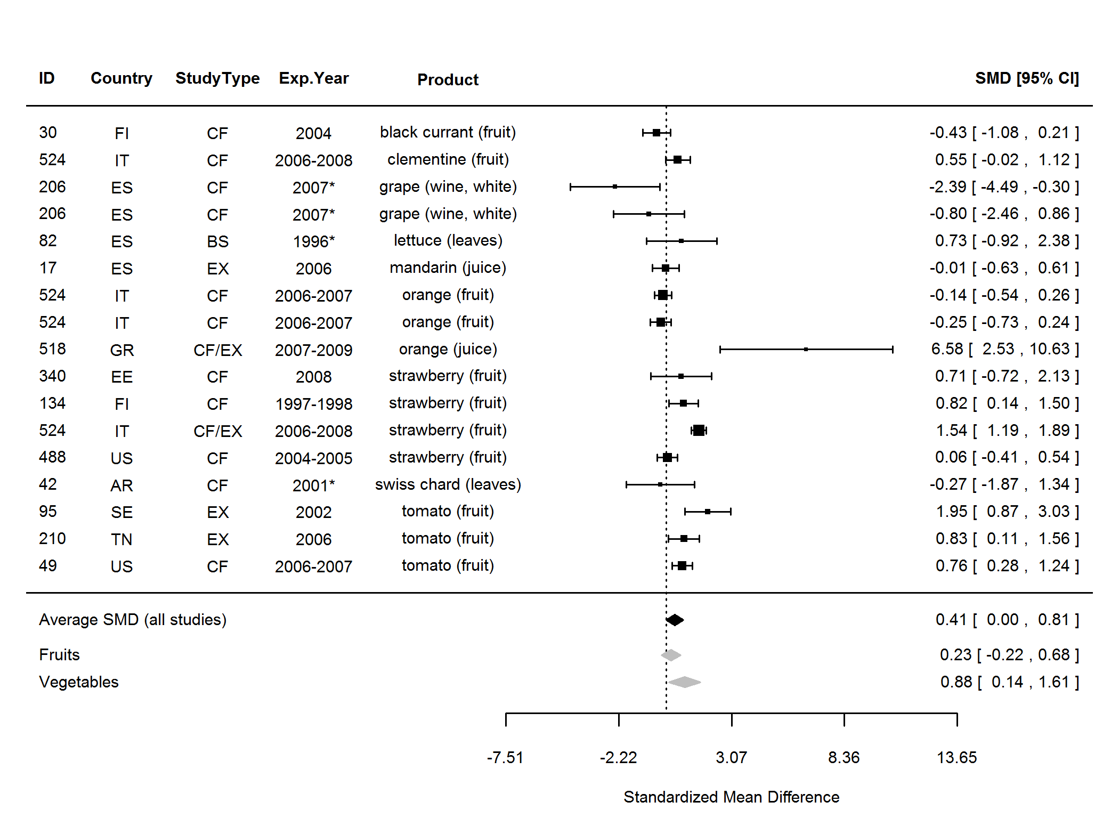

**Figure 5.** Forest plot showing the results of the comparison of titratable acidity between organic and conventional plant foods using standardised mean differences (SMDs) with 95% confidence intervals (CI), for studies included in standard weighted meta-analysis. The estimated average SMD for all studies and SMDs for different product groups are indicated at the bottom of the figure. Sign of the SMD indicates if the analysed parameter is higher (+) or lower (-) in organic foods. ID, Paper unique identification number (see Table 2 for references). *No information about the experimental year (estimated as publication year - 2).

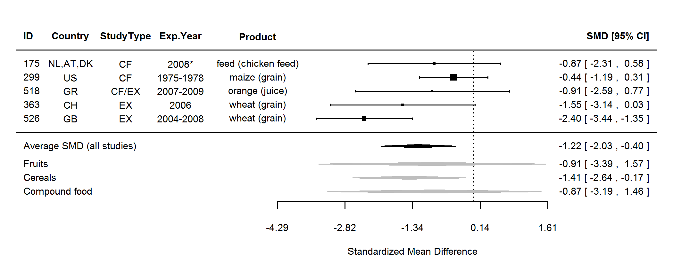

**Figure 6.** Forest plot showing the results of the comparison of arginine (Arg) between organic and conventional plant foods using standardised mean differences (SMDs) with 95% confidence intervals (CI), for studies included in standard weighted meta-analysis. The estimated average SMD for all studies and SMDs for different product groups are indicated at the bottom of the figure. Sign of the SMD indicates if the analysed parameter is higher (+) or lower (-) in organic foods. ID, Paper unique identification number (see Table 2 for references). *No information about the experimental year (estimated as publication year - 2).

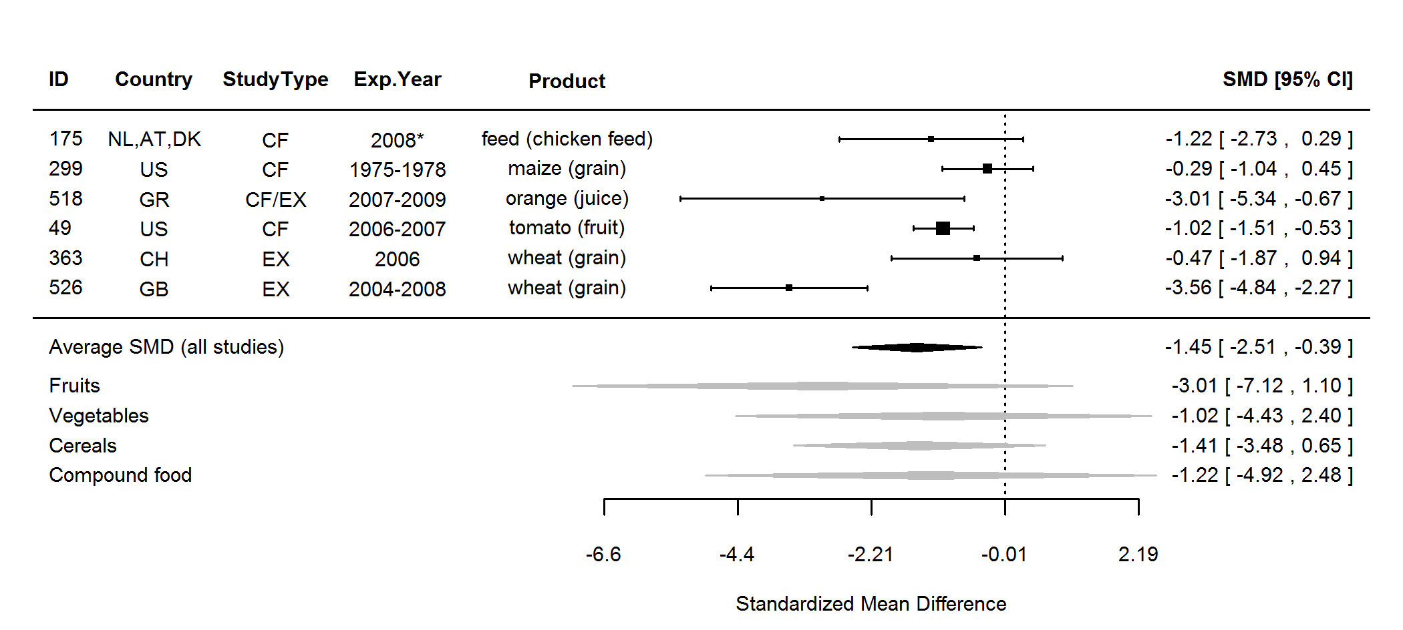

**Figure 7.** Forest plot showing the results of the comparison of histidine (His) between organic and conventional plant foods using standardised mean differences (SMDs) with 95% confidence intervals (CI), for studies included in standard weighted meta-analysis. The estimated average SMD for all studies and SMDs for different product groups are indicated at the bottom of the figure. Sign of the SMD indicates if the analysed parameter is higher (+) or lower (-) in organic foods. ID, Paper unique identification number (see Table 2 for references). *No information about the experimental year (estimated as publication year - 2).

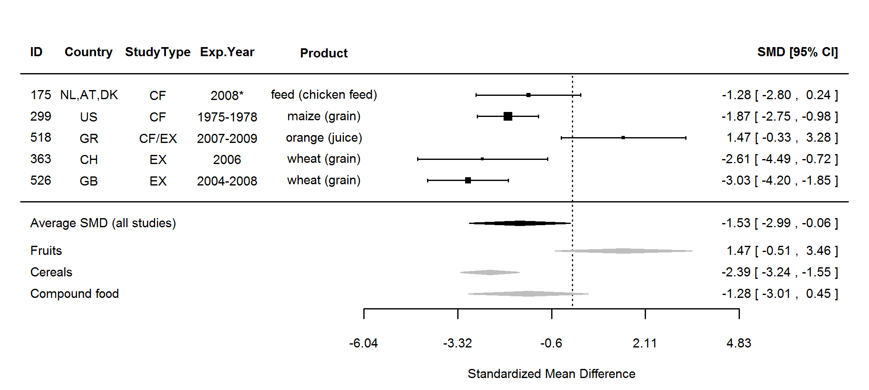

**Figure 8.** Forest plot showing the results of the comparison of isoleucine (Ile) between organic and conventional plant foods using standardised mean differences (SMDs) with 95% confidence intervals (CI), for studies included in standard weighted meta-analysis. The estimated average SMD for all studies and SMDs for different product groups are indicated at the bottom of the figure. Sign of the SMD indicates if the analysed parameter is higher (+) or lower (-) in organic foods. ID, Paper unique identification number (see Table 2 for references). *No information about the experimental year (estimated as publication year - 2).

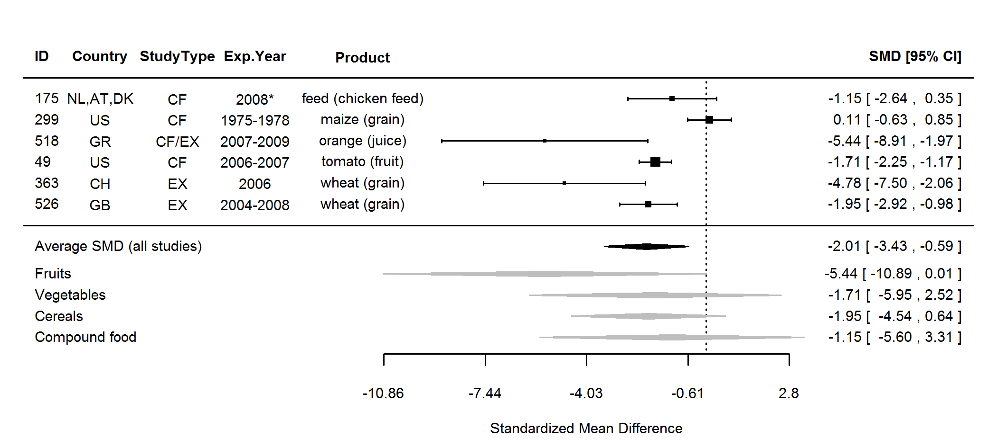

**Figure 9.** Forest plot showing the results of the comparison of lysine (Lys) between organic and conventional plant foods using standardised mean differences (SMDs) with 95% confidence intervals (CI), for studies included in standard weighted meta-analysis. The estimated average SMD for all studies and SMDs for different product groups are indicated at the bottom of the figure. Sign of the SMD indicates if the analysed parameter is higher (+) or lower (-) in organic foods. ID, Paper unique identification number (see Table 2 for references). *No information about the experimental year (estimated as publication year - 2).

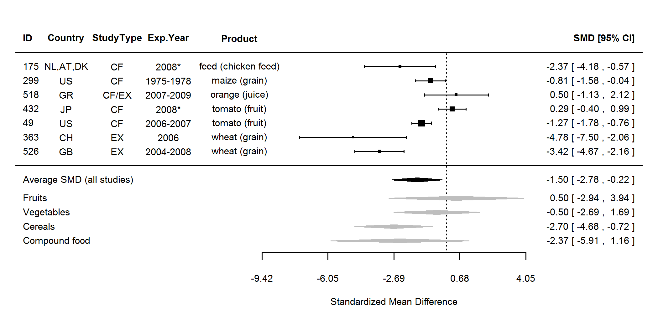

**Figure 10.** Forest plot showing the results of the comparison of phenylalanine (Phe) between organic and conventional plant foods using standardised mean differences (SMDs) with 95% confidence intervals (CI), for studies included in standard weighted meta-analysis. The estimated average SMD for all studies and SMDs for different product groups are indicated at the bottom of the figure. Sign of the SMD indicates if the analysed parameter is higher (+) or lower (-) in organic foods. ID, Paper unique identification number (see Table 2 for references). *No information about the experimental year (estimated as publication year - 2).

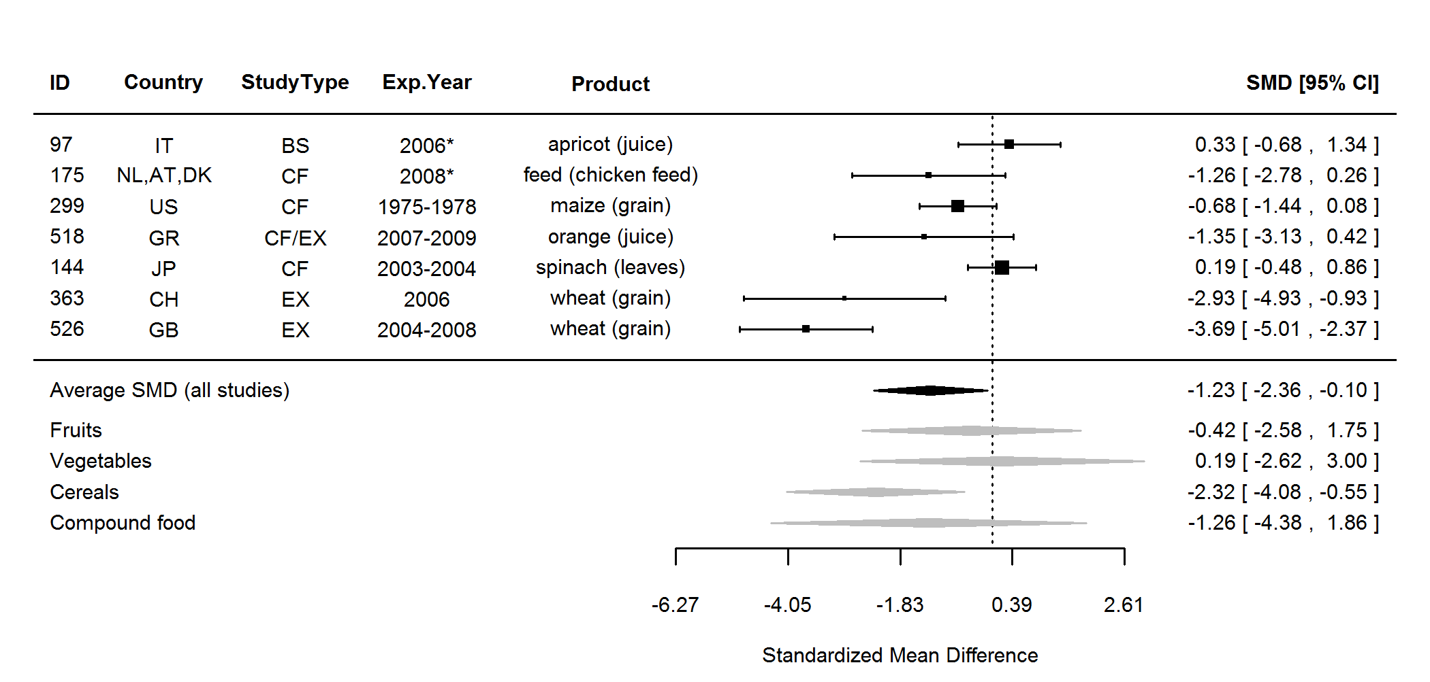

**Figure 11.** Forest plot showing the results of the comparison of proline (Pro) between organic and conventional plant foods using standardised mean differences (SMDs) with 95% confidence intervals (CI), for studies included in standard weighted meta-analysis. The estimated average SMD for all studies and SMDs for different product groups are indicated at the bottom of the figure. Sign of the SMD indicates if the analysed parameter is higher (+) or lower (-) in organic foods. ID, Paper unique identification number (see Table 2 for references). *No information about the experimental year (estimated as publication year - 2).

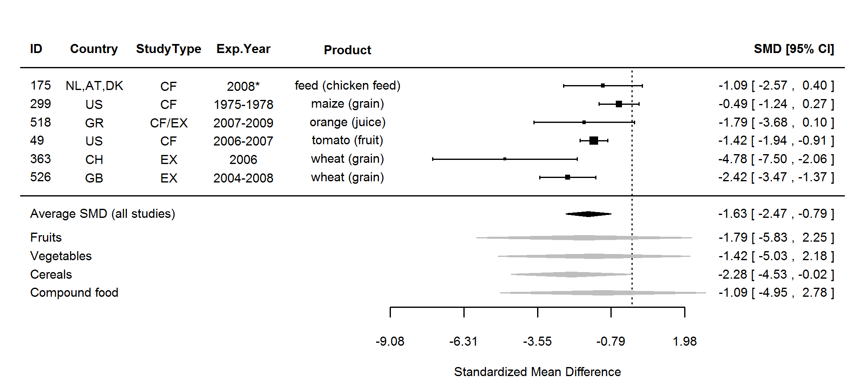

**Figure 12.** Forest plot showing the results of the comparison of threonine (Thr) between organic and conventional plant foods using standardised mean differences (SMDs) with 95% confidence intervals (CI), for studies included in standard weighted meta-analysis. The estimated average SMD for all studies and SMDs for different product groups are indicated at the bottom of the figure. Sign of the SMD indicates if the analysed parameter is higher (+) or lower (-) in organic foods. ID, Paper unique identification number (see Table 2 for references). *No information about the experimental year (estimated as publication year - 2).

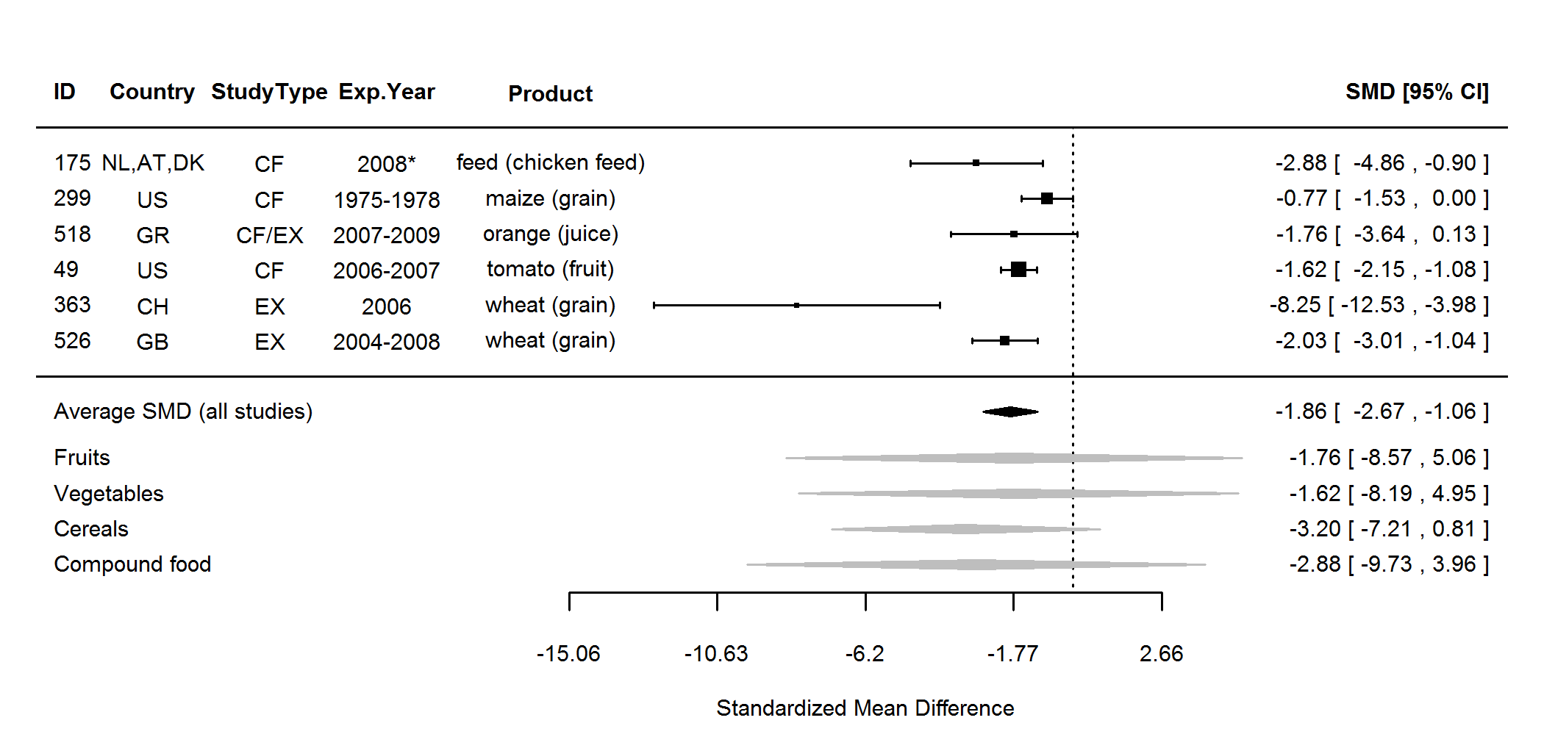

**Figure 13.** Forest plot showing the results of the comparison of tyrosine (Tyr) between organic and conventional plant foods using standardised mean differences (SMDs) with 95% confidence intervals (CI), for studies included in standard weighted meta-analysis. The estimated average SMD for all studies and SMDs for different product groups are indicated at the bottom of the figure. Sign of the SMD indicates if the analysed parameter is higher (+) or lower (-) in organic foods. ID, Paper unique identification number (see Table 2 for references). *No information about the experimental year (estimated as publication year - 2).

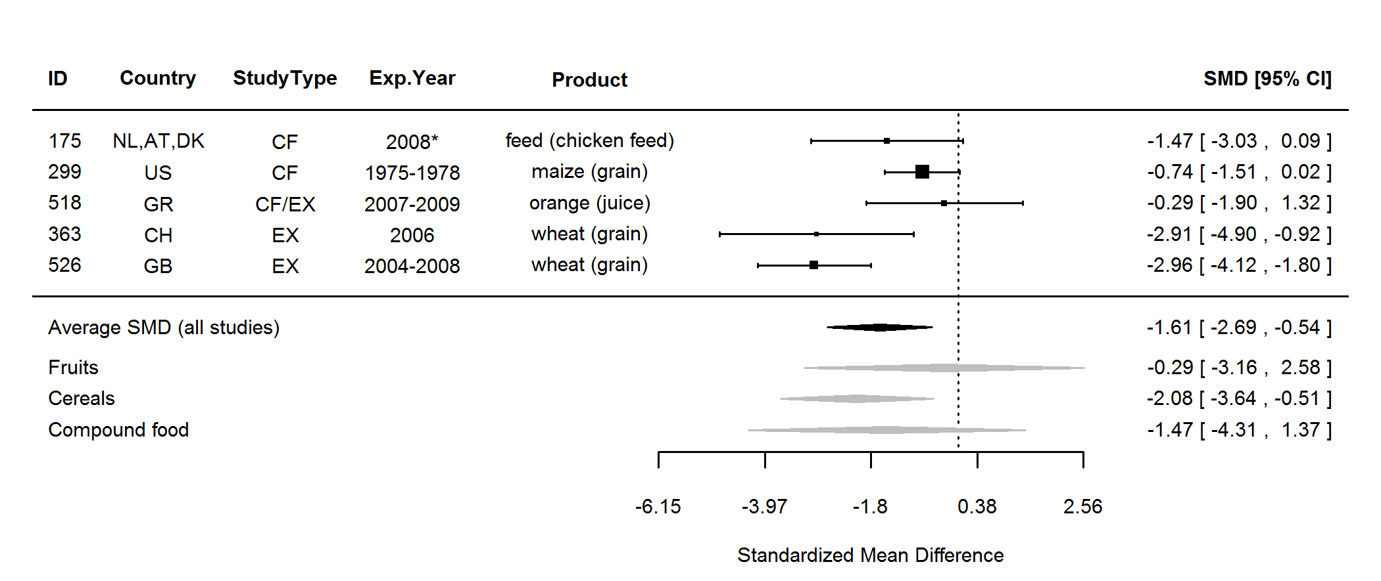

**Figure 14.** Forest plot showing the results of the comparison of valine (Val) between organic and conventional plant foods using standardised mean differences (SMDs) with 95% confidence intervals (CI), for studies included in standard weighted meta-analysis. The estimated average SMD for all studies and SMDs for different product groups are indicated at the bottom of the figure. Sign of the SMD indicates if the analysed parameter is higher (+) or lower (-) in organic foods. ID, Paper unique identification number (see Table 2 for references). *No information about the experimental year (estimated as publication year - 2).

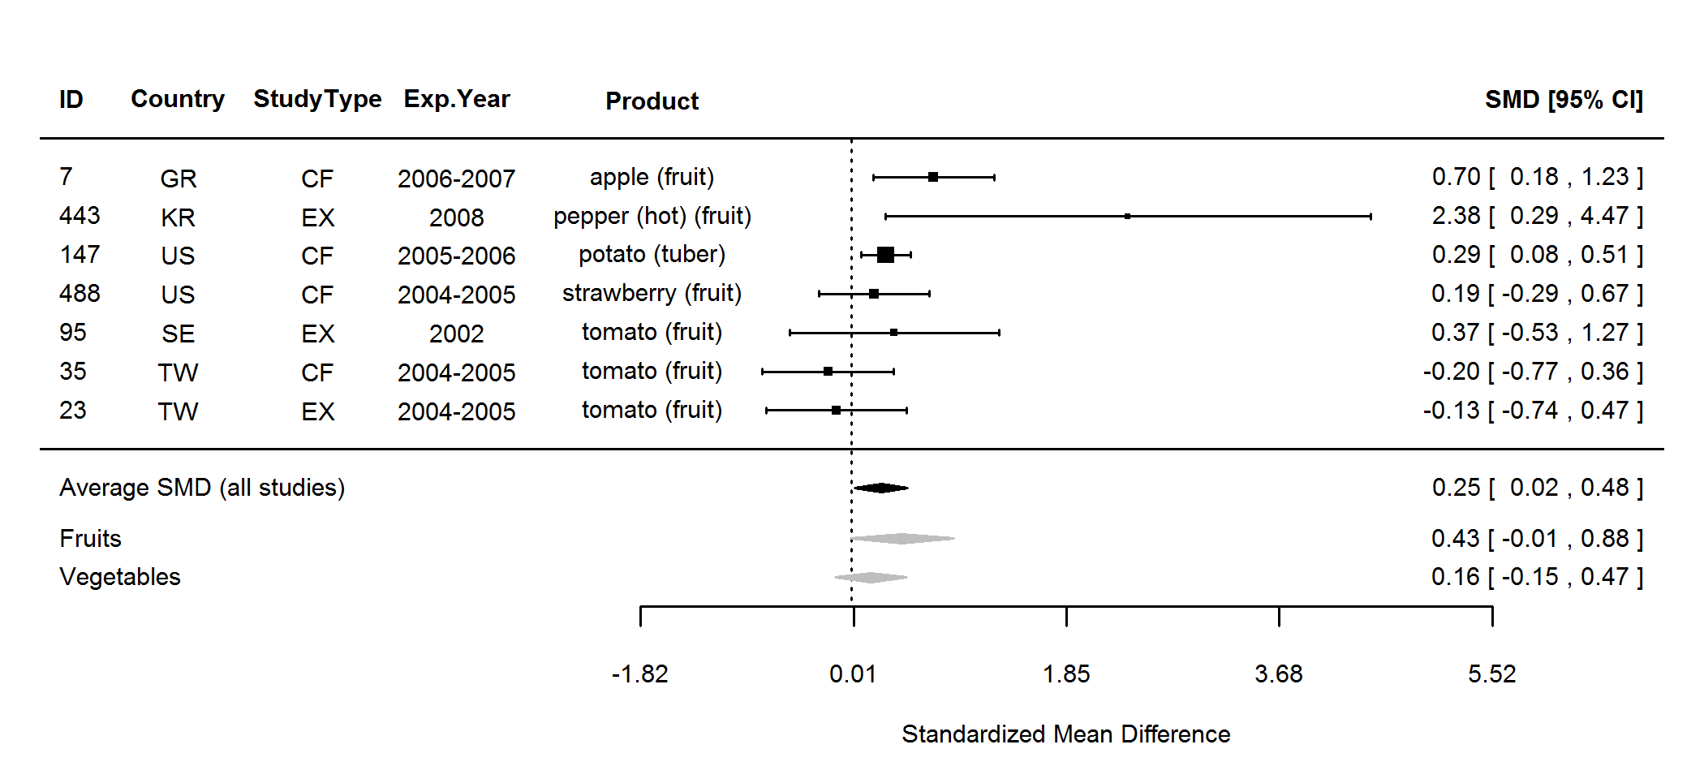

**Figure 15.** Forest plot showing the results of the comparison of antioxidant activity (TEAC) between organic and conventional plant foods using standardised mean differences (SMDs) with 95% confidence intervals (CI), for studies included in standard weighted meta-analysis. The estimated average SMD for all studies and SMDs for different product groups are indicated at the bottom of the figure. Sign of the SMD indicates if the analysed parameter is higher (+) or lower (-) in organic foods. ID, Paper unique identification number (see Table 2 for references).

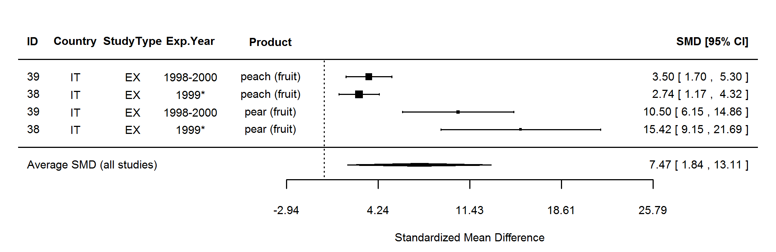

**Figure 16.** Forest plot showing the results of the comparison of polyphenoloxidase (PPO) activity (towards chlorogenic acid) between organic and conventional plant foods using standardised mean differences (SMDs) with 95% confidence intervals (CI), for studies included in standard weighted meta-analysis. The estimated average SMD for all studies is indicated at the bottom of the figure. Sign of the SMD indicates if the analysed parameter is higher (+) or lower (-) in organic foods. ID, Paper unique identification number (see Table 2 for references). *No information about the experimental year (estimated as publication year - 2).

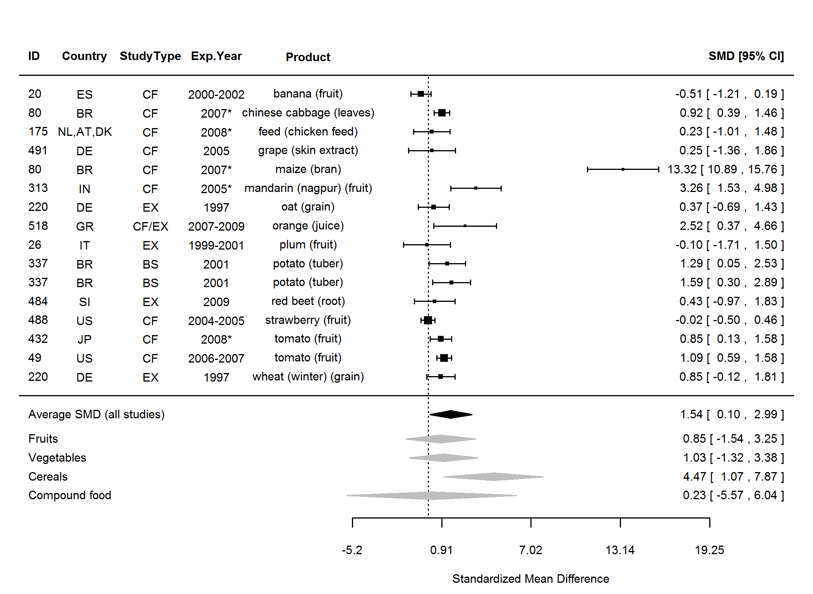

**Figure 17.** Forest plot showing the results of the comparison of carbohydrates (total) between organic and conventional plant foods using standardised mean differences (SMDs) with 95% confidence intervals (CI), for studies included in standard weighted meta-analysis. The estimated average SMD for all studies and SMDs for different product groups are indicated at the bottom of the figure. Sign of the SMD indicates if the analysed parameter is higher (+) or lower (-) in organic foods. ID, Paper unique identification number (see Table 2 for references). *No information about the experimental year (estimated as publication year - 2).

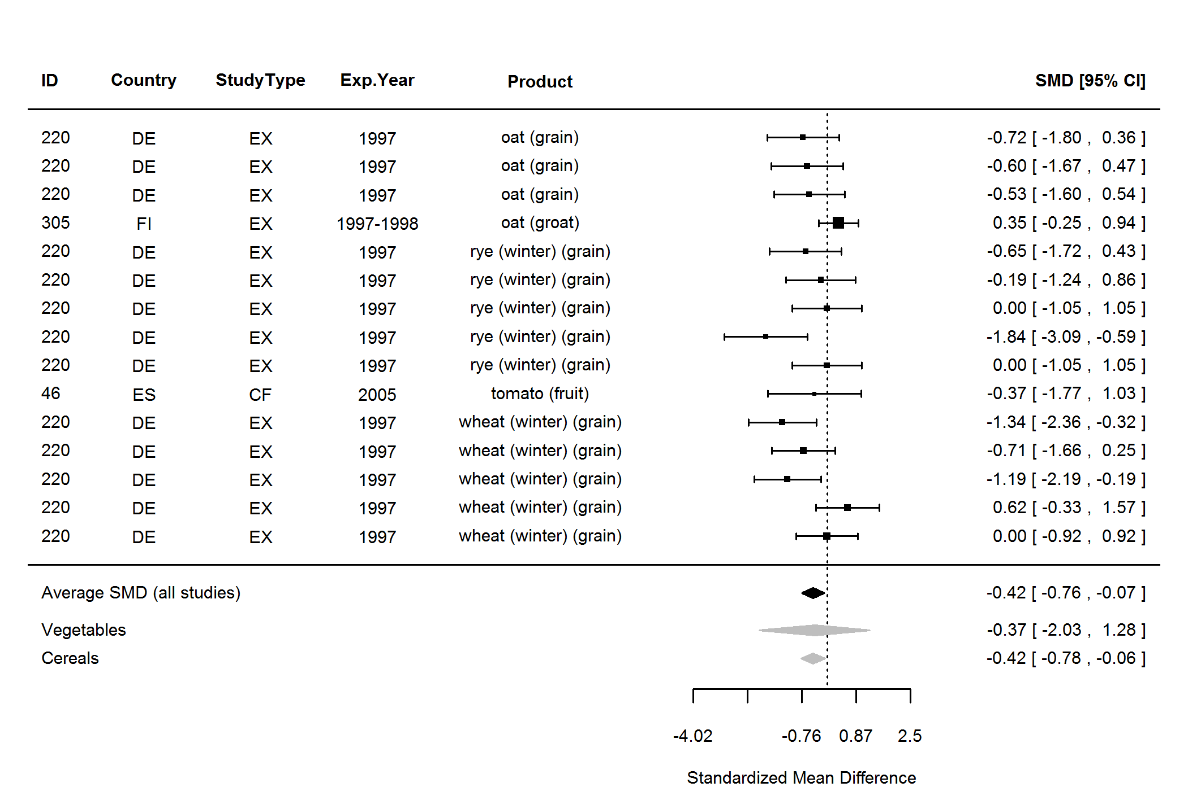

**Figure 18.** Forest plot showing the results of the comparison of fibre between organic and conventional plant foods using standardised mean differences (SMDs) with 95% confidence intervals (CI), for studies included in standard weighted meta-analysis. The estimated average SMD for all studies and SMDs for different product groups are indicated at the bottom of the figure. Sign of the SMD indicates if the analysed parameter is higher (+) or lower (-) in organic foods. ID, Paper unique identification number (see Table 2 for references).

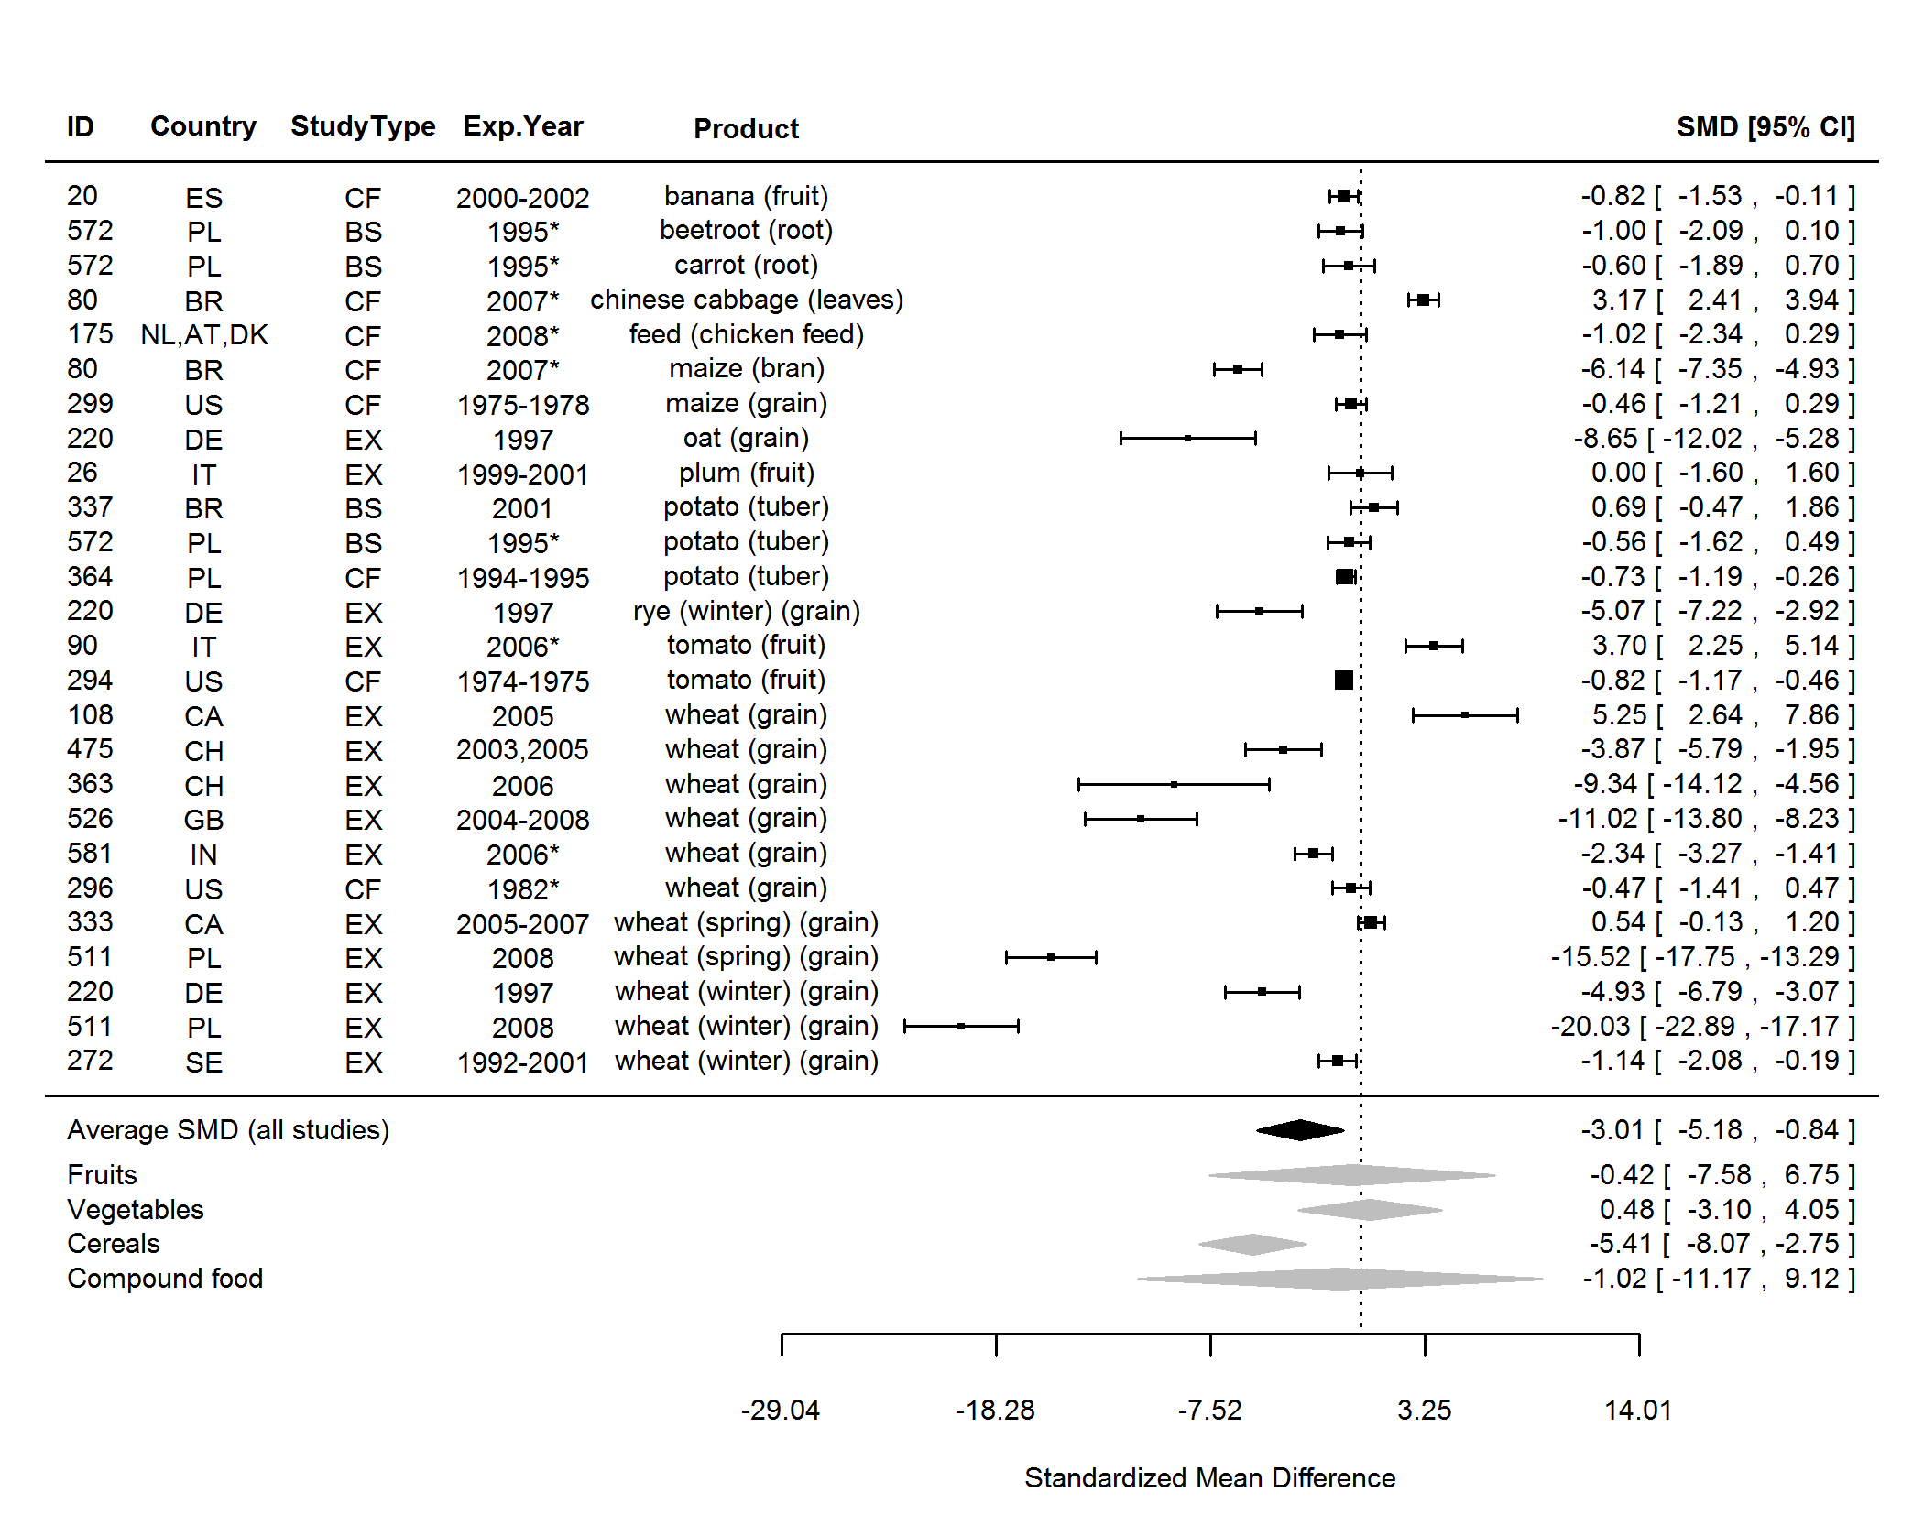

**Figure 19.** Forest plot showing the results of the comparison of protein (total) between organic and conventional plant foods using standardised mean differences (SMDs) with 95% confidence intervals (CI), for studies included in standard weighted meta-analysis. The estimated average SMD for all studies and SMDs for different product groups are indicated at the bottom of the figure. Sign of the SMD indicates if the analysed parameter is higher (+) or lower (-) in organic foods. ID, Paper unique identification number (see Table 2 for references). *No information about the experimental year (estimated as publication year - 2).

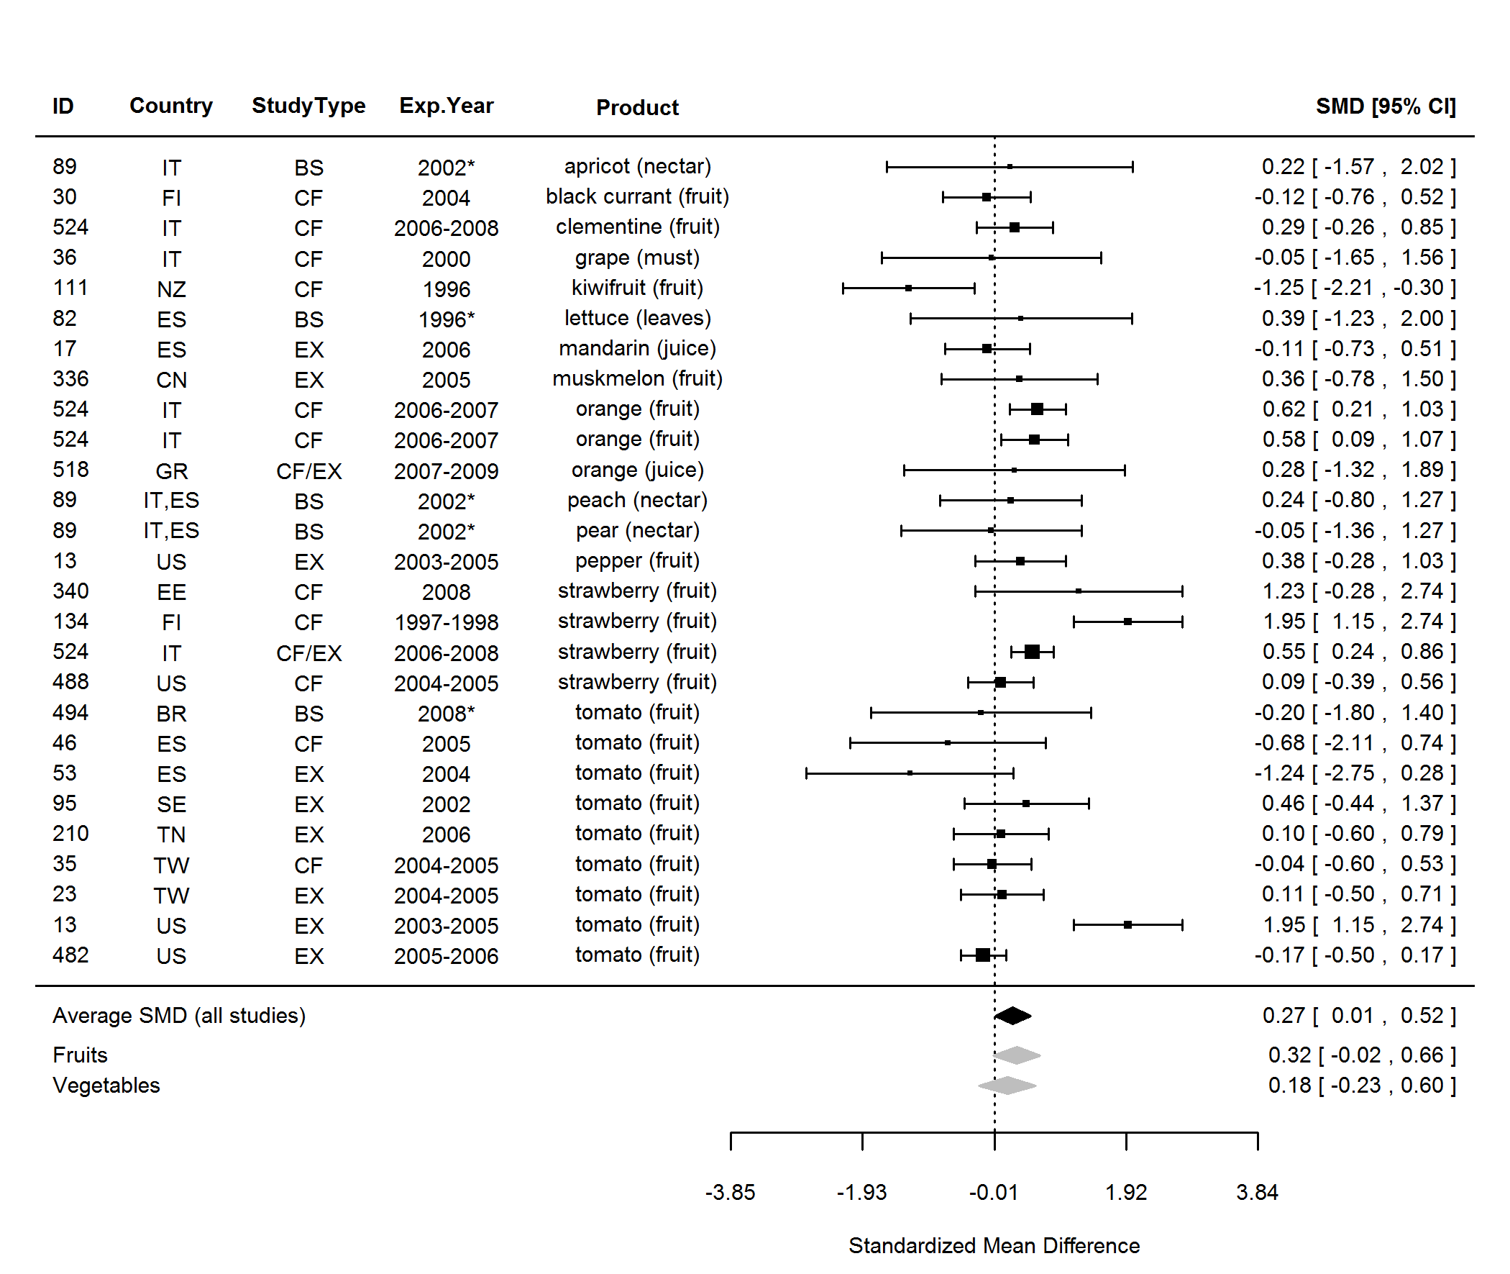

**Figure 20.** Forest plot showing the results of the comparison of solids (soluble) between organic and conventional plant foods using standardised mean differences (SMDs) with 95% confidence intervals (CI), for studies included in standard weighted meta-analysis. The estimated average SMD for all studies and SMDs for different product groups are indicated at the bottom of the figure. Sign of the SMD indicates if the analysed parameter is higher (+) or lower (-) in organic foods. ID, Paper unique identification number (see Table 2 for references). *No information about the experimental year (estimated as publication year - 2).

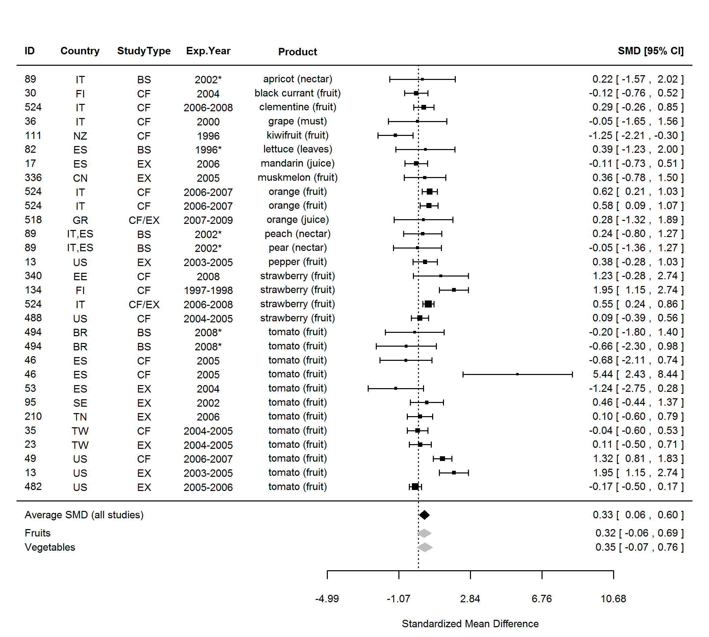

**Figure 21.** Forest plot showing the results of the comparison of solids between organic and conventional plant foods using standardised mean differences (SMDs) with 95% confidence intervals (CI), for studies included in standard weighted meta-analysis. The estimated average SMD for all studies and SMDs for different product groups are indicated at the bottom of the figure. Sign of the SMD indicates if the analysed parameter is higher (+) or lower (-) in organic foods. ID, Paper unique identification number (see Table 2 for references). *No information about the experimental year (estimated as publication year - 2).

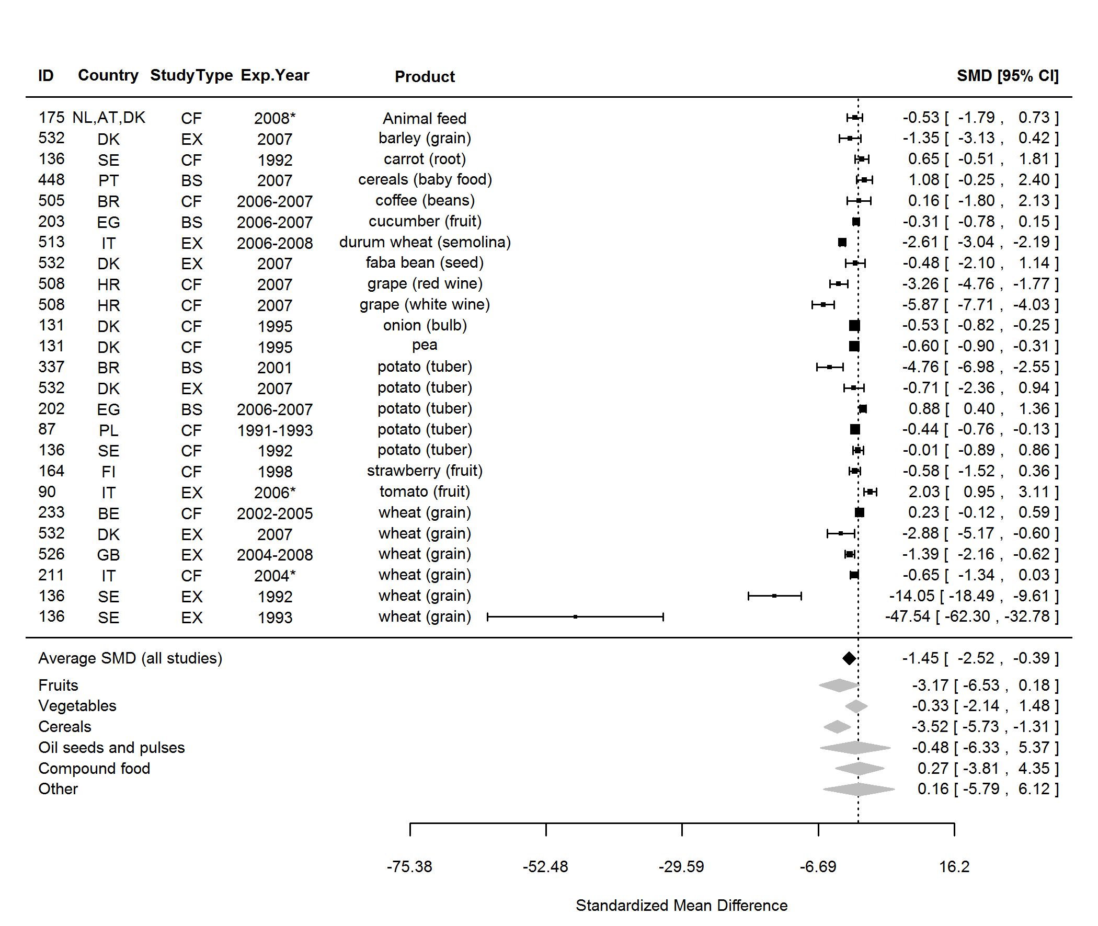

**Figure 22.** Forest plot showing the results of the comparison of cadmium (Cd) between organic and conventional plant foods using standardised mean differences (SMDs) with 95% confidence intervals (CI), for studies included in standard weighted meta-analysis. The estimated average SMD for all studies and SMDs for different product groups are indicated at the bottom of the figure. Sign of the SMD indicates if the analysed parameter is higher (+) or lower (-) in organic foods. ID, Paper unique identification number (see Table 2 for references). *No information about the experimental year (estimated as publication year - 2).

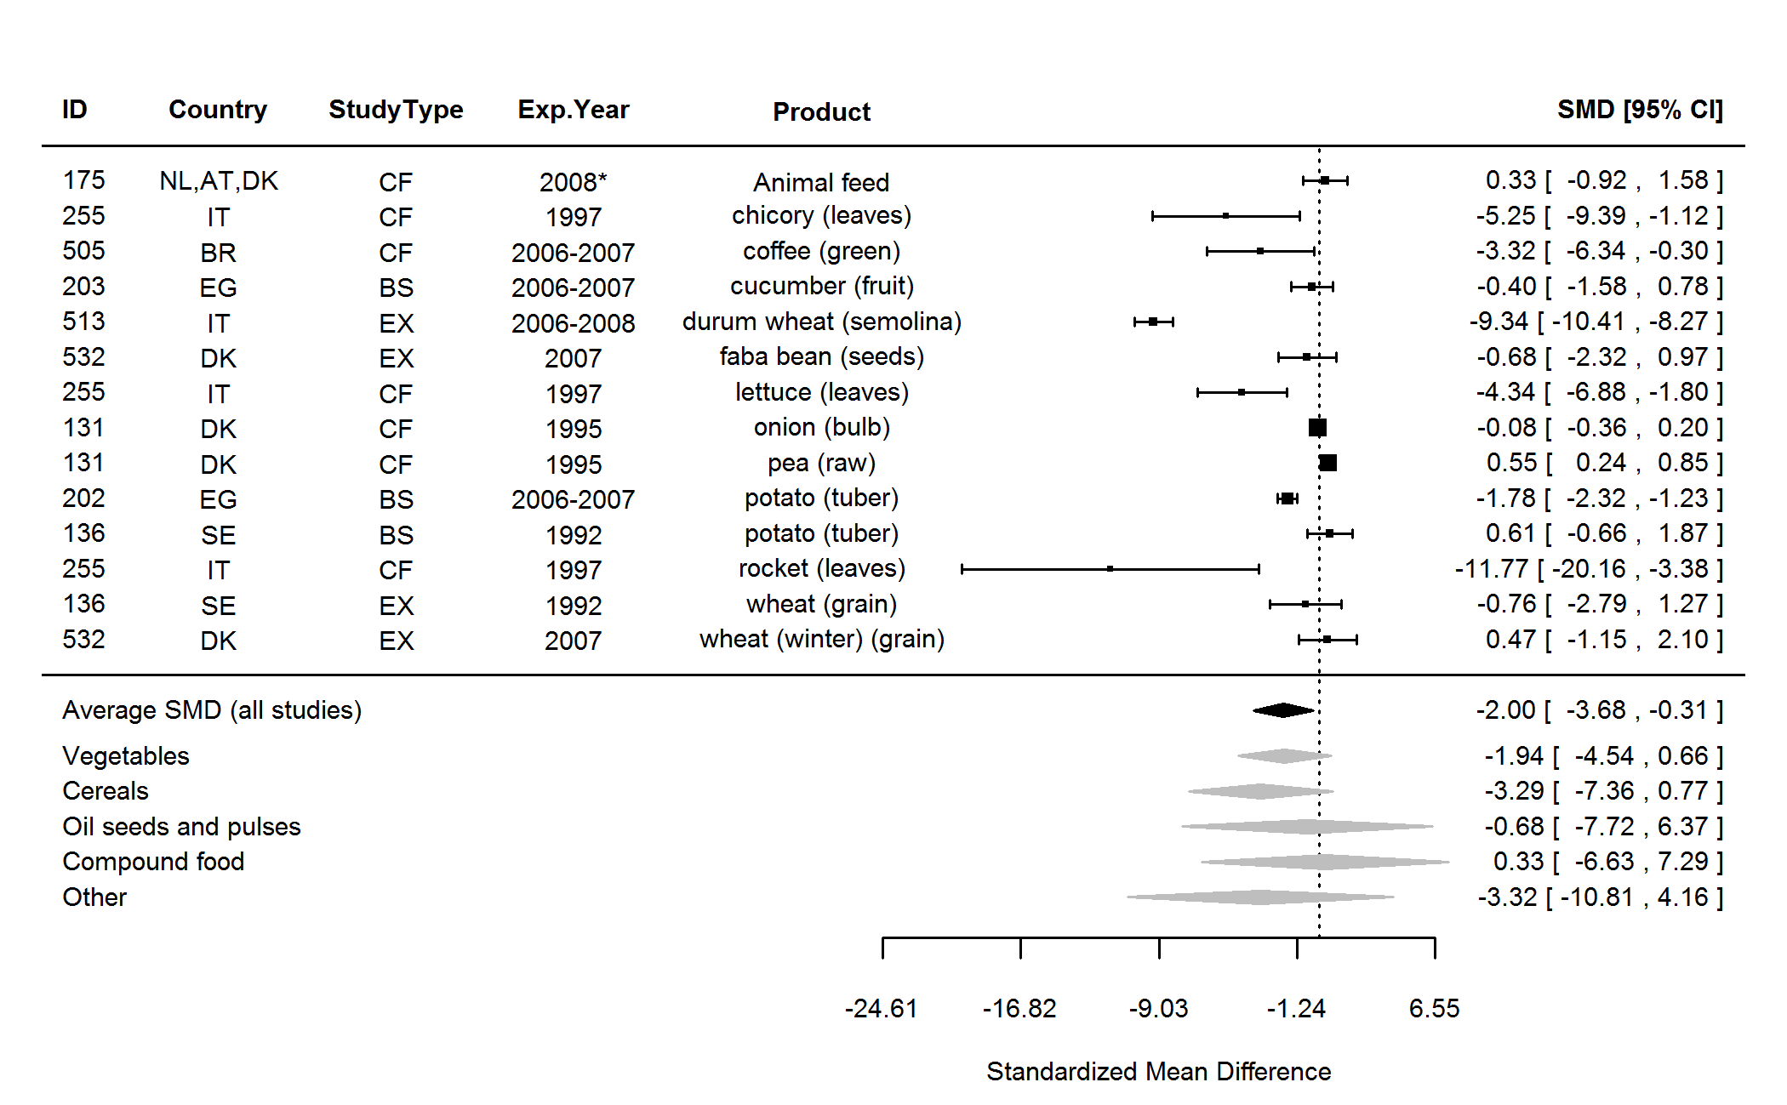

**Figure 23.** Forest plot showing the results of the comparison of chromium (Cr) between organic and conventional plant foods using standardised mean differences (SMDs) with 95% confidence intervals (CI), for studies included in standard weighted meta-analysis. The estimated average SMD for all studies and SMDs for different product groups are indicated at the bottom of the figure. Sign of the SMD indicates if the analysed parameter is higher (+) or lower (-) in organic foods. ID, Paper unique identification number (see Table 2 for references). *No information about the experimental year (estimated as publication year - 2).

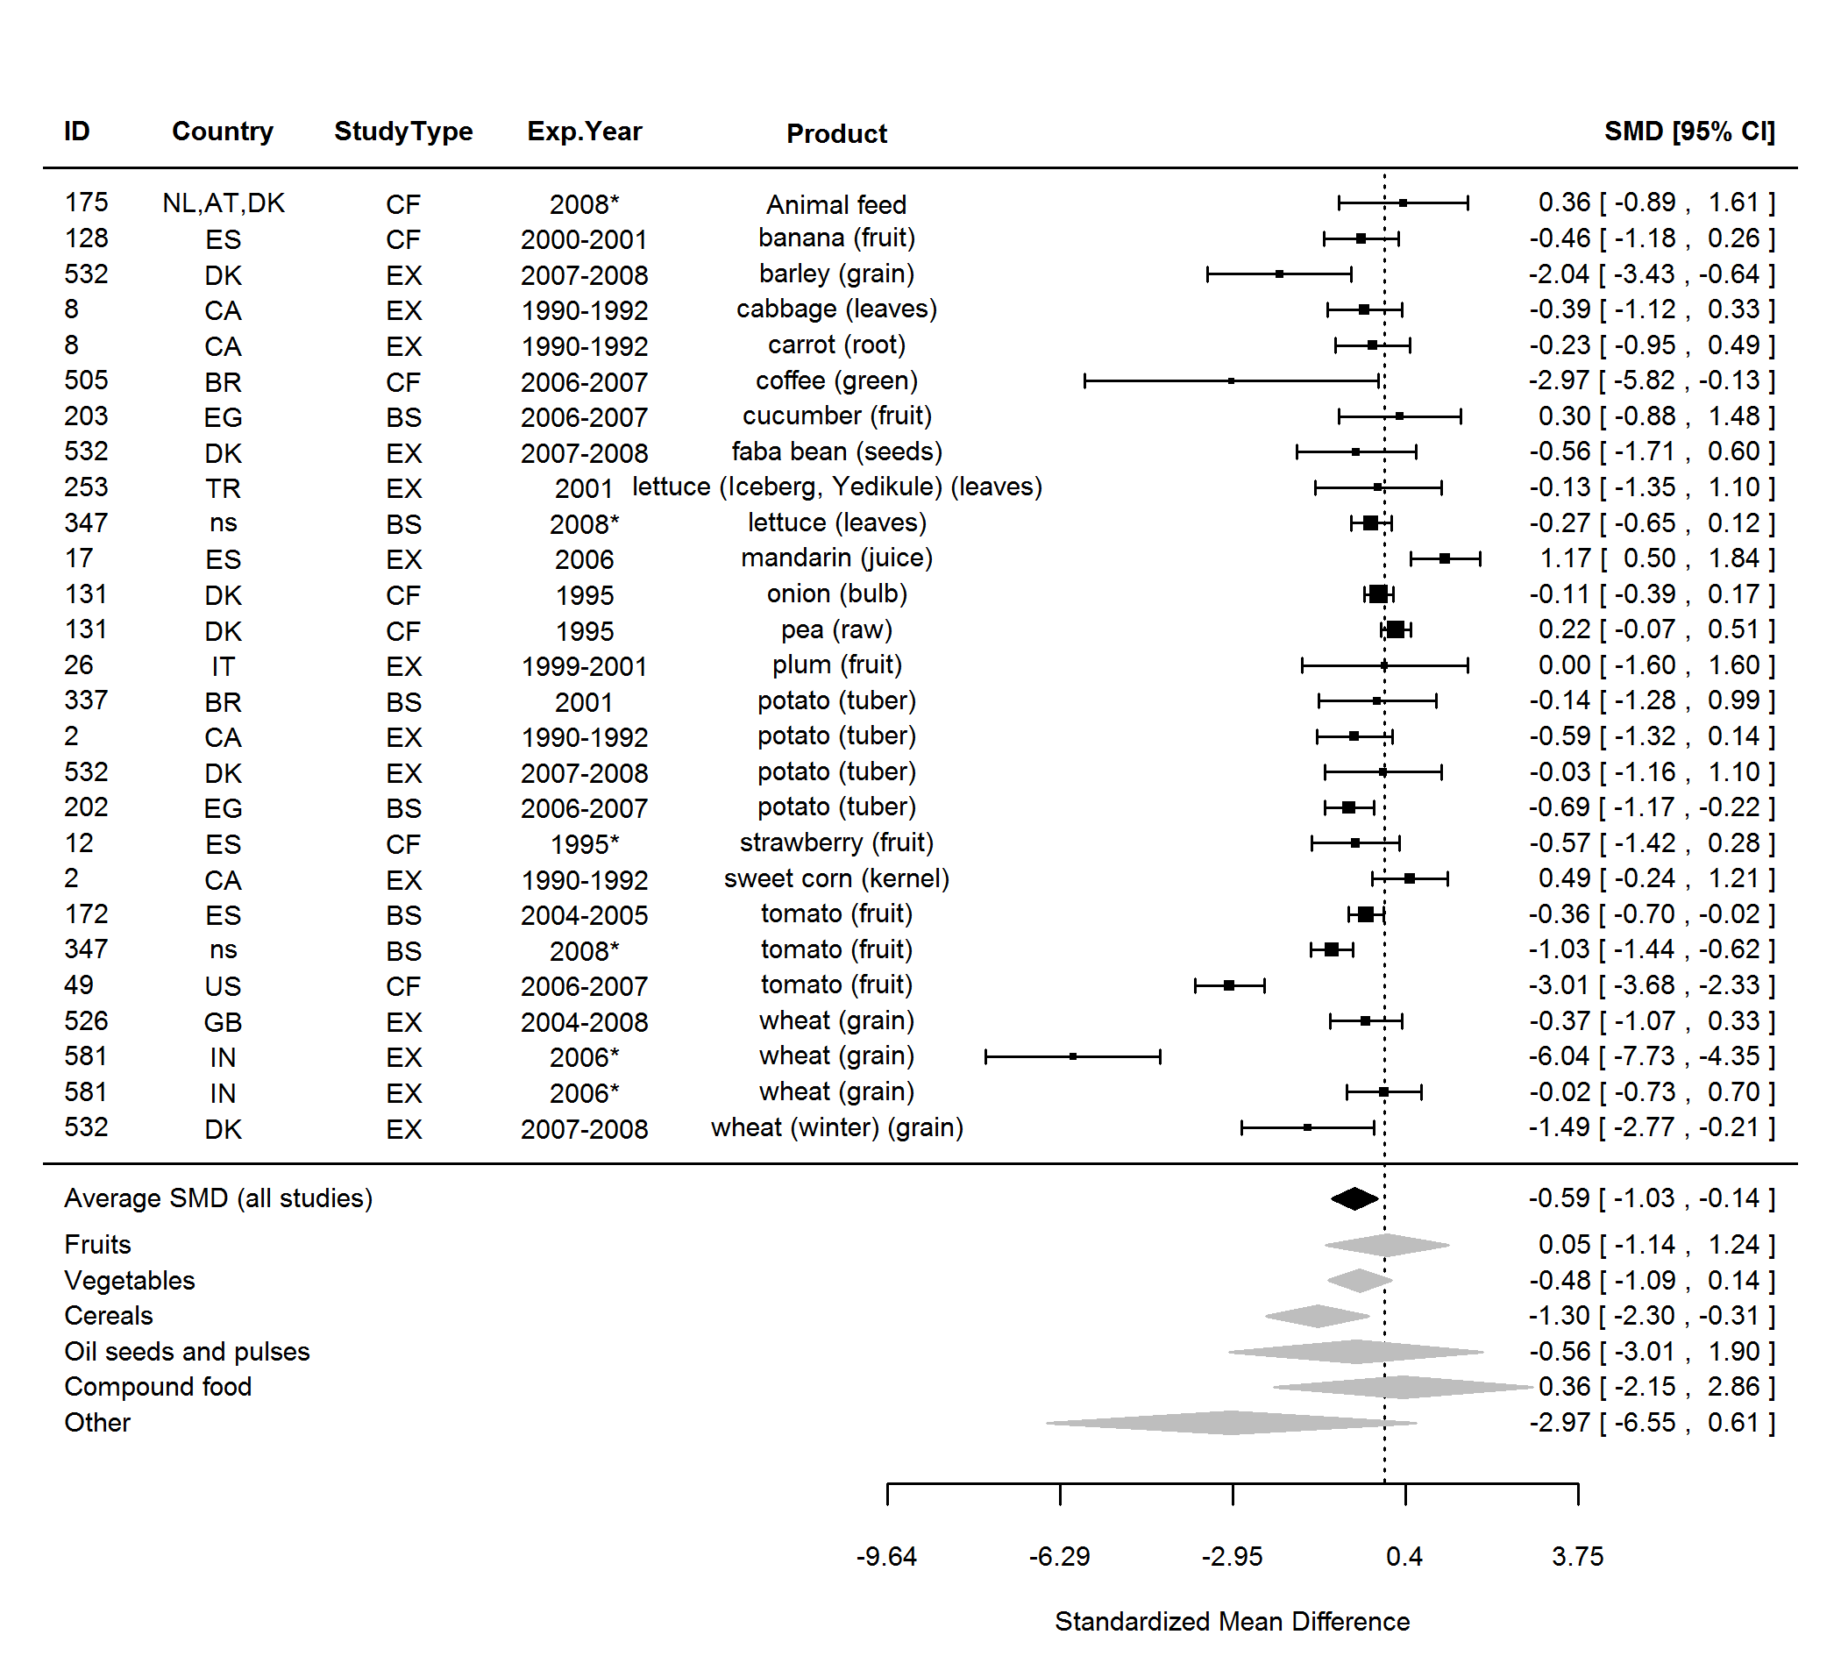

**Figure 24.** Forest plot showing the results of the comparison of manganese (Mn) between organic and conventional plant foods using standardised mean differences (SMDs) with 95% confidence intervals (CI), for studies included in standard weighted meta-analysis. The estimated average SMD for all studies and SMDs for different product groups are indicated at the bottom of the figure. Sign of the SMD indicates if the analysed parameter is higher (+) or lower (-) in organic foods. ID, Paper unique identification number (see Table 2 for references). *No information about the experimental year (estimated as publication year - 2).

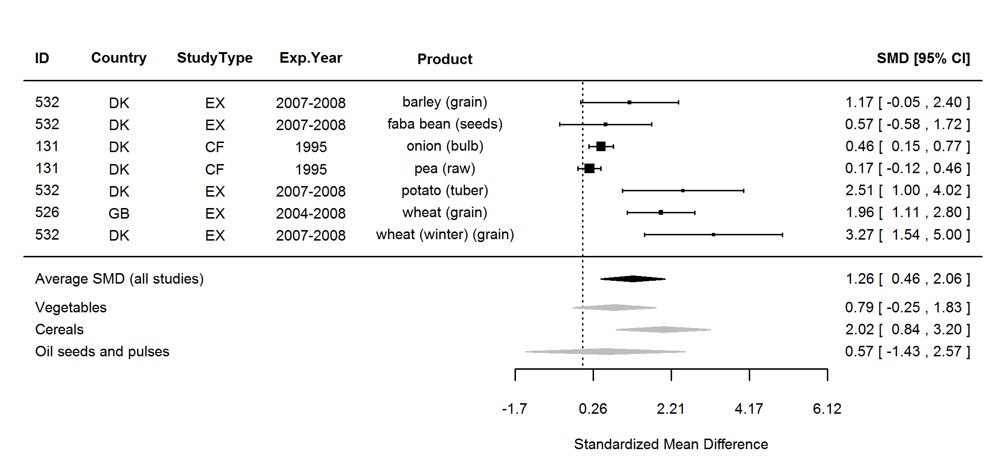

**Figure 25.** Forest plot showing the results of the comparison of molybdenum (Mo)between organic and conventional plant foods using standardised mean differences (SMDs) with 95% confidence intervals (CI), for studies included in standard weighted meta-analysis. The estimated average SMD for all studies and SMDs for different product groups are indicated at the bottom of the figure. Sign of the SMD indicates if the analysed parameter is higher (+) or lower (-) in organic foods. ID, Paper unique identification number (see Table 2 for references).

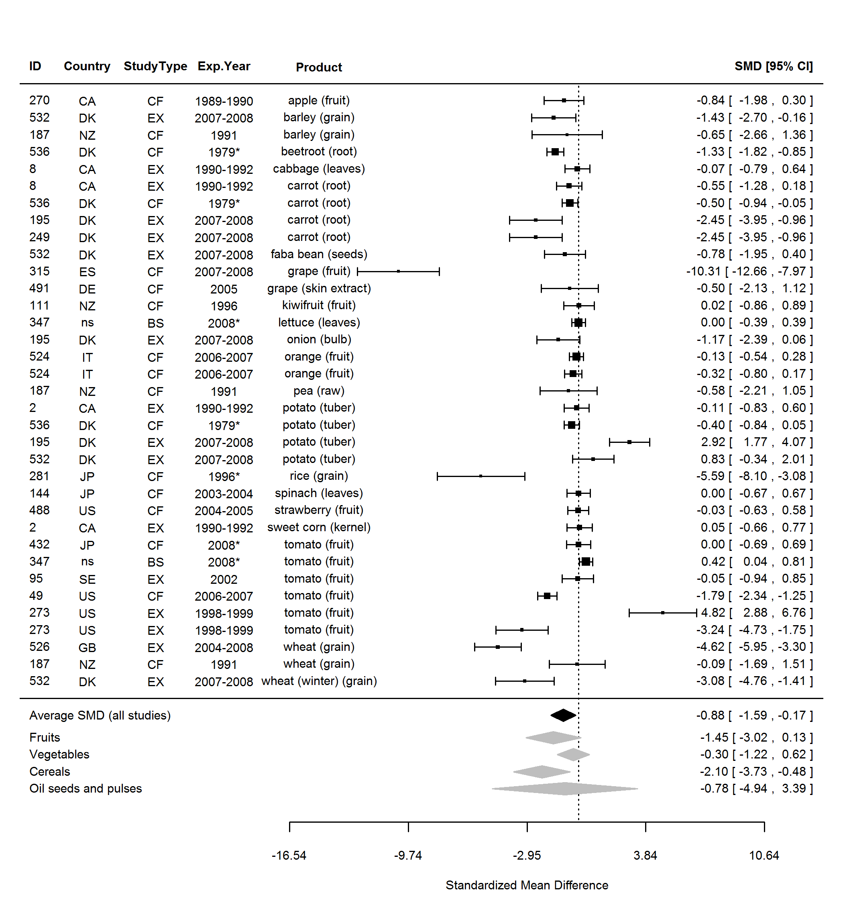

**Figure 26.** Forest plot showing the results of the comparison of nitrogen (N) between organic and conventional plant foods using standardised mean differences (SMDs) with 95% confidence intervals (CI), for studies included in standard weighted meta-analysis. The estimated average SMD for all studies and SMDs for different product groups are indicated at the bottom of the figure. Sign of the SMD indicates if the analysed parameter is higher (+) or lower (-) in organic foods. ID, Paper unique identification number (see Table 2 for references). *No information about the experimental year (estimated as publication year - 2).

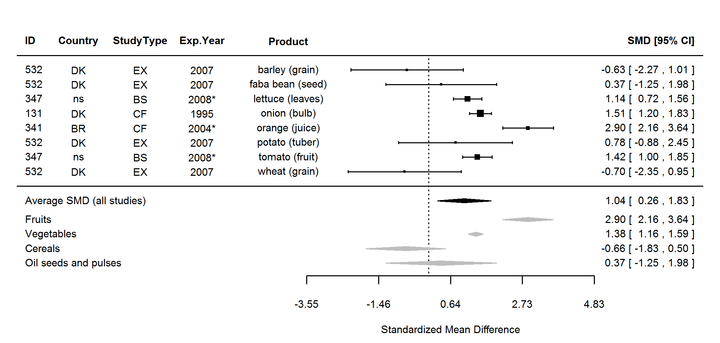

**Figure 27.** Forest plot showing the results of the comparison of rubidium (Rb) between organic and conventional plant foods using standardised mean differences (SMDs) with 95% confidence intervals (CI), for studies included in standard weighted meta-analysis. The estimated average SMD for all studies and SMDs for different product groups are indicated at the bottom of the figure. Sign of the SMD indicates if the analysed parameter is higher (+) or lower (-) in organic foods. ID, Paper unique identification number (see Table 2 for references). *No information about the experimental year (estimated as publication year - 2).

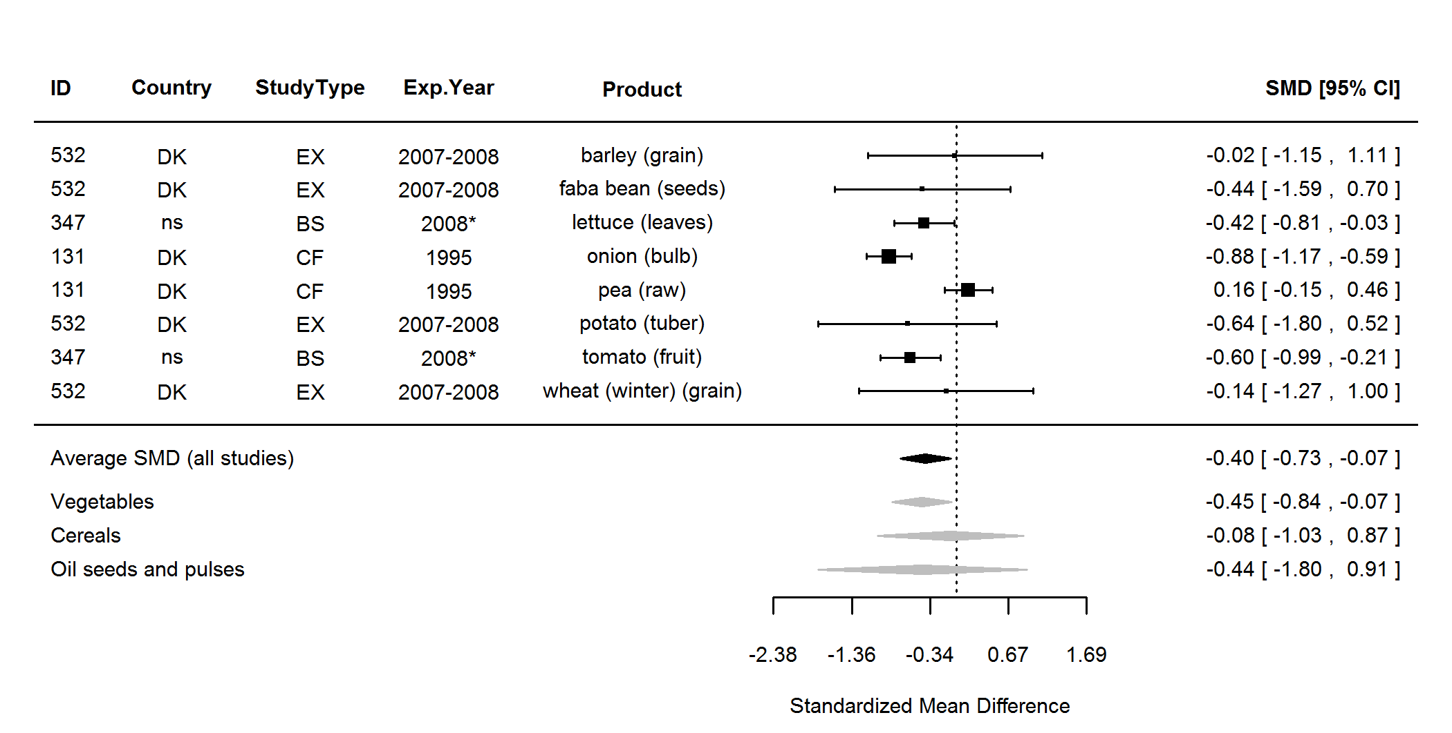

**Figure 28.** Forest plot showing the results of the comparison of strontium (Sr) between organic and conventional plant foods using standardised mean differences (SMDs) with 95% confidence intervals (CI), for studies included in standard weighted meta-analysis. The estimated average SMD for all studies and SMDs for different product groups are indicated at the bottom of the figure. Sign of the SMD indicates if the analysed parameter is higher (+) or lower (-) in organic foods. ID, Paper unique identification number (see Table 2 for references). *No information about the experimental year (estimated as publication year - 2).

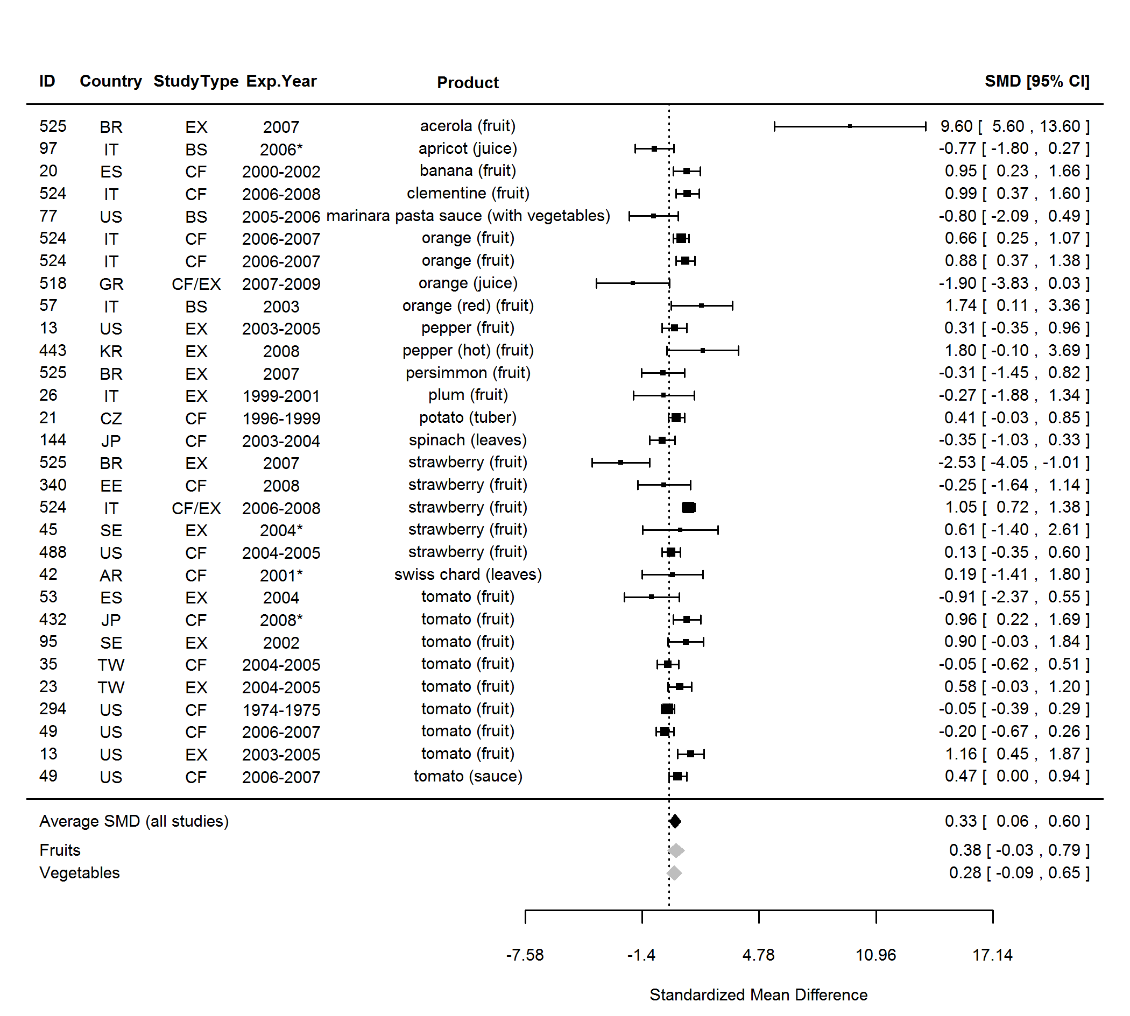

**Figure 29.** Forest plot showing the results of the comparison of ascorbic acid between organic and conventional plant foods using standardised mean differences (SMDs) with 95% confidence intervals (CI), for studies included in standard weighted meta-analysis. The estimated average SMD for all studies and SMDs for different product groups are indicated at the bottom of the figure. Sign of the SMD indicates if the analysed parameter is higher (+) or lower (-) in organic foods. ID, Paper unique identification number (see Table 2 for references). *No information about the experimental year (estimated as publication year - 2).

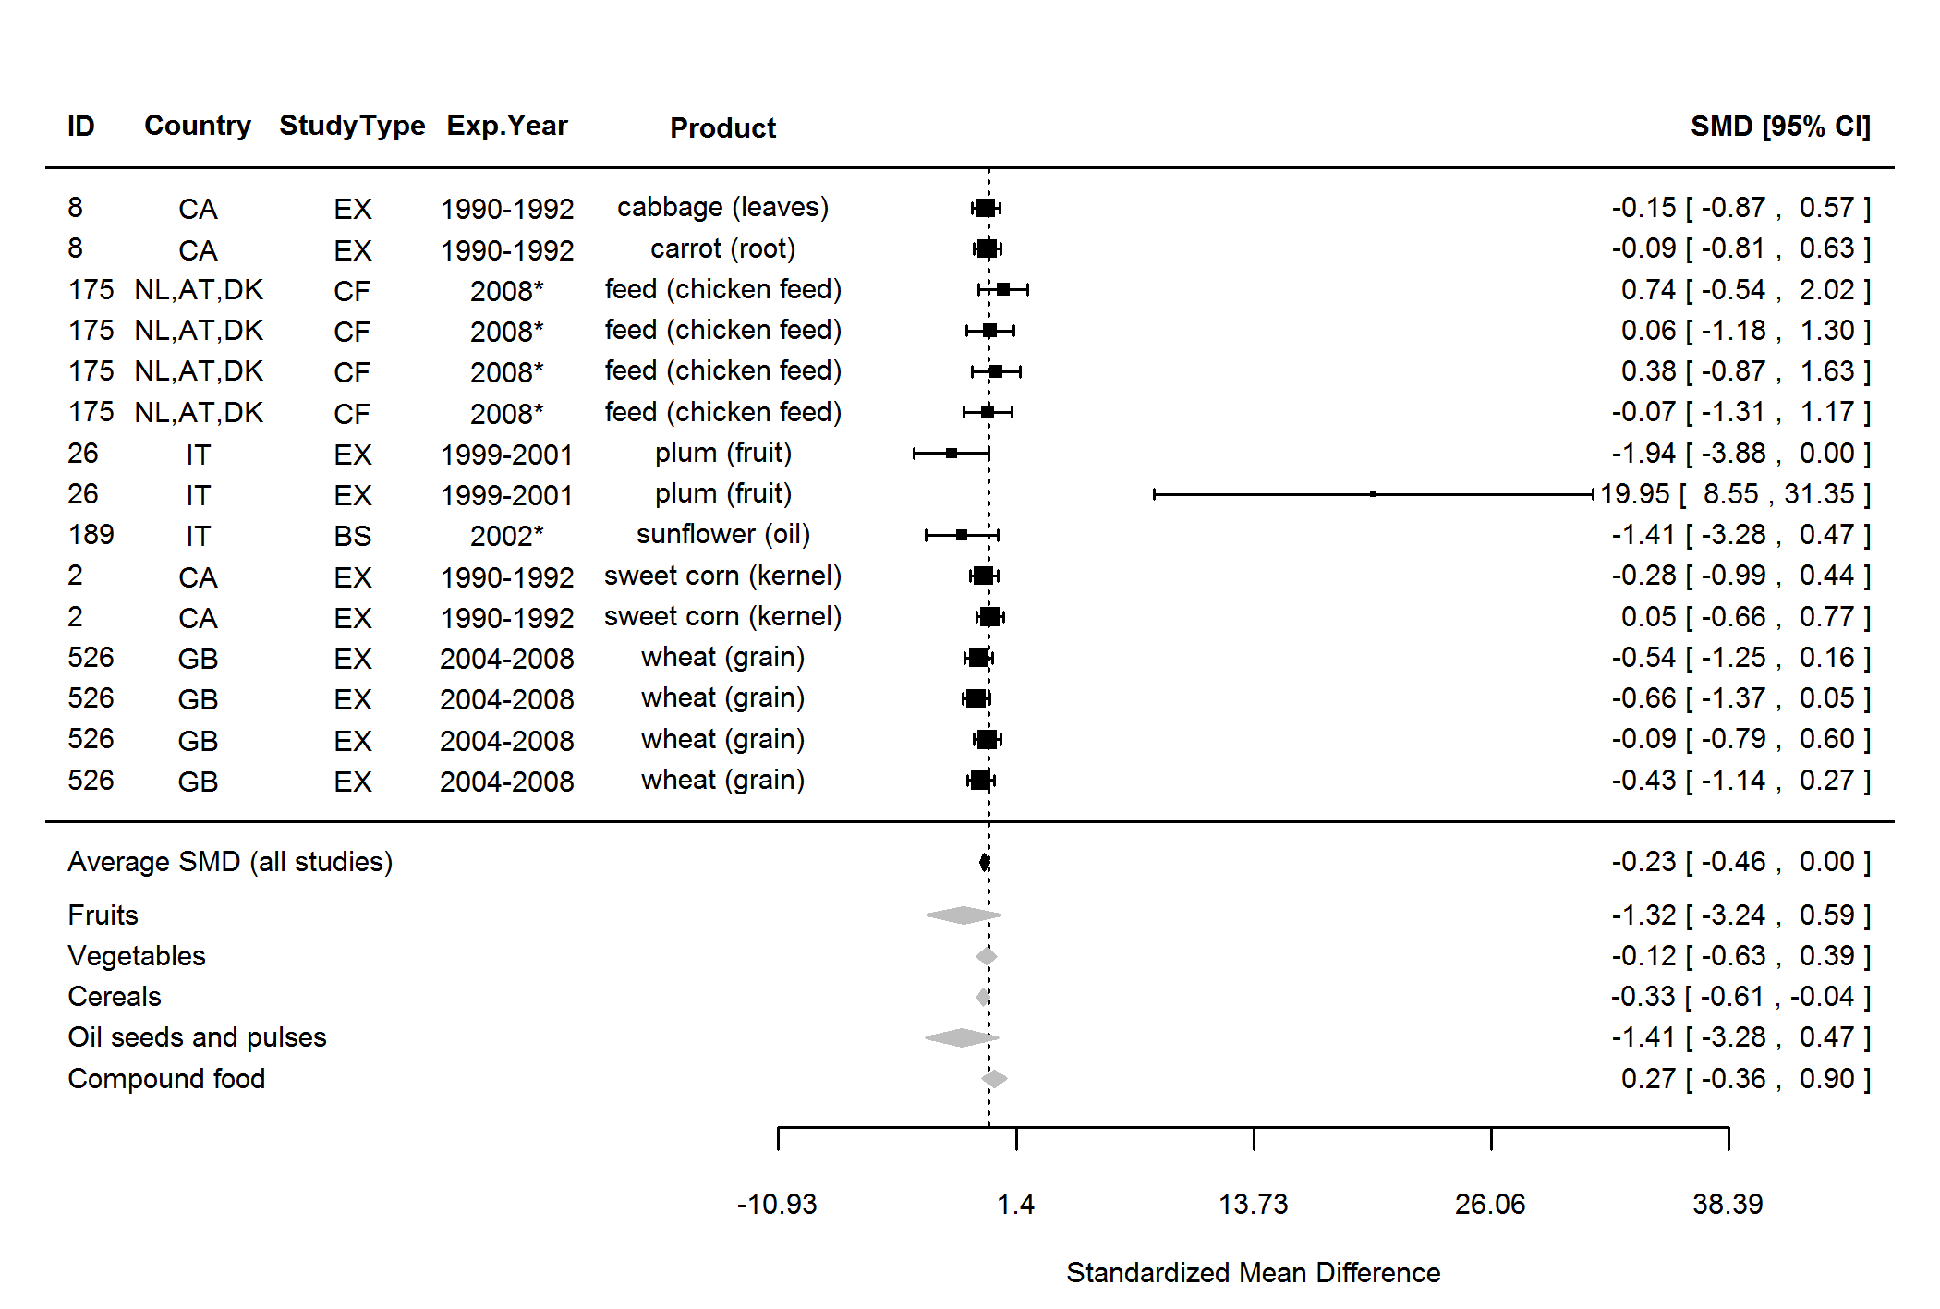

**Figure 30.** Forest plot showing the results of the comparison of vitamin E between organic and conventional plant foods using standardised mean differences (SMDs) with 95% confidence intervals (CI), for studies included in standard weighted meta-analysis. The estimated average SMD for all studies and SMDs for different product groups are indicated at the bottom of the figure. Sign of the SMD indicates if the analysed parameter is higher (+) or lower (-) in organic foods. ID, Paper unique identification number (see Table 2 for references). *No information about the experimental year (estimated as publication year - 2).

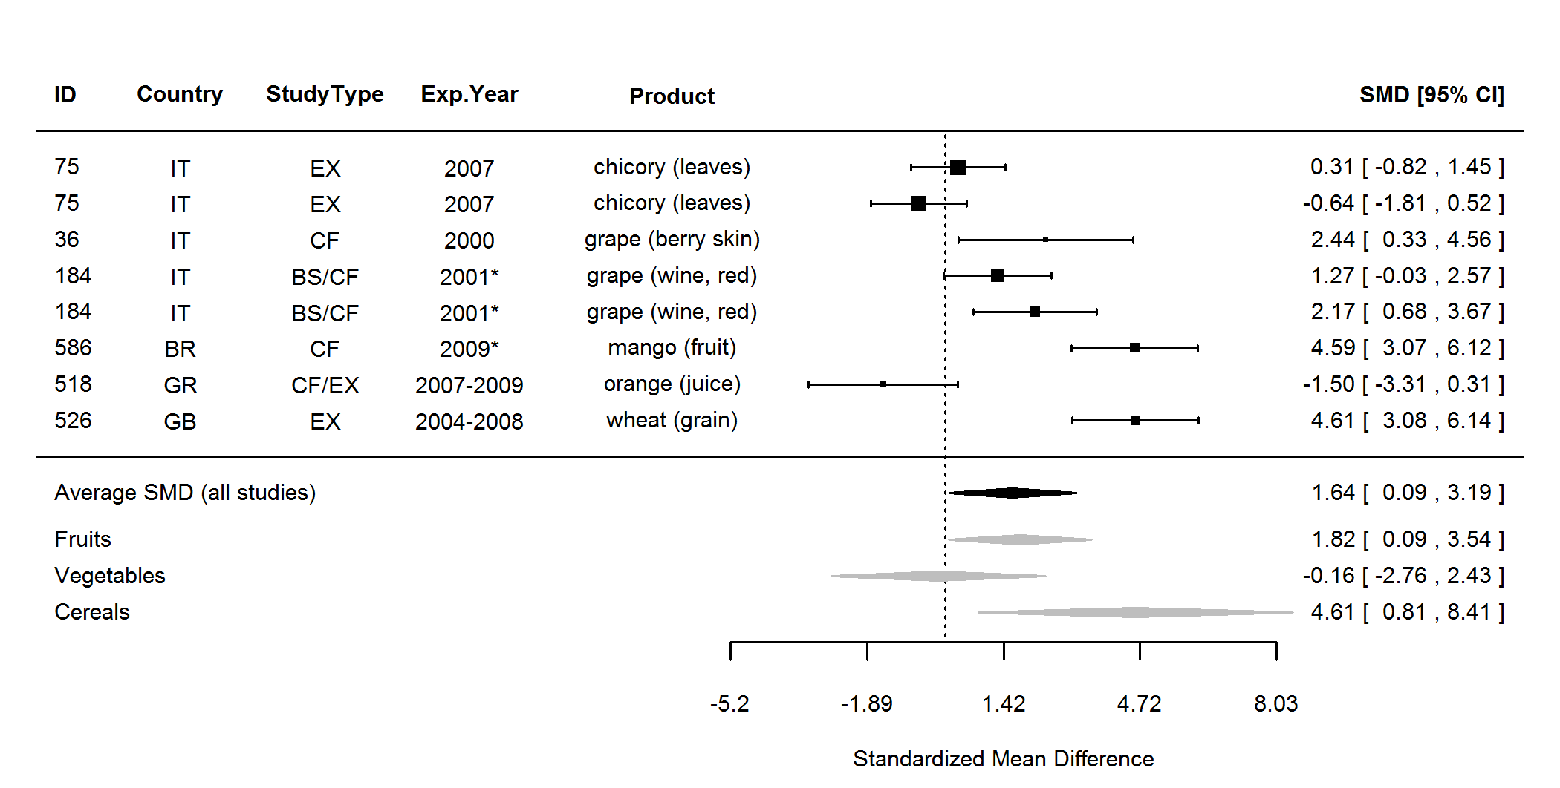

**Figure 31.** Forest plot showing the results of the comparison of flavonoids (total)between organic and conventional plant foods using standardised mean differences (SMDs) with 95% confidence intervals (CI), for studies included in standard weighted meta-analysis. The estimated average SMD for all studies and SMDs for different product groups are indicated at the bottom of the figure. Sign of the SMD indicates if the analysed parameter is higher (+) or lower (-) in organic foods. ID, Paper unique identification number (see Table 2 for references). *No information about the experimental year (estimated as publication year - 2).

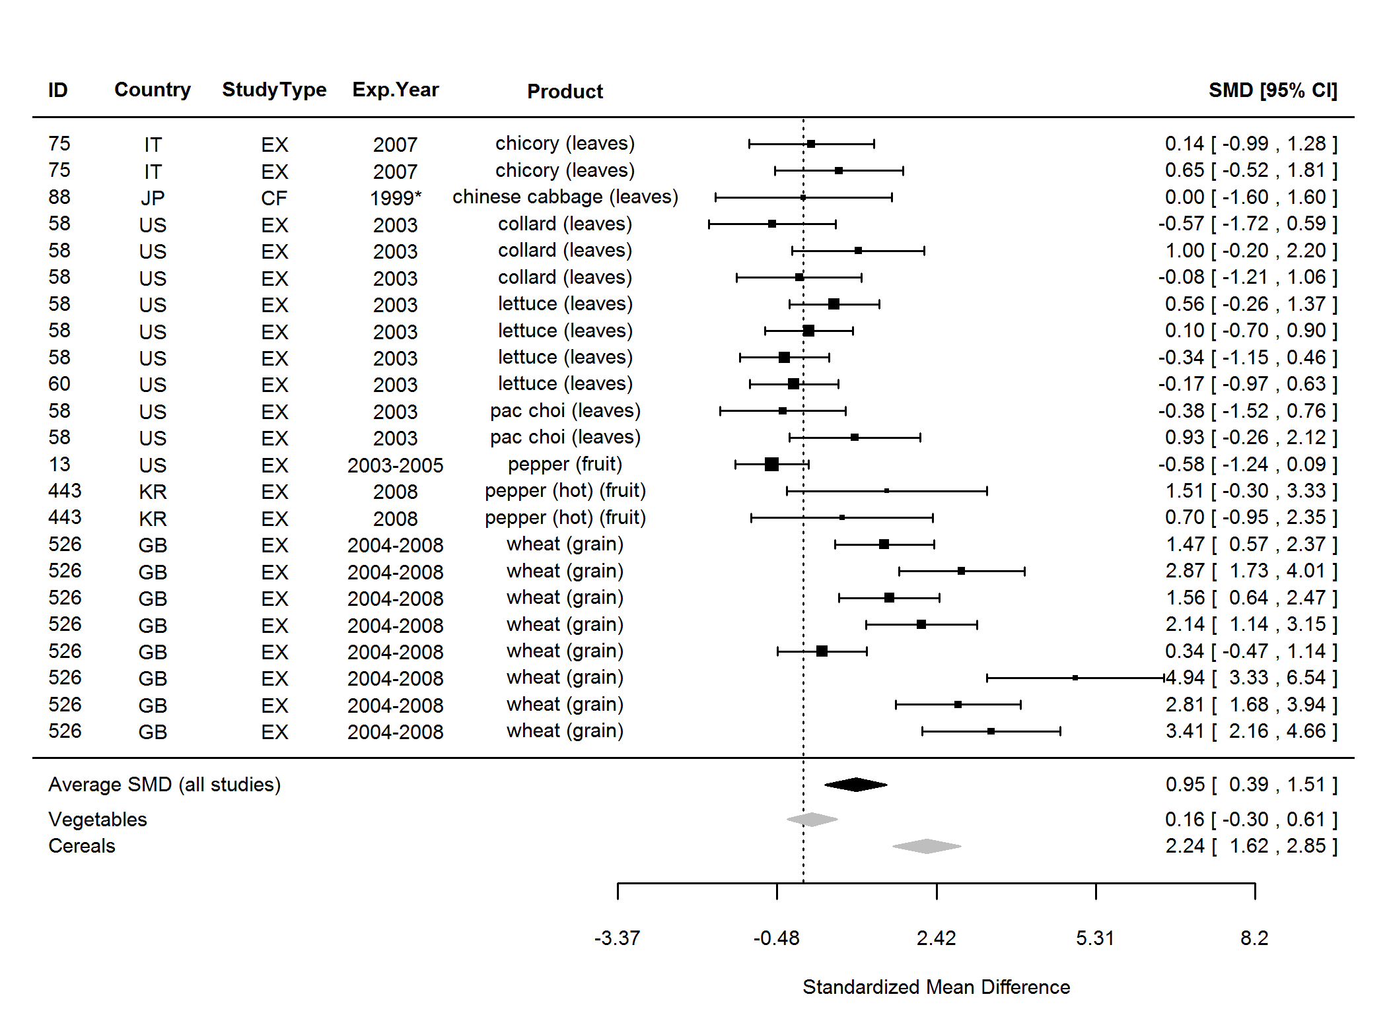

**Figure 32.** Forest plot showing the results of the comparison of flavones between organic and conventional plant foods using standardised mean differences (SMDs) with 95% confidence intervals (CI), for studies included in standard weighted meta-analysis. The estimated average SMD for all studies and SMDs for different product groups are indicated at the bottom of the figure. Sign of the SMD indicates if the analysed parameter is higher (+) or lower (-) in organic foods. ID, Paper unique identification number (see Table 2 for references). *No information about the experimental year (estimated as publication year - 2).

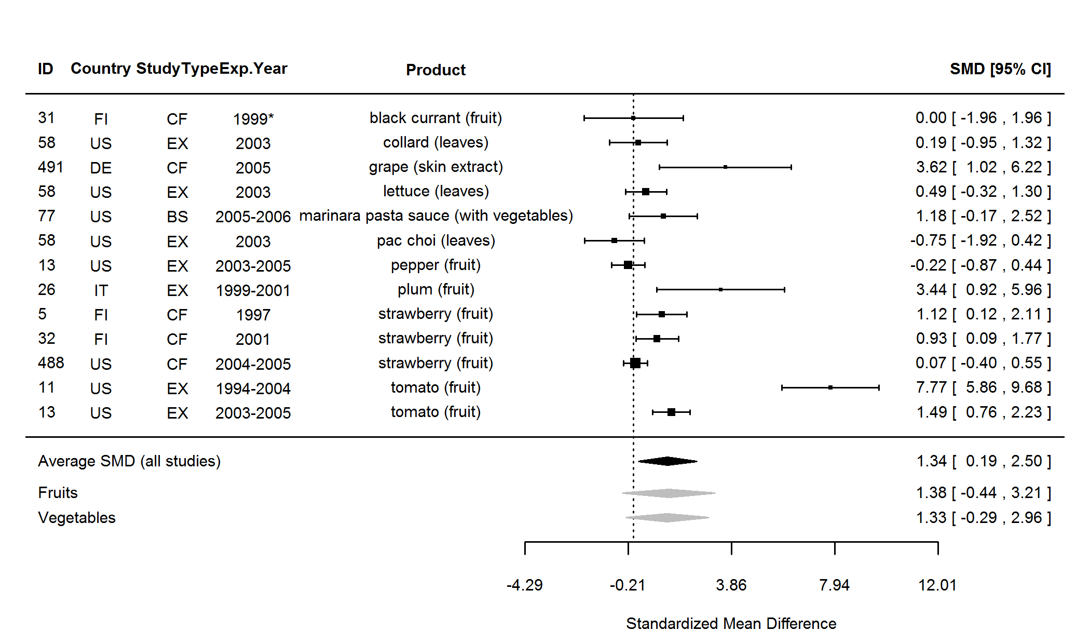

**Figure 33.** Forest plot showing the results of the comparison of kaempferol between organic and conventional plant foods using standardised mean differences (SMDs) with 95% confidence intervals (CI), for studies included in standard weighted meta-analysis. The estimated average SMD for all studies and SMDs for different product groups are indicated at the bottom of the figure. Sign of the SMD indicates if the analysed parameter is higher (+) or lower (-) in organic foods. ID, Paper unique identification number (see Table 2 for references). *No information about the experimental year (estimated as publication year - 2).

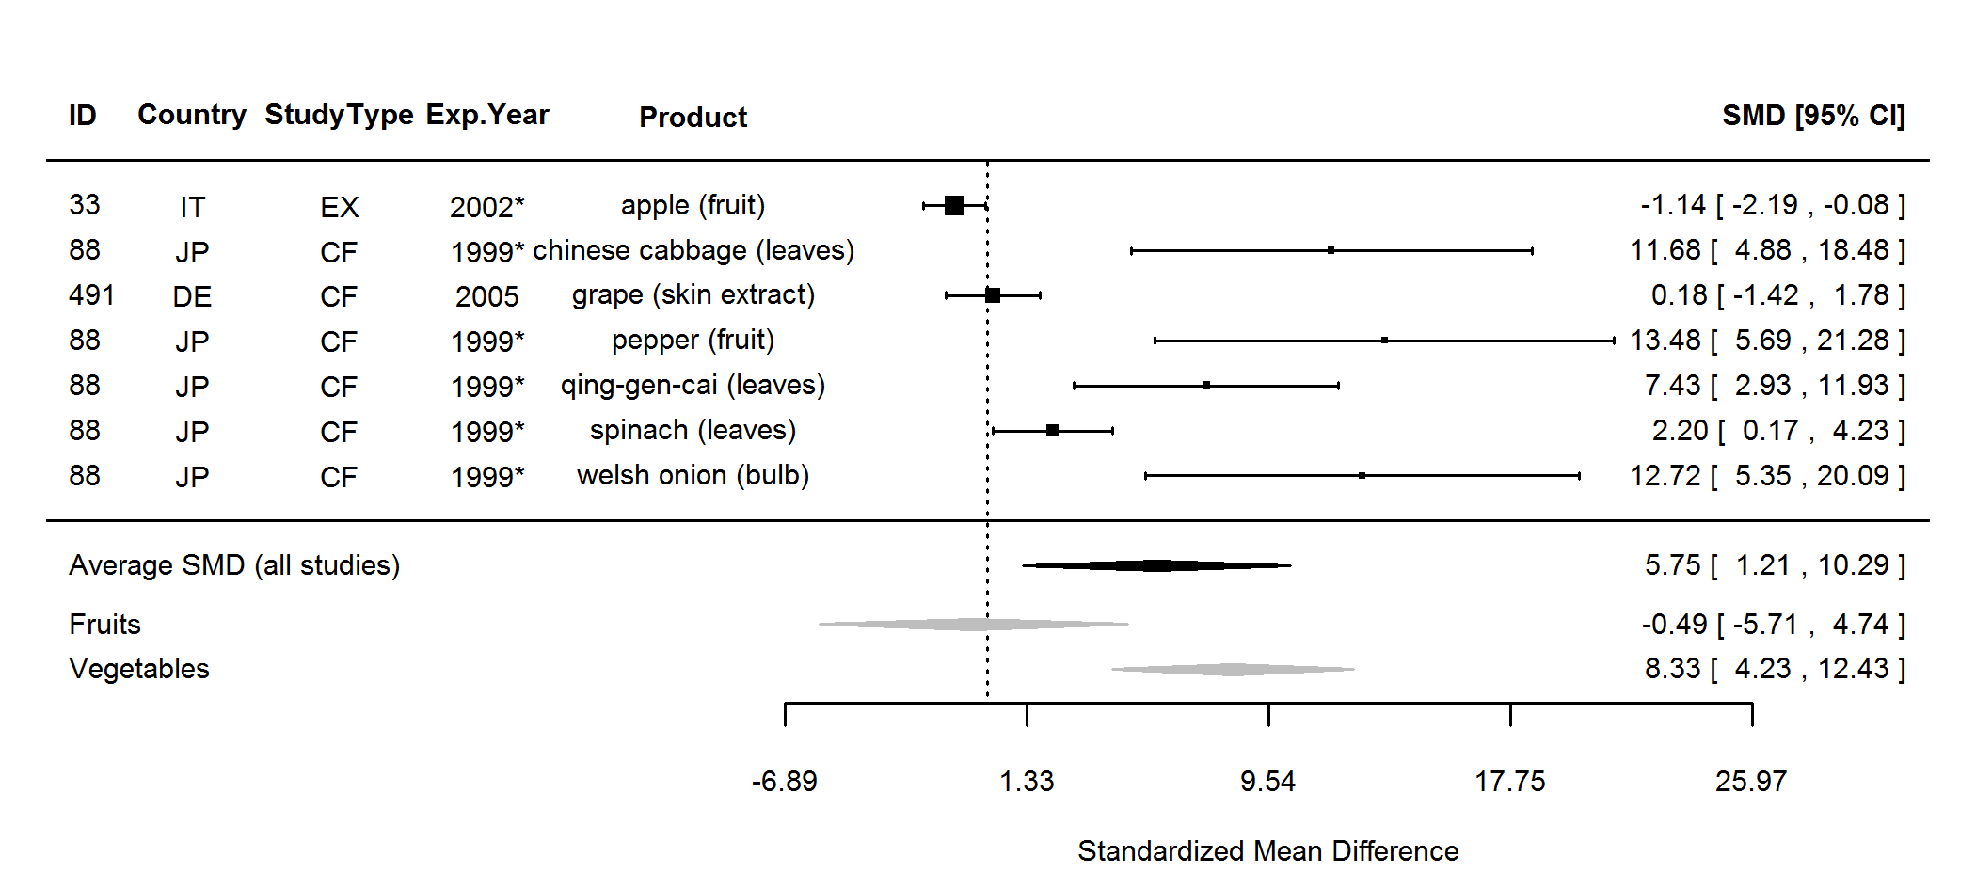

**Figure 34.** Forest plot showing the results of the comparison of quercetin 3-rhamnoside between organic and conventional plant foods using standardised mean differences (SMDs) with 95% confidence intervals (CI), for studies included in standard weighted meta-analysis. The estimated average SMD for all studies and SMDs for different product groups are indicated at the bottom of the figure. Sign of the SMD indicates if the analysed parameter is higher (+) or lower (-) in organic foods. ID, Paper unique identification number (see Table 2 for references). *No information about the experimental year (estimated as publication year - 2).

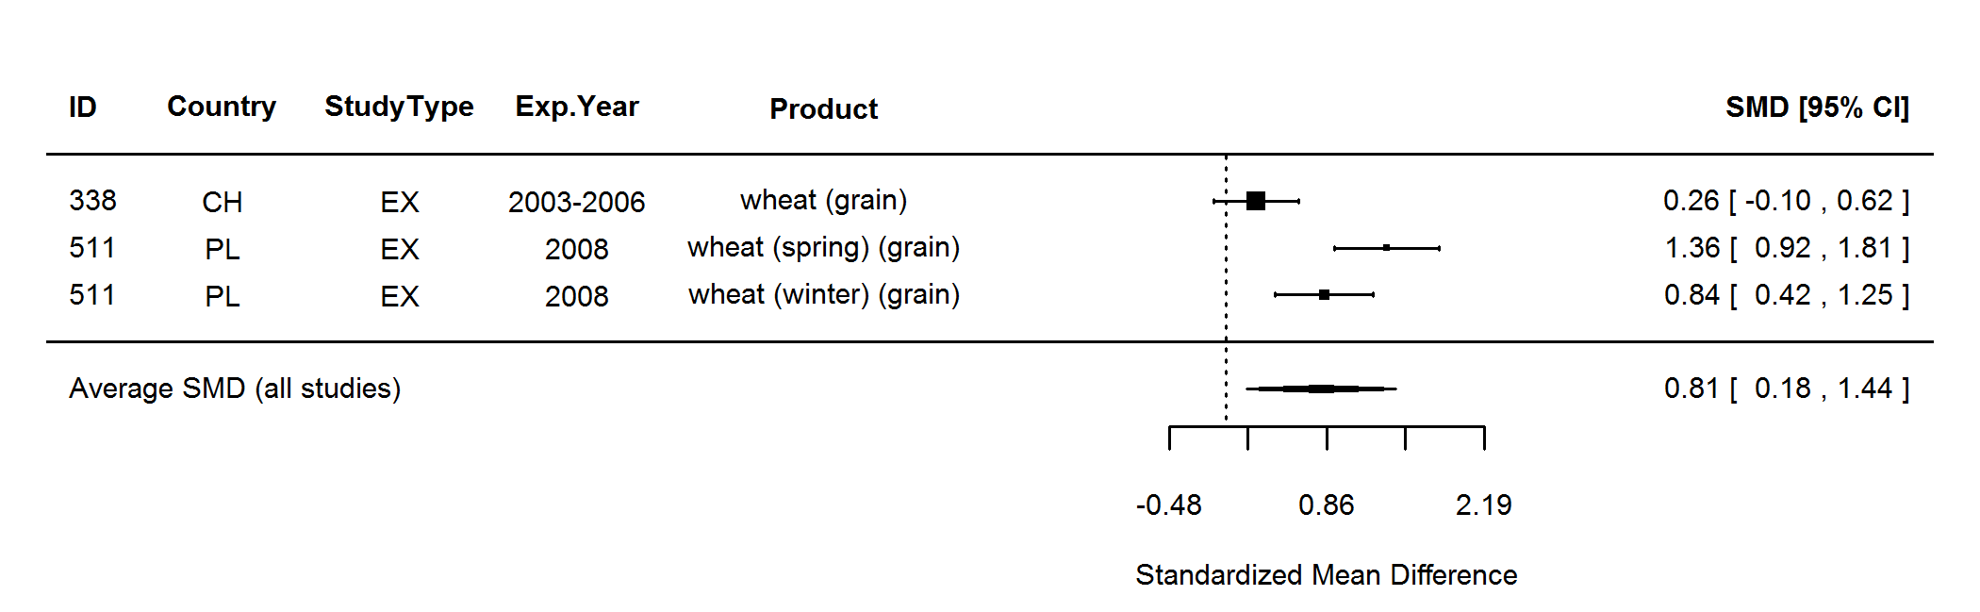

**Figure 35.** Forest plot showing the results of the comparison of phenolic acids (total) between organic and conventional plant foods using standardised mean differences (SMDs) with 95% confidence intervals (CI), for studies included in standard weighted meta-analysis. The estimated average SMD for all studies is indicated at the bottom of the figure. Sign of the SMD indicates if the analysed parameter is higher (+) or lower (-) in organic foods. ID, Paper unique identification number (see Table 2 for references).

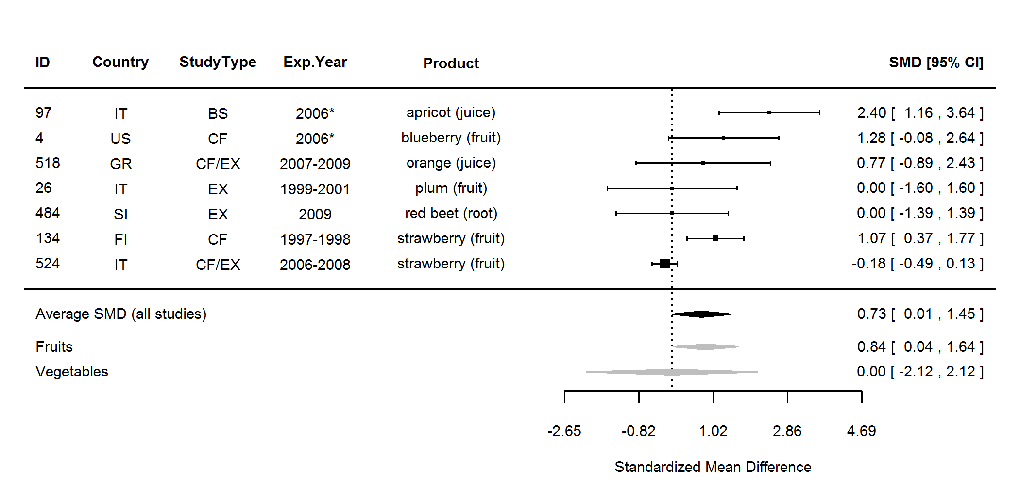

**Figure 36.** Forest plot showing the results of the comparison of malic acid between organic and conventional plant foods using standardised mean differences (SMDs) with 95% confidence intervals (CI), for studies included in standard weighted meta-analysis. The estimated average SMD for all studies and SMDs for different product groups are indicated at the bottom of the figure. Sign of the SMD indicates if the analysed parameter is higher (+) or lower (-) in organic foods. ID, Paper unique identification number (see Table 2 for references). *No information about the experimental year (estimated as publication year - 2).

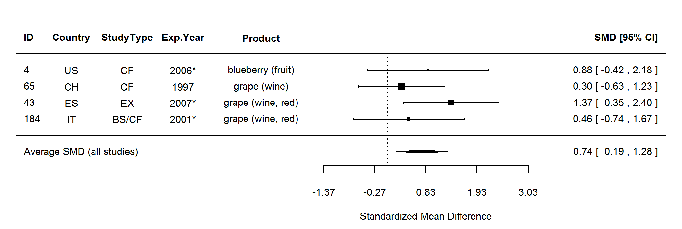

**Figure 37.** Forest plot showing the results of the comparison of stilbenes between organic and conventional plant foods using standardised mean differences (SMDs) with 95% confidence intervals (CI), for studies included in standard weighted meta-analysis. The estimated average SMD for all studies is indicated at the bottom of the figure. Sign of the SMD indicates if the analysed parameter is higher (+) or lower (-) in organic foods. ID, Paper unique identification number (see Table 2 for references). *No information about the experimental year (estimated as publication year - 2).

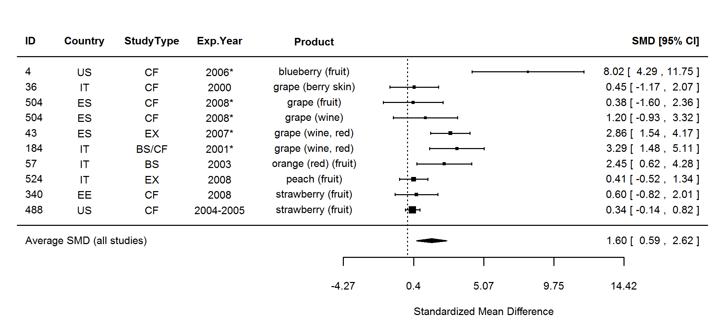

**Figure 38.** Forest plot showing the results of the comparison of other non-defense compounds (total) between organic and conventional plant foods using standardised mean differences (SMDs) with 95% confidence intervals (CI), for studies included in standard weighted meta-analysis. The estimated average SMD for all studies is indicated at the bottom of the figure. Sign of the SMD indicates if the analysed parameter is higher (+) or lower (-) in organic foods. ID, Paper unique identification number (see Table 2 for references). *No information about the experimental year (estimated as publication year - 2).

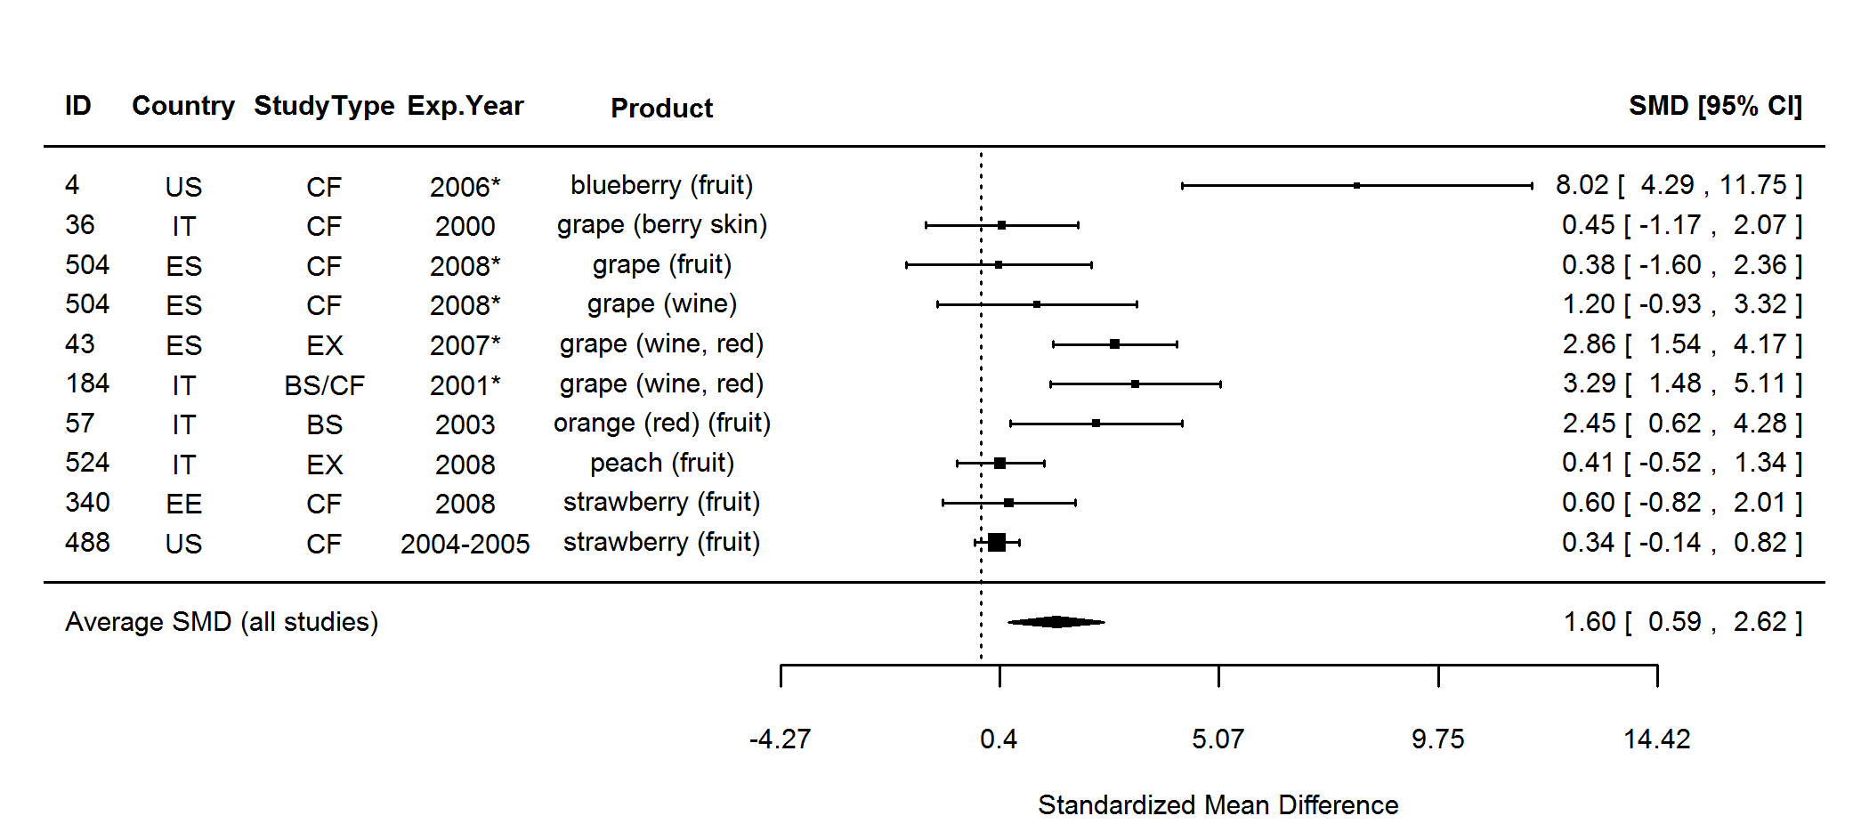

**Figure 39.** Forest plot showing the results of the comparison of anthocyanins (total) between organic and conventional plant foods using standardised mean differences (SMDs) with 95% confidence intervals (CI), for studies included in standard weighted meta-analysis. The estimated average SMD for all studies is indicated at the bottom of the figure. Sign of the SMD indicates if the analysed parameter is higher (+) or lower (-) in organic foods. ID, Paper unique identification number (see Table 2 for references). *No information about the experimental year (estimated as publication year - 2).

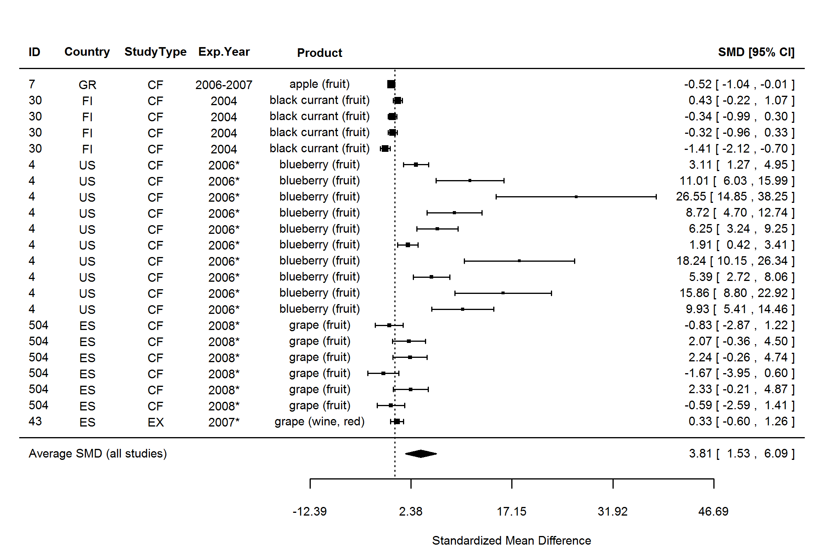

**Figure 40.** Forest plot showing the results of the comparison of anthocyanins between organic and conventional plant foods using standardised mean differences (SMDs) with 95% confidence intervals (CI), for studies included in standard weighted meta-analysis. The estimated average SMD for all studies is indicated at the bottom of the figure. Sign of the SMD indicates if the analysed parameter is higher (+) or lower (-) in organic foods. ID, Paper unique identification number (see Table 2 for references). *No information about the experimental year (estimated as publication year - 2).

P:\Quality of Organic Food (QOF)\Crops\MANUSCRIPT\suppl info fig 43.TIF

**Figure 41.** Results of the standard weighted meta-analysis comparing odds ratios with 95% confidence intervals for the frequency of pesticide residues in organic and conventional crops. A mixed-effect model with publication as moderator was used. OR, odds ratio for each product group (error bars indicate 95% confidence intervals); ORG, organic samples; CONV, conventional samples; *n*, number of data points included in meta-analyses. \**P* value <0.05 indicates a significant difference between ORG and CONV.

|  |  |  |  |  |  |  |  |  |  |
| --- | --- | --- | --- | --- | --- | --- | --- | --- | --- |
| **Table 12.** Results of the standard unweighted and weighted meta-analysis for parameters where none of the 8 meta-analysis protocols indentified significant effects. | | | | | | | | | |
|  | **Unweighted meta-analysis** | | |  | **Weighted meta-analysis** | | | | |
| **Parameter** | ***n*** | **Ln ratio\*** | ***P***† |  | ***n*** | **SMD** | **95% CI** | ***P***† | **Heterogeneity**‡ |
| Acidity (total) | 20 | 4.57 | 0.375 |  | 7 | -0.04 | -0.37, 0.30 | 0.835 | No (0%) |
| Acidity (volatile) | 4 | 4.75 | 0.254 |  | 3 | -0.54 | -2.03, 0.94 | 0.472 | Yes (66%) |
| Acids (total) | 5 | 4.55 | 0.402 |  | 3 | -1.46 | -6.46, 3.54 | 0.568 | Yes (92%) |
| Antioxidant activity (DPPH) | 46 | 4.62 | 0.391 |  | 23 | 0.79 | -0.95, 2.53 | 0.373 | Yes (94%) |
| Polyphenoloxidase (PPO) activity (towards caffeic acid) | 4 | 4.70 | 0.252 |  | 4 | 1.20 | -1.70, 4.10 | 0.417 | Yes (93%) |
| Phenolic compounds | 21 | 4.68 | 0.183 |  | 16 | -0.08 | -0.46, 0.29 | 0.663 | Yes (50%) |
| Hydroxycinnamic acids (total) | 7 | 4.49 | 0.173 |  | 4 | -1.03 | -2.78, 0.72 | 0.249 | Yes (87%) |
| Caffeic acid | 15 | 4.65 | 0.335 |  | 8 | 0.54 | -0.53, 1.61 | 0.326 | Yes (73%) |
| p-coumaric acid (pCA) | 11 | 4.67 | 0.365 |  | 5 | 0.21 | -2.37, 2.78 | 0.875 | Yes (99%) |
| Ferulic acid | 8 | 4.79 | 0.243 |  | 4 | 0.39 | -1.93, 2.70 | 0.743 | Yes (97%) |
| Sinapic acid (SA) | 5 | 4.67 | 0.442 |  | 3 | -0.74 | -1.74, 0.27 | 0.153 | Yes (88%) |
| 5-o-Caffeoylquinic acid (5-CQA) | 4 | 4.77 | 0.188 |  | 3 | 0.35 | -0.49, 1.18 | 0.412 | Yes (62%) |
| Ellagic acid | 5 | 4.81 | 0.063 |  | 4 | 1.93 | -1.31, 5.18 | 0.243 | Yes (97%) |
| Gallic acid | 8 | 4.83 | 0.070 |  | 5 | 0.07 | -0.52, 0.67 | 0.809 | Yes (51%) |
| Salicylic acid | 5 | 5.54 | 0.094 |  | 4 | 1.06 | -0.19, 2.32 | 0.095 | Yes (61%) |
| Apigenin | 6 | 4.63 | 0.476 |  | 5 | 0.14 | -0.47, 0.76 | 0.652 | No (23%) |
| Luteolin | 6 | 4.96 | 0.091 |  | 5 | 0.28 | -0.39, 0.95 | 0.413 | Yes (54%) |
| Myricetin 3-o-glucoside | 4 | 4.52 | 0.372 |  | 3 | 0.15 | -1.79, 2.09 | 0.879 | Yes (87%) |
| Quercetin 3-galactoside | 6 | 5.11 | 0.145 |  | 3 | 1.12 | -0.54, 2.78 | 0.184 | Yes (87%) |
| Quercetin 3-glucoside | 10 | 5.01 | 0.105 |  | 5 | 0.31 | -0.48, 1.10 | 0.446 | Yes (58%) |
| Quercetin malonylglucoside | 3 | 4.69 | 0.372 |  | 3 | 0.20 | -0.34, 0.75 | 0.462 | No (15%) |
| *n*, number of data points included in the comparison; SMD, standardised mean difference of fixed-effect model.*Ln ratio = Ln(ORG/CONV × 100%); †*P* value <0.05 indicates significance of the difference in composition between organic and conventional crop/crop based food; ‡Heterogeneity and the I2 Statistic. | | | | | | | | | |

|  |  |  |  |  |  |  |  |  |  |
| --- | --- | --- | --- | --- | --- | --- | --- | --- | --- |
| **Table 12 cont.** Results of the standard unweighted and weighted meta-analysis for parameters where none of the 8 meta-analysis protocols indentified significant effects. | | | | | | | | | |
|  | **Unweighted meta-analysis** | | |  | **Weighted meta-analysis** | | | | |
| **Parameter** | ***n*** | **Ln ratio\*** | ***P***† |  | ***n*** | **SMD** | **95% CI** | ***P***† | **Heterogeneity**‡ |
| Flavanols (total) | 7 | 4.59 | 0.437 |  | 3 | -0.58 | -2.05, 0.89 | 0.441 | Yes (86%) |
| Flavanols | 28 | 4.61 | 0.494 |  | 15 | -0.15 | -0.91, 0.61 | 0.693 | Yes (94%) |
| Naringenin | 6 | 4.67 | 0.384 |  | 4 | 1.41 | -1.54, 4.35 | 0.349 | Yes (96%) |
| Naringenin (R-enantomer) | 5 | 4.67 | 0.344 |  | 5 | 1.55 | -2.17, 5.28 | 0.413 | Yes (96%) |
| Chalcones | 21 | 4.57 | 0.500 |  | 13 | 0.28 | -0.26, 0.83 | 0.302 | Yes (87%) |
| Dihydrochalcones | 4 | 4.64 | 0.305 |  | 3 | -0.08 | -1.00, 0.84 | 0.866 | Yes (67%) |
| Phloridzin | 7 | 4.79 | 0.200 |  | 4 | 0.09 | -1.16, 1.35 | 0.883 | Yes (94%) |
| Procyanidins | 16 | 4.45 | 0.144 |  | 5 | -2.04 | -4.43, 0.36 | 0.096 | Yes (97%) |
| Glucosinolates | 30 | 4.59 | 0.437 |  | 18 | 0.21 | -0.31, 0.74 | 0.427 | Yes (93%) |
| Glucoraphanin | 4 | 4.69 | 0.193 |  | 3 | 0.20 | -0.28, 0.68 | 0.403 | Yes (39%) |
| Alpha-carotene | 6 | 4.74 | 0.189 |  | 4 | 0.14 | -0.83, 1.12 | 0.773 | Yes (77%) |
| Lycopene | 27 | 4.68 | 0.338 |  | 14 | 0.30 | -0.18, 0.78 | 0.217 | Yes (79%) |
| Beta-cryptoxanthin | 6 | 4.60 | 0.488 |  | 3 | 2.08 | -3.46, 7.61 | 0.462 | Yes (98%) |
| Zeaxanthin | 14 | 4.29 | 0.164 |  | 11 | -0.05 | -1.09, 0.99 | 0.927 | Yes (94%) |
| Dehydroascorbic acid | 7 | 4.16 | 0.134 |  | 6 | -0.60 | -1.71, 0.50 | 0.282 | Yes (92%) |
| Alpha-tocopherol | 12 | 4.50 | 0.240 |  | 7 | -0.28 | -0.62, 0.05 | 0.095 | No (0%) |
| Gamma-tocopherol | 6 | 4.61 | 0.467 |  | 3 | 5.39 | -6.24, 17.03 | 0.363 | Yes (99%) |
| Vitamin B | 13 | 4.76 | 0.072 |  | 9 | 0.54 | -0.22, 1.30 | 0.161 | Yes (73%) |
| Vitamin B1 | 4 | 4.76 | 0.252 |  | 3 | 0.45 | -0.39, 1.28 | 0.296 | Yes (50%) |
| Glucose | 19 | 4.65 | 0.263 |  | 11 | 0.77 | -0.53, 2.08 | 0.243 | Yes (95%) |
| Sucrose | 18 | 4.72 | 0.091 |  | 11 | 0.06 | -0.24, 0.37 | 0.685 | Yes (31%) |
| Fibre (soluble) | 4 | 4.56 | 0.061 |  | 4 | -0.55 | -1.10, 0.01 | 0.054 | No (0%) |
| Fibre (insoluble) | 5 | 4.60 | 0.443 |  | 5 | -0.26 | -0.97, 0.44 | 0.466 | Yes (57%) |
| *n*, number of data points included in the comparison; SMD, standardised mean difference of fixed-effect model.*Ln ratio = Ln(ORG/CONV × 100%); †*P* value <0.05 indicates significance of the difference in composition between organic and conventional crop/crop based food; ‡Heterogeneity and the I2 Statistic. | | | | | | | | | |

|  |  |  |  |  |  |  |  |  |  |
| --- | --- | --- | --- | --- | --- | --- | --- | --- | --- |
| **Table 12 cont.** Results of the standard unweighted and weighted meta-analysis for parameters where none of the 8 meta-analysis protocols indentified significant effects. | | | | | | | | | |
|  | **Unweighted meta-analysis** | | |  | **Weighted meta-analysis** | | | | |
| **Parameter** | ***n*** | **Ln ratio\*** | ***P***† |  | ***n*** | **SMD** | **95% CI** | ***P***† | **Heterogeneity**‡ |
| Asparagine (ASP) | 14 | 4.62 | 0.374 |  | 5 | -0.39 | -2.43, 1.65 | 0.709 | Yes (92%) |
| Aspartic acid | 10 | 4.57 | 0.240 |  | 5 | -0.38 | -1.40, 0.64 | 0.465 | Yes (85%) |
| Glutamine (Gln) | 11 | 4.64 | 0.407 |  | 4 | -0.71 | -1.75, 0.32 | 0.177 | Yes (86%) |
| Glycine (GLY) | 17 | 4.62 | 0.383 |  | 5 | -0.57 | -2.51, 1.37 | 0.566 | Yes (92%) |
| Serine (SER) | 18 | 4.59 | 0.280 |  | 6 | -0.63 | -1.64, 0.38 | 0.220 | Yes (81%) |
| Energy | 6 | 4.63 | 0.286 |  | 4 | 1.44 | -1.70, 4.58 | 0.370 | Yes (96%) |
| Fat | 23 | 4.63 | 0.235 |  | 10 | 0.39 | -0.67, 1.46 | 0.472 | Yes (92%) |
| Fatty acids | 94 | 4.55 | 0.115 |  | 60 | 0.00 | -0.22, 0.22 | 0.998 | Yes (49%) |
| Saturated fatty acids | 37 | 4.61 | 0.484 |  | 24 | 0.06 | -0.23, 0.35 | 0.681 | No (23%) |
| Saturated fatty acids (total) | 6 | 4.71 | 0.157 |  | 5 | 0.72 | -0.71, 2.15 | 0.323 | Yes (81%) |
| 16.0 fatty acid (palmitic acid) | 12 | 4.63 | 0.356 |  | 7 | 0.07 | -0.54, 0.69 | 0.817 | Yes (43%) |
| 18.0 fatty acid (stearic acid) | 12 | 4.70 | 0.291 |  | 8 | -0.08 | -0.96, 0.81 | 0.867 | Yes (72%) |
| 20.0 fatty acid (arachidic acid) | 7 | 4.58 | 0.358 |  | 5 | 0.00 | -0.46, 0.46 | 0.991 | No (0%) |
| 18.1 fatty acid (oleic acid) | 9 | 4.59 | 0.462 |  | 7 | -0.07 | -0.47, 0.33 | 0.725 | No (0%) |
| Polyunsaturated fatty acids | 32 | 4.66 | 0.193 |  | 23 | 0.10 | -0.33, 0.54 | 0.639 | Yes (68%) |
| 18.2 fatty acid (linoleic acid) | 11 | 4.56 | 0.319 |  | 8 | -0.11 | -0.91, 0.69 | 0.782 | Yes (67%) |
| 18.3 fatty acid (linolenic acid) | 9 | 4.74 | 0.139 |  | 5 | 0.17 | -1.00, 1.33 | 0.779 | Yes (79%) |
| *n*, number of data points included in the comparison; SMD, standardised mean difference of fixed-effect model.*Ln ratio = Ln(ORG/CONV × 100%); †*P* value <0.05 indicates significance of the difference in composition between organic and conventional crop/crop based food; ‡Heterogeneity and the I2 Statistic. | | | | | | | | | |

|  |  |  |  |  |  |  |  |  |  |
| --- | --- | --- | --- | --- | --- | --- | --- | --- | --- |
| **Table 12 cont.** Results of the standard unweighted and weighted meta-analysis for parameters where none of the 8 meta-analysis protocols indentified significant effects. | | | | | | | | | |
|  | **Unweighted meta-analysis** | | |  | **Weighted meta-analysis** | | | | |
| **Parameter** | ***n*** | **Ln ratio\*** | ***P***† |  | ***n*** | **SMD** | **95% CI** | ***P***† | **Heterogeneity**‡ |
| Aluminium (Al) | 10 | 4.64 | 0.336 |  | 4 | -0.02 | -0.59, 0.55 | 0.953 | Yes (83%) |
| Arsenic (As) | 3 | 4.52 | 0.374 |  | 3 | -40.77 | -108.34, 26.8 | 0.237 | Yes (100%) |
| Barium (Ba) | 13 | 4.53 | 0.121 |  | 6 | -0.05 | -0.24, 0.14 | 0.629 | No (0%) |
| Boron (B) | 25 | 4.66 | 0.314 |  | 11 | 1.20 | -1.72, 4.12 | 0.422 | Yes (100%) |
| Bromine (Br) | 6 | 4.97 | 0.222 |  | 5 | 0.91 | -0.72, 2.54 | 0.274 | Yes (85%) |
| Calcium (Ca) | 110 | 4.62 | 0.236 |  | 41 | 0.11 | -0.14, 0.35 | 0.390 | Yes (83%) |
| Carbon (C) | 8 | 4.60 | 0.395 |  | 5 | -0.08 | -0.56, 0.40 | 0.756 | No (0%) |
| Cerium (Ce) | 3 | 4.28 | 0.374 |  | 3 | -0.57 | -1.22, 0.09 | 0.091 | Yes (27%) |
| Chloride (Cl) | 6 | 4.48 | 0.062 |  | 5 | -0.42 | -1.10, 0.27 | 0.231 | No (0%) |
| Cobalt (Co) | 22 | 4.60 | 0.505 |  | 10 | -0.01 | -0.74, 0.72 | 0.978 | Yes (93%) |
| Copper (Cu) | 74 | 4.59 | 0.379 |  | 28 | -0.07 | -0.40, 0.26 | 0.672 | Yes (86%) |
| Iron (Fe) | 79 | 4.61 | 0.465 |  | 30 | -0.18 | -0.59, 0.22 | 0.379 | Yes (93%) |
| Lanthanum (La) | 3 | 4.73 | 0.369 |  | 3 | 0.28 | -0.72, 1.27 | 0.586 | Yes (96%) |
| Lead (Pb) | 34 | 4.58 | 0.432 |  | 16 | 0.38 | -7.42, 8.18 | 0.924 | Yes (100%) |
| Rhenium (Re) | 3 | 4.05 | 0.375 |  | 3 | 0.28 | -2.50, 3.06 | 0.843 | Yes (99%) |
| Sodium (Na) | 58 | 4.65 | 0.130 |  | 21 | 0.18 | -0.27, 0.62 | 0.443 | Yes (91%) |
| Sulphur (S) | 29 | 4.59 | 0.364 |  | 14 | -0.46 | -1.16, 0.24 | 0.197 | Yes (91%) |
| Thallium (Tl) | 4 | 4.68 | 0.250 |  | 4 | 0.62 | -1.28, 2.53 | 0.519 | Yes (98%) |
| Tin (Sn) | 3 | 4.40 | 0.252 |  | 3 | -11.43 | -29.58, 6.73 | 0.217 | Yes (100%) |
| Wolfram (W) | 5 | 4.97 | 0.092 |  | 5 | 0.27 | -0.03, 0.57 | 0.079 | No (0%) |
| *n*, number of data points included in the comparison; SMD, standardised mean difference of fixed-effect model.*Ln ratio = Ln(ORG/CONV × 100%); †*P* value <0.05 indicates significance of the difference in composition between organic and conventional crop/crop based food; ‡Heterogeneity and the I2 Statistic. | | | | | | | | | |

|  |  |  |  |  |  |  |  |  |
| --- | --- | --- | --- | --- | --- | --- | --- | --- |
| **Table 13.** Results of the statistical test for publication bias reported in Fig. 3 of the main paper. | | | | | | | | |
|  | **Trim and fill test\*** | |  | **No of missing *n* in Rosenthal’s Fail-safe N test**† |  | **No of missing *n* in Orwin’s Fail-safe N test**‡ |  | ***P* from Egger’s test for funnel plot asymetry**§ |
| **Parameter** | **No of missing *n*** | **funnel plot side** |  |  |  |
| **Antioxidant activity** | 0 | left |  | 1549 |  | 66 |  | 0.386 |
| FRAP | 2 | right |  | 24 |  | 5 |  | 0.069 |
| ORAC | 0 | left |  | 21 |  | 4 |  | 0.003 |
| TEAC | 1 | left |  | 17 |  | 7 |  | 0.180 |
| **Phenolic compounds (total)** | 0 | left |  | 615 |  | 58 |  | <0.001 |
| ***Flavonoids (total)*** | 0 | left |  | 95 |  | 8 |  | 0.597 |
| ***Phenolic acids (total)*** | 2 | left |  | 45 |  | 3 |  | <0.001 |
| Phenolic acids|| | 0 | left |  | 1601 |  | 89 |  | <0.001 |
| Chlorogenic acid | 0 | left |  | 149 |  | 14 |  | <0.001 |
| Flavanones|| | 0 | left |  | 457 |  | 54 |  | <0.001 |
| Stilbenes | 0 | left |  | 7 |  | 4 |  | 0.827 |
| ***Flavones and flavonols*** | 0 | left |  | 23198 |  | 134 |  | <0.001 |
| Flavones | 0 | left |  | 471 |  | 23 |  | 0.040 |
| Flavonols|| | 0 | left |  | 16927 |  | 111 |  | <0.001 |
| Quercetin | 5 | right |  | 54 |  | 17 |  | 0.426 |
| Rutin | 3 | right |  | 170 |  | 9 |  | 0.668 |
| Kaempferol | 0 | left |  | 189 |  | 13 |  | 0.010 |
| ***Anthocyanins (total)*** | 0 | left |  | 134 |  | 10 |  | 0.004 |
| Anthocyanins | 0 | left |  | 471 |  | 22 |  | <0.001 |
| **Carotenoids (total)** | 0 | left |  | 93 |  | 4 |  | <0.001 |
| Carotenoids|| | 0 | left |  | 1616 |  | 82 |  | 0.246 |
| *The method used to estimate the number of data points missing from a meta-analysis due to the suppression of the most extreme results on one side of the funnel plot; †Number of missing data points that need to be retrived and incorporate in the meta-analysis before the results become nonsignificant; ‡Number of missing data point that need to be retrived and incorporate in the meta-analysis before the estimated value of the standardised mean (SMD) difference reaches a specified level (here SMD/2); §*P* value <0.05 indicates funnel plot asymmetry; ||Outlying data-pairs for which the mean percentage difference between organic and conventional samples was over 50 times higher than the mean value including outliers were removed. | | | | | | | | |

|  |  |  |  |  |  |  |  |  |
| --- | --- | --- | --- | --- | --- | --- | --- | --- |
| **Table 13 cont.** Results of the statistical test for publication bias reported in Fig. 3 of the main paper. | | | | | | | | |
|  | **Trim and fill test\*** | |  | **No of missing *n* in Rosenthal’s Fail-safe N test**† |  | **No of missing *n* in Orwin’s Fail-safe N test**‡ |  | ***P* from Egger’s test for funnel plot asymetry**§ |
| **Parameter** | **No of missing *n*** | **funnel plot side** |  |  |  |
| ***Xanthophylls***|| | 0 | left |  | 1064 |  | 33 |  | 0.001 |
| Lutein | 4 | right |  | 83 |  | 13 |  | 0.603 |
| Ascorbic acid | 0 | left |  | 307 |  | 30 |  | 0.745 |
| Vitamin E | 1 | left |  | 0 |  | 15 |  | 0.058 |
| **Carbohydrates (total)** | 0 | left |  | 392 |  | 16 |  | 0.001 |
| Carbohydrates|| | 0 | left |  | 313 |  | 53 |  | <0.001 |
| Sugars (reducing) | 2 | left |  | 0 |  | 3 |  | 0.287 |
| **Protein (total)** | 0 | right |  | 1913 |  | 26 |  | <0.001 |
| Amino acids|| | 26 | right |  | 9089 |  | 117 |  | 0.001 |
| Dry matter|| | 0 | left |  | 212 |  | 24 |  | <0.001 |
| Fibre | 0 | right |  | 41 |  | 15 |  | 0.012 |
| **Nitrogen (N)** | 0 | right |  | 861 |  | 35 |  | 0.004 |
| Nitrate|| | 0 | right |  | 243 |  | 29 |  | 0.001 |
| Nitrite | 1 | right |  | 0 |  | 7 |  | 0.603 |
| **Cadmium (Cd)** | 0 | right |  | 996 |  | 25 |  | <0.001 |
| *The method used to estimate the number of data points missing from a meta-analysis due to the suppression of the most extreme results on one side of the funnel plot; †Number of missing data points that need to be retrived and incorporate in the meta-analysis before the results become nonsignificant; ‡Number of missing data point that need to be retrived and incorporate in the meta-analysis before the estimated value of the standardised mean (SMD) difference reaches a specified level (here SMD/2); §*P* value <0.05 indicates funnel plot asymmetry; ||Outlying data-pairs for which the mean percentage difference between organic and conventional samples was over 50 times higher than the mean value including outliers were removed. | | | | | | | | |