**Sprint Plan 2:**

**Heading:**

* Document name: "Sprint 2 Plan"
* Product name: Sandwich Story
* Team name: “The Sandwich Guys”
* Sprint Completion date: July 17th, 2017
* Revision number: Revision 1
* Revision date:July 10th, 2017

**Goal:**

1. Ability to both download and upload sandwiches to the database (the library activity)

**Task listing, organized by user story:**

* User Story 1: As a user, I would like to be able to share my recipes so I can show my creativity with other users.
  + Task 1 description: Make a dialog for uploading user data to database when saving recipes (1.5 ideal hours)
  + Task 2 description: Add to the save functions to upload to the database, calling JSON code (5 ideal hours)

**Total for user story 1: 6.5 ideal hours**

* User Story 2: As a user, I would like to be able to add other user created recipes to my list so that I have quick access to good recipes besides the ones I have created.
  + Task 1 description: Creating a front-end function which will request the specific information from the server (5 ideal hours)
  + Task 2 description: Implementing local storage functionality so the requested information from the database is correctly stored locally (5 ideal hours)
  + Task 3 description: Updating the sandwich list so that the contents are displayed on the view on the main activity (6 ideal hours)

**Total for user story 2: 16 ideal hours**

* User story 3: As a user, I would like to be able to add the most popular recipes to my list of recipes so that I can store and have quick access to the best recipes.
  + Task 1 description: Creating a front-end function which will send the information to the server (5 ideal hours)
  + Task 2 description: Implementing local storage functionality so the requested information from the database is correctly stored locally (5 ideal hours)
  + Task 3 description: Updating the sandwich list so that the contents are displayed on the view on the main activity (6 ideal hours)
  + Task 4 description: creating a way for the application to recognize what sandwiches are the most popular (2 ideal hours)

**Total for user story 3: 18 ideal hours**

* User Story 4: As a user, I would like to be able to add traditional recipes to my list of recipes so that I can store my favorite recipes from around the world.
  + Task 1 description: Creating a front-end function which will send the information to the server (5 ideal hours)
  + Task 2 description: Implementing local storage functionality so the requested information from the database is correctly stored locally (5 ideal hours)
  + Task 3 description: Updating the sandwich list so that the contents are displayed on the view on the main activity (6 ideal hours)
  + Task 4 description: Creating a list of traditional sandwiches to choose from (4 ideal hours)
  + Task 5 description: Write the backend code for parsing the text file that will be used for task 4 (6 ideal hours)

**Total for user story 4: 26 ideal hours**

**Team Roles:**

Alex Williamson - Product Owner, Front-End Developer, Backend Developer

David Stewart - Scrum Master, Front-End Developer, Backend Developer

Chris Hahn - Front-End Developer, Backend Developer

Celine Peña - Front-End Developer

Davie Truong - Scrum Master, Front-End Developer

Matthew Diep - Front-End Developer

**Initial Task assignment:**

Alex Williamson - User Story 1: Task 1

David Stewart - User Story 1: Task 1

Chris Hahn - User Story 1: Task 2

Celine Peña - User Story 2: Task 1

Davie Truong - User Story 3: Task 1

Matthew Diep - User Story 4: Task 1

**Initial Burnup chart:**

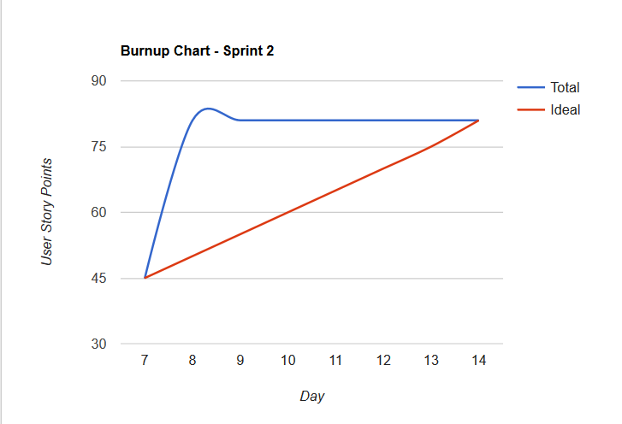

**Initial scrum board:**

http://scrumblr.ca/SandwichGUys_sprint2

**Scrum times:**

* Tuesday 12:30-4:30pm
* Thursday 12:30-4:30pm
* Sunday 2:30-10:30pm