

Assignment 1- Group 29

COMP353 – Databases

Mair Elbaz, 40004558

Daniel Vigny-Pau, 40034769

Francois David, 40046319

Alexandre Therrien, 40057134

Charles-Antoine Guite, 40063098

Professor: Dr. Desai

Fall 2019

Concordia University

**Question 1**

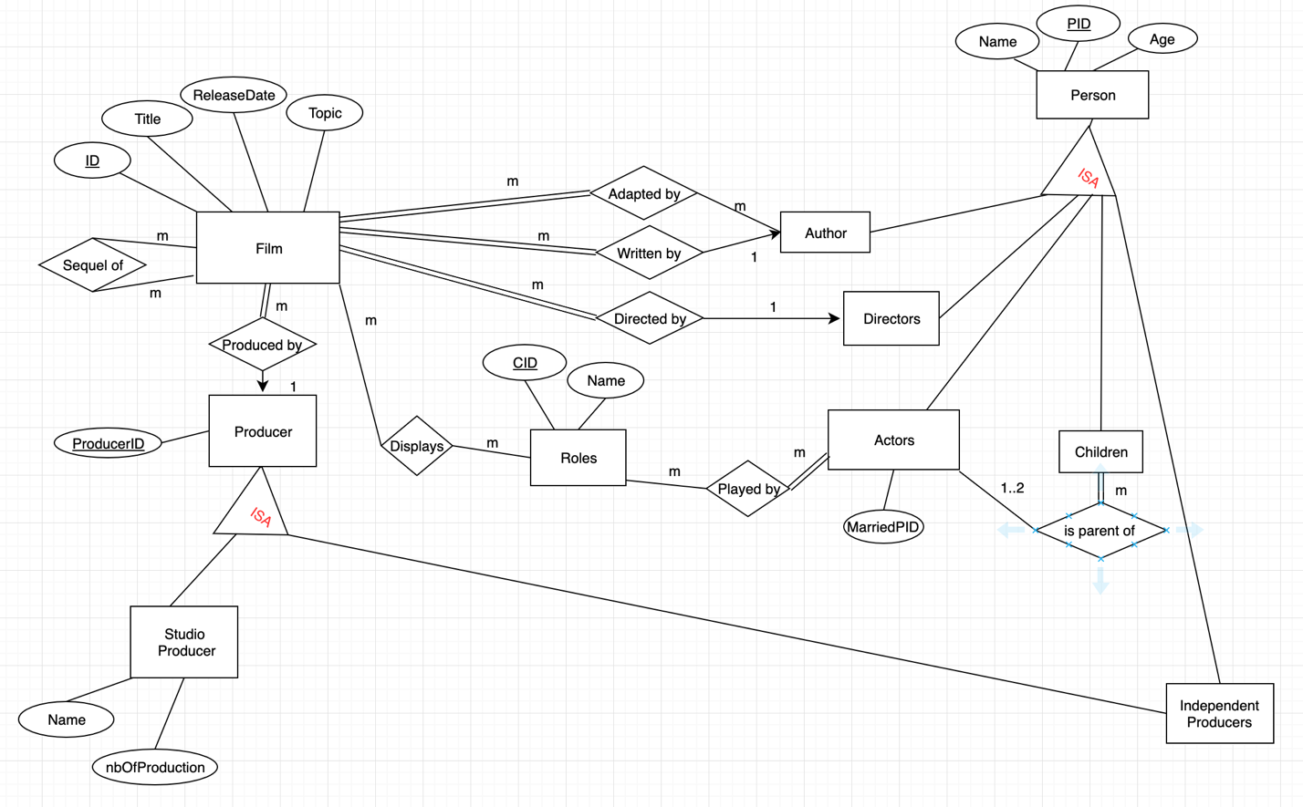

**Overview**

This is the E/R diagram that illustrate a DB application which would be used to support the world of movies. The entity set film have a few qualitative attributes and a primary key made of a unique ID for each film. We thought it would be more appropriate as the combination of two more general film attributes to avoid any conflicts. The films entity has a many-to-many relationship with the entity “Roles” as one film can display many roles and a role can be displayed by many films (ex: Batman). There is no total participation since a film can displays no role at all (ex: Documentary about animals).The “Role” entity set also has a many-to-many relationship with the entity-set “Actors” since an actor can play many roles and a role can be played by many actors. In this case, there is a total participation of the actors since an actor have to have at least one role to be considered an actor.

The “film” entity-set have a many-to-one relationship with the “Directors” (directed by) and the “Authors” entity-set (written by). The film has a total participation in those two relationships since the film needs to have a director and an author. The “film” entity also has a many to many relationship with the entity set “Author” for the adaptation of the film. Multiple films can be adapted by multiple authors. The film has total participation in this relationship since the film needs to be adapted by one or multiple authors. The “film” entity set also have a many to many relationship with itself where sequels can be checked. One film can be the sequel of many others. And many movies can have sequels.

The “Authors”, “Directors”, “Actors”, “Children” and “Independent Producers” entity-sets have an “isa” relationship with the “Person” identity set which have the primary key of a unique person identifier (PID). The “Actors” and the “Children” also have a many-to-many relationship since an actor can be the parent of more than one child and the children have more than one actor parent. However, the constraint that one child must at least have one parent and not more than two is added. Moreover, there is total participation of the children in this relationship since the child must have a parent to be in the database.

The film is produced by a producer, which is a many to one relationship since many films can be produced by a producer. In this relationship, the film has a total participation since each film needs to have a producer. The producer has a productionID to uniquely identify the instance. Then, the producer can be a studio producer or and independent producer, which is showed with an “isa” relationship. They both can be retrieve by the productionID inherited from the “producer” entity set. The “Studio Producers” entity set have a few attributes adequate to describe the instance.

**Question 2**

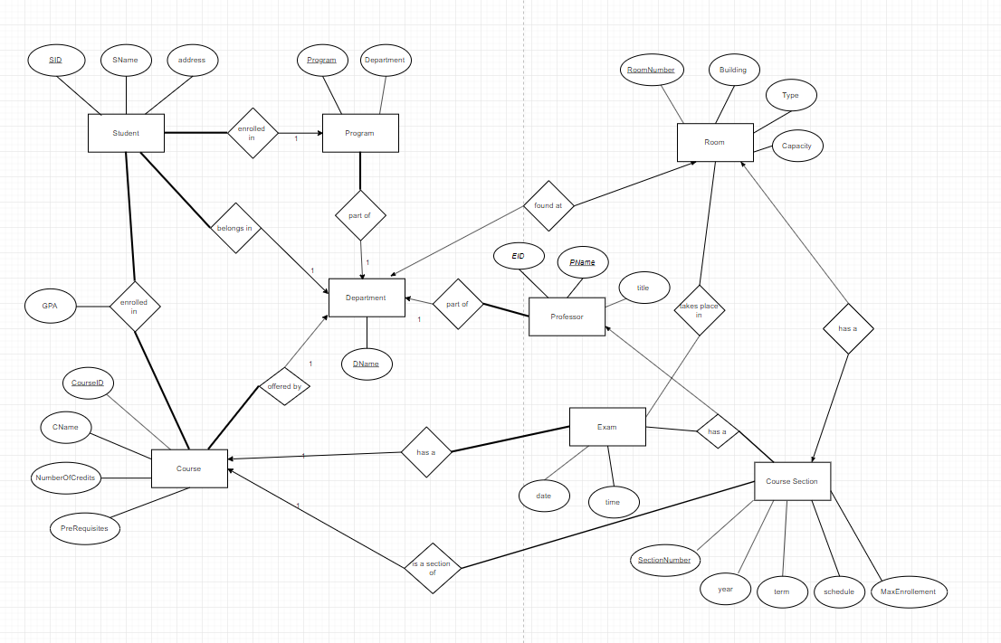

**Overview**

This is an E/R diagram illustrating a database application used for managing student information system of a university. Each student possesses several attributes including a primary key made of a unique student ID. Each student is enrolled in a program but the relationship Student and Program entity is one to many due to the fact that many Students can be enrolled in a specific program.

The entity Program and Student also share a one to many relationship with the entity Department as there can be many programs within a department and as a result, many student can be a part of a specific department. In addition, Department also shares a one to many relationships with Course as well as Professor since one or more Course can be offered by a specific department and the same can be said for Professor. However, one department can only be found in a specific room which is why the entities Room and Department share a one to one relationship.

The entity Course shares a one to many relationship with the entities Course Section as well as Exam. One course may possess several Course Section and as a result can have one or more exams. Course Section entity shares a one to one relationship Room and Exam. A course Section can be found in a specific room and each course section has an Exam associated to it.

The Professor entity shares a one to many relationship with Course Section since a professor can be in charge of one or more course section.

Since the system must manage the students enrolled in Courses, the entities that need to be included would be:

* Student
* Courses
* Course Section

The relationship between these entities involves the following. Student and Course entity would shares a many to many relationship because several Students can be enrolled in a specific course. On the other hand, a specific student can be enrolled in one or more Courses meaning that Each Student may be a part of one or more Course Section

Next, the system needs to record the final grade for each course the student takes so based on the data and attributes given to us originally, the entities required for this step would be the Student entity and Course Entity. They would share a many to many relationship since many Students can be a part of a single course and vice versa, many Courses can be taken by a single student therefore a student can have many grades corresponding to each courses taken.