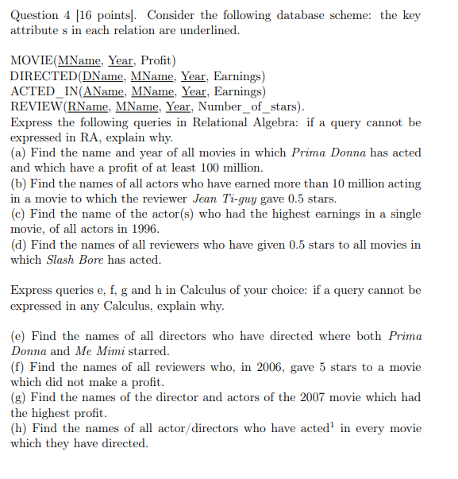

a)

Π MName, Year (σ (AName = “Prima Donna” ∧ Profit > 100 000 000 (ACTED_IN ⋈ MOVIE)))

b) Π AName (σ (Earnings > 10 000 000 ∧ RName = “Jean Ti-guy” ∧ Number_of_stars = 0.5 (ACTED_IN ⋈ REVIEW)))

c) This query is impossible to translates to relational algebra because it is asking us to find the highest value of an attribute which we cannot do.

d) This query is not possible to translate to relational algebra due to the fact that it requires us to keep track of all the entries which fill the given condition.

e) {d | ∃ a,b ∈ DIRECTED( a[MName] = b[MName])

∧ a[AName] = “Prima Donna” ∧ b[AName] = “Me Mimi” ∧

ACTED_IN(d[MName] = a[MName])}

f) {m | ∃ r ∈ REVIEW( r[Year] = 2006 ∧ r[Number_of_stars] = 5)

∧ m[MName] = r[MName]) ∧ m[Profit] = 0}

g) {t | ∃ d ∈ DIRECTED_IN( t[DName] = d[DName] ∧

∃ a ∈ ACTED_IN ( t[AName] = a[AName] ∧ a[MName] = d[MName] ∧

∃ m1 ∈ MOVIE ( ∃ m2 ∈ MOVIE (m1[Profit] > m2[Profit] ∧ m1[Year] = 2007)))}

h) {t | ∃ d ∈ DIRECTED_IN( t[DName] = d[DName] ∧

∃ a ∈ ACTED_IN ( t[AName] = a[AName] ∧ a[MName] = d[MName]))}