

Assignment 1- Group 29

COMP353 – Databases

Mair Elbaz, 40004558

Daniel Vigny-Pau, 40034769

Francois David, 40046319

Alexandre Therrien, 40057134

Charles-Antoine Guite, 40063098

Professor: Dr. Desai

Fall 2019

Concordia University

Question 1.

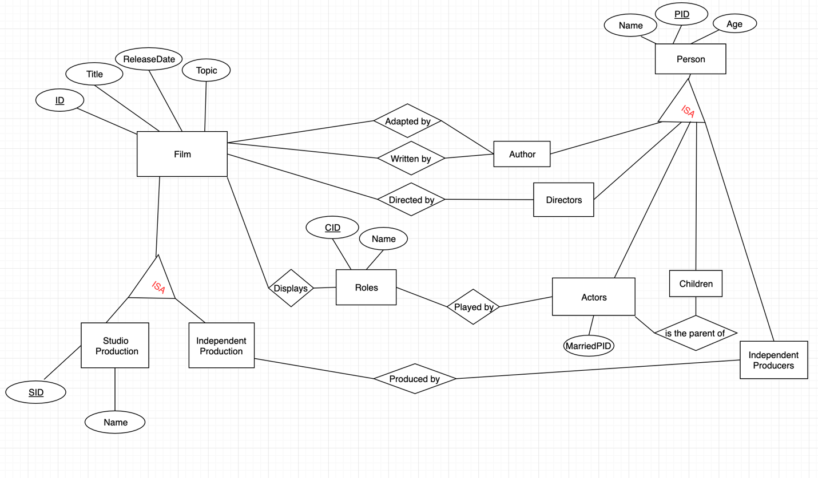

**Overview.**

This is the E/R diagram that illustrate a DB application which would be used to support the world of movies. The entity set film have a few qualitative attributes and a primary key made of a unique ID for each film. We thought it would be more appropriate as the combination of two more general film to avoid any conflicts. The films entity has a many-to-many relationship with the entity “Roles” as one film can display many roles and a role can be displayed by many films (ex: Batman). The “Entity set” also has a many-to-many relationship with the entity-set “Actors” since an actor can play many roles and a role can be played by many actors. The “film” entity-set have a many-to-many relationship with the “directors” (directed by) and “Directors” entity-set (adaptation and writers). The “Authors”, “Directors”, “Actors”, “Children” and “Independent Producers” entity-sets have an “isa” relationship with the “Person” identity set which have the primary key of a unique person identifier (PID). The “Actors” and the “Children” also have a many-to-many relationship since an actor can be the parent of more than one child and the children have more than one actor parent. The film can be a studio or and independent production which is showed as a “isa” relationship. If it is a studio production, the studio can be retrieved by a primary key unique to each studio. An independent production can be retrieved by the film key. The “Independent Producers” also have a many-to-many relationship with the “Independent Production” entity since a film can be produced by many independent producers and it is also possible for a producer to produce many films.