Project Crunch Down

-System admin, Controller, Event Manager, Participant

Details on participants: ID, Name, password, event/s (to be set to null if no event that belongs to him), organization, (etc.?), privilege level (admin vs rest)
-Event Manager is only one to be able to add/update participants (update?) and manage/update participants.
-Administrator can create/delete/update members and groups. Can also post content.
-Participant can become event manager, invite other participants, accept demand from other participants to join the group, post content on group. Only members of group can see content (just like FB). Members of group is visible to everyone within group, and members can send private communication from member to member within the same group.

“All event posting not intended for a group is accessible to all participants of the event and they can add contents and comments on any content.” → Does it mean that you can post your event to the general public and they can reply to that general post? Or is it inside of a group still?
CONTROLLER SETS CHARGE RATE FOR ADDING EVENTS ON WEBSITE.
-Event can be active or archived. Active event allows the participants to share, post and comment. An archived event only allows to see the general description of the event (because its as if everyone has been kicked out, so you cannot see the posts and content from the group anymore).

-Only event manager can change status of participant and add/remove participant, along with system admin.

-Email system that notifies the participants of an event of any change for a certain event. They are also sent that information when they get logged in the software SCC.

-GROUP: Must have a way to know who is admin of group, members of the group. Owner of group can add/remove members. Members can share images, videos, and posts. To add a member you need to know their SCC id, email address, first name and DOB (Distributed Objects???)
-Each user has a home page containing the mail they received (gmail sort of), along with the list of their events in which they participate in as well as the ones which they are the owners, and also the groups in which they participate in as well as those they own.
-Group owner can manage the permissions to any content. Permissions are: view only, view and comment, view and add/link to other content.

OTHER IMPORTANT FEATURES
-Admin features: mgmt of system, users and contents
-Create, Delete, Edit, Display a user/member/participant.
-Create/Delete/Edit/Display a group.
-Create/Delete/Edit/Display list of members in group.
-Event participant request to join a group in the event.
-Member’s ability to withdraw from a group.
-Member’s ability to post texts, images, or videos as well as view posts by other members and comment on them.
-Members can either post or view posts of only groups that they belong to.
-Member’s main page shows the latest posts from their groups.
-Members can send a private message to one or more members of a group where s/he is a member.
-Report of groups or members by specific category such as interest, age, profession, region, etc.
-Ability to organize an event for the group by voting on date/time/place from a set posted and/or alternates suggested by one of the group members.
-Registry and/or gift exchange (secret) ideas among a family (secret) or a group.

GROUP vs EVENT

Online work log (who what when why)
Document all communications that was sent from the team.

WebsiteHome.html
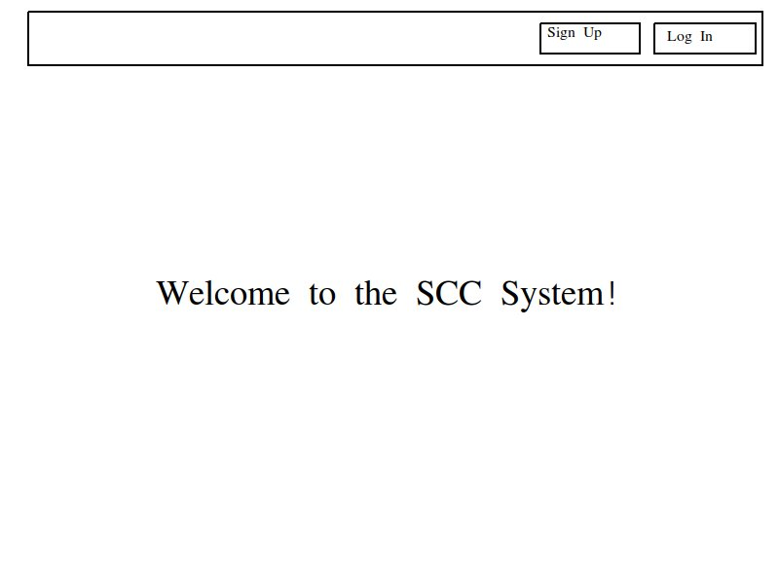
Self-explanatory.

homePage.html
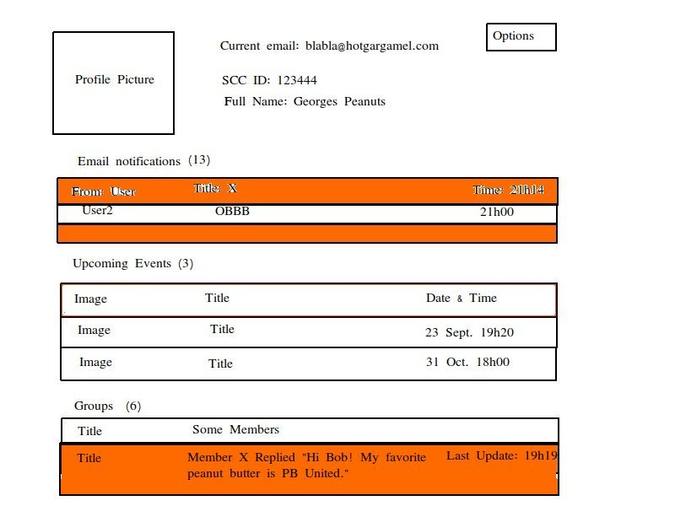

Orange bars indicate which have new content that have been added to recently that the user has not seen yet.
There is a mention of an email-facility on the home page, which is some kind of mailbox. Also, events and groups not being the same thing, I put them in two distinct categories. We could also indicate the number of new stuff to look at in Emails, Events, and Groups which have not been seen yet, such as the title Emails (13) for 13 new emails that have not yet been seen.

Clearly, some servlet must handle this, as the content is dependent on the user.
NOTE: Show only 5-10 of each of groups/events/mails. To see all of them, the user will need to click on the title that will show a detailed list of only groups/events/mails. That new window will be a flowbox that loads more content if the user requests for more.

When you click on this “Options” button, the following popup appears:

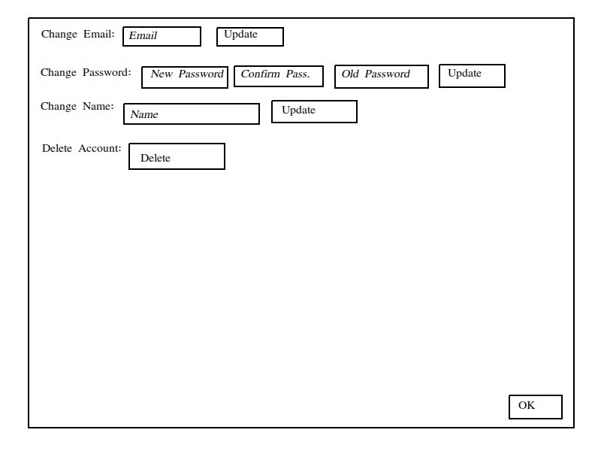

Simple configurations to change your user’s details, and allows to remove the user from the system.

Groups.html

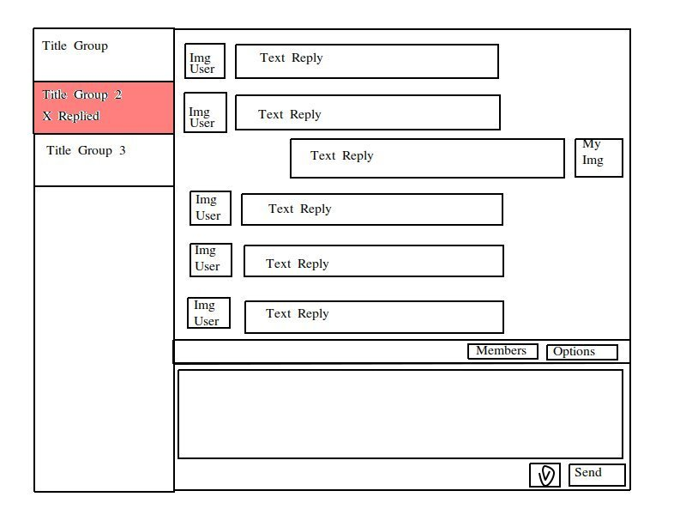
The pink is to indicate a reply has been received and has not yet been seen. The Options button will be used to Add/Remove members, send invitations, … (only for the group manager, but there is also a different Options button for the participant). There is a thumbnail next to the “SEND” to send an image or video. Once you click on the thumbnail, the user’s file system will appear and allow him/her to select an image or video on his computer. Once it is selected and OK of the popup is clicked on, the image/video will appear automatically in the group conversation.
The rest is pretty much self explanatory. The Members button allows you to see all members. Anyone has access to that button.
Also, the group manager is allowed to click on the text replies, which will make a dropdown appear which contains “View Only”, “View and Comment”, “View and add link to other content”, looking like this (ONLY GROUP MANAGER). In the case of anything other than View Only, an indented conversation will occur under the reply:
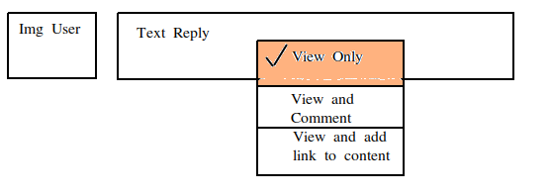

View and comment:
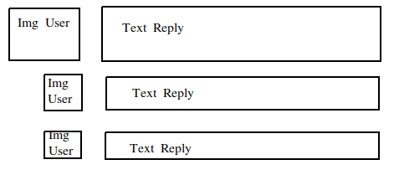
You can see the indentation that appears from a “View and comment” permission.

View and add link to content (View and reference):
Only difference with “View and comment” would be that it only accepts links input from user replies.

When you click on “Members”, this popup appears:
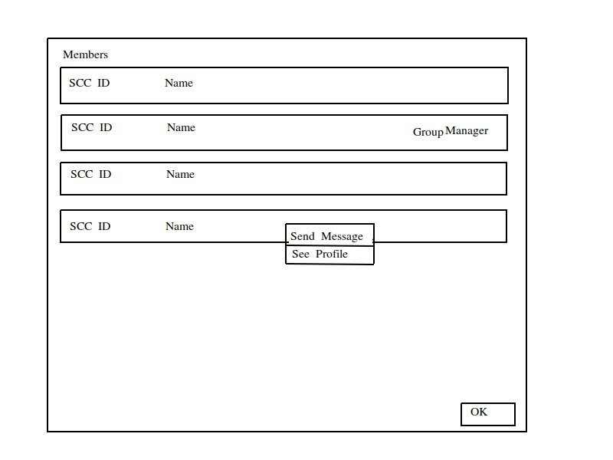

NOTE: If there are too many members that it goes over the popup, make it a flowbox, so that if you scroll down it loads additional members.
You should see the SCC IDs of each of the members. Everyone has the possibility to send a private message to someone else. Doing so will result in a new group being added on both of the users’ home page. It is the person that initiated that communication that becomes the group manager. However, this group will be hidden from the event’s page. Also, you need to know who is/are the group managers.

Also: The button OK returns back to the group conversation.

When you click on “See Profile”, you will end up with this view:
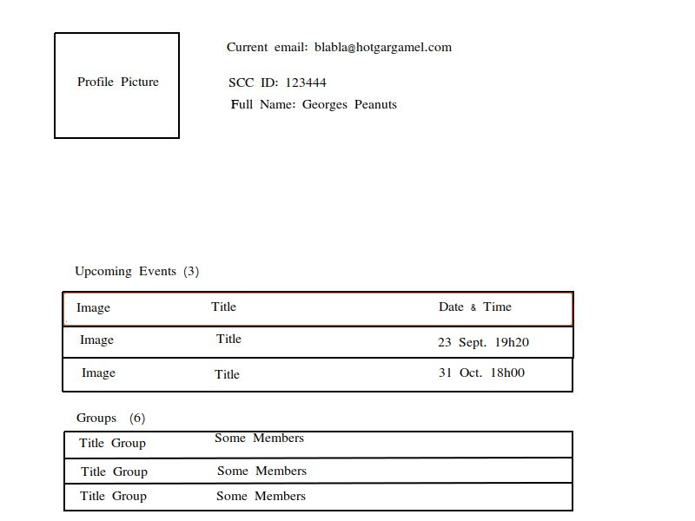

When you click on “Options” in Groups.html (Only for admin and group manager):
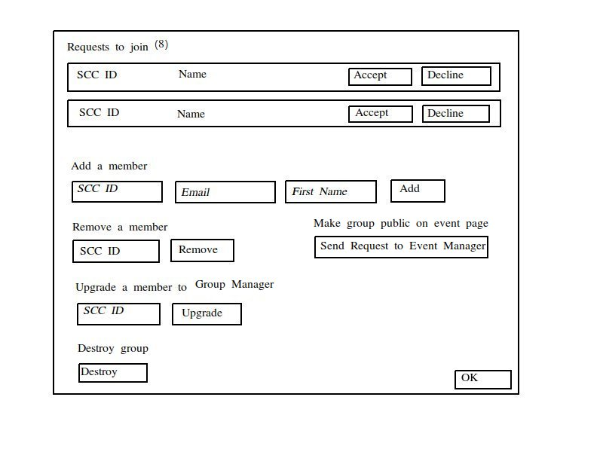

The italicized words are placeholders for values that are to be inputted. There is the buttons Add/Remove/Upgrade on the lower part of the picture. I also show some Requests to join the group as well as buttons Accept/Decline to add the user or just refuse their demand to join. A pop up should appear to confirm the group manager’s decision.
The button OK returns to the group conversation.

When you click on “Options” (as a Participant) on Groups.html, you get this popup:
It includes a button for withdrawing from the group, and a button OK that returns to the Group page.
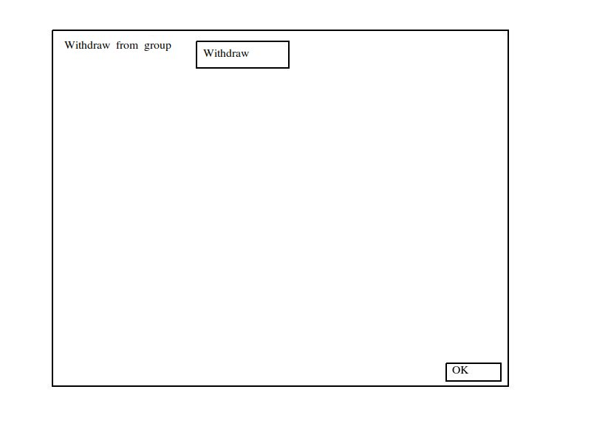

Events.html (View from someone who got accepted to the event):
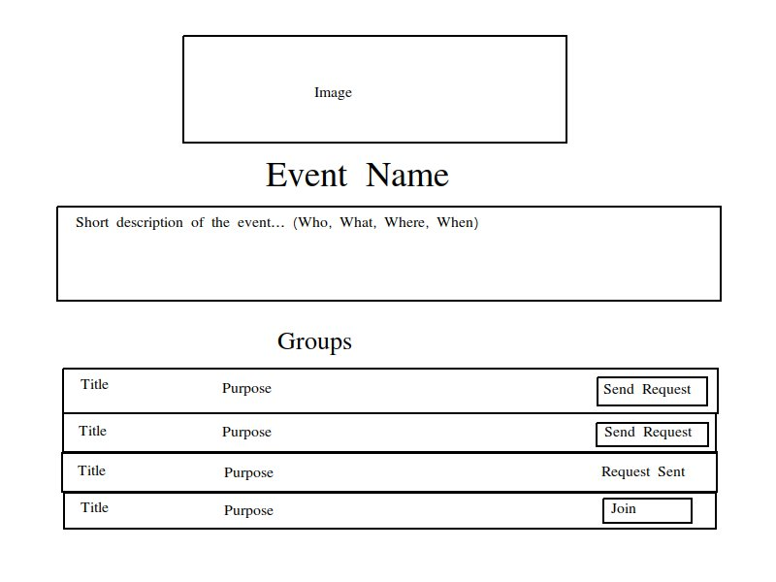
(We could have a similar setup as EventBrite. Only difference would be the groups section) The groups are part of the events. However, some groups are private (the ones that are created from within group members), and these cannot be seen from the event page.
There is the “Send Request” button for those groups which the user is not participating it. Once you click on that button, the words “Request Sent” appear, and then the Group manager will see that from the “Options” tab in the Groups.html. The button “Join” appears when the user is already a member of the group.

The “When” of the event can be set to “undefined”.

Also, there must be a search bar to be able to search for different available events.

Events.html (from someone not accepted to the event):

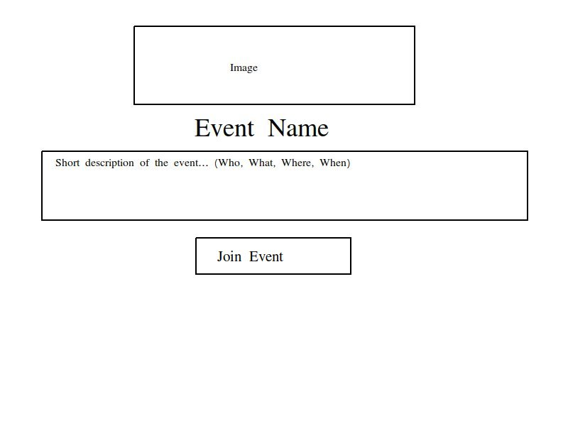
Self explanatory.

Should have a page to charge the user for creating an event, and for collecting more information on the event manager (as required: phone number, organization, ...)

