Software Architecture Document

Version 1.01

for

Web Geography

Prepared by

Alexandre Therrien

Source: SOEN341 class @ https://users.encs.concordia.ca/~cc/soen341/
Document history
Date | Version | Description | Author
22-12-18 | 1.0 | Filling SAD | Alexandre Therrien
28-12-18 | 1.01 | Add logical view | Alexandre Therrien

Table of contents
1. Introduction 4
2. Architectural representation 5
7. Architectural requirements: goals and constrains 7
8. Use case view (Scenarios) 8
9. Logical view 8
10. Development (Implementation) view 10
11. Process view 10
12. Deployment (Physical) view 10
13. Data view (optional) 10
14. Quality 11

List of figures
Figure 1: The 4+1 view model. 4

Introduction

Purpose
This document provides information about important architectural decisions that were made to build the application. It outlines different architectural views to get the reader aware of the architecture decisions on different aspects.

Scope
This document provides the architecture of the WebGeography web application developed by Alexandre Therrien.

Definitions, acronyms, and abbreviations
This section provides the definitions of all terms, acronyms, and abbreviations required to properly interpret the Software Architecture Document.

RUP: Rational Unified Process
UML: Unified Modeling Language
SAD: Software Architecture Document

Architectural representation
This section represents the application under different views: logical view, process view, development view, physical view, and scenarios.

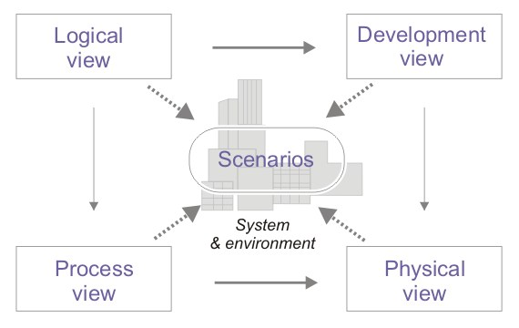
Figure 1: The 4+1 view model.

- Logical view : Audience: Designers. The logical view is concerned with the functionality that the system provides to end-users. UML Diagrams used to represent the logical view include Class diagram, and interaction diagrams (communication diagrams, or sequence diagrams).

- Development view (also known as Implementaion view): Audience: Programmers. The development view illustrates a system from a programmer's perspective and is concerned with software management. This view is also known as the implementation view. It uses the UML Component diagram to describe system components. UML Diagrams used to represent the development view include the Package diagram.

- Process view : Audience: Integrators. The process view deals with the dynamic aspects of the system, explains the system processes and how they communicate, and focuses on the runtime behavior of the system. The process view addresses concurrency, distribution, integrators, performance, and scalability, etc. UML Diagrams to represent process view include the Activity diagram.

- Physical view (also known as deployment view) : Audience: Deployment managers. The physical view depicts the system from a system engineer's point of view. It is concerned with the topology of software components on the physical layer, as well as the physical connections between these components. UML Diagrams used to represent physical view include the Deployment diagram.

- Use case view (also known as Scenarios) : Audience: all the stakeholders of the system, including the end-users. The description of an architecture is illustrated using a small set of use cases, or scenarios which become a fifth view. The scenarios describe sequences of interactions between objects, and between processes. They are used to identify architectural elements and to illustrate and validate the architecture design. They also serve as a starting point for tests of an architecture prototype. Related Artifacts : Use-Case Model.

- Data view (optional): Audience: Data specialists, Database administrators. Describes the architecturally significant persistent elements in the data model . Related Artifacts: Data model.

Architectural requirements: goals and constraints
There are some requirements to this project, due to the software that is being used.

The database that is used only allows for 500MB of data. For this reason, storage of scores must be limited. As well, only a specific number of users will be allowed due to the size of the database. Thus, the system must be able to kick them out after a certain amount of days without activity.

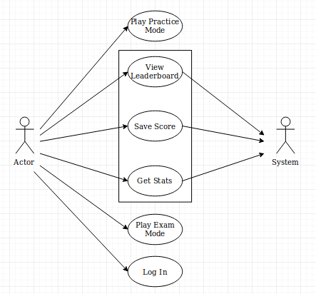

Functional requirements (Use case view)

Refer to Use Cases or Use Case scenarios which are relevant with respect to the software architecture. The Use Cases referred to should contain central functionality, many architectural elements or specific delicate parts of the architecture.

The overview below refers to architecturally relevant Use Cases from the Use Case Model (see references).

Source | Name | Architectural relevance | Addressed in:
Use case(s) or scenario(s). | Name of case(s) or scenario(s). | Description on why this use case or scenario is relevant to the architecture. | Section number where this use case or scenario is addressed in this document.

Non-functional requirements

Describe the architecturally relevant non-functional requirements, i.e. those which are important for developing the software architecture. Think of security, privacy, third-party products, system dependencies, distribution and reuse. Also environmental factors such as context, design, implementation strategy, team composition, development tools, time to market, use of legacy code may be addressed.

Usually, the non-functional requirements are already in place and can be referenced here. This document is not meant to be the source of non-functional requirements, but to address them. Provide a reference per requirement, and where the requirement is addressed.

Source | Name | Architectural relevance | Addressed in:
e.g. Vision, SRS. | Name of requirement. | Description on why this requirement is relevant to the software architecture. | Section number where this requirement is addressed in this document.

Use case view (Scenarios)

The uses cases for this system are:
1- Login
2- Play with Specific Continent Choice
3- Storage of Score from Play in Exam Mode
4- Play in Exam Mode
5- Play in Practice Mode
6- Accessing Scores for Leaderboard

1-Login (Missing removal of user account after long inactivity)
During the log in, a time stamp is instantiated. The system regularly checks for users’ time stamps to compare it with the current time. If the time stamp becomes too old, the user account is removed from the system.

2- Play with a Specific Continent Choice
When the user goes into play, he/she gets to choose the continent for which he/she wants to be asked questions. The images that are seen must be from the continent the user requested.

3- Storage of the Score from Play in Exam Mode
After the user made a mistake in exam mode, his score gets saved into the online database. This is made from an invisible form that is sent from a page to the database before going to the game over page.

4- Play in Exam Mode
In this mode, every country only gets asked once. Also, at the end of the game, the score is sent to the database. If the user gets all the right answers, he gets sent to a different page saying he won.

5- Play in Practice Mode
In this mode, the countries can be repeated many times. This mode also contains an answer button that gives the user the answer if he/she does not know. When the user makes a mistake, he/she is also sent to the game over page.

6- Accessing Scores in the Leaderboard
The scores from the leaderboard must be displayed from best to worst. Also, only ten scores can be retained for each mode. When a score has a time stamp that is beyond a week ago, it gets deleted.

Logical view

The logical view captures the functionality provided by the system; it illustrates the collaborations between system components in order to realize the system's use cases. Describe the architecturally significant logical structure of the system. Think of decomposition in tiers and subsystem. Also describe the way in which, in view of the decomposition, Use Cases are technically translated into Use Case Realizations.

Layers, tiers etc.
Describe the top-level architecture style. Deploy a UML class diagram.

Subsystems
Describe the decomposition of the system in subsystems and show their relation.

Architecturally significant design packages
Desribe packages of individual subsystems that are architecturally significant. For each package nclude a subsection with its name, its brief description, and a diagram with all significant classes and packages contained within the package.

Use case realizations
In this section you have to illustrate how use cases are translated into UML interaction diagrams. Give examples of the way in which the Use Case Specifications are technically translated into Use Case Realizations, for example, by providing a sequence-diagram. Explain how the tiers communicate and clarify how the components or objects used realize the functionality.

Development (Implementation) view

The development (or implementation) view describes the components used to assemble the system. Use a UML component diagram to capture this view.

Reuse of components and frameworks
Describe any third-party or home-made components and frameworks that will be reused.

Process view

The process view illustrates the system's processes, focusing on the runtime behavior of the system. The view illustrates parallelism and concurrency. Deploy a UML activity diagram to capture this view.

Deployment (Physical) view
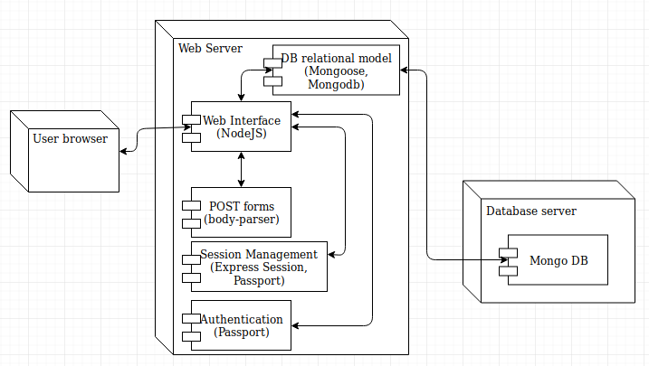
The deployment (or physical) view illustrates the physical components of the architecture, their connectors and their topology. Describe the physical network and hardware configurations on which the software will be deployed. This includes at least the various physical nodes (computers, CPUs), the interaction between (sub)systems and the connections between these nodes (bus, LAN, point-to-point, messaging, SOAP, http, http). Use a UML deployment diagram to capture this view.

Name | Type | Description
User Browser | Browser | The user’s browser to connect to the website. NOTE: STILL IN HTTP
Web Interface | Web API | The web interface handles the communication with the front end and with the database (back end)
POST forms Body-Parser | POST forms | Make the POST forms accessible from nodeJS
Session Management | Session | Enables a user to be logged in and navigate freely through the web pages.
Authentication Passport | Authentication | Enables verification of user credentials
DB relational model | Database Communication | Communicates with the database server
Mongo DB | Database | Stores the information of the website

Data view (optional)
An enterprise software system would additonally require a data view. The data view describes the data entities and their relationships. Deploy an Entity-Relationship (ER) Model to represent this view. Note that the ER model is not part of the UML specification. Additionally you can deploy a UML class diagram to represent the data view where classes would correspond to data entities.

Quality

A description of how the software architecture contributes to the quality attributes of the system as described in the ISO-9126 (I) standard. For example: The following quality goals have been identified:

Scalability:
- Description : System’s reaction when user demands increase
- Solution : J2EE application servers support several workload management techniques
Reliability, Availability:
- Description : Transparent failover mechanism, mean-time-between-failure
- Solution : : J2EE application server supports load balancing through clusters
Portability:
- Description : Ability to be reused in another environment
- Solution : The system me be fully J2EE compliant and thus can be deploy onto any J2EE application server
Security:
- Description : Authentication and authorization mechanisms
- Solution : J2EE native security mechanisms will be reused

