The Lightweight IBM Cloud Garage Method for Data Science

Architectural Decisions Document Template

# Architectural Components Overview

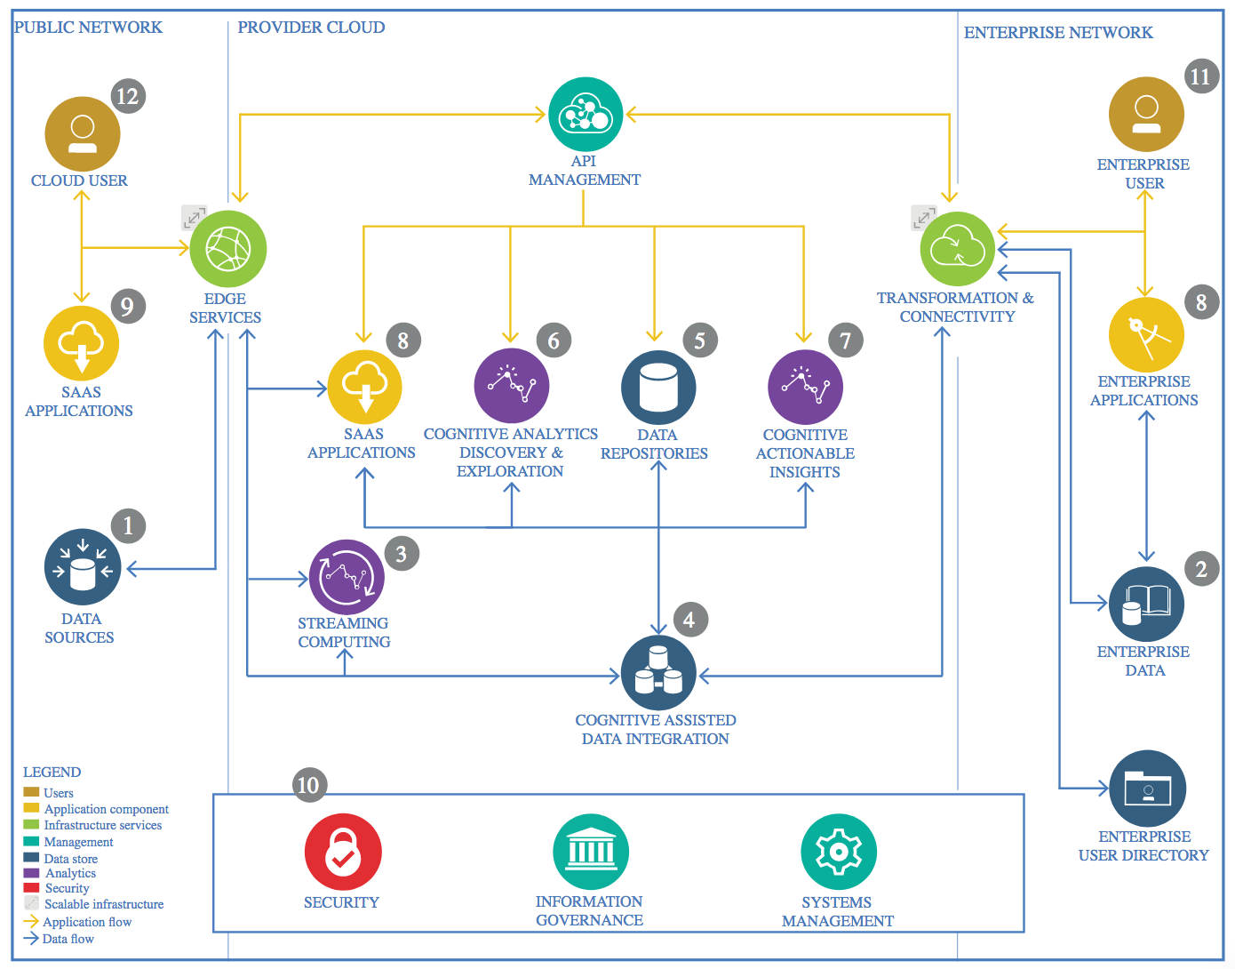

IBM Data and Analytics Reference Architecture. Source: IBM Corporation

## Data Source

### Technology Choice

In my project I have used PowerPlants estimated_generation_ growth.

### Justification

I’ve found interesting to work on that data. And its challenging though how we can perform feature engineering in it

## Enterprise Data

### Technology Choice

I have used this data from TMT infocom.

### Justification

Though its not known much but provided good data.

## Streaming analytics

### Technology Choice

I have used Missingno to check all the missing values. And matplotlib to plot the data.

### Justification

It performs well to clean the data.

## Data Integration

### Technology Choice

No Integration being performed here.

### Justification

No Integration being performed here.

## Data Repository

### Technology Choice

I have used Spark Shell

### Justification

Its best to be used with repository.

## Discovery and Exploration

### Technology Choice

I have used correlation map to find correlation between the data.

### Justification

Best to find relationship between the data.

## Actionable Insights

### Technology Choice

No Actionable Insights being done.

### Justificatin

No Actionable Insights being done.

## Applications / Data Products

### Technology Choice

I have used Watson’s Studio.

### Justification

Works best with data science projects.

## Security, Information Governance and Systems Management

### Technology Choice

No Security being provided.

### Justification

No Security being provided.