# PRACTICAL-1

<html>

<head>

<title>My php first website

</title>

</head>

<body>

<header>

<nav id="main-navigation">

<ul>

<li><a href="Home.php" target="_blank">Home</a></li>

<li><a href="About.php">About</a></li>

<li><a href="Gallery.php">Gallery</a></li>

<li><a href="Service.php">Service</a></li>

<li><a href="Login page.php">Login page</a></li>

<li><a href="Contact page.php">Contact page</a></li>

</ul>

</nav>

</header>

<div id="main-cantents">

This is page 1, the Home page</div>

<table>

<tfoot>

<th>

thank you visit my website..

</th>

</tfoot>

</table>

</body>

</html>

**PRACTICAL-2**

<?php

$name=$_GET['name'];

$age=$_GET['age'];

$gender=$_GET['gender'];

$mobilenumber=$_GET ['mobilenumber'];

$email=$_GET['email'];

$address=$_GET['address'];

echo"Name is:-$name <br/>You are:- $age year old.<br/>

Your mobile number is:- $mobilenumber <br/>Your email is:- $email

<br/>Your Address is:-$address<br/>"; echo"<h1>Form submitted</h1>";

?>

<html>

<head>

<title>GET method</title>

</head>

<body>

<form action="get.php" method="get" border="2">

<p>Name:-<input type="text" name="name" required></p>

<p>Age:-<input type="text" name="age" required></p>

<fieldset>

<legend> Gender

</legend>

<p>Male:-<input type="radio" name="gender" required> Female:-<input type="radio" name="gender" required></p>

</fieldset>

<p>Mobile number:-<input type="number" name="mobilenumber" required></p>

<p>Email:-<input type="email" name="email" required></p>

<p>Address:-<input type="textarea" name="address" required></p>

<p><input type="submit"></p>

</form>

</body>

</html>

**OUTPUT:-**

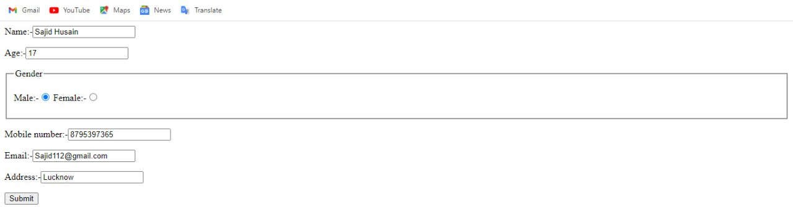

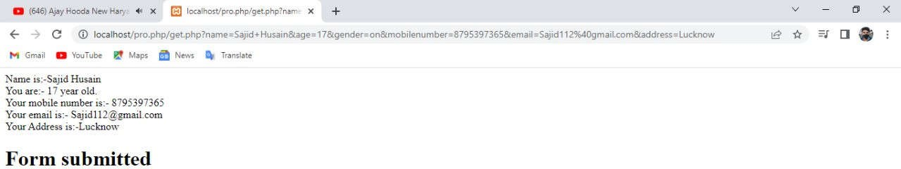

**PRACTICAL-2 [POST]**

<?php

if($_POST["name"]||$_POST["email"]||$_POST["password"]||$_POST["dateofbirth"]||$_POST["mob ilenumber"])

{/*if(preg_match("/[^A-Za-z'-]/",$_POST['name'])){

die("invalid name and name should be alpha");

}

?>

<html>

<head>

}*/

echo"welcome"." ".$_POST['name'].";"."<br/>";

echo"your email"." ".$_POST['email']." ".";"."<br>";

echo"your password "." ".$_POST['password']." ".";"."<br/>"; echo"your bate of birth is "." ".$_POST['dateofbirth'].";"."<br/>"; echo"your mobile number is "." ".$_POST['mobilenumber'].";"."<br/>"; exit();

<title>POST ()</title>

</head>

<body>

<form action="POST.php" method="POST">

<P>Name:-<input type="text"name="name" required></P>

<P>Email:-<input type="text"name="email" required></P>

<P>Password:-<input type="text" name="password" required></P>

<p>Date of birth:-<input type="text" name="date of birth" required></p>

<p>Mobile number:-<input type="text" name="mobile number" required></p>

<input type="Submit"/>

</form>

</body>

</html>