**---------------------------------------------------------------------------------------------------**

**Prerequisites**

**OS** : **centOS7**

**Memory : 16 GB RAM**

**---------------------------------------------------------------------------------------------------**

**All the tasks shall be performed as a root user.**

**$ sudo –iu root**



**Check the IP address.**

**Ifconfig –a**



**Install net-tools to get basic commands configured**

**$ yum install net-tools**

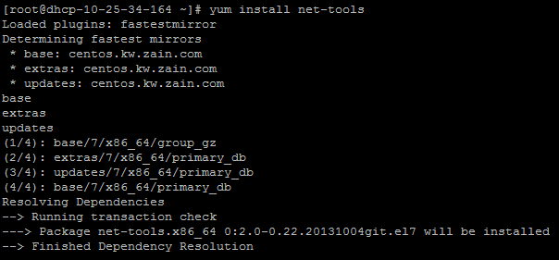

**Check the IP again using ifconfig command**

**$ ifconfig -a**

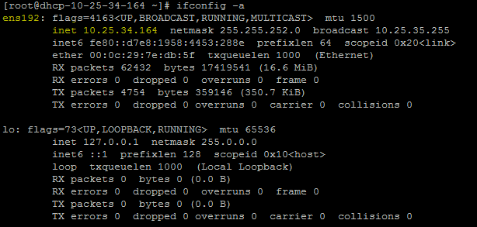

**2. Setting the Static IP**

**Check the gateway :**

**$ route –n**

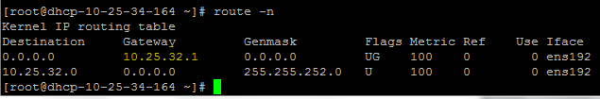

**Check DNS:**

**$ cat /etc/resolve.conf**

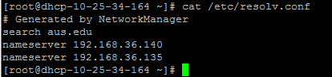

|  |  |  |
| --- | --- | --- |
| **IP address** | **Gateway** | **DNS** |
| **10.25.34.164** | **10.25.32.1** | **192.168.36.140**  **192.168.36.135** |

**Edit ifcfg-ens192 file : Add the following line at the bottom of the ifcfg-ens192 file and save.**

**NM_CONTROLLED=”no”**

**$ vi /etc/sysconfig/network-scripts/ifcfg-ens192**

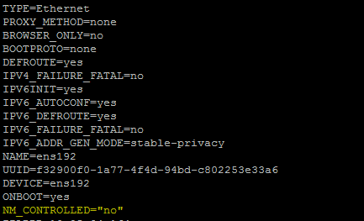

**Edit the connection for Ethernet port ens192**

**$ nmtui edit ens192**

**.**

**Restart the network**

**$ service network restart**

**Verify :**

**$ ifconfig –a**

**$ ping google.com**

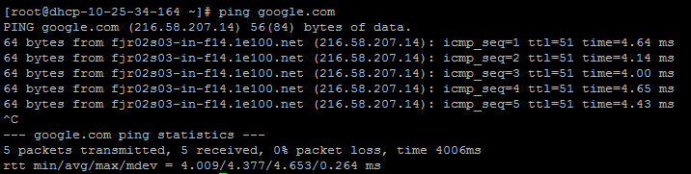

$ sudo systemctl disable firewalld

$ sudo systemctl stop firewalld

$ sudo systemctl disable NetworkManager

$ sudo systemctl stop NetworkManager

$ sudo systemctl enable network

$ sudo systemctl start network